jetty road child and

community Hub

Project information
The Jetty Road Growth Area -Stage 1 has seen significant residential development in recent years. The Jetty Road Growth Area is expected to accommodate 3,300 new homes once complete. With so many new residents it’s important that there are sufficient community facilities and services locally provided.
The Jetty Road Urban Growth Plan (2008) identified the need for a Child and Community Hub within the Neighbourhood Activity Centre (now Bayview Central). We’re now preparing for the delivery of the Child and Community Hub and an opportunity has emerged to consider collocating the hub on land alongside the Clifton Springs Primary School in Jetty Road.

What was originally planned
The proposed Child and Community Hub includes provision for child and maternal services and neighbourhood community space/s.
Where was it originally planned
During the subdivision process, land within the Neighbourhood Activity Centre was set aside for the future Child and Community Hub. The site at 2-10 Oceania Drive is owned by the City and is located between Bayview Central and the future regional park.

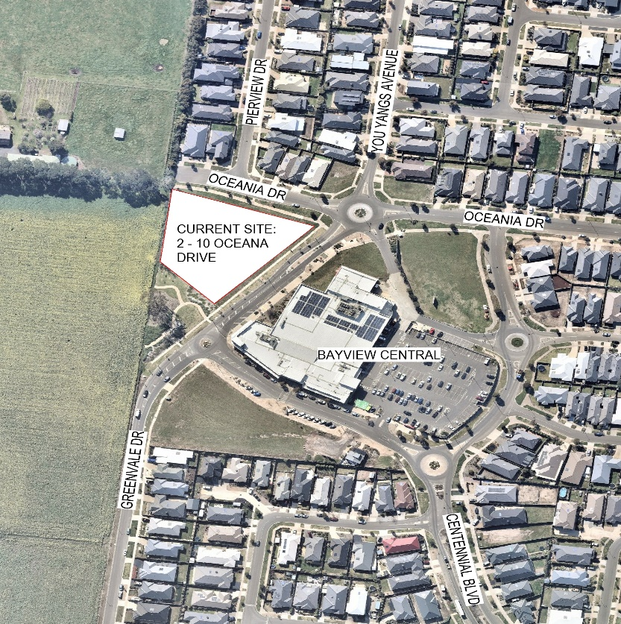

New opportunities
Since the adoption of the Jetty Road Urban Growth Plan in 2008, policy directions have shifted and the opportunity to relocate the proposed Child and Community Hub has emerged. The proposed hub including three and four-year old kindergarten program, playgroup, maternal and child health and neighbourhood community space/s.
Co-locating kindergarten programs with school sites provides many benefits for local families who have children from kindergarten to school age, making drop-off time simpler and more convenient, supporting a smooth transition between kindergarten and primary school. Having early years services and schools on the same site also helps create a hub that benefits the whole community. Relocating the hub to alongside the Clifton Springs Primary School site could provide a range of benefits to the community in the short and long term.
Alongside the Department of Education and Training, we have been exploring the possibilities of developing the Child and Community Hub on land beside the Clifton Springs Primary School site.

Clifton Springs Primary School Site

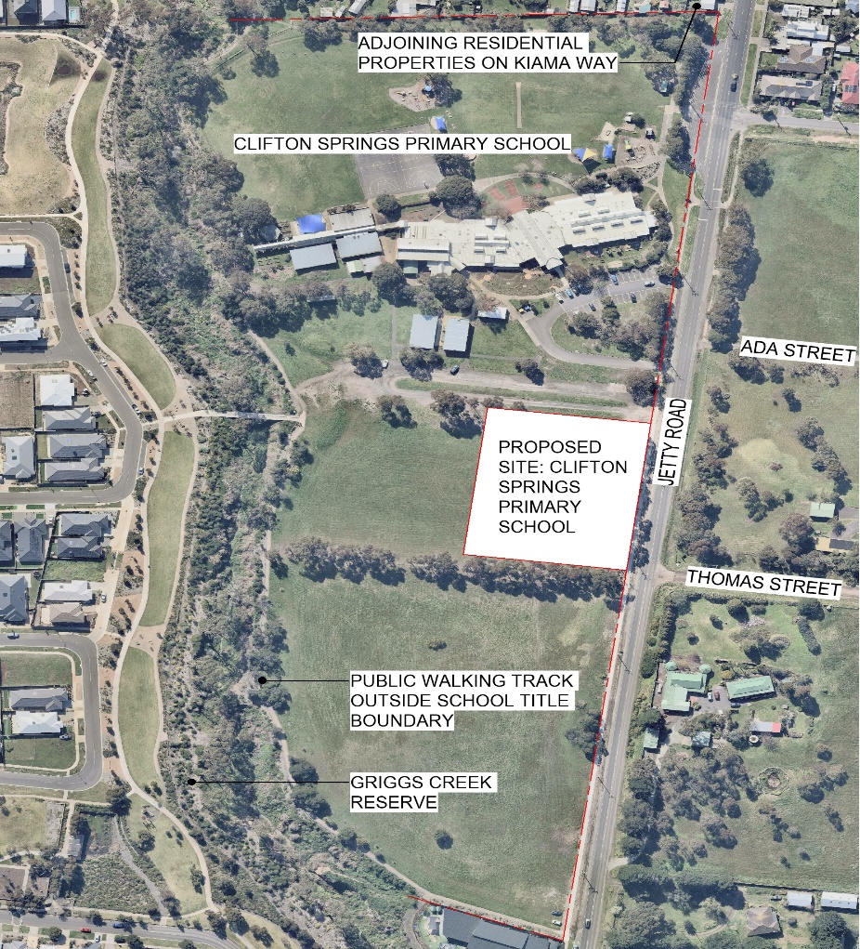

Location of both sites – approximately 1.2km between using local roads

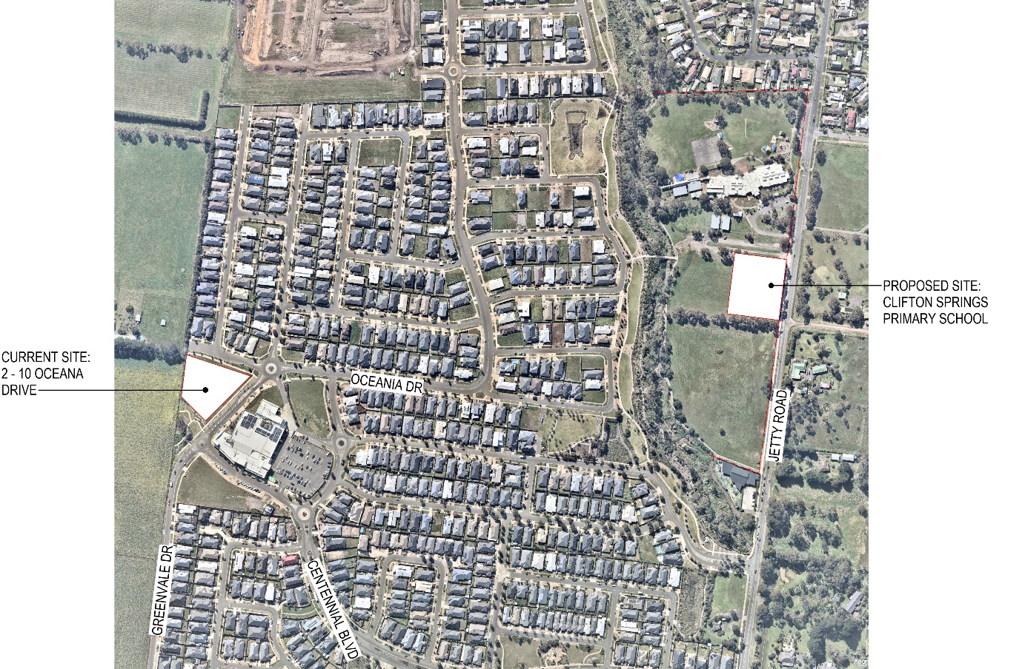

However, before any decisions can be reached, we’d like to understand your view about the preferred location.
Your feedback will inform a report to council in 2021. Further planning and engagement processes will follow subject to the decision of Council in relation to the preferred location.
for more information and/ or to Have your say
To find more information and / or to have your say, please visit
- www.geelongaustralia.com.au/yoursay and click Jetty Road Child and Community Hub link;
Or
- Register to attend an information session at https://yoursay.geelongaustralia.com.au/jettyroadccc
Or
- Contact Social Planning & Investment on 5272 4222

