jetty road child and

community hub

Frequently asked questions

Child and Community hub

What is a Child and Community Hub?
A Child and Community Hub is a facility that can provide early years services and community spaces to meet the needs of the growing community. At this stage we are considering child and maternal services, including three and four-year old kindergarten program, playgroup and maternal and child health and multipurpose space/s for complementary community uses.

Why is the Child and Community Hub needed?
The Jetty Road Growth Area is expected to accommodate approximately 3,300 homes when complete. The provision of local community infrastructure will be an important addition in supporting the residents to access services and participate in their local community.

Why are you asking the community about the location?
The Jetty Road Urban Growth Plan (2008) identified the need for a Child and Community Hub within the Neighbourhood Activity Centre (now Bayview Central). Since the adoption of the Jetty Road Urban Growth Plan in 2008, policy directions have shifted and the opportunity to relocate the hub has emerged. Co-locating kindergarten programs with school sites provides many benefits for local families who have children from kindergarten to school age, making drop-off time simpler and more convenient, and supports a smooth transition between kindergarten and primary school. Having early years services and schools on the same site also helps create a hub that benefits the whole community. However, before we can make any decisions or proceed with any process, we want to hear the views of the community on their preferred location.

What happens if the community do not support the move to Clifton Springs Primary School?
Council will consider all views as part of any final decision regarding the location of the Child and Community Hub. Council is committed through existing arrangements to ensuring residents have access to the services that would be provided through child and community services.
Decision making and approval
Following this consultation and subject to the outcome of the council report in 2021, there will be further steps and processes required to be undertaken before any final decisions are reached, including seeking agreement and approval from the Minister for Planning and Minister for Education.

How is the Child and Community Hub going to be funded?
A Developer Contributions Plan is in place for the Jetty Road Growth Area which will partly fund the construction. The Department of Education and Training supports infrastructure investment in the provision of kindergarten through existing programs and if the Child and Community Hub is to be re-located to the school site, we will seek State Government funding through established processes.

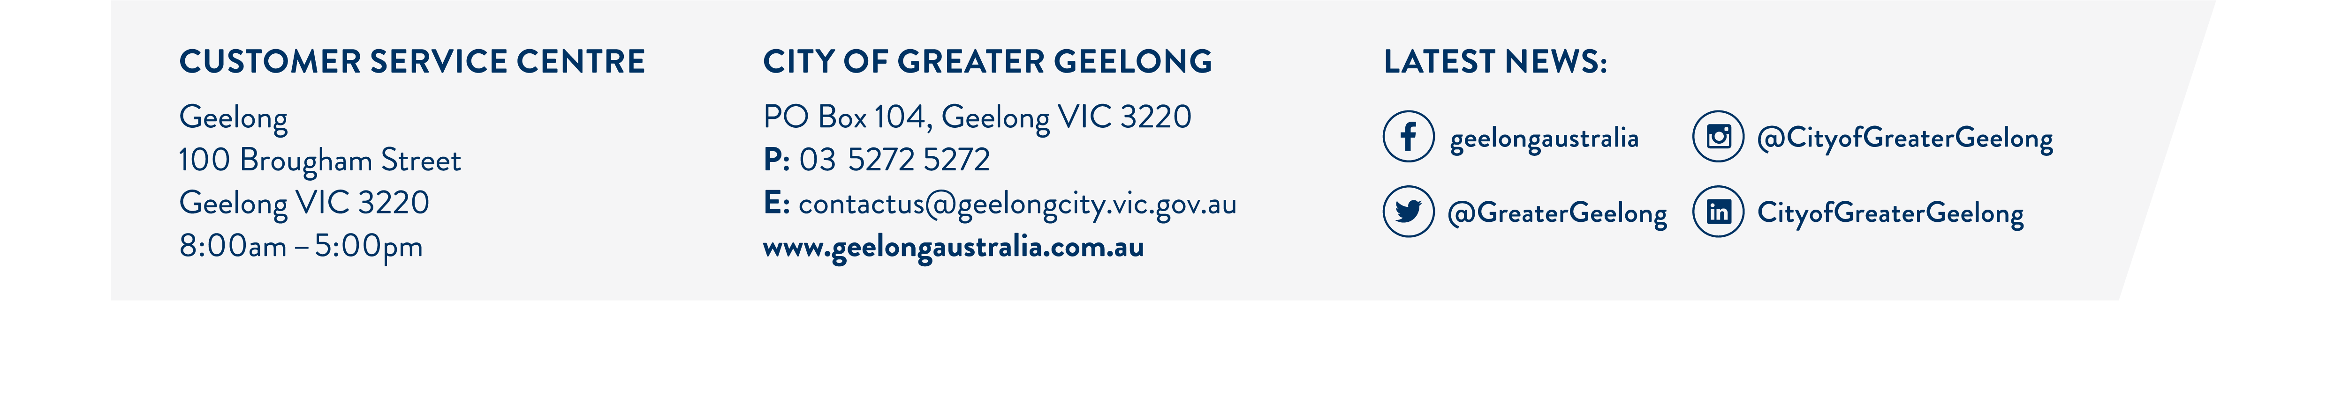
Oceania Drive Site

What will happen with 2-10 Oceania Drive if the Hub is relocated?
This will be subject to further consultation and approval processes however it is intended that the site at 2-10 Oceania Drive will be retained in council ownership and would be considered for a future use that is of benefit to the community. One possible example is public open space. Should the Oceania Drive site become available for a different public use, further consultation would be undertaken with the community.

Parks and Open Space

What parks and open space is available?
A sub-regional passive park of approximately 2.2 hectares is identified as part of the Jetty Road Urban Design Development Plan adjoining 2-10 Oceania Drive. The park spans across Stage 1 & 2 of the development area with a small section of land from Stage 1 under council ownership, with the balance to follow. Development of the open space will follow the structure plan and the park is likely to include elements of play areas, social seating, picnic areas and BBQ.

Jetty Road growth Area - Stage 2 development

When will stage 2 be delivered?
A pre-application for Stage 2 has been received and discussions are underway.

Project Information

Where can I find more information?
For more information or to register to attend an information session please visit https://yoursay.geelongaustralia.com.au/jettyroadccc
Or contact
Social Planning and Investment on 5272 4222

How long is the engagement open?
The engagement will be open for three weeks, opening Monday 23 November 2020 and closing COB Wednesday 16 December 2020.

Have your Say

How can I have input?
To have your say please complete the survey at https://yoursay.geelongaustralia.com.au/jettyroadccc

Staying Informed

How can I stay informed?
To stay up to date with the project please register your interest at www.geelongaustralia.com.au/yoursay

