drysdale library hub

frequently asked questions
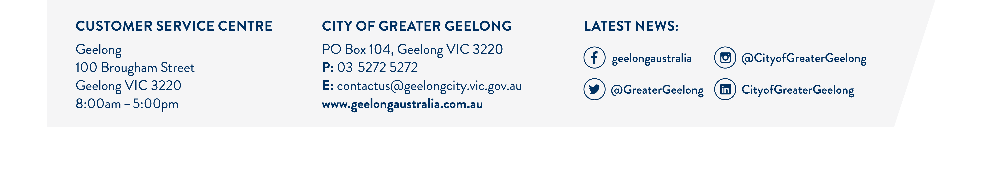
The City has been engaging with the community and stakeholders in the design of a new library to service the northern Bellarine Peninsula.

What is the project budget?
$9.15 million for design and construction.

Where is the COGG customer service in the existing library going?
Customer Service will be located within the upper level of the new library, alongside the library customer service desk.

What are the changes to parking?
11 formalised parking spaces in the new carpark to the NE of the site including 1 disabled bay. Wyndham St park will be modified; however, the 4 disabled bays will be retained.

What are the changes to Wyndham St?
Parking will be pushed up to the Western end to allow the Eastern end to become a pedestrian mall. Increased vegetation, seating area and alfresco dining opportunities.

Are we reducing the amount of greenspace within the town centre?
No - the library building will occupy the existing paved area next to the retail space. The tiered amphitheatre will occupy some of the existing grass area, however the greenspace will also be increased in the location of the existing seniors building.

What is happing with the Senior Citizens building and occupants?
The old children’s centre on Eversley Street is planned for redevelopment for broader community use. Once completed, the seniors will be relocated to Eversley Street and the existing brick building in the town centre will be demolished.

What are the construction timelines?
Construction activities are currently planned to commence in Sep/October, which is also dependant on the relocation of the seniors. The library building construction is expected to take approximately 15 months.

