Arts and Cultural Strategy | Survey Findings

City of Greater Geelong
1 September 2020

Contents
1. Overview 3
1.1. Scope of survey 3
1.2. Respondents 3
2. Findings 3
2.1. Current Situation 3
2.1.1. Strengths and Weaknesses of the Cultural Sector 3
2.1.2. Recent Changes and Developments 4
2.2. Use of Existing Cultural Facilities 4
2.3. Future Sector Developments 5
2.4. Strengthening the Cultural Economy 6
2.5. Infrastructure Development 7
2.5.1. Non-building improvements 7
2.5.2. Outside the CBD 8
3. Suggestions for the Strategy 8

- Overview
  - Scope of survey
A key part of developing the Arts and Cultural Strategy is direct consultation with the communities that contribute to Geelong’s vibrant cultural life. To facilitate this sector consultation, representatives were directed to the ‘Have Your Say’ online engagement portal, where responses to the Issues Paper could be made as a survey submission, written submission, or posted on the discussion wall. The engagement portal was active from the 20th July to the 12th August 2020.
The online engagement portal was promoted through social media (FB and Instagram) with a reach of 4,710, Instagram feed on mobile devices 2,816 with the highest engagement on socials 18-25y/o (30%). Total 607 individuals interacted with the online engagement portal with over 1,290 views. 174 responses to the survey were received
  - Respondents
Half of survey respondents were creative practitioners. 10% were creative professionals and 15% work in support roles for creative businesses or organisations. 11% identified themselves as volunteers within the creative sector, and a quarter of respondents said their role was outside those categories with examples such as educators, Libraries and Heritage specialists, business owners, committee members, community organisers and other supporters. The three largest sectors were visual arts, design and fashion (41%), Theatre, dance and music (33%) and education (21%).
58% of respondents were female, 35% male and 6.8% identifying as gender non-conforming or not disclosing. Only one-sixth of all respondents were aged below 35 years, with the largest age group being 50-59 year olds representing one-third of all respondents. 3% of respondents were First Nations peoples. Each suburb of Geelong was fairly represented with an even spread of respondents across the municipal.
- Findings
  - Current Situation
    - Strengths and Weaknesses of the Cultural Sector
Respondents were asked what they regard as strengths and weaknesses of the cultural economy in Geelong. The table following provides a summary:
Table 1 | Strengths and weaknesses of the cultural economy
Strengths | Weaknesses
- Cultural Precinct – GAC, Gallery, Library, Park, Waterfront  - GAC and Geelong Art Gallery, they deliver high quality experiences.  - Back to Back Theatre and Boom Gallery are standouts in terms of the quality of the work on show. Businesses like Boom create an affordable place for arts industry and a commercial gallery for artists to exhibit  - Strong community arts and amateur arts. Amateur theatre in Geelong is incredibly diverse  - Own cultural identity  - Strong established cultural events – Geelong After Dark, Pako festival, Mountain to Mouth, Archibald Prize  - Growing creative industry  - High achieving, unique local artists working across a variety of mediums  - Creatives working collaboratively in historic buildings like the Federal Mills and Courthouse  - Industrial heritage lending unique architecture, history, context, place and culture to contemporary practices  - UNESCO City of Design – potential as a known design, arts and culture hub  - Visual Arts is growing - Gallery Events, Arts trails, Public artworks, Kids Art venues, New Galleries  - Fashion design - so many great retailers within the community  - Arts and culture is broad minded, adventurous and accepting of creative expression – generally of a high standard | - Conservative attitudes. Low support for risky, experimental works  - Focus of CBD programming and infrastructure leaving regional areas behind  - Live music venues limited to pubs and clubs  - Limited arts and cultural events accessible for people with a lived experience of disability  - Events and programming for young people  - Council processes are prohibitive to facilitating small events and community activities  - Arts organisations resistant to sharing resources and cross-promoting  - Networking opportunities for creatives  - Limited commercial gallery offerings. Boom is the only commercial gallery of significance in Geelong  - Poor engagement with and promotion of First Nations art and culture  - Underrepresentation of arts and culture in tourism and making  - Affordability of performance, rehearsal, workshop and exhibition spaces  - Prioritisation of large organisations, institutions and events  - National Wool Museum, is outdated, does not appeal to a wide enough demographic.

    - Recent Changes and Developments
Respondents commented on the changes they have observed in the creative sector which need to be reflected in the Arts and Cultural Strategy. Some comments included:

- Development of the Geelong Arts Centre- and the opportunity this creates to extend its support of local independent creatives, developing and presenting new work
- Loss of meeting places for arts and culture, such as galleries closing
- More people are coming down here , and more studios, shops, and spaces are popping up under different group initiatives to lend support, give voice, or provide an outlet
- Music sector has fallen through gaps in support during Covid - this has highlighted how that sector doesn't fit in many funding and grant models and opportunities
- Overemphasis on creative industry at the expense of intrinsic artist development
- Funding shift towards supporting institutions rather than creatives
- Creative sector is becoming more fragmented as it grows without a central directory, guide or contact point
- Growing support for community art pushes professional practice out of the area
- Festival programming supporting spectacle, crowd pleasing work over conceptual work which reflects current issues.
- Continued exclusion of First Nations narratives
- Growing interest in museum collections
- Underutilisation of existing infrastructure such as community halls, pavilions, park lands and green space
- Covid restrictions resulting in a shift towards bespoke, unique, once off experiences for a limited audience

  - Use of Existing Cultural Facilities
Survey respondents were asked to comment on ways in which existing cultural facilities could be improved to maximise their impact.
- Affordable access to cultural venues for performance and exhibition program delivery. Increased low rent options in central Geelong for creative industries businesses. Encourage greater collaboration between larger cultural organisations
- Major events in cultural institutions. After-hours events when the audiences are ready to be out at night
- More use of outdoor areas, events spaces, streetscape. More shared space in facilities for various cultures to blend and share skills in an informal exchange of ideas and pastimes
- Keep developing the Arts and Civic precinct with arts areas and restaurants and cafes to enable socialising after events
- The National Wool Museum has the ability to expand and attract a larger and diverse grouping of the public, however, it is starting to look a little tired in certain areas and resources are needed to provide upgrades
Comments were also provided on underutilisation of current facilities:
- Osborne House has been derelict for far too long
- Free up any vacant blocks and underused buildings for use as studio spaces, like Collingwood precinct
- Geelong 's superb Bandstand/Rotunda is the centrepiece of the delightful Johnson Park. It should have live music every weekend throughout summer for free family picnics in the Park. In winter the free performances could be at the top of the Library
- Centenary Hall is large underutilised space. Geelong Showgrounds. The old power-station. Belmont Civic Centre
- Geelong Gallery has capacity to do more with more space including major 'main stream' exhibitions and bespoke- design focused exhibitions.
- Wool Museum - it has had some cosmetic improvements but it could host events. The theatre could be redesigned to host arts films. It could have a bar/event space upstairs. It seems like a wasted asset.

  - Future Sector Developments
Respondents were asked to identify changes they would like to see in their creative sector. Comments included:

- Affordable spaces for studios, workshops and exhibitions. Artist-run galleries and residency programs, funded with Council support
- Flexible, low cost arts workshop spaces in suburban locations as well as central Geelong
- Opportunities for emerging musicians and artists to perform and exhibit in smaller, accessible spaces
- Restructuring of grants systems to allow for greater accessibility and diversity of funding
- Funding – especially for traineeships and student development
- Showcasing of experimental practices
- Meaningful public art that showcases the history of the area
- Awareness of the strong skills, knowledge and teaching practice of First Nations people and artists practicing in Geelong
- Council involvement in broader promotion of local works, practicing artists and creative spaces – selling Geelong as a creative destination
- Artist involvement in multiple aspects of society such as residencies in aged care, schools, hospitals
- Nurturing of cultural leadership - artists and creatives represented on boards and committees across multiple aspects of society and the region
- Greater outreach and exposure for the community to participate in arts experiences
- More collaboration – social events to network
- A database of support material and opportunities

Comments were also solicited on the types of connections and collaborations that would most benefit a vibrant cultural sector, and the individual practitioners and organisations. The table following summarises these into examples of connections facilitated by Council, other institutions or creatives:
Table 2 | Connections and collaborations
Council | Institutions | Other Creatives
- Networking opportunities and creative industry forums  - Existing festivals (Pako Fest, Geelong After Dark)  - Development of new festivals specifically for emerging artists (Geelong Fringe Festival, Area wide arts tour)  - Grants to communities to drive their own ideas, so they are not in competition with Council  - Newsletter or improved co-ordinated marketing initiative (i.e. Art Atlas, Art Guide, Arts Trail)  - Outlying parts of Greater Geelong (rural and suburban)  - Councillors and project officers with a creative background leading projects | - Geelong Tourism (Arts specific marketing)  - Central Geelong Marketing (reframe Geelong as a cultural destination)  - Cultural facilities (Geelong Art Centre, local galleries)  - Education Institutions  - Local businesses for upskilling in marketing, social media, grant writing  - Collaboration between COGG’s GLAM institutions (Maritime Museum collaboration with National Wool Museum)  - Site specific works and events linking to Geelong’s heritage and culturally significant sites  - Smaller venues partnering with emerging musicians | - Accessible and affordable creative hub for the creative community  - Like-minded professionals and creatives for experimentation and project development  - Interdisciplinary projects and events  - Youth groups and schools  - Digital platforms (gallery tours)  - Direct webpage or mailing list to provide an information hub for upcoming events and opportunities  - Mechanism for establishing and developing collaborations and partnerships between creatives  - Mentorships

Views were also requested on how deeper engagement with the community could be encouraged:
- Public art which is appropriate for its site and includes representation of First Nations heritage
- Improved accessibility at events for disabled, vision impaired and First Nations people, ensuring safe spaces and cultural safety practices
- Greater outreach to all areas of Geelong
- Visibility of performances in public spaces and schools to inspire arts participation and demonstrate career possibilities
- Focus on strategic sector-wide facilitation and funding rather than big spends on individual projects that do not provide returns in creative development or participation
- Less focus on established affluent social classes and broader promotion of the arts among marginalised, young and at risk groups
- Coordinated networking opportunities such as a Creative Alliance breakfast once a quarter with Councillors in attendance
- Group training sessions run by Council e.g. how to apply for a public art grant, how to participate in festival programs
- Investment in keeping creatives in Geelong

  - Strengthening the Cultural Economy
Comments on ways in which the cultural economy could be strengthened include:
- Development of an arts precinct for emerging artists including exhibition, studio, workshops, performance and production spaces
- Visual production facilities and study and jobs. Music performance facilities, and study and jobs
- A strong mural identification like the Silo Trail
- The Little Malop street precinct has the potential to be a Beale Street style (Memphis, Tennessee) Arts hub. Geelong has a rich musical history and we should be proud to tell the world through our current creative artists of all disciplines.
- More dialogue with creatives for engagement with Mountain to Mouth
- Support for smaller once-off events or festivals
- More input and support for individuals and small businesses rather than larger organisations or corporations
- Forums and professional development opportunities for practitioners at all levels of practice. e.g. writing an artist statement, building a website, designing exciting marketing materials. Guest speakers, artists in conversation, forums on issues of relevance
- Generate an online Arts Hub that is practical, easy to use and collaborative. Facilitate connections between artists and administrators
- Foster a creative community - not dictate or lead that. There is a significant difference and it's not clear Council arts and culture understands it.
- Grow talent. Take risks. Invest. The North needs attention
- Arts based tourism. If we committed to funding high quality works that created a destination point for people to visit and stay and explore Geelong. Surely UNESCO City of Design status could be better used to stimulate the professional arts sector
- With a growing young population, a greater opportunity to engage lifelong arts consumers
- Genuine engagement with the Design community around the UNESCO City of Design designation - this shouldn't be led by a panel of suits and councillors but people who actually live and breathe design
- First Nations showcasing, involvement and leadership for events. Multicultural involvement across the board.
- Live music, contemporary interpretation of heritage, collaborative programming across institutions, coordinated marketing effort to position the region.
As a regional city Geelong can become an arts city of depth and diversity if it becomes less Melbourne-centric and supports and nurtures its creative communities. Arts reporting, building bridges between different practices and enthusiastic support from the city (not just financial) could make Geelong genuinely vibrant and challenging.

  - Infrastructure Development
    - Non-building improvements
Suggestions included:

- Pop-up [pocket] parks with seating, water fountains and beautiful community- supported gardens
- Make the most of sloping spaces - a natural amphitheatre from the main street of Portarlington leading to the foreshore
- Improved disabled access and especially increased disability parking near cultural facilities - e.g. libraries, routes.
- Parks, walks and possible outdoor gallery space
- More opportunities for ephemeral interventions in public. Commissions that have place around them that invite you to stop and consider the work and reflect. Integrated landscaping and public amenity like seating and lighting
- High value significant public art that helps define our identity. We need more than the bollards trail and a few random sculptures and murals. We need a curatorial framework and committed investment for the municipality. Please not just a strategy without investment
- Outdoor performance spaces e.g. in Johnstone Park Bar or cafe in Johnstone Park to create more presence and safety
- More street art and quirky buildings/space
- More use of our public areas library fronts, parks, footpaths on shopping strips - focus on the main street in all areas
- More green spaces, pathways, community gardens, and linkages from existing areas to new areas. Walking trails, bike paths, ensuring that new developments allow common areas.

    - Outside the CBD
Views were requested on hard and soft infrastructure needs in areas of Greater Geelong outside the CBD. Comments included:
- The northern suburbs might benefit from a creative hub that helps students develop their skills in a supportive and safe space
- I'd love to see the northern suburbs become a focus for the arts. For example, the old power station in North Geelong is the perfect site for a Geelong Convention Centre and cultural precinct, providing a buffer between the port and residential Geelong
- All areas could have interpretation of our First Nations people through art/sculptures and signage with a common theme running through that we recognise and acknowledge the Wadawurung people.”
- Public art, creative hubs and performance spaces for Portarlington
- Bellarine - lots of creatives - not many options
- The Coastal Tourism Towns (i.e. Ocean Grove, Barwon Heads, Point Lonsdale) need a community centre to provide social and cultural amenity in the region /. Our ageing population suburbs need creative hubs specifically designed for the elderly and young children. Is there an art gallery trail you can do on the Bellarine?

- Suggestions for the Strategy
Respondents were asked to identify three things that they would like to see in the Strategy. Amongst many other suggestions, the following are some of the proposals mentioned by multiple respondents. Many reiterate themes mentioned earlier:
- An openness to clever and creative use of public spaces
- An improved non-built environment. More green spaces, linkages, bike and walking paths.
- Build performance stages (with weather protection from rain, wind, sun) in CBD, waterfront, Eastern Beach
- Artist Run Initiatives
- Build makers spaces. Subsidised arts workshop spaces - even pop ups
- More community markets when we are allowed
- A purpose built Collection Storage Facility

- First Nations priority. Plan in partnership with Wadawurrung Aboriginal Corporation
- Disabled activity events
- Support for experimental art and cultural practices
- Commission high quality engaging work
- More performance opportunities and opportunities to show work
- Opportunities for artists to engage in non-arts spaces and contexts (e.g. in schools, aged care, hospitals, industry)
- A fringe festival
- Council sponsored artist residencies that lead to finished work
- A Barwon River Festival that lines the banks with art fashion music, food, families
- Innovate with new opportunities, events, ideas and forms
- More children and youth in events
- Hear new or silent voices
- Focus on the North

- More funding for individual projects not always linked to community
- Small business support
- Arts newsletter for Geelong including critical but accessible reviews and articles
- Forums, guest speakers, professional development for all artists
- Invest in professional artists who create work that speaks to our humanity and our time in history
- Artists on boards and committees / cultural leadership

- Take risks in creating a vibrant Geelong
- More children and youth in events
- Hear new or silent voices
- Promotion of Geelong as a cultural capital in Australia - support for cultural events.
- Increased awareness of the history of Geelong
- Communities given space to grow their own diverse cultures
- Support communities to access commonwealth or private funding, provide more community grants.
- Invest in engaging Design Community for UNESCO related activity

Disclaimer
Positive Solutions and its employees, representatives and consultants make no representation or warranty as to the accuracy, reliability or completeness in respect of information provided by City of Greater Geelong and its contractors. Financial and other information is based on information provided and informed by stakeholder consultation and prevailing market conditions.
Positive Solutions and its employees, representatives and consultants shall have no liability to City of Greater Geelong or other person under the law of contract, tort, the principles of restitution or unjust enrichment or otherwise for any loss, cost, liability expense or damage which may arise from or be incurred as a result of anything contained in this document, and any information supplied by or on behalf of Positive Solutions or otherwise arising in any way.
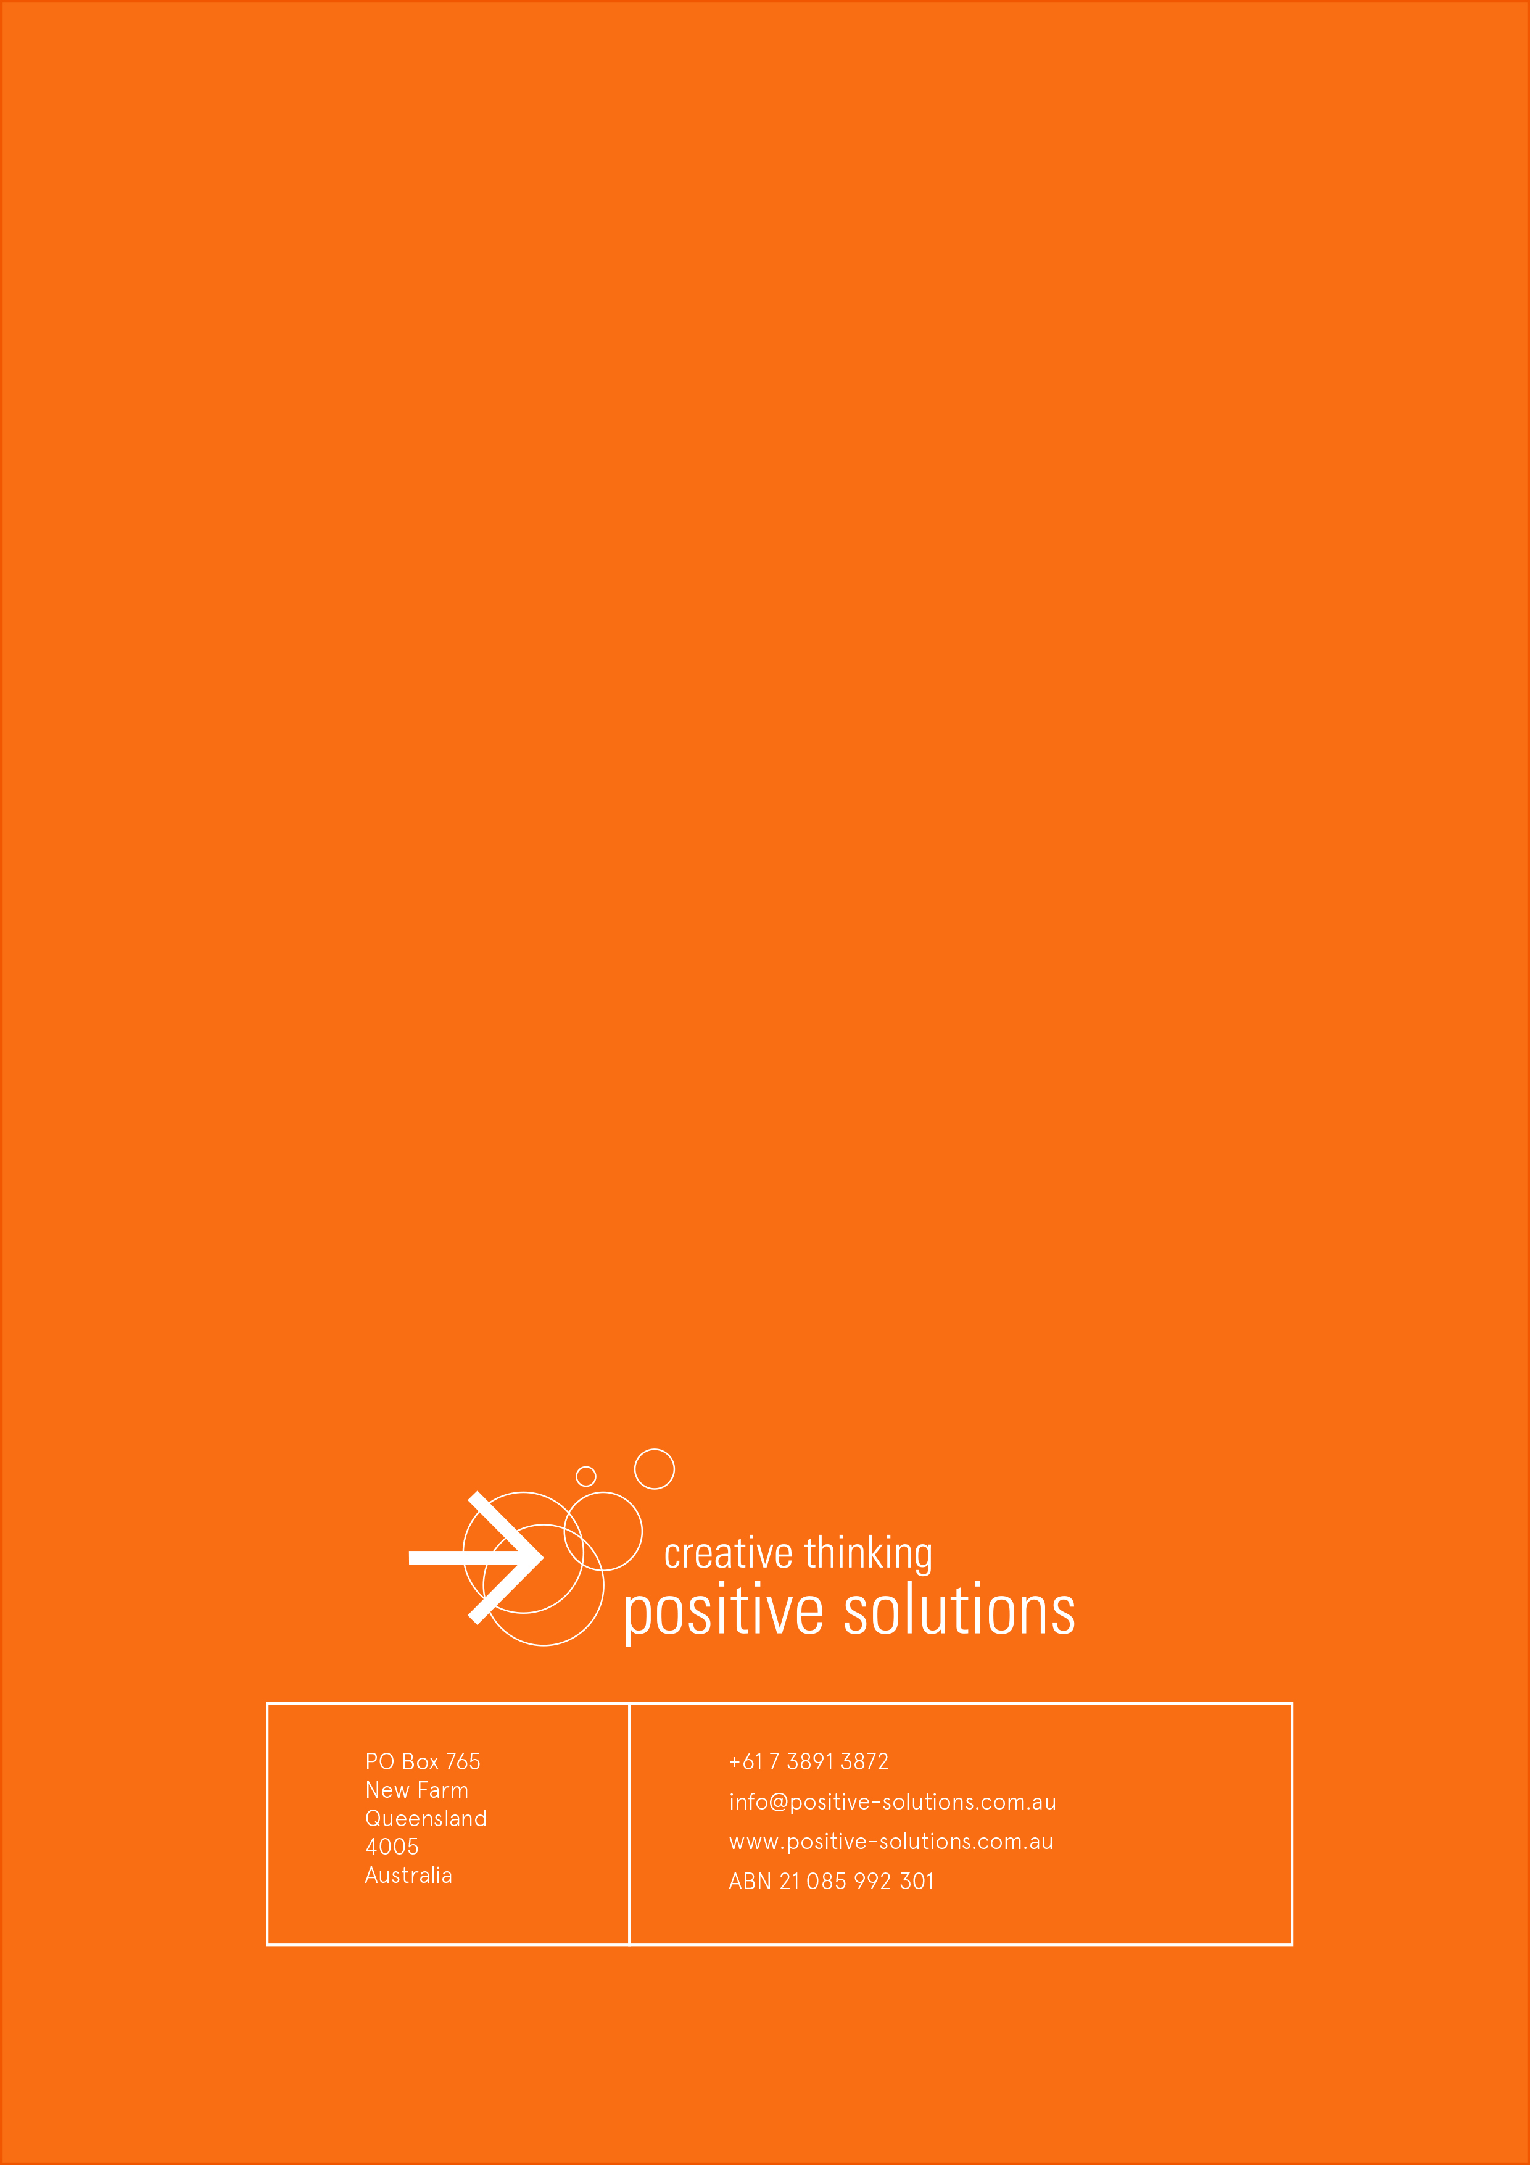

As respondents were able to select more than one category the percentage total exceeded 100%, totalling 145.5%

