The City Of Greater Geelong

OUR COMMUNITY Plan 2021–25

  - A PROUD, SAFE AND HEALTHY COMMUNITY

DRAFT

Contents
Contents 2
Mayor and CEO message 3
A unified plan 4
Our region 5
What is informing this plan 7
How we engaged 8
Greater Geelong health and wellbeing profile 10
Our health and wellbeing priorities 11
Our strategic directions 2021-25..………………………………………….13
Strategic direction 1: Healthy, caring and inclusive community 15
Strategic direction 2: Sustainable growth and environment 17
Strategic direction 3: Strong local economy 20
Strategic direction 4: High-performing Council and organisation 22
Our Council and organisation 24
Appendix A 27
Appendix B 38

AcknowledgEments
We acknowledge the Wadawurrung People, Traditional Owners of this land, and all Aboriginal and Torres Strait Islander people who are part of the Greater Geelong community today.
We would also like to thank the many individuals and stakeholder groups who willingly shared their time, knowledge and experience to help us develop this plan for the benefit of the Greater Geelong community.

Mayor and CEO message
As Greater Geelong continues to evolve and expand, so do our goals and priorities for the region.
We are becoming more environmentally, financially and socially sustainable, technology is opening new and exciting opportunities, and we have a deeper understanding of our precious natural environment.
This plan is a key strategic document that ensures we stay current and responsive to the region’s evolving priorities and opportunities.
Some things that haven’t changed are our long-term vision and values. We established these in 2017 as part of our Clever and Creative 30-year plan for our community, and they remain our ‘north star’ today.
We all know that in this rapidly changing world it’s important for a strategic focus to remain solid. However, the events of 2020 highlighted the need for short-term and medium-term plans to offer flexibility and for organisations to be agile.
The key is in staying true to values, while being adaptable enough to respond to the immediate circumstances and needs.
One of Council’s key priorities is improving the health and wellbeing of our community. This is why for the first time we have incorporated the municipal public health and wellbeing plan into Our Community Plan 2021–25.
The plan also identifies four pillars that we will focus our efforts on over the next four years, always moving towards the 30-year vision:
- Healthy, caring and inclusive community
- Sustainable growth and environment
- Strong local economy
- High-performing Council and organisation.
Read on to learn how we’re planning to build on each of these pillars, and how they will help guide our decision-making as we continue on our path towards a clever and creative future.
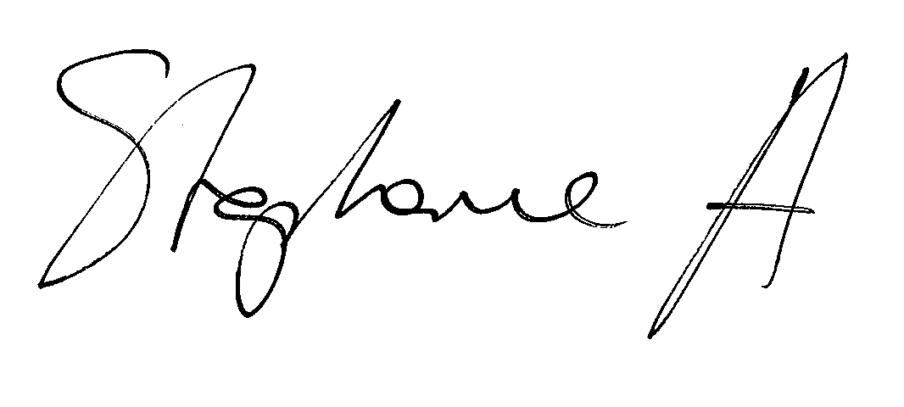  Cr Stephanie Asher  Mayor  City of Greater Geelong | 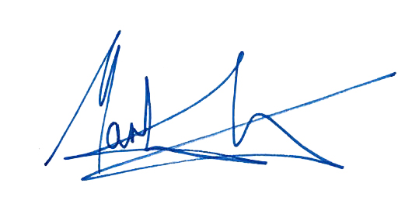  Martin Cutter  Chief Executive Officer  City of Greater Geelong

A unified plan
Our Community Plan 2021–25 is the key plan of the Greater Geelong City Council. It tells our community what our councillors are aiming to achieve during their four-year term.
All newly elected councils in Victoria are required to develop a council plan and municipal public health and wellbeing plan following council elections. This year, we’re bringing these plans together into one document to create a more focused agenda for our work and make it easier for our community to track our progress.
The plan will guide decisions about policy, programs, services, resources and performance. While the plan is for four years, it will be supported by an annual action plan and budget.
This is the first time we’ve incorporated our municipal public health and wellbeing plan into
our council plan.
We have done this because the health and wellbeing
of our community is central to everything we do – whether it’s supporting economic growth in our region, creating new opportunities for social connection or putting in place safeguards to encourage sustainable development.

Our region

With a population of nearly 265,000 people, the City of Greater Geelong is Victoria’s largest regional municipality.

Located 75 kilometres south west of Melbourne, the municipality covers an area of 1,252 km², comprising suburban, coastal and country areas. Greater Geelong is bounded by the Moorabool Shire in the north, Wyndham City Council and the Borough of Queenscliffe in the east, Surf Coast Shire and Golden Plains Shire in the west, and Bass Strait to the south.

Figure 1: The City of Greater Geelong ward map (left) and context map (right)

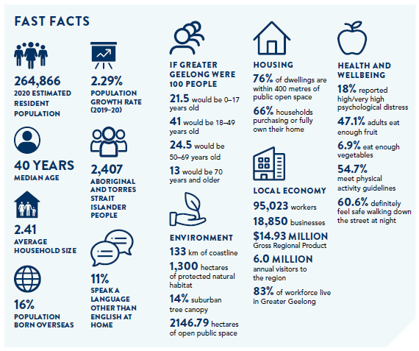

What is informing this plan
In developing this plan, we were guided by legislation, the federal, state and local context, our existing policies and plans, the health and wellbeing profile of our community and, most importantly, the views of our community.
Central to this process were:
- Our councillors – they led the development of the plan using their extensive knowledge and understanding of the current challenges and opportunities facing the Geelong region.
- Our strategic planning process – an integrated, long-term and transparent approach to planning, monitoring and performance reporting that aligns with our long-term community vision (see page 26).
What has influenced Our Community Plan 2021–25
Our community’s 30-year clever and creative vision  “By 2047, Greater Geelong will be internationally recognised as a clever and creative city-region that is forward looking, enterprising and adaptive, and cares for its people and environment.” | Features nine community aspirations:  - A prosperous economy that supports jobs and education opportunities  - A leader in developing and adopting technology  - Creativity drives culture  - A fast, reliable and connected transport network  - A destination that attracts local and international visitors  - People feel safe wherever they are  - An inclusive, diverse, healthy and socially connected community  - Sustainable development that supports population growth and protects the natural environment  - Development and implementation of sustainable solutions
Engagement with stakeholders and community | See a summary on page 8
Greater Geelong health and wellbeing profile | See a summary on page 10
Partnership priorities | - G21 Region Alliance  - Geelong City Deal
International context* | - Climate change and environmental sustainability  - COVID-19 pandemic recovery  - Advancing technology
Key state policies and strategies* | - Victorian Public Health and Wellbeing Plan 2019–2023  - Ending Family Violence – Victoria’s plan for change
Key local policies and strategies* | - Sustainability Framework 2020  - Social Equity Principles  - Reflect Reconciliation Action Plan 2020–21  - Settlement Strategy 2020

* For a full list of the health policies and strategies we reviewed, please refer to Our Community Plan 2021–25 – Municipal Public Health and Wellbeing Plan 2018–21 – Strategic Context document.

How we engaged
Engaging with our community and stakeholders is one of the most important elements to developing this plan.
It both informs our priorities and gives us an opportunity to check to make sure we are on track as we develop our plan.
Below is a summary of the engagement schedule we are currently using to develop the plan. It shows what has already happened, as well as what is yet to come:

Dec 2020–Jan 2021 | Jan–Feb 2021 | Jan–Mar 2021 | Feb 2021 | Apr 2021 | Jun 2021
Online and hard copy surveys made available to the general community for two months | An open submission opened to selected partner organisations, community groups and advisory committee | Deliberative engagement process | Stakeholder focus groups | Draft plan released for community feedback | Final plan, incorporating feedback from community, adopted by Council
239 responses | 12 submissions | 5 sessions held with a total of 98 community members | 8 workshops were conducted

What we heard
Following is a summary of the key themes that came out of the engagement process: We took all this feedback and developed a list of resident and community priorities (see blue box on following page).

Stakeholder submissions
- Improving mental health and wellbeing, including the need for better and more accessible mental health services
- Improved focus on gender equality
- Shared leadership and better engagement with stakeholders and community groups
- Sustainable economic growth and development that creates better environmental outcomes
- Personal safety, in particular for members of the LGBTIQA+ community, people with a disability and older people

Health and wellbeing partner focus groups
See Appendix B for the full list of partners who participated in the focus groups.
- Mental health and wellbeing, including social connection
- Early years and the importance of the first 1000 days for lifetime health and wellbeing
- Healthy eating and active living to prevent obesity and chronic illness
- Access to equitable opportunities for physical activity such as parks, open spaces and footpaths – particularly in the north of the municipality
- Addressing the impacts of disadvantage and inequity, as well as associated issues such as tobacco smoking and obesity
- Addressing the ongoing impacts of the COVID-19 pandemic, especially in relation to social isolation and delays in diagnosing health conditions, such as cancer
- Access to affordable and social housing, especially for women and older women experiencing housing insecurity
- Preventing violence against women and promoting gender equity
- Engagement in education and employment

TOP PRIORITIES
- A strong local economy with job opportunities for all
- An inclusive community which welcomes diversity
- Access to good healthcare services for all, especially mental health services, and a focus on wellbeing
- Improving infrastructure, connected networks and alternate modes of transport
SUPPORTING PRIORITIES
- Environmental sustainability in action
- Lifting community spirit and enhancing support networks
- A vibrant cultural hub which supports sport, arts and entertainment
- Being a safe place to live without the fear of violence, or threat of violence, and vandalism (including safety issues caused by drug and alcohol abuse)
CONTINUING PRIORITIES
- Celebrating and fully utilising the fantastic open spaces in the community
- Continuing to be a recognised leader in educational opportunities and facilities
- Water security for sustainable growth and living
- Impact of climate change on health and wellbeing

Deliberative engagement and survey outcomes
- The lack of health services in the region is a top priority in particular areas, such as mental health
- Having the infrastructure and services needed to equitably serve the community is more important than keeping rates low
- Perceived safety and the infrastructure that supports it is a key point of concern for the community
- Small business and young people are worse off from the COVID-19 pandemic and need additional support from all levels of government
- Recycling and waste management and road and street maintenance are the top two resident priorities
- The environment and climate change are a significant priority for residents and they’re looking to Council for leadership on these issues
- Parks, open spaces and trails for walking and cycling are considered to be among the most important infrastructure in Geelong and should be a high priority

Greater Geelong health and wellbeing profile
While behaviours, like being physically active and healthy eating, can impact an individual’s health, there are many factors that influence community health and wellbeing overall.
These factors – called social determinants – include access to services and transport, educational opportunities, housing, employment and freedom from violence and discrimination.
Our role is to understand local health characteristics and challenges so we can plan preventative health strategies, such as building urban environments that support active transport and tailoring our services to better meet community needs.

Snapshot of health data
Following is a summary of data that has shaped our priorities for this plan. It covers both experiences and behaviours that we know have an impact on health and wellbeing. Refer to Appendix A for a breakdown of this data and our demographic profile.

Greater Geelong compared to the Victorian average:
- More adults report meeting fruit and vegetable intake guidelines.
- More adults report meeting physical activity guidelines.
- More adults respond ‘yes, definitely’ when asked if they feel safe walking down the street at night.
- Fewer adults report they have excellent or very good health.
- Fewer adults report feeling that life is worthwhile.
- Fewer infants attending Maternal Child Health appointments are still being breastfed at six months.
- More adults report high or very high psychological distress.
- More women are at increased risk of alcohol-related harm and injury based on self-reported alcohol consumption.
- More women have a self-reported body mass index classified as obese.
- More men in Greater Geelong report they are current smokers.
- More women ran out of food during the previous year.
- More women were unable to raise $2000 within two days of an emergency.
- More men think multiculturalism does not make life in their area better.
- Higher overall average of premature deaths for men and women compared to the Victorian average.
- Higher rate of premature deaths for adults aged 0–74 caused by chronic disease including cancer, diabetes, circulatory system diseases and respiratory system diseases.

Other key data we’ve considered:
- Only three other Victorian local government areas experienced greater gambling losses from electronic gaming machines than Greater Geelong in 2017–18.
- From 2017–19, there was a rise in the rate of family violence incidents recorded by police in Greater Geelong and the overall rate of incidents is higher than the Victorian average.
- The top five suburbs impacted by heatwaves in 2020 were Wandana Heights, St Albans, Marshall, Point Lonsdale and Newcomb.
For a detailed breakdown of our community’s health and demographic data, refer to Our Community Plan 2021–25 – Demographics and Health Profile Background Document.

Our health and wellbeing priorities
As a local government, we play a crucial role in supporting the community to enjoy the highest attainable standards of health, wellbeing and participation at every age.
To achieve a whole-of-organisation focus on health and equity, we consider the social determinants of health and apply the World Health Organisation’s Health in All Policies Framework, which keeps health and wellbeing high on our agenda.
We have considered the priorities of the state health and wellbeing plan and considered both the Victorian Climate Change Act 2017 and the 2016 report from the Victorian Royal Commission into Family Violence.
The table below shows the health and wellbeing priorities we’ll be focusing on over the next four years. We formed these priorities after a thorough review of the policy context, health challenges and community engagement.
Health and wellbeing priority | What the community is saying | What the data tells us | Strategic direction links
Tackling climate change and its impact on health | The environment and climate change are a significant priority for residents. | There are a number of suburbs impacted by heatwaves and an increasing incidence of heat-related illness. | Strategic Direction 2: Sustainable growth and environment – page 17
Increase active living* | Access to public open space, sports facilities and walking trails is important. | More adults report meeting physical activity guidelines, however sustained effort is required to address the higher rate of premature deaths caused by chronic diseases in Greater Geelong (compared to the Victorian average). | Strategic Direction 1:  Healthy, caring and inclusive community – page 15
Demonstrate and promote gender equity practices* | Personal safety continues to be an area of concern, particularly for women. | From 2017–19 there was a rise in the rate of family violence incidents recorded by police and this is a disturbing trend. | Strategic Direction 1:  Healthy, caring and inclusive community – page 15
Improving mental wellbeing and social connection* | Addressing the ongoing impacts of the COVID-19 pandemic, especially in relation to social isolation and connection to community, is important. | More adults are reporting high or very high levels of psychological distress when compared to the Victorian average. | Strategic Direction 1:  Healthy, caring and inclusive community – page 15
Increasing healthy eating* | We need to make it easier to source and afford healthier food options. | More adults report meeting fruit and vegetable intake, however sustained effort is required to address the higher rate of premature deaths caused by chronic diseases in Greater Geelong (compared to the Victorian average). | Strategic Direction 1:  Healthy, caring and inclusive community – page 15
* This priority builds on the work from the Municipal Public Health and Wellbeing Plan 2018–21.
The data also indicates that use of tobacco, alcohol and other drugs, as well as gambling and homelessness, are challenges for some parts of our community.

OUR PARTNERSHIP APPROACH TO HEALTH AND WELLBEING

The importance of equity
Fair and equitable access to our services and facilities is a key principle of our work, regardless of gender, age, background, location and abilities. This is demonstrated by the social equity principles we adopted in 2017:
- All activities of the City will be informed by
up-to-date demographic and geographic information on social equity in the region which identifies priority areas and groups for attention
- Planning of all activities will be informed by effective, focused partnerships and engagement with priority groups and areas, aimed at fully understanding the needs and obstacles they experience in accessing services and facilities.
- Service and infrastructure design, location, communication and support arrangements will address the needs and obstacles faced by priority areas and groups.
Gender equity is a good example of how addressing equity helps. By looking at equity as a root cause, we aim to reduce the level of violence experienced by many but, in particular, women.
Guided by community needs, organisational priorities, business planning and funding opportunities, we will work with existing partners and explore new partnerships over the next four years.
Some of the key stakeholders we’ll be working with include:
- Active Geelong
- Barwon Child, Youth and Family
- Barwon Health
- Barwon Water
- Bellarine Community Health
- Department of Families, Fairness and Housing
- Diversitat
- Epworth Healthcare
- G21 Region Alliance
- Geelong Cats
- Sexual Assault and Family Violence Centre
- Wadawurrung Traditional Owners Aboriginal Corporation
- Wathaurong Aboriginal Co-operative
- Western Victoria Primary Health Network
- Women’s Health and Wellbeing Barwon South West.
Annual Review
Our health and wellbeing priorities will be reviewed annually with our partners who are integral to achieving positive health outcomes for our community. This will ensure our priorities remain relevant to emerging population needs.

our
STRATEGIC
DIRECTIONS
2021-25

We are committed to becoming the clever and creative city-region our community described when we asked them to form a long-term vision for the region in 2017.
This plan outlines the steps we’ll take over the next four years to move closer to that goal. The four strategic directions we’ve chosen to guide us are as follows:
- Strategic direction 1: Healthy, caring and inclusive community
- Strategic direction 2: Sustainable growth and environment
- Strategic direction 3: Strong local economy
- Strategic direction 4: High-performing Council and organisation
As well as the strategic directions, the plan also outlines:

Desired outcomes
The future state we’re aiming for in four years.

Our role
What we will do to help achieve the desired outcome.

Indicators
How we will monitor our progress.

Four-year priorities
The priorities we’ll focus on to help achieve our desired outcomes.
While the plan is intended to guide us for the next four years, we will review it annually as part of the budget and action planning process (see below). If changes are required to accommodate new priorities, incorporate new indicators or respond to community feedback, we will amend the plan.

ACTION planning and reporting
To help us measure our progress and respond to changing needs and expectations over the four years, Our Community Plan 2021–25 will be supported by the following:

An annual action plan and budget
This will highlight the projects, initiatives and programs that will take place in the next financial year to address our four-year priorities.

Quarterly updates and an annual report
The quarterly report will describe our progress on the action plan throughout the financial year, while the annual report provides an end of year overview of the City’s performance including how we’re tracking against the indicators.

Strategic direction 1: Healthy, caring and inclusive community
A healthy community is one where everyone has the opportunity to experience their best possible health and wellbeing.
As our health and engagement data shows, there are some pressing issues impacting the health and wellbeing of our local community, including mental health issues and impacts of climate change.
We cannot address these significant and complex challenges alone because it requires a whole-of-community approach to create a lasting impact that benefits everyone equally.
Working alongside other stakeholders and community groups, our role is to deliver liveable and accessible places, promote active and healthy lifestyles at every stage of life, deliver services and programs more equitably and support people to stay connected with others in their local community. We also need to create an environment where everyone feels welcome and valued for their unique contribution – regardless of age, ability, gender, cultural background, geographic location or income status.

Our role
- Planning communities that support healthy lifestyles
- Delivering services to the community
- Supporting community groups and local organisations
- Promoting healthy lifestyles and social equity
- Collaborating with local, state and federal government

Desired outcomes
- Our community feels welcome, safe and connected
- Our community has equitable access to health and social services, information and infrastructure
- Healthy behaviours and environments are promoted, supported and accessible

Four-year priorities
- Help our community, recreation groups and volunteers to prosper and grow
- Deliver health and community initiatives that are culturally sensitive and accessible across all life stages
- Foster and embrace community connectedness
- Demonstrate and promote gender equity practices
- Foster an inclusive community culture
- Facilitate social and affordable housing in Greater Geelong
- Provide access to places, spaces and services where and when people need them the most
- Strengthen relationships and partnerships with the Aboriginal and Torres Strait Islander community in
Greater Geelong
- Support the City’s cultural and creative life, history and heritage
- Provide facilities that foster and facilitate positive health and wellbeing outcomes
- Respond to the findings of the Royal Commissions into Aged Care and Mental Health
Supports health and wellbeing

INDICATORS

Municipal
- Proportion of adults experiencing high / very high psychological distress
- Proportion of adults meeting the physical activity guidelines
- Proportion of adults consuming the recommended number of serves of fruit and vegetables
- Reported incidents of family violence
- Community perception of safety in the area where they live
- Level of agreement that multiculturalism makes life better
- Proportion of community concerned about effects of climate change on health
- Proportion of adults that are a member of an organised group (sports, religious, school, professional, community
or action group)

City of Greater Geelong
- Community satisfaction with support services
- Community satisfaction with recreational facilities
- Community satisfaction with the level of access to City-owned infrastructure
- Number of key community infrastructure projects completed
- Community satisfaction with community and cultural activities

Related strategies and plans
- Multicultural Action Plan 2018–2022
- Access and Inclusion Plan 2018–22
- Ba-gurrk: A Gender Equity Framework
- Reflect Reconciliation Action Plan 2020–21
- Social Housing Plan 2020–41
- Social Infrastructure Plan – Generation One: 2020–2023
- Arts and Cultural Strategy 2021–31 (draft)
- Shared Trails Masterplan
- Central Geelong Live Music Action Plan 2017
- Sustainability Framework 2020 and supporting action plan

Links to clever and creative vision
- An inclusive, diverse, healthy and socially connected community
- People feel safe wherever they are
- Creativity drives culture
Supports health and wellbeing
Supports health and wellbeing

Strategic direction 2: Sustainable growth and environment

As Victoria’s largest regional city, Geelong’s proximity to Melbourne, lifestyle, strong employment growth and affordable housing have seen the population growth rate increase from 1.5 to 2.7 per cent.
Greater Geelong is forecast to continue to experience strong growth and demand for housing over a sustained period. Our role will be to manage population growth while maintaining what people love about living in this region, both now and in the future.
With global pressures to consider, such as climate change and waste, and significant flora and fauna in our region that need our protection, it’s clear that the stakes couldn’t be higher. It is therefore vital that we respond by creating high-amenity neighborhoods that are well-connected, liveable and sustainable.

Our role
- Facilitating housing supply, affordability and diversity
- Planning for sustainable growth and enhanced liveability
- Building sustainable community infrastructure
- Coordinating a community response to climate change
- Protecting indigenous biodiversity and nature reserves
- Managing climate change risks through adaptation and mitigation measures

Desired outcomes
- We are delivering our vision for sustainable growth across the municipality
- We have a choice of housing and lifestyles to meet the diverse needs of our community
- There are connected transport networks throughout the region that support liveability and prosperity
- Greater Geelong has quality, vibrant public spaces
- We are leading a reduction in community emissions and are increasing the City’s resilience to climate change impact
- We protect and restore our natural environment
- We minimise waste with good design and manage effective recovery of resources

Four-year priorities
- Meet the housing needs of our future community
- Meet existing and future transport needs
- Create engaging places and spaces
- Deliver best-practice Environmentally Sustainable Design principles and vibrant neighbourhoods
- Achieve carbon neutral in all City-managed operations by 2025 and manage our climate change risks
- Support our community and region to reduce emissions and build resilience to climate change
- Reduce the impact of waste
- Support greater indigenous biodiversity
Supports health and wellbeing

INDICATORS

Municipal
- Residential land supply
- Employment land supply
- Diversity of housing supply
- Journeys to work made by public transport, walking or cycling
- Percentage of residences living within 400 metres of public open space in urban areas
- Community greenhouse gas emissions
- Diversion of waste from landfill

City of Greater Geelong
- Community satisfaction with planning for population growth
- Percentage housing construction within existing urban areas
- Kilometres of bicycle, walking paths and shared paths
- Community satisfaction with local streets and footpaths
- Community satisfaction with sealed local roads
- Quantity of open space
- Community satisfaction with appearance of public areas (includes local parks, gardens, reserves and nature strips)
- Greenhouse gas emissions generated by City-managed operations
- Hectares of protected natural habitat
- Number of trees planted
- Community satisfaction with waste management

Related strategies and plans
- Settlement Strategy 2020
- Northern and Western Geelong Growth Areas Framework Plan
- Social Housing Plan 2020–41
- Social Infrastructure Plan – Generation One: 2020–2023
- Sustainability Framework 2020 and supporting action plan
- Environment Strategy 2020–30
- Climate Change Response Plan (draft)
- Urban Forest Strategy 2015–2025
- Waste and Resource Recovery Strategy 2020–2030
- Stormwater Services Strategy 2020–30
- Arts and Cultural Strategy 2021–31 (draft)
Supports health and wellbeing

Links to clever and creative vision
- Sustainable development that supports population growth and protects the natural environment
- Development and implementation of sustainable solutions
- A fast, reliable and connected transport network
- Creativity drives culture
- People feel safe wherever they are
Supports health and wellbeing

Strategic direction 3: Strong local economy

Our economy is changing to service Geelong’s growing population and meet the needs of emerging industries.
To stay competitive in a globalised economic environment, we must collaborate with stakeholders to market Greater Geelong’s competitive strengths, support local business and advocate for the infrastructure and services we need to attract investment and stimulate economic growth.
To secure Geelong’s economic future, we must support business and industry across:
- existing sectors – health, education, construction, tourism, retail and hospitality
- diversifying industries – advanced manufacturing, technology, research and innovation, transport, warehousing and logistics
- emerging industries – carbon fibre manufacturing, progressive agribusiness, creative and cultural industries, smart technology businesses, cleantech and circular economy businesses.
We will continue to work with a range of partners to leverage and promote our competitive strengths including transport and access, available and affordable land, and natural and cultural assets.
In addition, we will continue to work with our stakeholders to help prepare our workforce for this changing economy and support equal participation in the workforce for all.

Our role
- Influencing Geelong’s economic growth
- Advocating for new infrastructure and services needed by existing and future industries
- Partnering with others to leverage our competitive strengths
- Facilitating small business support, workforce development, investment attraction and events
- Marketing and positioning Geelong’s competitive advantages
- Leading tourism and creative industries

Desired outcomes

- We have a global, national and local reputation as a place to do business – especially in our key sectors
- We have a diversified, future-focused and sustainable economy to drive employment and support growth
- We are an influential Council that builds effective private and public partnerships, taking the lead role in advocating for future investment

Four-year priorities
- Attract and facilitate public and private investment
- Promote and leverage the competitive strengths and attractiveness of our region, globally, nationally and locally
- Support entrepreneurs, start-ups, innovation, research and digital connectivity
- Attract businesses with a carbon neutral and circular economy focus
- Support local business resilience and recovery from the impacts of the COVID-19 pandemic
- Attract, retain and enable participation in the workforce to meet industry needs
- Address high levels of unemployment in targeted areas of our region
- Promote our region as a trial location for innovation and new technologies
Supports health and wellbeing

INDICATORS

Municipal
- Number of jobs located in the City of Greater Geelong
- Small area unemployment rates across Greater Geelong
- Gross Regional Product
- Value of non-residential building approvals in City of Greater Geelong
- Number of businesses
- Tourism Sentiment Index
- Investment in Geelong
- Visitor expenditure

City of Greater Geelong
- Community satisfaction with business and community development
- Return on investment of Geelong major events

Related strategies and plans
- Revitalising Central Geelong Action Plan
- Smart City Strategic Framework 2021
- Sustainable Agribusiness Strategy for the G21 Region 2017–2022
- Arts and Cultural Strategy 2021–31 (draft)
- Tourism Greater Geelong and The Bellarine – Corporate Strategy 2021–25 (draft)
- Tourism Greater Geelong and The Bellarine – Tourism Development Plan 2019–22
- Geelong Major Events Strategy 2016–2026
- Retail Strategy 2020–36
- Geelong City Deal
- Sustainability Framework 2020 and supporting action plan

Links to clever and creative vision
- A prosperous economy that supports jobs and education opportunities
- A leader in developing and adopting technology
- Creativity drives culture
- A destination that attracts local and international visitors
Supports health and wellbeing

Strategic direction 4: High-performing Council and organisation

Under the leadership of Council, we are duty-bound to make decisions that are evidence-based, financially responsible and reflect the needs of the community and stakeholders we serve. In a rapidly changing environment, this can be a balancing act.
Advancing technologies, environmental issues, social inequity, rapid growth, organisational change and ageing assets all place pressure on our existing resources. We must adapt to these challenges if we are to continue delivering services, programs and infrastructure to our communities in a way that is equitable and fair.

Our role
- Delivering customer value that puts the needs of our community first through services, partnerships and advocacy
- Improving processes using new digital tools and ways of working
- Maintaining a workplace culture that is healthy, safe, inclusive and diverse
- Managing finances and infrastructure responsibly and equitably

Desired outcomes
- Our services are accessible and meet the diverse needs of our community
- We are acknowledged and recognised as a leading council and organisation
- We have a healthy, safe, inclusive and diverse culture
- We are a financially sustainable and resilient organisation

Four-year priorities
- Enable a customer-focused approach that delivers efficient and responsive service
- Communicate and engage effectively with our community to understand their needs and advocate on their behalf
- Deliver on our communities’ most important needs for infrastructure and services
- Continue to strengthen our workplace culture
- Create a more efficient and effective organisation
- Ensure that our employees are safe at work
- Focus on financial sustainability

INDICATORS
- Complaints resolution
- Community satisfaction with:
- customer service
- informing the community
- engagement / consultation
- overall council direction
- overall performance
- advocacy on behalf of the community
Supports health and wellbeing

- Lost Time Injury and Total Recordable Injury frequency rates
- Gender breakdown of City employees
- Number of Aboriginal and Torres Strait Islander people employed at the City
- Employee satisfaction and engagement
- Recurrent surplus / deficit
- Funds from sale of assets
- Cost recovery of services and revenue growth from new sources (fees and charges)
- Efficiency target
- Asset renewal gap

Related strategies and plans
- Customer Experience Strategy 2020–22
- Sustainability Framework 2020 and supporting action plan
- Ten-year Financial Plan
- Asset Management Strategy
- Clever Together
- Future Ways of Working
- Working Better Together

Supports health and wellbeing

Our Council and organisation
Like all local governments, the City of Greater Geelong is made up of two interdependent parts – the Council and the organisation. Collectively, we work together to serve our community.
The Council set the strategic direction for the municipality and make decisions on behalf of the community they’ve been elected to represent. The organisation oversees the day-to-day delivery of all services and functions guided by the Council, state and federal legislation and various funding agreements.
All Victorian councils are required to provide leadership for the good governance of the municipality and the local community. This means:
- considering the diverse needs of the local community in decision-making
- establishing strategic objectives and monitoring achievements
- managing resources in a responsible and accountable manner
- advocating local community needs to other communities and governments
- giving everyone the opportunity to participate in the democratic process and decision-making that shapes the community.
As well as performing these roles, our Council provides valuable support to key partner organisations and advocates for projects, programs and initiatives that benefit the region.

Our Council
Our Council is made up of eleven elected representatives, called councillors. Our current Council was elected for a four-year term on 26 October 2020.
CR STEPHANIE ASHER
Mayor
Bellarine Ward
CR TRENT SULLIVAN
Deputy Mayor
Bellarine Ward
CR JIM MASON AM
Bellarine Ward

CR EDDY KONTELJ
Brownbill Ward

CR SARAH MANSFIELD
Brownbill Ward

CR PETER MURRIHY
Brownbill Ward

CR BRUCE HARWOOD
Kardinia Ward

CR BELINDA MOLONEY
Kardinia Ward

CR RON NELSON
Kardinia Ward

CR ANTHONY AITKEN
Windermere Ward
CR KYLIE GRZYBEK
Windermere Ward

Our organisation

Our purpose
Working together for a thriving community

Our values
Respect and encourage each other
Create a healthy and safe environment for all
Embrace new ideas and better ways to work
Make people the centre of our business
We are an inclusive and flexible organisation and one of the largest employers in the region. We are responsible for:
- providing support and professional expertise to assist the Council in developing policies and making decisions
- engaging with the local community and significant stakeholders to make sure Council decisions are in line with community expectations
- delivering services and programs that benefit the whole community, such as waste management and roads
- delivering services and programs for specific communities, such as maternal child health and youth services
- enforcing legislation that has a local community impact, such as food safety and planning legislation
- building and maintaining infrastructure, such as local roads and community hubs
- protecting our natural environment, while supporting sustainable development
- supporting economic development that will benefit the whole community
- helping our community to plan for, and recover from, natural disasters and other emergencies.

Our team
While the Chief Executive Officer operates under the delegation of the elected Council and is responsible for our overall management and performance, this can only be achieved with the support and expertise of our people.
Below is a summary of the different divisions in our organisation and the directors who lead them:
MARTIN CUTTER  Chief Executive Officer | MICHAEL DUGINA  Director Customer and Corporate Services | KAARINA PHYLAND  Director Strategy, People and Performance
GARETH SMITH  Director City Planning and Economy | ROBYN STEVENS  Director Community Life | GUY WILSON-BROWNE  Director City Services

Our planning and reporting framework
We have developed an integrated, long-term and transparent approach to planning, monitoring and performance reporting that is aligned with our clever and creative vision.
The framework helps us set goals, make decisions, prioritise our workload, allocate resources, monitor how we’re going and adapt to changing circumstances that might challenge our progress. As Figure 2 shows, the top layer of this framework is most relevant to both our council and municipal public health and wellbeing planning processes.
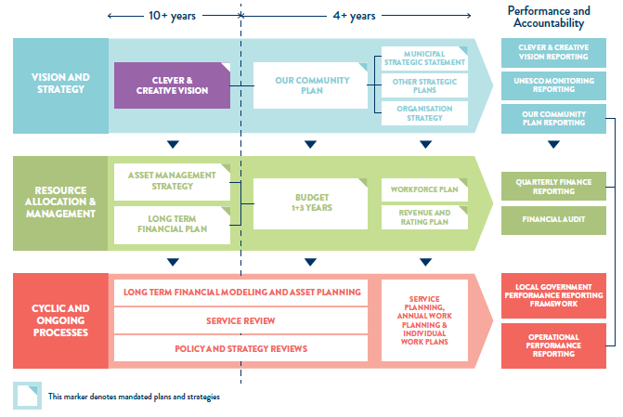
Figure 2: Draft City of Greater Geelong integrated strategic planning and reporting framework

Appendix A: Health status and determinants data

Summary of demographic data
Adults aged 35-49 are the dominant age group (2016 ABS Census)
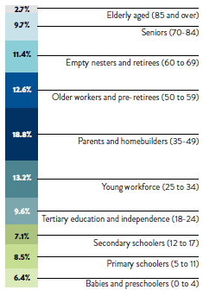
Figure 3: Population demographics (Source: ABS, 2016)

Mount Duneed, Armstrong Creek, Marshall-Claremont, Lovely Banks-Batesford-Moorabool, Curlewis are expected to experience the most growth by 2041 (forecast.id 2020)
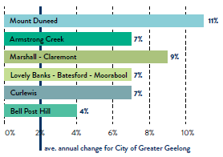
Figure 4: Population growth to 2041 (Source: forecast.id, 2020)

Adults aged 70 to 84 (100% increase) and 85 years and over (104% increase) will have the biggest population increases from 2016 to 2041 (2016 ABS Census and profile.id 2020)
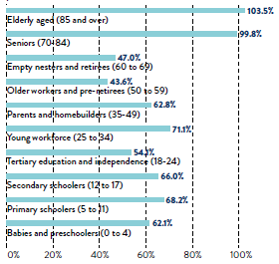
Figure 5: Population increase by life stage (Source: ABS, 2016)
The City of Greater Geelong has the highest proportion of people born in predominantly non-English speaking countries in the G21 region (11%) (2016 ABS Census)
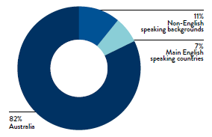
Figure 6: Birthplace (Source: ABS, 2016)

2402 people (1%) in Greater Geelong identify as being Aboriginal or Torres Strait Islander (2016 ABS Census)
The countries with the highest number of people recently arriving to Geelong (between 2011 and 2016) were from India (+1244), China (+650) and Afghanistan (+432) (profile.id 2020)
Corio, Norlane-North Shore and Whittington have high levels of disadvantage (indicated by low SEIFA scores – SEIFA: Socio-Economic Indexes for Areas) (2016 ABS Census)
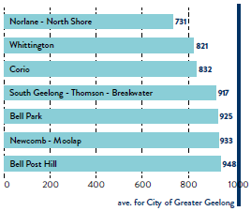
Figure 7: SEIFA scores for different areas (Source: ABS, 2016)

The City strives towards an equitable approach to health and wellbeing, which means greater attention is given to those at the greatest risk of poorer health outcomes. This includes the following priority populations:
- children
- young people
- women
- people experiencing family violence
- people experiencing homelessness or low income
- older people
- people with disabilities
- newly arrived, refugee and culturally and linguistically diverse communities
- Aboriginal and Torres Strait Islander people
- the Lesbian, Gay, Bisexual, Transgender, Intersex, Queer, Asexual community (LGBTIQA+), as well as gender diverse populations.

Summary of health data
Most of this summary data has been drawn from the Victorian Population Health Survey 2017 and therefore should be interpreted with caution for two reasons:
- most of the data is self-reported and this method has limitations in terms of reliability and validity
- any health impacts caused by the COVID-19 pandemic in 2020 – either positive or negative – are not reflected in
this data.
To supplement this data, we have included the following summary of demographic data for the Greater Geelong community.

Physical and mental health status
As Figure 8 shows, the Greater Geelong region has a lower percentage of men and women who report they have excellent or very good health when compared to the rest of Victoria (VPHS 2017). The region also has a higher rate of men and women who report high or very high psychological distress when compared to the Victorian average (see
Figure 9).
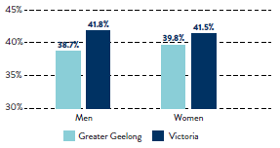
Figure 8: Men and women who rate their health as excellent or very good (%) (Source: VPHS 2017)
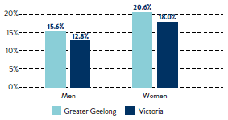
Figure 9: Men and women who report high or very high psychological distress (%) (Source: VPHS 2017)

Further to this, Figure 10 shows that a lower percentage of adults living in Greater Geelong report feeling that life is worthwhile when compared to the Victorian average.
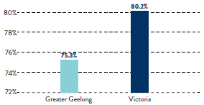
Figure 10: Proportion of adults who feel life is worthwhile (Source: VPHS 2017)

Health behaviours
While the percentage of adults who report meeting the fruit and vegetable intake guidelines is higher in Greater Geelong when compared to the Victorian average, Figure 11 shows that the overall percentage is still very low. This is particularly the case when it comes to the number of adults reporting they meet vegetable intake guidelines (6.9 per cent in Greater Geelong).
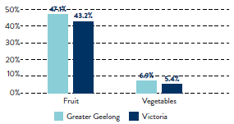
Figure 11: Adults who report meeting fruit and vegetable intake guidelines (%) (Source: VPHS 2017)

The situation is similar when comparing the percentage of adults who report meeting physical activity guidelines (see Figure 12). While a higher percentage of both men and women report meeting physical activity guidelines in Greater Geelong when compared to the Victorian average, the percentage is still only slightly higher than half the population (54 per cent of men and 55.6 per cent of women).
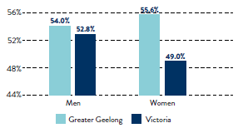
Figure 12: Men and women who report meeting physical activity guidelines (%) (Source: VPHS 2017)

Body mass index
Figure 13 shows the proportion of men and women with a self-reported body mass index that is classed as overweight / pre-obese and obese. While generally the Greater Geelong percentages are fairly close to the Victorian average, there is a greater proportion of women in Greater Geelong self-reporting a body mass index that would be classed as obese (23.6 per cent in Greater Geelong compared to 19.5 per cent Victorian average).
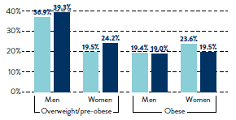
Figure 13: Men and women with a self-reported body mass index classed as overweight, pre-obese and obese (%) (Source: VPHS 2017)

Breastfeeding rates
As Figure 14 shows, the percentage of infants attending Maternal Child Health appointments who are still being breastfed at 6 months is lower in Greater Geelong when compared to the Victorian average, and has also dropped over time (41.4 per cent in 2014–15 compared to 17.4 per cent in 2017–18).
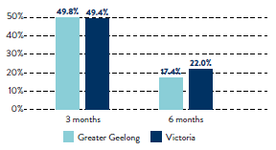
Figure 14: Infants attending Maternal Child Health appointments who were breastfed at 3 and 6 months for 2017–18 (%) (Source: DHHS 2020)

Smoking rates
As Figure 15 shows, the percentage of men in Greater Geelong who report they are current smokers (24.7 per cent) is well above the Victorian average (20.3 per cent). This percentage has also increased significantly since the last Victorian Population Health Survey in 2014, when only 17.5 per cent of men reported being current smokers (VPHS 2014-17).
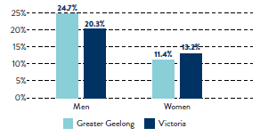
Figure 15: Men and women who report they are current smokers (%) (Source: VPHS 2017)

Alcohol-related risks
Figure 16 shows that the percentage of women in Greater Geelong consuming alcohol in a way likely to increase lifetime risk of alcohol-related harm is higher than the Victorian average (63.6 per cent versus 50.6 per cent women), as is the percentage of women at risk of alcohol-related injury on a single occasion (41.7 per cent versus 32.2 per cent).
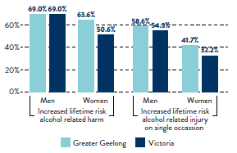
Figure 16: Men and women at increased risk of alcohol-related harm and injury based on self-reported alcohol consumption (%) (Source: VPHS 2017)

Gambling rates
As Figure 17 shows, players using electronic gaming machines in Greater Geelong lost $117.5 million in 2017–18. In the same year, only three other Victorian local government areas experienced greater losses than we did.
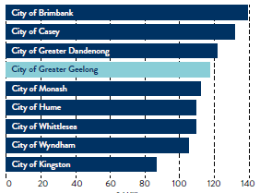
Figure 17: Total losses for players using electronic gaming machines in 2017–18 by municipality (Source: VCGLR, 2020)

Family incidents recorded by police
From 2017–19, there was a rise in the rate of family incidents recorded by police in Greater Geelong (per 100,000 population). As Figure 18 shows, the rate is also higher than the overall rate across Victoria.
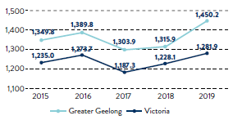
Figure 18: Family incidents recorded by police: rate per 100,000 population 2015–19 (Source: CSA, 2020)

Self-reported feelings of safety
Compared to the Victorian average, Greater Geelong has a higher percentage of men and women who respond ‘yes, definitely’ when asked if they feel safe walking down the street at night. As Figure 19 shows, the percentage of women in Greater Geelong who feel this way is still significantly less than men (45 per cent and 76.6 per cent respectively).
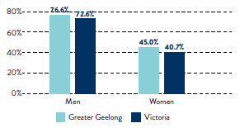
Figure 19: Men and women who report ‘yes, definitely’ when asked if they feel safe walking down the street after dark (%) (Source: VPHS 2017)

Emergency support and food security
As Figure 20 shows, the percentage of women in Greater Geelong who ran out of food during the previous year was higher by 5 per cent when compared to the Victorian average. Similarly, the percentage of women who were unable to raise $2000 within 2 days of an emergency was higher by over 4 per cent when compared to the Victorian average.
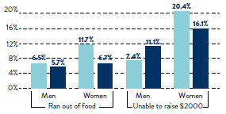
Figure 20: Men and women who ran out of food at any time during the previous year (left) and unable to raise $2000 within 2 days of an emergency (right) (%) (Source: VPHS 2017)
However, Greater Geelong has a higher percentage of men and women with a friend or relative that could care for them, or their children, in an emergency when compared to the Victorian average (see Figure 21).
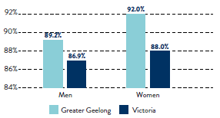
Figure 21: Men and women who have a friend or relative (not living with them) that could care for them (or their children) in an emergency (Source: VPHS 2017)

Support for multiculturalism
As Figure 22 shows, there is a higher percentage of men in Greater Geelong who think multiculturalism does not make life in their area better when compared to the Victorian average.
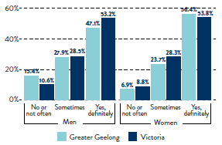
Figure 22: Adults who think multiculturalism makes life in their area better (%) (Source: VPHS 2017)

Suburbs vulnerable to heatwave
Figure 23 shows that the top five suburbs impacted by heatwaves in 2020 were Wandana Heights, St Albans, Marshall, Point Lonsdale and Newcomb. These suburbs will continue to be at highest risk through to 2070 (Roös et al 2020).

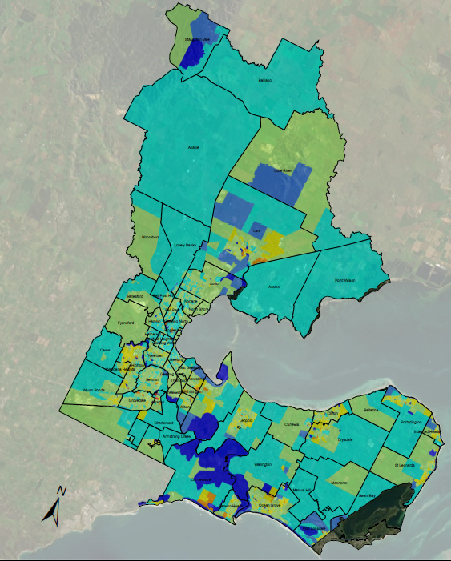
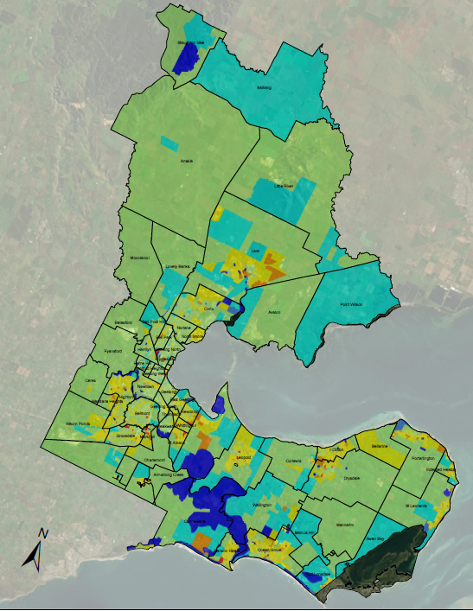

Figure 23: City of Greater Geelong suburbs vulnerable to heatwaves at MESH Block scale for 2040 (left) and 2070 (right) (Source: Roös et al 2020)

Appendix B
The health and wellbeing partners who participated in our stakeholder focus groups in February 2021 included:
- Active Geelong
- Barwon Child, Youth and Family
- Barwon Health
- Barwon Water
- Bellarine Community Health
- Diversitat
- Epworth
- G21 Region Alliance
- Geelong Cats
- Sexual Assault and Family Violence Centre
- Wathaurong Aboriginal Cooperative
- Western Victoria Primary Health Network
- Women’s Health and Wellbeing Barwon South West

Appendix C
© City of Greater Geelong 2020
CITY OF GREATER GEELONG
PO Box 104
Geelong VIC 3220
P: 03 5272 5272
E: contactus@geelongcity.vic.gov.au
www.geelongaustralia.com.au
CUSTOMER SERVICE CENTRE
Geelong
100 Brougham Street
Geelong VIC 3220
8:00am – 5:00pm
LATEST NEWS:
@CityofGreaterGeelong
@GreaterGeelong
@CityofGreaterGeelong
@CityofGreaterGeelong

@CityofGreaterGeelong

