THE CITY OF
GREATER GEELONG

BARWON HEADS
VILLAGE PARK
MASTER PLAN UPDATE

DRAFT
MARCH 2021

REVISION | DATE | AMENDMENT
F | 04/05/21 | Amend with CoGG comment
E | 14/04/21 | Amend with CoGG comment
D | 25/03/21 | Amend with CoGG comments
C | 24/03/21 | Amend with CoGG comments
B | 19/03/21 | Amend with CoGG comments
A | 26/02/21 | Draft for CoGG comment

CONTENTS
Page No.

ACKNOWLEDGEMENTS

1.0 INTRODUCTION 1
1.1 Project Scope 1
1.2 What is a Master Plan? 1
1.3 Study Area 2
1.4 Existing Conditions 2
1.5 Project Process 4
1.6 Consultation 4

2.0 STRATEGIC CONTEXT 5
2.1 Literature Review 5
2.2 Key Strategic Documents 5

3.0 ANALYSIS & PLANNING 11
3.1 Site Context 11
3.2 Land Ownership 11
3.3 History 11
3.4 Environment 13
3.5 Sports 17
3.6 Open Space 21
3.7 Other Users 23
3.8 Traffic and parking 25
3.9 Adjoining land use 28

4.0 STRATEGIC DIRECTIONS 29
4.1 What is proposed 29
4.2 Vision 29
4.3 Goals 29
4.4 Park Character 31

5.0 PARK MANAGEMENT ZONES 32
5.1 Environment and conservation zone 32
5.2 Recreation and open space zone 33
5.3 Active sport and recreation zone 33
5.4 Community service and use zone 33

6.0 DRAFT MASTER PLAN 34
6.1 BHVP - 02 - Draft Master Plan Update 2020 35

7.0 BIBLIOGRAPHY 36

INDEX OF FIGURES
Figure 1. Site Location 2
Figure 2. Environmental Values 16
Figure 3. Access and Circulation 26
Figure 4. Park Management Zones 32

ACKNOWLEDGEMENTS

The project has been guided by a Reference Group comprising local stakeholders including:

Ken Allen President, Barwon Heads Bowls Club
Helen Wood Captain, Barwon Heads Fire Brigade (CFA)
Colin Bridge Vice-Captain, Barwon Heads Fire Brigade (CFA)
Brian Cook Provisional Group Leader, Barwon Heads Scouts Group
Matthew Payne Member, OG/Barwon Heads Little Athletics Club
Libby Darcy Community Representative, Barwon Heads Association
Karen Firth Committee Member, Barwon Heads Association
Peter Birch President, Barwon Heads & District Pony Club
Brendan Curry President, Barwon Heads Golf Club/ Member, Barwon Heads Football Netball Club
Paul Summers President, Barwon Heads Cricket Club
Duncan Buller President, Barwon Heads Soccer Club
Rachel Feldman Member, 13th Beach Boardriders
Jason Ah Sam President, Barwon Heads Tennis Club
Tim Goddard President, Barwon Heads Football Netball Club
Tim Ford Vice President, Barwon Heads Football Netball Club

1.0
INTRODUCTION

  - PROJECT SCOPE

The Draft Master Plan Update has been undertaken as an update to the existing 2012 Master Plan. The project scope includes preparation of a revised master plan to accomplish the following objectives:

- Review the current 2012 Master Plan, comparing design to current site conditions, and ascertain if gaps and design differences need to be addressed to meet future challenges and changes in use.

- Identify issues and opportunities for the future use and development of the park and develop and test the appropriate design response with the local community.

- Develop a renewed Vision and Goals for Barwon Heads Village Park that is in line with the development aspirations of the growing community, identifies appropriate works/infrastructure to upgrade, ensuring future facilities meet community needs both from an active and passive recreational perspective and recognising the significant environmental and cultural heritage considerations of the reserve.

The draft vision and goals have been developed through extensive consultation with Key Stakeholders (Project Reference Group) to provide a holistic set of guidelines for the future management of the park.

1.2 WHAT IS A MASTER PLAN?

A Master Plan provides a vision for a site, identifying what it should look like and how it should function into the future. It establishes a strong and consistent direction by providing a framework for ongoing improvement. It considers the interrelationship between:

- Current character and functionality of the landscape
- Public expectations and needs delivered by date
- Emerging issues and trends
- The realities of the economic, social, environmental, and legislative context of the time.

The result is a plan that balances need across a range of often conflicting interests. The Master Plan does not necessarily suggest that all elements of the plan should proceed immediately, or that The City nor the user groups should be responsible for all capital costs, in respect of those items that are progressed.

It is important to note that the intent of a Master Plan is to provide a framework for future development of the park over an extended period of time so that ad-hoc improvements are avoided, and community use and long-term viability are maximised. To ensure this intent is achieved, a Master Plan should be regularly monitored to ensure the outcomes continue to meet community needs in the best possible way. Hence, the trigger for this project and its intent to review and update this existing plan.

1.3 STUDY AREA

Barwon Heads Village Park (BHVP) is the largest recreation reserve in the township of Barwon Heads. The 24ha District Level park is centrally located and bounded by Barwon Heads-Geelong Road to the south and Sheepwash Road to the west with established residential properties directly adjoining the northern and eastern boundaries. The park includes sporting facilities including tennis courts, synthetic bowling greens, two ovals, athletics facilities, basketball half court and pony club. The park provides facilities for and is used by local sporting clubs and community organisations including the Barwon Grove Golf Club and the local Scouts group. There is a large playground, skate facility picnic/BBQ area, public toilet facilities, open lawn areas and an extensive unsealed walking path network that is well used by both the local community and the large influx of visitors to Barwon Heads during summer holiday periods. The park also features a significant population of threatened Moonah Woodland, listed under the Flora and Fauna Guarantee Act 1988, and a section of Coastal Dune vegetation also known to contain areas of archaeological and cultural heritage sensitivity.

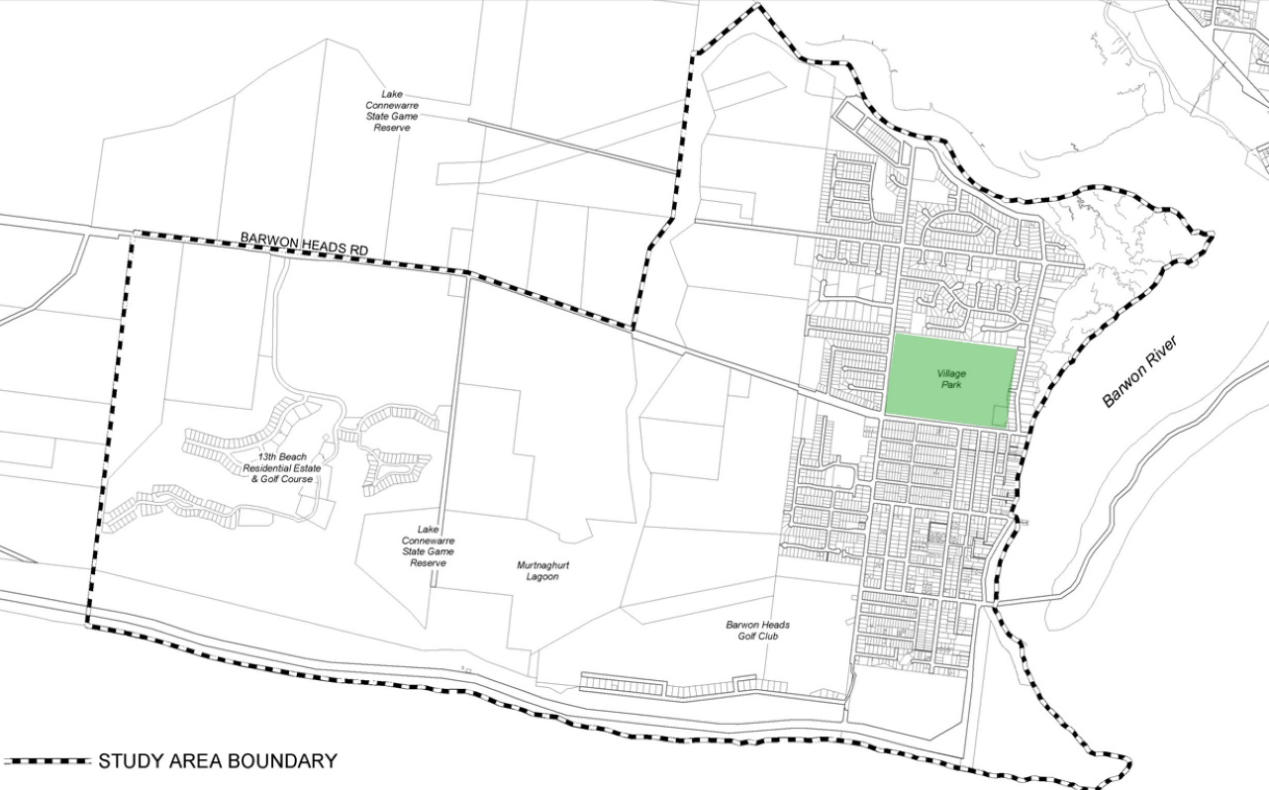

Lake Connewarre State Game Reserve
Ocean Grove

Barwon Heads Village Park

13th Beach Residential Estate & Golf Course

Lake Connewarre State Game Reserve
BARWON HEADS
Murtnaghurt Lagoon
Barwon Heads Golf Club
Bridge
Ingamells Bay

Point Flinders
(The Bluff)

Figure 1. Site location

1.4 EXISTING CONDITIONS

BHVP 01 Existing Conditions Plan

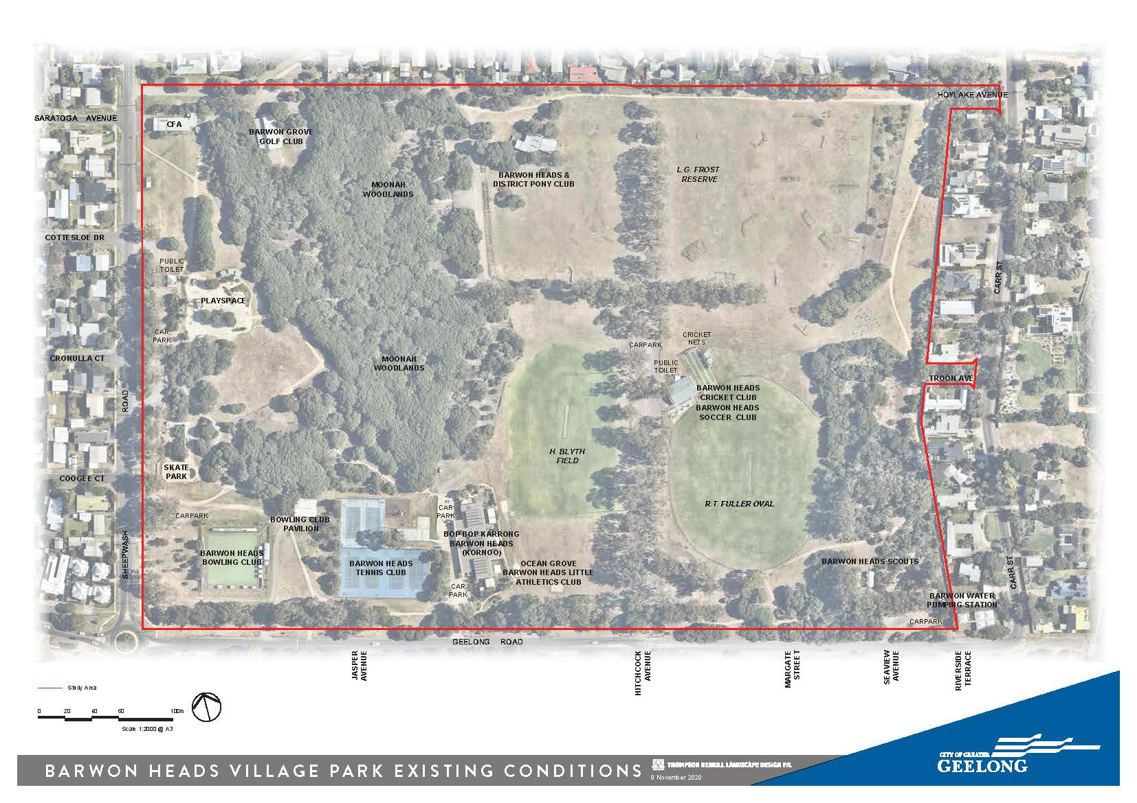

1.5 PROJECT PROCESS

Mar 2020
BACKGROUND RESEARCH

STAKEHOLDER CONSULTATION
Apr 2020
TO
Feb 2021
ISSUES & OPPORTUNITIES
Apr - Oct 2020

DRAFT VISION & GOALS
Nov- Feb 2021

Dec - Feb 2021
PRELIMINARY OPTIONS

Mar 2021
DRAFT MASTERPLAN

May - Jun 2021

COMMUNITY CONSULTATION

Sep 2021
FINAL MASTER PLAN

1.6 CONSULTATION

1.6.1 Stakeholder Consultation

There has been direct consultation with the Wadawurrung Traditional Owners Aboriginal Corporation and the following community groups and clubs have been consulted to understand use, existing issues and opportunities associated with the existing park environment, facilities and management. Core needs and aspirations identified have been captured in the Draft Vision and Key Goals. Representatives from these groups formed a Project Reference Group (PRG) which has provided input into the Draft Master Plan recommendations prior to commencement of broader community consultation.
- Barwon Heads Association
- Barwon Heads Bowling Club
- Barwon Heads Fire Brigade - CFA
- Barwon Heads Scout Group
- Ocean Grove Barwon Heads Little Athletics Club
- Barwon Heads and District Pony Club
- Barwon Grove Golf Club
- Barwon Heads Football Netball Club
- Barwon Heads Cricket Club
- Barwon Heads Soccer Club
- Barwon Heads Tennis Club
- 13th Beach Boardriders

1.6.2 Community Consultation

Consultation with the broader Barwon Heads Community will be via Council’s ‘Have Your Say’ online portal and drop in sessions (subject to COVID-19 restrictions) will be undertaken in May/Jun 2021 to refine and finalise the draft plan before it is presented to Council for endorsement later in 2021.

2.0
STRATEGIC CONTEXT

2.1 LITERATURE REVIEW

In order to present a clear picture of the background issues and opportunities influencing the potential development of the park a review of literature and standards has been undertaken. The following documents have been reviewed, as part of developing the Draft Master Plan recommendations.

LIST OF REFERENCE DOCUMENTS
- Active Victoria, A strategic framework for sport and recreation in Victoria 2017-2021, Department of Health and Human Services, July 2017
- AFL Growing the Heartland, Football Facility Development Strategy 2017 – 2022, AFL Victoria.
- AFL Preferred Facility Guidelines, State, Regional, Local School and Remote Facilities, AFL, 2019.
- City of Greater Geelong, Barwon Heads Village Park Master Plan (2012)
- City of Greater Geelong, Barwon Heads Structure Plan (2017)
- City of Greater Geelong, Biodiversity Strategy
- City of Greater Geelong, Dog Controls in Public Places Policy (2020)
- City of Greater Geelong, Domestic Animal Management Plan (2018-2021)
- City of Greater Geelong, Outdoor Sport and Recreation – Social Infrastructure Plan Generation One: 2020-23
- City of Greater Geelong, Planning Scheme
- City of Greater Geelong, Social Infrastructure Plan (2020)
- Community Cricket Facility Guidelines, Cricket Australia, September 2015.
- DSE, EVC 858: Coastal Alkaline Scrub Otway Plain bioregion Ecological Vegetation Class Benchmark.
- DSE, Action Statement No. 141 Coastal Moonah Woodland – Flora and Fauna Guarantee Act 1988
- Football Victoria, Football Facilities Building Development Guide, 2019.
- G21 and AFL Barwon Regional Strategy, G21 Regional Alliance, April 2015.
- G21 and Cricket Victoria Barwon Regional Cricket Strategy, Final Report, G21 Geelong Regional Alliance, May 2019.
- G21 Regional Football (Soccer) Strategy, G21 Geelong Regional Alliance, May 2012.
- G21 Regional Hockey Strategy. G21 Geelong Regional Alliance, March 2019.
- G21 Regional Tennis Strategy 2015-2025, Final Strategy Report, April 2015.
- Netball Victoria Statewide Facilities Guideline, Netball Victoria.
- Tennis 2020, Facility development and management framework for Australian Tennis, Tennis Australia.
- Victorian Cricket Infrastructure Strategy 2018 - 2028, Cricket Victoria, March 2018.

2.2 KEY STRATEGIC DOCUMENTS

The following is a brief summary of the key outcomes and recommendations from existing background documents that will inform the Master Plan Review. For more detailed descriptions please refer to the original reports.

2.2.1 Our Community Places, Spaces and Services: A Social Infrastructure Plan, Generation One: 2020-2023.

The Social Infrastructure Plan was prepared by the City of Greater Geelong as a strategic framework for the future development of the City of Greater Geelong area. The Plan outlines the needs of the community, investment priorities and the way forward to ensure that people know what is planned in the place that they live.

The plan is intended to provide Council and the community with a single, simpler and more integrated strategic summary of Council's investment priorities over the next 1-3 years.

Policy Context: The Social Infrastructure Planning and Investment Policy that underpins this plan and aims to provide Council and the City of Greater Geelong with a guide for prioritising investment decisions and to provide the community with a clear understanding of Council's role and how decisions are made.

Open Space
- Set open space quality standards covering land delivery, design, and infrastructure and user experience.
- Invest to improve the local park network by improving the basic amenity such as shade, shelter, seating, access, drinking fountains, signage, garden beds and trees in the older established areas.
- Barwon Heads Village Park is a local sport, open space and conservation reserve which due to its relative size along provides for other community uses.

Outdoor Sport and Recreation (including sports pavilions)
- Focus on infrastructure projects that build the quality, functionality and carrying capacity of the existing network. Maximise use of existing facilities by initiating and supporting upgrade projects that focus on sports lighting, gender neutral (i.e., Female Friendly) change facilities, sports surface conversion and supporting infrastructure such as supplementary training spaces.
- Focus on strategic partnerships to build capacity and capability across the network to deliver on infrastructure needs.
- Include planning for people and place (i.e., gender-neutral provisions, positive aging and access for all abilities).

Public Toilets
- Continue to audit, monitor and assess public toilets and amenity provision and performance.

2.2.2 Barwon Heads Structure Plan, City of Greater Geelong, March 2017

The Barwon Heads Structure Plan was prepared by the City of Greater Geelong and adopted as a strategic framework for the future development of the Barwon Heads township. The key issues, opportunities and constraints facing the township and relevant to BHVP identified in the Structure Plan are as follows:
- Policy Context
- There is a strong State and Local Planning Policy direction for the protection, enhancement and/or management of coastal environments, coastal hazards and the coastal impacts of climate change; sensitive environments, biodiversity and landscape features; Barwon Heads and its surrounding area including BHVP hold significant values for Indigenous cultural heritage and Building design and built form of the township including the opportunity for application of a range of policy and statutory planning controls. These controls will apply to any new buildings in the park as well.
- Natural and Urban Environment
- A need to recognise the significant landscape setting and key views of the coast and rural hinterland that surround the Barwon Heads ‘island’.
- There are significant biodiversity and sensitive environment features that require protection, including Ramsar wetlands.
- Indigenous cultural heritage values require protection.
- Demographics and Social Profile
- The town has a significant influx of people in the peak summer holiday season with moderate dwelling vacancy rates during the off season.
- A relatively wealthy and advantaged population with low unemployment.
- A private car reliant population.
- Slowing population growth as housing supply decreases.
- Township Facilities and Services
- The amount of open space within the town is sufficient to support the projected future population.
- Opportunity to enhance existing passive open space and recreation areas, particularly in northern areas of the town and improve linkages between recreational facilities.
- Opportunity for the continued improvement of facilities and amenities of the Village Park.
- Opportunity to establish and improve recreational paths and trails.
- Climate Change
- The Structure Plan acknowledges that Barwon Heads is particularly vulnerable to any effects of climate change due to its location and the history of flood events in the township. Most of the areas which may potentially be affected by climate change are located within the urban area, which includes BVHP. As such, and pending further research and information on climate change, the Structure Plan notes that a ‘no-risk’ approach is to be adopted for Barwon Heads, in regards to management of both infrastructure and natural values.

2.2.3 Overview of the 2012 Master Plan

Many of the operational initiatives have been implement but most of the larger capital projects have yet to be completed.

The following is a summary of the current status of recommendations outlined in the 2012 Master Plan. These have been assessed as part of the master plan update to confirm if they are still valid and if any other new issues and opportunities need to be considered:

Environmental and Cultural Values
- Liaison with the Wadawurrung is ongoing and Cultural Heritage Management Plans have been completed for works in areas of known cultural heritage sensitivity.
- Weed control and natural regeneration works in the fenced Moonah Woodland areas is ongoing, however some large isolated Moonahs remain unprotected.
- Coastal Tea tree removal from Dune Complex areas is ongoing however unfenced areas near the Scout Halls are subject to ongoing disturbance from informal tracks and bike jumps.
- Some removals of Tuart Gums have occurred and monitoring and maintenance is ongoing. Attempts at replanting along the avenues with indigenous species have been undertaken but relatively unsuccessful due to ground compaction, overshading and nutrient/water competition from existing trees.

R.T. Fuller Oval
- The soccer, AFL junior football, netball and cricket have noted increased female participation and memberships is growing.
- Training lights have been installed.
- Pavilion facilities have not been upgraded to meet the demands of increased participation and gender diversity.

H. Blyth Field
- Lighting and irrigation projects have been completed for the main playing area.
- No change to existing use for soccer and cricket however use and training loads have increased wear and tear on the surface.
- No longer needed as full athletics track and focus has been shifted to training only.
- No irrigation to southern end of the field.

Pony Club - L.G. Frost Reserve
- Membership numbers have reduced.
- L.G. Frost Reserve is now only used 12-16 times/year.
- There has been no change to the clubrooms and the proposed sand lunging area has not been delivered.
- The current dog control regulation for Barwon Heads Village Park allows for dog off leash in sporting grounds/ovals outside times when being used for organised sports, including training. This now includes the Pony Club area.

Tennis, Golf and Bowling Clubs
- Little change to the tennis and bowling club facilities.

Playspace, picnic areas and skate park
- There has been little change to the playspace, car park and picnic area

2.2.4 Sporting strategies

Since completion of the 2012 Master Plan there has been further emphasis in current sporting strategies and facility guidelines to ensure new facilities are fit for purpose and meet contemporary standards through universal design approaches that support greater gender equity, equality and accessibility. This in turn is providing facilities that will continue to support and grow participation in sport improving the community’s health and wellbeing. Key direction in outdoor sport and recreation include:

- Focus on infrastructure projects that build the quality, functionality and carrying capacity of the existing network.
- Maximise use of existing facilities by initiating and supporting upgrade projects that focus on sports lighting, gender neutral (i.e. Female Friendly) change facilities, sports surface conversion and supporting infrastructure such as supplementary training spaces.
- Focus on strategic partnerships to build capacity and capability across the network to deliver on infrastructure needs.
- Develop a robust understanding of network performance. Conduct a fit-for purpose audit of the network and investigate usage and occupancy, in both the public, private and education services, to help determine need and demand across the City.
- Invest in developing contemporary systems, data and insights and mature our current provision and performance reporting.
- Continue to enhance the relationship between peak governing bodies, government and community partners in the planning and provision of facilities. Align planning at local, municipal, regional, state and federal levels to ensure that all levels of the planning cycle are working collaboratively to deliver benefits to the community.
- Contemporise and undertake holistic planning and policy development. Focus on data, monitoring and reporting. Include planning for people and place (i.e. Gender-neutral provision, positive ageing and access for all abilities).
- Develop an Integrated Asset Management Plan and ensure planning, development and renewal budget programs are commensurate with the agreed service levels and outcomes for the network.
- Review existing renewal programs and budgets against agreed service levels.
- Initiate and support club and community development activities that respond to changing clubs needs with a focus on supporting financial sustainability, club capacity development and strategic planning.

Refer to 2.1 for a list of relevant guidelines and strategies.

2.2.5 Demand Analysis

Demographics
In 2016 Barwon Heads had a total permanent population of 4,554 usual residents according to the Australian Bureau of Statistics’ 2016 Census. The Australian Bureau of Statistics estimates this population to be 5,106 in 2019.

Statistics for the Barwon Heads - Connewarre - Breamlea area show that the population growth is forecast to slow considerably. In the 15 years from 2016 to 2031 the population is anticipated to grow by only 5.4% or 0.36% each year. The population projects indicate that there will be a significant growth in older residents and particularly those aged between 60-69 and 70-84 and that provision of open space and facilities is sufficient to meet future local population growth.. (Barwon Heads Structure Plan, August 2017).

Sporting use
Since completion of the 2012 Master Plan there has been significant residential development in the nearby Armstrong Creek area which is within 10-15 minutes drive of the Barwon Heads Village Park. The time gap between expansion of the Armstrong Creek residential population and establishment of new sporting facilities for this community has seen growth in membership of existing nearby clubs including, those at BHVP.

The first active sporting reserve to be delivered for Armstrong Creek will be on the corner of Horseshoe Bend Road and Warralily Boulevard located within the Eastern Precinct. The design to be for a multipurpose reserve with soccer as a key tenant. New sports and open space facilities will continue to be added to this area as the population increases. Once the Armstrong Creek multipurpose reserve is established, membership and demand at Barwon Heads Village Park is expected to stabilise as new residents use the new facilities closer to home. Residents and seasonal visitors to Barwon Heads will also be able to easily access the new facilities at Armstrong Creek. BHVP will therefore remain a local reserve focused on meeting only the sporting needs of the local community.

Equestrian use
Demand for equestrian use at BHVP has been falling since the park was enclosed by residential development and with closure of the old round the park cross country track. There are numerous pony clubs across the Bellarine Peninsula and major events have already been relocated to nearby better serviced equestrian facilities at Mt Duneed and Drysdale. Future demand for equestrian facilities in the region is likely to be met by these two clubs.

Open space use
Use of open space during COVID-19, especially during lockdown has seen a significant increase including at BHVP. While tourism visitation has been variable and is expected to return to normal levels the long term trends arising from this increase in local open space use are not yet known. However, the size and diverse nature of BHVP means that it is well equipped to meet any future changes in local and tourism demand for passive and active open space.

3.0
ANALYSIS & PLANNING

3.1 SITE CONTEXT

Barwon Heads is a seaside town located at the mouth of the Barwon River. The township was first developed in the 1890’s, providing an attractive destination for recreational users with a keen interest in boating and fishing. Barwon Heads is now a popular tourist destination, with an increase in permanent and seasonal residential populations.

The Village Park is centrally located and as the largest park in the area provides for local community sport, passive and active recreation. The park also provides pedestrian links from the more recently developed residential areas to the Primary School, the foreshore and Hitchcock Avenue activity centre.

A typical district level park is approximately 10ha in size. However, the BHVP is 24ha in size while providing for only local level facilities and open space use for the majority of the year. The parks built infrastructure and facilities have been integrated with large areas of significant remnant indigenous vegetation and unfenced open grass which provide an important continuation to the relaxed coastal character of the township.

3.2 LAND OWNERSHIP

3.2.1 Land ownership

The existing site is Crown Land, the City of Greater Geelong is the delegated land manager under the Crown Land Reserves Act 1978.

3.2.2 Planning

The majority of the site is currently zoned Public Park and Recreation Zone (PPRZ). Two small areas are zoned as Public Utility Zone 1 (PUZ1) – the CFA Station in the north-west corner off Sheepwash Road and the Barwon Water Pumping Station located in the south-east corners of the park. There is a Special Building Overlay (SBO) showing in the north west area of the park, and in the centre of the southern-most boundary as these areas can be subject to low level flooding after heavy rainfall.

Long term lease agreements for clubrooms and license agreements for use of the ovals and sporting grounds are in place between CoGG and the existing clubs operating in the park.

3.3 HISTORY

3.3.1 Indigenous Cultural Heritage
The Barwon Heads township is located along the Barwon River estuary and the site would have been an ideal location for Aboriginal people to obtain food and water and many areas in Barwon Heads are of cultural and archaeological significance. The Wadawurrung Traditional Owners Aboriginal Corporation is the Registered Aboriginal Party (RAP) and as the park is located within 200m of the Barwon River it is classified as an area of cultural sensitivity as defined in the Aboriginal Heritage Regulations 2018.

Archaeological assessment of the park indicates that the prominent linear sand dune along its eastern boundary has yielded Aboriginal archaeological materials, including midden shells and stone artefacts. This material has been registered with Aboriginal Victoria, as the 'Barwon Heads Village Park Shell Midden', Site No. VAHR 7721/486. Ground disturbance in this area must be avoided and ongoing consultation with the Wadarurrung is an ongoing part of park management.

Photo 1: Existing remnant dune area

Photo 2: R.T. Fuller Oval

3.3.2 Non Indigenous History
There are records of Europeans settling on the Ocean Grove side of the Barwon River from around 1854, but settlement of the Barwon Heads side did not begin until the mid-1870’s when the area was used for fishing. In the 1890’s an influx of hunters started to visit Lake Connewarre for ducks and other native birds, which saw the small fishing village start to grow and by the 1920’s the township had more facilities including the Barwon Heads Golf Club. The bridge was constructed across the Barwon River linking Barwon Heads and Ocean Grove in 1927 and the area in close proximity to Geelong has been a popular beach side resort from this period.
The history of BHVP is not well documented and there are no details in the previous management plan aside from several local references to the “54” or “54 Acres”. The Barwon Grove Golf Club was relocated to the site almost 50 years ago following a land swap agreement between the then State Government and Barwon Heads Golf Club which also resulted in them retaining limited playing rights at the Barwon Heads Golf Club.

3.3.3 Key cultural heritage considerations
- The eastern side of the park is a known area of high cultural heritage sensitivity.
- A Cultural Heritage Management Plan will likely be required for and ground disturbing works at the park.
- There is no identification of the Wadawurrung as the traditional owners or other information regarding aboriginal cultural heritage values at the park.
- The early establishment of the park and it’s importance to the development of the Barwon Heads community is not well documented or acknowledged within the park.

3.4 ENVIRONMENT

3.4.1 Flora

BHVP is located within the Otway Plain bioregion characterised by 550-600mm annual rainfall and a naturally sandy geology over calcareous dune rock. The pre 1750 Ecological Vegetation Class (EVC) is EVC 858 – Coastal Alkaline Scrub (syn. Calcarenite Dune Woodland). Significant species within this EVC include Coastal Moonah (Melaleuca lanceolata) Woodland which is listed and protected on Schedule 2 of the Flora and Fauna Guarantee Act 1988 and rare Coast Wirilda Acacia retinoides var. uncifolia which is also protected.

There are of two remnant Coastal Alkaline Scrub sub communities at BHVP and the indigenous vegetation is listed as significant as most of the remnants of this type have been cleared and remaining areas have been degraded due to fragmentation and weed invasion.

Zone 1 - Remnant Moonah Woodland
The Moonah Woodland is located primarily in the north western end of the park and the largest area 4.8ha has been fenced and protected since 2002. The woodland includes a mixed age community of primarily Melaleuca lanceolata protected by a network of perimeter and internal fencing to a number of define through tracks. The fencing installed to the internal track network has reduced the number of informal tracks protecting the existing trees and reducing the impacts of human activities on ground layer including areas with sensitive moss vegetation. Woody weed control has been largely successful however control of grasses and ground layer weeds including Pampas Grass Cortaderia selloana, Crassula multicava, Couch Cynodon dactylon and Buffalo Grass Stenotaphrum secundatum is ongoing.

Photo 4: Moonah Woodland 2
Photo 3: Moonah Woodland 1

Photo 5: Moonah Woodland access gate

Photo 6: Moonah Woodland Internal paths

Zone 2 – Dune Woodland
The Dune Woodland is located along the remnant dune system running north south along the eastern park boundary. It features two separate fenced areas. The northern remnant (0.31ha) features primarily groundlayer species including Kangaroo Grass Themeda triandra, Wallaby Grass Austrodanthonia sp. Knobby Club-rush Ficinia nodosa, Clematis microphylla, Rhagodia candolleana and Swainsona lessertifolia. Refer Photo 1.

The southern area (0.9ha) contains several large Moonah and Coast Wirildra with infill of Coast Beard Heath Leucopogon parviflorus and Coast Tea-tree Leptospermum laevigatum, which have naturally recolonised the dune area. The presence of the Coast Tea-tree in the remnant Dune Woodland is seen as a long term management issue. While Coast Tea-tree is normally associated with sand dunes in coastal areas the percentage cover of this species can lead to a loss of diversity, out-competing other indigenous trees, shrubs and groundlayer species and cover of less than 5% is preferred in these areas. Coast Tea tree management is undertaken by CoGG Conservation Reserves Team to maintain biodiversity values and minimise fire risk for directly adjoining residential properties in the south east corner of the park.

Outside the core fenced Moonah Woodland perimeter there are also some very large and very old established Moonahs which are cut off from the main fenced remnant woodland area (refer photo 8). These trees located at the rear of the Pony Club, at the play space and the Barwon Grove Golf Club car park are subject to higher levels of ground layer weed invasion and despite the presence of some fencing appear unable to naturally regenerate and are subject to higher threat in the form of root compaction and branch damage.

Photo 7: Coast Tea tree – SE Corner

Photo 8: Moonahs at the Pony Club

There is a mix of planted native and indigenous vegetation across the remainder of the recreational areas of the park, which contributes to the habitat values and landscape character of the park.

A key landscape feature of the site is the crossed avenue of Tuart Gums Eucalyptus gomphocephala planted north-south along the main roadway extension of Hitchcock Avenue and east-west through the centre of the park. Tuart Gums are a native of Western Australia and were planted on the site 40-50 years ago. Drought conditions in the early 2000’s saw a decline in health and a third of the trees were removed due to safety concerns and parking areas were more clearly defined. Since then they remaining population has stabilised however these trees are subject to continuous monitoring with spot removals undertaken as required to protect public safety.

Figure 2. Environmental values

Tuart Gum avenue is declining in health and will require ongoing monitoring and a staged replacement strategy
Fenced access tracks through Moonah Woodland
Add Moonahs to fenced conservation area
Lack of connection between remnant vegetation areas
Lack of connection between fenced areas of Dune Woodland
Lack of protection and weed control to very old Moonahs at the Pony Club
Existing Moonahs on private land
Weed invasion in understorey of Moonah Woodland limits natural regeneration and biodiversity values.
Potential redevelopment of Golf Club and any car park improvement works must ensure protection of significant vegetation adjoining the area
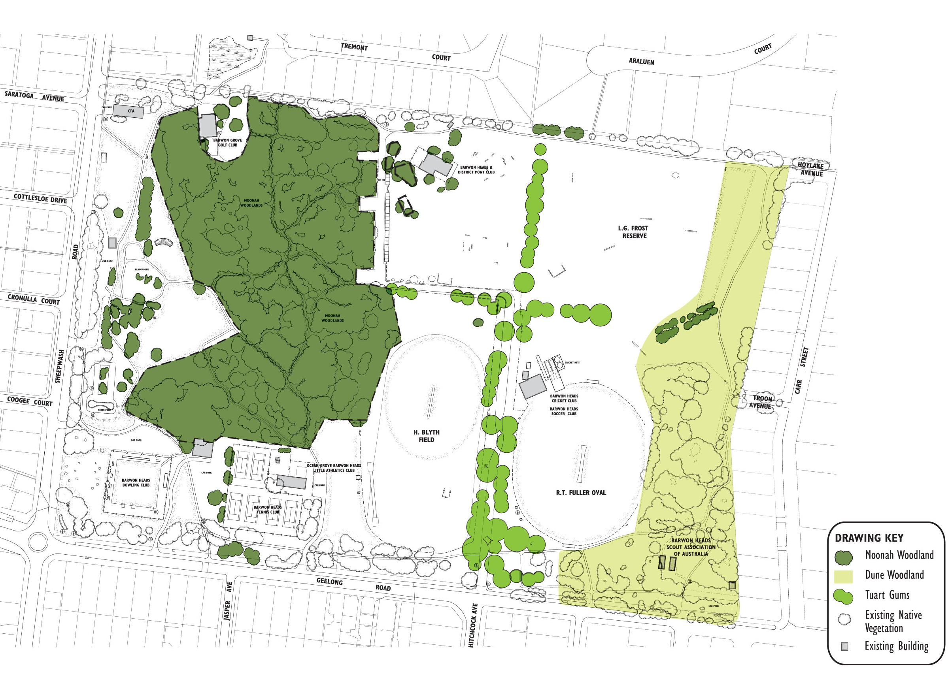
Southern area of Dune Woodland are unfenced and subject to higher levels of disturbance and weed invasion
Remove toilet facility to protect Moonah at Bowls Club
Add Moonahs to fenced conservation area
Potential issues with leaf litter and root damage at the tennis courts
High fire risk to adjacent residential properties due to proximity of vegetation and high percentage of Coast Tea tree

3.4.2 Fauna

There has not been a formal fauna assessment in BHVP, however the existing vegetation in the park provides important habitat values for local indigenous fauna. The DSE Field Guide to Coastal Moonah Woodland in Victoria notes that Moonah Woodlands provide habitat and food for many species of native animals and insects such bats, echidnas, ringtail possums, birds, beetles and spiders.

3.4.3 Key considerations
- Native vegetation within the park is protected by legislation and planning controls.
- Removal and control of Coast Tea-tree in the remnant vegetation areas to maintain biodiversity values and minimise fire risk will be ongoing.
- Density of vegetation at some road entries at path crossings will require pruning at times to maintain sightlines and public safety.
- Large Moonah trees near the Pony Club, playspace and within the Barwon Grove Golf Club car park remain unprotected.
- Large Moonah trees at the rear of the Bowling Club would be impacted by replacement of facilities in this location.
- Creation of informal bike jumps and tracks is impacting the Dune Woodland within in the south-east corner of the park.
- There is limited habitat connection between the fenced Moonah Woodland area and the Dune Complex along the eastern side of the site.
- Management of the ageing Tuart Gums avenue to minimise risk to the public will require ongoing removal of trees and infill planting will be required to retain the avenue character.

3.5 SPORTS

BHVP is the primary sporting reserve in Barwon Heads and provides for local cricket, soccer, athletics, tennis, junior AFL, lawn bowls and equestrian competition, training and informal use.

3.5.1 Existing Playing Fields

R.T. Fuller Oval
Full size irrigated unfenced grass cricket oval with synthetic wicket, sidescreens and recently installed training lights. The surface while undulating, is in good condition and the sandy subgrade assists drainage. The oval is also used for soccer and junior AFL over winter.

The pavilion has two change rooms, male/female and accessible amenities and a social room with kitchen/canteen facilities. There are male/female public toilets at the rear and synthetic cricket nets (3 lanes).

H. Blyth Field
The northern end of the large, unfenced reserve is irrigated and used for soccer and as the second cricket ground. The ground is narrow for cricket use.

The Little Athletics Club uses the reserve for training with permanent field sports areas including throwing cage, long jump put, shotput and high jump pad at the southern end of the field. There is no pavilion and the athletics club use an area in the Bop Bop Karrong building for storage.

3.5.2 Existing Clubs

Barwon Heads Cricket Club (BHCC)
The club fields 4 senior teams, and 10 junior teams using both R.T. Fuller and H. Blyth Field over summer for mens, womens and junior cricket. Training is held Monday to Thursday, with games Friday evening, all day Saturday and some Sundays. The existing pavilion was built primarily for cricket use and the social room is used for club and external functions.

Photo 10: Wickets on R.T. Fuller Oval
Photo 9: Cricket Club Pavilion

Barwon Heads Soccer Club (BHSC)
The club fields 3 senior teams and 4 junior teams using both R.T. Fuller and H. Blyth field over winter for mens, womens and junior soccer. Training is held Monday to Thursday afternoon/evenings with games on Saturday and Sunday through winter. The club has use of the Pavilion over winter.

Photo 11: Picnic tables under the canopy area in front of cricket club

Barwon Heads Junior Football Club (BHFC)
The Barwon Heads Football and Netball Club uses Hamer Oval within the Barwon Heads Caravan Park and does not have a permanent presence in the park but uses the R.T. Fuller Oval for junior footy games and training during winter.

3.5.3 Key AFL, Cricket and Soccer considerations

Key Soccer considerations
- Current Football Victoria (FV) guidelines for local and community competition level (senior level) pavilions require a minimum of four change rooms with corresponding amenities and two separate match officials change rooms as a minimum requirement to serve two soccer playing fields.
- The current pavilion was historically designed for cricket and provides for only two change rooms which are in reasonable condition. The pavilion configuration could be adapted to provide additional changerooms and amenities at the rear as required to meet current requirements for gender equity and at a reduced cost however more detailed cost benefit analysis will be required to determine if this is the preferred approach when weighted against the benefits of a complete, new build in lifecycle and management costs.
- The main access road divides the two playing fields with no defined crossing point or pedestrian priority crossing from the pavilion to H. Blyth Field.
- The current layout of the cricket pavilion does not cater for the needs of the Soccer Club in terms of availability of the required change rooms for mens, ladies, juniors and referees.
- Lack of bicycle racks to cater for the large number of park users who cycle to the park.
- The growing club is looking for other spaces for training and warm-up which could be considered as part of a multi-use irrigated space to the south of the current field.

Key Cricket considerations
- While the existing pavilion was built for cricket gender participation changes mean increasing to four changerooms would also benefit gender equity cricket use at the park as well.
- There is no scoreboard on R.T. Fuller Oval.
- The grass surface at R.T. Fuller is undulating with mixed grass species, top dressing and reseeding with more durable warm season grass would improve playability.

Key AFL considerations
- R.T. Fuller is an important venue for AFL training and junior football as a second ground. Future demand needs to be managed cooperatively with soccer remaining the core winter tenant at the park.

3.5.4 Barwon Heads Bowling Club (BHBC)

The fenced bowling greens are synthetic and used all year round. The club has approximately 80 playing members, and more than 40 social members. The clubrooms are located west of the existing tennis courts, away from the bowling greens. Toilet facilities at the rear of the clubroom back into existing Moonah vegetation, which is leaning over and into the toilet block. The existing clubroom is also hired out for private functions and other groups such as The Friends of the Bluff and the Barwon Heads Music Society.

Photo 12: Bowling Club Pavilion
Photo 13: Synthetic Bowling Greens and existing car park

Key Bowling Club considerations
- The Club toilet facilities are in poor condition and impact on the adjoining Moonah Woodland.
- The location of the club room and toilets away from the bowling green restricts access especially for the elderly and those with a disability.
- The Bowling Club secured $500K of federal funding for a new building including social room and accessible toilet facility located on the west side of the bowling greens however additional funding will be required to complete the project.

3.5.5 Barwon Heads Tennis Club (BHTC)

There are six hard courts, and the club has approximately 70 members training mid-week and Saturday mens, womens and juniors competition. The two northern courts need resurfacing. The clubrooms have a social room, small kitchen and toilets and other facilities include a tennis hitting wall and a swing set.

Key Tennis Club considerations
- The tennis club are seeking funding for refurbishment of their clubrooms but have advised that these improvements will not require changes to their existing footprint.
- Upgrade the existing tennis pavilion within the current footprint to meet contemporary standards improving gender equity and accessibility.
- Upgrade of the northern courts in synthetic grass is preferred.

3.5.6 Barwon Heads and District Pony Club (BHPC)

The club has a long history at BHVP however club membership has been in decline and event use is at L.G. Frost Reserve is down to 12-16 times per year.

The pavilion is currently located in the north-west corner of L.G. Frost Reserve and includes a fenced storage area and undercover verandah. Several jumps are in poor condition and there is no water for the jump.

Photo 14: Pony Club pavilion

Key Pony Club Considerations
- Other venue at Mt Duneed and Drysdale are well established for events and are capturing demand for equestrian activities in the region.
- The sand lunging area recommended from the 2012 Master Plan remains a key club priority.
- The age and proximity of Moonahs to the clubrooms will require ongoing monitoring to assess tree health and safety.

Photo 15: Show jumping infrastructure

3.5.7 Ocean Grove Barwon Heads Little Athletics Club (BHLAC)

The club use H. Blyth Field for training over the summer. Existing facilities include a long jump pit and discus cage and shot put rink for field sports at the southern end of H. Blyth Field. The concrete high jump pit is no longer used.

Key athletics club considerations
- BHVP is now used for training only.
- Grass damage from field sports such as shot put impacts on the soccer/cricket playing surface and these activities would be better suited to the southern end of the field.
- There is no irrigation in southern end of the field which increases wear and tear on the multi-purpose grass areas.

Photo 16: Existing long jump pits
Photo 17: Existing throwing cage

3.6 OPEN SPACE

3.6.1 Informal recreation

The park provides an excellent range of park facilities and infrastructure for both formal and informal activities. The skate park built in 2011 remains a popular space for users. This features a bowl and ramp/activities area with sound protection for adjoining residents. Other park facilities include the playspace which was recently upgraded including two new flying foxes play equipment, the picnic shelter, BBQ and public toilet located adjacent to the play space with a maritime theme.

There is a basketball half court at the Barwon Grove Golf Club and several picnic tables located around H. Blyth Field, R.T. Fuller Oval and around the existing play space.

Photo 19: Existing playspace
Photo 18: Existing skate park

Photo 21: Public toilets on Sheepwash Road
Photo 20: Basketball half-court at Golf Club
Photo 22: Recently upgraded picnic tables and benches adjacent to H. Blyth Field

3.6.2 Toilets

There are two public toilets located in the park. The main public toilet block is located adjacent to the playspace in the west of the park and services the playspace, the picnic area and the skate park users. The other toilet located at the rear of the R.T. Fuller Oval and services spectators on game days or major events and walkers and dog walkers using the eastern side of the park. All clubrooms in the park have toilets, which can usually be accessed by club members only when open for Club match days/functions. The toilet block located at the rear of the Bowls Club pavilion is managed by the Bowls Club as part of their lease agreement. Redevelopment of the Bowls Club would allow this toilet facility to be removed reducing impacts on the Moonah Woodland. Their proximity to the adjacent Moonah Woodland is also a maintenance issue.

Photo 24: Toilet block at rear of Bowls Club
Photo 23: Public toilets at Cricket Club

3.6.3 Dog Access / Control

The City’s municipal-wide Dog Controls in Public Places Policy, dogs are currently required to be on-leash in most parts of the reserve.

Dogs are prohibited from the existing playground, skate park and the tennis playground area. Dogs are only permitted to be off leash outside times when they are being used for organised sport and training and this now includes the Pony Club area.

3.7 OTHER USERS

3.7.1 Barwon Grove Golf Club (BGGC)

The BGGC was established in 1961 and has more than 260 members the clubrooms are known as the 'Tin Shed' and located in the north-west area of the park, with vehicle access from Sheepwash Road. There is an unsealed car parking area adjacent to the building with a basketball half court and outdoor picnic area which can be used by the public.

The BGGC competitions and events are held off site at Barwon Heads Golf Club or 13th Beach Golf Club and the club operates as a social club only. The Club is available for community hire and plays an important role in local fundraising activities for various other clubs and community initiatives such as the Good Friday Appeal.

Photo 25: Barwon Grove Golf Club

Key consideration Barwon Grove Golf Club (BGGC)
- Car parking capacity is important to the Club however protection of several large Moonahs is also important to protect root systems from further compaction.

3.7.2 Barwon Heads Scout Association of Australia (BHSAA)

1st Barwon Heads Scout Group was originally formed in 1959. After a hiatus of twelve years, the Scout Group was reformed in 2007 and now has more than 120 members.

The Scout Halls are located in the south-east corner of the park and include two steel cabins and a separate small toilet facility. The cabins are used as both meeting and storage space for camping and other key equipment and with the increase in membership there is limited space.

Key considerations Barwon Heads Scout Association of Australia
- The Scout cabins are located in an areas of known cultural heritage sensitivity. While existing activities can be managed redevelopment of the building’s toilet facilities and storage areas at this location is not preferred given potential impacts on cultural heritage values and the availability of other suitable sites in the park for redevelopment.

Photo 27: Tennis Courts
Photo 26: Scouts Hall and toilet block

3.7.3 Barwon Heads Fire Brigade - CFA

The CFA building is located in the north-west corner of the park. The grassed areas south of the building on Sheepwash Road are used for training drills. Fire risk assessment for the park is completed annually by CoGG Fire prevention Officer in consultation with the local CFA.

Photo 29: Barwon Water pumping station
Photo 28: Barwon Heads CFA

Key considerations for Barwon Heads Fire Brigade - CFA
- Retain unrestricted vehicle access to grass areas adjoining the CFA building for training and emergency management.

3.7.4 Barwon Water

Barwon Water has a lease agreement for the pumping station located in the south-east corner of the park. The facilities include a sewerage pumping station and equipment shed.

Key considerations for Barwon Water
- Retain vehicle access to the Barwon Water lease area from Geelong Road.
- Co-ordinate fire break vegetation management with the CoGG Conservation Reserves Team and Fire Prevention Officer.

3.7.5 13th Beach Boardriders

The 13th Beach Boardriders group is currently looking for a local home base within the Barwon Heads Village Park. The club has secured external funding to assist with establishment of a new storage facility and purchase of new equipment. A standalone facility is not proposed.

Key Considerations for 13th Beach Boardriders
- Location of the 13th Beach Boardriders within BHVP could be considered as part of improving facilities for an existing group such as the Scouts or Bowls Club who are actively looking to relocate.

3.7.6 Bop Bop Karrong Barwon Heads (Kornoo) Integrated Child and Family Centre

The Barwon Heads Early Learning Centre was established in 2013 and is now called the Bop Bop Karrong Barwon Heads (Kornoo) Integrated Child and Family Centre and brings together a range of services for children and their families, including: three and four year old sessional Kindergarten programs, occasional care, Maternal and Child Health services, playgroups, parenting programs and other family support services. The building also provides storage area for the Little Athletics Club and parking areas area shared with the tennis club.

Key considerations for the Bop Bop Karrong Centre
- Parking areas are considered adequate however the grass overflow area on the north side of the building becomes wet over winter.

3.8 TRAFFIC AND PARKING

3.8.1 Vehicle access and circulation

Vehicular traffic in Barwon Heads is seasonal and is typically low for most of the year, and heavier during the peak holiday season and weekends.

There are three main vehicular access roads to Barwon Heads. Barwon Road Heads Road is considered the main arterial and entry point to the town as it provides direct access to the town centre for most of the traffic coming from Geelong and Melbourne. The other two routes into Barwon Heads are across the Barwon Heads Bridge from Ocean Grove, and Thirteenth Beach Road, which becomes Ewing Blyth Drive.

Vehicular entry points to the park are located along Sheep Wash Road and Geelong Road, to access the clubs and other park facilities. All roads and car parking areas within the park except the Bop Bop Karron Centre are unsealed. The main vehicle entry to the park is located at the intersection of Geelong Road and Hitchcock Avenue, and provides vehicular access to the ovals and the Pony Club at the northern end of the park.

Photo 29: Vehicle entry to Barwon Heads Tennis Club and Bop Bop Kindergarten

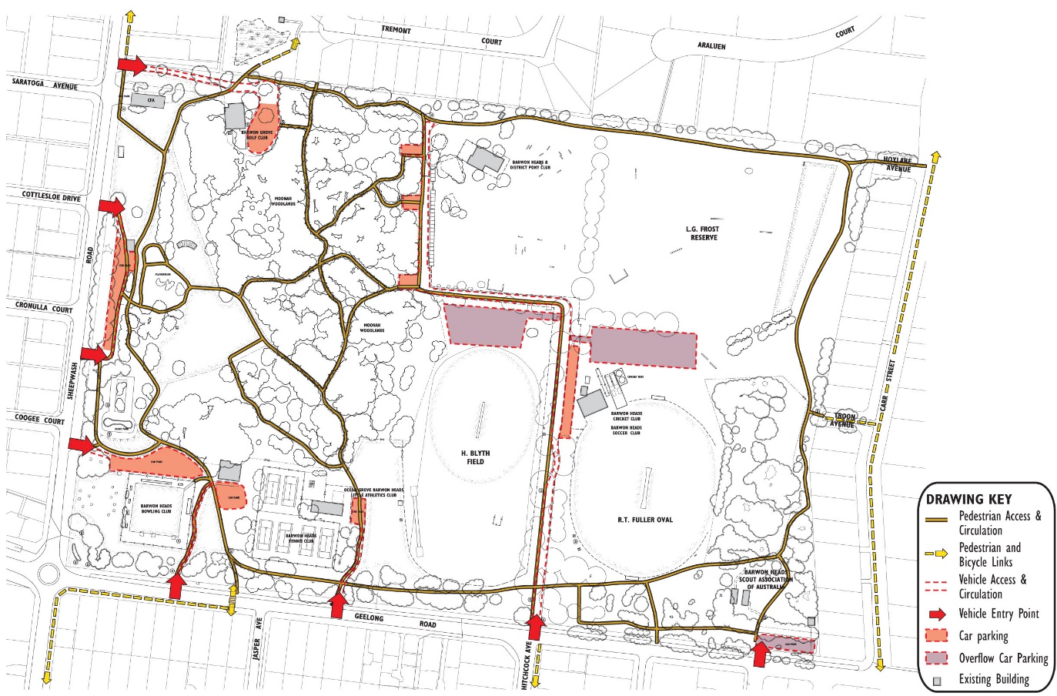
Figure 3. Access and circulation plan
Pedestrian link to school
Road layout at park entry creates confusion
Pedestrian access conflicts with vehicle access to residential properties
Link to town centre
No formal footpath along Geelong Road
Conflict between pedestrians and vehicles
Conflict between pedestrians and vehicles
Conflict between pedestrians and vehicles
No formal footpath along Carr Street
No formal footpath along Sheepwash Road
Grassed areas used as overflow car parking
Conflict between pedestrians and vehicles
Photo 30: Hitchcock Avenue entry

Photo 30: Hitchcock Avenue entry

Photo 31: Hitchcock Avenue extension

Photo 32: Existing slow point near the Cricket Club

3.8.2 Car parking

There is extensive car parking located around the park and in proximity to the various clubrooms and pavilions to service the clubs and visitors to the park. Refer Figure 5. The car parking spaces are unmarked and car parking is generally informal, and there is no definition of separate pedestrian access in these areas. The grassed areas north of H. Blyth Field and R.T. Fuller Oval are also used as overflow parking for trailers during major show jumping events.

3.8.3 Pedestrian and bicycle access and circulation

There is an extensive network of existing unsealed paths that provide a series of internal walking loops. The perimeter path provides a popular loop of approximately 1.8km. The north-south route from the pedestrian crossing past the playground and CFA has been designated as the 'safe school route'.

There are two minor access points along Carr Street from Hoylake Avenue and Troon Avenue and an access point from the adjoining reserve in the north, with links to Tremont Court. The existing network of unsealed access tracks within the Moonah Woodlands provides additional recreational walking experience and connectivity which is popular with visitors to the park.

Photo 33: Geelong Road pedestrian crossing

Photo 34: North-south safe school route
Key access and circulation considerations
- There is a lack of designated accessible parking spaces adjoining existing pavilions and clubrooms.
- Vehicle speeds on Hitchcock Avenue access road remain high and there is no designated pedestrian priority crossing between the R.T. Fuller Oval pavilion and H. Blyth Field.
- There is no off road path access from Geelong Road/Hitchcock Avenue to the R.T. Fuller Oval pavilion.
- Relocation of the Bowling Club to the new site on the west side of the Bowling Green will require realignment of pedestrian paths.
- Pedestrian access via Hoylake Avenue and Troon Avenue is shared with vehicle access to adjoining private properties.
- Lack of directional signage throughout the park.
- Informal track and bike jump construction increased in the south east corner of the park during COVID. Provision of a dedicated areas for this activity away from more sensitive environmental and culturally sensitive areas may be needed to reduce these impacts.

3.9 ADJOINING LAND USE

3.9.1 Residential properties

BHVP is bounded to the north and east by residential properties. Many of the properties along the northern boundary have an outlook onto the park and have access gates to the existing pedestrian path running parallel to the boundary line. The existing residential properties along the eastern boundary have standard timber fences and are not open to the park. There is pedestrian access though from Carr Street at Troon Avenue and Hoylake Avenue. The existing vegetation along the east boundary fence is actively managed to reduced fire risk.

Photo 35: Open Views along northern boundary

4.0
STRATEGIC DIRECTIONS

4.1 WHAT IS PROPOSED

The updated Barwon Heads Village Park Master Plan has been developed in close conjunction with existing site users and community stakeholders. The plan seeks to address the key objectives of the project including ongoing protection of key environmental and cultural heritage values, staged improvement of passive an active recreational facilities and maintaining the spaces and places that create the park’s unique character.

VISION

4.2
Preserve the natural environment, open space and existing informal village parkland character while supporting renewal of existing facilities and infrastructure that improve access, sustainability, and shared community use. Maintain the balance between organised sport, other community uses, service providers and informal recreation, while protecting and promoting understanding of the park’s significant environmental cultural heritage values.

4.3 GOALS

Environment
- The park’s unique natural environment of Moonah Woodlands, Dune Woodland, mature tree planting and grass open space must be protected and enhanced for future generations.

Cultural Heritage
- The significant cultural heritage of the park will be protected, and opportunities provided to improve awareness and understanding of cultural values.
- The history and stories of the park will continue to be captured and celebrated in creative and artistic installations.

Places and Community Use
- Maintain a range of different places and spaces to enable people to gather, socialise and build greater community connections.
- Activities in the park will foster a greater connection to nature for people of all ages and backgrounds.
    - Maintain balance between organised sport, other community use and informal recreation to support community health, wellbeing, and enjoyment of the parkland.

Social Infrastructure
- Social infrastructure will be redeveloped and replaced where it is deemed essential and supports the City’s Social Infrastructure Policy, ensuring they are compliant, inclusive and accessible facilities that support multi use and are fit for purpose.
- New social infrastructure will be designed in a way that is creative, sustainable, and responsive to the character and scale of the local coastal village setting.
- The building footprints will be contained to the minimum requirements, guided by legislation , sporting or other facility guidelines with opportunities sought to retire redundant facilities where possible.

Park Management
- The planning, development and management of the park will be done in an holistic manner integrating all current uses and functions in consultation with the community.
- New and emerging uses will be assessed according to the goals for the park, local needs and the broader regional context to determine whether they are appropriate for the park or can be accommodated in other locations.

Park Character
- The park will be managed in a way that protects the natural coastal bushland character blending open space, shaded lawns, winding unsealed roads, parking, trails with sporting and community use facilities that are nestled into the bushland setting.

Photo 36: Aerial view across the park to the Barwon River Estuary

4.4 CHARACTER STATEMENT

Barwon Heads Village Park is a diverse park built around the Moonah woodlands and spaces for small scale sport, recreation and community use consistent with the casual beachyness and unpolished character of the coastal village.

The park is covered in trees and vegetation intersecting and wrapping around the park protecting it from the wind and weather. The central core to the park, the Moonah woodlands provide a blanket of densely intertwined canopies with sheltered, quiet and calm trails tunnelling through the understorey.

The relatively large park has a strong sense of distinct and separate spaces, delicately balancing natural, informal open green space areas with developed sporting and organised community use areas nestled amongst the trees. A core unsealed outer trail and a web of smaller trails connect the park for the community to wander and explore. Unsealed roads and parking further add to the organic and rustic charm of the park.
The use of the park ebbs and flows across the day, the week and the seasons. If the main street is the heart of town, the Village Park is the lungs, bringing life to kids play, youthful adventure, sport and recreation for all ages, genders, backgrounds and abilities.

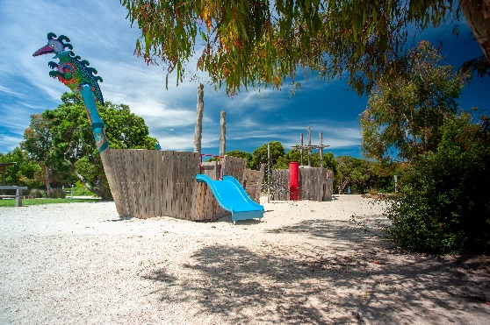

Photo 37: Park character images

5.0
PARK MANAGEMENT ZONES

The following zones build on work from the 2012 plan and are a key strategy to help achieve the vision and goals for the park. The zones are designed to guide the future development, use and management of different areas of the park to ensure there is a balanced approach to meet the needs of the park and the community.
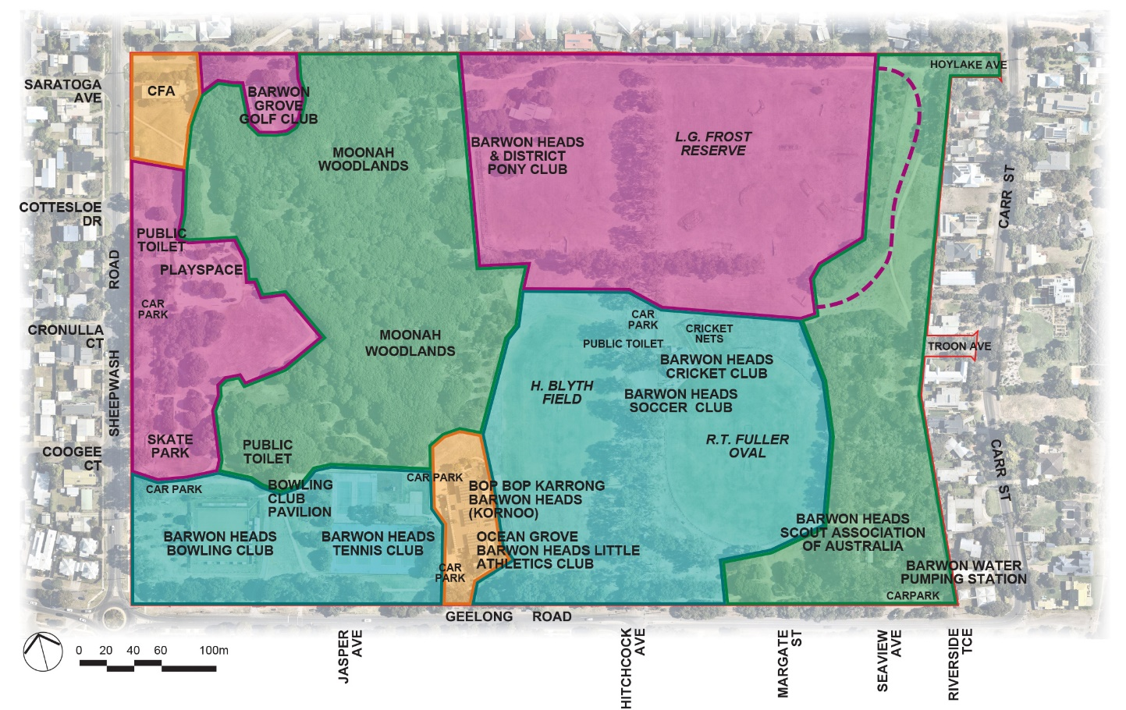

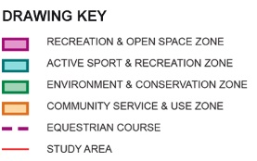

Figure 4. Park Management Zones

5.1 ENVIRONMENT AND CONSERVATION ZONE (Green)

The primary focus of this zone is to protect significant environmental and cultural values while allowing formalised trail use. Strategies in this zone will target key risks to environmental values with the aim of improving the condition and habitat value of the vegetation and reduce disturbance to cultural values. An appropriate fire management regime will be implemented. Activities in the zone include dog walking on-lead, walking, cycling, trail running and nature appreciation. Horses are not permitted in the zone.

Target measure:
- Increase in vegetation cover.
- Improvement in overall vegetation condition
- Reduction in disturbance to primary dune containing key cultural values.
- Fire risk managed within acceptable levels.
- No new building footprints
5.2 ENVIRONMENT AND RECREATION ZONE (Magenta)

The primary focus of this zone is to provide for organised recreation activities and open space for more informal recreation and passive use. A key feature of the zone is that development will be less obvious, less formalised and facilities will be nestled into the surrounding landscape providing greater open space. The zone covers three areas of the park. Activities in the North-east zone include equestrian activities, dog-off lead use and informal recreation and the western zone is focused on picnic and play with the main playspace, skate park and potential new bike discovery area. The North-east zone is focused on community use.

Target measures:
- Increase in vegetation cover.
- Maintain viewsheds and sightlines.
- Facilities meet minimum standards and are fit for purpose.
- Ensure that any new facilities comply with specified coastal character siting and design requirements.
- No increase in building footprint
- Enhance recreation opportunities.

5.3 ACTIVE SPORT AND RECREATION ZONE (Light blue)

The primary focus of this zone is to provide for smaller scale, club organised sport, recreation and community use that uses the park in a treed, parkland setting. Facilities should aim to meet minimum standards for the respective not-for-profit uses and will not be over-developed focusing on quality rather than quantity or size and will be designed and sited. Sport and uses in the zone include Cricket, Soccer, Football, Tennis, Lawn Bowls and a potential site for Scouts and Boardriders.

Target measures:
- Sports playing surfaces meet minimum standards and are fit for purpose.
- Pavilions meet minimum standards and are fit for purpose.
- Renewal or replacement of facilities within identified footprints
- Ensure that new development complies with specified coastal character siting and design requirements.
- Tree cover maintained.

5.4 COMMUNITY SERVICE AND USE ZONE (Orange)

The primary focus on the community service and use zone is on providing key public services to the community. The facilities will be fit for purpose with more developed infrastructure for the immediate needs. The spaces and design around these facilities will be in keeping with the parkland setting. The community services include the CFA and Bop Bop Karrong Integrated Child and Family Centre.

Target measures:
- Appropriate agreements will be in place to provide certainty of use for key tenants.
- No further increase in building footprint
- Landscaping around facilities will ensure the parkland character is maintained.
- Formal parking will be kept to a minimum
6.0
DRAFT MASTER PLAN

BHVP-02 Draft Master Plan Update 2021

The recommendations listed in the Draft Landscape Master Plan are the culmination of background assessment of issues and opportunities, and feedback from the Project Reference Group and key stakeholders providing a clear rationale for their inclusion.

Each of the recommendations has also been considered to ensure that they are consistent with vision, goals and management zoning approach for the park.

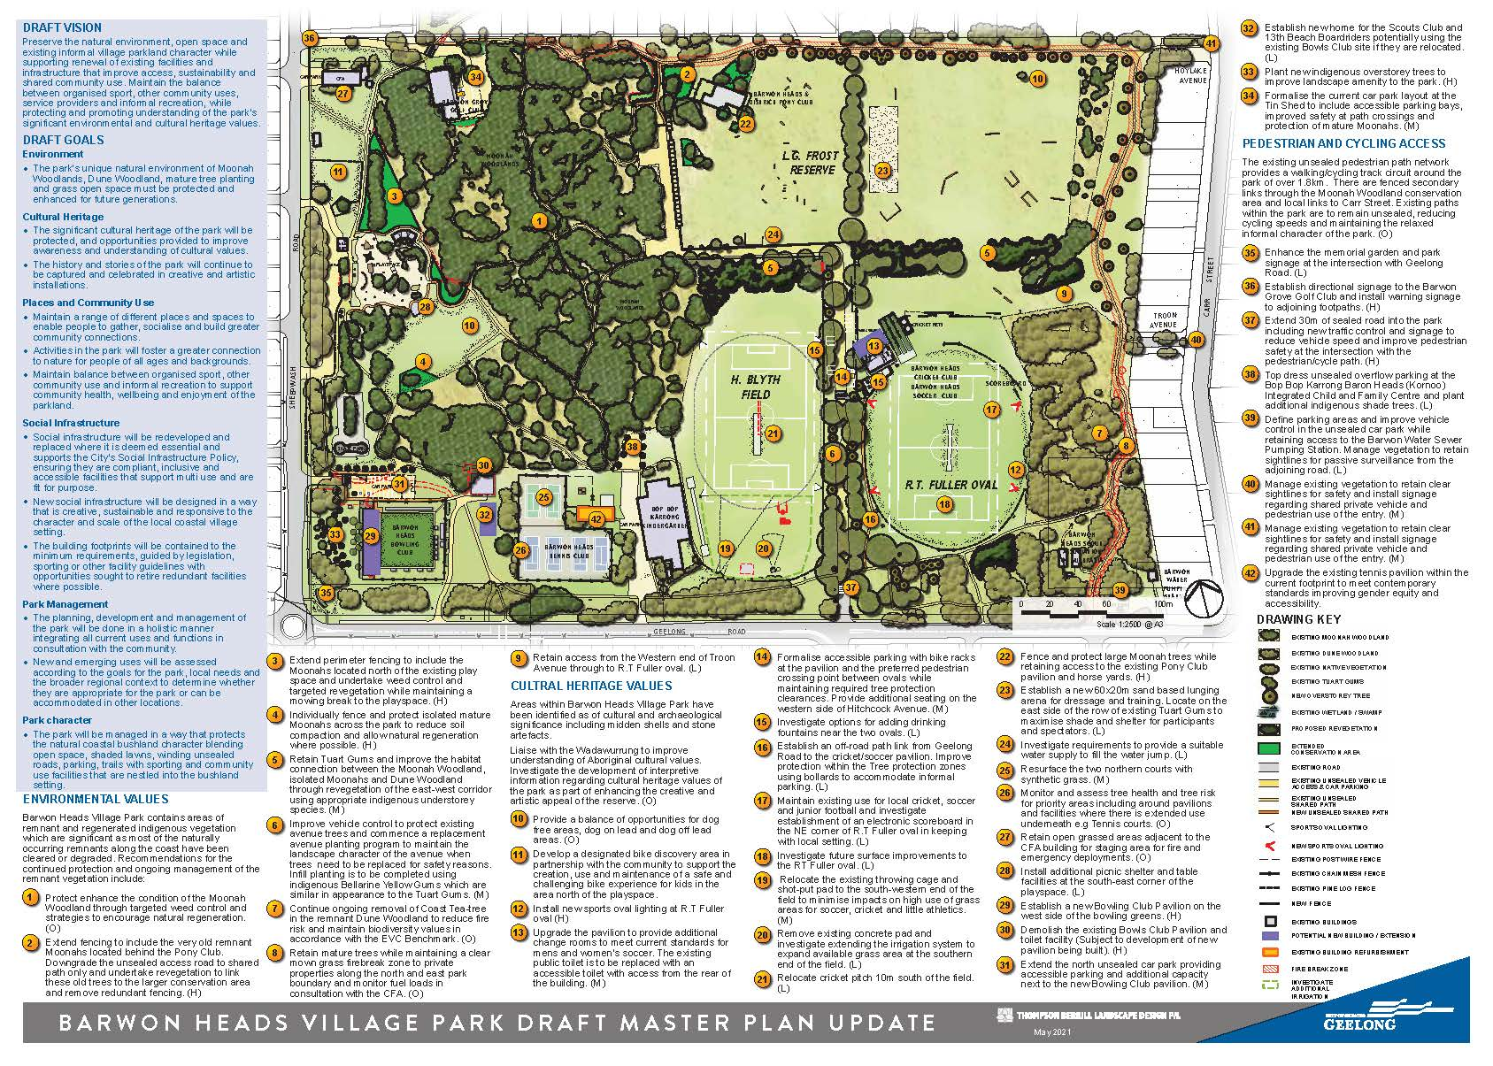

7.0
BIBLIOGRAPHY

Active Victoria, A strategic framework for sport and recreation in Victoria 2017-2021, Department of Health and Human Services, July 2017
AFL Growing the Heartland, Football Facility Development Strategy 2017 – 2022, AFL Victoria.
AFL Preferred Facility Guidelines, State, Regional, Local School and Remote Facilities, AFL, 2019.
City of Greater Geelong, Barwon Heads Village Park Master Plan (2012)
City of Greater Geelong, Barwon Heads Structure Plan (2017)
City of Greater Geelong, Biodiversity Strategy
City of Greater Geelong, Dog Controls in Public Places Policy (2020)
City of Greater Geelong, Domestic Animal Management Plan (2018-2021)
City of Greater Geelong, Outdoor Sport and Recreation – Social Infrastructure Plan Generation One: 2020-23
City of Greater Geelong, Planning Scheme
City of Greater Geelong, Social Infrastructure Plan (2020)
Community Cricket Facility Guidelines, Cricket Australia, September 2015.
DSE, EVC 858: Coastal Alkaline Scrub Otway Plain bioregion Ecological Vegetation Class Benchmark.
DSE, Action Statement No. 141 Coastal Moonah Woodland – Flora and Fauna Guarantee Act 1988
Football Victoria, Football Facilities Building Development Guide, 2019.
G21 and AFL Barwon Regional Strategy, G21 Regional Alliance, April 2015.
G21 and Cricket Victoria Barwon Regional Cricket Strategy, Final Report, G21 Geelong Regional Alliance, May 2019.
G21 Regional Football (Soccer) Strategy, G21 Geelong Regional Alliance, May 2012.
G21 Regional Hockey Strategy. G21 Geelong Regional Alliance, March 2019.
G21 Regional Tennis Strategy 2015-2025, Final Strategy Report, April 2015.
Netball Victoria Statewide Facilities Guideline, Netball Victoria.
Tennis 2020, Facility development and management framework for Australian Tennis, Tennis Australia.
Victorian Cricket Infrastructure Strategy 2018 - 2028, Cricket Victoria, March 2018.

