community engagement summary
In 2012, the City of Greater Geelong along with the local Drysdale community, developed an Urban Design Framework (UDF) for the Drysdale Town Centre which established a vision for how the town centre could be developed in the future. The Drysdale town square was identified as a key development site within the UDF.
The City commenced planning for the provision of a Regional Library & Community Hub for the Drysdale/Clifton Springs communities as a service requirement and an obligation of the Jetty Road Growth Area Developer Contributions Plan (DCP). A cross departmental working group undertook site options analysis and determined that the Drysdale Town Square was the preferred location for the library hub.
Community engagement was undertaken with Geelong Regional Library Corporation, Wadawurrung Traditional Owners Aboriginal Corporation, stakeholders and the local community through the community survey conducted in 2020 and direct engagement with community stakeholders via the Community Reference Group, to understand the vision and aspirations of the community in relation to the library service which directly informed the library design development in relation to service and user requirements for the provision of the collection, children’s and youth spaces, event opportunities, access to technology, comfortable and quiet spaces and car parking.
Community Information Sessions were held in February 2021 to present the concept plans to the community for comment.
A Planning Permit was lodged in early 2021 and received one objection which was subsequently withdrawn.
Construction is scheduled to commence in late 2021.
HOW WE ENGAGED
WHAT DID WE DO?
Please note engagement occurred during COVID 19 Restrictions. In person engagement was not possible during 2020 and intermittent during 2021 based on State Government directions.
The City of Greater Geelong undertook a survey of the Bellarine community to seek to understand what the community values about the Drysdale Library service to inform the design of a new library for Drysdale.
The survey asked a range of questions regarding the elements of the library service including “What do you like most about the Drysdale library?”, “Tell us three things you would like to see in the new Drysdale library?” and “Beside the borrowing collection, what is most important feature for you in a library?” Comfortable seating, internet, Wi-Fi and computers, dedicated quiet spaces and event and program spaces were most favoured elements nominated.
Insights from the community include “Friendly professional staff who are always available to give support and advice as required”, “Easy access and easy to use facilities”, ‘Firstly, and most importantly, that we have a library! So important and so wonderful. Secondly, it is a safe and friendly space for the community to browse the stacks, use the internet, read the paper. Just sit and be!

Survey Snapshot
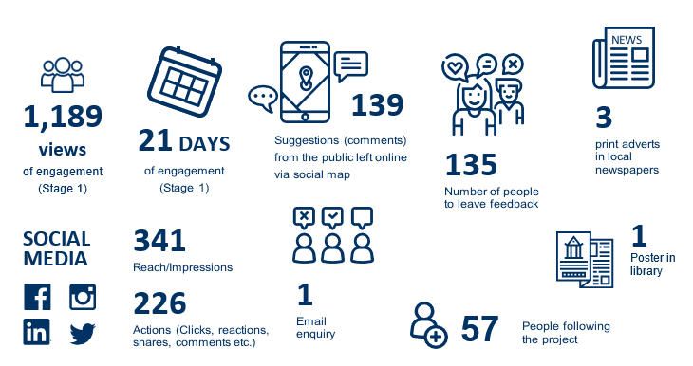

DATA METHODOLODY
The engagement was self-selected and open to all residents and visitors of the Bellarine Peninsula and City of Greater Geelong. An email from the Geelong Regional Library Service was distributed to 17,000 members on the Bellarine Peninsula inviting them to participate in the survey.
ENGAGEMENT TOOL AND TECHINQUES
A project specific engagement page was developed to provide project information and methods of ways to engage with the City.
A range of engagement tools and techniques were used to provide different types of opportunities for stakeholders and community to have their say. The main tools and techniques are explained in further detail below

HOW WE ENGAGED
geelong regional library corporation | The City partnered with the Geelong Regional Library Corporation in the development of a design for the new Drysdale Library
wadawurrung traditional owners | The City engaged with Wadawurrung Traditional Owners in the design development of the new Drysdale Library.
Community reference group | The City engaged with local community stakeholders via a Community Reference Group including membership from the Drysdale Clifton Springs Curlewis Community Association, Bellarine Historical Society, Springdale Neighbourhood Centre, Drysdale Seniors Citizens and the Festival of Glass committee.
Have Your Say Online Portal  Yoursay.geelongaustralia.com.au | An online HYS project page was designed to share relevant information to encourage community feedback on the Drysdale Library & Community Hub Design  Link to page https://yoursay.geelongaustralia.com.au/DRLCH
Survey (online and hardcopy) | Survey distributed via HYS page from 24th August to 14 September 2020  Objective of survey was to seek to understand what the community values about the Drysdale Library service to inform the design of a new library for Drysdale.
community information session (x2) | Community Information Sessions were conducted on Tuesday 2nd 5-8om & Saturday 6th February 9am-12noon, 2021. Session held in person at the Drysdale Senior Citizens Hall to present the design for community feedback.  The sessions were facilitated by City staff, Antarctica Architects & Architect Associates.  Approx. 104 members of the community participated in the 2 x 3-hour sessions  The workshop allowed participants to provide their feedback, apply their expertise to the design development
project reference group | The Project Reference Group met throughout the design development phase to provide input into the design development
Posters | Posters were placed at the Drysdale library.
Written submissions | Open at any time during the public engagement period. Submissions could be provided by email or mail.
Trader | Engaged by building owners in discussions about the development
One on one conversations | Multiple conversations were held over the phone with members of the local community in the design development
Communications
Survey and information sessions were promoted via the print media including City News, Geelong Independent 21 August and Bellarine Times 27 July 2020 and three media articles were published on 29 January 4th and 12th February 2021.
Bay FM Radio Station ran a digital story on 30th January 2021.
The City’s Social Media platforms were used to direct people to the Have Your Say page.
NEWS

SOCIAL MEDIA
341
Reach/Impressions
226
Actions (Clicks, reactions,
shares, comments etc.)
Radio announcement on Bay FM
1

3
Media articles in local newspapers

Who we engaged with

PARTICIPATION
During 2020-2021, the Have Your Say Page has had 3732 views with more than 135 people making a submission and engaging with the City about the Drysdale Library.
Of these, 56% engaged online, 44% engaged in person through our face to face events. The community were invited to share some demographic data with us, primarily through our HYS page survey. The following is a snapshot of these people.
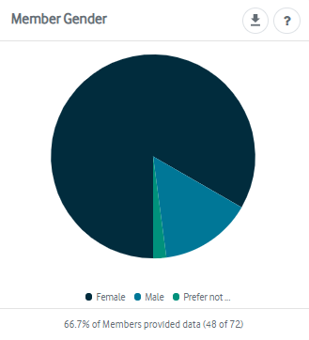
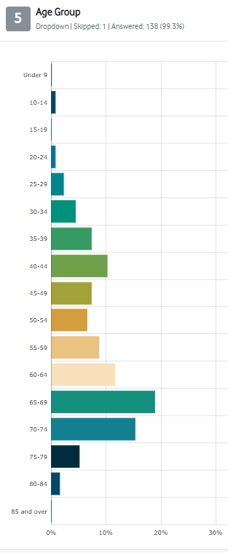
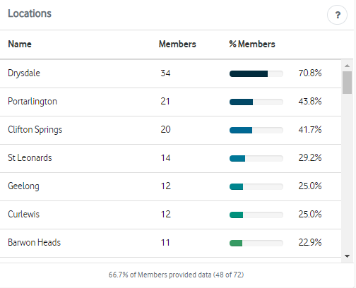

WHAT WE HEARD

survey FEEDBACK
Community sentiment was broadly positive in regard to the proposal to develop a new library for the Drysdale and northern Bellarine communities. Concerns were raised in relation to the need for the investment, location and perceived impact on the open space.
What do you like most about the Drysdale library?

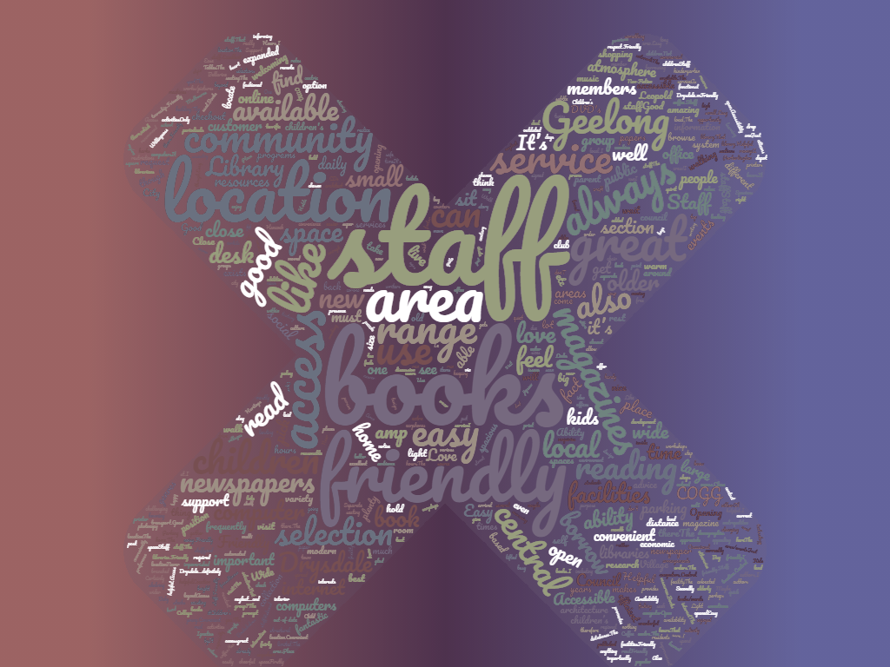
Overwhelmingly feedback was very positive ibn relation to friendly and helpful staff from the Drysdale Library.
A sample of responses are as follows:
“Small library, but very helpful staff and always will assist in tracking down a book for you.”

“I think it is outdated and needs to come into the 21st century with a more modern look and feel, with plenty of spaces, room to move around and seating for those who wish to stay awhile and read, separate computer spaces and enough toilets…”

Tell us three things you would like to see happen in the new Drysdale library?

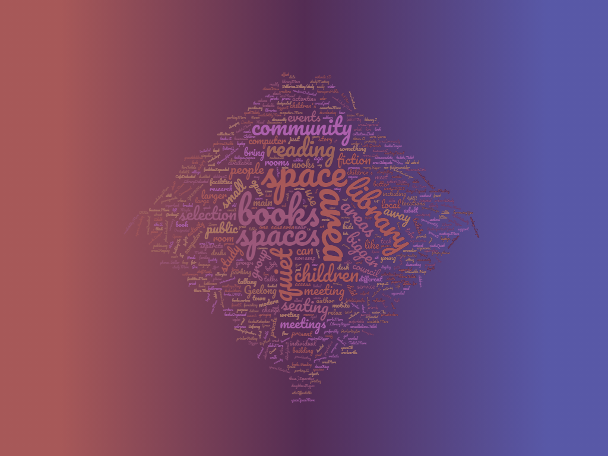
“Larger collection”
“Study nooks with computer and reading chairs for teenagers in high school”
“Speakers on a variety of subjects - at present it seems to just be the main library in Geelong that has this.”
“Sustainable building”
“Vast array of books and magazines and technology. Story time for pre-schoolers.”
“Toilets!!!”
“Retention of Green Spaces in the town - please don't take away our iconic green space!”

What sort of technology would you like to see available to use in the library and community spaces?
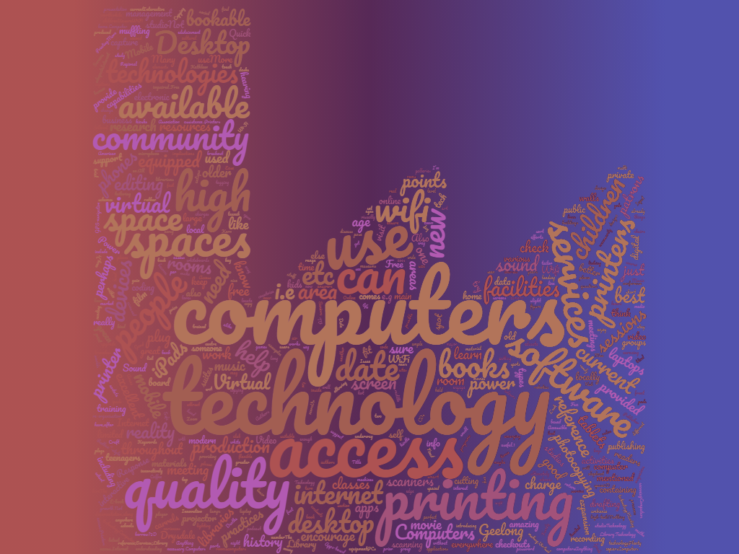
“Assistive technology including for blind, hearing impaired, dyslexic people.”
“Virtual reality 3D printing”
“Definitely computers and plenty of self-checkouts, at least 3.”
“Internet, Wi-Fi and computer access. Coding classes for children. Any kind of new technology that children (and adults) can access and learn from.”

“Family history sites with the old CD roms from Births Deaths and Marriages info…”

“The current technology is adequate”

The survey asked the following:
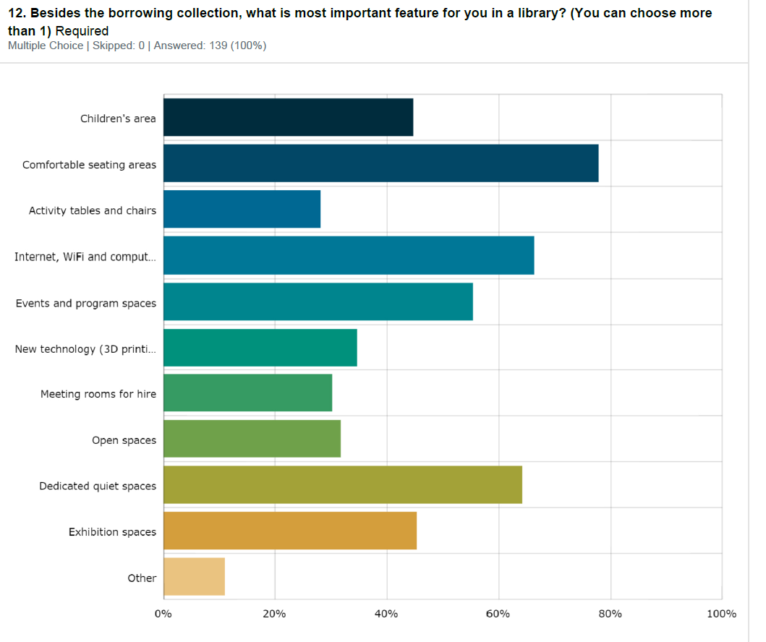
How do you imagine the community spaces being used?
A sample of responses:
“A quiet place to escape the hustle and noise of the outside
Available for community groups to book on an ongoing basis for meetings and events.”
“Meeting rooms - for the events that you highlight on the website booklet eg. Feng Shui etc.. School trips to the library so room used for learning
Post-COVID are people going to be going back to offices or are they going to be redundant spaces?”
“Wouldn't it be great if our community could all come together in one facility. We need something to allow our young and old to cross paths and to have the outdoors and indoors. Building on the towns iconic great space is not the answer.”

COMMUNITY REFERENCE GROUP
A Drysdale Library Community Reference Group was convened to inform the design development. Membership of the group included Wadawurrung Traditional Owners Aboriginal Corporation, Drysdale Clifton Springs Curlewis Community Association, Bellarine Historical Society, Drysdale Seniors Citizens, Springdale Neighbourhood Centre and the Festival of Glass Committee.
COMMUNITY INFORMATION SESSIONS FEEDBACK
Community Information Session were held in February 2021 to present the design to the community and provide information and rationale for design outcomes. In excess of 100 people attended across two sessions and feedback was generally very positive.
PLANNING PERMIT
Based on the endorsed design, an application for a Planning Permit was submitted and closed late February and received 1 objection which was withdrawn.

OVERALL KEY FINDINGS
The City engaged with the Wadawurrung Traditional Owners, Geelong Regional Library Corporation, local community stakeholder and residents to inform the development of a design for the Drysdale Library.
The community were asked both qualitative (open) or quantitative (closed) questions relating to what they liked about the existing Drysdale library service, what the most important features were for them in the library, what they would like to see in the new library and questions pertaining to technology and the potential use of the community spaces.
What did the data tell us?
- The Drysdale Library and CoGG Customer Service staff are highly skilled and valued by the local community.
- The current facility is not fit for purpose given the limited floor area, lack of basic amenities including toilets and subsequent significant impact on building capacity to meet the needs of contemporary library service delivery objectives.
- Besides the library book collection, the community rated comfortable seating, technology, dedicated quiet spaces and event/program spaces as their priority.
- Public open space and event space is highly valued.
- Car parking is of concern to local residents

NEXT STEPS

NEXT STEPS
- The engagement results directly informed the development of the design and a Planning Permit has been issued for the development.
- Construction is proposed to commence in late 2021. Construction updates will be uploaded to the Have Your Say Page and distributed to the Community Reference Group as appropriate.

