ENGINEERING Design note 15

Requirements For street lighting

|  |  |  |  |
| --- | --- | --- | --- |
| Approved by: |  | APPROVAL DATE: | Draft |
| Authorising Officer: | **Director City Services** | REVIEW DATE: | **4 years from approval** |
| Responsible Officer: | **Manager Engineering Services** | EXPIRY DATE: | N/A |

# Purpose

This document outlines how the City will work with developers, the Distributor, and other streetlight providers to meet our street lighting requirements and respond to lighting requests.

This Design Note 15 supports Council’s Street Lighting Policy and outlines additional requirements for use alongside the *Australian/New Zealand Standard AS/NZS 1158 Road Lighting Standards* and the *Infrastructure Design Manual (IDM)*.

This Design Note 15 forms the basis of street lighting design in the City by:

1. Defining who is responsible for the design and installation of new street lighting from an individual street light, subdivision and/or precinct level lighting;
2. Providing a consistent approach to the installation of new street lighting;
3. Replacing existing street lighting with cost-effective, environmentally appropriate fittings and Control Management System;
4. Integrating emerging technologies such as Control Management Systems, 5G network roll-out, to limit their visual impact within the streetscape;
5. Identifying when shields are used to address complaints glare/light spilling into property.

# Scope

Design Note 15 applies to street, public place and precinct lighting managed by the City.

The additional requirements in Design Note 15 build on the documents listed in the references below.

Passive open spaces managed by the City are in scope with the exclusion of active open space.

# References

* *Road Management Act 2004*
* *Electricity Industry Act 2000*
* *Australian/New Zealand Standard AS/NZS 1158 Road Lighting Standards*
* City of Greater Geelong:
* Greater Geelong Planning Scheme and amendments
* Where the following applies to a location or precinct and have been adopted by the City:

Precinct Structure Plans

Urban Design Frameworks

Other relevant plans, frameworks and documents

* Public Realm Framework, update November 2019
* Street Lighting Design Note 15, Version 1, 2021
* Local Government Infrastructure Design Association: Infrastructure Design Manual (IDM) Current Version
* AustRoads: Guide to Road Design, Part 6B: Roadside Environment 2021
* VicRoads: TCG 006: Guidelines to Street Lighting Design, January 2016 Rev B
* Essential Services Commission: Public Lighting Code Version 2, December 2015

# Definitions

**ACTIVITY AREA –** An area that has high pedestrian, cyclist and vehicle traffic. e.g. shopping precincts, sporting fields, and entertainment areas.

**THE CITY -** The City of Greater Geelong organisation, led by the CEO.

**CONTROL MANAGEMENT SYSTEM –** Lighting management system that operates and remotely diagnoses faults in the street light network.

**COUNCIL -** The City of Greater Geelong Council comprised of elected councillors, led by the Mayor.

**Built-up Area -** An area consisting of roads along which there is urban development and street lighting is provided.

**DEcorative non-Standard lightING -** Decorative non-standard lighting is normally on a non-metered supply, maintained by the City and subject to the Public Lighting Code.

Lamp, luminaire, mounting bracket, street lighting pole, supply cable or control equipment must be acceptable to the City and Distributor.

The following images demonstrate the lighting styles that are the only City approved decorative non-standard street lights:

**Decorative (P Category) Decorative (V Category**)

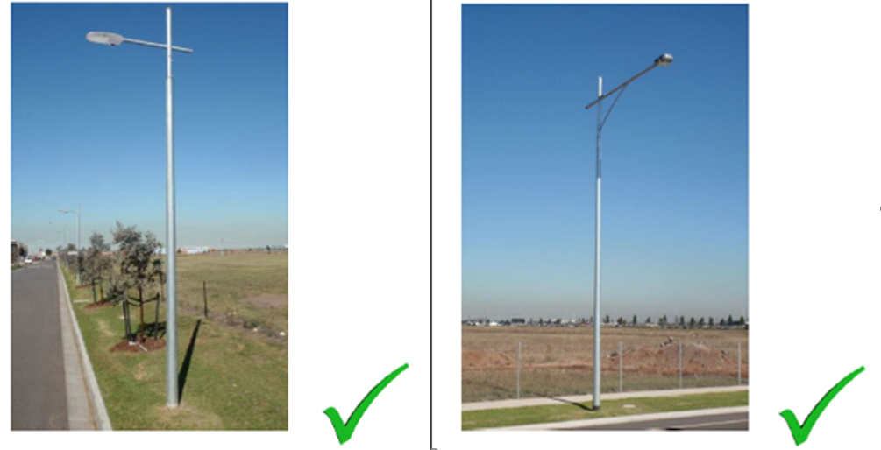

The street light height, spacing and luminaire outreach are defined by the AS/NZ 1158 and the IDM.

**Distributor -** An organisation that holds a distribution licence under the Electricity Industry Act 2000 for the distribution and supply of electricity (Powercor is Geelong’s current distributor).

**Metered Power supply –** Dedicated power supply for the operation of the street lighting network, typically located with Major Activity Centres or the Central Business District.

**Non-Metered POwer supply –** The main source of power for the City’s street lighting network. Only standard poles, fittings and control systems can be connected to this network.

**NON-STANDARD FITTING -** Any fitting other than standard lighting / fitting that is on a metered supply with replacement managed by the City.

**Precinct -** An area where a development plan exists for the development and/or redevelopment of an area that creates >1,000. Plans may include but are not limited to a Precinct Structure Plan, Development Plan, Activity Centre Plan.

**PUBLIC PLACE –** includes places owned or managed by the City such as

1. any bridge, footpath, court, alley, passage or thoroughfare open to or used by the public; or
2. any park, garden, reserve or other place of public (passive) recreation; or
3. any open space to which the public has or is permitted to have access; or
4. any wharf, pier or jetty open to or used by the public.

This definition excludes arterial roads managed by Regional Roads Victoria.

**RESPONSIBLE OFFICER -** Council Officer in the Development Planning Unit with the responsibility to assess and endorse engineering plans including street lighting detail.

**SMART STREET LIGHTING -** A SMART street light is a public light fixture that incorporates technology, such as cameras, light-sensing photocells and other sensors to introduce real-time monitoring and control functionalities.

**STANDARD LIGHTING -** Lamp, luminaire, mounting bracket, lighting pole, supply cable or control equipment accepted and maintained by the Distributor on behalf of the City.

Standard lighting is on a non-metered supply and is maintained exclusively by the Distributor and subject to the Public Lighting Code.

The following images demonstrate the current approved Distributor standard street lights:

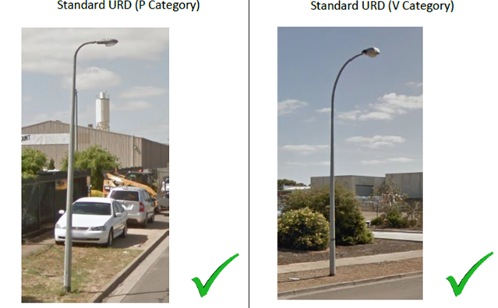

The street light height, spacing and luminaire outreach are defined by the AS/NZ 1158 and the IDM for the safest and most practicable street light design and layout.

**STREET LIGHTING –** Lighting managed by the City or Distributor that illuminates public places at night.

**Summary & Roles**

# Summary

All street lights to be designed in accordance with *Australian/New Zealand Standard AS/NZS 1158 Road Lighting Standards* and the Public Lighting Code.

This document outlines the City’s additional street lighting requirements for our municipality and who is responsible for the design, operation and management of the street lighting network.

Street lighting services are delivered by:

1. Installing new street lights at an individual, through to subdivision/precinct level;
2. Replacing existing street lighting with cost-effective, environmentally appropriate fittings and control management systems;
3. Identifying when shields are used to address concerns of glare/light spilling into a property; and
4. Organising repair of faulty or damaged street lighting managed by the City.

# Roles and Responsibilities

The following table outlines the responsibilities of the City in relation to street lighting design, delivery, management and maintenance.

|  |  |
| --- | --- |
| Role | Key Responsibilities |
| Manager Engineering Services | * Oversees the development and operation of the street lighting network |
| Manager Smart Cities | * Supports the delivery of new street lights in development areas * Ensures that new street light technology connects seamlessly with existing infrastructure (e.g. smart lighting and CCTV) |
| Coordinator Development PLanning | * Oversees and approves the delivery of new street lights in development areas/subdivisions/precincts; * Ensures that street lighting assets in a precinct are consistent with appropriate controls in place, including section 173 agreements; * Supports the development of Urban Design Frameworks (and associated strategy urban planning processes) where street lighting design is required; * Ensures the street lighting network meets design requirements * Manages street lighting assets, including maintenance * Approves the delivery of the individual street light requests and shields |

**Additional Requirements**

# General Street Lighting Design Considerations

Street lighting design should apply the most practicable street light layout and conform to *Australian/New Zealand Standard AS/NZS 1158 Road Lighting Standards*.

The provision of lighting to follow the lighting categories in *Australian/New Zealand Standard AS/NZS 1158 Road Lighting Standards* and other related documents (see References).

New LED lanterns must be controllable with a smart cell installed, conforming to the Distributor’s standards (ie PE cells with 7-pin NEMA socket).

# Specific Street Light Design Requirements

These standards do not apply;

* where residential allotments exceed half a hectare (5,000 square metres). Standard street lighting is not required unless there is significant pedestrian traffic.
* in rural living areas. Except for public safety reasons or where the developer requesting the street light meets the purchase and installation costs.

The City will not fund undergrounding overhead power in an urban or rural residential area.

Specific street lighting requirements for the precinct type/land use zoning are:

## **Existing Residential & Rural Living Areas**

Street lights serviced by overhead power lines require a controllable Distributor-approved LED luminaire.

The LED luminaire should be placed on at least every second pole after considering

* *Australian/New Zealand Standard AS/NZS 1158 Road Lighting Standards*
* variations in pole spacing
* the need to light intersections
* changes in road alignment
* traffic management devices
* nature strip trees
* particularly dark areas.

Arterial, sub arterial or principal roads that correspond with *Australian/New Zealand Standard AS/NZS 1158 Road Lighting Standards* Road Lighting Categories V2, V4 and V5, also require a controllable Distributor-approved LED luminaire lanterns.

### **New Residential & Rural Living Areas**

Street lights in residential areas that front arterial, sub arterial or principal roads that correspond with *Australian/New Zealand Standard AS/NZS 1158 Road Lighting Standards* Categories V2, V4 and V5 require a controllable, Distributor- approved LED luminaire lanterns.

Where access to a rural subdivision is from a principal or arterial road, lighting of the access intersection to be provided by the Developer as part of the development works.

### **Commercial Areas**

The City will provide effective and consistent lighting to minimise dark areas for public safety. Controllable Distributor-approved LED lights will be placed on each pole except in small commercial centres.

Where an arterial road abuts a commercial area, lighting to be designed and provided to *Australian/New Zealand Standard AS/NZS 1158 Road Lighting Standards* Category V1.

In areas of special significance such as heritage, specialised retail development, cultural and civic centres, non-standard lighting in conjunction with underground servicing will be considered. The preferred option is for approved lighting on the distributor’s network.

Controllable, Distributor-approved LED lighting should be used in central Geelong, commercial spaces and high-profile centres.

### Major Carparks at Reserves and Community Facilities

Lighting to be designed to *Australian/New Zealand Standard AS/NZS 1158 Road Lighting Standards* using street light engineering/design software.

Lighting must be a metered supply and controllable.

### Industrial Areas

Lighting considerations should be similar to residential areas. However, lighting standards may be reduced at the discretion of the Responsible Officer based on allotment size and frontage width.

The City does not provide private security lighting. If security is a concern, private properties are to install their own security lighting.

For industrial premises abutting category V roadways which have heavy vehicles entering and leaving the property, controllable, Distributor approved LED lanterns must be used.

All new street lighting to be designed to Distributor standards utilising standard poles, outreaches and lanterns.

### Major Traffic Routes

Lighting will follow *Australian/New Zealand Standard AS/NZS 1158 Road Lighting Standards* Category V standards.

The City will assess the need for appropriate lighting to be installed where Common Property roads intersect with Road Reserves and traffic volumes that may impact safety. If required, additional lighting to be provided by the Developer as part of the development works.

### Rural Intersections

Street lighting at a rural intersection is dependent on traffic volumes and the availability of low voltage power supply.

High risk intersections may be require reflectorized delineation and/or solar powered lights where a low voltage supply is not economical.

### Parks, Reserves and Community Facilities

Lighting of parks will be considered where the park is used for passive night time recreation, public safety concerns or when the park is an access route from one road to another.

Lighting of small parks may require movement sensor security lights to maintain amenity for neighbouring properties.

### Laneways

Lighting to be provided at each end of a laneway, but not within laneways. The laneway may require extra lighting if it is in a high activity area or there are concerns of anti-social behaviour or public safety.

## Decorative non-standard street lighting - poles and fittings

New street lighting shall meet the Distributor’s standards using approved poles, outreaches, and luminaires. These poles and fittings can be either galvanised or powder coated black, navy blue, heritage green or silver.

Standard street lights are considered decorative non-standard if they are powder coated in black, navy blue, heritage green or silver.

Developers shall contribute a maintenance levy of 100% of the initial capital cost to cover additional maintenance and replacement for each decorative non-standard street light installed.

Non-standard fittings and non-standard poles are only permitted in exceptional circumstances. This may include heritage precincts or as defined in the Precinct Structure Plan, Urban Design Framework or supporting Council plan.

Decorative non-standard street lighting is only available within a development precinct.

The table below outlines the approved decorative characters of non-standard street lights and their commensurate maintenance levy.

|  |  |  |
| --- | --- | --- |
| Pole Colour | Luminaire/Fitting Type | Maintenance Levy |
| galvanised | Standard | 0% |
| Powder coated black, navy blue, heritage green, silver | Standard | 100% |
| Other colours (painted or powder coated) | Standard | Not Allowed |
| galvanised | Non-Standard | 100% |
| Powder coated black, navy blue, heritage green, silver | Non-Standard | 100% |
| Other colours (painted or powder coated) | Non-Standard | Not Allowed |

When a decorative non-standard street light requires replacement, the City reserves the right to replace the light with a standard light that will be maintained by the Distributor.

## Street Light Pole Placement

Where practicable, all light poles must be installed at an offset of 0.8m from the back of kerb. The exception is where it is located within an intersection or curved radius, then the offset will be 1.0m and at least 500mm from footpath.

All light poles shall be offset 1.0m from infrastructure e.g. pits and driveways. Where heavy traffic will be entering/exiting near street lights, turning circle templates to be used to ensure accidental damage is avoided.

**New Street Lighting**

# Overview

The two pathways for new street lights in the City are:

1. New street lights scheme in a precinct or subdivision;
2. Individual street lights (and shields) requested in established areas.

## Responsibilities for street lighting installations

The following table details responsibilities for the delivery of new street lights according to the development site, type and scale.

|  |  |
| --- | --- |
| Level of street light installation | WHo is Responsible? |
| Precincts  (As defined in Definitions) | It is the responsibility of the Developer to install street lighting as part of the development, once approved by the City.  Street light poles and fittings are to be consistent throughout a precinct. All Developers that are part of a precinct must agree on the consistent design of the street light fitting and pole for the precinct.  If the developers are unable to agree on the street light design, then standard lighting must be installed.  The lighting design will not alter during the development of the precinct. |
| Subdivisions | It is the responsibility of the Developer to install standard street lighting as part of the development, once approved by the City. |
| Individual street light | If a community request for an individual street light installation is approved, the City will direct the distributor to erect a standard street light. |
| Major improvements and/or the development of a street lighting scheme | The Distributor or street lighting consultant may be requested to design the street lighting scheme.  The City will be responsible for the delivery and may apply as Special Rate and Charge Scheme to properties that receive special benefit from the street lighting scheme. |

# New Street Lights in Developments and precincts

The City will consider the merits of the proposed street lighting for each development application by:

* determining whether standard or non-standard street lights and poles are suitable for the proposed development or precinct and complement the design intent of the relevant council plan
* considering the operation, maintenance, repairs and future replacement
* ensuring the developer delivers approved street lighting that is subject to defect liability periods.
* determining whether the street lights are transferred to its contracted maintenance provider or is maintained by the City.

## Development Application and Assessments

All street lighting designs must be designed by an accredited lighting designer in accordance with Australian Standards, the IDM and the City’s requirements.

The following flow chart outlines the process for gaining approvals for any development application where street lighting is required.

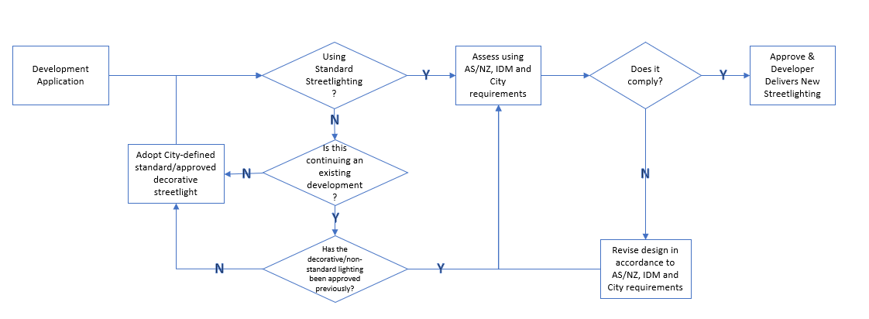

## ****Variations from approved plans****

On occasion a street light is installed in a different position to the approved plans, in these cases:

* Any lateral variation up to and including 500mm **does not** need to be resubmitted for approval;
* Any variation from back of kerb making the light pole further away from back of kerb up to 100mm **does not** need to be resubmitted for approval.
* Any variation from back of kerb making the light pole closer to back of kerb **does** require approval in writing from the City.

## Process for approving decorative non-standard street lighting

As part of precinct scale developments decorative non-standard street lighting may be proposed and the maintenance levy for each light installation will apply.

Deviations from standardised street lighting should be identified in the Precinct Structure Plan, Urban Design Framework or other supporting council document where a design intent on an area’s appearance has been made. In the absence of a clear design outcome regarding street lighting in a supporting council document, the options for decorative street lighting will be limited to the approved styles.

|  |  |  |
| --- | --- | --- |
| Stage | WHo is responsible | Considerations/comments |
| Proposal | Developer | How does the preferred street light design meet the City’s design intent of creating a sense of place, amenity and most importantly safety? What is the lifecycle of the proposed, eg 5 or 30 years?  Confirmation of consistent street lighting throughout the precinct. |
| Evaluate | City | Review whether the application complies with the City’s policies, strategic planning and design objectives. The documentation should also consider long-term operation, management and maintenance requirements. |
| Negotiate | City & Developer | The developer may choose to further negotiate if do they not agree with the City’s decision. The developer must demonstrate how the City’s decision does not reflect the intent of the street lighting policy and this document. |
| Decision | City | The Manager Engineering Services makes the final decision on approving a decorative non-standard proposal. |

# Individual Street Light Requests

Each new request for street lighting is considered by the Responsible Officer on their individual merits:

* availability of funding and the cost of the light requested;
* safety and amenity according to the relevant standards;
* connecting communities;
* emerging technology and;
* availability of design and installation resources.

The assessment process for new individual street lighting requests is summarised below:

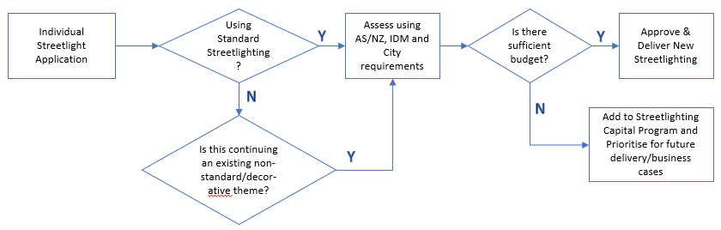

The intention of each new street light request is to adopt appropriate standardised street and public place lighting technology that aims to reduce energy consumption and greenhouse gas emissions without compromising on effectiveness.

## Street Light Shields

Street Light shields minimise the impacts of light spill onto properties; the City will only install shields after investigating the site. The provision of lighting shields will only occur where;

* it will not substantially decrease the level of lighting, and
* all practical attempts to reduce light affecting the requestor’s property have been made to the satisfaction of the City e.g. block out curtains/blinds.

The suitability of fitting shields to street lights is extremely limited due to the large and diverse range of existing light fittings that are used throughout the municipality. Shields will only be fitted to a light if it is on the same side of the street as the impacted property.

**Operations, Maintenance & Repair**

This section details how the City will manage reported faults and who is responsible for the ongoing costs of operating, maintaining and repairing faulty street lights.

# Reporting Street Lighting Faults

Any public requests regarding malfunctioning street lights where it is part of the standard fleet of street lights are forwarded to the Distributor for repair.

Decorative non-standard lighting faults will be managed by the City.

In the above cases, the replacement street light and pole will:

* Be replaced with more energy efficient fittings and/or control management system
* Consider SMART technology that reduces the visual clutter that may have existed before
* Reduce impact of light spilling onto private property
* Be replaced with a standard pole.

# street Lighting Costs and Sharing

The City is responsible for the maintenance, replacement and operating costs of street lighting.

## Precincts/subdivisions

A developer will be liable for additional costs when:

* Street lights are installed on behalf of the City and until the defect liability period of the installation ceases;
* Where decorative non-standard street lights have been installed, the developer will pay a maintenance to the City prior to receiving Statement of Compliance. The City will ensure the funds are available when the asset is scheduled for renewal.

The cost of street lighting in new subdivisions shall be met by the developer including all design and implementation costs. The City is responsible for the operating costs once the assets are transferred from the developer.

## Individual Street Lighting Requests

The City is responsible for the installation and operating costs for individual street light requests.

If the applicant insists the street light is installed when funds are not available or it has been determined that it would exceed the current level of service, the applicant may fund the requested street light(s). The City will meet for the ongoing expenses. This excludes security lighting.

## Arterial Roads

Arterial roads are defined in the Road Management Act (2004).

## Public places

The City is responsible for the installation and operating costs for City managed public places.

## Privately owned public places

The cost of providing lighting in privately owned public places (eg, shopping centres) is the responsibility of the landowners.

## Security Lighting in Road Reserves

Security lighting on poles in the road reserve are at the cost to the property owner and all arrangements are to be through the Distributor.

**Records and review**

# Records

Records created when following this document shall be retained for at least the period shown below.

|  |  |  |  |
| --- | --- | --- | --- |
| Record | Retention/Disposal Responsibility | Retention Period | Location |
| Customer enquiries or new individual street light requests | Senior City Safe Officer | 3 years | SUB-18-5927 |
| Street light plans for subdivisions | Coordinator Development Planning | Ongoing | Each stage of development |
| Maintenance Levy contributions | Manager Engineering Services | Ongoing | Financial Management System |

# Review

This Design Note 15 to be reviewed at least every four years or when the Public Street Lighting Policy is updated or as required.

The approved non-standard street lighting options to be reviewed in the event these are no longer commercially available.

# Attachments

## Nil