|  |
| --- |
| The City Of  Greater Geelong |
| Domestic Animal Management Plan 2022-2025  community Engagement report |
| JUNE 2021 |

Contents

Executive Summary: 3

What we heard 3

What we did/what we will do 3

Introduction 4

Project Background 4

Engagement Purpose 4

About this Report 4

How we engaged 5

Format 5

Schedule 5

Promotion 5

Who we engaged 6

Who we planned to engage 6

Participation 6

Demographics 6

Residential suburb 6

Age 7

Gender 7

Who actively engaged 7

Pet ownership status 7

What we asked 8

TOPICS FOR CONSULTATION 8

Why we asked 8

What we heard 9

Key Findings overview 9

Dogs in public places 10

Dog signage 11

Dog poo 11

Dogs in coastal areas 12

Dog attacks and incidents 14

Open space needs 15

Cat desexing 17

Nuisance cats and dogs 18

Cats 18

Dogs 19

Responsible pet ownership 20

Dog parks 22

Animal identification and lost animals 22

Animal Management team 24

Domestic Animal Businesses 25

Discussion 27

Online format 27

Promotion 27

Consultation timing 27

Hardcopy survey 27

Next steps 28

Next Steps 28

Appendix A – Survey hardcopy 29

Dogs in public places 51

Dog poo 51

Dog incidences and attacks 51

Open space needs 52

Nuisance cats and dogs 52

Responsible pet ownership 52

Dog parks 53

Animal Management team 53

Other comments: 53

Appendix B – Promotional materials for consultation 54

Appendix C – Responses to “What does it mean to be a responsible pet owner?” 55

Appendix D – Free-text comments 82

# Executive Summary:

The Domestic Animal Management Plan (DAMP) 2022-2025 is a state-legislated document that guides the work of the City’s Animal Management Unit for a four-year period, to ensure that the domestic animal needs of our community are met.

In order to fairly represent the community’s views and concerns, a community engagement on key domestic animal related topics ran for six weeks, and this feedback will shape the next DAMP.

Engagement overview

The community engagement period for the City’s Domestic Animal Management Plan 2022 – 2025 ran from March 12 – April 23, 2021, with the aim of capturing the community’s opinions on a broad range of animal management topics. Hearing the community’s priority assists the City’s Animal Management Unit to better understand what they do well, areas for further improvement, and what issues need to be addressed over the next four-year period.

How we engaged

Our community engagement was run primarily online through a survey connected to our “Have Your Say” page, which allowed participants to elect the animal-centric topics that mattered most to them, and they could then answer the appropriate questions.

A hardcopy of the survey was made available to those without internet access, at our three operational customer service centres.

Who we engaged

It was key that the City obtained feedback from pet owners and non-pet owners, to ensure the views and wishes of the wider community were identified through the engagement process.

* 717 people completed the online survey
* 2 people completed a hardcopy and returned it to the City
* Social media and radio promotion provided the greatest spikes in online survey completion levels
* Women were far more likely to complete the survey (83% of all respondents)
* Middle aged residents were the demographic who provided the highest number of responses (23% of all respondents)
* 82% of participants owned one or more domestic animals

## What we heard

* The topics we received the most feedback on were:
  + Dogs in public places
  + Responsible pet ownership
  + Dog poo
* Community members want changes implemented based on their pet ownership status, as well as geographical location
* Many respondents want additional Animal Management staff available to conduct more frequent patrols, issue more infringements and provide a faster service with more frequent updates on how their investigation or issue is progressing
* Nuisance cats and dogs are a big issue for our municipality
* Dog owners would like more off-leash areas to exercise their dogs
* Pet owners are more invested in the management plan and therefore were more likely to respond to the survey,

## What we did/what we will do

After conducting the community consultation for a 43-day period, the next steps for the DAMP 2022-2025 development project are to:

* Collate and review consultation findings and produce both a snapshot and in-depth engagement report (this report).
* Submit consultation findings to Council for review
* Produce a draft DAMP 2022 – 2025.
* Conduct a second community engagement for public review of the draft DAMP 2022 - 2025.
* Produce the final DAMP 2022 – 2025 document for publishing.
* Release the DAMP 2022 – 2025 to the community by 4 December, 2021.

# Introduction

## Project Background

Every Victorian local government must, under the *Domestic Animals Act 1994*, prepare a plan outlining how it will manage dogs and cats within its municipal boundaries.

The state-legislated document identifies how the City will:

* help pets, pet owners and the general community to live together
* protect the environment and local wildlife from the negative impacts of dogs and cats
* balance the needs of those who own pets with those who do not
* address animal management welfare and legal issues
* promote responsible pet ownership
* improve the experience of animal ownership

This report highlights the key themes and findings identified from the community consultation run between 12 March and 23 April 2021, regarding the upcoming DAMP 2022 – 2025. This feedback will be presented to Council, and will then act to shape the draft plan, ensuring our resident’s feel heard and catered for.

## Engagement Purpose

As part of writing the new Domestic Animal Management Plan 2022 -2025, it was key that the City consult with the community to better understand the most pressing animal issues, what our residents feel is working well in the current plan and what areas need further improvement.

The City was solely responsible for designing and running the engagement, as the issues faced by the community are intrinsic to the work and experiences of the Animal Management team, and this pre-existing knowledge shaped the topics for consultation.

The City also recognised the opportunity to improve our understanding of the community’s awareness of certain local laws regarding their pets, as well as knowledge of best practice when it comes to caring for their animal. This insight will allow the City to strategically direct education and promotion of initiatives to areas or demographics with less knowledge of dog laws, cat curfews, the City’s cat desexing program and other key initiatives.

## About this Report

The purpose of this report is to:

* Collate the feedback from the community regarding domestic animal issues, and summarise the common themes in the feedback provided
* Present feedback to Councillors for consideration as part of the draft-writing process
* Inform the community of engagement findings and maintain transparency in the information that shapes the City’s decisions and actions
* Provide ‘community input’ into the draft DAMP 2022 - 2025

# How we engaged

### Format

Providing the community with an opportunity to share feedback anonymously via an online survey allows for honest discussion of issues and eliminates several barriers that may be present in other engagement styles, including;

* The survey can be completed at any time of day, and on any day of the six-week consultation period, ensuring other commitments do not prevent a participant from providing their feedback in this format
* Allowing people to complete this survey in private means that they may feel freer to speak their truth without fear of judgement or ridicule from others
* The online format may be easier to access/utilise for those people with limited mobility or access to transport
* Those from the CALD community can use the translation tab on the City’s webpage to convert the survey to their language of choice and allow them to communicate their thoughts on animal management

A hardcopy version was made available to those without internet access; however uptake of this option was very low.

A hardcopy of the full survey and a summary of responses received can be found in Appendix A.

### Schedule

The consultation ran for a period of 43 days, starting at 9am on Friday 12 March, finishing at 4pm on Friday 23 April 2021.

A six-week consultation period, with 24-hour a day access to the survey, was considered to provide ample time for interested persons to be able to leave their feedback.

### Promotion

The peaks and troughs in participation can be somewhat explained by the scheduled promotional activities, and the effectiveness they had on participation uptake.

Social media was the most effective promotion method utilised, clearly boosting survey participation levels, likely due to the ease of being directed to the survey source from a click, versus reading a print advertisement or listening to a radio advertisement, and then having to remember the details of where to find the survey.

# Who we engaged

## Who we planned to engage

The City sought to engage with all members of the Greater Geelong community, whether they were pet owners or not, to ensure a fair representation of voices and views were shared through the community consultation.

From previous experience, we know that consultations regarding pets elicit an emotional and passionate responses, and sometimes those who own animals, can drown out the voices of those who don’t. Regardless, all community members are impacted by the presence of dogs and cats, some find it to be a positive experience while others have a negative experience. Understanding these experiences allows the City to develop a DAMP focused on addressing key issues across the region.

## Participation

Over the six-week period that the consultation was open, 717 people completed the online survey through the City’s “Have Your Say’ page.

Of these, 606 were “complete”, whilst a further 111 were “partial”, which means the participant skipped a question we asked them to complete.

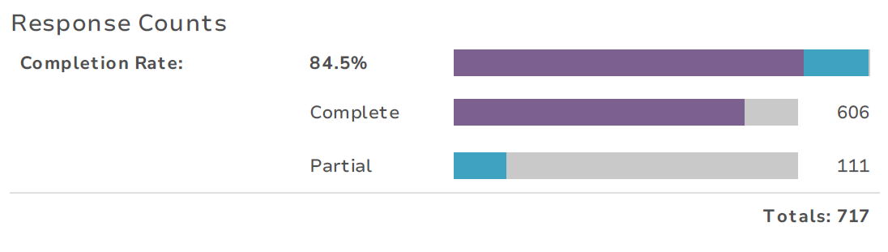

Additionally, two hardcopies were completed and submitted by community members who do not have internet access and attended a Customer Service Centre to complete it in person. A summary of these responses can be found at Appendix A.

No face-to-face engagements took place due to a lack of staff availability and additionally due to the efforts of reducing covid-19 transmission risk

The online survey completion rate is broken down into the week by week uptake as displayed below.

|  |  |  |  |
| --- | --- | --- | --- |
| *Week no.* | *No. of online surveys completed* | | *Promotional activity* |
| *1 (12/3 – 14/3)\** | | *88* | Geelong Independent article |
| *2 (15/3 – 21/3)* | | *196* | Social media ads |
| *3 (22/3 – 28/3)* | | *156* | Social media ads |
| *4 (29/3 – 4/4)* | | *51* | - |
| *5 (5/4 – 11/4)* | | *23* | City News article |
| *6 (12/4 – 18/4)* | | *170* | Bay FM radio ad  Social media ads |
| *7 (19/4 – 23/4)\** | | *30* | *-* |
| *Total* | | *717* |  |

* denotes incomplete week

## Demographics

The demographic information captured included residential suburb, age, gender, and their pet ownership status.

### Residential suburb

Residents living in Ocean Grove, Belmont, Highton and Barwon Heads had the highest participation levels by suburb at 9.1%, 6.6%, 6.1% and 5.1% respectively. This is not surprising considering the level of community interest around the recent dog order changes affecting the Barwon Coast, and that Highton and Belmont are two of the largest suburbs within the City of Greater Geelong.

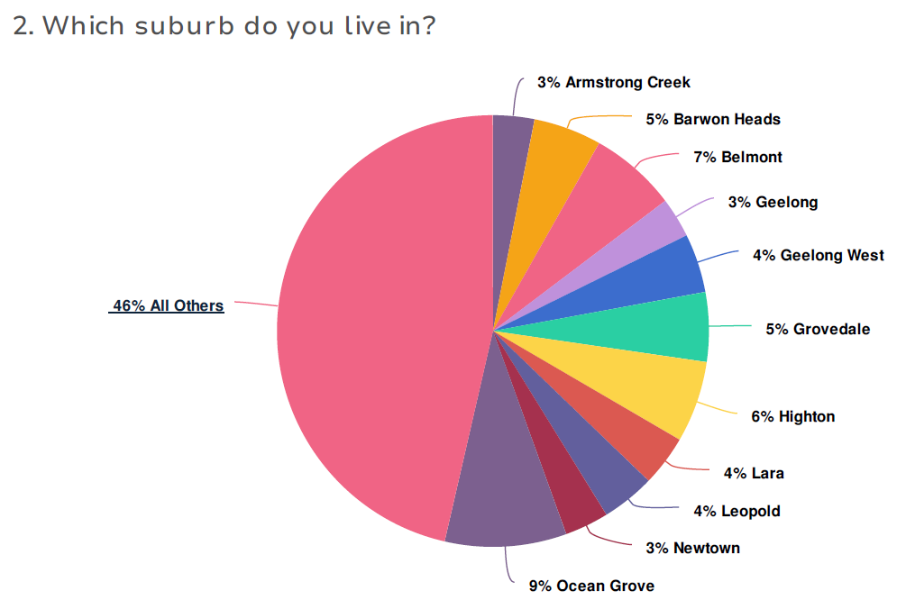

### Age

Community members who were between the ages of 50 – 59, had the highest participation level in the online survey (162 respondents), followed by 60 – 69 year old’s (150), 40 – 49 year old’s (142), 30 – 39 year old’s (119), 70 – 79 year old’s (60), 18- 29 year old’s (57), 80 – 89 year old’s (6) and under 18’s (2).

This spread of age groups, indicates that domestic animal issues affect all age groups, but those of middle age may feel most affected and passionate about it or have more available time to participate.

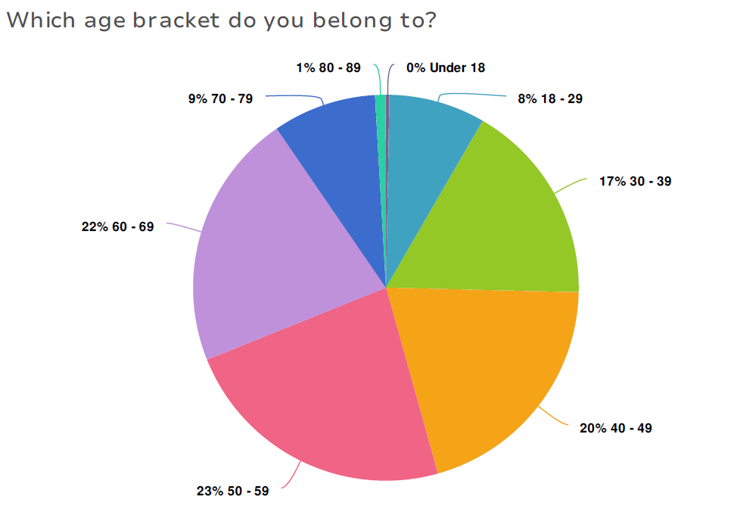

### Gender

Female respondents significantly outweighed their male counterparts when it came to leaving feedback on domestic animal issues, at a rate of 5:1, with an additional 4% of respondents preferring to either not say, selecting “other” or identifying as non-binary.

### 

## Who actively engaged

### Pet ownership status

82% of respondents were pet owners to 18% non-pet owners, an understandable result considering community members without animals may have felt that the management of domestic animals is not as applicable to them.

Of the 696 participants who answered this question, 92 identified as cat owners, 351 as dog owners, and 131 reported owning both a cat and dog.

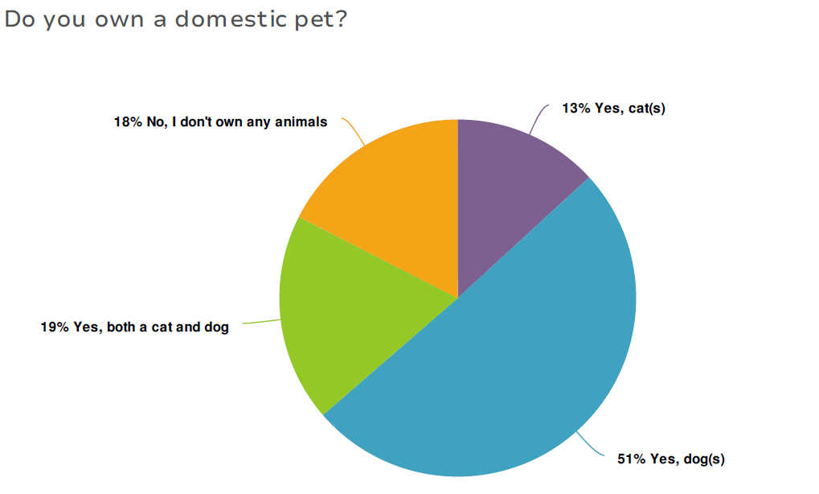

# What we asked

## TOPICS FOR CONSULTATION

The Domestic Animal Management Plan 2022 – 2025, has 11 key items to be discussed and consulted on:

* Dogs in public places
* Dog poo
* Dogs in coastal areas
* Dog attacks
* Open space needs
* Cat desexing
* Nuisance cats and dogs
* Responsible pet ownership
* Dog parks
* Animal identification and lost animals
* Animal Management team

Under each key item, there were between three to six specific questions relating to the topic that would generate through a logic function, so that they appeared when prompted by the relevant previous answer.

A full list of the questions can be found in the hardcopy version of the survey, Appendix A.

## Why we asked

The questions in the consultation survey were designed to gain an in-depth understanding of what the community feels works well from our current DAMP and its objectives, what needs further improvement, and if there are any other issues they would like addressed regarding domestic animals.

Additionally, the City’s Animal Management team used this survey as an opportunity to better understand what the community’s level of knowledge was on certain local laws. From this, we can identify gaps in public knowledge and identify ways to address this in future projects.

A combination of multiple choice and free-text questions were asked of our participants. The multiple-choice style allowed the data to be filtered more readily and trends and themes to be easily identified.

The free-text questions allowed participants to provide in-depth answers regarding their experiences, concerns and ideas on more complex matters, and provide answers that may fall outside the City’s anticipated responses.

# What we heard

## Key Findings overview

The topics with the highest number of responses, and therefore the topics the community were most passionate about, were:

1. Dogs in Public Places (72.8%)
2. Responsible pet ownership (60.2%)
3. Dog poo (57.9%)

The topics producing the lowest number of responses, and therefore the least amount of community interest, were:

1. Domestic Animal Businesses (20.5%)
2. Animal Management Team (25.3%)
3. Cat desexing (30.3%)

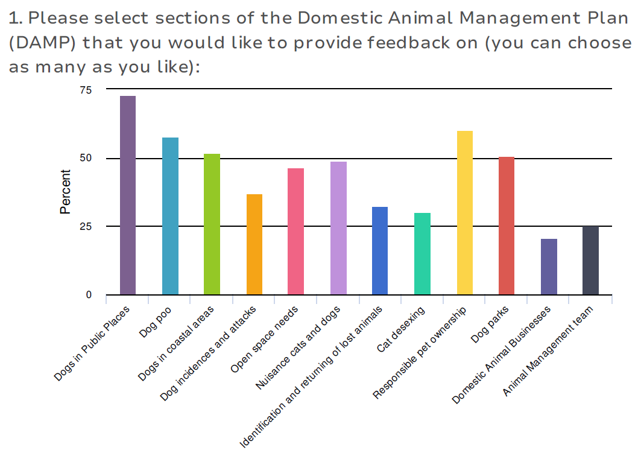

Engagement Activity 1 – OnLINE SURVEY

The following quantitative data was collected for each of the topics throughout the online survey.

In addition to the online surveys, two hard copy survey responses were received, these can be found in Appendix A.

### Dogs in public places

The topic of Dogs in Public Places explored the balance of dog-friendly and dog prohibited areas, on leash order adherence, and dog signage.

513 people left feedback on this topic – the highest number of responses received for a topic.

47% of respondents in this section believed that there are not enough “dog off-leash” areas; 15% believed there aren’t enough dog-free areas, and the remainder feel there is a good balance of on and off lead areas.

Most respondents believe that the community follows “dog on-leash” orders less than 50% of the time, whereas the majority of respondents believe that they themselves follow the ‘dog on leash” orders 100% of the time.

Some verbatim responses from the community are:

“There are a small number of off-leash areas in my area that are not shared sporting ovals. When sport or training activities are on, these areas cannot be used by dog owners and I have to resort to using non-designated off-leash areas. This is particularly challenging in winter when there are shorter daylight hours.”

“I want my dogs to be safe from traffic and other dogs and don't want them running up to people who don't like dogs”

“I walk my dogs mostly in on lead areas only and occasionally take one dog to an off-lead area. People walking dogs off lead in an on lead only area is a big safety issue. Not all dogs want to be approached by other dogs and there are getting to be too many people letting their dogs off lead in on lead only areas. The council do not seem to police this as the same people are always walking their dogs off lead. The retractable leads are also a problem as the owners have no control if their dog is on a retractable lead, even though technically they are complying. Retractable leads can also lead to other people or dogs being wound up by the lead and potentially injured.”

*“People where I walk generally follow the rules”*

The charts below depict the community’s feedback on Dogs in public places.

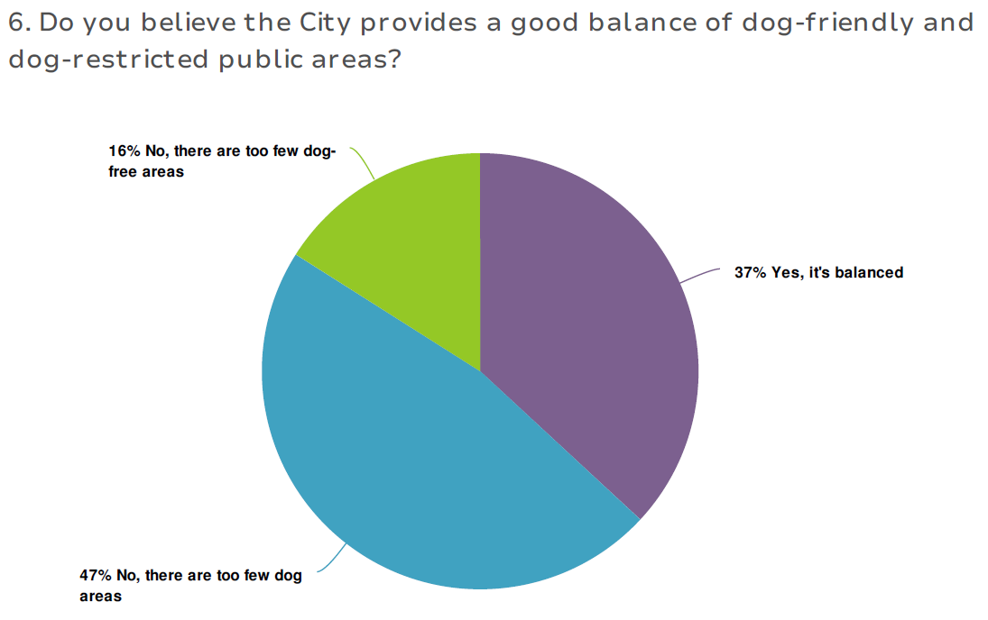

For the following two questions, participants were asked to rate adherence to orders on a scale of 0 = Never, to 10 = Always.

* “How well do you think your local community follows dog on-leash orders?”
* “What percentage of time do you follow your local dog on-leash orders?”,

24% of participants feel the community follow on-leash orders 50% of the time, while 58% of participants indicate they follow on-leash orders 100% of the time.

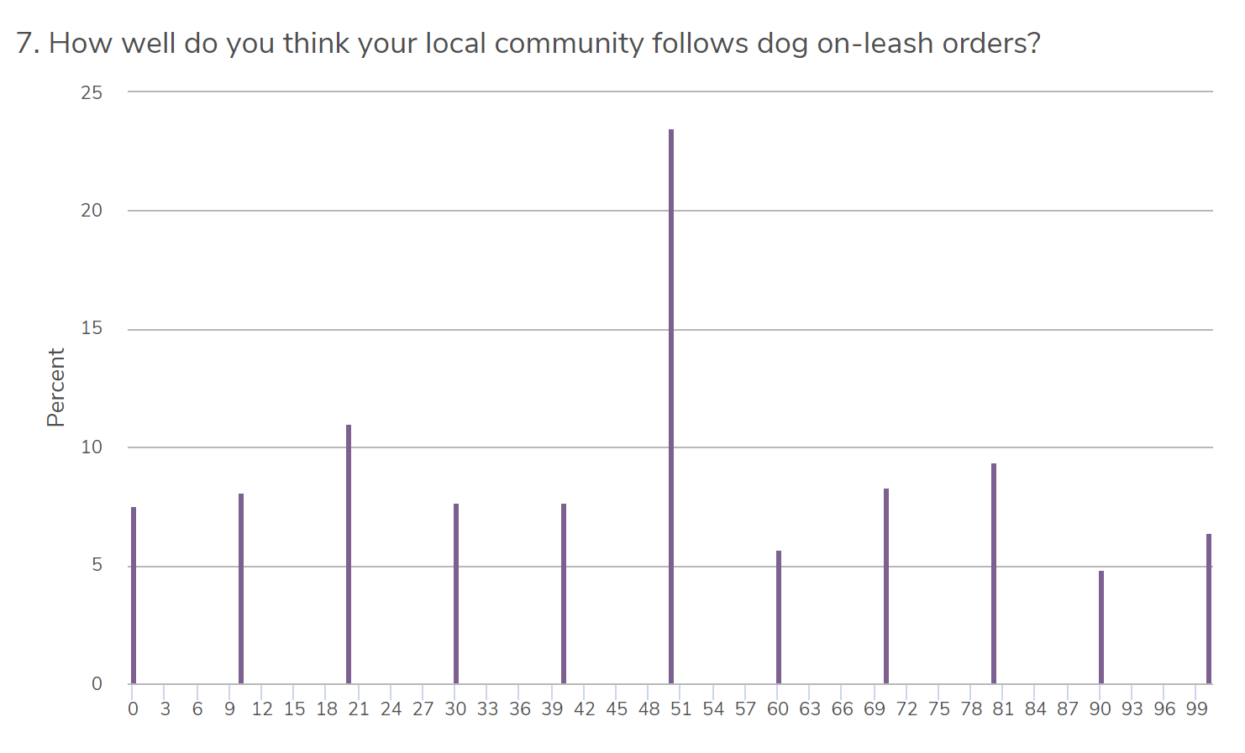

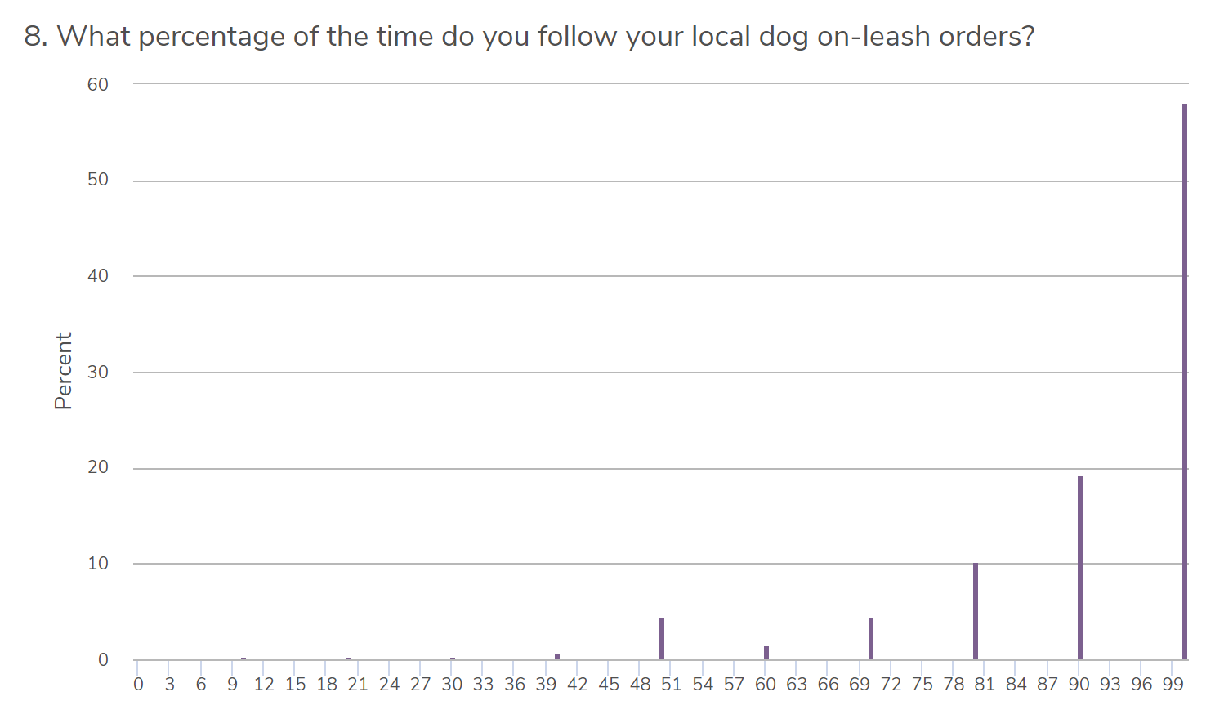

### Dog signage

50% of participants feel there is enough signage across the City regrading dog control orders, 40% reported there needs to be more, and 10% provided a free-text response.

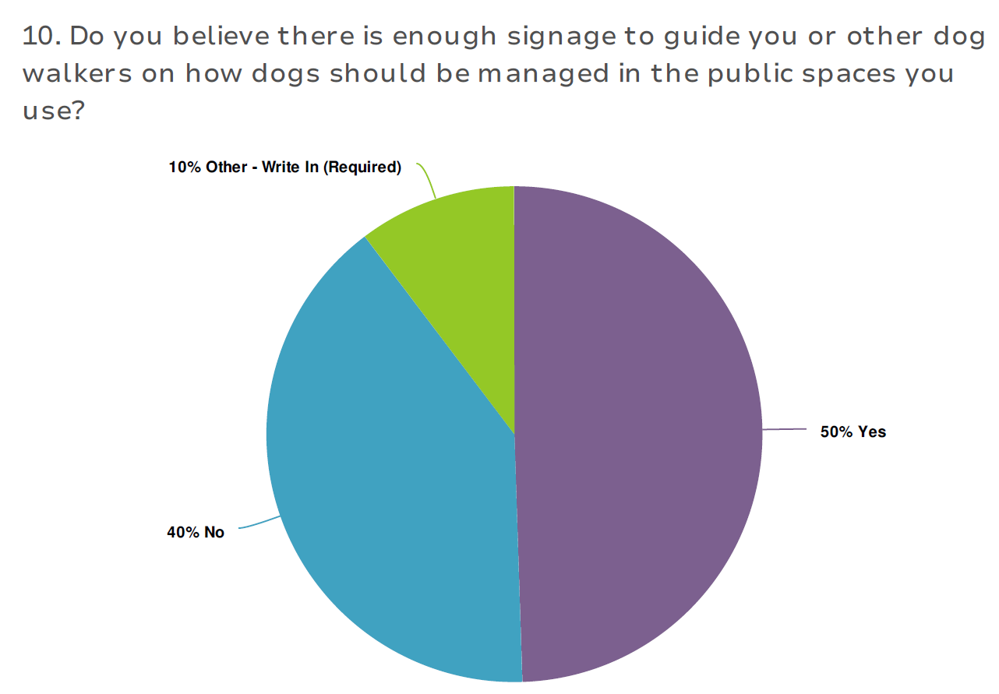

The top 5 areas identified by the community needing more signage are listed below:

|  |  |
| --- | --- |
| Locations requiring additional signage | Count |
| Beaches | 21 |
| Everywhere | 17 |
| Parks | 12 |
| Footpaths | 11 |
| Barwon River | 9 |

### Dog poo

407 (57.7%) survey participants elected to leave feedback regarding the issue of dog poo. Respondents were asked:

* If and why they felt dog poo is an issue across the City
* Whether there are particular areas of concern that they would like to alert us to

Of the participants who responded to this question, 83% believe that dog poo is an issue across the City.

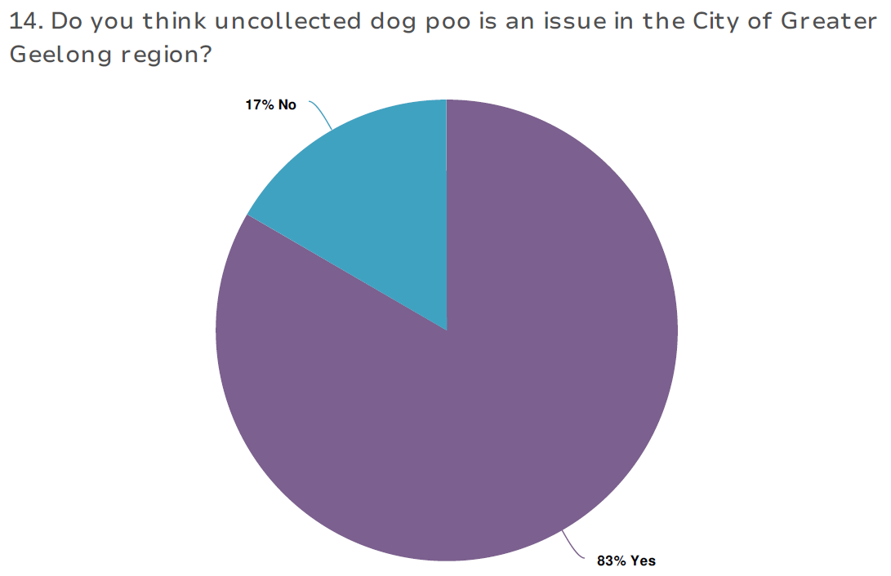

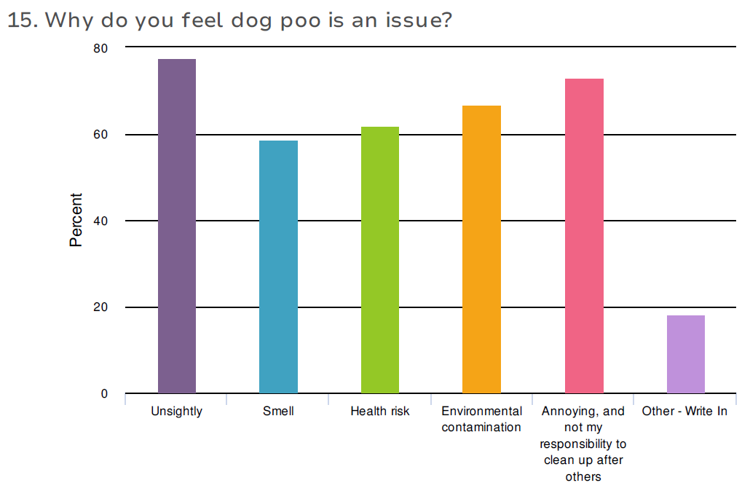

A selection of verbatim responses received are below

“There is insufficient waste management arrangements along popular walking routes in Geelong, making it challenging for dog owners to appropriately dispose of dog poo. Some examples include the waters' edge between Griffin Gully Pier and Rippleside Park, tracks along the Barwon River and around Eastern Park. While there are some bins in these areas, these are concentrated in picnic areas rather than spaced strategically, and you can walk for several hundred meters (over a kilometre in some examples) without encountering a bin. I believe dog owners want to do the right thing, but no one wants to carry dog poo for 20 minutes.”

“Fines if busted, but how does one even manage the streets?”

“The council is using plastic bags in its poop bag dispensers. There is a company that makes dog poop bags from corn starch which are environmentally friendly and available for councils. Their company was formed in Geelong too so would be good to support them. This will need to be a consideration with the future ban on single use plastics <https://www.ohcrap.com.au/pages/council-oh-crap-dog-poop-bags>”

“There needs to be a ban on dogs on sports grounds. It's everywhere. I'd like to see more fines, signs, owners being stopped and asked f or bags. I've never seen anywhere as bad.”

The top 5 locations identified by respondents as having dog poo issues are:

|  |  |
| --- | --- |
| Locations where dog poo is reportedly problematic | Count |
| Ocean Grove beaches, trails and footpaths | 27 |
| Barwon River | 25 |
| Barwon Heads beaches, trails and footpaths incl. the Bluff | 23 |
| Private nature strips | 20 |
| Mt Duneed/Armstrong creek reserves, trails and paths | 20 |

### Dogs in coastal areas

In this section we assessed whether the community was aware of Council’s obligation to work with coastal management committees, which beaches the participants would like to leave feedback on, and what they would like us to consider going forward.

A total of 364 people or 51.6% of all respondents chose to comment on this issue.

Some of the verbatim comments received were

*“More visits and fines by the ranger. If people were fined or spoken to by someone in authority, they may be more likely to obey the dog poo requirements and the dogs on leash or no dogs signage”.*

*“Police it more. It's completely out of control. I feel threatened every time I walk my dogs”*

*“A fairer seasonal management of the river and coastal areas”*

*‘We are banned from certain beaches for a long time over summer till May. Consider opening some areas of the beach and river when the children have returned to school. Shut it again at Easter”*

Of the 364 people who answered the questions regarding dogs in coastal areas, 27% were not aware that the City works collaboratively with coastal management committees, and therefore are also unlikely to understand the underpinning roles and responsibilities of each organisation within these partnerships.

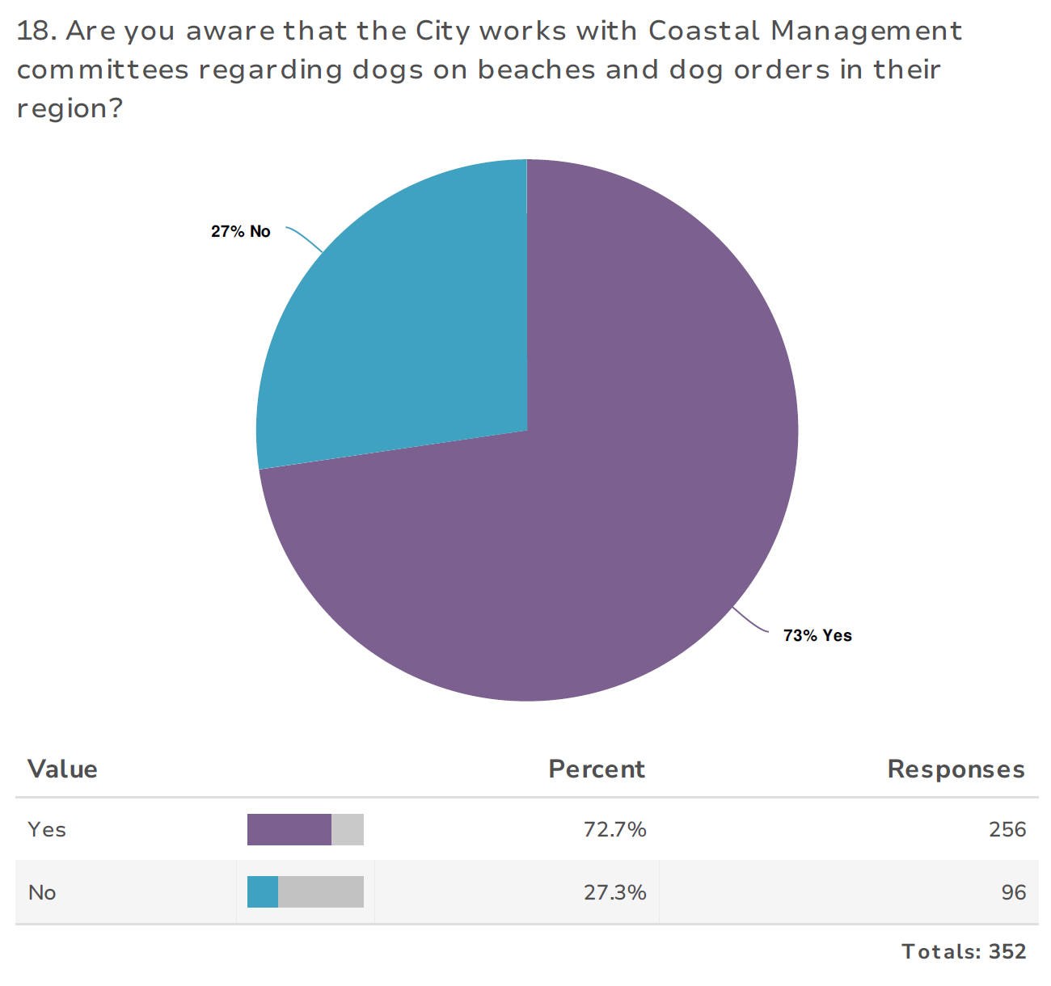

Of those wanting to leave feedback on coastal areas, 51.1% provided feedback on City-managed beaches, whilst 33.4% were interested in engaging on the Barwon Coast, and a further 15.4% on the Bellarine Bayside. The feedback collected through this engagement will be passed on to the relevant Coastal Management Committee for consideration.

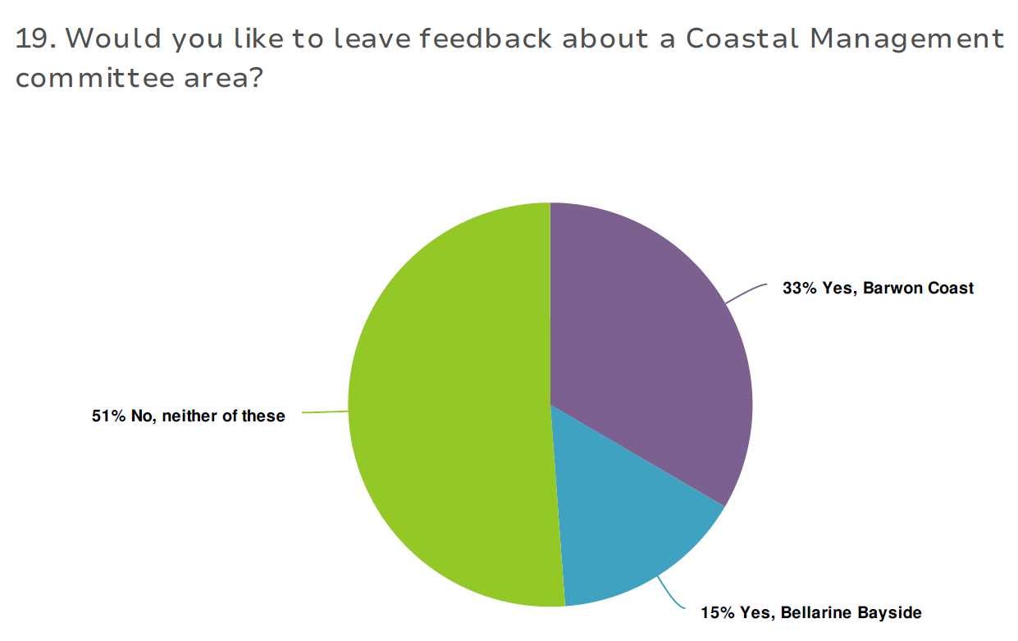

However, many respondents stated they didn’t want to leave feedback on a Coastal management committee area, or a City-managed beach, and elected to “write in” their response, listing

Ocean Grove (7)

Portarlington (3)

Barwon Heads (3)

Collendina (2)

13th Beach (2)

Queenscliff and Torquay (4) (managed by the Borough of Queenscliffe and Surf Coast Shire respectively).

These responses indicate that many respondents do not know the beach areas that fall under coastal management committee control, despite answering that they did.

The top 5 grouped responses to the “What would you like the City to consider?” question, are as follows:

|  |  |
| --- | --- |
| Themes: regarding coastal are management | Count |
| More patrolling and enforcement required | 41 |
| More dog off-leash beach areas needed | 34 |
| Barwon Coast “summer” restrictions and dog-free hours are too long. Should be Dec 1 – Jan 31 | 26 |
| Birds need more protection | 19 |
| Better/more signage and upkeep (incl. from water and multilingual) | 19 |

### Dog attacks and incidents

259 survey respondents opted to leave feedback regarding “dog incidents and attacks”. They were asked:

* If they had personally experienced or witnessed a dog-centric incident
* What type of incident it was
* If it was reported to the City
* Were they happy with the City’s management of the incident
* If they could suggest how the incident may have been avoided.

68% of respondents stated they had witnessed or been involved in a negative dog-centric incident.

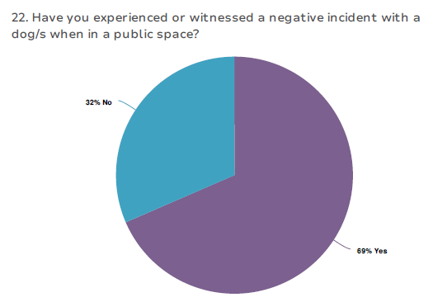

70.5% of those who reported being involved in a negative incident were involved in a menacing rush, over 30% were knocked over by a dog and had had their pet attacked by a dog, and 15.6% had been attacked by a dog themselves.

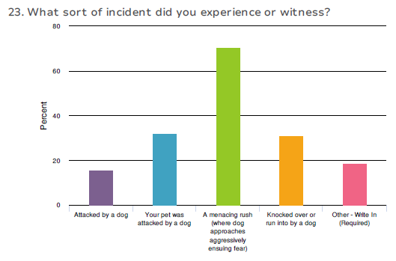

19% of the people who witnessed or were involved in the incident reported it to Council. 23% stated they didn’t know they could or should.

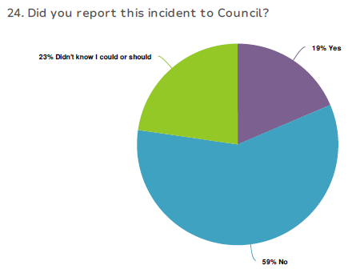

Of those who used the City’s services for this incident, 44% were satisfied with how it was managed.

### 

When respondents were dissatisfied with the way in which the incident was handled, it was most commonly due to not receiving adequate feedback on the outcome of the incident (4), or because the City told them that they were not able to go further with the investigation due to limited details (6).

When asked “Can you identify how this incident could have been avoided”, 88.4% stated “Yes”, and their reasons were as follows:

|  |  |
| --- | --- |
| Themes: How to avoid dog-centric attacks and incidences | Count |
| Keep dogs on leash | 11 |
| Better dog training/socialisation | 4 |
| Ban specific breeds | 2 |
| Better containment | 2 |

### Open space needs

When considering open space needs for our community and their beloved pets, the City wanted to assess whether the community felt there are ample on leash and off leash space near where they live, as well as suitable amounts of dog-free space.

Of the 328 people who elected to leave feedback on “open space needs”, 80% felt they had ample access to on-leash open spaces, whilst 14% stated they did not, and 6% were unsure.

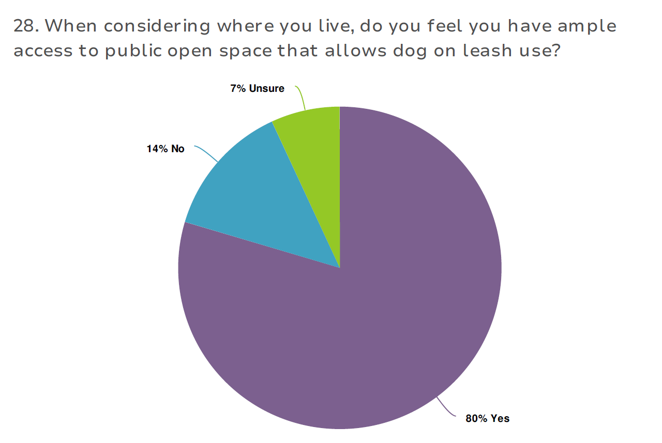

62% of respondents felt that they did not have ample access to dog off leash areas, whilst 25% said they did, and 13% weren’t sure.

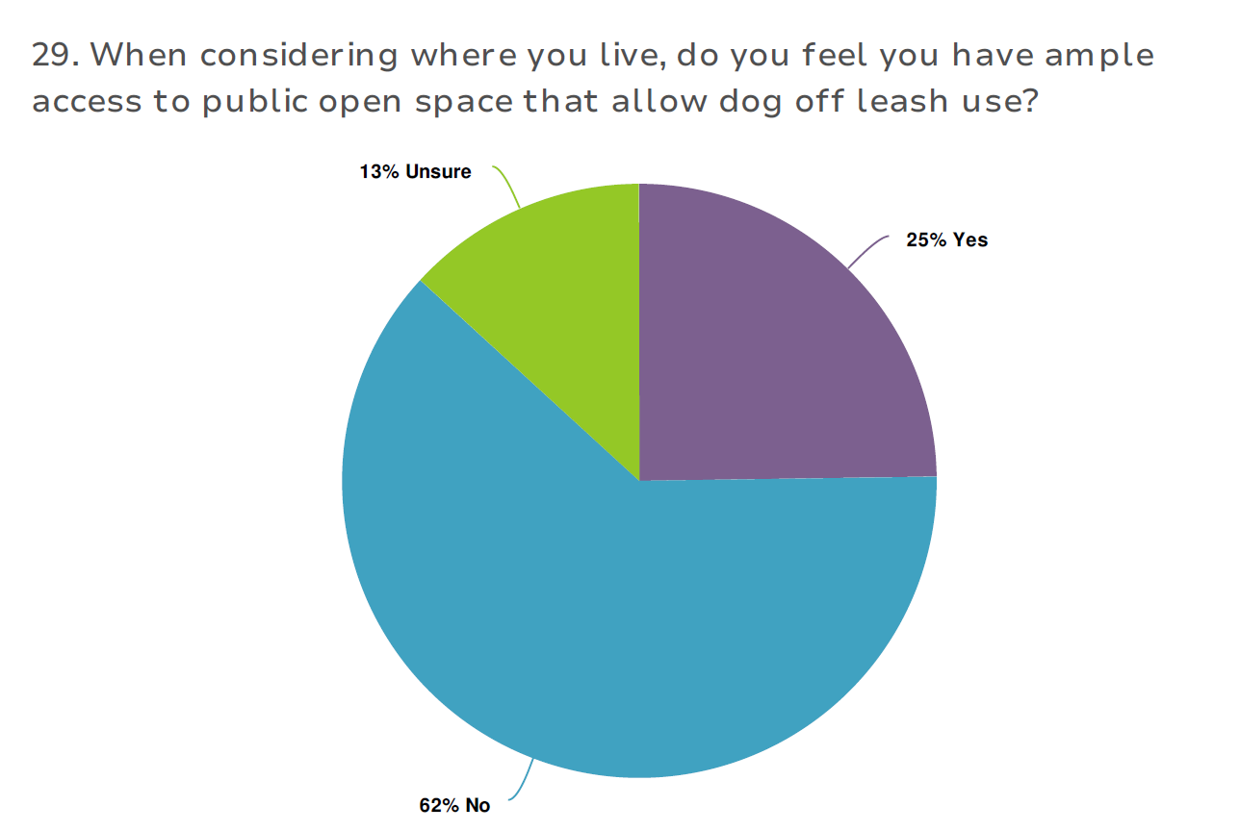

Finally, 46% felt they had ample access to public spaces that prohibited dogs, with 15% stating they did not, and 37% were unsure.

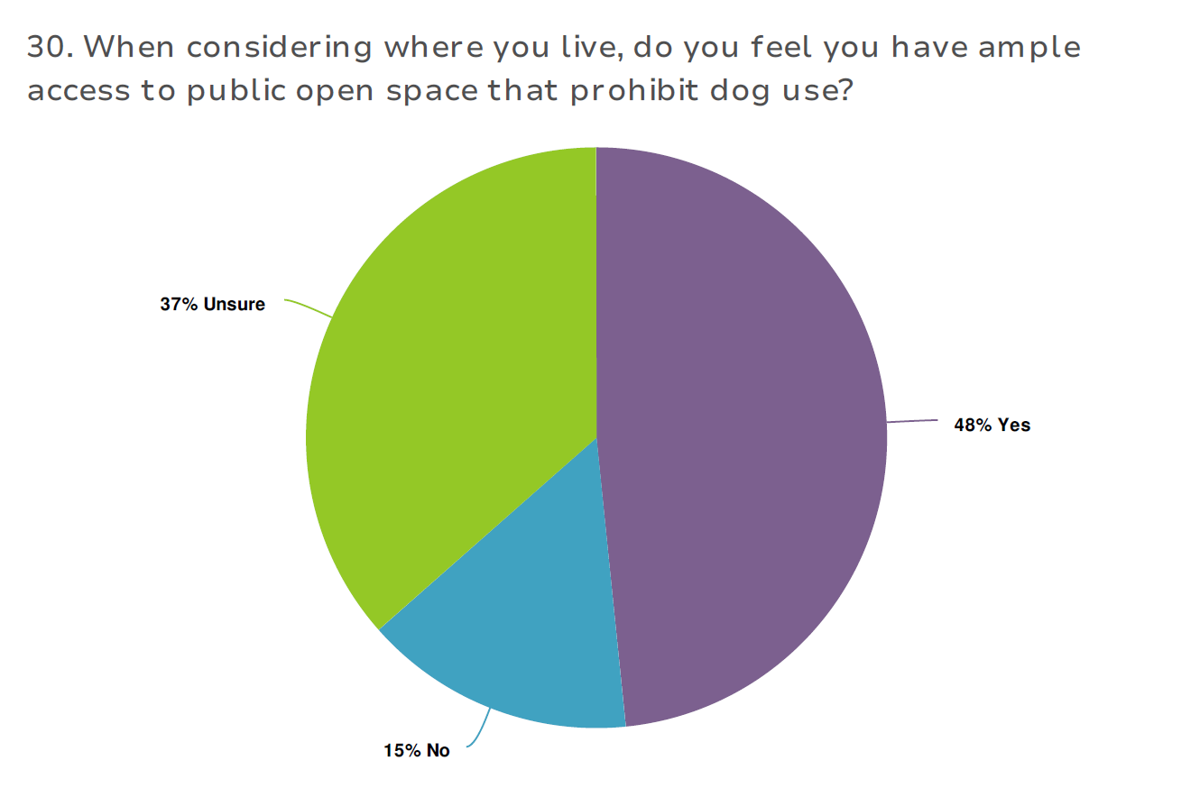

For the 77 participants who acknowledged living in a townhouse, unit or on a small block, 61 of them said they factored in the limited space when choosing a pet, whilst the other 16 did not.

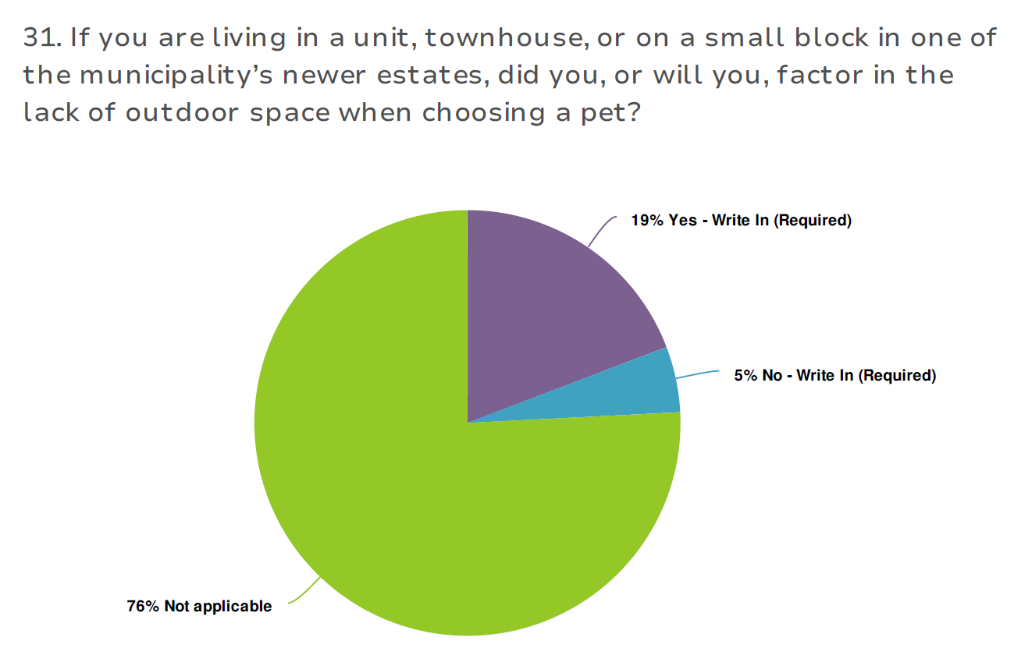

Pet owners were also asked whether they considered the size of their land and local facilities before taking on a pet in the question above and were provided the opportunity to comment. The response trends are identified below:

|  |  |
| --- | --- |
| Themes: regarding land allotments and pets | Count |
| Definitely considered pets space needs | 19 |
| Lot size/house chosen based on existing pet needs | 11 |
| Actively seek exercise in public spaces | 11 |
| Pet selection based on land size | 8 |
| Couldn’t have a larger breed due to block size | 4 |

### A selection of the verbatim responses are listed below

“Refuse to live in newer estates as there is no room for your dogs to play or naturally run about. You are not able to be with them 24/7 and these new estate housing do not fit the animals need.”

“Many breeds can do well on small spaces if exercised appropriately and plenty of environmental enrichment”

### Cat desexing

The cat desexing questions attempted to establish:

* What percentage of the community has their cat desexed
* What are the barriers preventing owners from desexing their cat
* Awareness of the discount cat desexing program, how we may better publicise it and support the community to desex their cats

217 of the 717 survey participants confirmed they owned a cat, and pleasingly, 98.2% or 213 of them stated their cat was desexed.

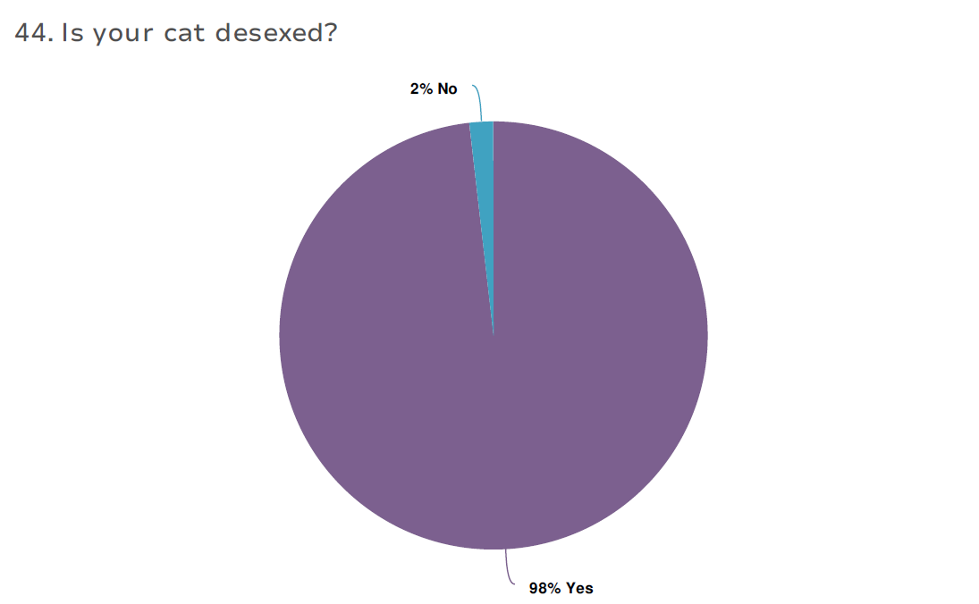

Only four out of 217 people responding to the cat desexing topic stated that they did not have their cats desexed, due to either “being a registered breeder” (3) or “expense” (1).

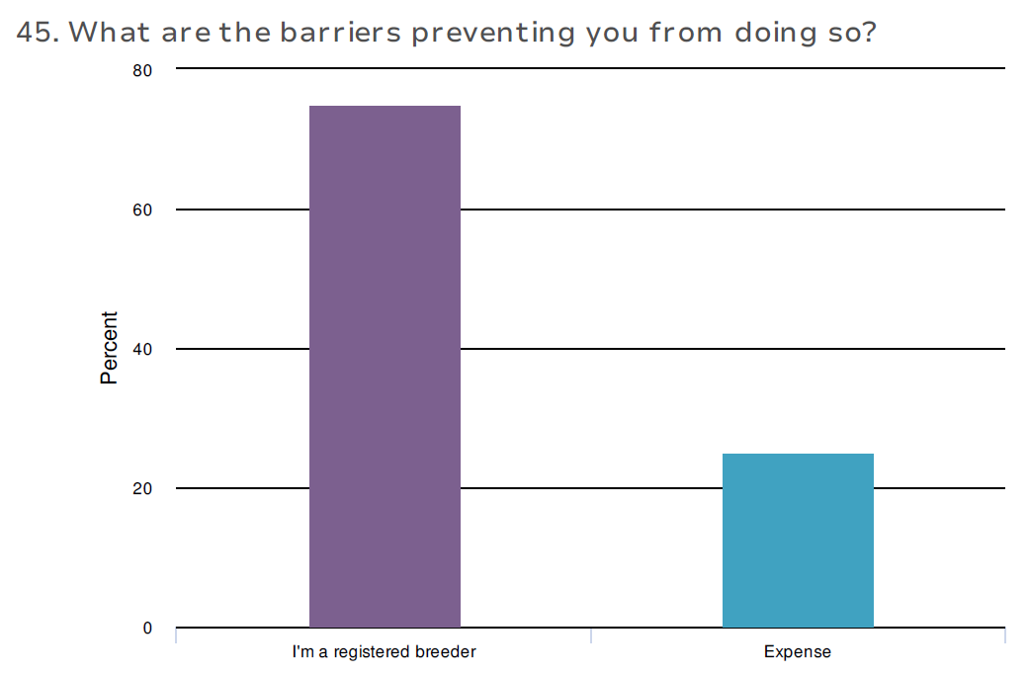

51% of 207 people asked about the City’s discount cat desexing month, were aware it is conducted annually.

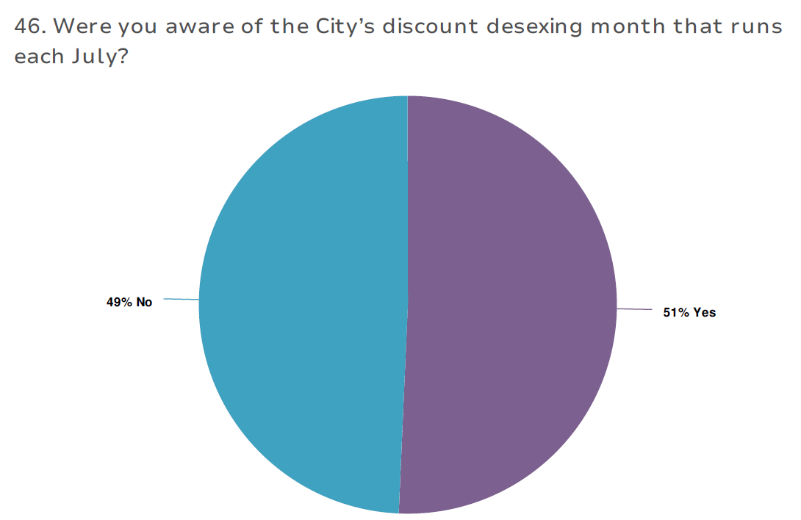

Respondents provided a number of ideas on ways in which the City can better promote the discount desexing program.

The top 5 response themes to “Do you have any suggestions on how you believe Council could further support and encourage the community to desex their animals?” are collated below:

|  |  |
| --- | --- |
| Themes: Improving cat desexing rates | Count |
| Further reduce expense | 18 |
| Education on desexing benefits incl. at schools | 16 |
| Offer it more than once a year | 14 |
| Free | 13 |
| Fines | 11 |

### Nuisance cats and dogs

Survey respondents were asked whether they experienced issues with nuisance cats and dogs, what type of nuisance they experienced, and how these issues could be better managed by the City.

### Cats

337 people elected to leave feedback on nuisance cats. Of these, 229 or 68% stated that they have experienced issues with nuisance cats in their neighbourhood.

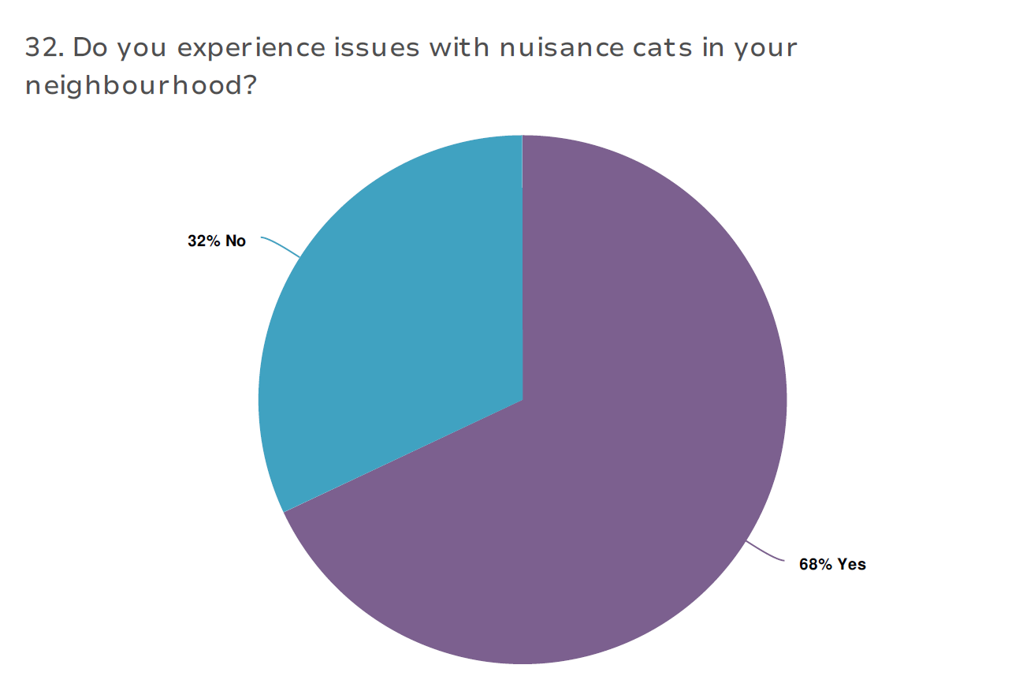

The most common issues reported re: nuisance cats were trespass onto private property (84.3%), impact on native birds and wildlife (57.6%), and destruction of property (42.8%).

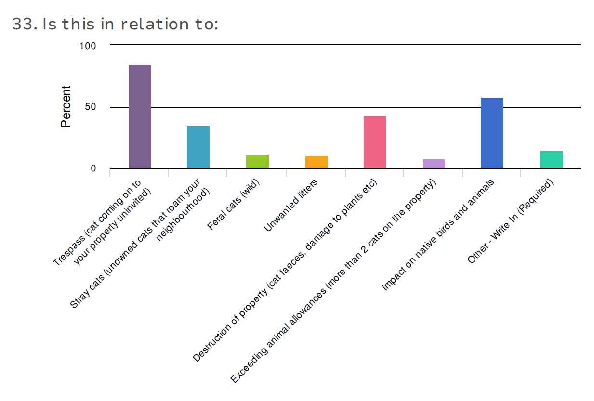

### 

The top 5 suggestions from community members on how to better manage nuisance cats included:

|  |  |
| --- | --- |
| Themes: nuisance cat management | Count |
| 24/7 cat curfew | 40 |
| Police cat curfew incl. night patrols | 39 |
| Enforcement and fines | 31 |
| More traps | 29 |
| Education | 22 |

A selection of the verbatim comments received are:

“As a non-cat owner, I would be very supportive of requiring cats to be kept indoors unless in a secure cat run”

“Roaming cats is a big issue. Educating cat owners on local laws regarding keeping their cat on their property 24/7, cat curfew and how to sustain a happy cat indoors with enrichment will hopefully decrease these complaints. Info sources of where to obtain cat enclosures or DIY ideas. Team up with Bunnings for a "Learn how to DIY your Cat enclosure". Supply those who attend a discount code to use when buying the materials to make their enclosure. On those days organise with a reputable animal rescue to have a sausage sizzle to raise money they need as they help with the cat issues of Geelong unfunded. Community engagement is essential if we are going to put a dent in this issue.”

“Allow people to trap cats. If those cats have a home, the owner should be fined for not following the curfew. If they are not desexed then they should be desexed before releasing to owners.”

### Dogs

Of the 335 people who wanted to respond to nuisance dogs, 45% confirmed they had experienced issues in their neighbourhood.

### 

The most common issue was barking dogs, which was reported as a nuisance by 75.3% of the respondents commenting on this topic.

“Dogs not being kept on leash in on-leash public spaces” (48%) and “uncollected dog poo on your property” (47.3%), were the second and third most problematic issues raised.

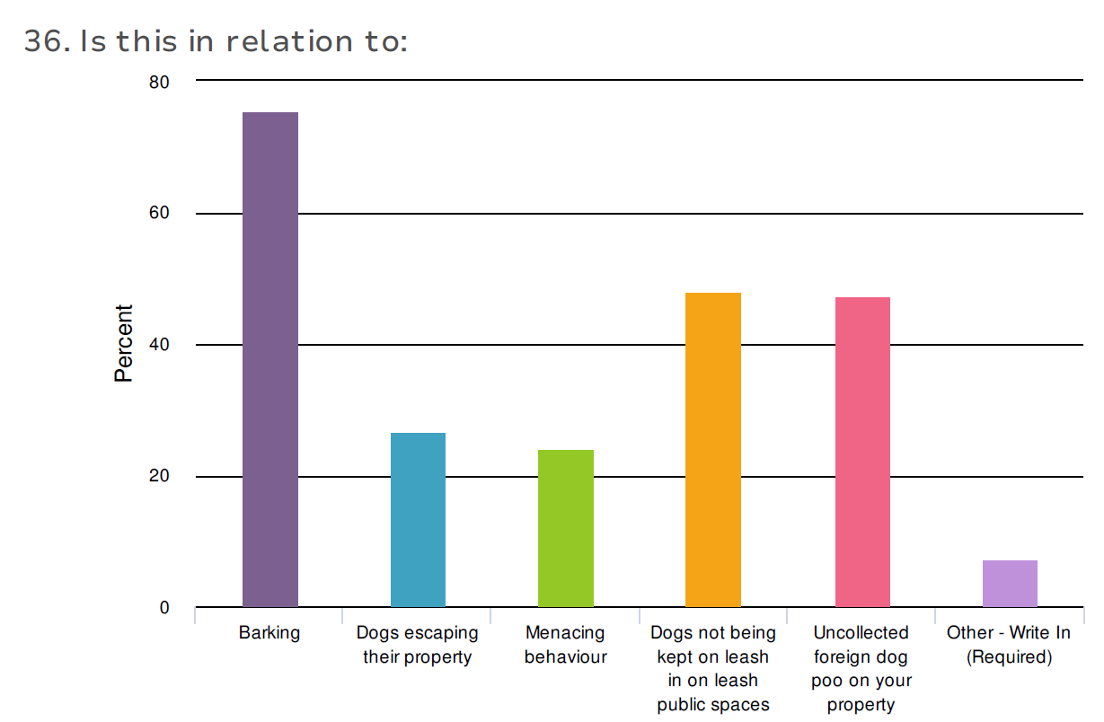

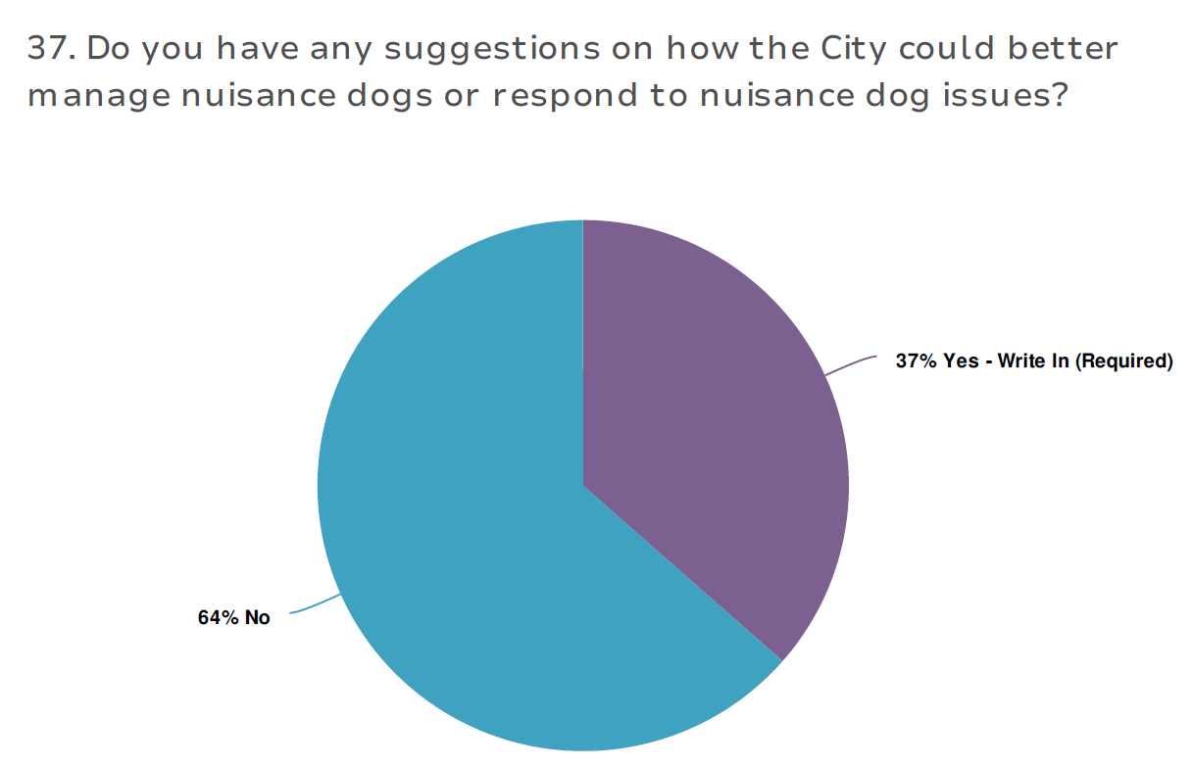

Top suggestions from community members on how to better manage nuisance dogs included:

|  |  |
| --- | --- |
| Themes: nuisance dog management | Count |
| Fines | 19 |
| Take nuisance barking complaints seriously/scrap diary | 16 |
| Education on enriching environments for dogs | 14 |
| Animal Management unit to act promptly to complaints and provide follow up | 12 |
| More patrolling | 11 |

Some of the verbatim comments received are:

“I understand how difficult it is but reminding dog owners who go off to work each day and leave their dogs outside that constant barking while dogs wait for their owners to return is a real concern. Too many dog owners (particularly of large dogs) seem totally unaware of the need to exercise their dogs.”

“If someone contacts council with a barking dog problem DO SOMETHING ABOUT THE PROBLEM ! If I have to keep a Barking Dairy DON'T tell the owner because they keep the dog quiet for the 2 weeks and then NOTHING is done!”

“Campaigns around responsibility of owners eg: walking, socialising, care giving etc. so many are locked in backyards and never walked.”

### Responsible pet ownership

Regarding the issue of responsible pet ownership, we attempted to gauge the public’s awareness of certain local laws and expectations of domestic animal owners, as well as gain suggestions about how the community thinks we can improve responsible pet ownership across the municipality.

An open-ended question of “What do you think it means to be a responsible pet owner?” was asked of respondents, and their answers have been directly exported and included in Appendix C.

62% of the 429 survey respondents in this section knew the local law, that cats are required to be desexed by the time they are three months of age.

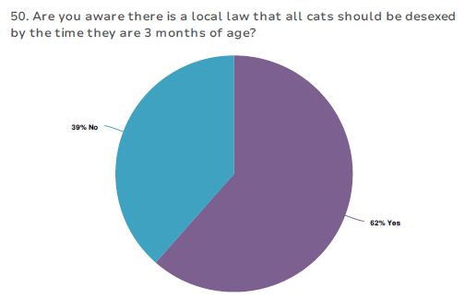

97.8% of respondents understood the need to vaccinate their pets.

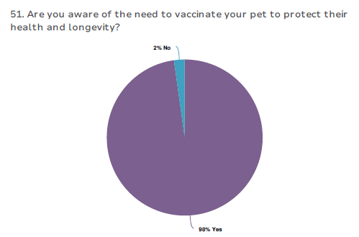

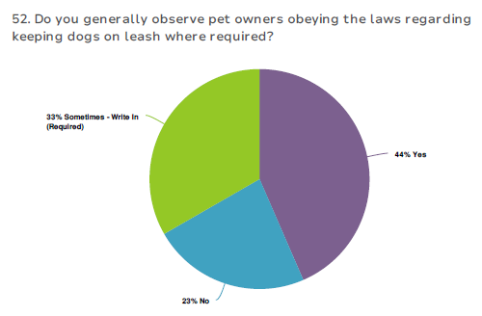

See Appendix D for further analysis of “sometimes” responses to above question.

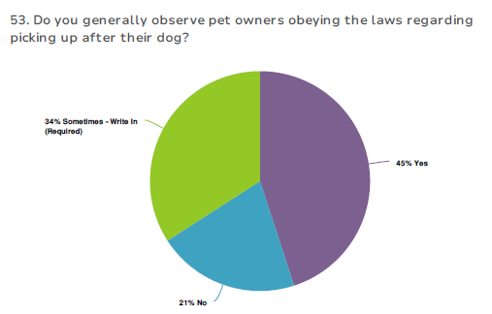

See Appendix D for further analysis of “sometimes” responses to above question.

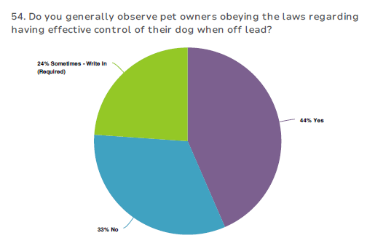

See Appendix D for further analysis of “sometimes” responses to above question

Anonymous verbatim comment from survey respondent:

“Honestly what really is effective control? Dogs wandering behind owner is common, owner not looking back. Dogs way in front of owner is not effective control. Dogs approaching myself or little ones is not effective control, and this happens a lot. People swimming whilst dog on beach off lead is not effective control. I see this heaps. Dogs barking incessantly whilst anywhere, on beach, at home, where-ever, is not effective control. Dogs running near me and around me whilst trying to walk is common. Am sick of people telling me their dog is just being friendly.”

*“Most owners have well trained, responsive dogs. A minority have uncontrollable dogs that are a menace.”*

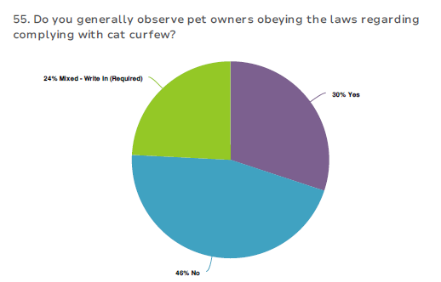

See Appendix D for analysis of “mixed” responses to above question.

Finally, we asked respondents to this section, “How do you think the City can encourage more of our community members to be responsible pet owners?”

All responses can be found in Appendix D.

### Dog parks

As the topic of “Dog Parks” has already been consulted on extensively by the Open Space Planning team who is responsible for their rollout, the DAMP consultation simply asked the open-ended question, “would you like to leave any comments regarding dog parks?”

The top 5 grouped answers are listed below:

|  |  |
| --- | --- |
| Themes: dog park comments | Count |
| New parks sound great | 50 |
| Need more | 49 |
| Separate area for timid/small dogs is great idea | 26 |
| Bellarine dog park needed | 26 |
| Hotspot for problems – dogs MUST be supervised | 23 |

Some of the verbatim comments received were

“People don't expect features. People just want a safe, fully fenced area where dogs can socialize. I am excited for the Belmont one, however, the amount of features included makes me worry how long it will take. The more we have, the better! People currently are using sporting ovals, but these aren't fully enclosed and can't be accessed at all times.”

“The stead park off leash dog area is extremely small and plain. There's more dog fights because you can't walk anywhere and there's nothing to do. There is much more room in that area and simply extending the fenced area would be a great start.”

“Still 10 years behind the necessary commitment. Endless playgrounds that are never utilised, endless space for children to play. Hard to access, small secured areas are available now. Whilst the two additional ones are great - it would have been proficient years ago. With increased demand it simply isn't enough.”

“Allow local trainers to make use of the dog parks by holding training classes in separate agility/training area so that owners are better educated regarding handling their dogs. Patrol the parks more of ten checking registration and microchips making sure details are up to date. Would be nice to have more tress and shade areas at Belmont Park and maybe a wet area. Pond/pool where dogs can cool off also Cap number of dogs able to use the parks at one time.”

*“More dog parks would be great”*

### Animal identification and lost animals

Questions relating to “Animal identification and lost animals” aimed to explore how the community thinks we can more efficiently reunite animals with their owner/s, as well as gain insight into the public’s understanding of pet-ownership requirements and barriers to meeting these.

96% of the 220 respondents to this section knew it was a Council requirement to have their pet cats and dogs registered and microchipped by the time they were three months old.

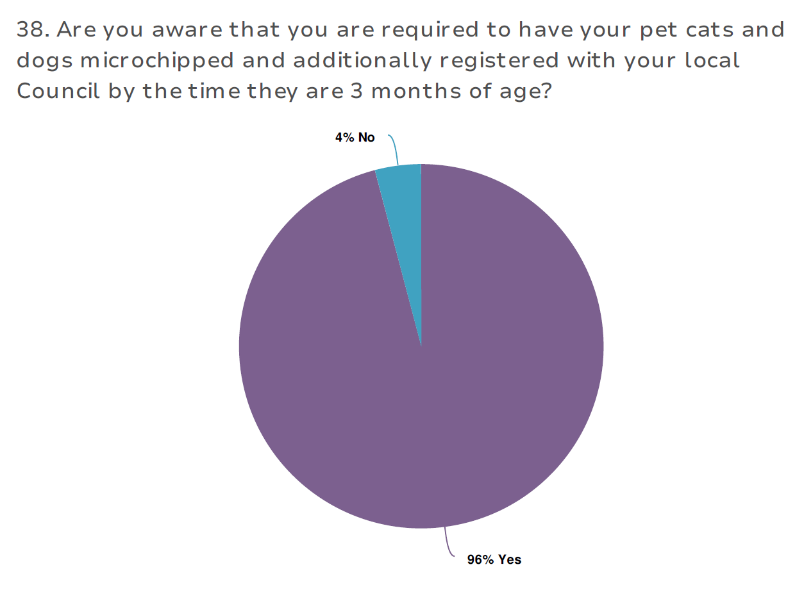

89.9% of respondents confirmed all their animals were registered with Council, whilst 5% stated “some” were, and a further 5% stated “none” were.

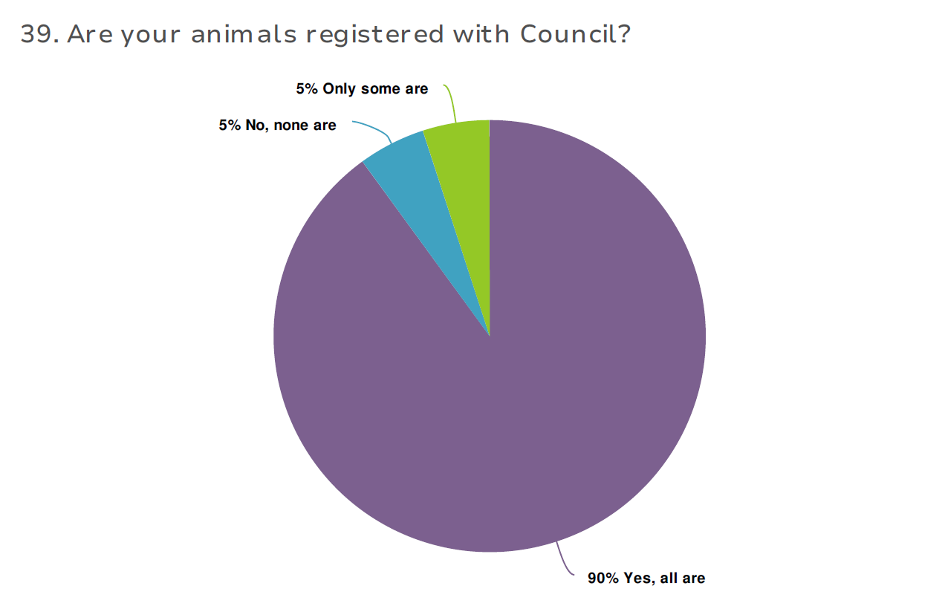

The main barriers preventing respondents from registering their pets with Council included, “Other” (63.6%), expense (40.9%).

“Other” reasons included:

* + Want my pet to be older so they can be desexed prior and get cheaper rate
  + Awaiting another council transfer
  + Fee for “entire” animals is too high
  + Don’t feel the money paid is reinvested well back into the animal
  + Too difficult for first timers
  + Should have lifetime registration option

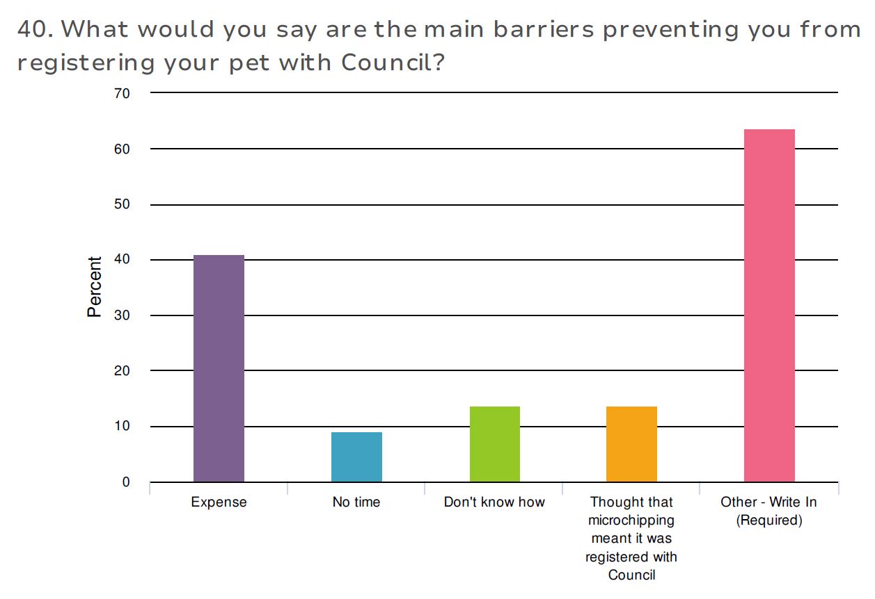

87.7% of respondents knew they need to update their personal details with both Council and Central Animal Records (CAR) to allow the swift reunion of lost pets, whilst 10% thought Council and CAR were the same thing.

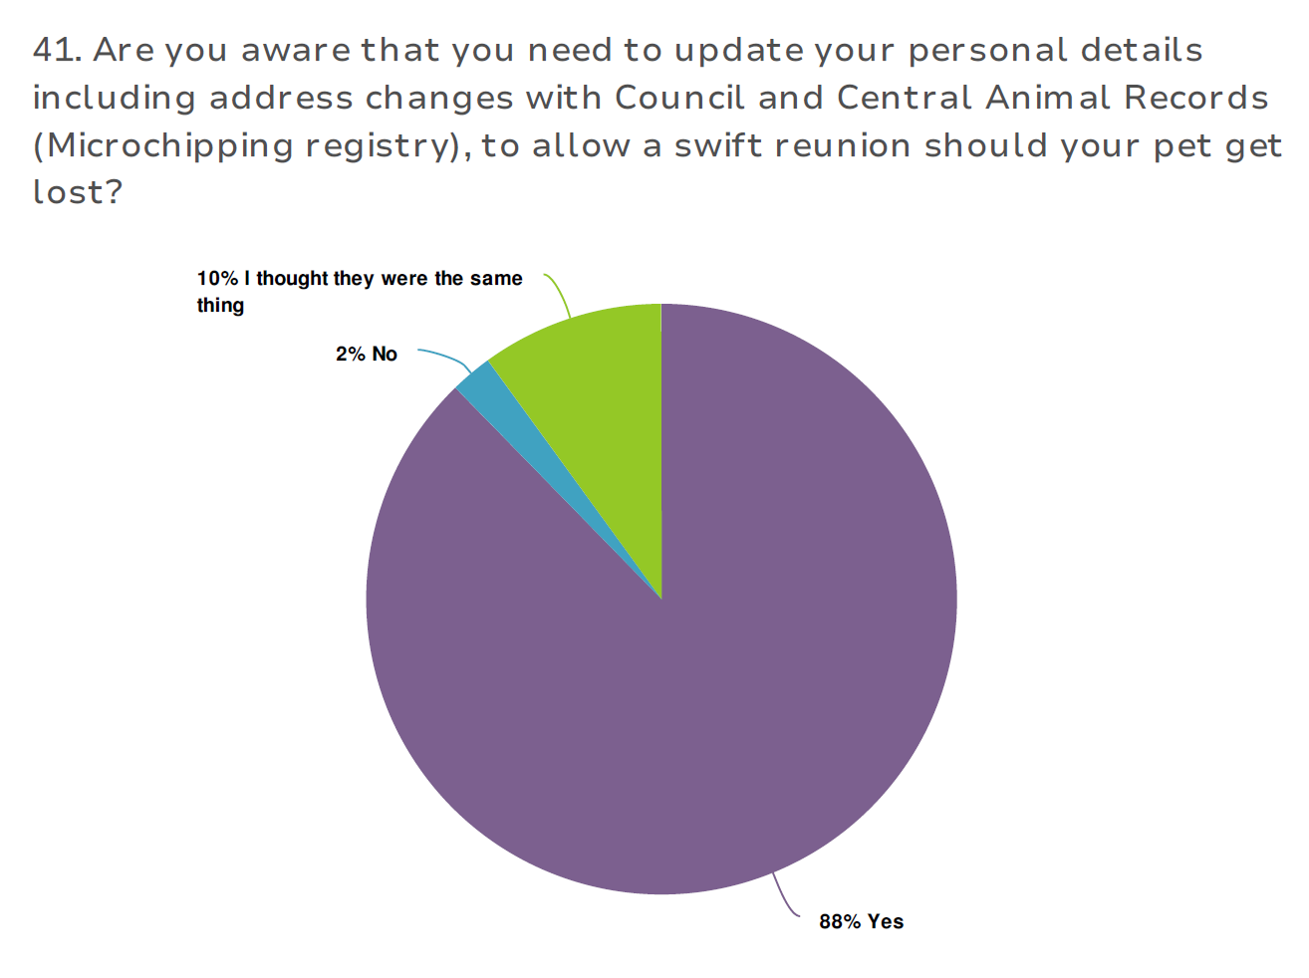

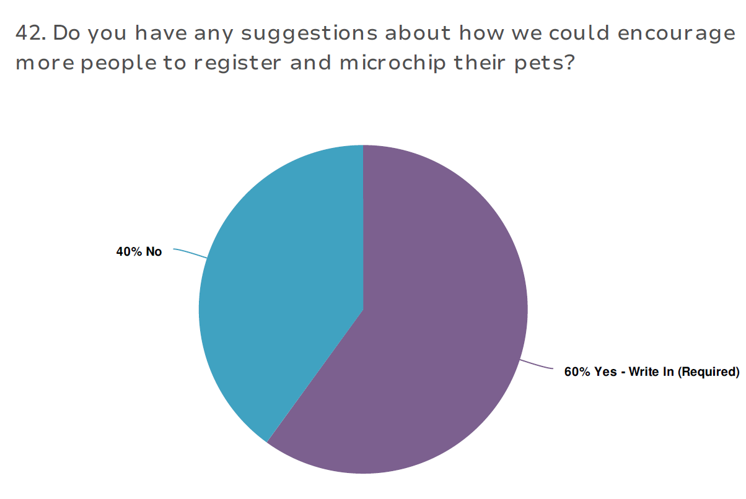

The top 5 recommendations from respondents on how to improve registration and microchipping adherence rates are below:

|  |  |
| --- | --- |
| Themes: Registration and microchipping adherence | Count |
| Make it free/subsidised (particularly first year) | 42 |
| Higher fines for non-compliance | 15 |
| Microchip/rego drives | 13 |
| Spot checks | 9 |
| Free gift/vet appointment/training incentive | 9 |

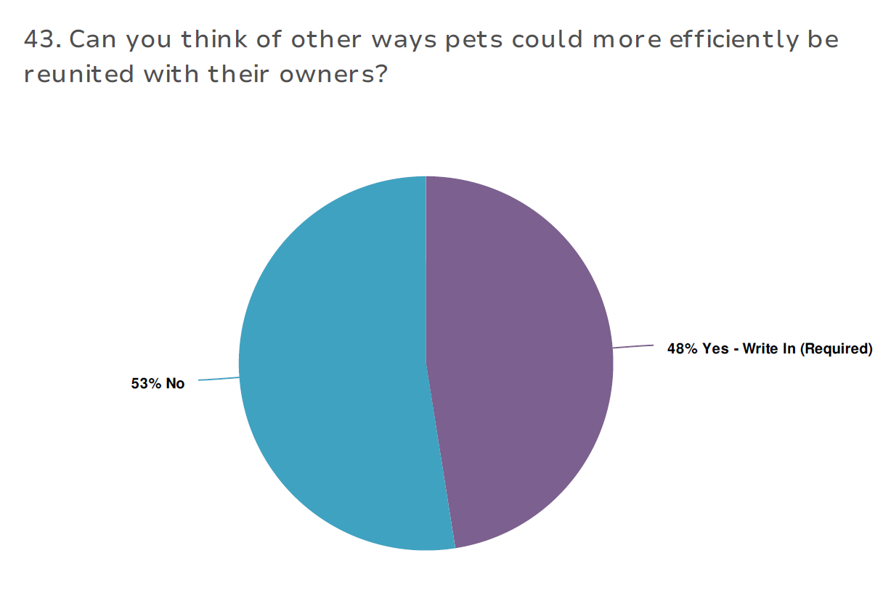

Ways the respondents felt we could better manage the reunion of pets with their owners included allowing vets to reunite animals, utilise social media, create a lost and found database and lower release fees.

|  |  |
| --- | --- |
| Themes: Reunion of Pets and Owners | Count |
| Allow vets with relevant legal authority to unite animals directly | 18 |
| Use social media | 16 |
| Create a council database “lost and found registry” | 11 |
| Immediate contact made with owner prior to impoundment | 9 |
| Lower pound release fees | 9 |

### Animal Management team

169 online survey participants elected to leave feedback on the Animal Management team. They were asked questions relating to visibility, interactions and how the team can improve their service to the community.

41% of respondents acknowledged they have seen the Animal Management team patrolling

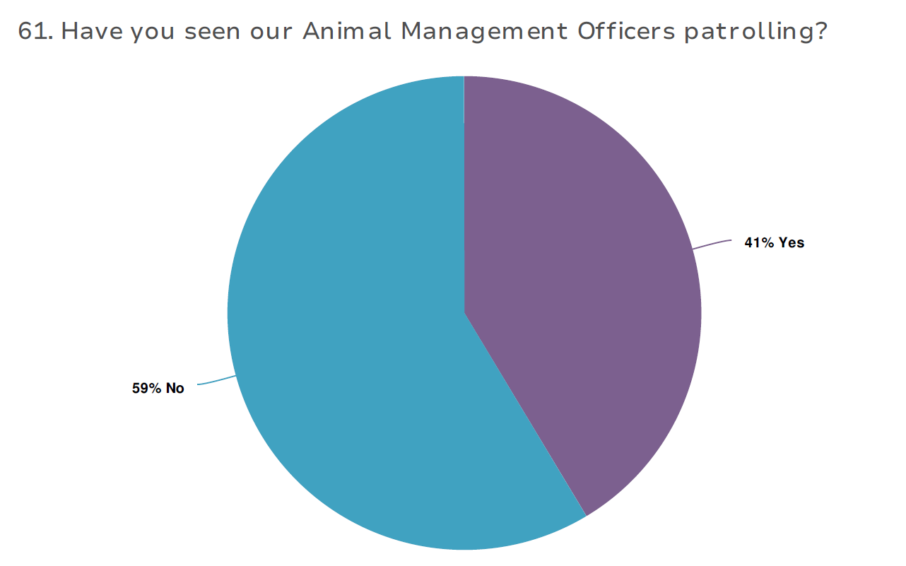

38.5% confirmed the branded vehicles have improved their visibility/public awareness.

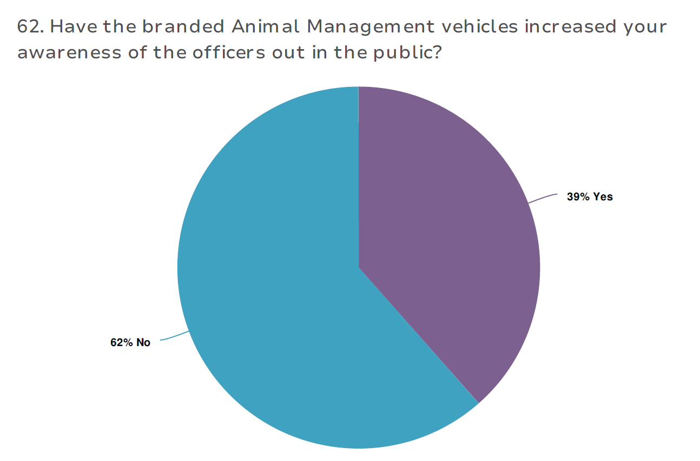

41.4% of survey participants have had an interaction with a member of the Animal Management team.

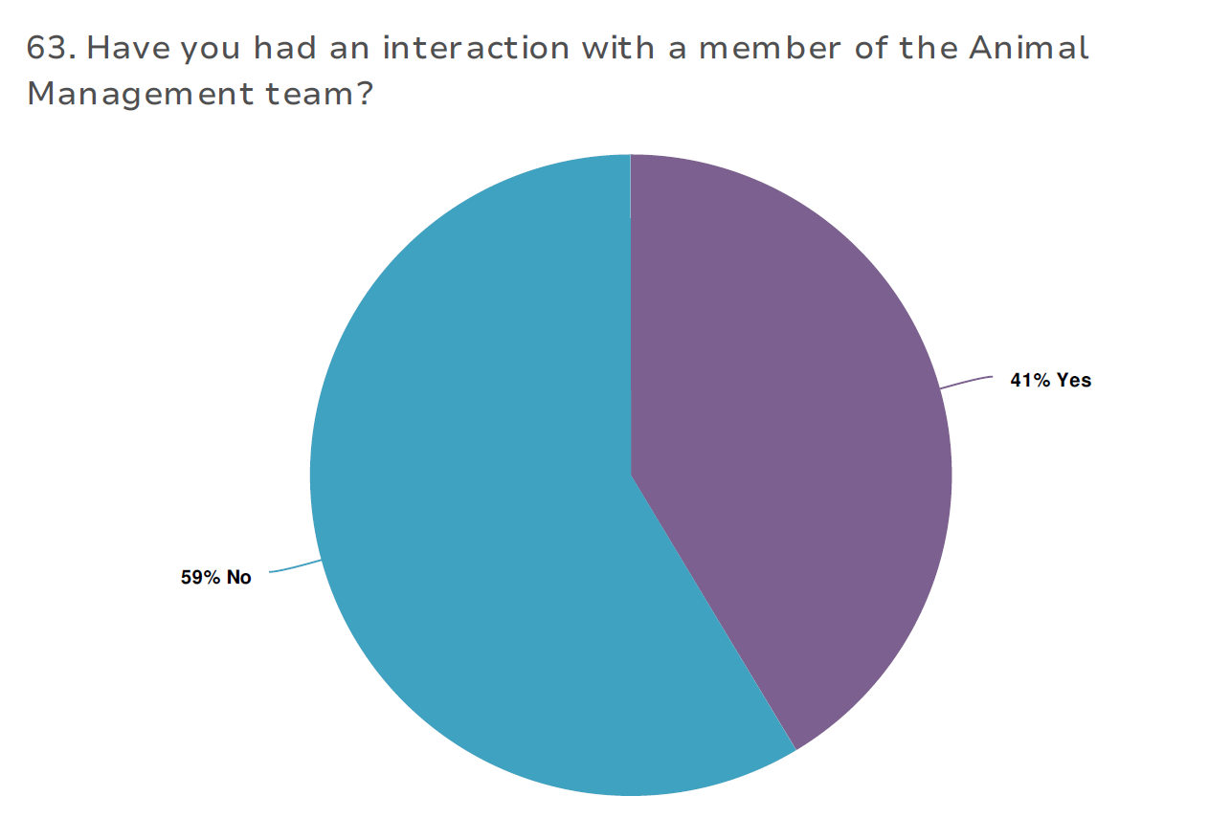

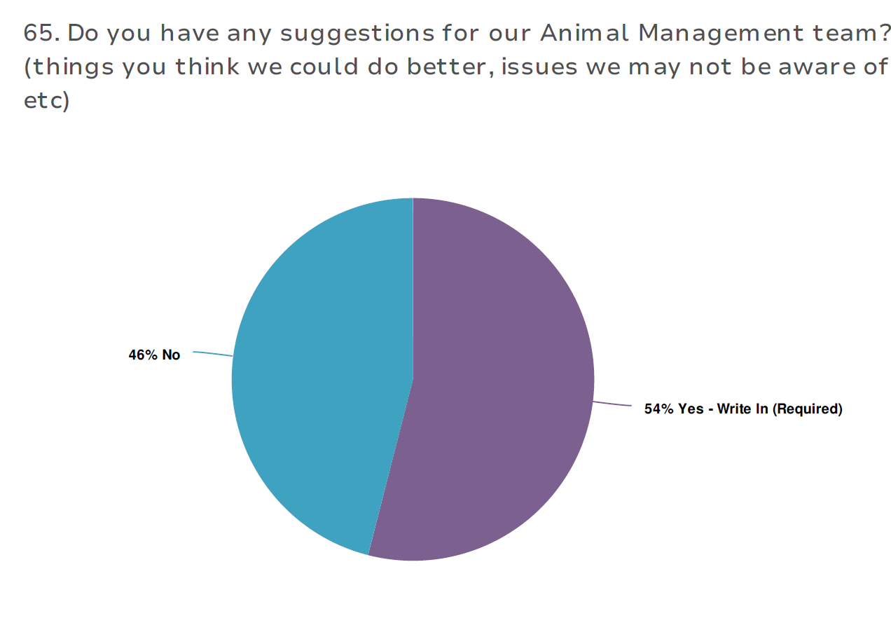

The top 5 suggestions on how the Animal Management team could improve their service included:

|  |  |
| --- | --- |
| Themes: suggestions for the Animal Management team | Count |
| Be more visible | 16 |
| Need more officers | 16 |
| Enforce the law | 12 |
| More patrols | 9 |
| Keep interactions pleasant | 8 |

Collated responses to “Would you like to leave any further feedback or comments about any of the topics listed above, or another animal-centric issue that is not discussed above?”, are compiled into themes and can be found at Appendix D.

### Domestic Animal Businesses

138 respondents chose to answer the questions regarding Domestic Animal Businesses. These questions were designed to gauge the understanding of whether respondents understood the licencing requirements for Domestic Animal Businesses, and whether people knew that they could report their concerns regarding these businesses to the City.

76% of respondents confirmed they knew animal businesses were required to be registered with council.

### 

72% of respondents were aware they could report concerns with animal management businesses to Council.

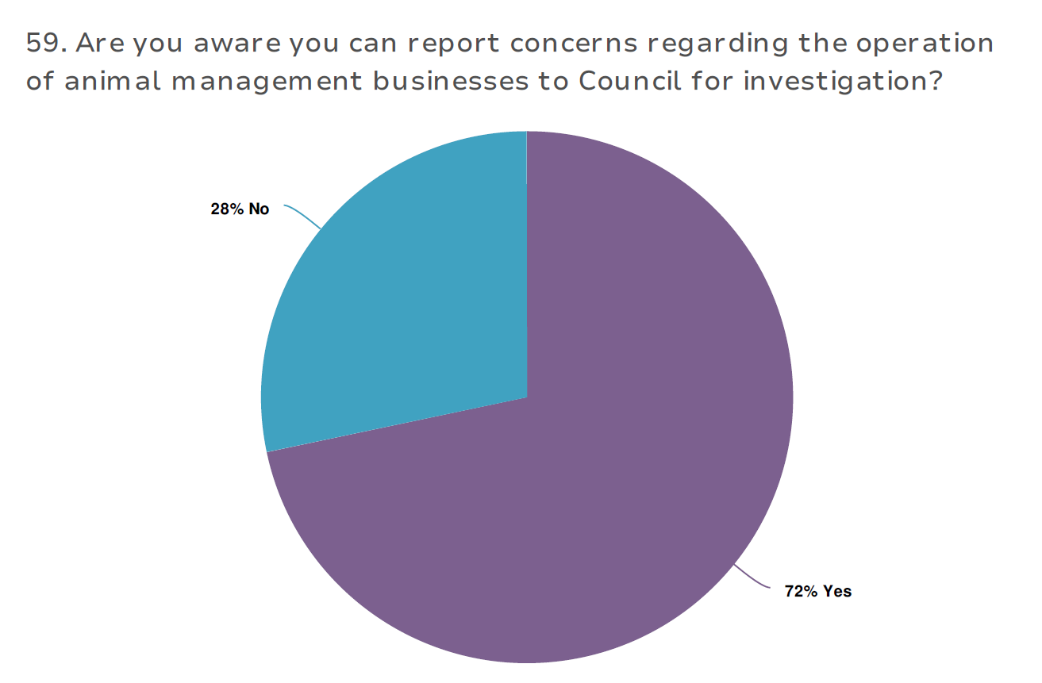

The collated responses have been grouped into themes, which are listed below:

|  |  |
| --- | --- |
| Themes: Domestic Animal Businesses | Count |
| Concerns regarding business operations, including non-reg and animal cruelty | 15 |
| Registration process is too difficult | 1 |
| Need further awareness of what constitutes a Domestic Animal Business | 1 |
| Other issue, not related to Domestic Animal Businesses | 4 |

# Discussion

Community engagement successes

### Online format

The duration of the community consultation was ample to collect a significant amount of feedback from members of the community who wished to participate.

In the 43-day period, we collected 719 responses to the survey in either online or hardcopy form.

### Promotion

It was highlighted through the increased activity on weeks where promotion occurred, that the various forms of promotion utilised were effective in generating further traffic to the online survey link, particularly the use of social media and radio ads.

Community engagement areas for improvement

### Consultation timing

We did not anticipate that the timing of Easter, which fell in the middle of the engagement, would reduce participation to the degree it did.

Over the Easter long weekend, only nine surveys were completed. Additionally, the uptake for the survey completion afterwards remained lower than prior to the Easter period.

### Hardcopy survey

The survey was constructed on an online survey software program called Alchemer™, which allows you to embed restrictions on answer styles (select one or several answers), compulsory questions, and logic on how a certain answer will then create a flow on of appropriate questions.

This works well in an online format, however as a hardcopy, the survey is not streamlined.

Instead every question constructed, whether applicable or not to the participants answers, is printed. The ability to restrict participants from moving forward in the survey if they have not answered a compulsory question is removed.

Overall, it looks much longer, and the format is awkward in comparison to its online counterpart, however, there is nothing that can be done about this when using a printed version.

In future it may be best to support participants at customer service centres to fill the survey in online using City property, whether that be a computer or tablet.

# Next steps

A short “Snapshot” engagement report was uploaded onto the City’s “Have Your Say” page in April 2021. Community members who elected to ”follow” the project page will receive updates regarding this project and access to any reports and additional information shared through this platform.

In addition, this detailed, extended community engagement report has been written and will be shared through the same medium.

## Next Steps

This engagement report will be used to inform the objectives of the next Domestic Animal Management Plan. Commentary collected from the community will be included in the “What we heard” sections of each topic, and will help the Animal Management team and Council decide what future steps should be taken to meet community needs and address issues raised.

The draft DAMP 2022 - 2025 report will be released to the public, for review later in the year, before being finalised and published in line with the 3 December 2021 expiry date of the current DAMP 2018-2021.

# Appendix A – Survey hardcopy

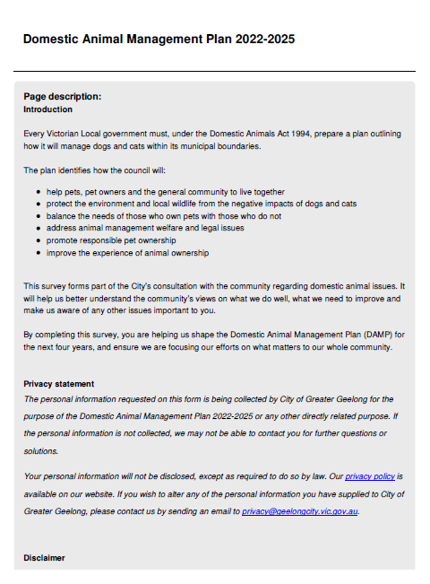

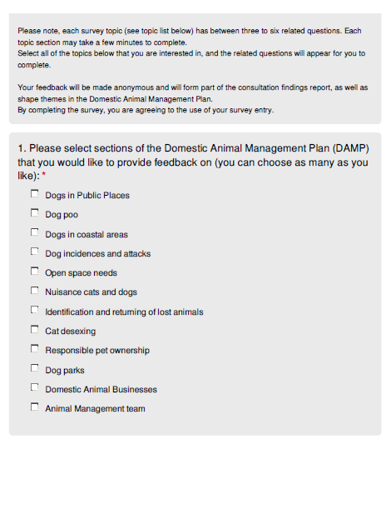

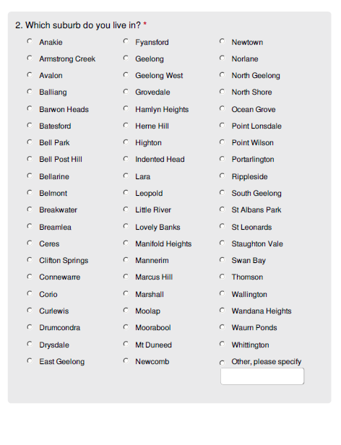

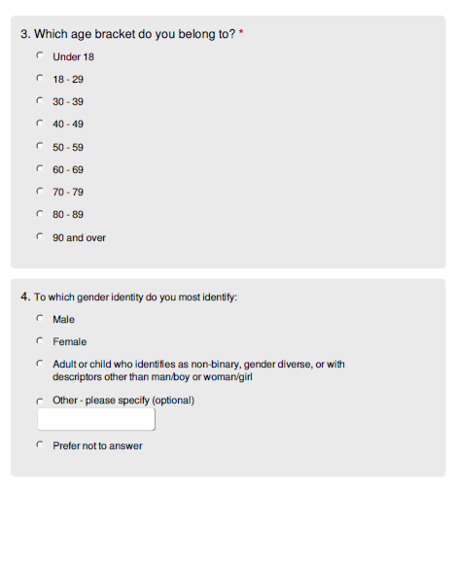

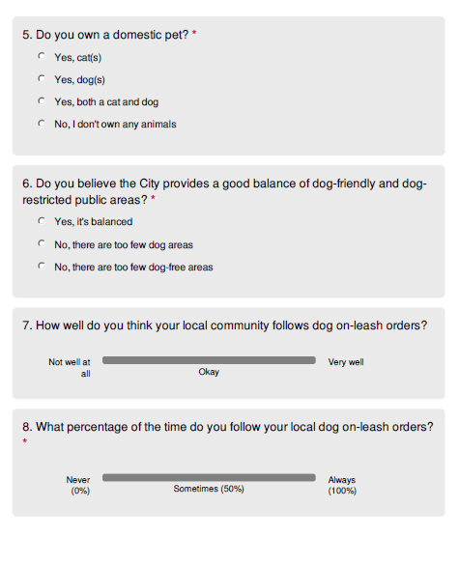

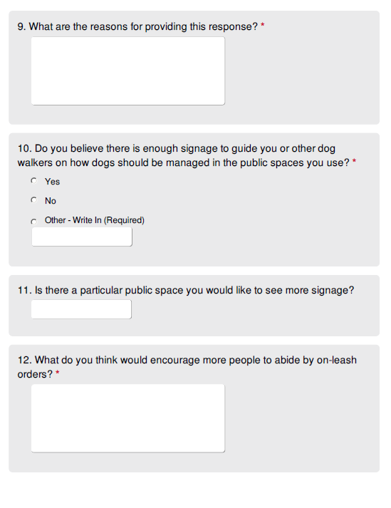

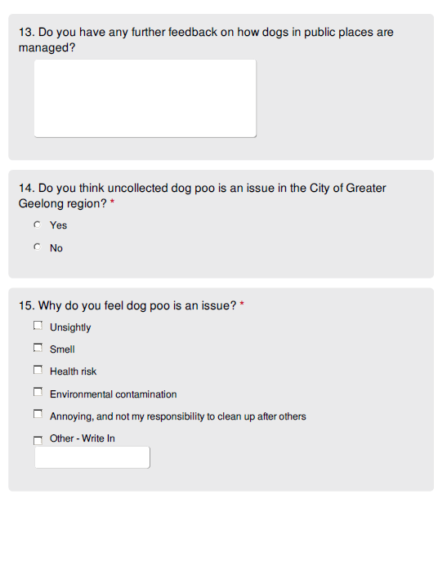

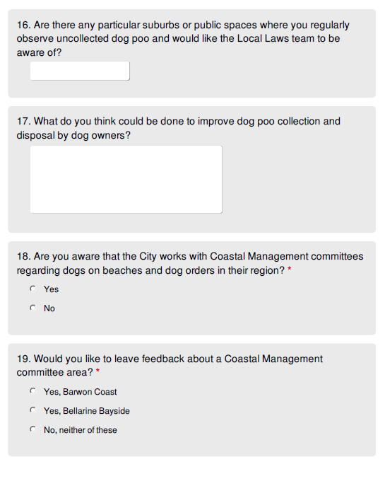

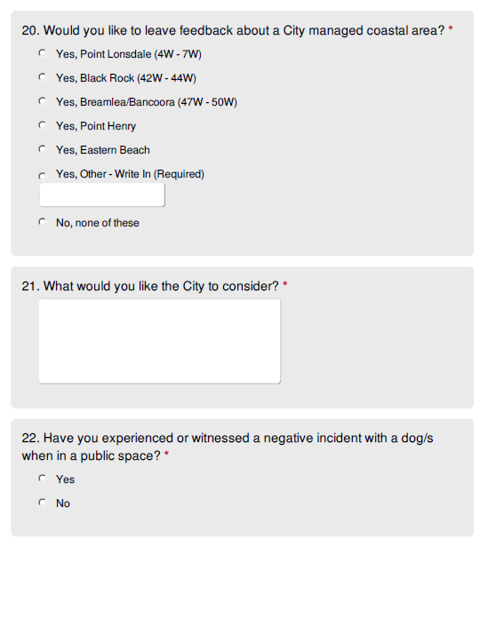

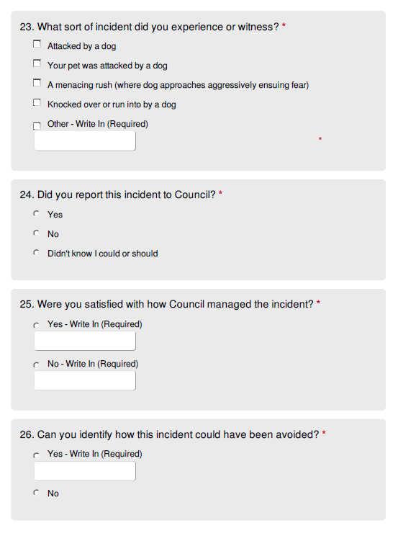

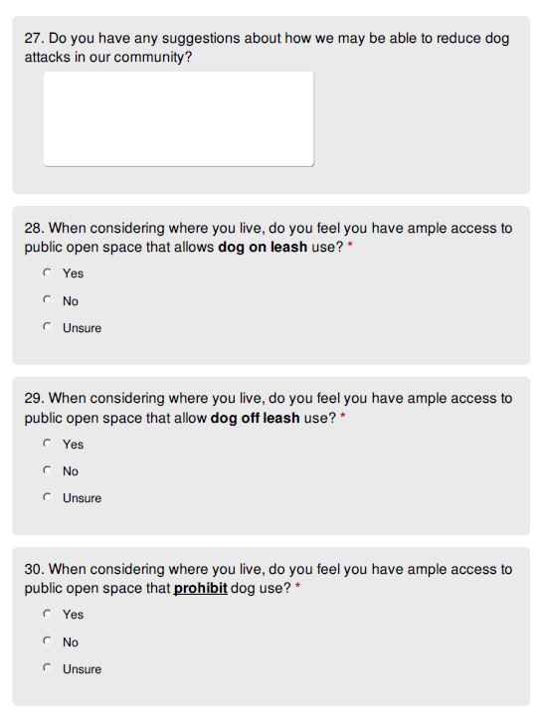

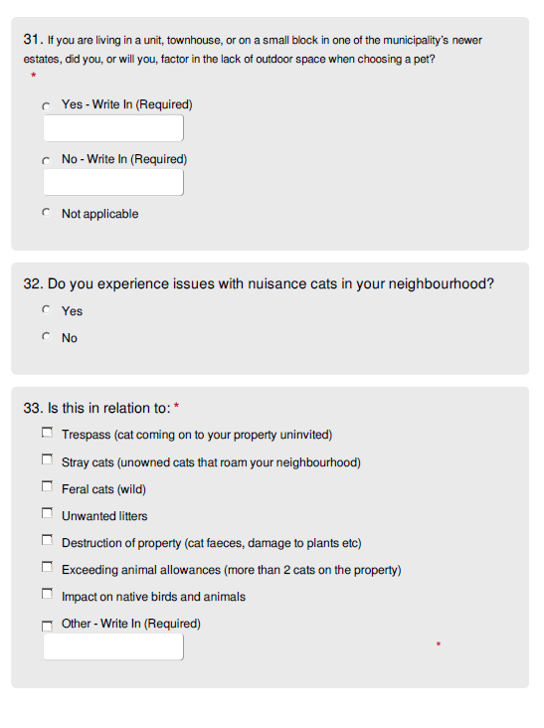

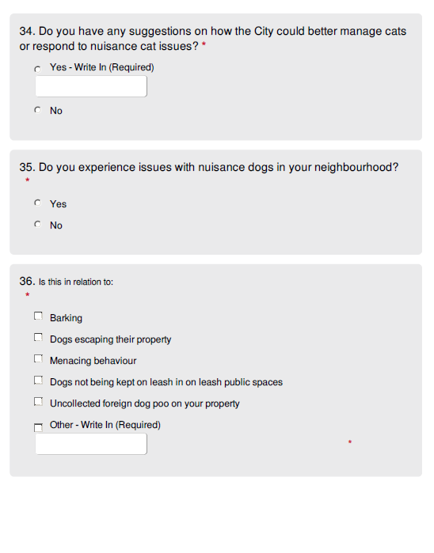

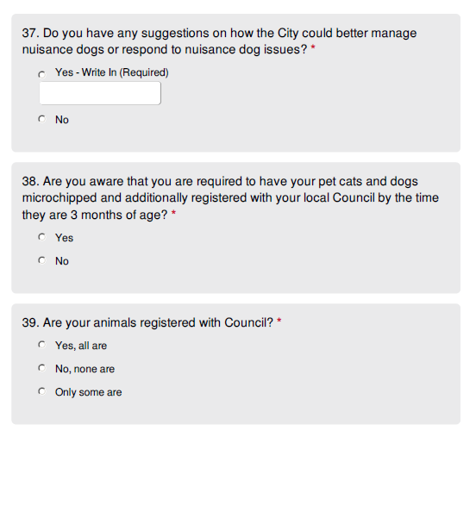

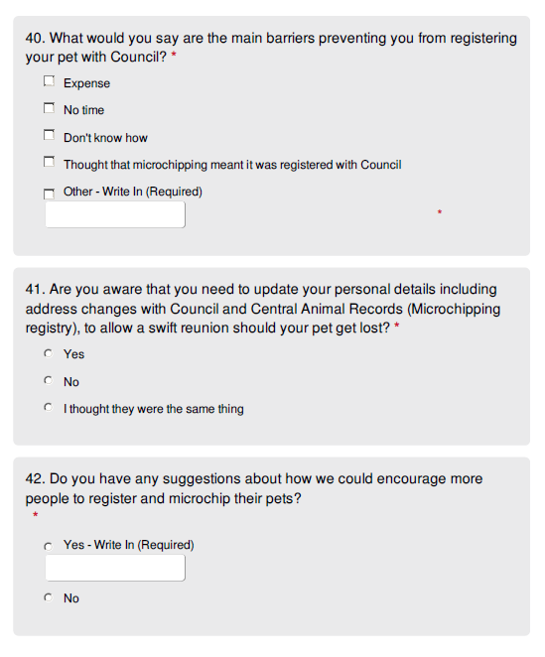

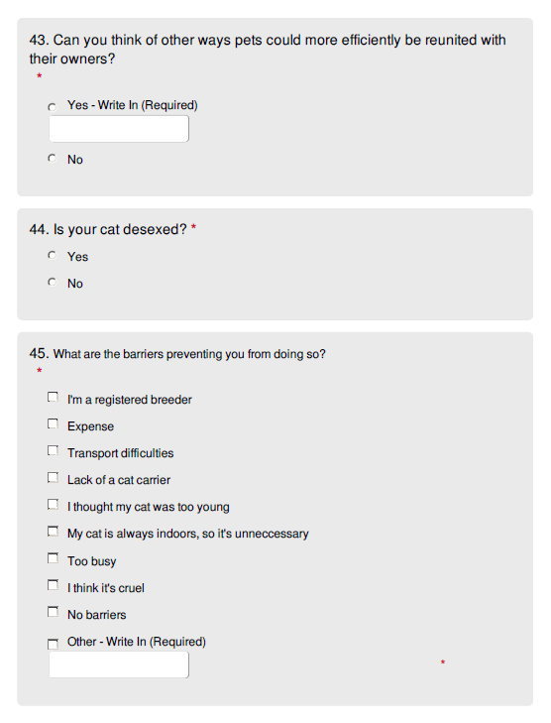

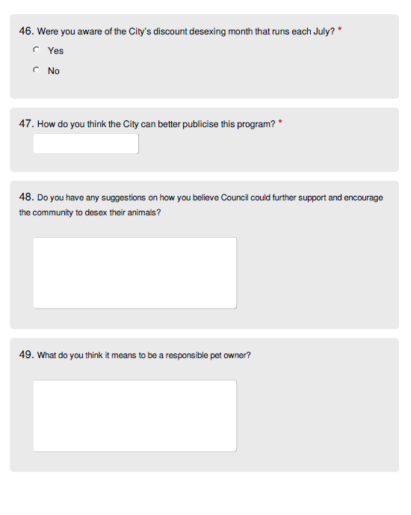

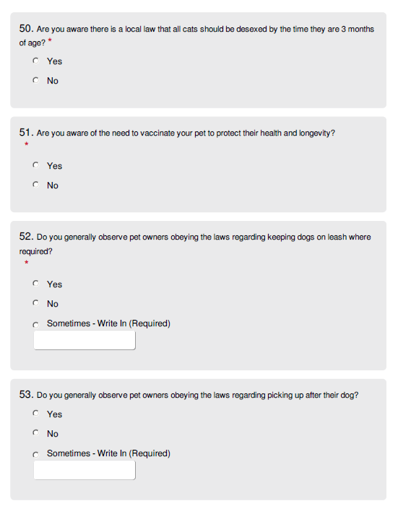

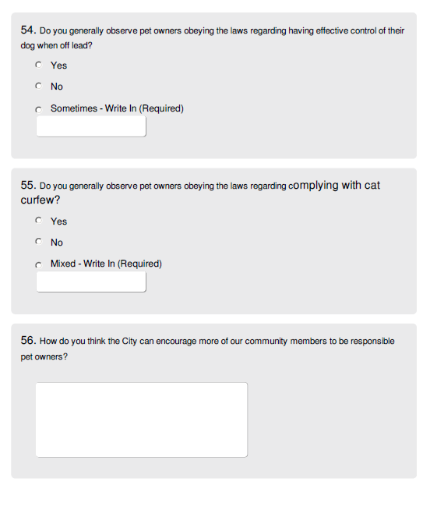

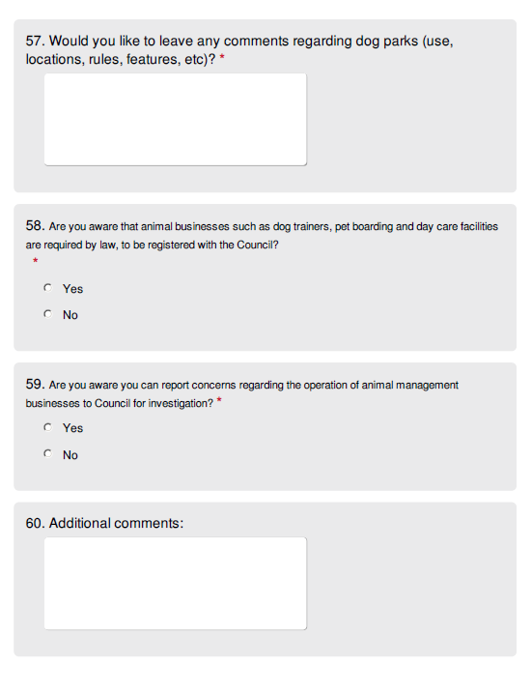

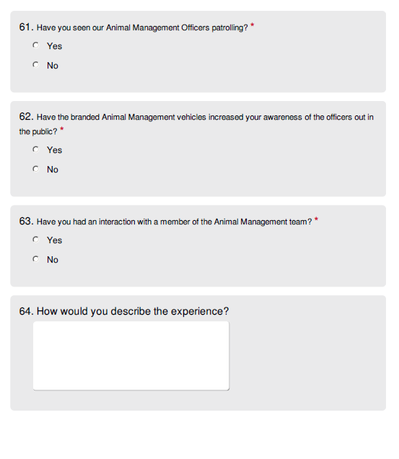

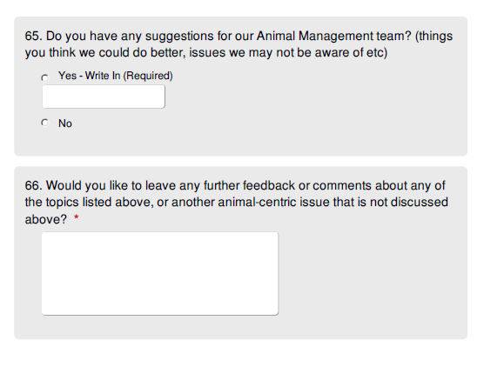

Engagement ACtivity 2 – HARDCOPY SURVEY

Only two hardcopy surveys were completed and submitted back to Council for consideration.

Unfortunately, one was not suitably filled in, and instead included a large block of text voicing issues they wanted to raise.

These comments have been included under all appropriate topics.

Participants lived in:

* Rippleside (1)
* Belmont (1)

Were in the age bracket of:

* 60 – 69 (2)

Identified as:

* Female (1)
* Male (1)

Stated they:

* Owned dog/s (2)

Wanted to leave feedback regarding

* Dogs in Public Places (1)
* Dog Poo (2)
* Dogs incidences and attacks (2)
* Open Space needs (1)
* Nuisance cats and dogs (2)
* Responsible pet ownership (1)
* Dog Parks (2)
* Animal Management team (1)

The following quantitative data was collected for each of the topics throughout the hardcopy survey:

### Dogs in public places

* Too few dog-free areas
* Community follows orders very well
* Participant always follows dog orders
* There is enough signage in the public spaces the participant uses.
* Education will encourage more people to abide by on-leash orders

### Dog poo

* Uncollected dog poo is an issue (2)
* It is unsightly, smells, poses a health risk, leads to environmental contamination and is annoying and not my responsibility to clean up.
* Place more bins along the western beach lower path and at the end of Rippleside pier.

### Dog incidences and attacks

* Yes, I have experienced or witnessed a negative dog incident in a public space
* My pet was attacked by a dog
* I did report this to council
* I was unsatisfied with the City’s handling of the incident as they were unable to follow up

This could have been avoided by restricting sales of dangerous dogs and providing owners with more education around breeds, pet behaviour etc

There has been no follow up on a dangerous German Shepherd I have reported in Belmont.

### Open space needs

* Ample access to on leash space
* Ample access to off leash space
* Ample access to dogs prohibited space

### Nuisance cats and dogs

* Yes, there are nuisance cats in my neighbourhood
* This is in relation to:
  + Trespass
  + Strays
  + Destruction of property
  + Impact on native birds and animals
* Enforce cat curfew laws
* No nuisance dog issues

“My dogs have been accused of nuisance barking. When I explained what was going on, the girl realised it was a nuisance complaint, made without a basis. The rangers make up their mind before contact is made with the owner. I don’t appreciate being told I am telling lies.”

### Responsible pet ownership

* I am aware of microchipping and registering my pets by 3 months of age
* My pets are all registered with Council
* I am aware I need to update microchipping details with CAR
* Being a responsible pet owner means providing them with love and discipline – the same as children
* I am aware vaccinating my pet protects their health and longevity
* I generally observe pet owners abiding by dog on leash orders
* I “sometimes” observe dog owners picking up their dogs’ poo
* I generally observe pet owners executing “effective control” over their dogs when off leash
* I do not generally observe cat owners complying with cat curfew
* Rippleside beach water is not suitable for humans to swim in, but good for dog swimming

“Dog owners on beaches, quite often are 100 metres or more away from their dog”

### Dog parks

“Dog parks are too small – This will only lead to incidences”

### Animal Management team

* I have seen Animal Management officers patrolling
* The branded vehicles have increased my awareness that they are in public
* I have interacted with Animal Management officers
* The experience was “Quite gruff and rude. Last year during Covid”

“Animal management team don’t listen to both sides when investigating.”

### Other comments:

“Dogs are being tied up at Supermarkets”

# Appendix B – Promotional materials for consultation

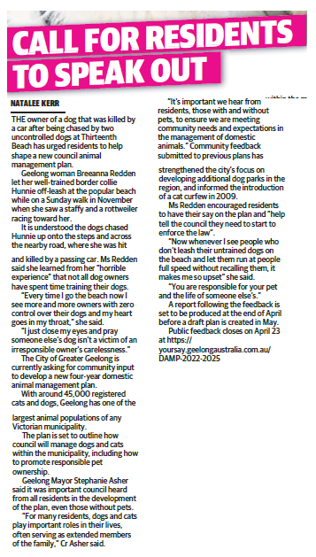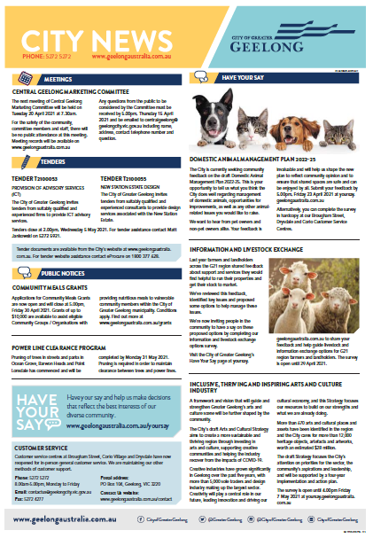

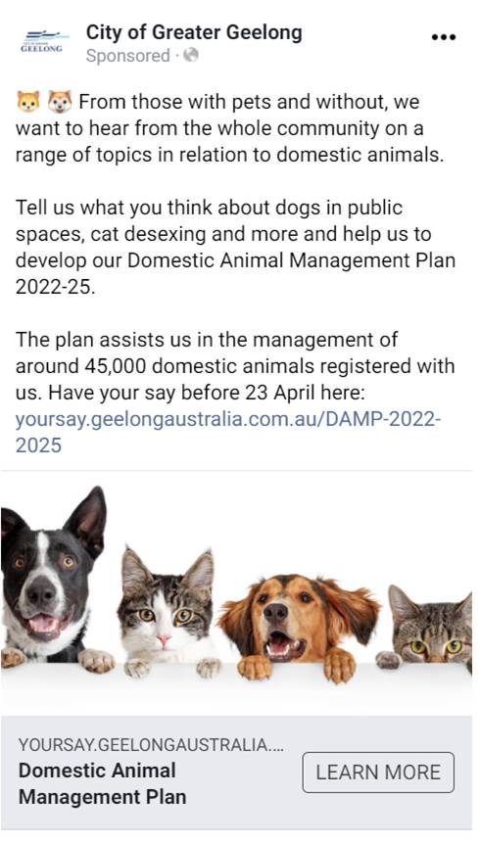

# Appendix C – Responses to “What does it mean to be a responsible pet owner?”

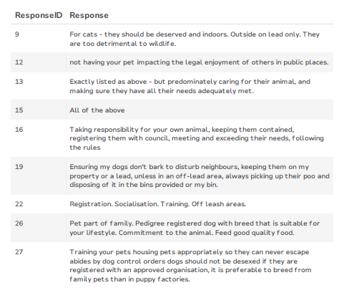

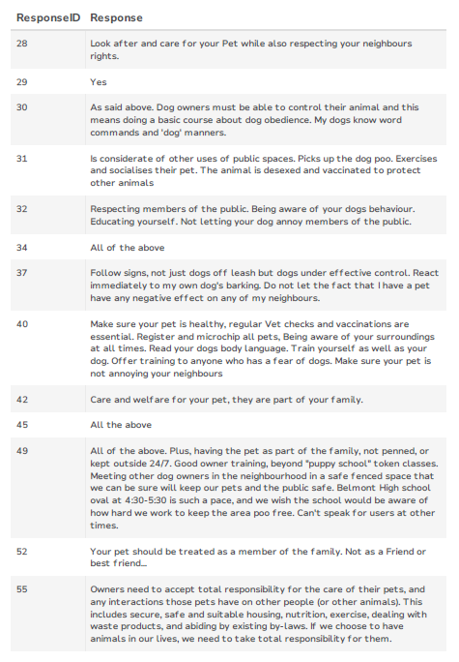

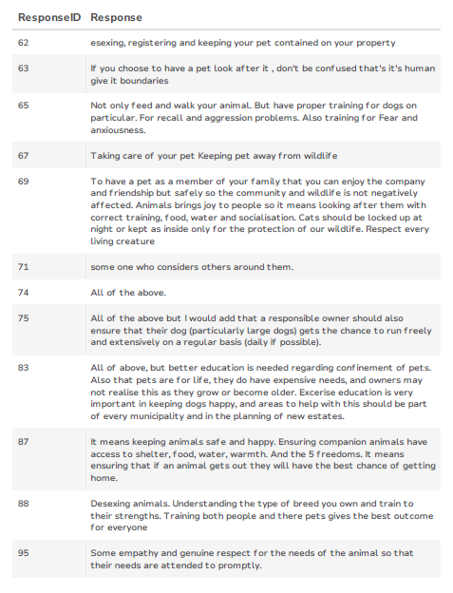

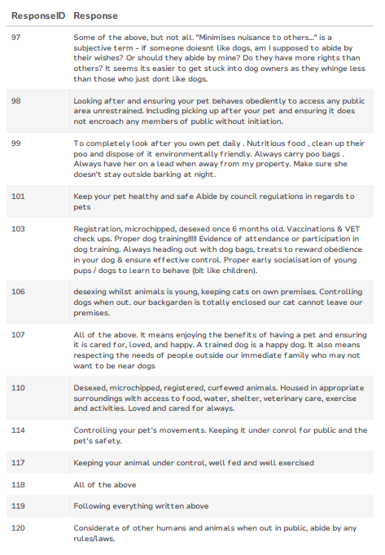

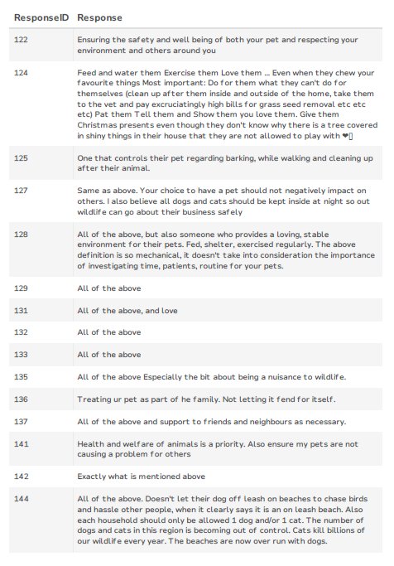

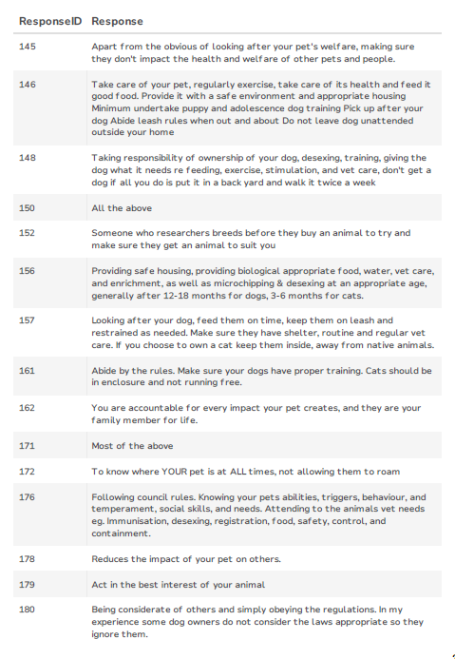

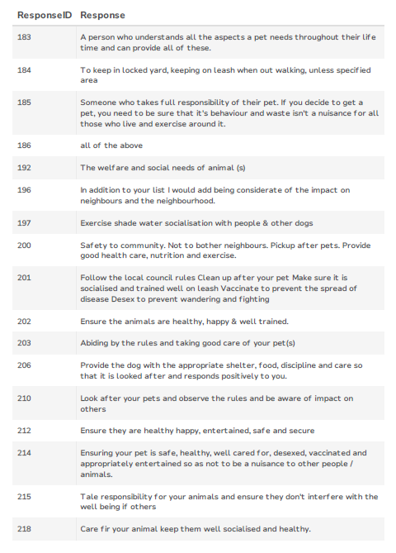

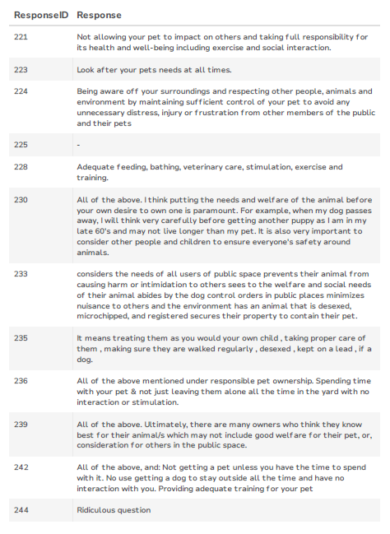

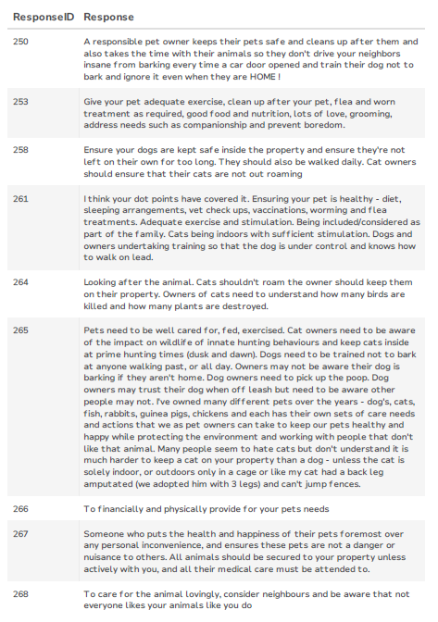

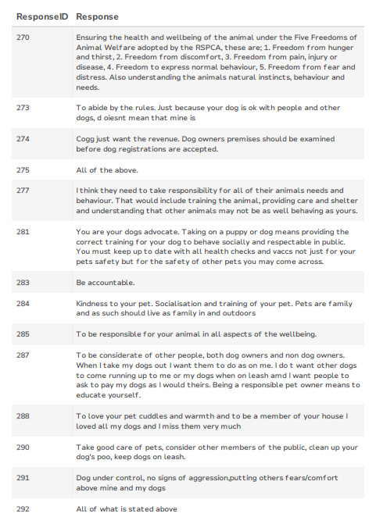

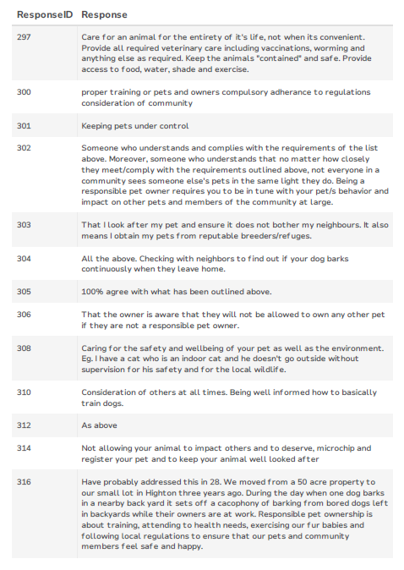

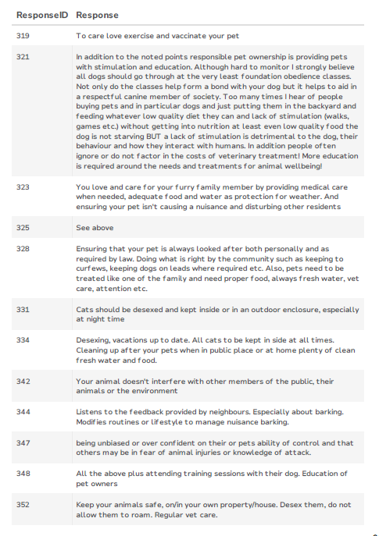

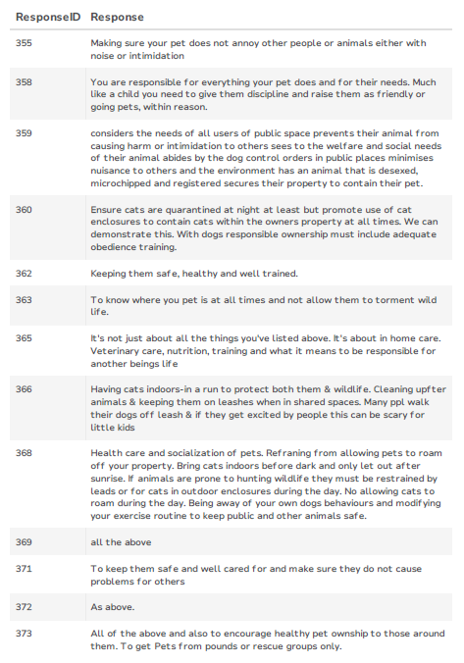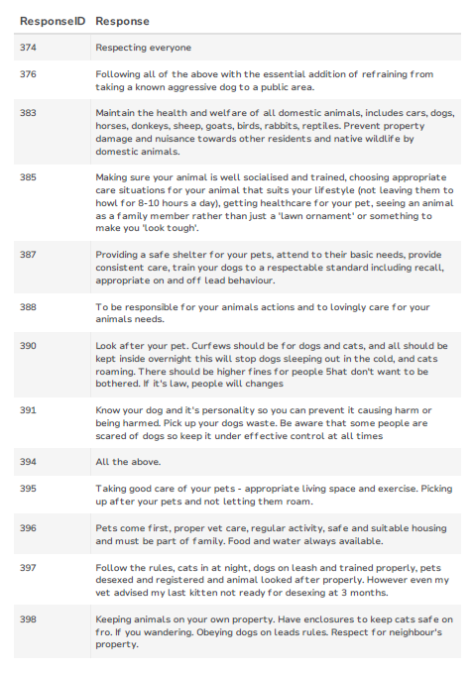

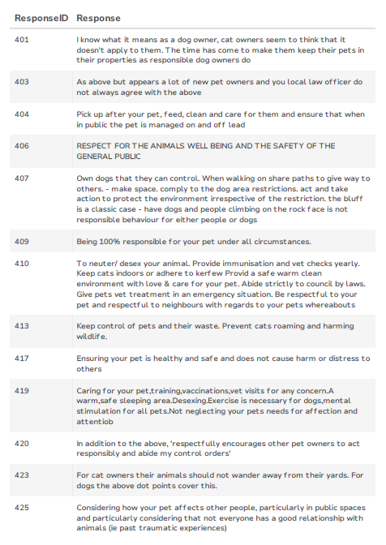

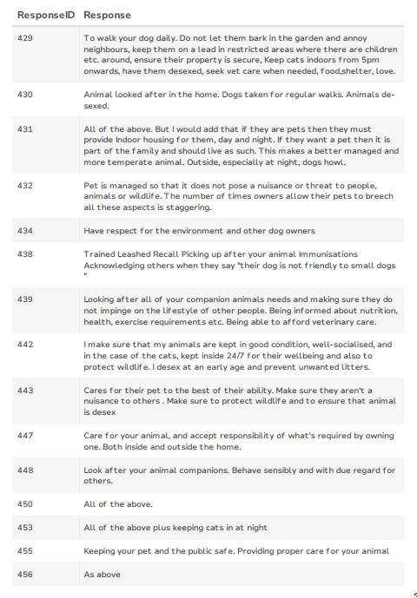

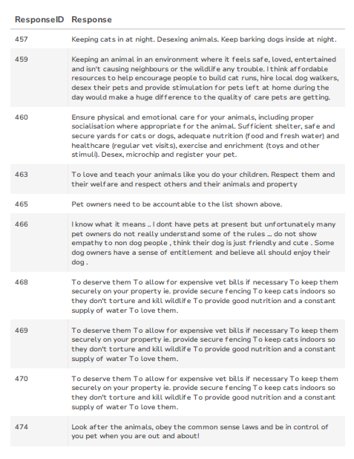

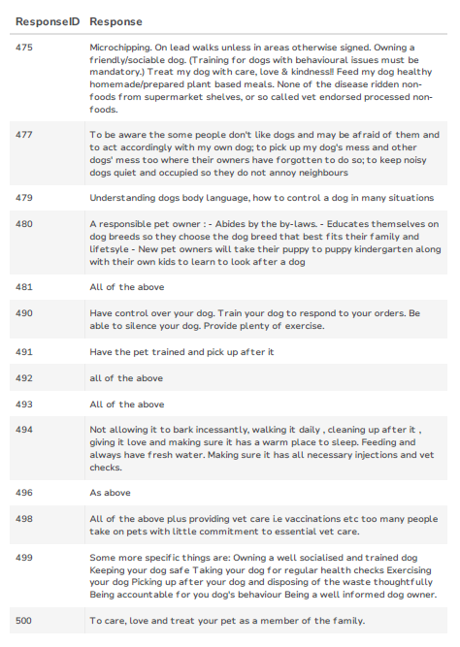

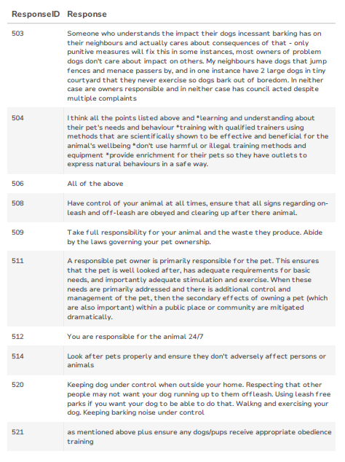

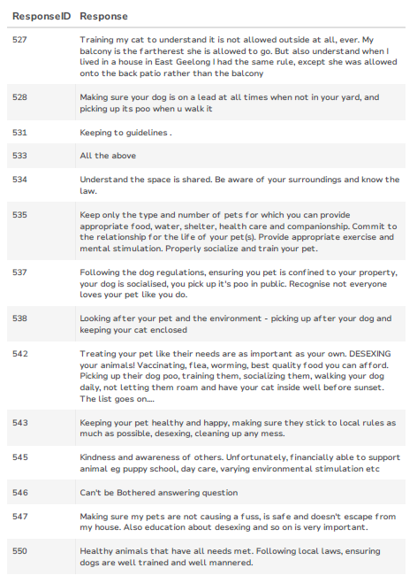

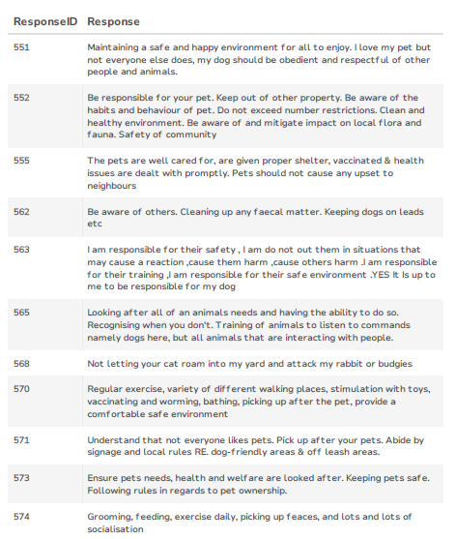

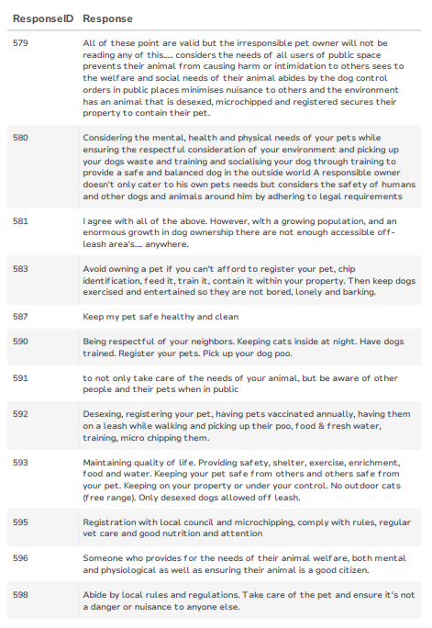

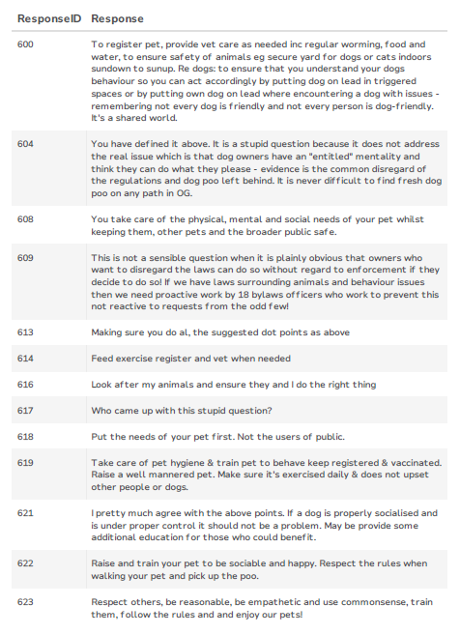

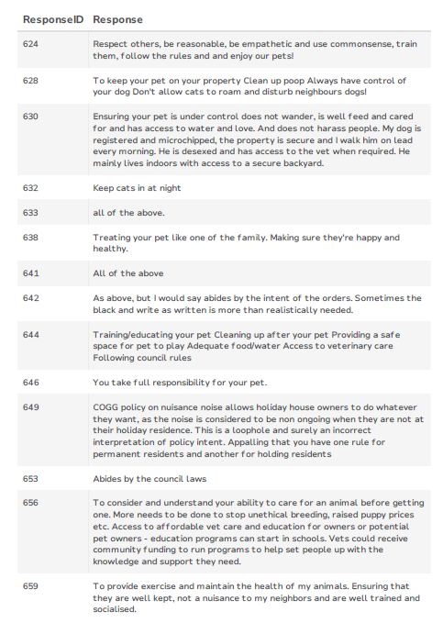

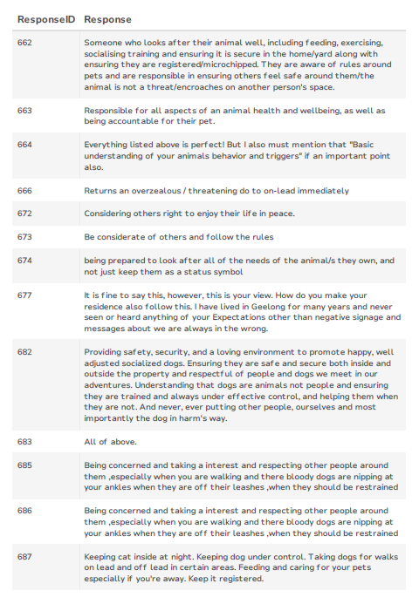

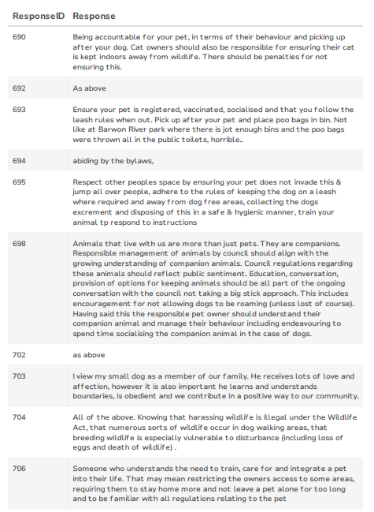

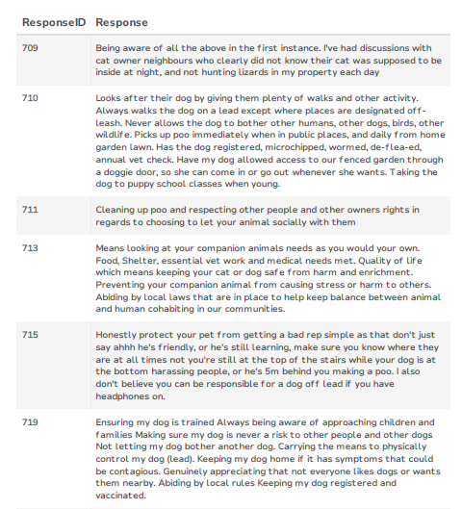

# Appendix D – Free-text comments

The following tables highlight the themes that came through for each of the open text questions.

|  |  |
| --- | --- |
| Themes: “sometimes” observe dog on leash orders being followed | Count |
| 50/50 | 17 |
| Minority refuse to comply | 17 |
| Not always on leads when they should be | 15 |
| Current on lead orders too restricted when parks are quiet | 11 |
| Regularly see dogs illegally off-leash | 10 |
| Barwon River poor compliance | 8 |
| Beaches are problematic | 8 |
| If dogs are under effective control, they should be allowed off leash anywhere | 7 |
| Illegally off-leash at Playgrounds | 4 |
| Lack of rangers = perpetrators don’t care | 4 |
| Rail Trail poor compliance | 3 |
| Eastern Beach problematic | 3 |
| Illegal off leash dogs create problems for on-leash dogs | 3 |
| Waurn Ponds trail poor compliance | 2 |
| Dogs should be on=leash everywhere | 2 |
| Those I witness off-leash are responsible | 2 |
| Dependent on location | 2 |
| Dog owners become aggressive when reminded of on-leash orders | 1 |
| Dogs often off lead when owner jogging | 1 |
| My dog needs off leash exercise | 1 |
| More off leash areas would improve compliance elsewhere | 1 |
| Visitors the issue, not locals | 1 |
| The Dell problematic | 1 |
| Rarely | 1 |
| Local parks with no signs used off-leash | 1 |
| Suburban streets | 1 |
| Blue Waters Lake poor compliance | 1 |

|  |  |
| --- | --- |
| Themes: “sometimes” observe owners picking up after their dog | Count |
| 50/50 | 24 |
| Owner behaviour dependant on others observing, time of day and location | 20 |
| More do than don’t - just | 19 |
| Watch owners deliberately leave it | 14 |
| Some owners don’t appropriately supervise their dog, and don’t see it poo | 10 |
| I haven’t seen people deliberately avoiding it, but some must by the amount uncollected | 8 |
| People don’t carry receptacles | 7 |
| Dump the poo bag rather than bin it | 5 |
| Need more bins at recreational areas | 4 |
| Locals do, visitors don’t | 4 |
| Men | 4 |
| I speak up if I see it | 3 |
| I see a lot of uncollected poo in my area | 3 |
| Nature strips worse than public ovals etc | 3 |
| Lara | 2 |
| Eastern Beach | 2 |
| Barwon River | 1 |
| Blue Waters Lake | 1 |
| Binning it in plastic is counterintuitive | 1 |
| Beach access tracks | 1 |
| Estuary | 1 |
| Dog owners aggressive when approached | 1 |
| Rail Trail | 1 |

|  |  |
| --- | --- |
| Themes: “sometimes” observe effective control of dogs when off lead | Counts |
| Most dogs I see have no recall | 35 |
| Less than 50% of the time | 12 |
| Owners distracted on phones etc, not supervising dog | 10 |
| Poor community understanding of what “effective control” is | 10 |
| Need more training | 8 |
| Most have control | 7 |
| Off leash dogs unwantedly approaching on lead dogs | 6 |
| Beaches | 5 |
| Inconsiderate owners think their dog is “good” and “friendly” when not under effective control and don’t realise impact on others | 5 |
| Not when near birds | 2 |
| Only effective control is when a dog is on lead | 2 |
| I avoid off leash areas because dogs are not under control | 1 |
| Injury sustained by an uncontrolled dog | 1 |
| Dogs are too far away from owners | 1 |

|  |  |
| --- | --- |
| Theme: “mixed” observation of pet owners obeying cat curfew | Count |
| Cat curfew mostly ignored | 48 |
| Mixed experience | 18 |
| Don’t see many cats roaming my neighbourhood | 9 |
| I abide, neighbours don’t | 8 |
| Unsure | 6 |
| Not sure what cat curfew is | 5 |
| Strays | 3 |
| Noticing improvement in responsible cat ownership | 3 |
| Perhaps sometimes owners can’t get their cats back inside before curfew starts? | 2 |

|  |  |
| --- | --- |
| Themes: Additional comments | Count |
| More education on responsible pet ownership | 28 |
| Stop cats roaming/introduce 24/7 curfew | 27 |
| More fines for those flouting the rules | 23 |
| Dog owners feel too entitled | 15 |
| More patrolling | 15 |
| Promote adoption over breeding/support rescues/foster care | 13 |
| Improve awareness and number of cat desexing programs | 13 |
| More poo bags and bins | 11 |
| More off leash areas | 11 |
| More bird specific signage and protection | 10 |
| Dog parks are a great community asset – need more | 10 |
| Improve barking dog process | 10 |
| More AMOs needed | 9 |
| Most dog owners are responsible | 8 |
| Entire animals found off property should be desexed automatically before release | 8 |
| Dog restricted summer season too long on beaches | 7 |
| More signage | 7 |
| More responsibility/restrictions on breeders | 6 |
| Too much aggression both ways between dog and non-dog owners | 5 |
| Commercial racehorses off beaches/make horse owners collect their horses’ poo | 5 |
| Bigger fines for uncollected dog poo | 5 |
| Encourage more dog-friendly businesses in Geelong | 5 |
| Report on real pound/animal/cost stats | 4 |
| Cats destroying birdlife | 4 |
| Domestic Animals should include birds, reptiles, rabbits, horses etc | 4 |
| Repeat behavioural assessments in pounds | 3 |
| Dogs off leash where they shouldn’t be | 3 |
| Ensure owners get contacted promptly when pets are lost and found | 3 |
| Dog owners inconsiderate of others’ space/needs | 3 |
| More swimming access for dogs | 3 |
| Dogs should be on lead everywhere | 2 |
| More attention paid to the social benefits of pets and off leash areas | 2 |
| More balance between human needs and animal needs | 2 |
| Cyclists are dangerous and should be held accountable | 2 |
| Grass moving at dog-friendly reserves | 2 |
| Dedicated dog park in Geelong West | 2 |
| Greyhound off leash space | 2 |
| Single use plastic bags should not be provided by council | 2 |
| Discount rego for proven responsible pet owners (desexed, microchipped, cat enclosure, training complete etc) | 2 |
| Council fees too high | 2 |
| “Blitz’s” with public forewarning | 2 |
| Why need a multi animal permit for 3 animals? Not consistent with other councils. Should be issued prior to obtaining animal also | 2 |
| Stray/feral cat management program and education | 2 |
| Every drink fountain to have dog bowl at base | 2 |
| Council too controlling on pet owners’ rights to keep entire pets etc | 2 |
| More community input to dog off-leash/on-leash and prohibited areas | 1 |
| Sign cohesiveness between City and management authorities | 1 |
| Cooperative use of school ovals after hours | 1 |
| Abolish puppy farms | 1 |
| Upgrade Stead Park |  |
| Have Council owned shelter | 1 |
| Black Rock to be dog off leash area | 1 |
| Dog park use education | 1 |
| Cats should not be left unattended in vet clinics over weekends | 1 |
| Water station required on west Waurn Ponds trail | 1 |
| Swifter action from Council | 1 |
| Work with the dog-owner community | 1 |
| Why is puppy desexing before rego not compulsory | 1 |
| Remove 1080 poison from use | 1 |
| Support for pets of the homeless | 1 |
| Too many coastal signs | 1 |
| Cheaper fees for seniors | 1 |