Portarlington Recreation Reserve

Ecological assessment to inform Master Plan

Prepared for
City of Greater Geelong

October 2020

Contents
Contents 2
Introduction 4
Study Area 4
Methodology 5
Taxonomy 5
Literature and Database Review 5
Strategic context and previous studies 5
Field Survey 7
Defining Significance 7
Results 8
Ecological Vegetation Class 8
Vegetation Description 8
Broad Vegetation Communities 9
Area 1 – Golden Wattle dominated Woodland 9
Area 2 - Lightwood dominated Woodland 10
Area 3 - Spiny Mat-rush dominated open sedge/grassland. 11
Area 4 - Common Reed dominated wetland 12
Area 5 - Brackish Sedge Wetland 13
Area 6 - Manna Gum dominated woodland 14
Area 7 – Highly disturbed areas 15
Flora significance 17
Fauna significance 17
Overall Significance 18
4 Risks to Values 19
Evaluation: 22
Recommendations 23
Weed management 23
Biodiversity management 23
Collaborative management 24
Water and wetland management 24
Connecting the community to nature 24
Appendix 1 - ASSESSING CONSERVATION SIGNIFICANCE 26
Appendix 2 Indigenous Plant Species recorded July 14 2020 and Conservation Significance 27
Appendix 3 Exotic Plant Species recorded July 14 2020, Life Form and Threat Level 29
References 32
Plates 1-6 Vegetation existing conditions 33

Disclaimer
Although all the necessary steps to ensure that an accurate document has been prepared, no liability is accepted for any damages or loss incurred as a result of reliance placed upon the report or its contents.

Introduction

This report was commissioned by the City of Greater Geelong (CoGG) to provide an assessment of the current conservation significance of the indigenous vegetation of the Portarlington Recreation Reserve.

Project objectives:
- Collate all known environmental values in the reserve and provide an indication of the significance of those values.
- Identify other potential values based on EVC and habitat that could potentially exist.
- Discuss the overall strategic significance of the reserve from a landscape and bioregional perspective highlighting the relationship and connectedness with the Point Richards flora and fauna reserve and foreshore.
- Discuss the collective size that block creates when combined with Point Richards and the relevance of that for the Bellarine, referencing other strategic biodiversity strategies and distinctive landscape recognition.
- Discuss changes in condition over last 10 years.
- Identify key threats to the values such as weeds (including weeds of national significance), pest animals, disturbance, fire and dogs.

Study Area
Portarlington Recreation Reserve (38.5 ha) is a City of Greater Geelong managed Reserve located to the east of the Point Richards Flora and Fauna Reserve (Figure 1) at Portarlington. The subject of this assessment is the western area of the Reserve (approximately 25 ha), specifically the area that is comprised in the main of native vegetation (highlighted in yellow).

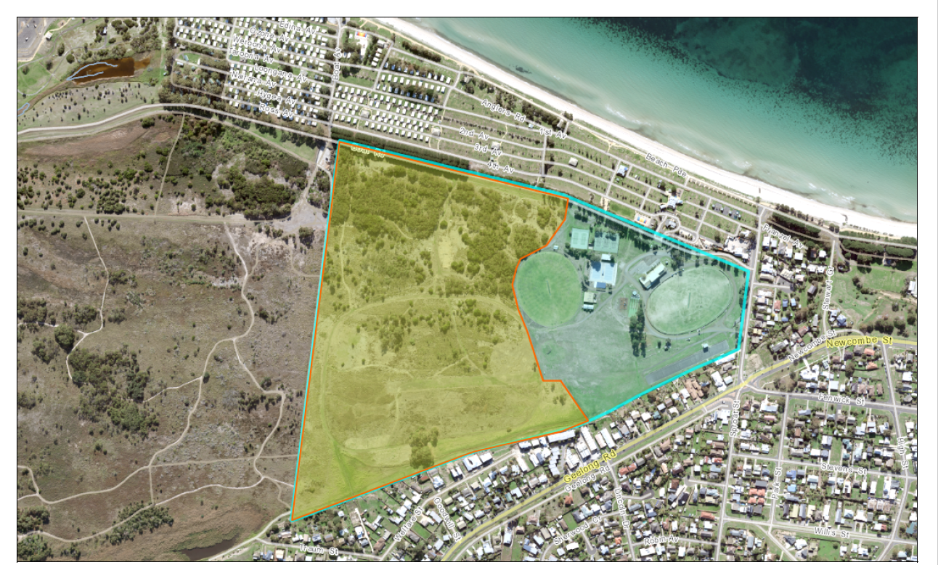
Figure 1. Study area location.

Methodology
The project involved a review of relevant data and literature and a single site field survey to understand the values and significance of the area.

Taxonomy
Scientific names for plants follow the Flora of Victoria (RBG website). Common names for plants follow the Flora of Victoria Vols 2-4 (Walsh and Entwisle 1994-1999).

Literature and Database Review
Relevant literature, online resources and databases were reviewed to provide an up to date assessment of ecological values associated with the study area and surrounds, including:

- The Victorian Department of Environment, Land, Water and Planning (DELWP) NVIM tool (DELWP website ii) for:
  - Modelled data for remnant vegetation patches and habitat for rare or threatened species and
  - the extent of historic and current Ecological Vegetation Classes (EVC)s.
- The Victorian Biodiversity Atlas (VBA) (DELWP website iii) for previously documented flora and fauna records within the project locality (to approximately 10 kilometres of the study area).
- Aerial photography of the study area (Google maps).

Strategic context and previous studies
The City’s Environment Strategy 2022-2030 guides planning, decision-making and actions that aim to improve the health of the local environment, reduce the Cities environmental footprint and protect the lifestyle the community enjoys. The strategy and supporting action plan have been informed by local and international environmental trends, and by the knowledge and ideas of the community and regional stakeholders.
One of the 5 goals is to:
- Protect, enhance and restore our region’s biodiversity.
As part of the strategy, one of the key targets is to:
- Establish conservation protection for all remnant biodiversity patches larger than 10 hectares by 2025.
Key actions of the strategy that are relevant to this report include:
- Review and update the biodiversity strategy
- Ensuring planning controls provide strong protection for biodiversity
- Undertake assessments to identify, protect and manage existing biodiversity values.
This assessment and report on the environmental values of the Portarlington Recreation Reserve will directly contribute to the overall objectives of these strategies.
The City of Greater Geelong prepared a biodiversity strategy in 2003 which highlighted that ‘Land use impacts, predominantly for agriculture and more recently industrialisation and urbanisation, have reduced the pre-European biodiversity of the region to a fraction of that which formerly existed. It is conservatively estimated that about only 5% of former pre-European indigenous vegetation exists in the City of Greater Geelong and that which remains is often severely degraded’.
The 2003 biodiversity strategy identified several strategic objectives and a hierarchy of conservation assets. The study area within the Portarlington Recreation Reserve aligns with a Secondary Biodiversity Conservation Area, recognizing the role that parks and open space play in conserving a paucity of biodiversity assets. The reserve has been mapped as a biodiversity site within a primary biodiversity zone in figure 2.0 that highlights the lack of remnant vegetation on the Bellarine Peninsula and the significant role the reserve can play.
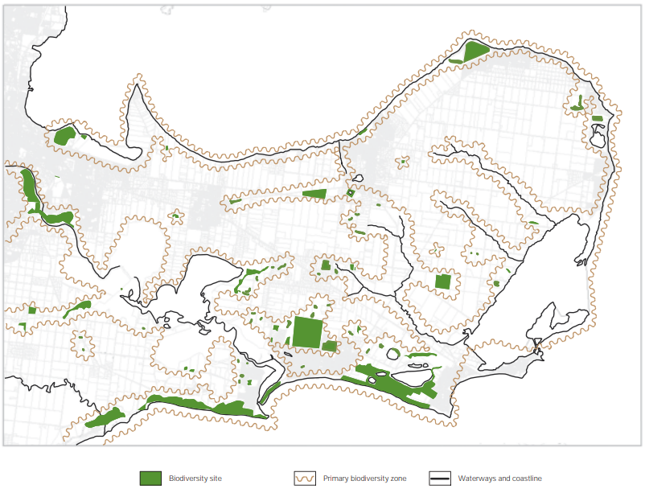
Study area
Figure 2.0 – Biodiversity map East

In 2018 the Victorian Government passed legislation to recognise and protect the states distinctive areas and landscapes. This was done through the Planning and Environment Amendment Act (Distinctive Areas and Landscapes) Act 2018. The Bellarine Peninsula was identified as a Distinctive Area landscape to protect the environment, landscape and lifestyle of the area. The department of Environment, Land, Water and Planning is developing a Statement of Planning Policy to help identify the measures to implement the legislation.

Other previous studies undertaken for his reserve and the adjacent Flora and Fauna Reserve include the following:
- Bellarine Bayside Vegetation Management Plan (Mark Trengove Ecological Services 2015).
- Fire Management Plan Point Richards Flora and Fauna Reserve and Portarlington Recreation Reserve (Peter Moulton Western Ecological Consultants and Mark Trengove Ecological Services 2005).
- Point Richards Flora and Fauna Reserve and Portarlington Recreation Reserve Vegetation Communities Plan (Thompson Birrell Landscape Design and Mark Trengove Ecological Services 2004).
- The City of Greater Geelong Biodiversity Management Plan (Ecology Australia 2001) assessed the study area as having State conservation significance for the large population of Austral Crane’s-bill and for the tree form of Silver Banksia. It appears the Silver Banksia is no longer extant in the Reserve.

Field Survey
The site was inspected on foot on the 14th of July 2020. The entire site was traversed. Records were made of all indigenous vascular plant species. Records were made of the dominant exotic vascular plant species. The location of native vegetation communities was mapped. Native vegetation communities were photographed.

Defining Significance
A number of criteria are applied in order to assess the significance of flora species and vegetation communities. The definition of the criteria is detailed in Appendix 1.

Results

Ecological Vegetation Class
Ecological Vegetation Classes (EVCs) are the primary level of classification of vegetation communities within Victoria. An EVC contains one or more plant (floristic) community and represents a grouping of vegetation communities with broadly similar ecological attributes. Classification of EVCs in this report follows Oates and Taranto (2001).

The pre-1750 EVC mapping of the study area undertaken by Department of Environment, Land, Water and Planning (DELWP) (DELWP website iii) indicates that the study area and immediate surrounds were comprised of the following EVCs:
- EVC 3 Damp Sands Herb-rich Woodland.
This assessment finds that the study area is comprised of partially intact to relatively intact native vegetation that accords with the EVC 3 Damp Sands Herb-rich Woodland, EVC 821 Tall Marsh and EVC 891 Plains Brackish Sedge Wetland.
Each EVC has a determined bioregional conservation significance (DSE Website iii). The bioregional conservation status of the extant EVCs is provided as follows in Table 1.

Table 1 EVCs recorded for the study area and Bioregional Conservation Significance
EVC | BCS (Otway Plain)
3 Damp Sands Herb-rich Woodland | Vulnerable
821 Tall Marsh | Vulnerable
891 Plains Brackish Sedge Wetland | Vulnerable

Vegetation Description
The vegetation of the conservation area mostly consists of a continuous area of relatively intact vegetation that conforms to EVC 3 Damp Sands Herb-rich Woodland within the northern and central areas.
The Northern area, subjected to an ecological/fuel reduction burn in (Dec 2007) is dominated by now mature Golden Wattle with a relatively intact understorey dominated by Spiny Mat-rush.
The central area is dominated by mature Lightwood with a relatively intact understorey dominated by Spiny Mat-rush. Further south the central area is dominated by more open Spiny Mat-rush dominated vegetation with occasional trees including one population of Coast Manna Gum.
To the south are areas of more disturbed areas dominated by exotic plant species as well as damper areas dominated by Common Reed (EVC 821 Tall Marsh) and sedges and herbs (EVC 891 Plains Brackish Sedge Wetland) as well as one population of Coast Manna Gum.
Evident within the central sector is the extensive amount of weed management that has been undertaken (in particular removal of the woody Flax-leaf Broom [as is also the case in the Flora and Fauna Reserve] and the Kikuyu that was planted in association with the previous horse tracks) as well are revegetation and rationalization of the track network in keeping with the CoGG Works Plan. These works have led to an increase in vegetation quality.
Refer to Figure 2 for the distribution of extant vegetation communities.

Broad Vegetation Communities

Area 1 – Golden Wattle dominated Woodland
Description | Image
This area is characterised by relatively intact native vegetation with a canopy of Golden Wattle of similar age and is in the best condition overall. It is likely that an ecological and fuel reduction burn undertaken in the reserve circa 2007 stimulated the seedbank. There is no eucalypt tree canopy cover but there is quite a diverse and intact understorey.  This area has previously been infested with Flax-leaf Broom but an active control strategy over recent years has removed most of those woody weeds. Some remain along with other environmental weeds such as Sallow Wattle and a mixture of grassy weeds along the more disturbed track edges.  The area is rated as in Good condition | 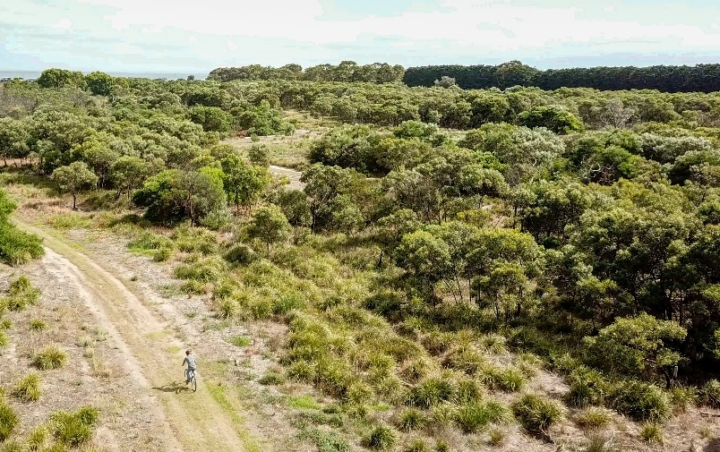  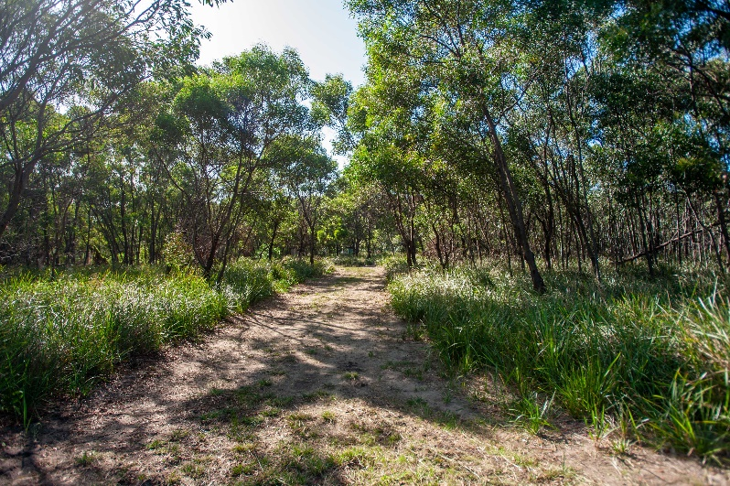

Key recommendations:
- Monitor regeneration and continue weed management.
- Continue the control of woody weeds, particularly the Flax-leaf Broom.
- Focus on regeneration of areas where woody weeds have been removed.
- Address Sallow Wattle as significant weed.
- Re-introduce Silver Banksia.

Area 2 - Lightwood dominated Woodland
Description | Image
This area is characterised by relatively intact native vegetation with scattered Lightwoods presenting as the only canopy tree. There is no eucalypt tree canopy cover. The understorey is dominated by Spiny Mat-rush with some diversity of other native species.  The lack of canopy and inter-tussock spaces means this area is slightly more disturbed.  This area has previously been infested with Flax-leaf Broom but an active control strategy over recent years has removed most of those woody weeds.  Some remain along with other environmental weeds such as Sallow Wattle and a mixture of grassy weeds along the more disturbed track edges.  The area is rated as in Moderate to Good condition | 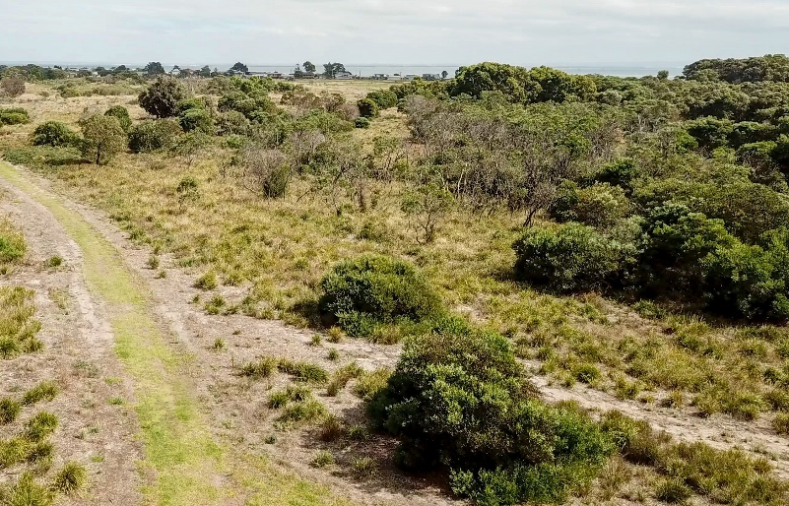  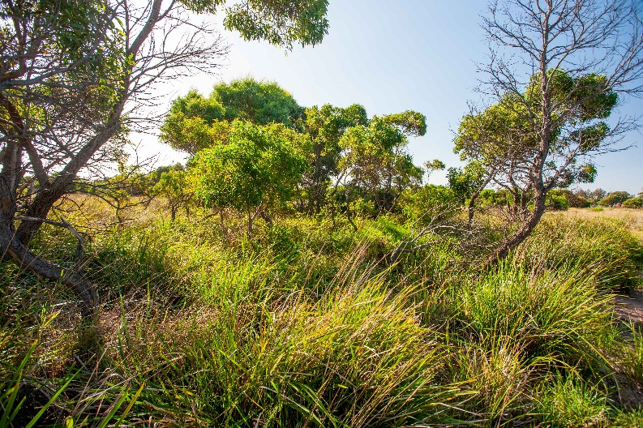

Key recommendations:
- Monitor regeneration and continue weed management.
- Continue the control of woody weeds, particularly the Flax-leaf Broom.
- Focus on regeneration of areas where woody weeds have been removed.
- Address Sallow Wattle as significant weed.
- Re-introduce Silver Banksia.

Area 3 - Spiny Mat-rush dominated open sedge/grassland.
Description | Image
This area is largely an understorey dominated by Spiny Mat-rush, native grass tussocks and other sedges and is relatively intact and in fair to good condition. Scattered Lightwood and Golden Wattle exist, and this area surrounds a patch of Manna Gum identified as a separate area. A greater number of introduced weeds are present in this block.  It represents a transition from the more highly disturbed area 7 towards area 1 and 2 where more middle storey and canopy wattles exist.  Previous woody weed control has been largely successful with grassy weeds such as Kikuyu along trails also contained.  The area is rated as in Moderate condition | 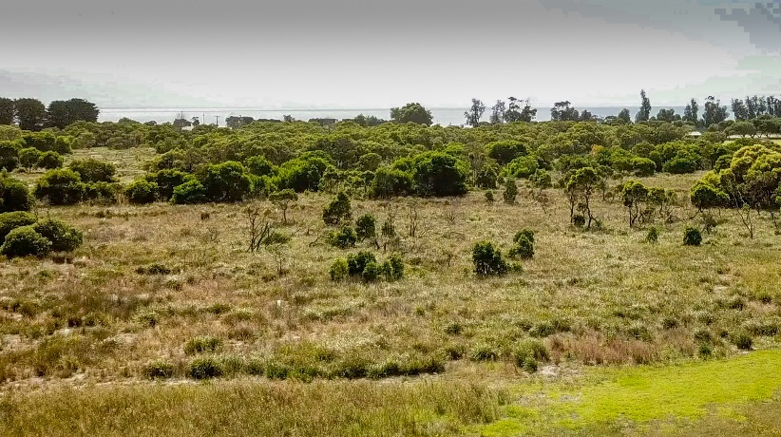  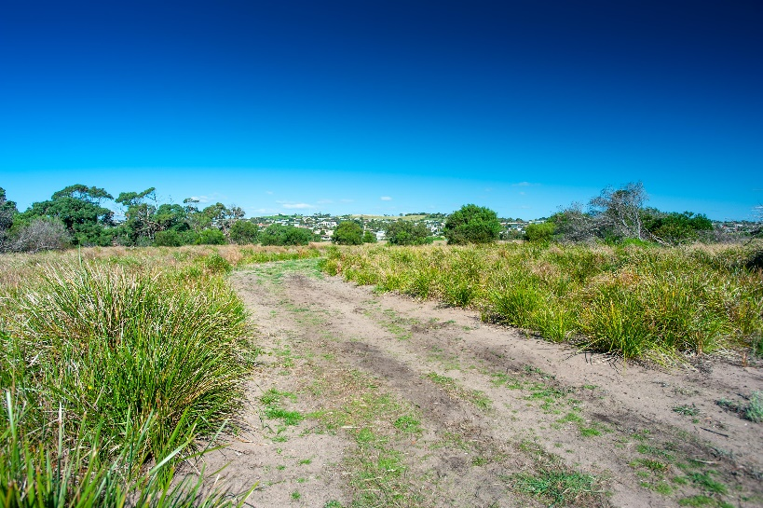

Key recommendations:
- Monitor regeneration and continue weed management.
- Continue to control Kikuyu along former Pony trails.
- Continue the control of woody weeds, particularly the Flax-leaf Broom.
- Focus on regeneration of areas where woody weeds have been removed.
- Address Sallow Wattle as significant weed.
- Maintain as predominately open vegetation with limited woody large shrubs/trees.
- Biomass control/ use of fire/ use of herbicide

Area 4 - Common Reed dominated wetland
Description | Image
This flat and slightly low-lying area is a wetland dominated by Common Reed. It is surrounded by areas of Spiny Mat-rush dominated Sedgeland/Grassland. Although the wetland is located away from the southern edge of the reserve and the water channels dug along its edge have become dominated by weeds, it still retains soil and water characteristics suitable for this community.  The area is rated as in Poor to Moderate condition with low diversity. | 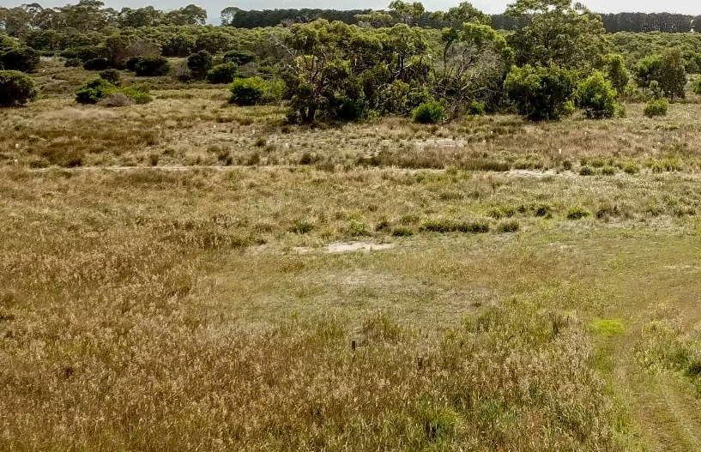

Key recommendations:
- Monitor regeneration and continue weed management.

Area 5 - Brackish Sedge Wetland
Description | Image
The Brackish Sedge Wetland is a relatively degraded vegetation community located within the lower lying areas at the south of the study area. In the survey it was difficult to confirm the distribution due to high weed cover. The extent of this community is likely constrained by variations in soil conditions and drainage modifications across the southern end of the site.  The area is rated as in Poor condition with low diversity. | 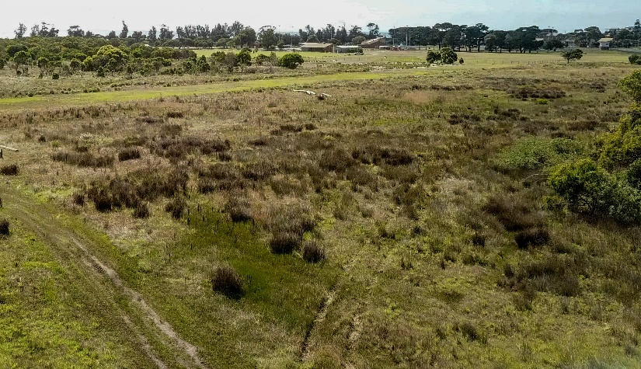

Key recommendations:
- Monitor regeneration and continue weed management.

Area 6 - Manna Gum dominated woodland
Description | Image
Manna Gums Eucalyptus viminalis ssp. pryoriana rather than Messmates are the only Eucalypt species at the site. Manna Gums are associated with EVC 3 as the canopy species in the Benchmark for the Warrnambool Plain bioregion so arguably could represent the canopy species at this site instead of Messmate.  Manna Gums also occur in the adjoining Point Richards Flora and Fauna Reserve.  The Manna Gums occur in two distinct and separated patches in the southern half of the precinct with relatively few individuals in each patch. They consist of a mixture of mature trees and some younger plants. The canopies are in good health except one individual.  They are a striking difference, adding significant change in structure, to the vegetation throughout the rest of the precinct. There is limited diversity of indigenous understorey but also few weeds.  The area is rated as in good condition with low diversity | 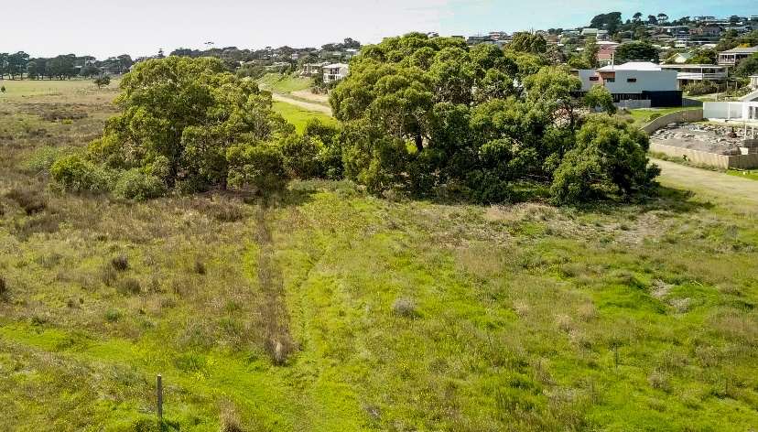  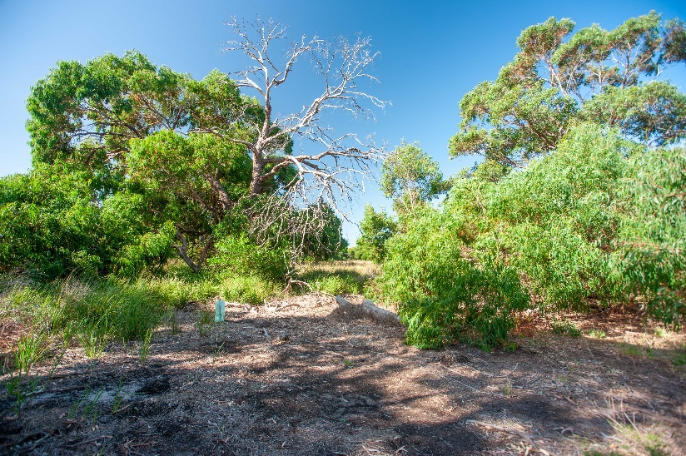

Key recommendations:
- Monitor regeneration and continue weed management.
- Expand into revegetation area and to form link with Point Richards FFR

Area 7 – Highly disturbed areas
Description | Image
Significant sections around the southern part of the precinct are dominated by exotic species, Kikuyu which has smothered other vegetation to create virtual monocultures. In other areas a range of other exotic species dominate with pockets of native vegetation surviving.  These areas are associated with higher levels of disturbance from past uses ranging from a racecourse, cross country horse track and overflow parking use. Sections have been treated through an active spraying program to reduce the weed cover and are transitioning to a Spiny Mat-rush dominated open sedge/grassland.  There is also evidence of changed hydrological regimes with a drainage channel running along the southern boundary.  This boundary is also the boundary with residential dwellings with increased weed risks coming from gardens.  A wide swathe within this area remains as a slashed break approximately 300m long x 20m wide.  A further 10m slashed break runs along the southern edge including the embankment up to the adjoining properties.  This area is rated as in poor condition with moderate diversity | 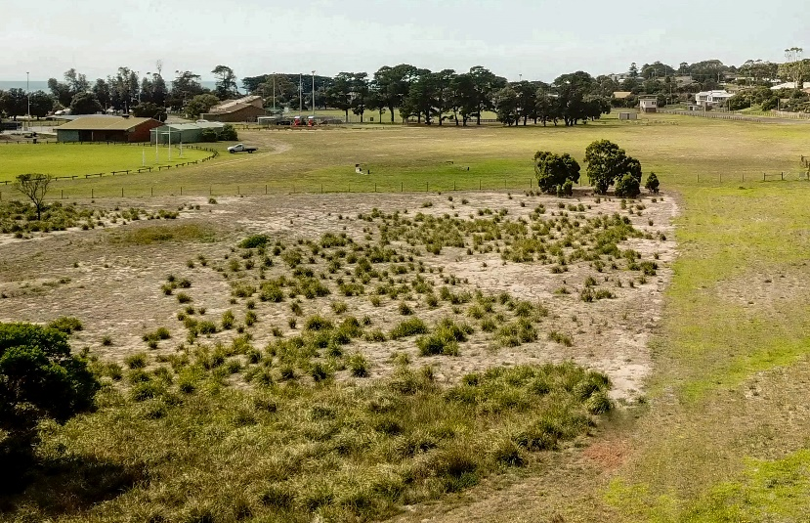  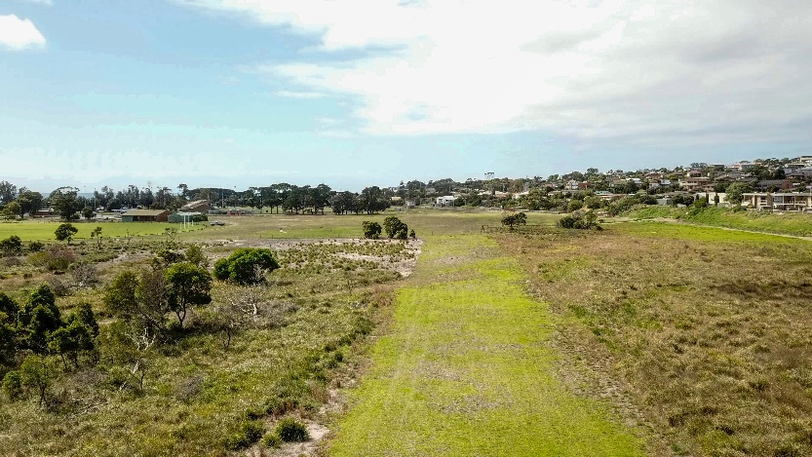  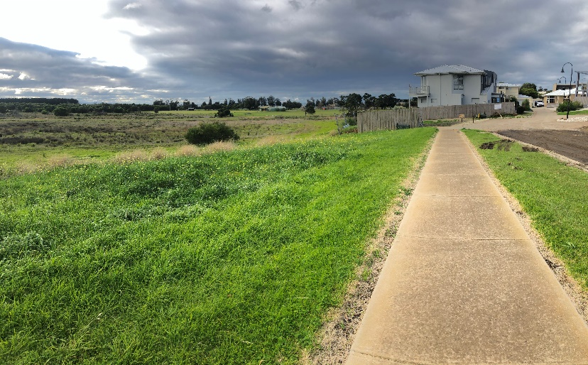

Key recommendations:
- Continue weed control and revegetate with indigenous woody species and Spiny Mat-rush.
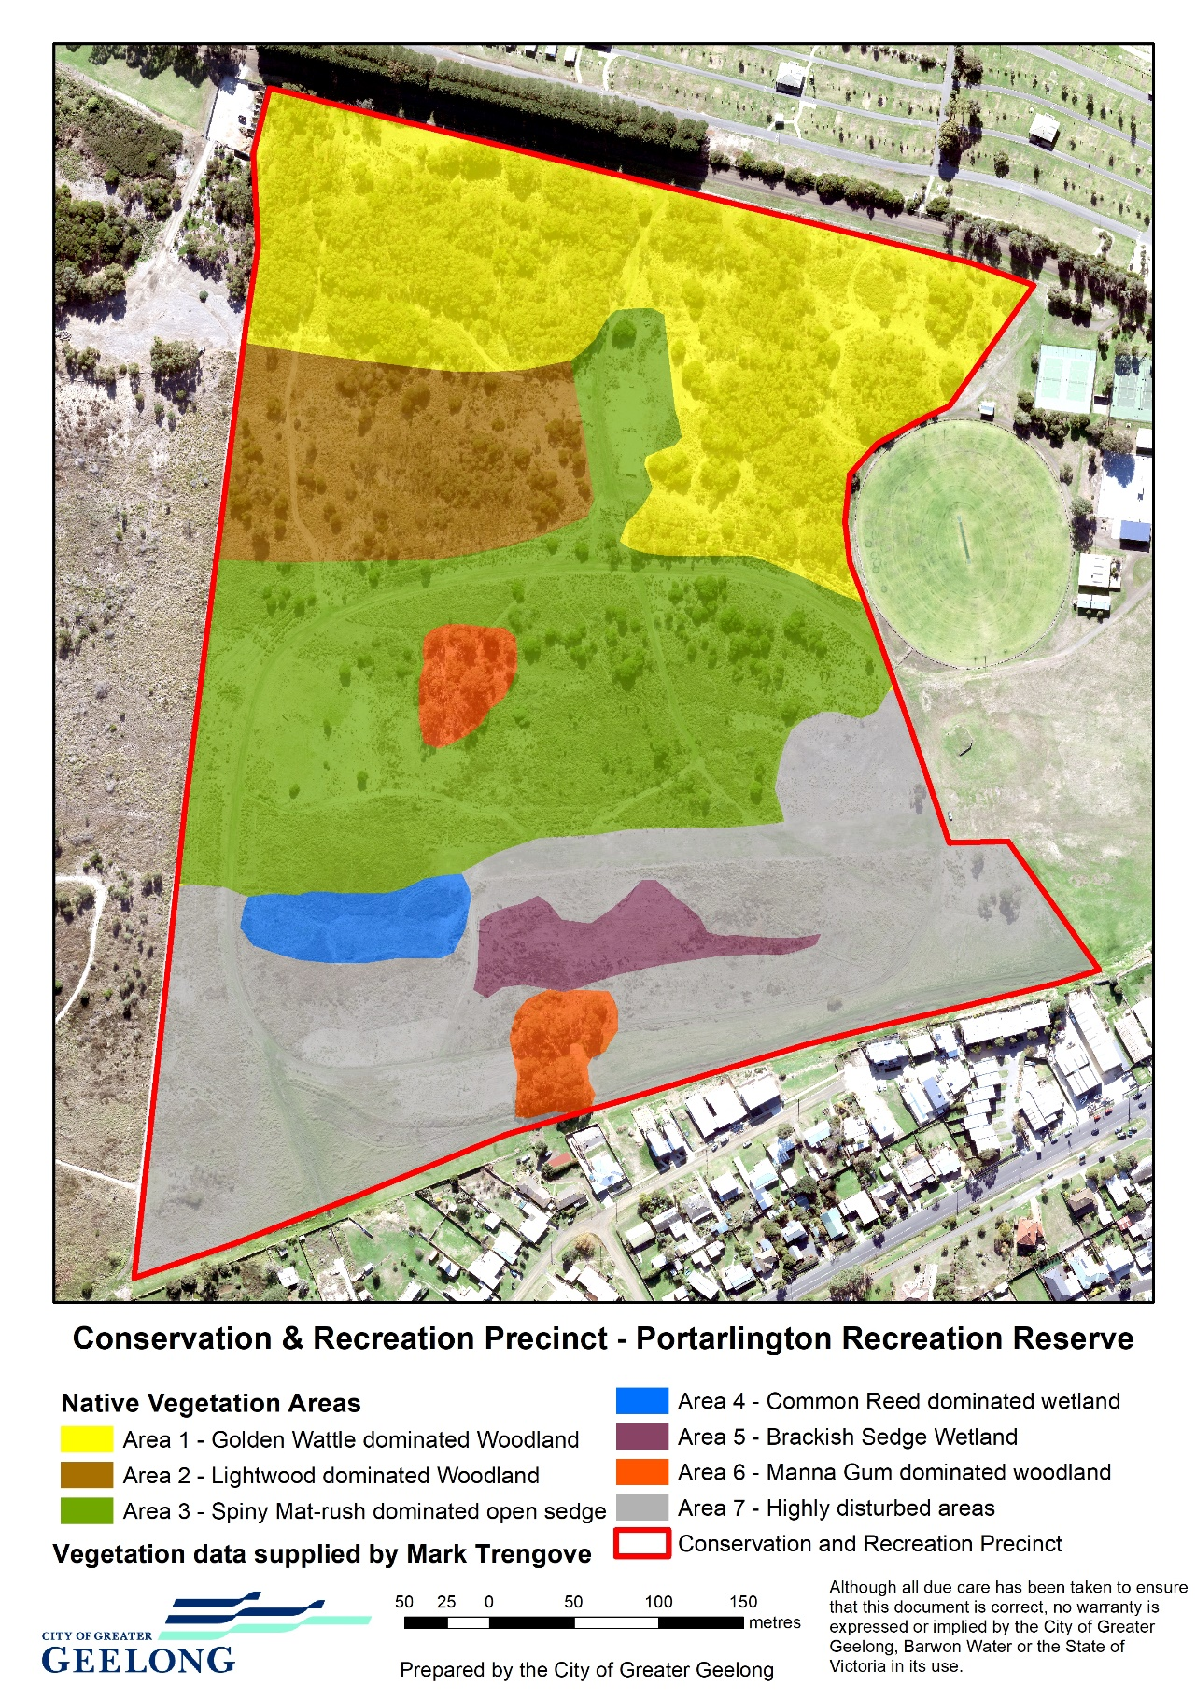

Figure 2. Study area and distribution of broad vegetation communities based upon July 2020 survey.

Flora significance
A total of 42 indigenous vascular plant species were recorded for the study area. The indigenous vascular plant species list (refer below Table 1) is comprised of the data collected during this survey.
All indigenous vascular plant species recorded for the study area, including botanical and common name and conservation significance are listed in Table 2. State significant species are listed in bold type. All exotic vascular plant species recorded for the study area are listed in Table 3.
Note that the Regionally significant tree form of Silver Banksia (Banksia marginata) is apparently no longer extant in the Reserve. This plant could be re-introduced form the nearest appropriate provenance.
Note that only one plant of the regionally (and potentially State) significant Native Sow Thistle was recorded this survey. This plant should be monitored.
While the overall condition of native vegetation may not be as high as pristine remnants that have seen minimal disturbance, there remains a diverse mix of indigenous species that will continue to provide a solid platform for restoration efforts going forward.

Fauna significance
There has only been limited survey efforts and records of fauna for the study area and no further fauna specific study was part of the scope of this project. The Victorian Biodiversity Atlas (VBA) has recorded 5 bird species using a polygon of the Recreation Reserve. This expands to 118 fauna species when the Point Richards Flora and Fauna Reserve is included. While not all 118 fauna observations were record within the Portarlington Recreation Reserve, it still provides an indication of what fauna are likely to use the reserve as habitat. The VBA shows that 105 bird species have been recorded in the vicinity of the reserve, one bat species, seven frog species, three reptile species and one small mammal.
Thirteen fauna species recorded are listed on the Department of Environment Land Water and Planning’s advisory list of threatened flora and fauna. One record of the Endangered Australasian Bittern (also listed as Endangered under the EBPC Act) dates from 1976. There has been a more recent record of the Endangered Freckled Duck. The Vulnerable Grey Goshawk and Great Egret are also recorded in the area. The Endangered Growling Grass Frog (listed as Vulnerable under the EPBC Act) was recorded there in 2009.
These results highlight the existing and potential habitat that the conservation and recreation precinct provide as an extension to the Point Richards Flora and Fauna Reserve.

The Point Richards Flora and Fauna Reserve was gazetted following a recommendation in the Land Conservation Council Melbourne Study Area Final Recommendations (1977) as is was an ‘area of special significance as habitat for the Short-Nosed (Common Brown) Bandicoot, in grassland’.

Although there are no known recent records for the Common Brown Bandicoot (the most recent records seem to be from the early 1980’s (Laurie Conole, Grant Baverstock and Trevor Pescott pers comm), the sections of the study area that have native vegetation provide significant habitat for native fauna species for the following reasons:

- Relatively large habitat area.
- Relative intact native vegetation.

The study area and the Point Richards Flora and Fauna Reserve combined is assessed by Ecology Australia as having ‘moderate fauna habitat significance’.

Overall Significance
The Portarlington Recreation Reserve and Point Richards Flora and Fauna Reserve combined represent the only significantly sized area of EVC 3 Damp Sands Herb-rich Woodland on the Bellarine Peninsula and within the CoGG.
The Portarlington Recreation Reserve and Point Richards Flora and Fauna Reserve combined represent the largest extant area of native terrestrial vegetation remaining on the northern Bellarine Peninsula and contributes significantly to the goals of the Bellarine Distinctive Area Landscape.
The three Ecological Vegetation Classes recorded for the study area, EVC 3 Damp Sands Herb-rich Woodland, EVC 821 Tall Marsh and EVC 891 Plains Brackish Sedge Wetland are all depleted within the Otway plain bioregion.
The City of Greater Geelong Biodiversity Management Plan (Ecology Australia 2001) assessed the study area as having State conservation significance for the large population of Austral Crane’s-bill and for the tree form of Silver Banksia. Combined with the other flora, the reserve contains an important diversity of native flora species.
Whilst recognising the current fauna data is limited, the flora and vegetation communities are likely to support a range of bird species and other potential fauna with further research.

Risks to Values
To effectively protect the environmental values within the Portarlington Recreational Reserve, a risk evaluation process was undertaken to rate each risk according to the likelihood of it occurring and the potential consequences. The risk assessment assists in developing mitigation strategies and actions to protect the identified values.
This section describes the risks to the environment values and the potential consequences.

Key Risks: | Threats | Description of threat and its impacts | Rating
Loss of vegetation and habitat | Vegetation removal and trampling | Loss of vegetation can result from new infrastructure, creation of new trails, trampling of vegetation from vehicles or people. | High

Key Risks: | Threats | Description of threat | Rating
Loss of flora biodiversity and habitat | Invasion of native vegetation by ‘noxious weeds’ | An assessment of weed species (table 3) within the reserve found 59 species of exotic species and 3 native species that pose a threat to native vegetation. Whilst it is acknowledged that the historical EVC is significantly altered, weed species will continue to threaten both the extent of native vegetation and quality by occupying greater space as they compete with and smother native vegetation.  The large variety of weed species makes this a greater challenge as the control techniques for one species may create a space for other exotic or environmental weeds to take over.  Aggressive weeds such as Flax-leaf Broom and Gorse have had large populations in the past and have significant annual seed set colonising areas quickly supressing native regeneration and biodiversity.  An ongoing source for weeds will come from both those areas that are more highly infested and adjoining private land where garden weeds may escape. | Extreme
 | New and emerging weeds | New and emerging weeds such as Bridal Creeper and Chilean Needlegrass pose one of the largest future threats to the reserve biodiversity due in part to its smothering nature and the difficulties in treating this weed. | Extreme
 | Inappropriate fire regimes causing disruption to sustainable ecosystem processes and resultant loss of biodiversity. | Fire has been part of the Australian landscape for thousands of years. With colonisation those fire regimes and purposes have significantly altered along with the change and loss of vegetation. Fire regimes need to have clear objectives with fire frequency and intensity maintained within the tolerance limits of the desired native vegetation characteristics. Inappropriate use of fire could further alter the desired vegetation diversity and structure or trigger major weed events from dormant species such as Broom, Gorse and Coast Wattle. | High
 | Loss of biodiversity as a result of the spread of invasive plants native to Victoria, such as Coast Wattle (Acacia longifolia subsp. sophorae) and Sallow Wattle (Acacia longifolia subsp. longifolia), into areas outside their natural range. | Coast Wattle is recognised as a particularly invasive and aggressive coloniser of disturbed areas. It is widely distributed across the study area and potentially has a large dormant seedbank. Further disturbance and/or the use of fire could trigger major colonisation events that would need to be carefully managed if they were to be used for other objectives. | High
 | Spread of Pittosporum undulatum in areas outside its natural distribution. | Sweet Pittosporum is like many other native plants that have expanded beyond their range initially as garden escapees. The additional challenge of this species is the allelopathic effects it has on soil and the suppression of other plants species growing under its canopy. There are relatively few plants in the reserve. | Moderate
 | Fragmentation | The conservation and recreation block is quite fragmented with a high edge to core ratio. Fragmentation further reduces the ability for natural processes to occur with disturbance along edges being a source of further weed invasions and weed spread. | Moderate
 | Trail use spreading weeds | The use of trails may be a source of new weeds coming in or spread of weeds along tracks further reducing biodiversity values. | Low
 | Trail maintenance spreading weeds | Machinery brought into the reserve for maintenance, particularly slashing activities can be a source of weeds such as Chilean Needlgreass and potentially new weed species and or spread weeds along tracks and vegetation edges. | Low

Key Risks: | Threats | Description of threat | Rating
Wetland loss and degradation | Change in water regime, dredging, draining, filling and grazing. | Past and future changes to drainage at the reserve dry out previously wetter areas reducing natural flooding and inundation regimes changing vegetation characteristics in key EVC’s.  Past changes to drainage have reduced the frequency and duration of ephemeral wetland events reducing the wetland habitat for a range of bird and frog species. | High

Key Risks: | Threats | Description of threat | Rating
Loss of fauna biodiversity | Predation of native wildlife by the cat, Felis catus. | Cats are a highly aggressive and effective hunter of native wildlife. Although there are a small number of fauna species listed and an unknown cat population, they remain a risk to the presence or increase of fauna populations. | Moderate
 | Predation of native wildlife by the introduced Red Fox Vulpes vulpes. | Foxes are a highly aggressive and effective hunter of native wildlife. Although there are a small number of fauna species listed and an unknown fox population, they remain a risk to the presence or increase of fauna populations. Trails increase the access to habitat reducing core areas that may afford greater protection against predation. | Moderate
 | Off-lead dog disturbing or causing loss of wildlife | Dogs off-lead have the potential to reduce bird diversity and abundance through predation and disturbance. Under the current controls, dogs off-lead are not permitted, however evidence suggests this still may occur, but the frequency is uncertain. There is likely to be a higher consequence from dogs off-lead with potential bird mortality and a greater area impacted. This may also be a risk factor to other small mammals if they exist. | Moderate
 | Motorbikes | Motorbikes have the potential to reduce bird diversity and abundance through disturbance with higher speed and noise. | Moderate
 | Dogs on lead disturbing wildlife | Dogs on-lead have the potential to reduce bird diversity and abundance through disturbance. No data has been collected on the frequency or duration of dog walking but from the community consultation and anecdotal evidence suggests it is a common activity. The level of disturbance is unknown as no research has been undertaken on the abundance of birds, but research indicates this is a risk factor. | Low
 | Walking and cycling disturbing wildlife | Walking and cycling has the potential to reduce bird diversity and abundance through disturbance. No data has been collected on the frequency or duration of walking but from the community consultation and anecdotal evidence suggests it is a common activity. The level of disturbance is unknown as no research has been undertaken on the abundance of birds, but research indicates this is a risk factor. | Low
 | Impacts of climate change | Changes in climate may put further pressure on fauna through impacts on migratory species, changes in vegetation and habitat and increased risk of extreme weather events and fire. There are likely to be impacts over and above other impacts. | Low

Evaluation:
The above assessment has highlighted several key threats to the values at the reserve that pose a risk to the environmental objectives for the precinct. The past disturbance and land use have had a significant impact on the diversity and quality of values in the precinct and ongoing and future risks will continue to make this area a challenge to manage.
The relatively small size of the reserve and fragmentated nature will limit the ability for many of the natural processes to occur. In this regard the adjoining Flora and Fauna reserve plays a critical role creating a larger body of vegetation and habitat.
The biodiversity and habitat values of the reserve are important with vulnerable vegetation communities present albeit in a variety of states of regeneration and recovery. The past and ongoing impacts of weeds and changes in fire regimes have had a deleterious impact on the diversity and condition of vegetation and habitat. Weeds continue to be the major threat to vegetation in this area due to their type and abundance. The changes in vegetation have also had significant impacts on the habitat values which have limited the presence and diversity of fauna in the reserve. Recent weed control activities have however, shown the ability to have a positive impact on reducing this risk.
Further vegetation loss through removal and trampling would also reduce the values in the reserve. The exact impacts would depend on the extent of the loss and the quality of the areas being impacted but should be avoided where possible.
The exact nature and timing of changes to drainage at the reserve are somewhat unknown but a modified drainage channel exists along the southern boundary. Remnants of EVC 821 Tall Marsh and EVC 891 Plains Brackish Sedge Wetland suggest these may have been more prominent in this southern section of the reserve but have perhaps been impacted by these changes. Further changes to water regimes and drying episodes associated with climate change may reduce the viability of the EVC’s being present at the reserve. This may further impact on the habitat values for frogs using these wetter environments.
There have been few fauna records from the reserve indicating the need for more fauna surveys to be undertaken, however this could also reflect how changes in vegetation over time that have impacted their habitat. Combined with the previous disturbance, continued threats of predation from foxes and cats are likely to remain. The impacts from dog walking and other recreation activities are generally rated low, particularly in the more disturbed areas.

Recommendations
A variety of high-level recommendations are suggested here to provide guidance for operational plans to protect and enhance the environmental values of the reserve. These actions could also form part of a risk mitigation strategy to help protect environmental values from threats identified above.

Weed management
- Take a holistic and integrated approach to weed control to create conditions that will encourage the regeneration of native vegetation and increase flora diversity starting with higher value areas and working outward to more degraded ones.
- Continue to control weeds of National Significance including Broom and Gorse to prevent further seed spread and reduce weed seedbank with the aim of eradicating from the reserve.
- Target emerging highly invasive weeds such as Bridal Creeper and Chilean Needlegrass to contain and eradicate from the reserve.
- Ensure plant and equipment brought into the reserve for maintenance activities are free from weed seed to minimize the introduction of new weed species.
- Implement more broad scale weed control as required to address specific weed threats in high value areas and contain a wide variety of weeds within disturbed areas.

Biodiversity management
- Introduce small scale targeted revegetation activities as required of species consistent with the EVC benchmarks to supplement the natural regeneration of indigenous species.
- Undertake further flora surveys to build on our current knowledge of floristic values and improve the resolution of EVC mapping. Further assess EVC 891 Plains Brackish Sedge Wetland to clarify the EPBC listed status in the survey work undertaken by EHP in 2016.
- Undertake fauna surveys to improve knowledge of fauna species utilising habitat within the reserve and establish a baseline from which we can monitor future change potentially arising from management actions and climate change.
- Implement a monitoring program to evaluate flora and fauna changes over time in response to management actions and climate change, in populations of state and regionally significant species.
- Consolidate trails and discourage users from creating informal tracks in vegetated areas through signage and other deterrents.
- Continue to restrict vehicle access to defined areas.

Collaborative management
- Collaborate with the Wadawurrung Traditional Owners and use traditional knowledge of country to enhance the natural and cultural values of the site, including opportunities to carry out cultural burns.
- Prepare a fire management plan in partnership with DELWP and the CFA. Review previous fire management plans to identity a suitable regime that promotes the desired vegetation community and reflects the ability to use fire for positive ecological outcomes and fuel management objectives including consideration of cultural burning practices.
- Investigate opportunities for more integrated and collaborative management of values and risks across this precinct and the adjoining Flora and Fauna Reserve.
- Chose indigenous species consistent with the EVC Benchmarks when planting in the adjoining open space areas to the east, to further enhance the biodiversity values of the reserve.
- Investigate planting a linear corridor of indigenous vegetation through the open space area to initiate the start of a biolink into Portarlington.

Water and wetland management
- Re-establish a wetland system along the southern end of the reserve creating conditions to enhance the EVC 821 Tall Marsh and EVC 891 Plains Brackish Sedge Wetland.
- Install litter and pollutant traps on drains entering the reserve from adjoining residential areas and create new sediment ponds and deeper wetland pools as part of the wetland system to improve stormwater quality management and wetland habitat, in particular for the Growling Grass Frog

Connecting the community to nature
- Improve information and interpretative signage about the values and ways to sustainably explore the precinct.
- Improve regulatory and information signage to more clearly identify what is and is not permitted and when.
- Encourage volunteering and citizen science to support the environmental programs in the precinct.
- Monitor and enforce dog regulations and review if there are compliance and further impacts identified.
- Investigate the use of boardwalks to connect new wetlands along the southern boundary with the natural wetlands to the north.
- Improve the amenity of the reserve by meandering the straight path adjoining Boat Road.
- Identify, in partnership with the Bellarine Agriculture Show organizers, an area for event parking in the approximate location of the former gallop track and the weedy area south/east of the gallop track and the appropriate fencing required.
- Liaise with Bellarine Bayside to investigate improved pedestrian access through from Traum Street to the reserve and provide access at Welfare Street.

Appendix 1 - ASSESSING CONSERVATION SIGNIFICANCE
Conservation significance is assessed at a range of scales, including global, international, national, state, regional and local. Criteria used for determining the conservation significance of flora at national to local scales are presented below for botanical conservation significance.

Botanical Significance

National botanical significance applies to an area when it supports one or more of the following attributes:
a population of at least one nationally threatened plant species listed by Briggs and Leigh (1996) or plant species listed on the schedules to the Commonwealth Environment Protection and Biodiversity Conservation Act 1999.
A nationally threatened ecological community listed on the schedules of the Environment Protection and Biodiversity Conservation Act 1999.

State botanical significance applies to an area when it supports one or more of the following attributes:
A population of at least one plant species threatened in Victoria, as listed by Gullan et al. (1990), NRE (2000a) or more recently in the unpublished records of the Flora Information System (NRE), or on the schedules to the Victorian Flora and Fauna Guarantee Act 1988.
An ecological community considered threatened in Victoria through its listing on the schedules of the Flora and Fauna Guarantee Act 1988.

Regional botanical significance applies to an area that supports one or more of the following attributes:
Supports a population of one or more regionally depleted species defined in a valid regional assessment of biodiversity (eg. Regional Native Vegetation Plan, Environment Conservation Council Report or Comprehensive Regional Assessment documents).
An ecological vegetation class that is considered endangered or vulnerable in a particular bioregion (based on Conn 1993 and the Regional Native Vegetation Plan), in which case the area is of High Regional significance.
An ecological vegetation class that is considered depleted in a particular bioregion (based on Conn 1993 and the Regional Native Vegetation Plan), in which case it is of Regional significance.

Local botanical significance applies to all remnant native vegetation that does not meet the above criteria. In much of Victoria native vegetation has been so depleted by past clearing and disturbance that all remaining vegetation must be considered to be of at least local conservation significance.

Appendix 2 Indigenous Plant Species recorded July 14 2020 and Conservation Significance
Botanical Name | Common Name | Conservation Significance
Acacia implexa | Lightwood | R
Acacia longifolia ssp sophorae | Coast Wattle | L (potential weed)
Acacia mearnsii | Late Black Wattle | L
Acacia melanoxylon | Blackwood | L
Acacia pycnantha | Golden Wattle | L
Acaena novea-zelandiae | Bidgee-widgee | L
Austrostipa flavescens | Coast Spear-grass | L
Bursaria spinosa | Sweet Bursaria | R
Clematis microphylla | Small-leaf Clematis | L
Convolvulus erubescens | Blushing Bindweed | L
Cotula australis | Common Cotula | L
Dianella brevicaulis | Coast Flax-lily | L
Dianella revoluta | Black-anther Flax-lily | L
Dichondra repens | Kidney Weed | L
Distichlis distichophylla | Austral Salt-grass | L
Eleocharis acuta | Common Spike-rush | L
Epilobium hirtigerum | Hairy Willow Herb | L
Eucalyptus viminalis ssp. pryoriana | Coast Manna Gum | R
Ficinia nodosa | Knobby Club-rush | L
Geranium solanderi var. solanderi | Austral Crane's-bill | S
Imperata cylindrica | Blady Grass | R
Juncus spp. | Rush
Lepidosperma gladiatum | Coast Sword-sedge | R
Leptospermum laevigatum | Coast Tea-tree | L (potential weed)
Lobelia alata | Angled Lobelia | L
Lomandra longifolia | Spiny Mat-rush | L
Muehlenbeckia australis | Climbing Lignum | L
Myoporum insulare | Common Boobialla | L
Pelargonium australe | Austral Storks-bill | L
Phragmites australis | Common Reed | L
Poa poiformis var. poiformis | Coast Tussock-grass | L
Pseudognaphalium luteoalbum | Jersey Cudweed | L
Pteridium esculentum | Bracken Fern | L
Rhagodia candolleana | Seaberry Saltbush | L
Rubus parviflorus | Native Bramble | L
Schoenus nitens | Shiny Bog-rush | R
Selliera radicans | Swamp Selliera | L
Senecio biserratus | Jagged Fireweed | L
Senecio minimus | Small Groundsel | L
Solanum laciniatum | Kangaroo Apple | L
Sonchus hydrophyllis | Native Sow Thistle | R ?S
Tetragonia implexicoma | Bower Spinach | L

Conservation Significance:
L – Local
R – Regional
S – State

Appendix 3 Exotic Plant Species recorded July 14 2020, Life Form and Threat Level
Botanical Name | Common Name | Life Form | Threat | Status
Acacia longifoia ssp. longifolia (?x sophorae) | Sallow Wattle | MS | S
Aira sp | Hair Grass | MTG | L
Anagallis arvensis | Pimpernel | MH | L
Arctotheca calendula | Capeweed | LH | M
Asparagus asparagoides | Bridal Creeper | SC | S | WoNS, R
Avena fatua | Wild Oat | MTG | M
Banksia integrifolia | Coast Banksia | MT | S
Briza maxima | Large Quaking Grass | MTG | M
Bromus catharticus | Prairie Grass | MTG | M
Bromus diandrus | Great Brome | MTG | M
Bromus hordeaceus ssp. hordeaceus | Soft Brome | MTG | M
Cakile maritima | Sea Rocket | MH | M
Cenchrus clandestinum | Kikuyu | MNG | S
Centaurium erythraea | Common Centaury | SH | L
Cerastium glomeratum | Common Chickweed | SH | L
Chenopodium album | Fat Hen | MH | L
Chenopodium glaucum | Glaucous Goosefoot | MH | L
Cirsium vulgare | Spear Thistle | LH | M | R
Conyza bonariensis | Flax-leaf Fleabane | MH | M
Conyza canadiensis | Canadian Fleabane | LH | L
Cynodon dactylon | Couch Grass | MNG | M
Dactylis glomeratus | Cocksfoot | MTG | S
Ehrharta calycina | Perennial Veldt-grass | MTG | S
Ehrharta erecta | Panic Veldt-grass | MTG | S
Ehrharta longiflora | Annual Veldt-grass | MTG | S
Euphorbia peplus | Petty Spurge | SH | L
Fumaria muralis | Smoke Plant | MH | M
Galena pubescens | Blanket Weed | MH | S
Galium murale | Bedstraw | SH | L
Genista linifolia | Flax-leaf Broom | LS | S | RC
Genista mospessulana | Montpelier Broom | LS | S
Hedypnois rhagadioloides ssp. cretica | Cretan Hedypnois | SH | L
Helminthotheca echioides | Bristly Ox Tongue | MH | M
Hypocharis radicata | Flatweed | SH | M
Lactuca serriola | Prickly Lettuce | MH | L
Lagurus ovatus | Hare’s-tail Grass | MTG | M
Leotodon taraxacoides | Hairy Hawkbit | MH | L
Lolium perenne | Perennial Rye-grass | MTG | M
Malva dendromorpha | Tree Mallow | LH | M
Medicago polymorpha | Burr Medic | SH | M
Melilotus indicus | Sweet Melilot | MH | M
Oxalis pes-caprae | Soursob | MH | S
Parapholis incurva | Coast Barb-grass | MTG | M
Phalaris aquatica | Canary Grass | LTG | S
Pittosporum undulatum | Sweet Pittosporum | MT | S
Plantago coronopus ssp. coronopus | Buck’s-horn Plantain | MH | M
Plantago lanceolata | Ribwort | MH | M
Polycarpon tetraphyllum | Four-leaf Allseed | MH | L
Rapistrum rugosum | Giant Mustard | LH | M
Romulea rosea | Common Onion Grass | SH | L
Rubus fruiticosus spp. agg. | Blackberry | LH | S
Rumex crispus | Curled Dock | MH | M
Solanum nigrum | Black Nightshade | MH | M
Sonchus asper | Prickly Sow Thistle | MH | L
Sonchus oleraceus | Common Sow Thistle | MH | L
Sporobulus africanus | Rat-tail Grass | MTG | M
Stellaria media | Chickweed | MH | L
Stenotaphrum secundatum | Buffalo Grass | MNG | S
Trifolium dubium | Clover | SH | L
Ulex europeaus | Gorse | LS | S | RC
Vicia sativa | Common Vetch | SC | L
Vulpia bromoides | Squirrel-tail Fescue | MTG | L
Vulpia myoris | Fescue | MTG | L

Life Form
LT- Large Tree, MT- Medium Tree, LS- Large Shrub, MS- Medium Shrub, SS- Small Shrub. LH- Large Herb, MH- Medium Herb, SH- Small Herb, Gc – Cormous Geophyte, LTG- Large Tufted Graminoid, MTG- Medium Tufted Graminoid, MNG- Medium Non-tufted Graminoid, SC- Scrambler/Climber.

Threat Level:
S – Serious
M – Medium
L – Low

Status
WoNS – Weed of National Significance.
RC – Regionally Controlled
R – Restricted (CaLP Act).

References

Anon. (1994). ‘Garden Escapes are Going Bush and Becoming Environmental Weeds’ Brochure. City of Greater Geelong.
Atlas for Living Australia
https://biocache.ala.org.au/occurrences/search?q=species_group%3AReptiles+AND+cl959%3A%22Greater+Geelong+%28C%29%22#tab_mapView
Banks, P.B. and Bryant, J.V. (2007) Four-legged friend or foe? Dog walking displaces native birds from natural areas. Biology Letters 22: 611–3.
Bellarine Bayside Vegetation Management Plan (Mark Trengove Ecological Services 2015).
Bird, E (1993). ‘The Coast of Victoria’ Melbourne University Press, Melbourne.
Blood, K. (2001). ‘Environmental Weeds: A field guide for SE Australia.’ CRC for Weed Management Systems, Adelaide.
Bradley, J. (1988). ‘Bringing Back the Bush’ Lansdowne Press, Sydney.
City of Greater Geelong (2001). Biodiversity Management Plan (Ecology Australia).
Carr, G.W.,Yugovic, J.V. and Robinson, K.E. (1992). ‘Environmental Weed Invasions in Victoria’. DCE and Ecological Horticulture.
Corangamite Catchment Management Authority (2005). ‘Corangamite Native Vegetation Plan 2003-2008’ CCMA, Colac Victoria.
DELWP Website i.
http://www.depi.vic.gov.au/environment-and-wildlife/biodiversity/native-vegetation
DELWP Website iii.
http://www.depi.vic.gov.au/environment-and-wildlife/biodiversity/evc-benchmarks
Foreman, D B, and Walsh, N G. (1993). Flora of Victoria Volume 1 Inkata Press, Melbourne.
Land Conservation Council (1977). Melbourne Study Area Final Recommendations.
Mouton P and Trengove M (2005). Fire Management Plan Point Richards Flora and Fauna Reserve and Portarlington Recreation Reserve (Peter Moulton Western Ecological Consultants and Mark Trengove Ecological Services).
Muyt, A. (2001). ‘Bush Invaders of South-East Australia’. T.G. and F.J. Richardson, Meredith, Victoria.
Oates, A. & Taranto, M. (2001): ‘Vegetation mapping of the Port Phillip &Westernport region’ Arthur Rylah Institute for Environmental Research, DNRE, Victoria.
Rosengren, N. (1988). ‘Sites of Geological and Geomorphological Significance on the coast of Port Phillip Bay.’ Ministry for Planning and Environment, Melbourne.
Trengove, M. (1992). ‘The Vegetation and Management of the Coastal Remnants of the Borough of Queenscliffe’. Borough of Queenscliffe.
Trengove, M. (2004). in ‘Point Richards Master Plan’ – Prepared by Thompson Birrell Landscape Design.
Trengove, M. (1999). ‘Edward’s Point Fauna Reserve Vegetation Management Guidelines’. Prepared for The Friends of Edward’s Point and Parks Victoria.

Plates 1-6 Vegetation existing conditions

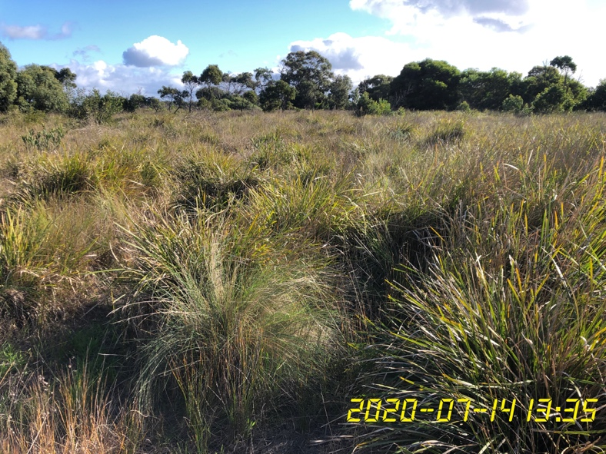
Spiny Mat-rush dominated open sedge/grassland.

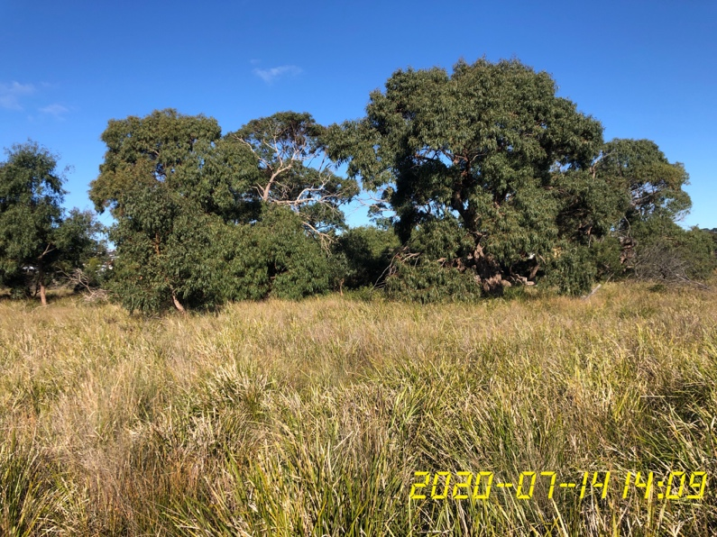
Manna Gum dominated woodland with areas of Brackish Sedge Wetland in foreground.

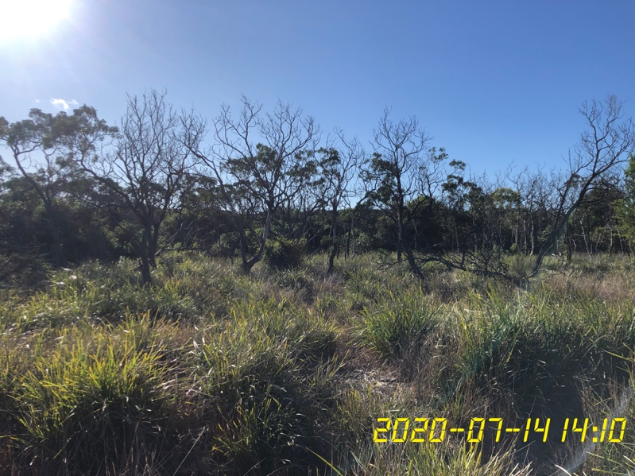
Lightwood dominated Woodland.

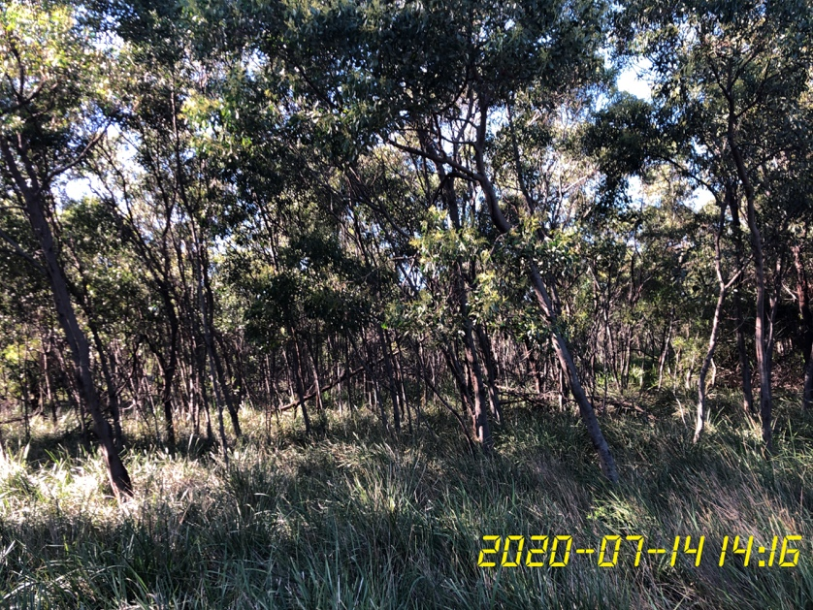
Golden Wattle dominated Woodland.

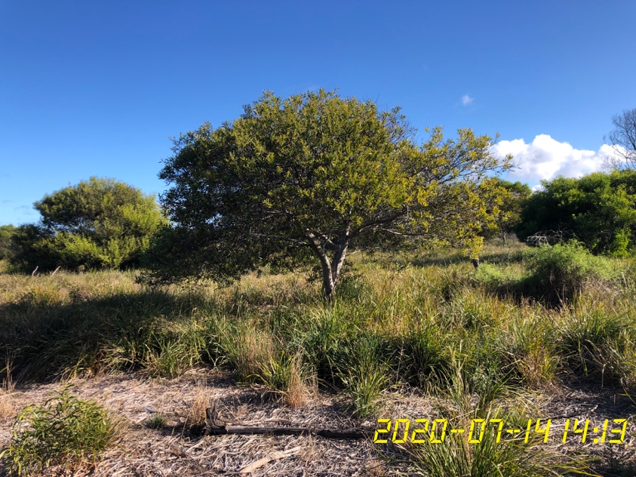
Sallow Wattle weed invasion.

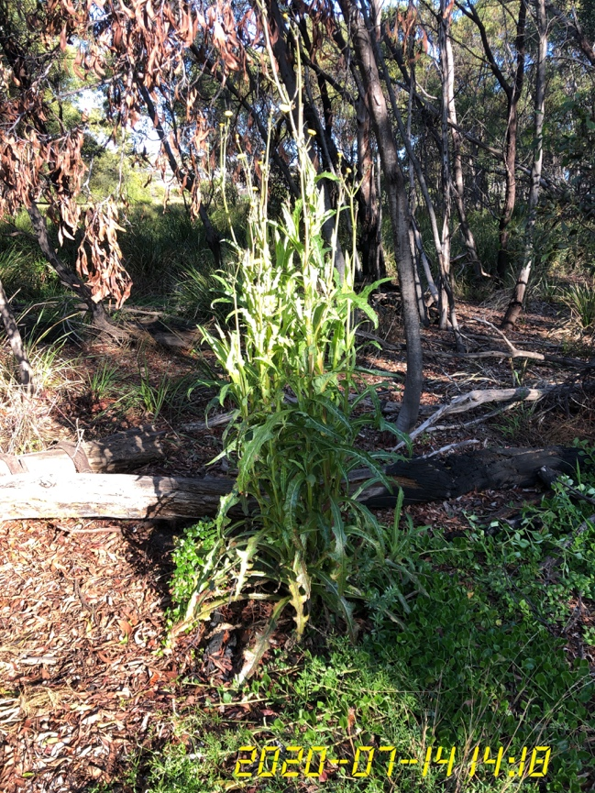
Native Sow-thistle.

