THE CITY OF
GREATER GEELONG

BARWON HEADS VILLAGE PARK
DRAFT MASTER PLAN

COMMUNITY ENGAGEMENT INTERIM REPORT

JULY 2021
community engagement SNAPShOT OF RESULTS

The City of Greater Geelong invited the community and stakeholders to help establish a vision, series of goals and recommendations for a new Barwon Heads Village Park Master Plan.

The Barwon Heads Village Park Draft Master Plan was approved for release at the April council meeting for a six-week period of community consultation from May through to 11 June 2021. The closing date for the consultation period was extended by a week due to COVID restrictions to allow for a second drop-in information session to be rescheduled.

The focus of the draft master plan is to protect the park’s values and character, whilst also responding to increases in community use and participation in organised sport. The draft plan also aims to improve accessibility and minimise increases to the footprint of buildings.

The updated master plan will include recommendations that consider the cultural and environmental values of the reserve, landscape and amenity, sporting infrastructure requirements, needs of tenant clubs and groups, trail connections and community events, and guide future funding off the village park for the next decade.

ENGAGEMENT APPRoaCH
The emphasis of the engagement with the community was to understand and acknowledge their concerns, aspirations and views on the draft master plan.

The seven-week consultation period allowed time to reach stakeholders across the community, including members of the Project Reference Group, residents, users and visitors of the park.

282
Number of contributions

79
49 DAYS
of engagement
3,271
Have Your Say website views engagement
People following the project

174 people engaged with the City about the Barwon Heads Draft Master Plan, of these 78% engaged online, 17% engaged in person through the drop-in sessions and the remaining 5% by phone or email. Other informal participation occurred through comments on Facebook on both the City’s and Talking Heads Facebook page. A community led petition calling for greater planning protection for the park also attracted 548 signatures.

ENGAGEMENT TOOL AND TECHINQUES
A project specific engagement page was developed to provide project information and methods of ways to engage with the City.
A summary of the consultation process, techniques and feedback received is provided below.

162  ideas and votes posted to the vision board | 23  Online written submissions | 91  surveys completed | 5  Community phone calls
4  emails received direct to project email | 2  Hard copy plans hand delivered | 29  People attended 2 drop-in sessions held on | 55  Contributions received at drop in sessions

HOW WE ENGAGED
Have Your Say Online Portal  Yoursay.geelongaustralia.com.au | An online HYS project page was designed to share relevant information to encourage community feedback. The initial release for information occurred in late December 2020 and the core feedback period was opened on 1st May 2021 for seven weeks closing on 18th June 2021.  A detailed hotspot map was prepared with information and images for all the recommendations in the plan overlayed on the draft landscape plan.
Survey (online and hardcopy) | The survey was available on online and/or in hard copies if required.  The online survey was the core feedback tool provided targeting people with 10-15 minutes of available time. 91 surveys were completed. The survey sought feedback on the vision and objectives, zoning, recommendations and any issues that the community had with the future use and management of the park. The survey included some information and about peoples use and connection to the park.
Online vision board | The Visioner tool was designed as a quick means to post a note about the Vision for the park. While, the original intention was focused to get feedback specifically on the vision statement and objectives, it ended up being a means of providing a quick post it notes about any element of the plan. 54 responses were provided using this tool.
submission form | The submission form enabled people to provide more detailed open-ended feedback on any aspect of the draft master plan. This tool also enabled people to add attachments. 23 submissions were made with five attachments. A larger submission was also provided by email due to the size limitation on the website.
email | A project specific email address was created enabling people to provide feedback through a fourth medium. Nine people provided email feedback about the plan.
Listening Posts | Listening posts were conducted on two nights (26 May and 17 June). The listening posts sought to engage people who preferred face to face engagement or were otherwise unaware of the project, and to collect their input. Community members were invited to rate recommendations and post notes on the plans displayed in the session, have a discussion with staff and/or complete a survey. 29 people registered their attendance at the sessions with 55 contributions.
Communications
The Barwon Heads Village Park Draft Master Plan communications approach was largely about directing traffic through the City’s Have Your Say Page, where all the information about the project and feedback tools were provided. The engagement was initially launched through a media release and complemented throughout the engagement period by posters in the park, the mailout and Facebook post to help inform the community about the opportunity to provide feedback on the draft plan.
SOCIAL MEDIA
9597
Reach/Impressions
250
Actions (Clicks, reactions,
shares, comments etc.)
NEWS

10
Park posters installed
2
Print adverts in local newspapers
1,229
Flyers delivered to residents

How we communicated
media release and news articles | A media release for the project, launched at the start of the engagement, was run as an article in the Ocean Grove Voice and Bellarine Times.
SIGNAGE/posters | Ten posters were installed in early May within the park advertising the community consultation to reach users of the park.
MAIL OUT | In late May, the mailout delivered flyers to 1,229 residents surrounding the park. The objective was to inform residents about the project and direct them to the on-line platform.
social media | On 26th May a targeted Facebook post was shared by the City to a potential audience of 82,000 people with an estimated reach of 2,000. The post included a short summary of key elements of the plan, a call to action to go to the page and an accompanying video. https://www.facebook.com/179561632079584/posts/3932722340096809

SURVEY RESponse profile

Profile data was only collected through the online platform. During the community engagement period there were 91 survey contributions. Of the survey respondents 88% said they are a general user of the park with 36% members of a sporting club. 17% indicated they were associated with a community organisation and around 5% part of a service organisation.
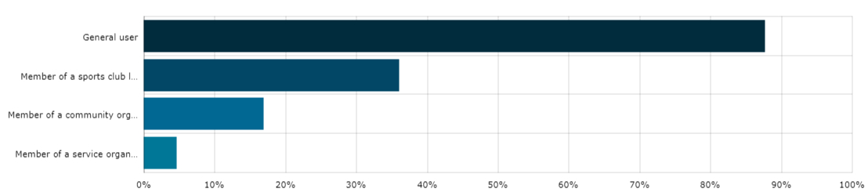
Of the 91 survey respondents, 53 chose to identify a group they were associated with which provides a small snapshot of the groups represented but it not necessarily reflective of the overall representation from all the community feedback. This data provided some insights into the community and the fact that many people were involved in several groups along with being general park users.
It also showed that most of the respondents were regular users of the park with more than half using it daily.
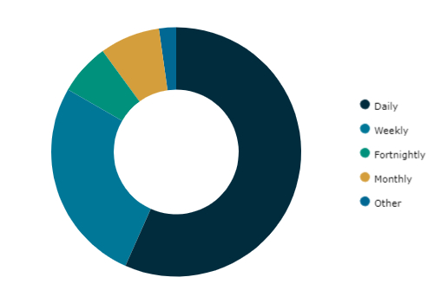
When asked “what would be the main reason you would visit the park” the top four responses were:
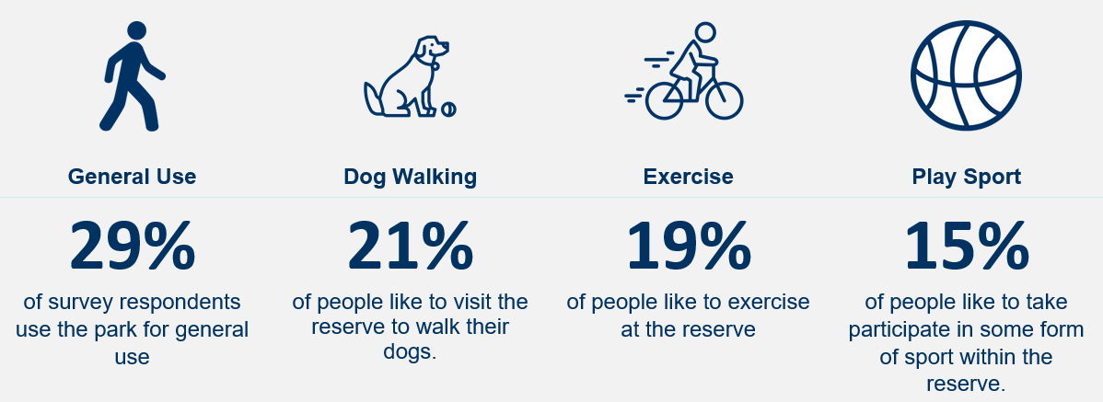

SNAPSHOT OF WHAT WE HEARD – survey results
The responses received highlighted that:
- over 80% are ‘very supportive’ or ‘supportive’ of the vison and goals
- 70% of respondents were’ very supportive’ and ‘supportive’ of the management zones
- 70& of respondents were very supportive and supportive of the recommendations proposed.
KEY THEMES
There was a strong theme in the feedback that the park is well loved as it is, and that generally the community don’t want to see a great deal of change. The following outlines some of the key themes that emerged from the engagement activities ranked in terms of the number of contributions around that theme.
# 1 | # 2 | # 3 | # 4 | # 5
Protect Open Space and character of the park from over development | Sustainable Pavilions | Sustainable place for kids to ride | Environmental and cultural values | Maintain dog off lead areas/consider fenced dog park
“We love the park and want the natural aspect to be maintained and protected.”  “Barwon Heads is desperate to maintain its character of being a village. We need more planning overlays like this to ensure we preserve it” | “Renewal and upgrades of buildings is long overdue. Multipurpose buildings make sense instead of several smaller ugly structures.”  “Scout club facilities, should be redeveloped at current site”  “13th beach boardriders MUST be part of this plan” | “It will be wonderful to have a bike discovery park for the kids locally. Let’s keep our kids outdoors and active, challenging themselves” | “I appreciate acknowledging the significant and protected cultural heritage of the park and the awareness of improving the understanding of cultural values” | “Please don’t take away the off-leash area when no sporting events on. Enclosed dog parks off leash are great for some dogs but not for all”

NEXT STEPS
- The City is currently reviewing the engagement results and will discuss the feedback further with the Project Reference Group to address the key themes and specific support or changes to specific recommendations.
- Following this, the City will prepare a key finding report and update the final master plan to be presented to Council for a decision later this year.

