The Avalon Corridor Strategy (ACS) is a strategic land use framework that has been developed by Hansen Partnership for the City of Greater Geelong and Wyndham City Council, in collaboration with the Victorian Department of Environment, Land, Water and Planning (DELWP).

Project Update
The draft ACS was considered by both councils at the City of Greater Geelong’s Council Meeting on Tuesday 27 July 2021 and Wyndham City Council’s Planning Committee Meeting on Tuesday 10 August 2021. Following this, it was agreed that the draft ACS would be released for community consultation for a period of six weeks (details below).

Community Consultation
In November 2016 we listened to community views and aspirations for the Avalon Corridor and used these to guide the development of the draft ACS and Framework Plan. We are now coming back to the community to seek further input before finalising the ACS. In this next stage of consultation, we would appreciate your feedback on the draft ACS and Framework Plan, including the key principles, future land uses and proposed areas for further work (such as possible planning instruments).

The second round of community engagement will commence at 9:00am on Wednesday 11 August and conclude at 5:00pm on Tuesday 21 September 2021. Please visit www.yoursay.geelongaustralia.com.au for details on the various engagement activities through which you can have your say.

Feedback from both Greater Geelong and Wyndham community members and stakeholders is being collected via the same Have Your Say page, hosted by City of Greater Geelong. If you want to contact Wyndham to discuss a particular matter, please refer to contact details on the Have Your Say page.

An online feedback form will be available on the Have Your Say page from the beginning of the consultation period. Alternately, both Wyndham and Greater Geelong community members and stakeholders can email feedback to: Avalon_CorridorStrategy@geelong.vic.gov.au or send your written feedback via post to: Coordinator Strategic Planning, City of Greater Geelong, Wadawurrung Country, PO Box 104, Geelong VIC 3220.

STAGE 1 STAGE 2 STAGE 3 STAGE 4 STAGE 5
PREPARATION OF DRAFT FRAMWORK PLAN (documenting the vision)
FINALISE THE STRATEGY & IMPLEMENTATION
( executing the framework plan)
CONSULTATION ON DRAFT FRAMEWORK PLAN
(refining the framework plan)
PROJECT INCEPTION
(getting the project started)
INFORMATION ANALYSIS AND STAKEHOLDER ENGAGEMENT
(learning about the place)

Related Projects

Aircraft Noise
In 2020, Avalon Airport commissioned GHD to undertake a revised Australian Noise Exposure Concept (ANEC) analysis of future airport operations. The 2020 ANEC analysis models the second parallel runway identified under the 2015 Master Plan, though does not model the potential third cross runway. The ANEC analysis will be used to produce a new Australian Noise Exposure Forecast (ANEF), which is currently with Airservices Australia for approval.

While Avalon Airport have indicated that the existing north-south runway is likely to meet projected demand for the duration of the 2015 Master Plan (up to 2035), the proposed ANEF is included within the draft ACS as it has helped to determine future land use within the Avalon Corridor to 2050. Avalon Airport will consult with the community separately to the ACS process, before the proposed ANEF is finalised.

Further information on aircraft noise can be accessed via the following resources:
- Airservices Australia – www.airservicesaustralia.com/community/environment/aircraft-noise
- DELWP – www.planning.vic.gov.au/policy-and-strategy/airports-and-planning/about-aircraft-noise

Employment Precincts
New jobs and employment opportunities will be created through the development of a number of Precinct Structure Plans (PSPs) within the Avalon Corridor – the Werribee Junction PSP and Avalon Employment Precinct PSP. The Avalon Employment Precinct includes land immediately to the west and north of Avalon Airport (below the Princes Freeway). At the City of Greater Geelong Council Meeting on 27 July, Council resolved to write to the Minister for Planning to appoint the Victorian Planning Authority (VPA) to prepare the PSP for Avalon Employment Precinct. Preliminary work on this is expected to commence following finalisation of the Avalon Corridor Strategy. The Werribee Junction PSP is similarly expected to include employment uses focussed on industry and logistics. Further information on this PSP can be found on the VPA’s website.

Cultural Heritage Assessment
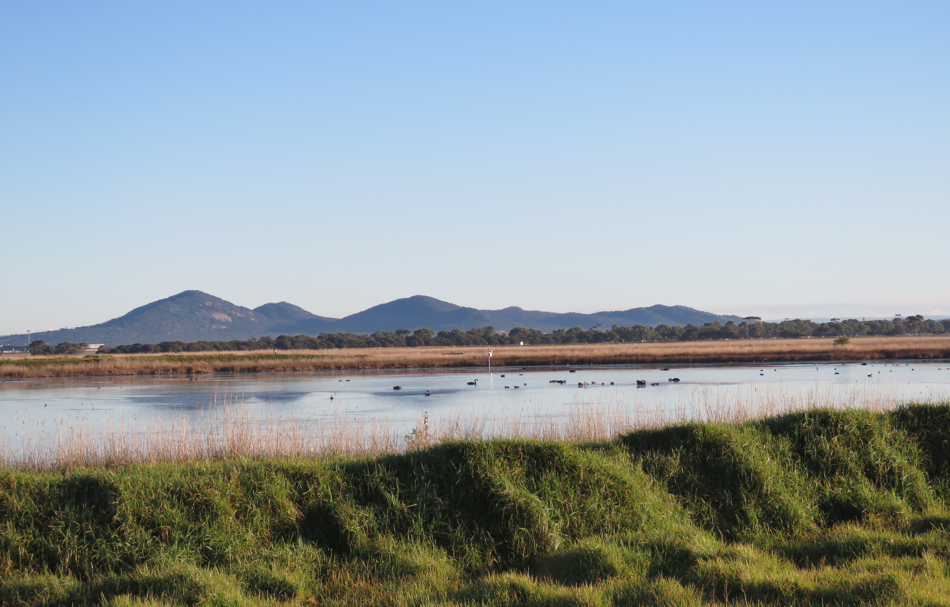
A preliminary Cultural Values Assessment was completed by Unearthed Heritage and Wadawurrung Traditional Owners Aboriginal Corporation (WTOAC). Outcomes of this have been built into the Strategy, including a recommendation to review the extent of the existing Significant Landscape Overlay (SLO1) for the Foothills of the You Yangs (Wurdi Youang).

Expansion of SLO1 is further supported by a Landscape Character Assessment completed by Hansen Partnership. However, further work will be required to determine the optimal extent.

Next Steps
Once the Avalon Corridor Strategy has been updated following community consultation, the Framework Plan will be incorporated into both the Greater Geelong and Wyndham Planning Schemes via a planning scheme amendment. A number of other potential planning scheme amendments may also support implementation of the Avalon Corridor Strategy, such as possible changes to zones and overlays. However, the community however will be given an opportunity to provide feedback on these individual projects sometime in the future by the relevant authorities.

Like to know more?
We are committed to keeping the community informed about the progress of the Avalon Corridor Strategy. We will provide further updates via the Community Bulletins at various stages of the project.

You can register to receive further community bulletins and update on the project and ensure you are notified directly of upcoming events by emailing:
Avalon_CorridorStrategy@geelongcity.vic.gov.au

Website updates will also be posted.
Please contact:

Jayden Holmes, Senior Strategic Planner
City of Greater Geelong
Ph: 03 5272 4859
Email: Avalon_CorridorStrategy@geelongcity.vic.gov.au

Sean Diffey, Strategic Planner Wyndham City Council
Ph: 03 8376 5511
Email: Sean.Diffey@wyndham.vic.gov.au

