Attachment 2 – Plan

Originally proposed map of footpaths – 22.8 km - 12 December 2019

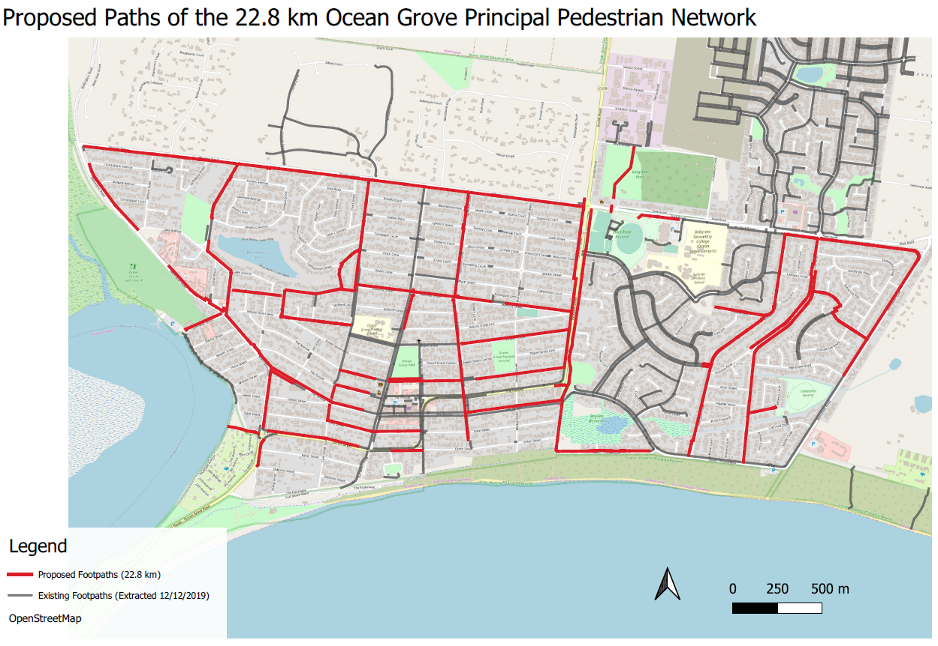

Proposed map - Intention to Declare 23 March 2021 – 25.2 km



Proposed map post Submission Review Panel Meeting and feedback from residents – 24.3 km - updated 7 August 2021

