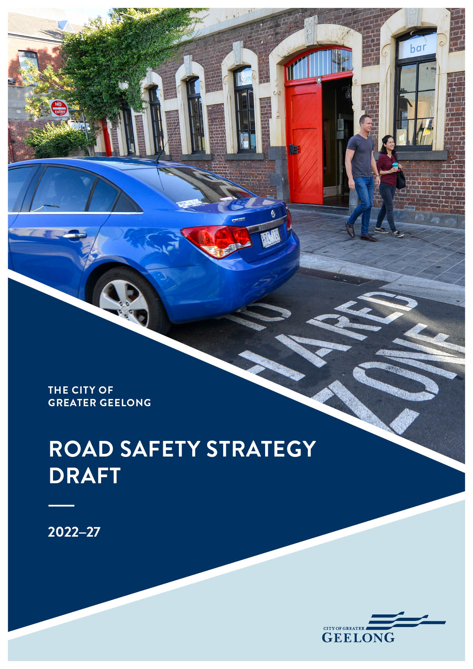

Contents
Acknowledgements 2
Mayor’s message 3
Executive summary 4
Introduction 5
About our municipality 5
Roads in our region 5
The bigger picture 6
Towards Zero 6
The Safe System 6
Principles of the Safe System 6
Elements of the Safe System 7
Post-crash care 7
Doing what works 7
Road safety data for Greater Geelong 8
Crash comparisons (2010–19) 8
Overall crashes 8
Greater Geelong crash data (2015–19) 8
Where are crashes happening? 9
What are the most common types of crash? 9
Who is involved in crashes? 9
Fatal and serious injury crash breakdown 9
Other crash characteristics 9
Data interpretation 9
The engagement process 11
How we engaged 11
What we heard 11
Community road users 11
Stakeholder feedback 12
Our road safety strategy 13
Action themes 13
1. Leadership and best practice 14
2. Safe system approach 16
2.1 Safe roads and paths 16
2.2 Safe speeds 19
2.3 Safe people 21
2.4 Safe vehicles 22
3. Active and public transport 23
4. Working together 25

Acknowledgements
The City of Greater Geelong acknowledges the Wadawurrung People as the Traditional Owners of this land.
It also acknowledges all other Aboriginal and Torres Strait Islander People who are part of the Greater Geelong community today.
This plan been developed in consultation with community groups, road safety experts and key stakeholders from across the municipality. We would like to acknowledge all those who contributed their experiences and ideas to help us shape this plan.
Report prepared by: Safe System Solutions

Mayor’s message
The Mayor’s message will be prepared once the community engagement process for the draft document is complete.
During the engagement phase, we will also seek comments about the plan from Victoria Police, the Department of Transport and TAC to include in this section.

Executive summary
We all want a liveable city where people feel connected and able to live life to the full. To achieve this requires a transport system that functions safely and efficiently.
As our population grows, more people will be on our roads. To accommodate this growth, we must keep improving and maintaining the road network in a way that promotes road safety.
Over the last decade the number of fatal and serious injury crashes on our roads has fluctuated from year to year, but overall the number has remained steady. We average 200 fatal and serious injury crashes every year, 8 of which are fatal. This is too high.
In line with the Victorian Road Safety Strategy 2021–2030, we’re aiming to halve road deaths and serious injuries by 2030. This will keep us on track to help reach the longer-term target of zero deaths by 2050.
To understand the road safety issues we face, we:
- looked at the data collected in local accidents
- asked road users what they thought and
- worked with road safety experts.
Using this information we identified four strategic themes that will drive our road safety program over the next five years:
- Leadership and best practice: We are committed to Towards Zero and the Safe System Approach and we will act as leaders in road safety.
- Safe System approach: We apply the globally recognised Safe System approach, which addresses the four main factors that contribute to a crash:
        - Safe roads and paths
        - Safe speeds
        - Safe people
        - Safe vehicles
- Active and public transport: We will reduce risks for active transport users, recognising how important this is for a healthy and sustainable community.
- Working together - We will work with our road safety partners and the local community to shape the future of road safety together.
Using these themes, we have set ourselves an ambitious Road Safety Strategy, which we will deliver with the support of our road safety partners and the broader community.

Introduction
We all want a liveable city where people feel connected and able to live life to the full. To achieve this requires a transport system that functions safely and efficiently.
As with state and federal governments, we believe that, while all face risks on our roads, a choice to use the road shouldn’t cost us our lives or cause serious injury. The purpose of this strategy is to develop a safe transport system – one that protects us from our own mistakes and the mistakes of others.

About our municipality
Located 75 kilometres from the Melbourne CBD, the municipality covers 1,247km, comprising country, coastal and suburban areas.
Between 2010–19, the population increased by 46,349 people. Growth is projected to continue and has been concentrated most heavily in suburban Geelong, as well as Lara and Leopold. During peak holiday season the population can increase by up to 70 per cent.

Roads in our region
Our region has strong links with Victoria’s wider transport networks and is a major transport hub. The primary road link to the wider region is the Princes Freeway (M1), which links the Geelong road network to Melbourne. Geelong is also the gateway to the Great Ocean Road scenic roadway – a popular tourist route.
Many of the region’s highways converge in Geelong, including:
- the Midland Highway
- Hamilton Highway
Figure 1 Major roads in our municipality
- Princes Highway
- the Geelong-Bacchus Marsh Road
- Bellarine Highway and
- Surf Coast Highway.
Completing the Geelong Ring Road in early 2013 resulted in all regional level highways linking with the M1, thus providing through access to Melbourne.
While Regional Roads Victoria manages over 500 kilometres of arterial roads within the municipality, we manage approximately 2250km of roads, including:
- Sealed roads – 1765 kilometres
- Unsealed roads – 358 kilometres
- Sealed lanes – 34 kilometres
- Unsealed lanes – 38 kilometres
- Unformed Fire Tracks – 14 kilometres
- Recreation tracks – 46 kilometres.
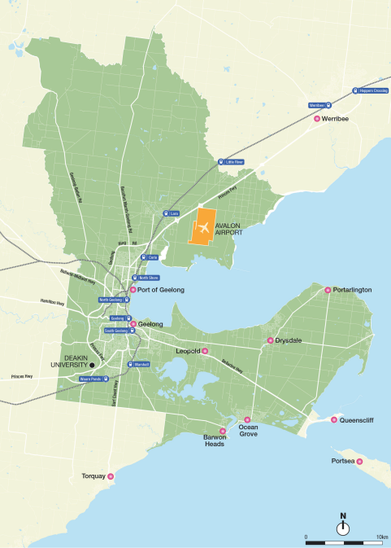

The bigger picture
This strategy has been informed by internationally recognised approaches to road safety, as well as national, state and local government legislation and policies.
It aligns with our 30-year clever and creative vision and, in particular, the following community aspirations:
- A fast, reliable and connected transport network
- People feel safe wherever they are.
Other relevant policies and strategies include:
- Our Community Plan 2021–25
- Integrated Comprehensive Transport Plan 2015
- Access and Inclusion Plan
- Municipal Road Management Plan 2018
- G21 Regional Road Transport Plan 2017–27
- Environment Strategy 2020–30.

Towards Zero
In developing this strategy, we aim to align with the Toward Zero aspirations of both federal and state road agencies.
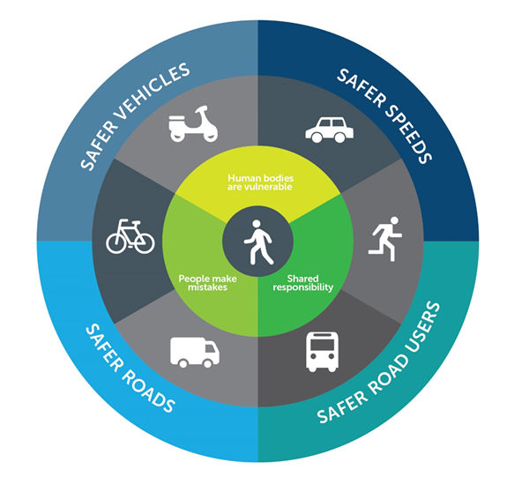
Towards Zero means working towards zero road deaths on our roads. The road safety principles that can drive the fatalities down are in place across most Australian states and territories. Overseas, many other countries have also adopted the same principles – also known as Vision Zero – including Sweden, Canada, the United Kingdom, France, Norway and many large cities in the United States.
Figure 2: The Safe System for roads

The Safe System
The Safe System (see Figure 2) is an internationally recognised framework to reduce road trauma. The system, based on a Swedish framework that reduced fatal and serious injuries by 40 per cent over 10 years, is recognised in many other countries as best practice, including Australia.

Principles of the Safe System

Principle 1: The only acceptable fatality or serious injury toll on our roads is zero (zero tolerance)
Everyone is susceptible to being injured, no one is exempt from being missed. Road safety needs to be focused towards reducing fatal and serious injuries.

Principle 2: People are vulnerable
When vehicles crash at high speeds, our bodies are subject to forces they cannot withstand. The approximate tolerances for the human body under different crash conditions are:
- Head-on crash: 70 km/h
- Side-impact crash with another vehicle: 50 km/h
- Side-impact crash with a tree: 30 km/h
- Pedestrian crash: 30 km/h
While our ability to withstand the impact of a crash is outside of our control, there is a lot that we can do to reduce or avoid these potential impacts.

Principle 3: People make mistakes
Human error is inevitable and, on our roads, human error can result in crashes and trauma. The Safe System recognises the unavoidable nature of human error, rather than placing the blame on the road user, it recognises the need for those involved in road design, road maintenance, and road use to share responsibility for the many factors that contribute to serious injury or death on our roads.

Principle 4: Shared responsibility
Creating a safe road network is everyone's responsibility. Businesses, organisations, governments, communities and individuals all have a role to play in moving Towards Zero.

Elements of the Safe System
There are four elements that can contribute to a crash, which make up the Safe System:

Safe roads and paths
Roads and paths should be designed and maintained to minimise or avoid risk in all conditions and forgive human error.

Safe speeds
Even minor differences in speed can change the outcomes in an accident situation. Setting appropriate limits for the road environment road users comply with, it will reduce fatalities and serious injuries.

Safe people
Road safety can only be achieved if individual drivers know and follow the road rules and show respect for all other road users, regardless of their mode of transport.

Safe vehicles
Through better safety technology, vehicles will help reduce the likelihood of serious crashes.

Post-crash care
The length of time between a serious crash and the arrival of emergency treatment is critical to the outcomes of an accident. Emergency vehicle accessibility must therefore be considered in our road safety planning.

Doing what works
Research shows that road trauma can be reduced when:
- leaders are committed
- road safety is addressed methodically
- the community is involved in planning and delivering road safety outcomes
- adopted safety measures have been proven to be effective.

Road safety data for Greater Geelong
Crash history between 2010 and 2019 shows there has been a decrease in serious injury crashes in our municipality, but fatal crashes are (on average) not decreasing.
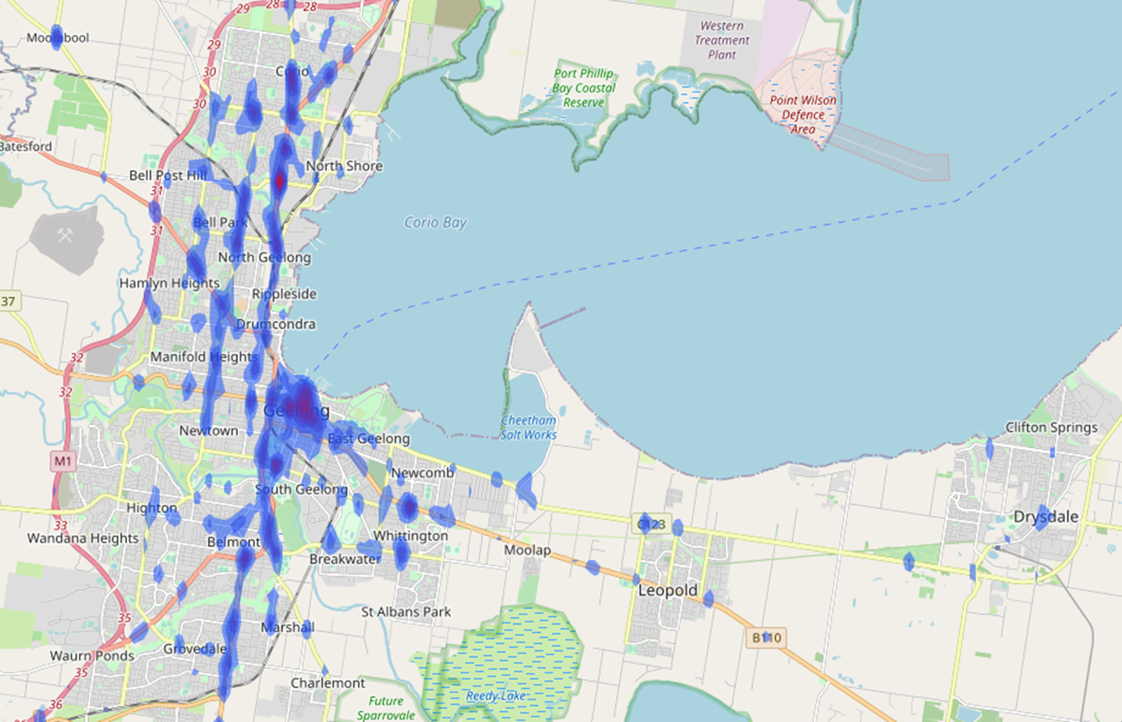
Following is a summary of the key data we’ve taken into account when formulating this strategy.
Figure 3 Heat map showing fatal and serious injury crash hotspots
A full breakdown of data is available in the Road Safety Strategy Background Report.

Crash comparisons (2010–19)

Between Geelong and Victoria
Prior to 2016 Geelong generally had a lower crash rate per 100,000 population than Victoria. Comparing average fatal and serious injury crashes per 100,000 people from 2010 to 2019, Geelong has not performed as well as the Victorian average – 86 crashes per year compared to 80 per year respectively.

Between Geelong and other regional cities
Geelong’s crash rate does not compare favourably with the regional cities of Bendigo and Ballarat. The average fatal and serious injury crash rate per 100,000 population from 2010–19 was: 86 crashes in Geelong; 77 crashes in Bendigo; and 61 crashes in Ballarat.

Overall crashes

Fatal
Since 2010, we have averaged approximately 8 fatal crashes per year, although the number has been as high as 13 (2011) and as low as 4 (2015 and 2018).

Fatal and serious injury
In 2010, the number of fatal and serious injury crashes was 197. While this dropped to 150 in 2019, crash rates were well over 200 in 2017 (258 crashes) and 2018 (244 crashes).
The average number of crashes from 2010–19 was 200 crashes per annum.

Greater Geelong crash data (2015–19)
We analysed crash data for the five-year period between 2015 and 2019 (the latest year for which a complete data set is available).

Where are crashes happening?
Between 2015 and 2019 there were 1073 serious injuries and 40 fatalities on our roads.
As Figure 3 shows, fatal and serious injury crashes are most likely to happen in two location types:
- Where there are high volumes of traffic and vehicles are able to cross paths – for example, arterial roads and local to intersections. These show up as red and yellow hotspots where crashes tend to concentrate.
- Where there are significant movements of motor vehicles in close proximity to pedestrians and cyclists – for example, local roads (speed limits up to 50 km/h). These crashes are more dispersed and show up in green across the network
Forty per cent of fatal and serious injury crashes happen on local roads and 60 per cent happen on arterial roads.

What are the most common types of crash?
The most common crash types tend to be at intersections and where vehicles turn across oncoming traffic (‘right through’ crashes).
The frequency of crash types is different for local roads compared to arterial roads. On local roads, there is a higher frequency of collisions with parked vehicles and objects on the left side of the road. There is also a significant number of crashes involving vehicles striking pedestrians who are trying to cross the road. On arterial roads, rear-end collisions are most prevalent.

Who is involved in crashes?
Vulnerable road users, such as cyclists and pedestrians, are disproportionately affected by fatal and serious injury crashes. For example:
- pedestrians were involved in 7 per cent of fatal and serious injury crashes, but comprised 10 per cent of fatal and serious injuries
- cyclists were involved in 4 per cent of crashes, but comprised 7 per cent of fatal and serious injuries and
- motorcyclists were involved in 6 per cent of fatal and serious injury crashes, but comprised 10 per cent of fatal and serious injuries.
Most of these crashes happen on roads with speed limits of 60 km/h and 50 km/h.

Vulnerable road users comprise 38 per cent of all fatalities and 31 per cent of vulnerable road user fatalities happened on local roads.

Fatal and serious injury crash breakdown
See Table 1 for a breakdown of fatal and serious injury crashes in Greater Geelong.

Other crash characteristics
Crash data tells us that, for many crashes, there are no exceptional road, weather or lighting conditions.
When lots of people are travelling at the same time and in close proximity to each other, human error is usually the cause of most crashes – not environmental conditions.
From the crash data, we know:
- crashes are fairly evenly distributed across days of the week with weekdays being slightly higher, generally in line with the amount of traffic on the roads
- crashes occur most often during peak hour traffic flows; 8:00–10:00 am and 3:00–6:00pm.
- over 86 per cent of fatal and serious injury crashes happen in dry conditions.

Data interpretation
Although we are making gradual improvements, we know that it is becoming increasingly difficult to drive down the rate of fatal and serious injury crashes due to the growing population and high rate of car ownership in the municipality.
 | Local roads | Arterial roads | Most common type | Hotspots | Comments
Pedestrians | 65 | 53 | Generally being struck when crossing the road, or crossing driveways. Approximately 60 per cent are mid-block – between intersections. | Roads with high pedestrian activity, such as Central Geelong. | Although pedestrian crashes occur more often on roads with lower speed limits, vehicle speeds are still high enough to cause significant trauma when a crash does happen.
Cyclists | 52 | 36 | Crossing intersections and right turns are when cyclists are most at risk. | Central Geelong, Corio, Belmont/Highton, Grovedale/Marshall and Whittington.
Motorcyclists | 55 | 62 | Right-turn crashes (both head-on and side impacts) are relatively frequent, split fairly evenly between intersections and mid-block. Loss of control on a straight carriageway is also relatively frequent. | Central Geelong and along a north-south corridor from Corio to South Geelong, via Drumcondra.
Cars (personal vehicles, taxis, station wagons, utility vehicles and panel vans) | 384 | 557 | Rear-end crashes – especially on arterial roads. Cross traffic at intersections and right turn crashes are also relatively frequent, with a fairly even spread across other crash types. There is an even split between intersection and mid-block crashes. | Central Geelong and the corridor running north-south from Corio to Grovedale. There is also a hotspot in Whittington. | Most of the crashes are on roads with 60 km/h or above because drivers are more likely to lose control at higher speeds and the crashes are likely to be more severe.
Heavy vehicles | 19 | 51 | Cross-traffic crashes at intersections. Nearly 70 per cent of crashes occurred at intersections. |  | A little over 70 per cent of heavy vehicle crashes occurred on arterial roads, with hotspots between Geelong and Corio.
Table 1: Fatal and serious injury crashes in Greater Geelong

The engagement process
As well as reviewing crash data to inform this plan, we also asked road users in the community, as well as road safety experts, for their views.
This information we learnt through this process supplements the engineering data and gives us an insight into road safety issues that matter to the community.
A full breakdown of the data we collected during the engagement process is available in the Road Safety Strategy Background Report.

How we engaged
We conducted the following engagement activity to inform this plan:
- online public survey (275 respondents)
- held five public community consultations
- held a stakeholder workshop with key road safety partners.
We also collected feedback as part of regular forums with interest groups, through our website and via other communication channels.

What we heard
Following is a summary of the key themes that came out of the consultation process.

Community road users
The majority of concerns expressed by community road users were related to driver behaviour.
There were also significant concerns about the adequacy of road infrastructure, bearing in mind growing traffic volumes, and the need for better maintenance.
Lack of cycling facilities could be improved by separating bikes from vehicular traffic where possible and people would like to see heavy vehicles bypass the CBD.
The following information shows the feedback we received according to road user type. It is important when looking at this data to acknowledge that the sample size for some user types – for example, motorcyclists and truck drivers – was very small.

Vehicle drivers
Road maintenance is the top concern and people would like to see infrastructure kept in better condition. Safe driving behaviour is also major concern, which is why more enforcement, education and an improvement in driving culture are amongst the top suggestions for improvement. Related to this is the need to avoid distraction, especially from mobile phones. A reduced default speed limit on local roads would improve safety and amenity for vulnerable users.
Pedestrians
The primary road safety issue for pedestrians is a lack of facilities; notably footpaths, lighting and crossings.
There is a need to complete, upgrade and maintain footpath connections. Pedestrians are also concerned about poor driver behaviour which is why education, enforcement and traffic calming are amongst the top suggestions for improvement.

Cyclists
There is a desire for more dedicated cycling facilities including separated bike paths, bike lanes, and wider bike lanes. These facilities need to be better connected, especially along key cycle routes, and well maintained. Cyclists are wary of unsafe driver behaviour, which is why driver education is also a concern.

Motorcyclists
Motorcyclists would like drivers to be more aware of motorcycles and drive with greater care and attention. Road maintenance is also a concern, as is the perception of excessive use of road signs. Survey respondents also noted that large vehicles block sight lines and reduce a rider’s ability to spot hazards and be seen by other drivers.

Truck drivers
Truck drivers identified road maintenance and driver behaviour as concerns. With regards to the latter, some drivers/riders of other vehicles seem to be unaware of safe truck stopping distances. Driver distraction was also identified, particularly due to mobile phone use.

Public transport
Feedback on public transport was limited to about a dozen responses, which suggests that it is not a major concern in terms of road safety. Instead people are more sensitive to personal safety issues and would like more staff and/or police, backed up by CCTV surveillance. Generally, people wanted to see more frequent and reliable services and an increase in capacity for train services.

Stakeholder feedback
We consulted with a range of experts and stakeholders to identify issues and potential solutions as part of the engagement process, including:
- Safe System Solutions (prepared this report on our behalf)
- Surf Coast Shire
- Golden Plains Shire
- Regional Roads Victoria
- Department of Transport
- TAC
- Victoria Police
- Fit 2 Drive
- Barwon Community Health
- Geelong Local Safety Committee
- Road Trauma Support Services and
- Road Trauma Families Victoria.
Discussions with the community and key stakeholders explored ideas for how trauma could be reduced on our roads. Following is a summary of the top talking points:
- Vehicle technology – Intelligent vehicle technologies can assist in preventing crashes, or protecting passengers in the event of a crash. For example, technology will help to manage speeds and lane discipline, and detect driver intoxication and fatigue.
- Speed reduction – Lower speeds reduce the likelihood and severity of crashes. Speed limit reviews on local and arterial roads, and in targeted areas – such as the CBD, around schools and in areas of high pedestrian activity – could help to protect vulnerable users and improve the amenity of activity centres.
- Education – Driver behaviour has consistently been identified by the community as a concern. Good education campaigns can help to improve knowledge and awareness of road rules and other road users. Topics that could be covered include good journey planning, understanding road rules, knowledge of high-risk locations, high-visibility safety gear for riders of bikes and motorcycles, and a culture of sharing the road.
- Bicycle infrastructure improvements – Building and maintaining bicycle infrastructure in Geelong will improve safety and encourage more cycling. Improvements could include separated bike paths, on-road bike lanes, protection at intersections, bike parking and improved connectivity.
- Pedestrian infrastructure improvements – Building and maintaining pedestrian infrastructure will improve safety and encourage more walking. The community wants more, safer pedestrian crossings points that follow pedestrian desire lines, and are available near activity centres and bus stops.
- General infrastructure improvements – This might include building or maintaining flexible crash barriers, traffic lights, safer intersections, improving infrastructure in subdivision and growth areas, audio-tactile line marking, improving the condition of roads and duplicating existing arterial roads.
- Changes to the law – Some suggestions included mandatory roadworthy vehicle checks, increasing the drinking age, reducing the 0.05 BAC limit, mandatory licence review for older adults, reviewing motorcycle laws, reviewing the maximum age of vehicles on our roads, reducing maximum speed of new vehicles and improving learner driver education.
- Data collection – Collecting, analysing and sharing road crash data with road safety engineers and partners will help deliver improvements based on sound evidence. Communicating compelling messages to road users can help to improve road user behaviour and foster a culture of shared responsibility.
- Education in schools – Road safety education was identified as essential to promoting safe use of our roads. Early education programs at all levels of schooling can be very effective and should include pedestrian and bike rider safety, learner driver safety, vehicle passenger safety and probationary driver safety.
- Heavy vehicles – Many road users would like to see separation between heavy vehicles and other traffic. This could include removing heavy vehicles from the CBD, heavy vehicle bans in Geelong on weekends, a Geelong bypass, left-lane only travel for heavy vehicles and moving freight to trains. Other safety measures could include side curtains on all heavy vehicles and refresher driver training.

Our road safety strategy
Like all local government authorities, we have an important role to play in improving road safety.
Our roles include:
Road authority – managing safety of the roads we own and manage, including a duty of care towards road users
Planning Authority – making decisions about land use and development that won’t compromise road safety
Employer – maintaining safe fleet vehicles and making sure our employees behave responsibly on the roads. We must also extend these principles to our contractors.
Lobbyist – advocating to government for funding that improves transport infrastructure and services, as well as changes to legislation that will benefit the community.
Community advocate – engaging and empowering our community to contribute to road safety by supporting community education and coordinating local resources.

Action themes
Based on our research and analysis of the policy context, we have identified the following themes to guide our road safety response over the next 5 years:
- Leadership and best practice: We are committed to Towards Zero and the Safe System Approach and we will act as a leader in road safety.
- Safe System approach: We will apply the globally recognised Safe System approach, which addresses the four main factors that contribute to a crash:
- Safe roads and paths
- Safe Speeds
- Safe People
- Safe Vehicles
- Active and public transport: We will reduce risks for active transport users, recognising how important this is for a healthy and sustainable community.
- Working together - We will work with our road safety partners and the local community to shape the future of road safety together.
We have shaped an ambitious action plan around these themes.

1. Leadership and best practice
We will integrate Towards Zero and the Safe System approach into our way of working and encourage others to do the same. Over time, we will build our capability to deliver road safety improvements based on sound evidence, the latest ideas and technologies, and careful prioritisation.

No. | Aim | Actions/Tasks | Measure | Target | Partners | Timeframe
1.1 | Provide professional development opportunities in road safety. | Road-safety themed professional development session | 1 x session delivered | 20 professionals trained |  | Yearly
1.2 | Map all pedestrian facilities in Geelong. | Develop a dataset of existing pedestrian facilities in Geelong for use in ARC GIS | Dataset created | Pedestrian facilities in Geelong are mapped |  | Year 2
1.3 | Improve safety on road network. | Monitor the speed and volume of vehicles on roads identified as potential high-risk locations (based on community feedback and/or crash data) | Analysis completed | > 80% of identified roads | VicRoads | Yearly
1.4 | Review and update our approach to promoting safe cycling. | Develop a new Greater Geelong Cycle Strategy | Strategy document published on website
1.5 | Integrate road safety into all of our strategies and plans. | Incorporate the main themes, principles and actions of this Road Safety Strategy in all new council strategies and plans | Review and sign off Road Safety contribution to all new (relevant) strategic documents | All documents |  | Yearly
1.6 | Improve safety on road network. | Maintain local roads and roadsides, in line with Making Roads Motorcycle Friendly Guidelines | Maintenance depots and contractors are aware of guidelines | 80% of employees aware when surveyed | VicRoads | Life of plan
1.7 | Improve council understanding of road safety. | Perform an annual review of road crashes focussing on fatal and serious injuries. Use this data to monitor long-term crash trends and to guide interventions. | Review performed. |  |  | Yearly
1.8 | Make road safety an integral part of planning and development. | Include road safety design and initiatives as part of the planning and approval process. | Undertake a review of the current planning and approval process, determine where road safety design considerations should be included and then include them as part of the process. |  |  | Years 1 and 2
1.9 | Utilise a safe vehicle fleet. | Review and update Council vehicle fleet policy to incorporate requirements for minimum ANCAP ratings, latest vehicle safety technologies and establish a maximum vehicle and fleet age. | Integrate updates into vehicle fleet policy. |  |  | Year 1

2. Safe system approach
We will apply the four elements of the Safe System approach in our practice – safe roads, safe speeds, safe people and safe vehicles.

2.1 Safe roads and paths
Our roads and streets should be designed, built and maintained so that the risk of a crash is minimised and the severity of crashes are reduced.
No. | Aim | Actions/Tasks | Measure | Target | Partners | Timeframe
2.1.1 | Improve pedestrian safety through infrastructure improvements. | Review crash data and associated maps to identify areas with high pedestrian crashes. Identify the most common types of pedestrian crashes within each area. Introduce road safety countermeasures to target the identified common crash types. | Reduction in both targeted pedestrian crashes, and overall across Geelong | Completion | VicRoads | Yearly
2.1.2 | Improve cyclist safety through infrastructure improvements. | Review crash data and associated maps to identify areas with high cyclist crashes. Identify the most common types of cyclist crashes within each area. Introduce road safety countermeasures to target the identified common crash types. | Reduction in targeted cyclist crashes and overall across Geelong | Completion | VicRoads | Yearly
2.1.3 | Improve motorcyclist safety through infrastructure improvements. | Review crash data and associated maps to identify areas with high motorcyclist crashes. Identify the most common types of motorcyclist crashes within each area. Introduce road safety countermeasure to target the identified common crash types. | Reduction in motorcyclist crashes at each identified area, and overall across Geelong | Completion | VicRoads | Yearly
2.1.4 | Improve passenger vehicle safety through infrastructure improvements. | Review crash data and associated maps to identify areas with high vehicle crashes. Identify the most common types of vehicle crashes within each area. Introduce road safety countermeasure to target the identified common crash types. | Reduction in passenger vehicle crashes at each identified area, and overall across Geelong | Completion | VicRoads | Yearly
2.1.5 | Improve heavy vehicle safety through infrastructure improvements. | Review crash data and associated maps to identify areas with high heavy vehicle crashes. Identify the most common types of heavy vehicle crashes within each area. Introduce road safety countermeasures to target the identified common crash types. | Reduction in targeted heavy vehicle crashes and overall across Geelong | Completion | VicRoads | Yearly
2.1.6 | Increase safety at Black Spot Sites | Review crash data and associated maps to identify areas with high fatality crashes. Assess what treatment is required for each black spot. Submit application for funding to improve black spot safety. | Number of black spot sites removed over time | Two sites | VicRoads | Yearly
2.1.7 | Improve proactive identification of road safety issues. | Develop a program of Local Area Traffic Management Plans for precincts to proactively review and address identified road safety issues. |  |  | VicRoads
2.1.8 | Improve parking safety. | Undertake a rolling review of safety and accessibility of parking spaces. Conduct a program of upgrades. | Upgrade 2 parking areas (zones servicing a specific area or activity centre) each year |  | VicRoads

2.2 Safe speeds
Our roads should have appropriate speed limits and road users should travel at speeds that are safe for the road conditions, so that the chances and consequences of a crash are reduced.
No. | Aim | Actions/Tasks | Measure | Target | Partners | Timeframe
2.2.1 | Increase safety for vulnerable road users around schools. | Review crash data and associated maps to identify areas with high pedestrian crashes. Identify the most common types of pedestrian crashes within each area. Introduce road safety countermeasures to target the identified common crash types. | Trial 30km/h school zones and pavement marking project | Evaluation of project |  | Life of plan
2.2.2 | Improve safety on road network. | Advocate for reducing default 100 km/h speed limit on unsealed roads to 80 km/h. | Advocacy letter developed and sent to Victorian Government | Completion | VicRoads | Year 3
2.2.3 | Improve safety on road network. | Review speed limits on high risk local roads. | Speed limits reduced where warranted | Review completed |  | Year 1
2.2.4 | Improve safety on road network. | Review speed limits on arterial roads in built-up areas. | Speed limits reduced where warranted | Review completed | VicRoads | Life of plan
2.2.5 | Improve community understanding and acceptance of safe speeds. | Review crash data and associated maps to identify areas with high heavy vehicle crashes. Identify the most common types of heavy vehicle crashes within each area. Introduce road safety countermeasures to target the identified common crash types. | Reduction in targeted heavy vehicle crashes and overall across Geelong.
2.2.6 | Improve community understanding and acceptance of safe speeds. | Provide information to the community on the relationship between speed, safety and liveability, as per Advocate the Movement and Place framework. | Number of messages and mediums of delivery | Leading up to peak accident months, such as holiday seasons |  | Life of plan

2.3 Safe people
We will encourage our community to exercise care, attention and awareness of others when using our roads.
No. | Aim | Actions/Tasks | Measure | Target | Partners | Timeframe
2.3.1 | Increase awareness of the top contributing factors to crashes in Geelong. | Make information available via our communication channels, such as our website and Community Update. | Updates as required | Increased compliance rates for contributing factors |  | Life of plan
2.3.2 | Increase awareness of road safety data and trends in Geelong using crash data, customer and stakeholder feedback and community survey results. | Make information available via our communication channels, such as our website. | Updates as required | Increase monthly users of road safety web page by 2 per cent per year |  | Life of plan
2.3.3 | Improve awareness of road safety issues in schools. | Make information available via our communication channels, such as our website, and promote to schools. | Updates as required | Increase monthly users of road safety web page by 2 per cent per year |  | Life of plan
2.3.4 | Improve parking behaviour around schools. | Make information available via our communication channels, such as our website, and promote to schools. | Updates as required | Increase monthly users of road safety web page by 2 per cent per year |  | Life of plan

2.4 Safe vehicles
We will publicly support modern vehicles that include features that improve the safety of drivers, passengers and other people.
No. | Aim | Actions/Tasks | Measure | Target | Partners | Timeframe
2.4.1 | Increase awareness of safety ratings when purchasing a vehicle. | Make information available via our communication channels, such as our website and Community Update. | Updates as required | Web content updated to include link to ANCAP website |  | Life of plan
2.4.2 | Improve safety of infant / young child vehicle passengers. | Make information available via our communication channels and fund up to 200 child restraint fitting checks. | Updates as required, plus number of checks completed | Increase monthly users of road safety web page by 2 per cent per year and provide 200 restraint checks per year. |  | Life of plan
2.4.3 | Improve awareness of new vehicle technologies. | Make information available via our communication channels, such as our website and Community Update. | Updates as required | Increase monthly users of road safety web page by 2 per cent per year |  | Life of plan
2.4.4 | Improve the safety of City of Greater Geelong vehicle fleet. | Assist with fleet purchasing strategy, which includes minimum ANCAP safety ratings and expected safe driving practices. | ANCAP rating for City-owned vehicles increased | 5-star rating for all fleet vehicles |  | Year 5

3. Active and public transport
As pedestrians and cyclists are particularly vulnerable on our roads, we will actively seek to reduce the risks for this group of road users. By doing so, we hope to encourage people to adopt healthier and more sustainable transport habits that will benefit the whole community.
Our strategy will focus on:
- addressing high risks for pedestrians, which will cover locations of high-pedestrian activity
- making crossing the road safer and
- implementing speed limits that are appropriate to the operating environment.
No. | Aim | Actions/Tasks | Measure | Target | Partners | Timeframe
3.1 | Improve the pedestrian and bicycle connectivity between new estates and existing infrastructure. | Include pedestrian and bicycle connectivity planning provisions with all new developments OR create a standard planning provision to be used with all new developments. | Standard planning permit requirement in operation | Completed |  | Year 2
3.2 | Improve awareness of vulnerable road users in high pedestrian areas. | Trial pavement marking project to improve safety in high pedestrian areas. | Trial undertaken | Trial completed |  | Year 2
3.3 | Improve pedestrian movement within CBD. | Review signal phasing to improve pedestrian movement in CBD. | Signal phasing changes in the CBD | Review completed and changes from review implemented |  | Year 2
3.4 | Improve pedestrian crossing facilities. | Deliver pedestrian crossing facilities in high priority areas including areas of high pedestrian use, schools, activity centres and public transport locations. | Number of new pedestrian crossing facilities constructed | 2 sites per year |  | Yearly
3.5 | Reduce risk of car dooring along strategically identified bike routes. | Review road widths along strategically identified bike routes for suitability. | Car door buffer zones implemented | Review completed |  | Year 3
3.6 | Increased road bike lanes on local road network. | Review local road network connections to strategically identified bike routes for suitability. | Number of new local road connections to strategically identified bike routes | Review completed |  | Year 3
3.7 | Improve active transport links to schools. | Work with schools to review active transport routes to schools. | Active transport maps for participating schools | All participating schools |  | Year 5
3.8 | Improve student bike riding skills. | Provide fully funded training opportunities for Bike Education Facilitators. | 20 Bike Education facilitators trained | 1 Bike Education session per year, per participating school |  | Yearly for the life of the plan
3.9 | Increase awareness of active transport options. | Make information available via our communication channels, such as our website and Community Update. | Updates as required | Increase monthly users of road safety web page by 2 per cent per year |  | Life of the plan

4. Working together
Creating a safe road network is everyone’s responsibility. We will work with:
- road safety partners – to achieve what we could not alone, we will work with the Department of Transport, TAC, VicRoads, Victoria Police and our local health services
- our community – this will help shape the future of road safety in a way that fits the local context.

No. | Aim | Actions/Tasks | Measure | Target | Partners | Timeframe
4.1 | Improve emergency access to new estates. | Include emergency vehicle connectivity planning provisions with all new developments OR create a standard planning provision to be used with all new developments. | Standard planning permit requirement in operation | Completed |  | Year 3
4.2 | Use crash data and associated maps to identify blackspots and seek federal government input to address them. | Continue to develop blackspot projects in accordance with federal guidelines. | Reduction of blackspots |  |  | Life of the plan
4.3 | Understand community perceptions and priorities of road safety. | Undertake a biennial road safety survey of better understand topical community issues.
4.4 | Maintain cross-government organisational collaboration on road safety. | Hold liaison meetings with the Department of Transport, VicTrack, bus operators, Public Transport Victoria, Metro, Utility providers and Victoria Police. | Number of meetings held, follow-up on agreements and outcomes |  |  | Life of the plan
4.5 | Maintain cross-government organisation collaboration on road safety. | Work in collaboration with Road Safety Partners to support the communication of key road safety messages relevant to the local community. | Number of messages delivered from road safety partners |  |  | Life of the plan

