Draft Climate Change Response Plan for the City of Greater Geelong
Independent Summary of Submissions

Produced for
client logo

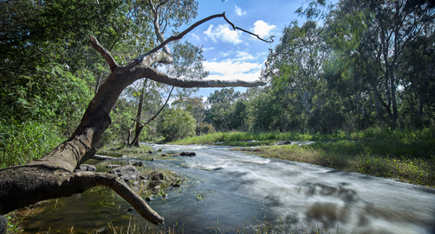

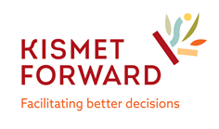
September 2021

Using this document

Discretion should be exercised in making decisions based on the data in this report. Kismet Forward was engaged to prepare this report based on feedback from 39 submissions received by the City of Greater Geelong. Significant effort has been made to accurately reflect the contribution of people who took part in this consultation.
This report provides an independent summary of the feedback received, which by its nature is subjective and not always consistent. It cannot necessarily be construed to be an accurate reflection of the weight of broader community or stakeholder opinion. The report does not provide recommendations or opinions of the consultancy team, and no formal statistical analysis or fact-checking of data has been undertaken.
No responsibility or liability can be taken for errors or omissions, or in respect of any use of or reliance upon this report by any third party.
Abbreviations used in this document
DELWP Department of Environment, Land, Water and Planning
IPCC Intergovernmental Panel on Climate Change
SMART Specific, Measurable, Achievable, Realistic and Time-limited
The City City of Greater Geelong
The Draft Plan Draft Climate Change Response Plan

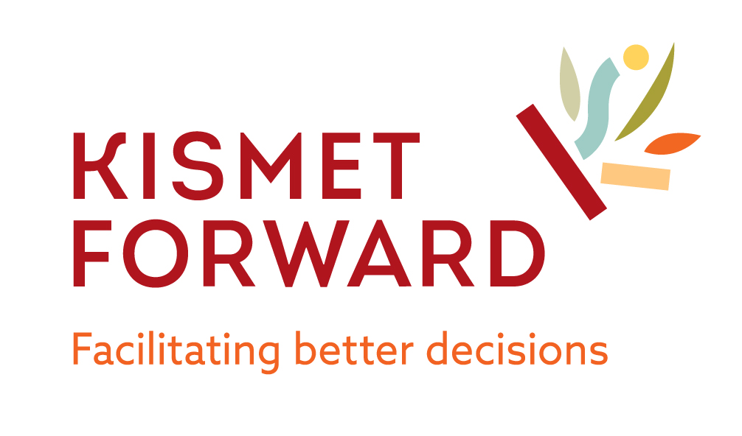 | Prepared by Jennifer Lilburn, Director, Kismet Forward (jen@kismetforward.com.au) and Sally Chandler-Ford for the City of Greater Geelong  Kismet Forward provides specialist advice and support in the areas of community engagement, facilitation,  conflict management coaching, program logic, strategy, evaluation, training and project management.  Further information can be found at www.kismetforward.com.au

It is acknowledged that this report focuses on the City of Greater Geelong, which is on the traditional lands of the Wadawurrung people.

Source: City of Greater Geelong Reconciliation Plan. Image: Wadawurrung Country & Connection 2019. Artist: Billy Jay O’Toole
Table of Contents
Executive Summary 4
Introduction and Background 5
Notes regarding this report 6
What we heard 7
Overview of submissions 7
Mitigation Target: Achieve net zero community emissions by 2035 9
Principle 1: Support an empowered and active community 9
Principle 2: Increase energy efficiency and renewable energy production. 10
Principle 3: Switch to sustainable transport and cleaner fuels 11
Principle 4: Reduce non-energy emissions and increase carbon storage 12
Principle 5: Increase awareness and understanding of climate change impacts 13
Principle 6: Build climate action into decision making 13
Principle 7: Increase collaborative climate change responses 13
Other comments 14

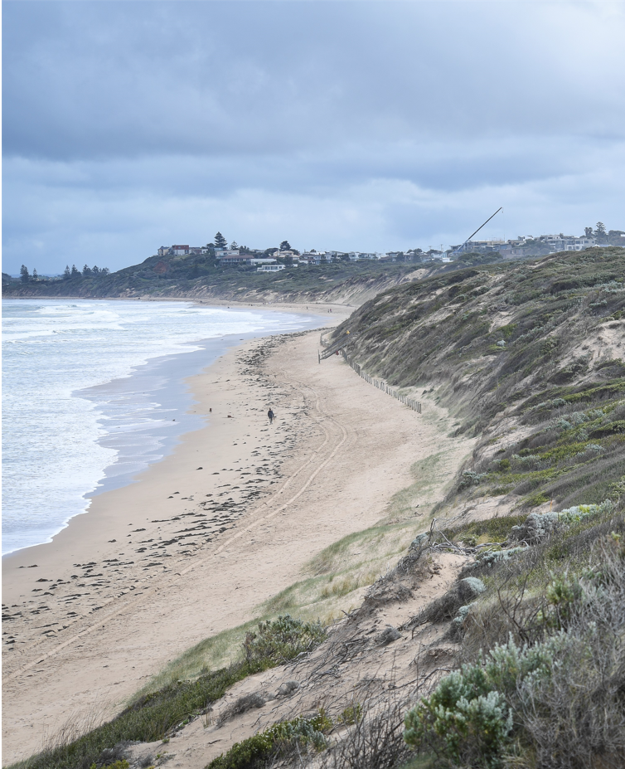
Source: City of Greater Geelong

Executive Summary
The City of Greater Geelong (‘the City’) recognises the urgent need to take appropriate action on climate change. In response to this, the City has developed a Draft Climate Change Response Plan (‘Draft Plan’), identified as a priority action in the Sustainability Framework and Environment Strategy 2020-2030.
At the Council Meeting on Tuesday 27 July 2021, Council endorsed the Draft Climate Change Response Plan for public exhibition and stakeholder and community consultation.
The City received 39 submissions to the Draft Plan, 33 of which were from private individuals. A further five were from community-based groups, and one was from a commercial enterprise. Collectively, 431 comments provided feedback on the Draft Plan.
Of the 39 submissions, 17 commended the City on preparing the Draft Plan, particularly Council’s acknowledgment of the climate change issue and its leadership role in supporting the community’s attainment of the mitigation target to achieve net zero community emissions by 2035. The Draft Plan was regarded as a well-considered, scientifically based, sound response to the issue, and submitters acknowledged the hard work involved in preparing such a document. Three submissions provided only negative sentiments on the Draft Plan, whilst a further 19 either offered both positive and negative sentiments or didn’t indicate their sentiment one way or the other.
Across the submissions, the greatest interest lay in Principle 1: Support an empowered and active community, and specifically the need for clear accountability, sufficient funding and community leadership.

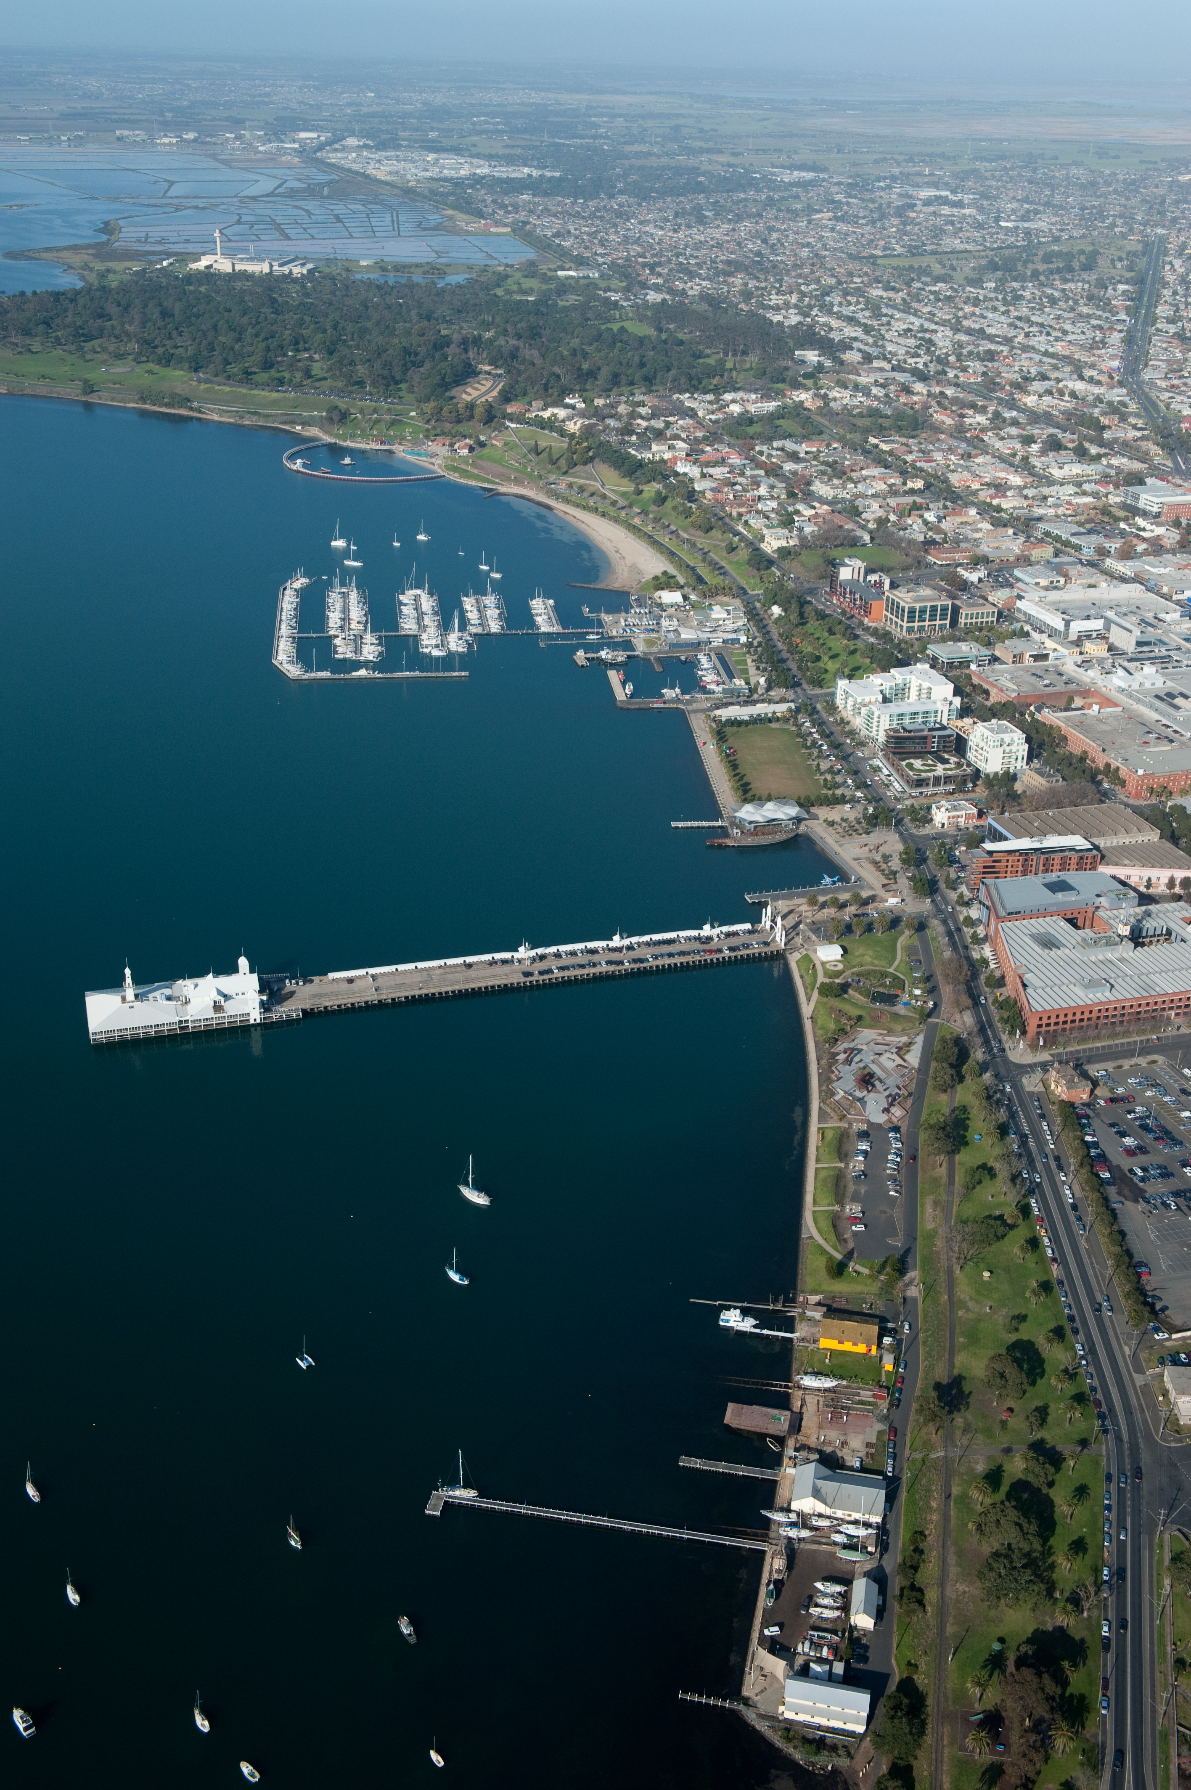
Source: City of Greater Geelong

Introduction and Background
The City of Greater Geelong (‘the City’) recognises the urgent need to take appropriate action on climate change. In response to this, the City has developed a Draft Climate Change Response Plan (‘Draft Plan’), identified as a priority action in the Sustainability Framework and Environment Strategy 2020-2030.
The Draft Plan builds on the Environment Strategy's strategic goals and identifies how the City will support community and business efforts to reduce emissions and adapt to the likely impacts of the changing climate. The Draft Plan also provides a roadmap for reducing the City’s operational carbon emissions and managing its climate change risks.
On 27 July 2021, Council endorsed the Draft Climate Change Response Plan for public exhibition and stakeholder and community consultation. The Draft Plan was then exhibited on the City’s ‘Have Your Say’ webpage until 25 August.
The City received 39 submissions to the Draft Plan, 33 of which were from private individuals. A further five were from community-based groups, and one was from a commercial enterprise. The submissions collectively yielded 431 comments provided feedback on all aspects of the Draft Plan.
As detailed in this report, the City engaged Kismet Forward to provide an independent summary of the submissions.
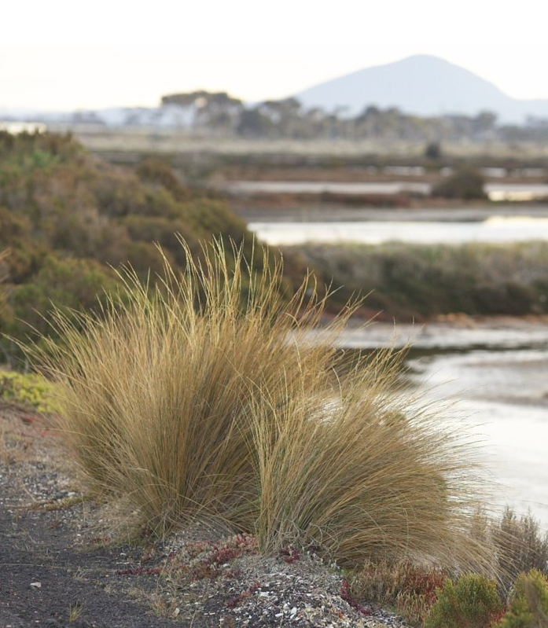
Source: City of Greater Geelong

Notes regarding this report
Some submissions provided extensive and detailed comments on the report including critiques of the Draft Plan’s content, additions, deletions, edits, annotations, re-wordings and Draft Plan restructure. Whilst this report provides a summary of the content contained within all submissions, this level of greater detail has not been captured.
All submission comments, including those referred to above, have been provided to the City in a separate spreadsheet for detailed consideration. In addition, however, one submission contains major re-writes, edits, additions and deletions of multiple sections of the Plan which have not be picked up in the separate spreadsheet. It is suggested that the City reviews this submission in greater detail.

Source: City of Greater Geelong

What we heard

Overview of submissions
Overall positive sentiment
17 submissions (44%)
17 of the 39 submissions commended the City on preparing the Draft Plan, particularly Council’s acknowledgment of the climate change issue and its leadership role in supporting the community’s attainment of the mitigation target. They saw the Draft Plan as a well-considered, scientifically based, sound response to the issue, and submitters acknowledged the hard work involved in preparing such a document. However, these submissions also included areas for improvement or concerns about the Draft Plan’s content.
Overall negative sentiment
3 submissions (8%)
Three submissions provided only negative sentiments, suggesting that the Draft Plan was not good enough, boring in its presentation, lacked inspiration and that the Draft Planned changes were too slow.
Overall neutral or undetected sentiment
19 submissions (49%)
Three submissions offered both positive and negative introductory sentiments, whilst 16 submissions didn’t provide an overall sentiment one way or the other.

The scale of feedback relating to each component of the Draft Plan is outlined in Table 1.
Across the submissions, the greatest interest lay in Principle 1: Support an empowered and active community, which received 105 (30%) comments across 24 (62%) submissions (Table 1). Discussion related to this principle centred on the need for clear accountability (51 comments), sufficient funding (32 comments) and the need for strong community leadership (22 comments).
Principle 4: Reduce non-energy emissions and increase carbon storage received 61 comments, shared between the need to reduce waste and recover waste energy (30 comments) and supporting the establishment of regional drawdown solutions (31 comments).
22 of the 29 comments regarding Principle 6 emphasised the need to integrate and align the Draft Plan with others across the City and, more broadly, with state government policies and regulations.

Component of Plan | Number of Comments (%) | Number of Submissions
Overall positive or negative sentiment | 26 (7%) | 26
Mitigation target: Achieve net zero community emissions by 2035 | 19 (5%) | 14
Principle 1: Support an empowered and active community | 105 (30%) | 24
Principle 2: Increase energy efficiency and renewable energy production | 39 (11%) | 16
Principle 3: Switch to sustainable transport and cleaner fuels | 24 (7%) | 15
Principle 4: Reduce non-energy emissions and increase carbon storage | 61 (17%) | 19
Principle 5: Increase awareness and understanding of climate change impacts | 8 (2%) | 3
Principle 6: Build climate action into decision making | 29 (8%) | 11
Principle 7: Increase collaborative climate change responses | 51 (15%) | 16
Other Comments | 69 (20%) | 22
TOTAL | 431 | 39
Table 1: Number of comments and submissions received on components of the Draft Plan

Mitigation Target: Achieve net zero community emissions by 2035
19 comments across 14 submissions referenced the 2035 zero community emissions target, with overwhelming support offered for the City’s courage in setting such a target and using the science-based data approach upon which it was developed. Some comments called for an earlier target date of 2030, whilst others suggested that interim targets for 2025 and 2030 would be useful. The need to include the business sector within the definition of ‘community’ and for businesses to commit to this target was mentioned. The role of Council in leading the community to meet this target was also highlighted.

Principle 1: Support an empowered and active community
This principle received 105 comments across 24 submissions, of which 22 comments concentrated on Focus Area 1.1 (Community Awareness, education and capacity building), 51 comments on Focus Area 1.2 (Governance and accountability) and 32 comments on Focus Area 1.3 (Resources and Investment Focus).
Queries regarding the level of engagement with the business sector and marginalised groups during the Draft Plan’s development were raised, with the opinion that all community elements need to be involved in affecting climate change. Council’s key leadership role in the community’s response to climate change, together with a need for a stronger focus on opportunities, public participation and community partnerships, were highlighted.
One submission considered that the contents of Principle 5 (increase awareness and understanding of climate change impacts) should be moved to this section and become Focus Area 1.2.
51 comments raised the need for regular reporting, monitoring, target setting and evaluation, focusing heavily on the current absence of clear timelines and measurables for each of the Draft Plan’s actions. Whilst the intention to include these in the final version of the Draft Plan is discussed on Page 21, it appears that many readers may have missed this. It highlights the importance of these elements in the final version.
The need to establish SMART actions (Specific, Measurable, Achievable, Realistic and Time-limited) was highlighted, as was regular, public and transparent reporting with suggested reporting frequency timeframes varying between three and 12 months. Suggested reporting tools included those used by other organisations, such as environmental dashboards and the Cities Activity Database.
Whilst Page 21 of the Draft Plan suggests a document review in 2024, this was considered too far away, particularly if strategies prove ineffective or opportunities are missed in the interim.
The need for clear accountability for implementation was highlighted, with several comments suggesting that this wasn’t clear in the current Plan. The common offering across those comments was that responsibility should sit with the City’s Chief Executive Officer and that the Draft Plan’s implementation needed to occur across the whole of the organisation.
32 comments focused on funding aspects of the Draft Plan, many highlighting the importance of adequately resourcing the Draft Plan’s implementation. Whilst the commitment to fund actions was welcomed, there were concerns that the indicated resources, both project funding allocations and staffing, were insufficient to match the Draft Plan’s ambitions. Calls for action prioritisation to assist in funding allocations were offered. Several comments suggested that, given the inclusion of currently unfunded actions, Council’s existing funding be reprioritised based on the level of risk or impact, and resources should be redirected from currently funded Council projects that don’t contribute to the zero net emissions target.
This consideration was repeated in comments relating to Principle 6, Focus Area 6.2: Corporate climate risk management and disclosure. The need for Council to leverage funding from state and federal governments and private industry was also suggested.
Many comments referred to the general funding discussion on Page 21 and the actions outlined in Focus Area 1.3. The addition of community climate change officers was welcomed (Action 1.3.1), and the need for these staff to work across all areas of the City was highlighted.
Other comments included:
- That Action 1.1.1 (community awareness-raising campaign) start in 2022, not 2023.
- An additional action in the creation of a ‘Citizens Assembly.’
- The specifics around Action 1.3.3 (climate action strategic partnership fund) were queried, including the extent of intended resource allocation.

Principle 2: Increase energy efficiency and renewable energy production.
17 of the 39 comments across 16 submissions provided comments on Focus Area 2.3: increasing renewable energy use. Nine comments related to Focus Area 2.1: improving energy efficiency in existing buildings, facilities and infrastructure, and 13 comments related to Focus Area 2.2: optimising energy efficiency in new buildings, facilities and infrastructure.
Queries were raised as to why supporting the transition to gas-free operations should be considered long-term rather than commencing the transition now (Action 2.1.1). Rate relief for people on lower incomes who install solar panels was suggested as an additional offering to promote community take-up of renewable energy alternatives.
Frequent comments pushed for changes to planning and building regulations on new developments to prevent gas connections and, instead, to require the use of renewable energy alternatives in the drive for lower emissions. However, one submitter stated that the active discouragement of gas infrastructure in new developments could unintentionally result in limited access to future lower carbon energy alternatives such as biomethane or hydrogen.
Several submissions expressed concern about the proposed New Energies Service Station.
A wide-ranging set of comments was offered on renewable energy use. Training and support to local businesses to transition their businesses to zero emissions was suggested. Incentives and support programs for householders to transition to renewable energy alternatives in existing dwellings and investing in neighbourhood battery applications to enable residents to easily access the benefits were also proposed.
There was varying opinion on the use of green hydrogen with suggestions that a wind and solar farm be built with hydrogen storage where excess energy can be added to the gas network to displace a portion of conventional gas with green hydrogen. However, a contrary view questioned whether green hydrogen was a well-considered use of limited resources, given the current absence of federal policy to incentivise its use. It was also suggested that solar panel installations on individual buildings are no guarantee of resulting in carbon reductions. The high cost of Action 2.3.4, investigating opportunities to support ‘smart grids’ in new developments was queried.
Other comments included:
- State government regulatory changes requiring energy efficiency disclosure before all residential leases/sales
- Funding renewable generators through community enterprises
- Funding studies on domestic wind generators
- Partnerships with research facilities and potential manufacturers
- Turning street lights on later and off earlier
- Retirement of all glass fridges, freezers and refrigerated vending machines
- Introducing an additional tariff payment to purchase renewable energy from the grid

Principle 3: Switch to sustainable transport and cleaner fuels
24 comments across 15 submissions were offered on this principle, 14 of which related to Focus Area 3.1, prioritising development of sustainable transport infrastructure and services, and 10 related to Focus Area 3.2, transitioning the regional fleet to zero-emissions power sources.
Many comments supported the actions in the Draft Plan. There was particularly strong support for better active transport and public transport routes and infrastructure within the Geelong region, car share schemes, shuttle buses with free parking/collection points and ensuring that the transport needs of new residential developments are met.
The need for a detailed data-driven assessment of trip types, distances, and frequencies to target the resourcing of sustainable transport options and a behavioural-based study to understand what would improve bus and cycling use were suggested. Examples of successful implementation of such strategies in other locations were provided as references.
While some supported electric vehicles as an alternative mode of transport, the cost and sustainability of batteries for charging them concerned others.
The high costs of implementing Actions 3.1.1 (development of an integrated transport study) and 3.1.3 (delivery and promotion of the Shared Trails Master Plan) were queried.
In supporting Council’s target for a zero-emission fleet by 2027, one submitted highlighted the hydrogen transport hub within the proposed New Energies Service Station as a key demonstration of the types of infrastructure projects that could support these initiatives. As previously mentioned, converse opinions were also offered on the merits of this proposed facility by other submitters.
Other comments included:
- Placing kerbside bins on the one side of the street only to reduce garbage truck emissions by 40% as is implemented in Germany
- The need for measurable targets related to the number of charging stations outlined in Action 3.2.5.

Principle 4: Reduce non-energy emissions and increase carbon storage
61 comments were offered across 19 submissions, with comments split almost evenly across Focus Areas 4.1 (reduce waste and recover waste energy) and 4.2 (support establishment of regional drawdown solutions). There was strong support for moves to a circular economy, although it was suggested that substantial effort would be required to affect this considerable behavioural change.
Responses strongly supported the urgent introduction of a food waste recovery program, questioning the need for a trial before implementation. Calls for actions to reduce plastic waste included taxes on plastic materials, introducing a plastics recycling program and incentives to businesses to manage and avoid surplus food generation and reduce food waste.

There was strong support for regional carbon drawdown solutions, with 18 recommendations supporting the transition from animal agriculture to plant-based food alternatives and water consumption reductions. However, a distinction between the minimal cost in setting a carbon sequestration target in Action 4.2.3 and the substantial cost (and community and environmental benefits) of implementing the action was made.
There was a concern that rural land managers and farmers hadn’t been engaged in the Draft Plan’s development but were critical partners that would require sustainable agriculture practices incentives (Action 4.2.1).
Concerns were expressed that Geelong’s urban growth projection of 54% by 2050 will require substantial carbon drawdown initiatives and that the mitigation targets and actions should be prioritised over adaptation activities.
One submitter suggested that parallel decarbonisation strategies in other sectors, such as the transition from traditional fuels to battery electric vehicles, will place additional pressures on the electricity system. It was also suggested that the New Energies Service Station could assist in reducing emissions.
Other comments included:
- Acceptance of green waste at resource recovery centres at no cost to the ratepayer
- Support for the core principles of localising goods and services and strengthening the community as outlined in the global Transition Streets movement
- Clarity was sought on the municipal waste emission reduction target in Action 4.1.1.
- Council could be more proactive in promoting Deakin University’s blue carbon research and other initiatives.

Principle 5: Increase awareness and understanding of climate change impacts
Only eight comments across 3 submissions related specifically to improving local climate risk knowledge. One suggested that Focus Area 5.1 be re-written as ‘Improve climate risk knowledge for business and communities to improve their decision-making and adaptive capacity’. It was thought that this wording would better illustrate the intended audience and that, rather than focusing just on physical risks, opportunities and threats associated with energy transition should be highlighted to ensure that communities are early adopters and don’t get left behind.
However, another submission considered that the contents of Principle 5 should be moved to Principle 1, that Principle 5 be re-written as ‘Adaptation measures’. The submitter suggested adding a new focus area relating to incorporating climate action awareness into planning at all levels.

Principle 6: Build climate action into decision making
11 submissions yielded 29 comments on this principle, 22 of which related to Focus Area 6.1 (embed climate thinking in our decisions), specifically the alignment and integration of the Draft Plan with and across all other Council plans and state government policies and regulations. This was considered a critical requirement in the Draft Plan’s successful implementation, with suggestions that developing a policy to facilitate this (Action 6.1.2) wasn’t sufficient. Furthermore, the need for the Draft Plan to be embedded in job descriptions and performance plans across the City was highlighted.
Several suggestions supported the strengthening of planning regulations related to energy-efficient infrastructure (solar, water tanks plumbed to toilets etc.) and the maximising of sustainable practices, coupled with protecting biodiversity values in new housing developments.
Replacement of the term ‘climate risks’ with ‘climate change risks’ was suggested to reflect natural variability risks and the interchange between these and climate change.
Seven comments on Focus Area 6.2 (Corporate climate risk management and disclosure) highlighted the need to prioritise climate change outcomes over financial outcomes in all decision making. There was also strong support for Action 6.2.5, directing funds away from projects that are not environmentally sustainable or inhibit the City’s ability to adapt to climate change. There was also a call for a climate-conscious procurement policy for all Council purchases.

Principle 7: Increase collaborative climate change responses
16 submissions yielded 51 comments on this principle, 18 of which centred on Focus Area 7.1 (Build networks and partnerships for adaptation responses) whilst 33 related to Focus Area 7.2 (Collaborate in areas of emerging climate risks), 18 of which were biodiversity-focused actions.
18 comments considered advocacy, particularly to state and federal levels of government, to be a critical requirement for the City. Some submissions considered this issue was omitted from the current Plan, while others indicated the need for a stronger emphasis and priority on this role in the document.
In advocating for a unified response to climate change, comments also stressed the need for the City to ensure it is aligned with key state and federal government strategies, legislation and targets. The opportunities presented by Geelong’s location in a marginal seat were highlighted as a key point to leverage additional resources to the region.
Seven comments identified a lack of adequate inclusion or recognition of Traditional Owner culture, perspectives and land management practices, and the need to incorporate their knowledge in the Plan. Reference to the Borough of Queenscliffe’s Climate Emergency Response Plan as a best practice example was made.
Other comments under Focus Area 7.2 reference materials on reducing Urban Heat Islands, the need to move away from broad-scale monoculture crops and a suggestion that artificial reef and sand fences initiatives need to be site-specific.

Other comments
69 comments across 22 submissions didn’t fit neatly into the seven principles and are summarised below:
- Frequent requests to update data in the Draft Plan (Page 10) following the Intergovernmental Panel on Climate Change (IPCC) Report.
- Promote and accentuate social and economic opportunities in the Draft Plan for job creation, green industries and improved civic places resulting from early adoption of climate change measures.
- Climate change is not just an environmental but also a physical and mental health issue.
- The need to ensure the equitable adaption to climate change and protect the vulnerable from the effects of climate change whilst also driving down emissions and protecting biodiversity.
- The need for a communications plan, including specific branding/visuals to ensure positive messaging in the community and to ‘bring the Draft Plan to life’.

https://yoursay.geelongaustralia.com.au/CCRP
The ‘overall neutral or undetected sentiments’ outlined on page 7 are not included.

