PROPOSED SALE OF Various council properties
Source: | Customer & Corporate Services – Property, Procurement & Assets
Director: | Michael Dugina
Report To: | Council Meeting
Portfolio: | Finance
Purpose
- To seek Council approval for the City to give public notice of the intention to sell the following land (properties) located at:
  - 116-120 Purnell Road, Corio
  - 11 McHarry Court, Corio
  - 34-40 Esperance Crescent, Highton
Background
- In line with the City’s key priority to “proactively manage our assets, including land holdings”, land identified as no longer require by the Council for strategic operations may be identified as surplus and for potential sale.
- The properties listed no longer meet the requirements for which they were previously managed. Attachments 2 to 4 of this report provides the specific information for each property.
Key Matters
- The listed properties are no longer fit for purpose or are surplus to the City’s needs and are considered for disposal.
- Council should commence the sale process for the properties in accordance with section 189 of the Local Government Act 1989 (Act) which involves giving public notice of the intention to sell land and invite submissions.
- If submissions are received regarding a specific property, they will be considered by the Council or if requesting to be heard, the Submissions Review Panel will hear the submissions and a further report will be put to Council.
- If no submissions are received for a listed property it is proposed that the property a report will be provided to the CEO, as the delegate, to determine if the property may be sold by a public process determined in discussion with the appointed agent.
- A current market valuation will be obtained for each property before it is offered to the market to set the reserve price.
Recommendation
- That Council:
  - Commence the process to sell the properties at:
    - 116-120 Purnell Road, Corio, being certificates of title volume 08887 folio 191 and volume 08887 folio 192;
    - Part 11 McHarry Court, Corio, being certificate of title volume 9332 folio 123; and
    - 34-40 Esperance Crescent, Highton being certificate of title volume 11072 folio 590.
  - In accordance with section 189 of the Local Government Act 1989 (Act), a public notice of the intention to sell land, being the listed properties and the right of a person under section 223 of the Act to make a submission in relation to each proposed property sale be issued;
  - Consider any submissions received or appoint the Submissions Hearing Panel to hear the submissions if requested and report to the Council on any submissions in relation to the proposed property sales;
  - Notes that if submissions are received concerning one of the properties a further report will be put to Council regarding that property;
  - If there are no submissions received for a specific property the CEO, as the delegate, will determine if the property may be sold by a public process identified in discussion with the appointed agent;
  - The reserve price of each property will be no less than a certified valuation of the property obtained no more than 6 months prior to the date of sale; and
  - Authorise the Director Customer and Corporate Services to sign all documents relating to the sale of the properties.

Attachment 1
Financial Implications
- The sale of these properties will reduce the financial impact of maintaining land and assets which are surplus to the City’s needs.
- The proceeds from the sales will provide income for the City.
- Demolition of the building on 116-120 Purnell Road, Corio would present a capital cost of approximately $115,000 to prepare the property for sale.
- The costs associated with the sales such as public notice, property valuations and sales commission will be offset against income.
Community Engagement
- Any person will have an opportunity to make a written submission on any of the proposed sales in accordance with the notice of intention to sell land.
- A submitter is entitled to request in the submission that the person wishes to appear in person, or to be represented by a person specified in the submission, at a meeting to be heard in support of their submission.
- Should a sale proceed, an agent will be appointed to sell the property by a public process and the method of sale will be determined in consultation with the agent. Sale options include public auction, sale by expressions of interest or listing.
Social Equity Considerations
- There are no social equity issues associated with this matter.
Policy/Legal/Statutory Implications
- Section 189 of the Act requires that Council must obtain a valuation of the property from a suitably qualified property valuer which is made not more than 6 months prior to the sale and give public notice of its intention to sell the land and consider any submissions received. If any submissions are received, they will be considered by Council and if requested, heard by the Submissions Review Panel followed by a report to Council. If no submissions are received the property will be sold.
- While zoned as General Residential 1, the title description for 11 McHarry Court, Corio and 34-40 Esperance Crescent, Highton identifies the properties as Reserves. The title status can be amended in accordance with Section 24A of the Subdivision Act 1988 prior to the sale of each property.
- Section 24A (8) of the Subdivision Act requires that
(8) If a body sells land under this section that was public open space, it must apply the proceeds—
(a) first, in paying the expenses of or incidental to the sale;
(b) secondly, for any of the following recreational or cultural purposes—
(i) halls and public buildings;
(ii) sport, recreation, leisure and arts;
(iii) parks, gardens and reserves;
(iv) libraries and museums;
(v) historic buildings and places;
(vi) public entertainment.

- Section 20 of the Subdivision Act 1988 requires that: -
  - The Council must use any payment towards public open space it receives under this Act or has received under section 569B(8A) of the Local Government Act 1958 but has not applied under subsection (8C) of that section or the proceeds of any sale of public open space to—
- buy land for use for public recreation or public resort, as parklands or for similar purposes; or
    - improve land already set aside, zoned or reserved (by the Council, the Crown, a planning scheme or otherwise) for use for public recreation or public resort, as parklands or for similar purposes; or
    - with the approval of the Minister administering the Local Government Act 1989, improve land (whether set aside on a plan or not) used for public recreation or public resort, as parklands or for similar purposes.
  - Public open space can be used for municipal purposes in accordance with the planning scheme, or sold only if the Council has provided for replacement public open space.
  - This section does not apply in relation to any land that is specified in an approved infrastructure contributions plan as land to be set aside as public open space.
- There are no human rights ramifications to the proposal.
Alignment to Council Plan
- The sale of these properties which are no longer required by the City and have financial implication in maintaining and aligns with the strategic priority of organisational leadership, strategy and governance and its key priority of ‘proactively managing our assets, including land holdings’.
Conflict of Interest
- No officers or contractors involved in the preparation of this report have a direct or indirect interest in the matters to which this report relates.
Risk Assessment
- No notable risks associated with implementation of the recommendations.
Environmental Implications
- There are no environmental issues identified with selling the properties.

Attachment 2
116-120 PURNELL ROAD, CORIO
Background
- The City operated a child care facility at its property at 116-120 Purnell Road, Corio.
- The child care service has been relocated to the new Corio Integrated Child and Family Centre, therefore this centre has been closed.
- Prior to the completion of the Corio Integrated Child and Family Centre, the Council considered redeveloping 116-120 Purnell Road into a play space, however the site was
- At its meeting of 11 June 2019 resolved the Council resolved:
That Council:
  - Note the proposal to include a local play space within the public open space of the new Corio (Purnell Road) Integrated Child and Family Centre;
  - Authorise officers to commence design of a district nature-based play space at Goldsworthy Reserve in consultation with the community; and
  - Note the intention to sell the site of the Corio City Learning and Care following its closure.
Key Matters
- The property consists of two titles; Lots 316 and 317 of LP91706, being certificates of title volume 08887 folio 191 and volume 08887 folio 192.
- With a total land area of approximately 2,297.60m2, the two titles should be sold together to maximise the sale outcome.
- The property, no longer fit for purpose, has been vacated and is surplus to the City’s needs and should be considered for disposal.
- The proposal aligns with the City’s Municipal Children’s Services Infrastructure Plan 2013-2030 which was endorsed by the Council on 24 March 2015 which identified the replacement of the service with the new Integrated Child and Family Centre.
- The existing building will be demolished and the property sold as vacant land.
- The land is zoned for general residential purposes so there will be no requirement for rezoning to prepare it for sale.
- The estimated cost of demolition is $115,000.

Aerial Pictures - 116-120 PURNELL ROAD, CORIO

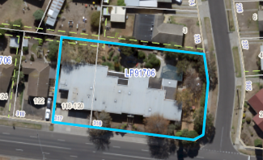

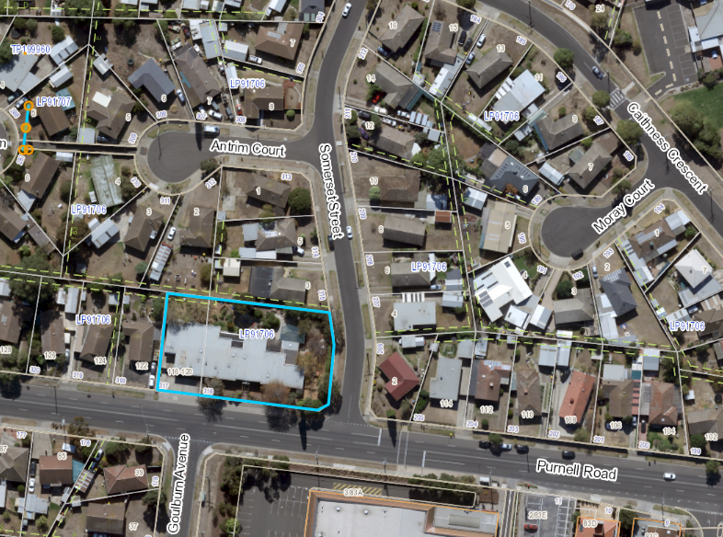
Attachment 3
PART 11 MCHARRY COURT, CORIO
Background
- This parcel of land was originally created as a reserve for drainage, sewerage and recreation purposes.
- The land was rezoned for residential purposes following the Council resolution at the Council meeting of 16 February 2016 to adopt Planning Scheme Amendment C330 to rezone part of Connections Park to the General Residential Zone.
- Although the address is 11 McHarry Court, Corio, the parcel of land connects to Welch Court, Consedine Court, Kilpatrick Court, and Goodwin Court, Corio.
Key Matters
- The property is Res1 PS123689 on certificate of title volume 9332 Folio 123 and measures 1.119Ha.
- The ‘reserve’ status on the certificate of title will need to be removed prior to sale so the land can be developed in accordance with its General Residential Zoning.
- The nearby property, formerly the Rosewall Primary School, is likely to be sold by the State Government and be a complimentary redevelopment opportunity to the City’s land.
- The reserve is poorly situated and suffers from a lack of passive surveillance and safety concerns. The Corio Norlane Structure Plan, July 2012 recognises that “Redevelopment of the former Rosewall Primary School site provides an opportunity to address the lack of permeability in the existing street layout, as well as improve the surveillance and security of the Connections Park open space area.”
- The report presented to the Council meeting of 16 February 2016 noted “the long-term strategy to redevelop Connections Park East for residential use complements other renewal projects that will bring significant benefits for the local community
- The retention of the western part of Connections Park at over 1.3 hectares, with established playground equipment and neighbouring the Rosewall Neighbourhood House, will adequately serve local open space needs. The loss of the site as designated open space in the Planning Scheme will not adversely impact on the community.”

Aerial Pictures - PART 11 MCHARRY COURT, CORIO
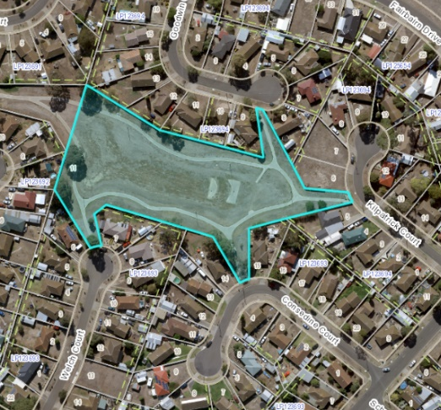
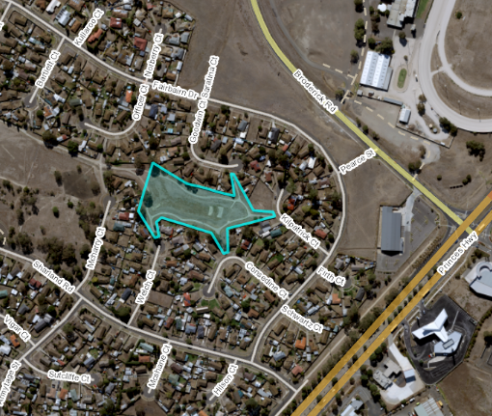
Attachment 4
34-40 ESPERANCE CRESCENT, HIGHTON
Background
- This property was originally purchased in 2008 and considered for community facilities, however has never been developed and remains as vacant land.
Key Matters
- The property is Res1 PS543354 on certificate of title volume 11072 Folio 590 and measures 5,000m2.
- The ‘reserve’ status on the certificate of title will need to be removed prior to sale so the land can be developed in accordance with its General Residential Zoning.

Aerial Pictures - 34-40 ESPERANCE CRESCENT, HIGHTON
