0-=0 07
Ocean Grove Main Beach
Dog Control Orders Trial Year 1

Independent Report of Community Survey Results
October 2021

Report prepared for and
Using this document
Discretion should be exercised in making decisions based on the data in this report. Kismet Forward was engaged to prepare this report based on feedback received from respondents to a survey distributed and promoted by Barwon Coast and the City of Greater Geelong. Significant effort has been made to accurately reflect the contribution of people who took part in this consultation.
This report provides an independent summary of the feedback received, which by its nature is subjective and not always consistent. It cannot necessarily be construed to be an accurate reflection of the weight of broader community or stakeholder opinion. The report does not provide recommendations or opinions of the consultancy team, and no formal statistical analysis or fact-checking of statements has been undertaken.
No responsibility or liability can be taken for errors or omissions, or in respect of any use of or reliance upon this report by any third party.

Barwon Coast supplied the cover photo.
All other photos used in this report are stock images
Abbreviations and terms used in this document
Barwon Coast Barwon Coast Committee of Management
Dog Owners Respondents who visit Ocean Grove Main Beach and either own a dog or exercise someone else’s dog
Main Beach Ocean Grove Main Beach, also known as Area D for the purposes of the trial
n The number of people who answered a question
Respondent Someone who completed a survey
The City City of Greater Geelong

Prepared by Jennifer Lilburn, Director, Kismet Forward (jen@kismetforward.com.au)
Kismet Forward provides specialist advice and support in the areas of community engagement, facilitation,
conflict management coaching, program logic, strategy, evaluation, training and project management.
Further information can be found at www.kismetforward.com.au

It is acknowledged that this consultation took part on the traditional lands of the Wadawurrung people.

Source: https://doongal.com.au/content/ocean-beauty-0
Table of Contents
Introduction and Background 4
What we did 5
The survey 8
Who contributed feedback 9
What we heard 10
Profile of Ocean Grove Main Beach use 10
Reasons for not visiting Main Beach 14
The dog controls trial 16
Impact of the trial 18
Implementation of the trial 19
Signs, promotion and enforcement 20
Other Feedback 21
General Observations 23
Health and Wellbeing 23
Previous bad behaviour 24
Equity and ‘our rights’ 24
Rationale 24
Enforcement, education and signs 25
Where to from here 26
Appendix A: Full Survey 27
Appendix B: Residential location of respondents 32

Introduction and Background
Barwon Coast Committee of Management (‘Barwon Coast’) is appointed by the Victorian State Government to manage 15kms of coastal Crown land adjacent to Ocean Grove and Barwon Heads. The City of Greater Geelong (‘the City’) is responsible for enforcing dog controls in this area under the Domestic Animals Act 1994. New dog controls were approved and came into force on 1 January 2021.
Barwon Coast and the City consulted on dog controls in 2019-2020, and more than 1700 community members provided feedback. Responses highlighted the need for an area of beach to be set aside as dog-free all year round. Barwon Coast determined that Ocean Grove Main Beach (‘Main Beach’), a high-use activity node, was the most suitable location. This area comprises 5% of Barwon Coast’s management area, is approximately 805 metres long and is called ‘Area D’. Area D is shown in red on the map in Figure 1.
By the end of 2021, Area D will have ramp and stairway access to coastal paths at either end; a project to upgrade access at Hodgson Street is nearing completion.
To determine arrangements that best suit community members, a two-year trial is underway for Area D at Ocean Grove Main Beach:
- Year One (2021) - dog walking is allowed on leash from 1 May to 30 November and prohibited for the remainder of the year.
- Year Two (2022) - dog walking will be prohibited for the entire year.
In August/September 2021, Barwon Coast and the City began to seek community feedback on opinions and experiences over the first year of the trial. Geelong-based engagement consultant Kismet Forward was contracted to design and independently report on a community survey to capture this feedback.
This information about community experiences and attitudes about dogs on Ocean Grove Main Beach will be combined with information gathered from another engagement process in Year Two of the trial (2022). It will help inform the most acceptable option for permanent dog controls in Area D.
This report details the feedback received on the first-year survey.
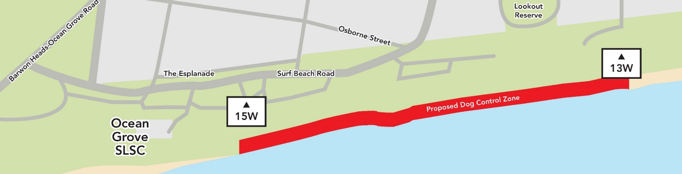
Figure 1: Map of the area in Ocean Grove in which the trial dog controls apply

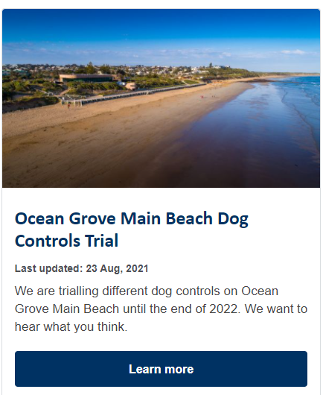
Figure 2: Project tile on the City’s website https://yoursay.geelongaustralia.com.au/

What we did
A 32-question survey was developed on Survey Monkey and distributed by Barwon Coast and the City as described below. It was open from 18 August to 26 September 2021.
- The ‘Have Your Say’ Page on the City’s website (see Figure 2)
- Media releases 23 August, 6 and 7 September, resulting in coverage in
  - Herald Sun 20 August
  - Geelong Advertiser 20 August
  - Geelong Independent 10 September
  - Bellarine Times 26 August and 16 September
- Advertisements (see example in Figure 3)
  - ‘City News’ in Times News Group, Geelong Independent (3 and 10 September) and Geelong Advertiser (11 September)
  - Bellarine Times 26 August and 28 September
  - Bellarine Times Mayors Column 2 September
  - Ocean Grove Voice 27 August, 10 and 20 September
  - Talking Heads 3 September
  - Flyer (Figure 4) sent to six local schools for their newsletter
- Six signs posted around Ocean Grove Main Beach (see Figure 3)
- Facebook posts
  - 20 August (reach = 12,810, engagements = 275 including 28 shares)
  - 24 August (reach = 534, engagements = 66)
  - 7 September (reach = 233, engagements =22)
- 22 September (reach = 2288, engagements = 65)

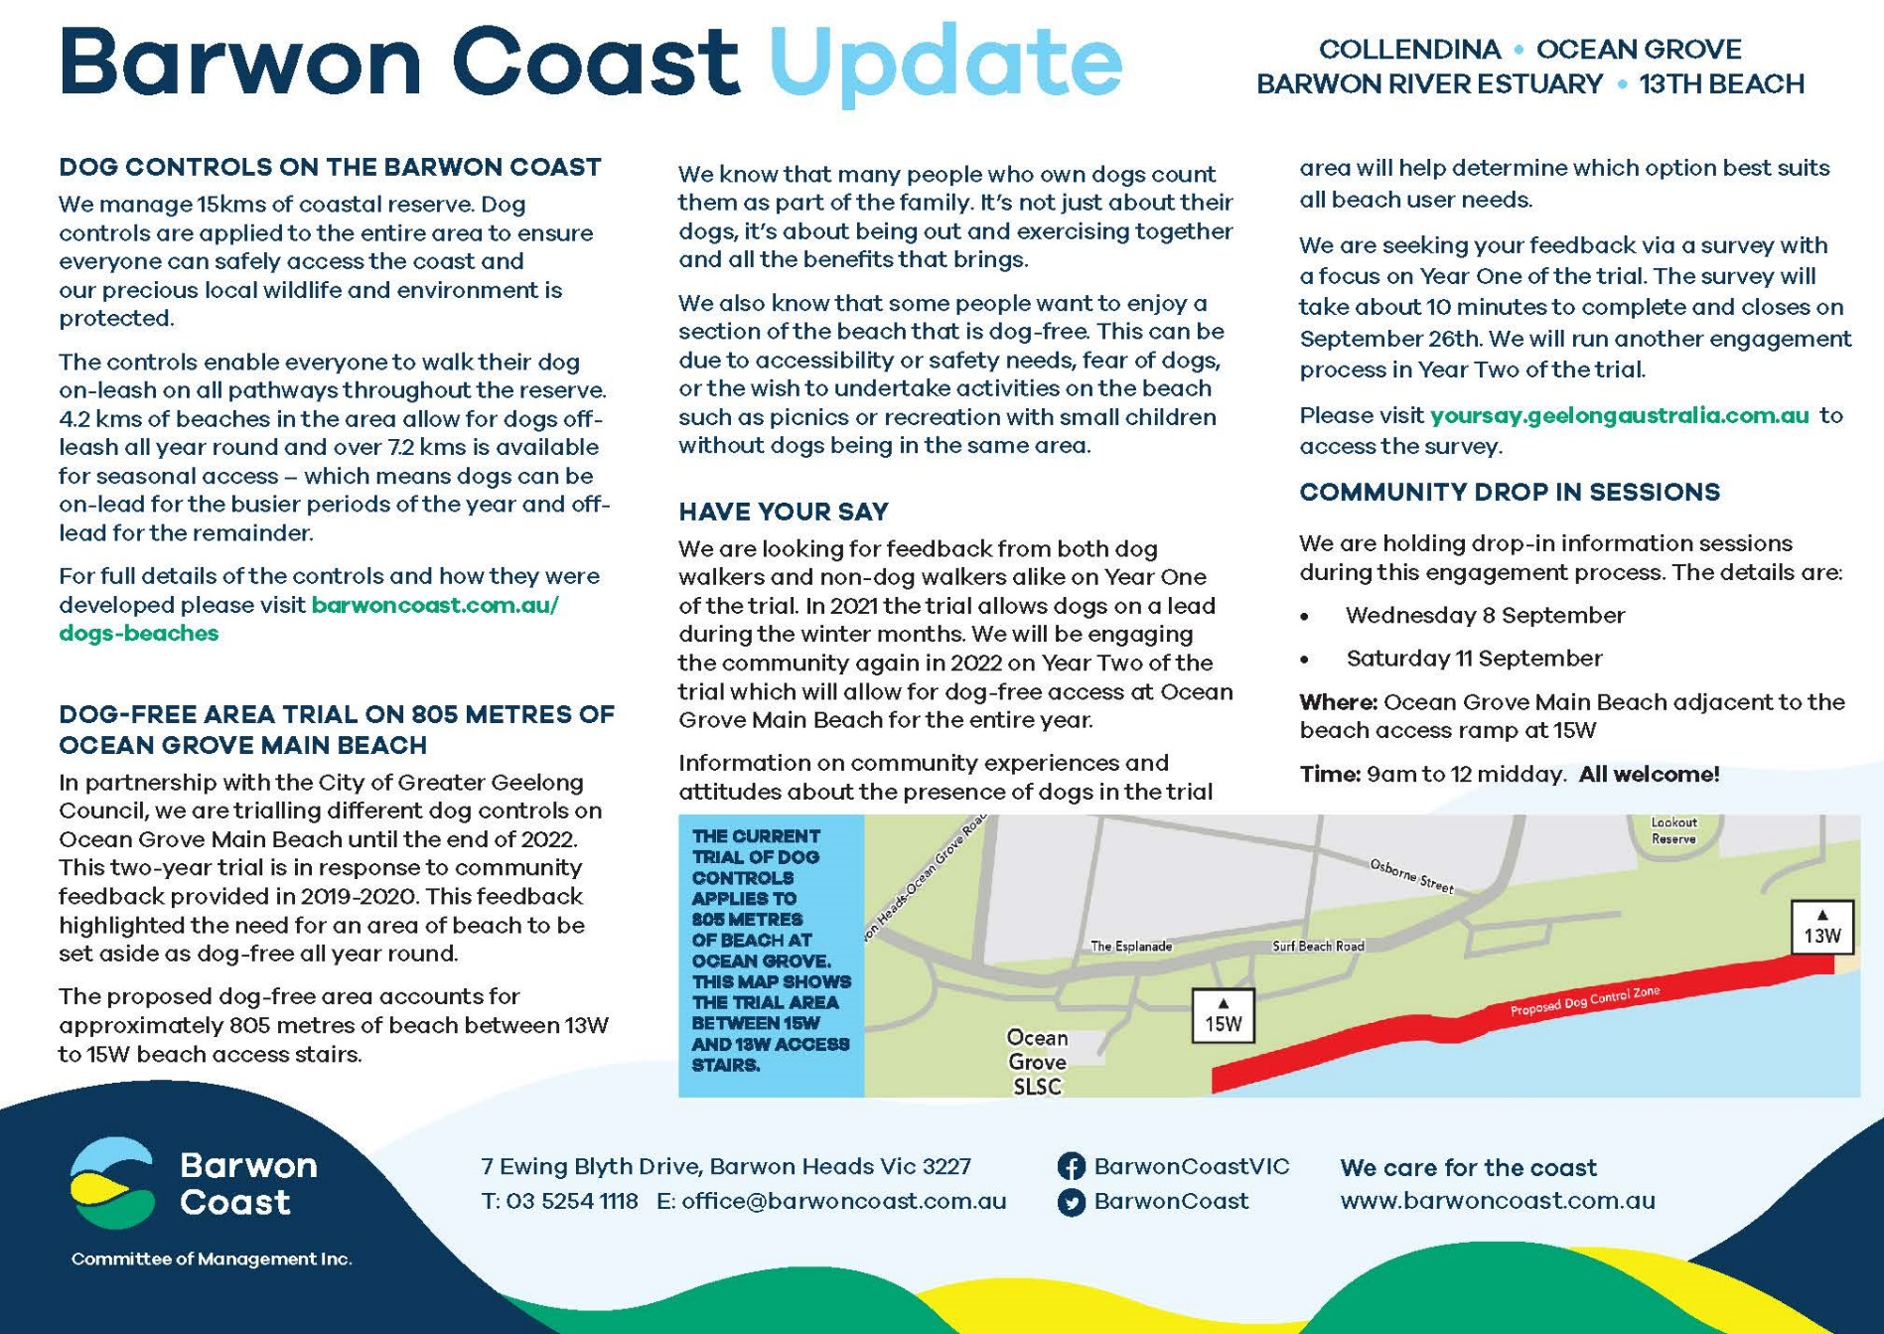
Figure 3: Sample advertisement placed in local media by Barwon Coast

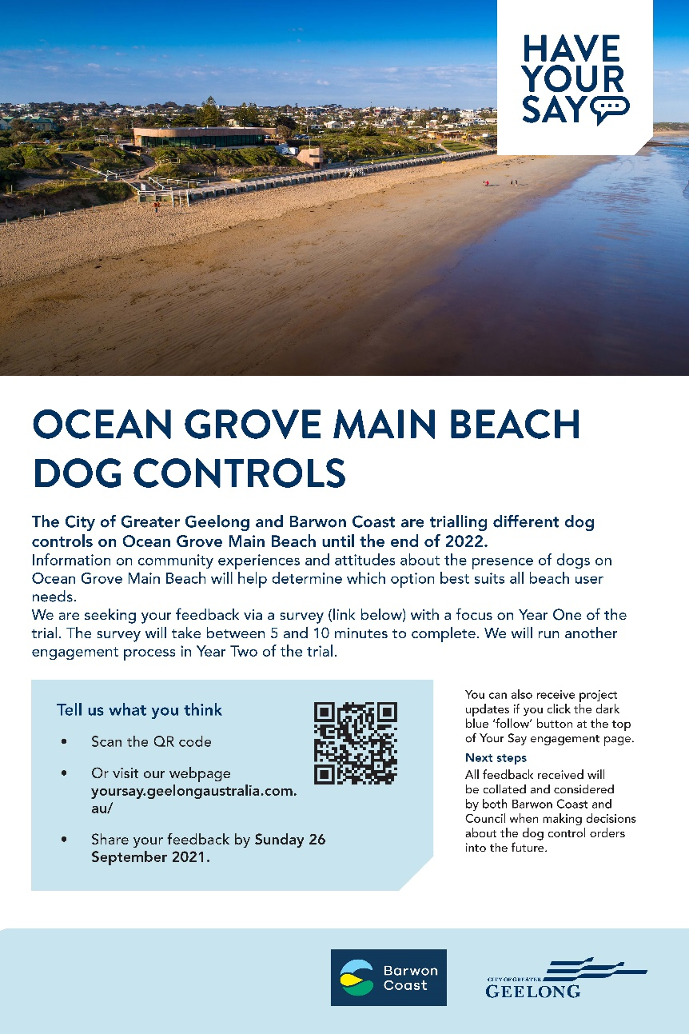
Figure 4: Sign at Main Beach and flyer sent to schools

- Instagram post 24 August (reach = 4037, engagement = 106 including 6 shares)
- Direct emails sent to:
  - 235 community members who had expressed an interest in dogs or contacted Barwon Coast via previous engagement or with relevant complaints
  - 55 other stakeholders, including local coastal community recreation and environmental groups, local business and community associations, coastal commercial activity and tour providers, Traditional Owners, adjacent land managers, local vets and coastal caravan park guests.
Unfortunately, due to Covid-19 restrictions, community drop-in sessions scheduled for 8 and 11 September were cancelled.

The survey
The survey included question and page logic, so that different questions were asked of respondents according to whether they visit Main Beach, own a dog (or exercise someone else’s), and if so, how often they visit Main Beach with the dog. Respondents who said they don’t visit Main Beach (with or without a dog) were asked why. Beach users were asked how often they visit and at what times of the day/week and year they do so.
All respondents were asked about the Year 1 Trial, including whether they agree with it, whether it has resulted in a change to beach visiting habits, and whether they had observed various positive and negative dog/owner behaviours. All respondents were also asked about the signage, promotion and enforcement of the dog control orders.
The survey questions and logic are shown in Figure 5; the full survey is included in the Appendix.

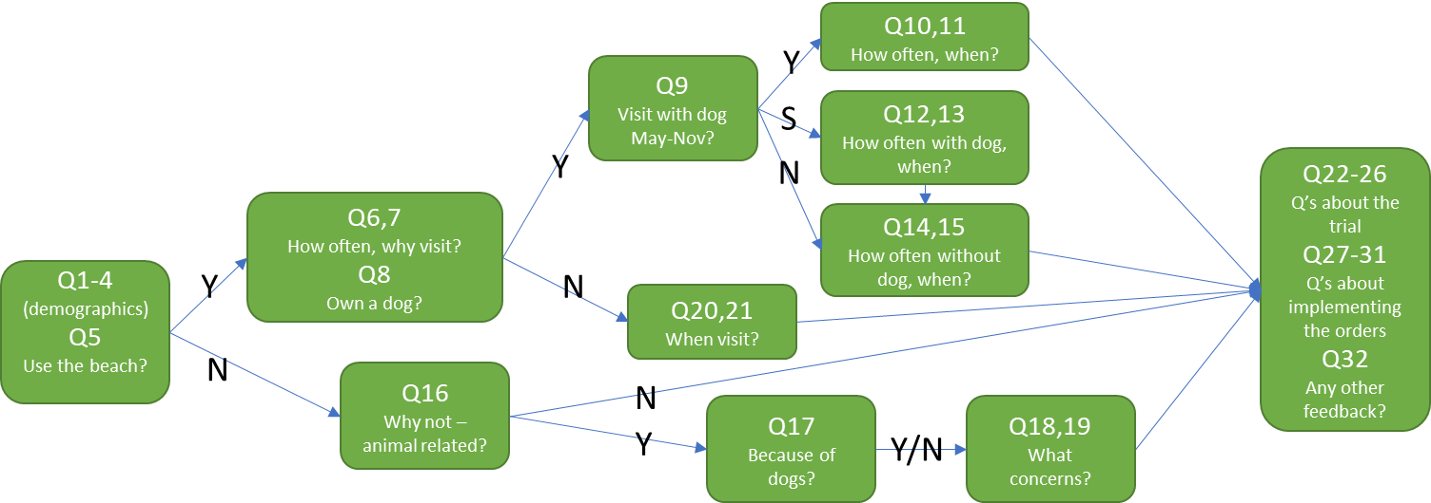
Figure 5: Survey logic and question summary.
Respondents were asked between 17 and 24 questions, depending on whether they answered ‘Yes’ (Y), ‘No’ (N), or ‘Sometimes’ (S) to various questions.

Photo by Feri & Tasos on Unsplash

Who contributed feedback
1139 people contributed to the survey over the 40 days it was open. Survey Monkey analytics revealed a 90% completion rate, and respondents typically spent just over 9 minutes completing the survey.
The first four questions sought to reveal the demographic spread of respondents. When considering the figures below, (Qx) refers to the survey question from which a particular data set was drawn and n refers to the number of respondents who answered a question.
The typical respondent was female (72%), aged between 35 and 69 years (81%), and an Ocean Grove resident (72%), as shown below.

Figure 6: Age breakdown of survey respondents, showing that most were aged 35-49 (35%), 50-59 (25%) or 60-69 (21%). All respondents were required to answer this question (Q1, n=1139).
Almost three-quarters of survey respondents (72%) identified as female. 27% were male; 1% either identified as neither or preferred not to indicate gender (Q2, n=1139).
72% of respondents live in Ocean Grove, and 12% in Barwon Heads. The remainder were from across the municipality, and a small number (2%) live elsewhere in Victoria and beyond. (Q3+4, n=1139). A breakdown of respondents’ residential locations is in Appendix B.

Photo by Jonathan Singer on Unsplash

What we heard
1139 responses were received to the survey, together with one emailed submission. That submission has been incorporated with the survey feedback in this report as a 1140th response. From these responses, a total of 4953 comments was provided across the eight questions that enabled free-text responses. All feedback is summarised below.

Profile of Ocean Grove Main Beach use
99% of all survey respondents indicated they currently use Main Beach at least annually (Q5). Only 17 respondents said that they didn’t visit the beach.
As shown in Figure 7, 76% of the respondents who visit Main Beach own a dog or exercise someone else’s dog (Q8). These 848 respondents are referred to as ‘dog owners’ in this report.

Figure 7: About 3/4 of respondents who use Main Beach own a dog
(Q8, n=1115)

Use frequency and reasons for visiting Main Beach
Respondents typically visit Main Beach at least weekly (83%) to exercise (92%), with or without a dog, as shown in Figures 8 and 9.

Figure 8: Frequency of visits to Main Beach (Q6, n=1114)

Figure 9 shows that the reasons for visiting the beach were varied (respondents could choose more than one of the options mentioned in Q7). 48 respondents listed another 57 reasons, including
‘other’ reasons for visiting Main Beach | #
Dog walking | 22
Surf club activities | 9
For exercise, e.g. walking, rehabilitation | 6
Visit The Dunes café/kiosk | 5
Enjoy the surroundings | 4
Mental and emotional health and well being | 3
For recreation activities such as surfing, swimming, fishing | 3
Friends and family time | 2
It is noted that some of these responses duplicate the question options described in Figure 9. It is not clear whether the respondents who entered these ‘other’ reasons also checked the response options for the question.

Figure 9: Reasons for visiting Main Beach
(Q7, n= 1114, more than one response was possible)

When dog owners visit Main Beach
65% of dog owners reported visiting Main Beach with their dogs from May to November, and another 28% of dog owners indicated they sometimes do so with/without their dogs. Only 8% stated that they do not take their dog to Main Beach (Q9).
As shown in Figures 10 and 11, most respondents visit Main Beach with their dogs at least weekly (86%) and on weekday mornings (50%) or weekend mornings (54%). Weekend evenings are the least popular time (18%) to take dogs to Main Beach.

Figure 10: Frequency of visits to Main Beach with dog/s during May-November (Q10+12, n=774)

Figure 11: When respondents take their dog/s to Main Beach
(Q11+13, n=774, more than one response was possible)

Dog owners who do not take their dogs to Main Beach visited it less frequently, and their visitation patterns were less regular, as shown in Figures 12 and 13.
For example, visits were at least weekly for 83% of respondents with their dogs, compared with 58% of respondents who left their dogs at home. 42% of respondents took their dog to the beach at irregular times/days, compared with 59% of respondents who visited without their dogs. There was also a lot less variability in times of the week that respondents said they visited the beach without their dogs.

Figure 12: Frequency of dog owners’ visits to Main Beach without their dog/s during May-November (Q14, n=290, more than one response was possible)

Figure 13: When dog owners visit Main Beach without their dogs
(Q15, n=292, more than one response was possible)

When NON-dog owners visit Main Beach
People who do not own dogs indicated that they use Main Beach throughout the year, perhaps less often during the winter months. Figure 14 shows that the usage pattern follows a predictable seasonal trend.

Figure 14: Months that non-dog owners visit Main Beach
(Q20, n=267, more than one response was possible)

As was the case for dog owners, morning beach visits were preferred by Main Beach users who do not own dogs – 46% visit the beach on both weekday and weekend mornings. 55% of these respondents said they use the beach at irregular times and days (Figure 15).

Figure 15: When non-dog owners visit Main Beach
(Q21, n=267, more than one response was possible)

Reasons for not visiting Main Beach
1% (17) of all survey respondents indicated that they do not currently use Main Beach (Q5). As shown in Figure 16, these respondents were primarily in the 35-49 or 60-69 age brackets (29% or 5 each).

Figure 16: Age of respondents who do not visit Main Beach (Q1+5, n=17)

The main reasons cited for not visiting Main Beach were fairly evenly split between those relating to animals on the beach (47%) and it is not their closest or preferred beach (41%). Two people selected ‘other’ reasons but did not state what those reasons were. Only one response was permitted for this question.
The 8 respondents who don’t visit Main Beach for ‘animal-related reasons’ variously said this was due to the following concerns about dogs (Q17,18,19):
- Dogs not being restrained on a leash
- A dog off-lead rushing up to the respondent or others, or their on-lead dog
- Owners not picking up their dog’s poo
- Dogs fighting or being aggressive to other dogs
- Fear of a dog attacking the respondent or others
- A dog off-lead going into the dunes or other environmentally sensitive areas
- Dogs taking food
- Fear of dogs
- Dogs no longer permitted off-leash

Photo by Tim Mossholder on Unsplash

Photo by Artem Beliaikin on Unsplash

The dog controls trial
By this stage of the survey, 60 respondents had completed their feedback (i.e. they had left the survey by this point). The 1079 remaining respondents were invited to provide feedback on the dog controls trial for Main Beach. Of these, 79% indicated that they knew that the trial was taking place (Q22).
When asked how they felt about the controls throughout the trial (Q23), about half of the respondents indicated that they would prefer dogs to be allowed off-leash under effective control from May to November.

Q23 Response choices | No. respondents  n=1079
I would prefer dogs to be allowed off-leash under effective control on Main Beach (Area D) from May to November | 516 (48%)
I support dogs being on-leash on Main Beach (Area D) from May to November | 315 (29%)
I would prefer dogs not be allowed on Main Beach (Area D) | 242 (22%)
I’m not sure | 6 (1%)

Q24 asked respondents to explain their answer to the previous question, i.e. how they felt about the controls throughout the trial. 1035 respondents provided explanations, totalling 1554 comments collectively.
Of these, 156 comments stated that the controls during the first year of the trial (i.e. dogs permitted on-lead from May to November) were appropriate, essentially repeating the first response choice for the previous question. 128 people stated that dogs should be allowed off-lead during the offseason, repeating the second response choice.
Another 85 stated that the trial was not well known, and 35 stated that there is not enough enforcement to encourage everyone to follow the rules.
Other themes are listed below; numbers in brackets indicate the number of times each point was made.

Comments made in support of dogs being allowed off-leash or otherwise against the trial
- Dogs should be allowed on-lead (at all times or no season indicated) (268)
- The trial is too limiting (190)
- Social connection (with others and their dogs) is very important/there are mental health benefits/this is family time/I feel safer when walking with my dog (101)
- Dogs should be allowed off lead/under effective control (at all times or no season indicated) (76)
- Don't agree with the dog ban in 2022 (61)
- Can't see what the problem is/there's enough space for everyone/my dog is well-behaved (18)
- There are not enough places where dogs are allowed/other areas will become too crowded (16)
- I love watching the dogs romp/play (13)

Alternative suggestions
- Dogs should be allowed off lead during very early morning/evening year-round (31)
- There should be shorter on-leash restrictions, e.g. Nov to Jan (12)
- Dogs should be allowed off lead during very early morning/evening in the off-season (9)
- Dogs should be allowed on a lead during very early morning/evening year-round (8)
- Dogs should be allowed on a lead during on season (6)
- Dogs should be allowed on a lead during very early morning/evening in the off-season (1)

The current controls are not limiting enough
- Dog owners don't always comply with on-leash restrictions/dogs are often not under effective control/leave dog poo/the impact on wildlife (157)
- Dogs should not be allowed at all (comments made often as a result of negative dog experiences)/the trial not limiting enough (104)
- There should be designated 'dog free' zones for children and wildlife (15)
- This beach is too crowded (2)

Another 62 respondents provided a range of additional comments against the trial, including some relating to the rights of dogs, that the trial is a decision by stealth, that dog owners should be allowed to walk dogs where they live, that this problem is due to other people moving into or visiting Ocean Grove, people with prams/wheelchairs should be able to walk their dogs in accessible areas, Area D is too large, the restrictions should apply to the area outside the Surf Club instead, people who don’t like dogs don’t go outdoors, people are going to continue using the area as they wish, the majority shouldn’t be punished, and there are too many rules (in society).

Impact of the trial
Question 25 asked whether respondents’ beach-visiting habits or experience had (or was expected to) change since the trial began on 1 January 2021. Of the 1079 respondents, 42% indicated ‘yes’, 45% stated ‘no’, and 13% were unsure.
925 respondents took the opportunity to explain further (Q26), collectively submitting 1060 comments, including:
- 175 said that they are/will not use Main Beach as much due to the controls
- 112 said that their experience hadn't changed, with many indicating that people still don't follow the rules or dogs were often not under 'effective control'. 28 respondents expressed frustration that the restrictions are not policed.
- 69 respondents stated that their (and their dog’s) experience was worse as a result of the trial controls
- 56 said that they would continue to use the beach (but did not mention dogs)
- 56 respondents indicated that their experience is better because they are not as worried by dogs
- 48 indicated confusion or were unaware of the trial
- 44 said that Covid-19 restrictions (rather than the controls) had changed their behaviour
- 37 said that they were going to continue to use the beach as before (ignoring the controls)
- 26 stated that they would continue to use Main Beach with their dog on a leash, and
- 13 said they are using Main Beach more as a result of the controls.

The remaining 396 comments expressed similar sentiments to those in response to Question 24, including that access to the beach/public spaces should be for all, there are too many rules, a ratepayer/local should be entitled, the beach is why residents live here, Council should focus on other things, a dog should be allowed if under 'effective control’, most dog owners are responsible, access at other areas is more difficult (e.g. due to stairs), the restrictions will make other areas more crowded, disagreement with restrictions (especially in 2022), the restrictions punish the majority for the few, the restrictions seem unnecessary when there are no others around (e.g. early morning/evening or off-season), dogs should be allowed on a leash all year round or at specific times.

Implementation of the trial

Community and animal behaviour
Respondents were asked in Question 27 whether they had observed various community and animal behaviours since the start of the trial; the results are shown below. The most common behaviours were owners removing dog litter (72% observed this behaviour ‘often’ or ‘almost always’) and people following dog orders (49% observed this behaviour ‘often’ or ‘almost always’). The least common observed behaviours were dogs impacting wildlife (62% said this was observed ‘rarely’ or ‘almost never’).

Figure 17: Behaviours observed at Main Beach since the introduction of the trial (Q27, n=1058)

Signs, promotion and enforcement
1049 people answered Question 28, with 67% stating that the signs regarding dogs on beaches and the access trials across the Barwon Coast region were clear. 21% said that the signs were not clear, and 12% were not sure.
671 suggestions from 783 respondents were received for improving signs about the dog controls (Q29). They included the following; numbers in brackets refer to the number of times a suggestion was made.

Sign content and size
Bigger/more obvious signs (116)
Make them less wordy/present the content simply and clearly (106)
Consistency in content or style/use of maps (23)
Explain why the controls are in place, provide links to surveys, include fines, use humour, QR codes to provide more information, explain ‘effective control’, multi-lingual, give a number to call (11)
Ensure that signs are accurate and not confusing or contradictory (10)
Change signs seasonally as restrictions change (8)

Number and location of signs
Need more signs to cover all access/exit points/zones/carparks (158)
Place signs at beach entrances and alongside dog poo dispensers (30)
Get rid of them/there are too many restrictions/they ruin the look of the area/can be hazardous/keep them away from swimmers in high tides (25)
There are too many signs (16)

Other
Regular inspection and maintenance of signs/make them vandal-proof (24)
28 ‘other’ suggestions included undertake ‘proper consultation’, include messages about dune protection and unruly children, and the need for other forms of promotion (e.g. send a letter to all dog owners, residents, newspaper ads etc.).
Additional comments included that respondents had never seen or noticed signs, people just don't follow them or read signs, that it's up to people to follow the signs – no more are needed, dogs should be allowed on the beach/respect for dog owners as well/dogs on the beach during quiet times, dogs should be kept on a lead, if restrictions were all year round it would be easier to follow.
More policing of the restrictions was the subject of 46 comments.

Improving community understanding and compliance
810 suggestions from 660 respondents were received to help community members better understand and abide by the dog control orders (Q30). They included:
- Ranger presence, enforcement and punishment (234)
- Educate dog owners (71)
- Use media/social media etc. to publicise restrictions (69)
- Explain the reasons for controls - in general and on signs (33)
- Educate tourists/non-locals (25)
- Encourage a respectful, dog-friendly community that shares the area (16)
- Provide more bags and reinforce that dog litter should be picked up (13)
- Make sure there are enough accessible areas left for dogs to be exercised (9)
- Help people understand what 'effective control' is (6).

As was previously the case, many respondents took the opportunity to comment on the trial or the dog orders: no dogs on Main Beach at all, dogs on leash at all times, don't punish the majority for the few, be fair, access for everyone, Council should focus on other things, make the orders practical, clear and easy to understand, the controls are not needed/are unfair, don't make restrictions seasonal.

Ranger presence
Question 31 asked whether respondents had seen or interacted with a City Animal Management Officer or Ranger in the previous 12 months. 1049 people responded, with 82% stating that they had not and 18% saying they had.

Other Feedback
The final question (Q32) invited respondents to provide further feedback about implementing the dog controls, either on Main Beach or generally. 858 comments were received from 680 respondents.
197 respondents stated that they disagreed with the controls (especially those to be trialled in 2022).
92 respondents commented that they appreciated or agreed with the trial, and 17 stated that it would help to protect wildlife.
Most of the other comments have already been reported, except for the following views. Direct quotes that capture common sentiments are shown in “quotation marks”.
- Barwon Coast dog controls are inconsistent and biased towards people who want to walk/recreate their dogs on the beaches
- “There are no BIG shaded well designed dog-walking tracks in this area. You need to separate dog-walkers from joggers and bikes.”
- “You need to open up more dog walking spaces and dog parks.”
- “Put in place an effective community notification network for injured wildlife.”
- “15W to 13W should be the same restrictions as Area B and Area C.”
- “The dog free area should be Area C. This would cut off this area from the dog beaches. With dogs allowed both ends of Area D, people just keep walking through and disregard any notices.”
- “The trial area should be extended to the next number marker past 15W (heading towards Barwon Heads). The area is not quite big enough to enable social distancing whilst keeping in the dog free area, particularly in summer.”
- “Implement from 12W, not 11W.”
- “Agree that restrictions should be around 13W as this is the main car park but don’t include 12W.”
- “I live near W7, and the number of dogs on Collendina Beach at any one time is unsustainable and unreasonable for people who just want a quiet unharassed walk on the beach.”
- “Having time-share over summer for the main beach can be highly effective whilst allowing other off-leash areas to remain. It becomes quite difficult for dog owners when plover season begins, and they are asked to keep their dogs on the lead even in off-leash areas.”
- “Interactions with rangers can be very negative”
- “I feel sorry for the rangers having to police such confusing and illogical rules!”
- “Give the few rangers or officers who patrol the areas drones so they can cover a wider area.”
- “I recommend that the indigenous communities are also consulted regarding the damage dogs are causing to the local wildlife and faeces impacting the environment.”
- “Would love a coloured collar system implemented across CoGG”
- “The flexibility of allowing access to dogs between 7pm and 9am is excellent and should be continued.”

Photo by Linda Robert on Unsplash

General Observations
The following themes became apparent during the analysis of data and compilation of this report of Year One feedback. It is not intended to be a definitive list of respondents’ views. It should be noted that, as an independent researcher, I neither agree nor disagree with the sentiments below. Direct quotes that capture common sentiments are shown in “quotation marks”.

Health and Wellbeing
- Dogs are important members of many families, and their owners want to take them on family activities such as walking or watching kids at the surf club.
- Many respondents discussed the mental health benefits of walking with dogs, particularly during Covid-19 restrictions. Some respondents were very emotional about the prospect of not being able to continue this activity “I don’t know what I’ll do if I can’t walk on the beach with my only friend.”
- Others do not want dogs on the beach because of previous experiences with dog owners not controlling their dogs. There was a strong sentiment that people have a right to enjoy the beach undisturbed by other people’s dogs. Some described the beach experience as less enjoyable or frightening if they encounter a dog.
- Covid restrictions were frequently mentioned: some considered the dog controls to be further constraints that limit or cause detriment to people in their daily lives.
- The café was often mentioned as part of their walking ritual, with many commenting that they like to walk their dogs there to meet friends. This was considered particularly important given recent lockdowns.

Previous bad behaviour
- There was much discussion about past encounters with dogs not being under ‘effective control’. For example, there were stories of dogs urinating on towels, stealing food, jumping up on people, including children, rushing up to dogs on leads, in wildlife areas and chasing birds. While the trial does not include dogs off-lead, these experiences (and those described in the previous section) have influenced the attitudes of some respondents about the legitimacy of dogs on the beach in the future.
- Some respondents were frustrated by dog owners being “unaware of what their dogs are doing” and not seeing or picking up their dog’s poo.
- Others see the controls as placating a loud minority. “Extreme policies initiated by Local Government just create resentment with ratepayers.”
- Statements along the lines of “Most people do the right thing. Don’t punish all for the actions of a few” were made numerous times.
- “Humans do more damage than dogs” was stated in some responses, and that “Council should put their energies elsewhere” (examples included management of litter, people climbing dunes, fishers leaving hooks/bait)

Equity and ‘our rights’
- Some respondents referred to some dog owners having a ‘sense of entitlement’ in using the beach or believing that others should love their dogs as much as they do.
- The ‘sense of entitlement’ was apparent in some respondents who spoke of their ‘rights’ as ratepayers, with a few commenting that they will continue to use the beach as they always have, regardless of the controls. “Walking my dog at the beach is why I came to live here.”
- Some respondents remarked that Area D has better access than the dog beach, with a ramp enabling older people and those with prams or disabilities to access the beach.
- Some respondents questioned how they would get their dogs past the ‘no dog’ area when going for a long walk. Comments noted that dog walkers have to move up to the narrow walking path near the car park, which is frequently very busy.

Rationale
- There is confusion about why there is a trial, with some stating, “once something is ‘trialled’, it’s a done thing.” Others wondered, “how will they know if the trial is a success/failure?” or “What data has driven this change?”
- Some respondents questioned why they couldn’t exercise a dog on an empty beach, e.g. off-season, early/late in the day; others commented that they feel safer with a dog on quiet beaches.

Enforcement, education and signs
- Dog litter left on the beach and nearby trails was the focus of frustration from some Main Beach users. Respondents asked for more bags, bins, promotion on signs etc.
- Inadequate enforcement of restrictions was raised frequently by both dog owners and non-dog owners: more patrols were requested, rangers should be more visible, fines should be issued
- Some regarded a “blanket ban” as a “cop out” or a “lazy” approach, rather than investing in “proper enforcement”.
- Dog control signs are confusing to many, with large amounts of information, inconsistencies, changing rules/zones, and confusion over where restrictions apply. Some respondents wanted maps on signs to make restriction zones clear.
- The concept of “effective control” was seen by some as ambiguous or not well understood.
- “A 24/7, 365-day ban is effectively unenforceable and completely alienates dog owners who have used this area for years.”
In considering these reflections and the data in this report, it should be remembered that some data trends may be a result of (or at least influenced by) the fact that three-quarters of the respondents are dog owners.
In general terms, it could be assumed that dog owners are less likely to support controls that limit or exclude dogs than those who do not own or enjoy being around dogs. Indeed, the 3:1 ratio of dog:non-dog ownership among respondents was reflected in 22% of respondents preferring that dogs be excluded from Area D.
It is unknown whether this proportion of dog ownership is representative of the local population or the people who use Main Beach across the year.

Photo by Siednji Leon on Unsplash

Where to from here
Barwon Coast and the City of Greater Geelong provided the following information:
This report analyses and presents the results from a community engagement process during Year One of a two-year trial. A second engagement process will be conducted in 2022 during year two of the trial.
In October and November 2021, this report will be presented to the Barwon Coast Committee of Management and the City of Greater Geelong Council for information and consideration.
This report will also inform a final report that will be produced at the conclusion of the trial. At this point, a decision on future dog controls for Area D of Ocean Grove Main Beach will be made. These decisions will be based on information from the engagement processes, beach use data, equity of access requirements and other management considerations such as natural resource conservation requirements.
For further information on this engagement process or dog controls on the Barwon Coast, please visit the following weblinks
geelongaustralia.com.au/yoursay
www.barwoncoast.com.au/dogs-beaches

Appendix A: Full Survey
The full survey follows. Note that not all questions were asked of all respondents, as explained in the Methodology.

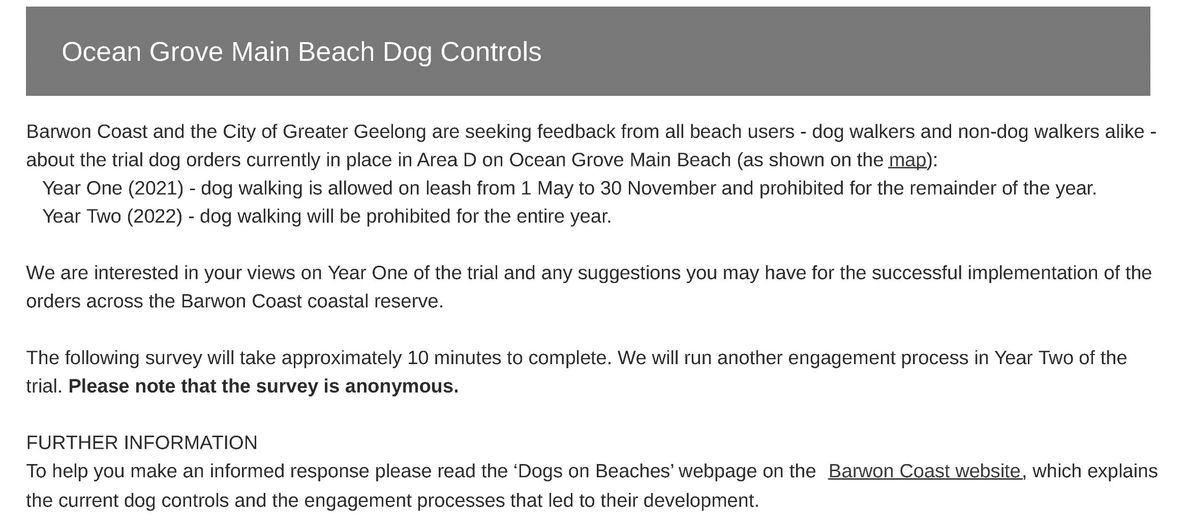

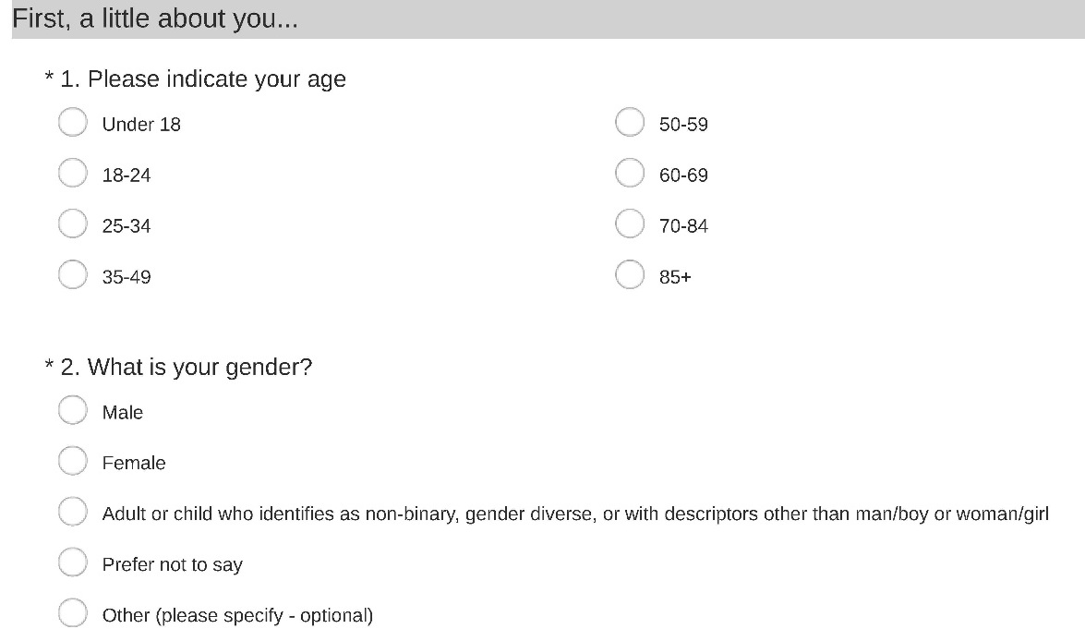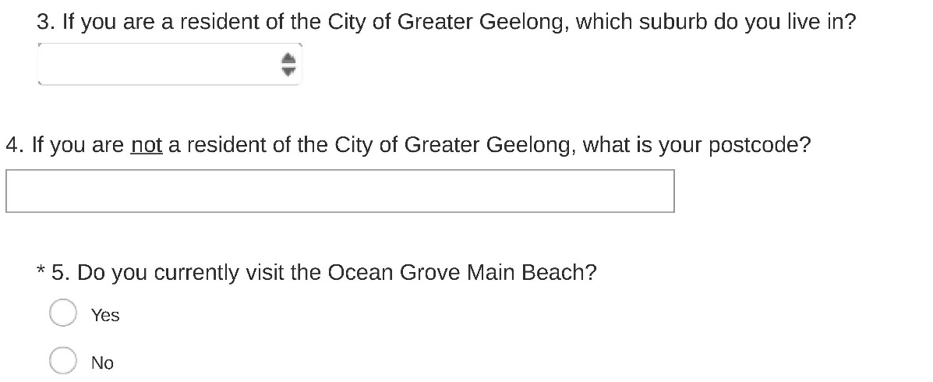
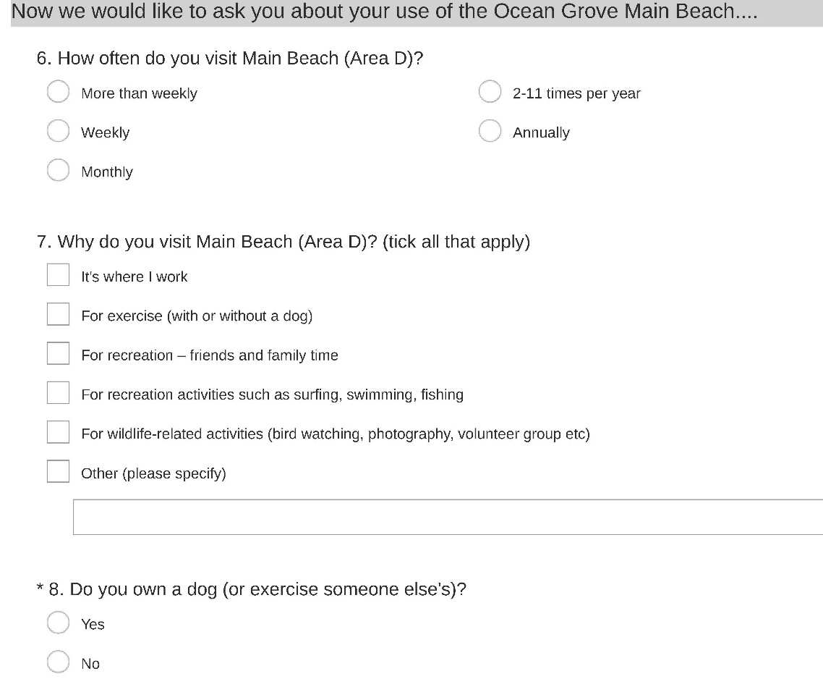

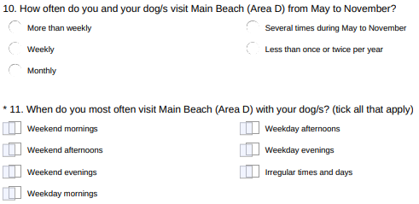
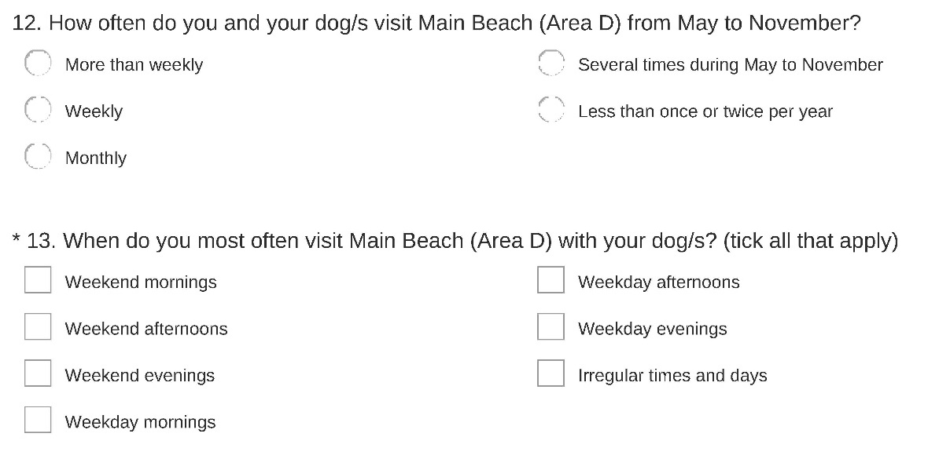
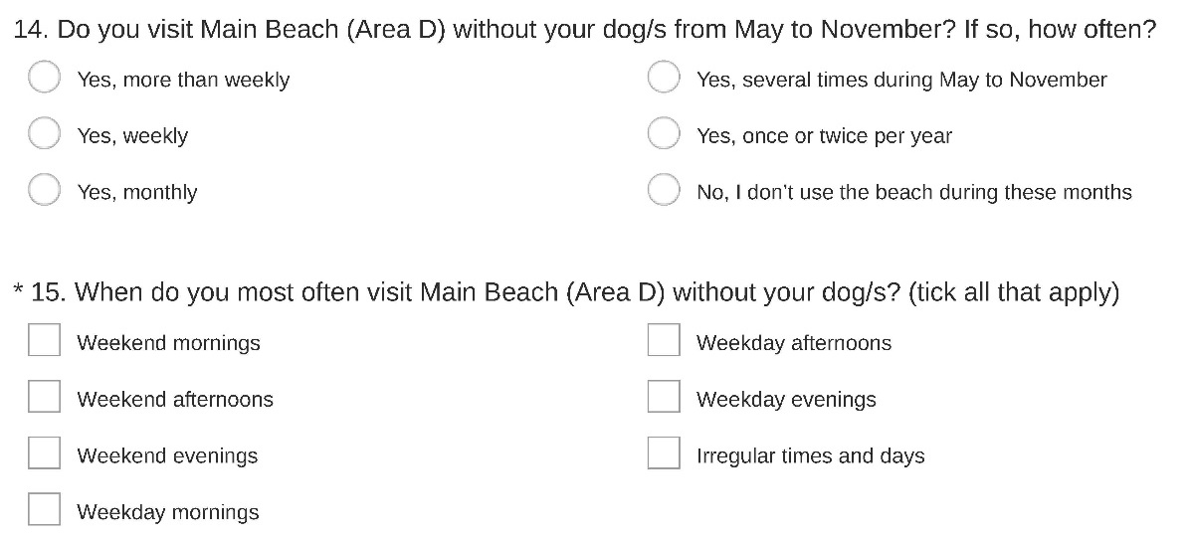

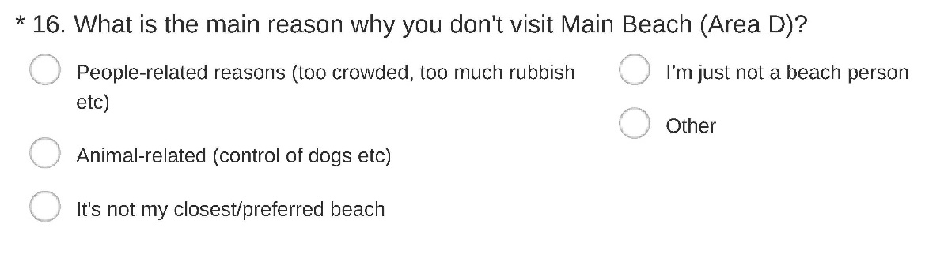
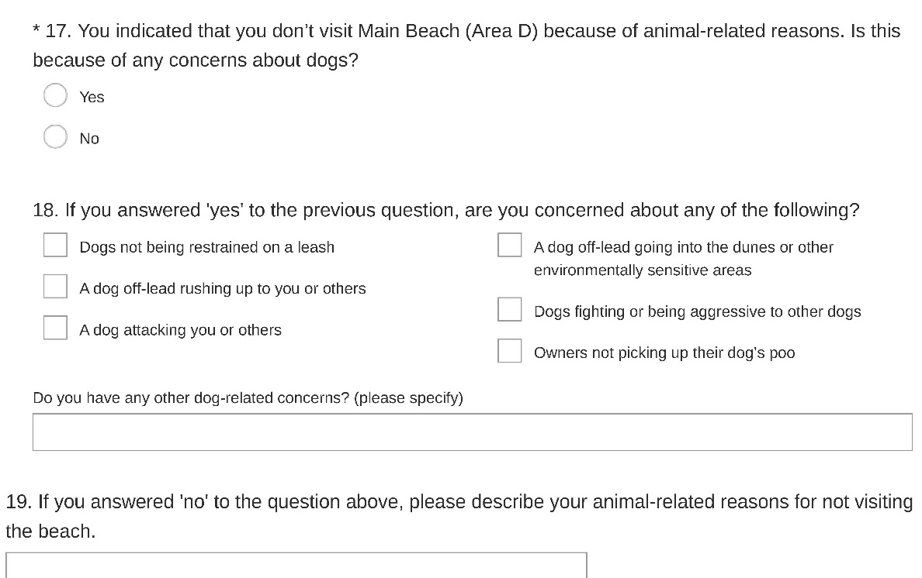
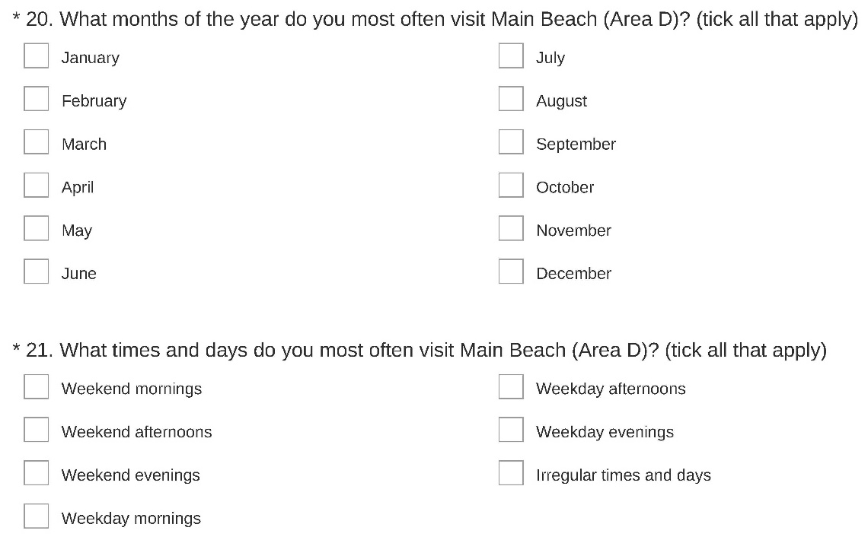
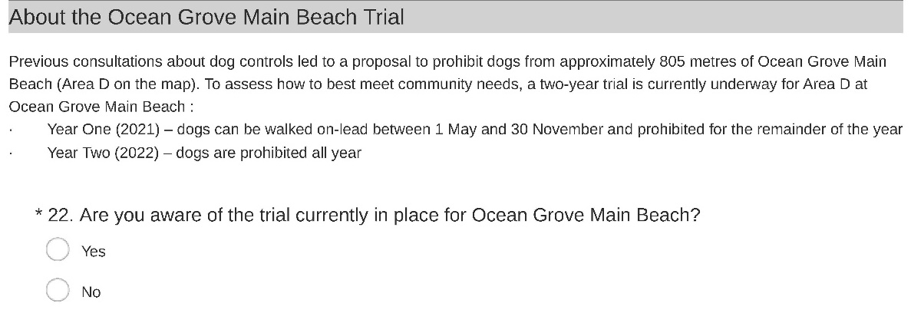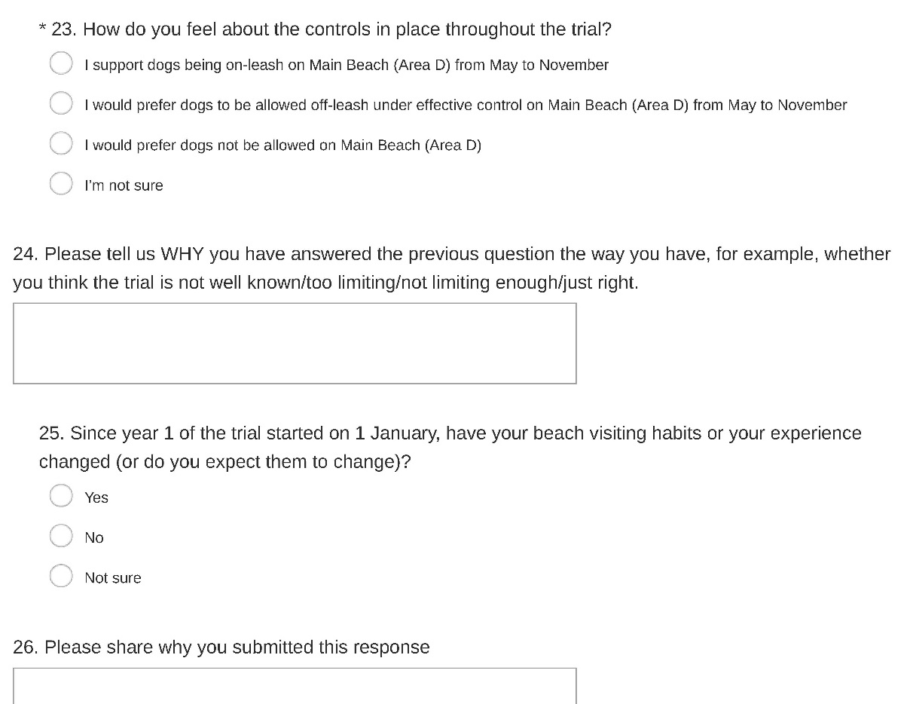

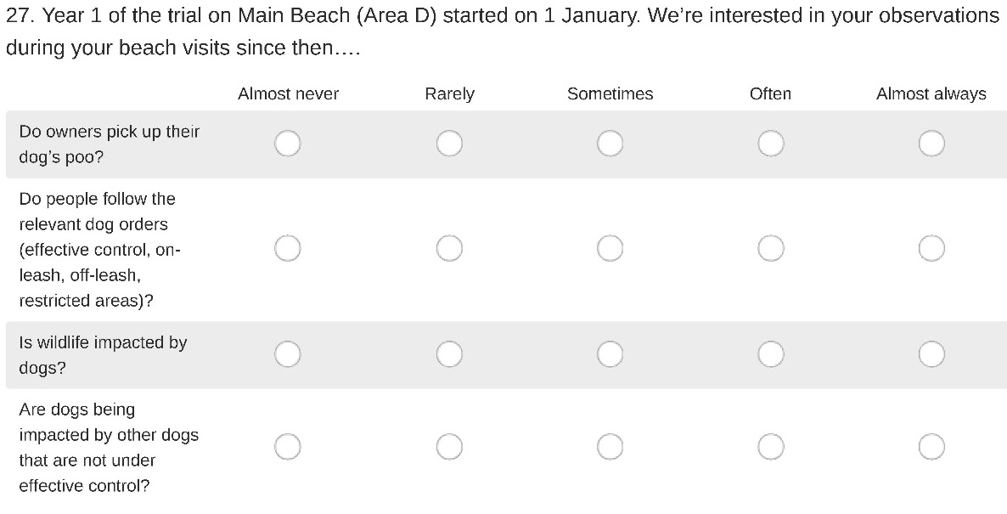

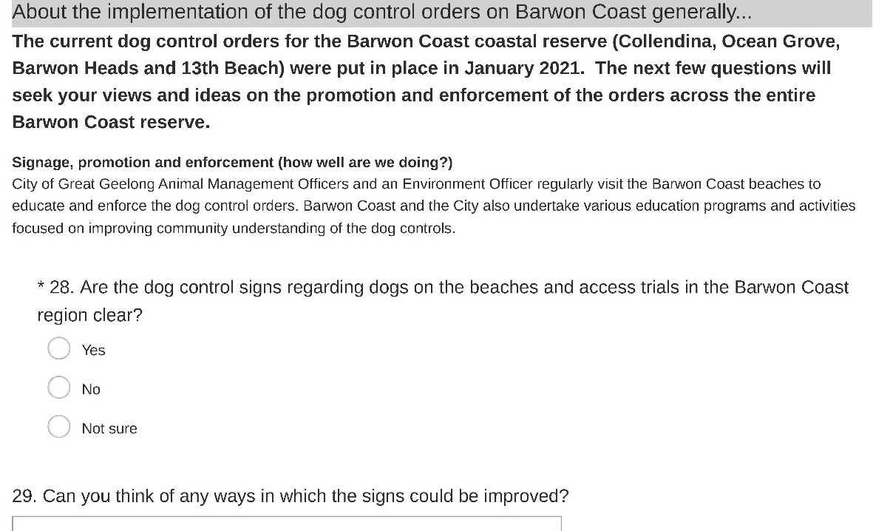

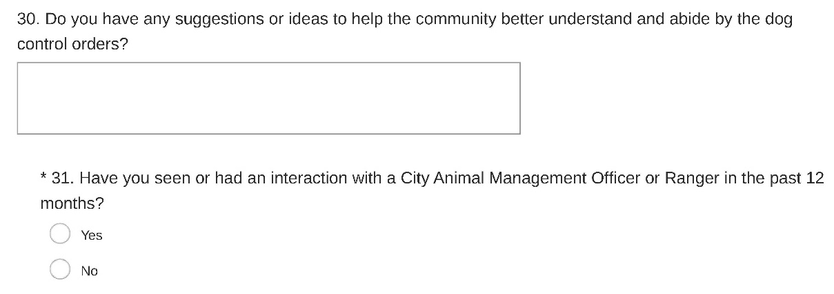
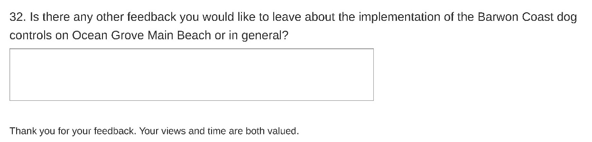

Appendix B: Residential location of respondents

Suburb | % respondents | No. respondents
Anakie | 0% | 1
Armstrong Creek | 0% | 4
Barwon Heads | 12% | 130
Bellarine | 0% | 1
Belmont | 1% | 7
Ceres | 0% | 1
Charlemont | 0% | 1
Clifton Springs | 2% | 23
Connewarre | 1% | 6
Corio | 0% | 1
Curlewis | 1% | 13
Drysdale | 1% | 15
East Geelong | 1% | 6
Geelong | 0% | 4
Geelong West | 0% | 4
Grovedale | 0% | 2
Hamlyn Heights | 0% | 2
Highton | 1% | 7
Indented Head | 0% | 2
Lara | 0% | 1
Leopold | 1% | 16
Manifold Heights | 0% | 2
Marcus Hill | 0% | 3
Marshall | 0% | 2
Mount Duneed | 0% | 1
Newcomb | 0% | 4
Newtown | 0% | 5
North Geelong | 0% | 2
North Shore | 0% | 1
Ocean Grove | 72% | 805
Point Lonsdale | 1% | 8
Portarlington | 1% | 7
Rippleside | 0% | 2
South Geelong | 0% | 1
St Leonards | 0% | 4
Thomson | 0% | 1
Wallington | 2% | 20
Wandana Heights | 0% | 1

When answering Q4 ‘If you are not a resident of the City of Greater Geelong, what is your postcode?’, 154 respondents provided Geelong postcodes. It is assumed (but can’t be confirmed) that these respondents had already answered the previous question.

25 respondents stated that they live in municipalities other than the City of Greater Geelong, as shown below (Q4):

Postcode | Suburb/town* | No. respondents
3350 | Alfredton | 2
3078 | Alphington | 1
3143 | Armadale | 1
3340 | Bacchus Marsh | 1
3777 | Badger Creek | 1
3193 | Beaumaris | 1
3228 | Bellbrae | 2
3550 | Bendigo | 1
3130 | Blackburn | 1
3240 | Buckley | 1
3037 | Calder Park | 2
3260 | Camperdown | 1
5085 | Clearview (South Australia) | 1
3363 | Creswick | 1
3400 | Horsham | 1
3441 | Mount Macedon | 1
3070 | Northcote | 1
3225 | Point Lonsdale | 4
3049 | Westmeadows | 1

* Suburb/town names were ascertained via a web search of the postcode provided. Where multiple places apply to a single postcode, only one has been entered in the table above.

