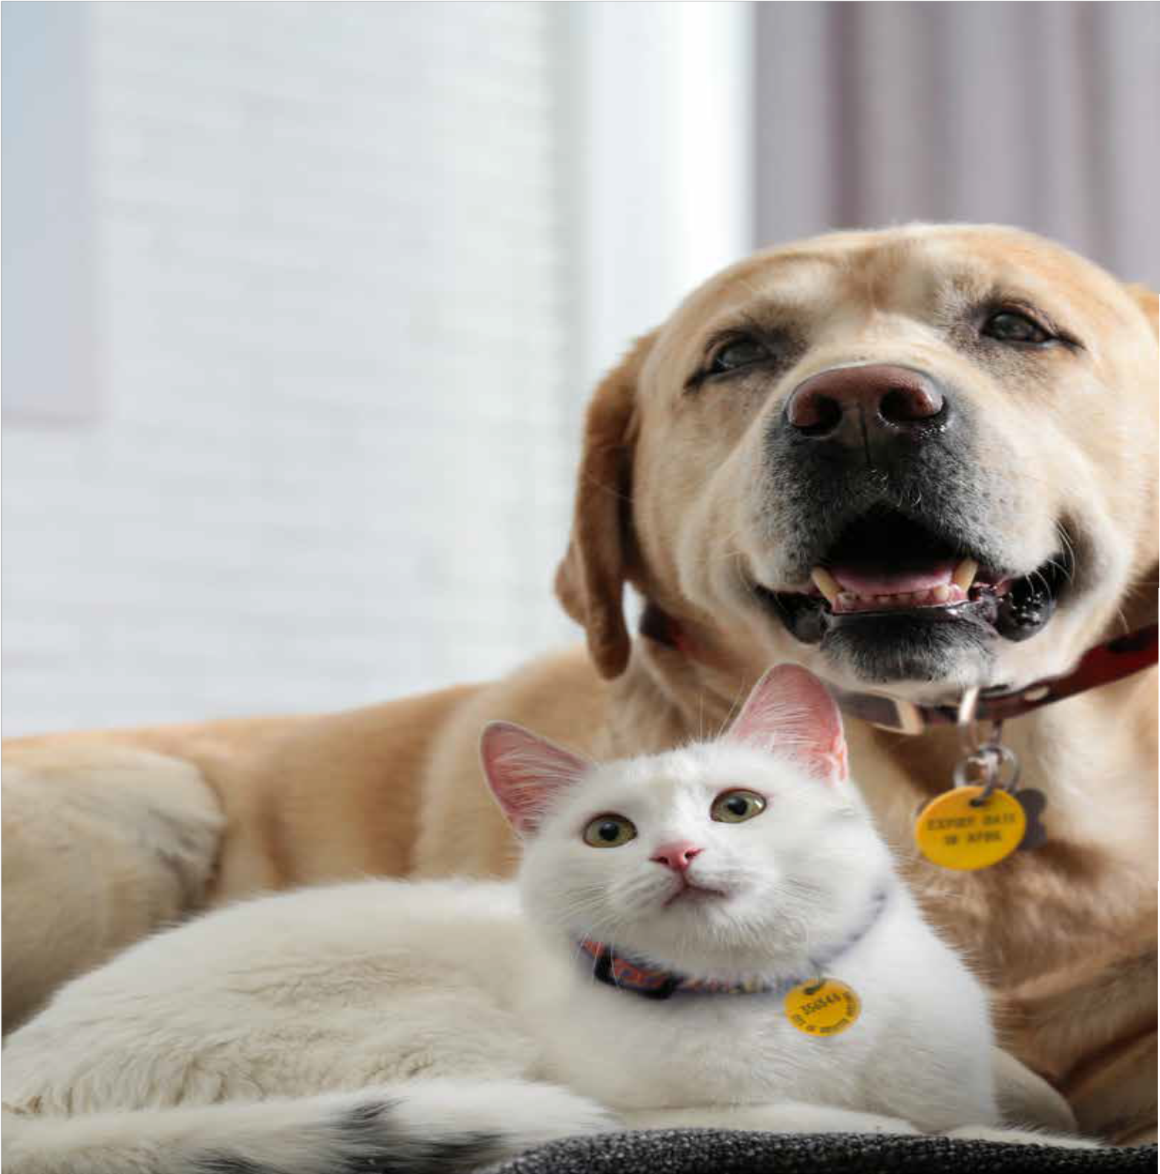THE CITY OF
GREATER GEELONG

DOMESTIC ANIMAL

MANAGEMENT PLAN

2022–25

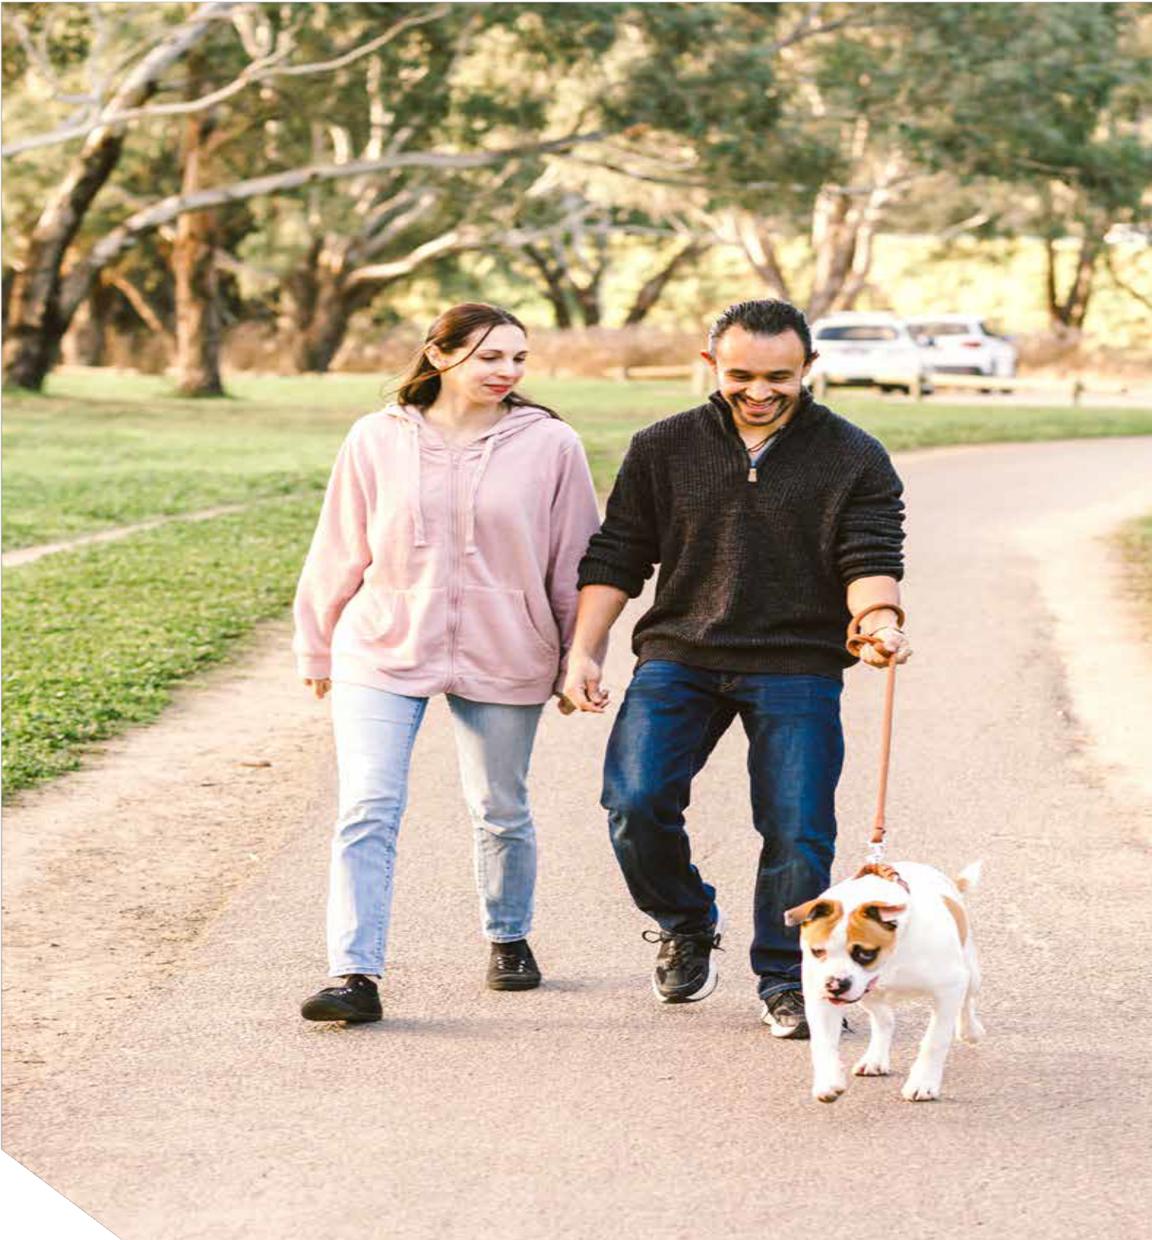

CONTENTS

MAYOR’S MESSAGE 4
WHAT IS A DOMESTIC ANIMAL MANAGEMENT PLAN? 5
Guiding principles 5
How do we currently manage animals? 5
The broader context 6
ACTION PLAN 7
PROGRESS AND REPORTING 7
ISSUE 1: DOGS IN PUBLIC PLACES 8
ISSUE 2: OPEN SPACE NEEDS 9
ISSUE 3: DOG PARKS 10
ISSUE 4: DOGS IN COASTAL AREAS 11
ISSUE 5: NUISANCE CATS AND DOGS 12
ISSUE 6: DOG POO 13
ISSUE 7: CAT DESEXING 14
ISSUE 8: DOG ATTACKS 15
ISSUE 9: RESPONSIBLE PET OWNERSHIP 16
ISSUE 10: ANIMAL IDENTIFICATION AND LOST ANIMALS 17
ISSUE 11: OUR ANIMAL MANAGEMENT TEAM 18

We acknowledge the Wadawurrung People, Traditional Owners of this land, and all Aboriginal and Torres Strait Islander people who are part of the Greater Geelong community today.

3

MAYOR’S MESSAGE

Owning a pet can be a source of great pleasure in life.
Having a constant companion who gives you unconditional love is invaluable, as is the responsibility and lessons that children learn in looking after a furry friend. In fact, scientific studies have found owning a pet can increase a person’s physical and mental wellbeing through lower stress levels, increased fitness levels and more opportunities to socialise. As the owner of many cats and a few dogs in my life, currently one of each, I can attest to these benefits and more.
With around 37,000 registered animals in Greater Geelong already living across 1,250 square kilometres, and forecast population growth likely to lead to higher density living,
the importance of helping pets, owners and the general community live together harmoniously will only grow.
The community’s feedback has helped to shape the City of Greater Geelong’s Domestic Animal Management Plan
2022–25. This plan not only outlines our organisation’s role in animal management, but is also intended to have an educational focus, encouraging and teaching community members that it’s every owner’s responsibility to take care of their pets. By doing the right thing, we can all continue to enjoy safe shared spaces, have healthy pets and protect our unique native habitat.

4
Over the last four years, we have accomplished a lot in animal management, including the construction of new dog parks, branding of animal management fleet for greater visibility and increasing the availability of open space areas for dogs.
In the coming few years, we are committed to doing more, including: constructing two additional dog parks for supervised off-leash dog socialisation; investigating and advocating for the purchase of sustainable dog poo bags; increasing proactive patrols across trails, reserves, parks and beaches; and exploring the viability of an extra cat desexing month each year.
By working with the community, we can continue to ensure that pet owners, their animals and the broader community can continue to enjoy a high quality of life.

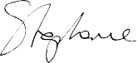

Cr Stephanie Asher Mayor
City of Greater Geelong

WHAT IS A DOMESTIC ANIMAL MANAGEMENT PLAN?

Every Victorian local government must, under the Domestic Animals Act 1994, prepare a plan outlining how it will manage dogs and cats within its municipal boundaries. Other domestic animals are exempt from the plan.

GUIDING PRINCIPLES
The following principles underpin this plan:
- Pets contribute to our quality of life.
- The needs of pet owners must be balanced with the needs of others.
- Responsible pet ownership is highly valued.
- Animal management and education should be proactive.
- The environment and local wildlife must be protected from the negative impacts of dogs and cats.
- The best outcomes result from working in partnership.
- The City has a leadership role in animal management.

The plan identifies how the council will:
- help pets, pet owners and the general community to live together
- protect the environment and local wildlife from the negative impacts of dogs and cats
- balance the needs of those who own pets with those who do not
- address animal management welfare and legal issues
- promote responsible pet ownership
- improve the experience of animal ownership.

HOW DO WE CURRENTLY MANAGE ANIMALS?

As well as registration and identification of dogs and cats, our central functions are to:

- promote and encourage the responsible ownership of dogs and cats
- make sure people manage their animals in accordance with the law
- minimise the risk of attacks by dogs on people and animals
- encourage registration and
identification of dogs and cats
- address overpopulation and high euthanasia rates for dogs and cats, where they exist
- minimise the potential for dogs and cats to create a nuisance
- effectively identify all dangerous, menacing and restricted breed dogs, and make sure they are kept appropriately
- contract the Geelong Animal Welfare Society (GAWS) to deliver our pound service
- work with land management authorities to develop local dog control orders.
See Table 1 for a breakdown of the roles and responsibilities of local authorities and service providers.

Table 1: Roles and responsibilities of local authorities and service providers

REGIONAL LAND MANAGEMENT AUTHORITIES | LOCAL GOVERNMENT AUTHORITY | CONTRACTED POUND SERVICE
- Barwon Coast Committee of Management Inc  - Bellarine Bayside Foreshore Committee of Management Inc  - Corangamite Catchment Management Authority | City of Greater Geelong | The Geelong Animal Welfare Society (GAWS)
 | - Manage pet registration  - Develop dog control orders in areas not under land management authority  - Adopt, monitor and enforce dog control orders in all areas  - Promote responsible pet ownership  - Conduct animal investigations  - Provide advice about the management of domestic animals  - Manage contract for pound service | - House and care for impounded animals  - Provide veterinary care for impounded animals  - Microchip and register animals prior to their release
- Establish local area dog control orders, with advice from the City
- Engage with the community regarding dog control orders

5

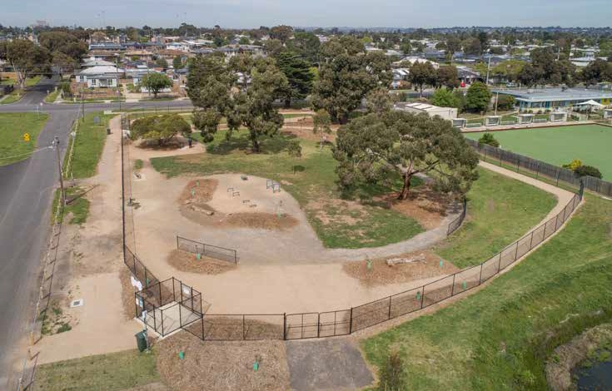

THE BROADER CONTEXT
Animal management is guided by a combination of legislation, local orders, policies and local laws.

VICTORIAN LEGISLATION
- Domestic Animals Act 1994 and associated codes of practice
- Domestic Animals Amendment (Restricted Breeds) Act 2017
- Domestic Animals Amendment (Puppy Farms and Pet Shops) Act 2017

CITY OF GREATER GEELONG POLICIES AND LOCAL LAWS
- Dog Controls in Public Places Policy 2018
- Cat curfew and desexing order 2015
- Neighbourhood Amenity Local Law 2014

LOCAL DOG CONTROL ORDERS
While the Dog Controls in Public Places Policy 2018 determines how dogs must be managed in most places in the City of Greater Geelong, including many coastal areas, there are some areas within the municipality where it does not apply (see Table 2).

In these areas, dog control orders are jointly determined between the City and the relevant authority. We have the power through legislation to adopt these orders.

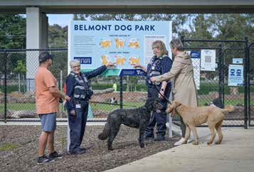

Table 2 Other local authorities that set dog control orders

AUTHORITY | AREA
Barwon Coast Committee of Management Inc. | Coastal areas between 13th Beach near Barwon Heads, Ocean Grove and Collendina.
Bellarine Bayside Foreshore Committee of Management Inc. | Coastal areas along the northern Bellarine, between Portarlington and St Leonards.
Corangamite Catchment Management Authority | The Barwon River and adjacent parkland, between Queens Park Bridge and Breakwater.

6

ABOUT THIS PLAN

We will seek to address the following issues over the next four years of our plan:
Issue 1: Dogs in public places Issue 2: Open space needs Issue 3: Dog parks
Issue 4: Dogs in coastal areas Issue 5: Nuisance cats and dogs Issue 6: Dog poo
Issue 7: Cat desexing
Issue 8: Dog attacks
Issue 9: Responsible pet ownership
Issue 10: Animal identification and lost animals
Issue 11: Our animal management team
For each issue, we have provided a summary of:

What we currently do to address the issue.
These actions will be ongoing throughout the 2022–25 period.

A summary of community views about the issue.
We believe it is important to reflect the views of those who
took the time to contribute to our consultation.
We are limited by legislation and resources, so we cannot address every issue raised.

New actions planned for 2022–2025.
These new actions will be carried out in addition to those we are currently undertaking.

PROGRESS AND REPORTING
We review our plan annually, presenting it to Council and the Change to Department of Jobs, Precincts & Regions. A summary is also included in our annual report.

Successful implementation of the plan should result in the following outcomes:
- The community regards us a responsive, trusted, knowledgeable resource for pet owners, providing relevant advice to residents.
- Responsible pet owners can own a pet without undue restrictions.
- Geelong is regarded as a safe and harmonious place to live where quality of life is not negatively impacted by irresponsible pet owners.
- There is a simple and clear process to register your pet through multiple channels.
- Residents select the most suitable pet and breed for their circumstances.
- The negative impacts on environment and wildlife by domestic animals are minimised.
- There is fair and equitable access to public open spaces.

We’ll measure performance through:
- the number of dogs and cats that are registered
- annual community pulse surveys
- the percentage of animals that are impounded*
- the percentage of irresponsible animal management complaints.*
- Calculated by dividing the number of complaints or impounded animals by the total number of registered animals

KEY FACTS
  - The City of Greater Geelong has one of the largest animal populations of any Victorian
municipality and, as of 2021, had over 37,852 registered dogs and cats.
  - We manage a total land area of 1,250 square kilometres, including a mix of urban, rural and coastal areas.

- Currently the municipality has an estimated population of 264,866 (2020), with approximately 116,500 residential dwellings.
- By the year 2031, it is estimated the population will be in excess of 330,000 residents. This population growth will likely bring a significant increase in pet ownership.
- There are 50 domestic animal businesses registered in the area.

- There were 618 dog attacks lodged between 1 July 2018 and 30 June 2021. From 2019 to 2020, dog attacks decreased by 23 per cent.
- The number of unpaid animal registrations doubled from 3,465 in 2019 to 6,866 in 2020, which is likely related to COVID-19 impacts.

7

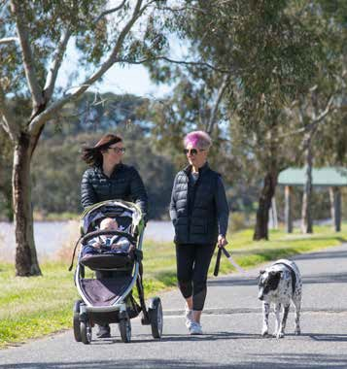
ISSUE 1:
DOGS IN PUBLIC PLACES

Dogs must be kept on-leash in all public areas, unless signs indicate otherwise. This is to reduce conflict between dogs and the general community. However, the size of our municipality makes it difficult to enforce.
To give dog owners space to exercise and socialise their animals, there are designated off-leash areas in many reserves and coastal areas. However, these spaces are also used by the general community. Dog owners must follow certain rules – such as having their animal under effective control – if they want to have their dog off leash.

WHAT WE CURRENTLY DO | COMMUNITY VIEWS | NEW ACTIONS FOR 2022–25
Enforce dog control orders designed to balance the needs of all public space users, wildlife and the environment.  Publish maps and dog control information on the Geelong Australia website. | Dog owners are only following on-leash orders 50 per cent of the time.  Some people believe we need more dog off-leash areas. | - Increase proactive patrols across a variety of trails, reserves, parks and beaches in our municipality.  - Organise a community education information campaign to promote that dogs must be kept on-leash in Greater Geelong unless otherwise signed.  - Increase presence of animal management officers at dog  parks by scheduling open days.
Update dog orders in reserves and add new reserves to the Park Your Pet app. | Some people would like more dog-free areas. | 4. Advocate for open space areas suitable for exercising dogs in new housing developments.
Patrol public places and issue fines to those not following leash requirements. | Dog signage is adequate in many areas. | 5. Review key locations to ensure our resources are deployed where they are most needed.
Review and adjust current dog control orders in conjunction with community consultation, as required.  Install and maintain dog order signs in over 360 reserves to help the community understand the dog orders for each location. | Dog signage could be improved in key open space areas, such as beaches, the Barwon River, the Waterfront and in new estates. | - Work with land and asset managers to provide appropriate dog control signs.  - Review the Dogs in Public Places Policy in 2022 in consultation with the community.  - Build better relationships with animal-related businesses  and community groups.  - Promote the Park Your Pet mobile app to increase the number of users.
Install and maintain dog order signs in over 360 reserves to help the community understand the dog orders for each location. |  | - Develop education programs about the importance of puppy schools and obedience clubs.  - Create education materials about the 10 commandments of  effective control.
 |  | 12. Develop school education programs about safely managing domestic animals.

8

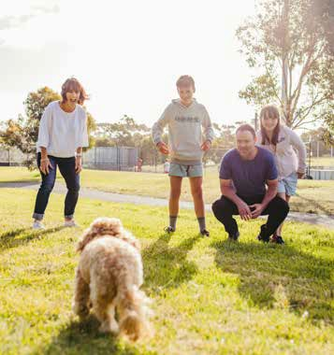
ISSUE 2:
OPEN SPACE NEEDS

Limited lot sizes in new estates and a lack of open space to exercise dogs can present a challenge for residents living in new growth areas. This can result in problem behaviours in dogs:
frequent escaping, digging, chewing and incessant barking.
In response to the communities request for more off leash space in our last plan, we produced a Dogs in Public Places Policy at the end of 2018, which ruled grassed, public sporting reserves could be used for off-leash dog recreation when no organised sport (including club training) is taking place. This change resulted in 21 new off-leash spaces for use by local dog owners.
We remain open to reviewing the dog order status of reserves across our municipality.

WHAT WE CURRENTLY DO | COMMUNITY VIEWS | NEW ACTIONS FOR 2022–25
Review dog orders across the City’s reserves as necessary.  Administer the Neighbourhood Amenity Local Law 2014, placing limits on the number of animals that can be kept without a permit (based on land use zone and property size).  Build and maintain fenced dog parks.  Work with the management of new estates to address any issues that arise.  Attend public events in new developments to offer advice about choosing and caring for pets. | Most people are happy with the on-  leash open spaces available to them.  Many would like additional off-leash  areas for their dogs.  Some people would like more open spaces where dogs are banned.  When considering a new pet, people are likely to choose a pet suitable for the size of their yard.  If people already have a pet, they will consider their needs when choosing a new place to live. | - Advocate for the consideration of dogs in planned open spaces.  - Respond to community requests and feedback about open spaces.  - Attend community open days and events in new estates to develop relationships with dog owners in these communities.  - Continue to educate the community regarding our Dogs in Public Places Policy 2018.

9

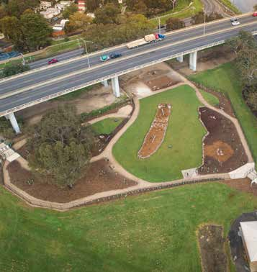
ISSUE 3:
DOG PARKS

Dog parks are designed to give dogs a space to exercise and socialise under the close supervision of their owners.
Dog parks are a great asset for everyone within our community. As well as providing fully fenced spaces for dogs to explore and play, they separate off-leash animals from those in the community who may feel less comfortable around dogs.
Dog parks are a very popular concept that is well-supported by dog owners. However, not all dogs are able to use them. Section 27 of the Victorian Domestic Animals Act 1994 requires owners to keep their greyhounds on-leash in all public areas, including dog parks.
In addition to our existing dog parks in Corio and Belmont, we have committed to building two new dog parks in Lara and on the Bellarine. We remain committed to identifying new areas that would be suitable for such facilities.

WHAT WE CURRENTLY DO | COMMUNITY VIEWS | NEW ACTIONS FOR 2022–25
We build, maintain and manage upgrades of existing dog parks.  We assess requests for dog parks in areas where facilities are not currently available and advocate for dog parks in new developments. | The community would embrace more dog parks.  We should consider a separate park for timid and small dogs.  We need to encoura ge responsible pet ownership in these parks. | - Construct new dog parks in Lara and on the Bellarine Peninsula from 2021.  - Create a promotional campaign to encourage dog owners to take advantage of dog parks.  - Conduct regular proactive patrols of dog parks and organise community events, such as open days.  - Review the availability of bins in dog parks.  - Consider on-site options for communicating with dog owners  attending dog parks, such as community noticeboards.  - Promote the benefits of fenced dog parks to land developers.  - Explore alternative options for the exercise of pet greyhounds.

10

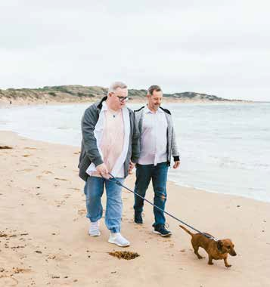
ISSUE 4:
DOGS IN COASTAL AREAS

Dog control orders in coastal areas exist to support the fair, safe and shared use of coastline for all, including dogs.
Most coastal areas contain areas of high environmental significance, such as sand dunes and wetlands, and they are also important to wildlife.
State-appointed independent land management authorities, which include Bellarine Bayside and Barwon Coast, are responsible for large portions of the coastline around the Bellarine Peninsula. As the responsible land manager, these authorities must develop dog orders for these areas with input from the community and other stakeholders. We then become responsible for patrolling these areas and enforcing the orders.
The broad range of views expressed during both of the community consultation processes demonstrated that the issue of dogs on beaches remains a contentious issue for dog owners and non-dog owners alike.

WHAT WE CURRENTLY DO | COMMUNITY VIEWS | NEW ACTIONS FOR 2022–25
Patrol coastal areas and monitor compliance with dog control orders proactively. | There are many different views on how dogs should be managed on our beaches.  Some community members are concerned about the impact dogs on beaches have on local birdlife.  We need more signage on beaches.  The community wants more frequent patrols on beaches to improve owner compliance with dog orders.  Some community members are unaware that the City works collaboratively with coastal management committees as the responsible land manager. | 1. Complete a one-year trial of revised dog control orders for the Ocean Grove Main Beach by November 2022 and use community engagement to evaluate.
Provide guides and maps to help dog owners understand their responsibilities in coastal areas. |  | 2. Attend coastal events to provide education and resources to local community members and tourists.
Undertake community consultations to gauge how satisfied the community is with dog control orders.  Invoke seasonal dog orders to protect endangered wildlife and coast-nesting birds. |  | - Explore the feasibility of dedicating additional staff to  patrol beaches over the summer period.  - Explore the possibility of increasing resources to better meet community patrolling and enforcement expectations.  - Increase the use of our Kubota off-road vehicle for greater efficiency and coverage of patrol areas.
Enforce seasonal orders designed to minimise the impact of dogs  on beaches during the summer  season. |  | 6. Work collaboratively with land managers to respond to complaints received.
Work in conjunction with land management authorities to successfully develop and review dog orders, while meeting legislative requirements for enforcement. |  | - Improve signage on the beach to alert dog owners about dog controls that apply in particular areas.  - Review and update our website with clear information about our relationship with land managers, and our respective responsibilities.

11

ISSUE 5:
NUISANCE CATS AND DOGS

We are required to investigate all complaints regarding trespassing cats and barking dogs.
We also deal with a lot of issues related to dogs in public places – for example, escaping dogs and dogs that are not under effective control, or leashed in on-leash areas.
Our goal in every situation is to work closely with everyone involved and reach a positive outcome. However, these situations are often very complicated and resolving them can be very difficult.

WHAT WE CURRENTLY DO | COMMUNITY VIEWS | NEW ACTIONS FOR 2022–25
Encourage cat owners to comply with the Cat Curfew Order.  Loan cat traps to property owners dealing with nuisance cats and advise on their safe and appropriate use. | Trespassing cats and barking dogs are the most frequent cause of nuisance. | - Review our barking dog investigation procedures.  - Explore new technology to support our barking dog investigations.  - Work with the Department of Justice and Community Safety to create alternative dispute resolution methods for barking dogs.  - Participate in industry- based discussions about nuisance cats.  - Explore proactive monitoring to enforce the Cat Curfew Order.  - Investigate the option of 24-hour cat confinement as a tool to address nuisance cats, aligned with best practice in animal management and in consultation with cat owners.
Offer an annual subsidised cat desexing program to minimise the effects of stray and feral cats on neighbourhoods and the environment. | Many people believe the cat curfew should be policed.
Coordinate mediation and conflict resolution services, where  appropriate.  Provide the community with information on cat enclosures, cat  ownership responsibilities and cat confinement. | The process for investigating nuisance barking complaints should be improved.
Investigate barking dog complaints and implement appropriate actions.  Provide information on the causes of excessive barking and encourage owners of barking dogs to seek professional advice. | The community is concerned about the impact cats are having on native birds and animals.
Capture ‘at large’ dogs and return them to their owners.
Assess property fencing and advise dog owners on how to better contain their pets and keep them safe.
Investigate menacing rushes – that is, where a dog has displayed aggressive behaviour without actually biting – and educate owners about how to improve this behaviour.
Administer infringements to deter owners from ignoring nuisance behaviours.
Patrol our on and off leash reserves to ensure dog owners are abiding by the dog orders and allowing all members of our community to enjoy safe, shared spaces.

12

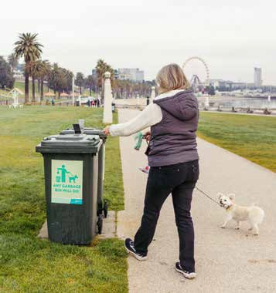
ISSUE 6:
DOG POO

It is the responsibility of any dog owner or supervisor to carry poo bags or some other receptacle with them to pick up poo, and then dispose of it responsibly. Our animal management officers have the power to fine anyone who does not do this.
Dog poo is not just unsightly. It is also toxic for the environment and can lead to the growth of blue-green algae in our waterways. Despite this, getting everyone in the community to pick up after their dog is an ongoing challenge.

WHAT WE CURRENTLY DO | COMMUNITY VIEWS | NEW ACTIONS FOR 2022–25
Patrol public places and issue fines, where  possible.  Respond to complaints about owners not picking up after their dogs in public spaces.  Deliver information campaigns about correct disposal of dog poo.  Prohibit dogs from being exercised on turf wickets, within 10 metres of playgrounds and on synthetic sports surfaces.  Investigate complaints from the community about  insufficient bins for disposing dog poo.  Install messages about disposing dog poo on signs and bin decals across the municipality. | Most people believe that dog poo is an issue.  Residents believe dog poo is unsightly, annoying and not their responsibility to pick up.  Many people are concerned about environmental contamination from dog poo.  Shared spaces such as beaches and parks are felt to have the worst dog poo issues.  More bins are needed in public areas. | - Investigate and advocate for the purchase of sustainable alternatives to plastic dog poo bags.  - Create a targeted educational campaign about owner responsibilities to collect and dispose of dog poo that is supported by an enforcement strategy.  - Carry out a mapping process to make sure there are sufficient bins available in reserves and open spaces.

13

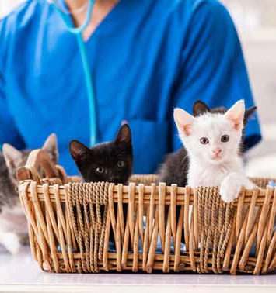
ISSUE 7:
CAT DESEXING

The unwanted and uncontrolled breeding of cats leads to high numbers of stray and feral cats in our municipality.
These cats often overwhelm animal welfare shelters, such as the Geelong Animal Welfare Society (GAWS), and put a significant strain on resources. Stray cats are also a threat to other animals, killing native fauna – birds, marsupials and amphibians – and spreading diseases to domesticated cats through fighting.
For the past 6 years, we have been working with several veterinary clinics to provide discounted cat desexing throughout the month of July. The goal of this annual campaign is to encourage more residents to have their cats desexed and reduce the burden of stray cats on the community.

WHAT WE CURRENTLY DO | COMMUNITY VIEWS | NEW ACTIONS FOR 2022–25
Offer an annual subsidised cat  desexing program. | The majority of survey respondents reported their cat was desexed. | 1. Explore the viability of offering an additional cat  desexing month each year.
Promote the benefits of cat desexing through various educational resources.  Reduce the cost of pet registration for desexed pets. | It was generally felt that there’s not enough promotion of the  discounted cat desexing  initiative. | - Expand marketing of the existing cat desexing month in July.  - Develop an education campaign regarding the  benefits of cat desexing.
 | Cost was identified as a concern for owners when considering whether to desex their cat. | - Develop additional programs to encourage responsible cat ownership.  - Explore opportunities to work collaboratively with local and State agencies to develop a coordinated approach to cat desexing, stray and feral cats.

14

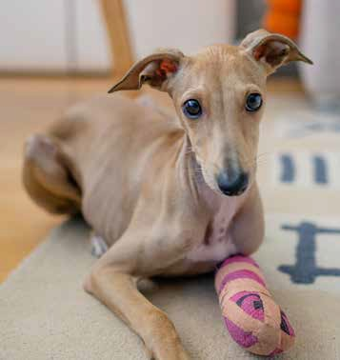
ISSUE 8:
DOG ATTACKS

Responding to dog attacks remains a top priority for our animal management officers. Attacks can involve people, dogs, cats, wildlife and livestock.
There are medical costs, legal costs and personal trauma for everyone involved when a dog attack occurs. It is also an issue of significant community concern. With proper management and education, attacks are preventable.
There were 31 successful prosecutions in the 2019–20 financial year, but only 5 successful prosecutions in the 2020–21 financial year due to COVID-related court delays.

WHAT WE CURRENTLY DO | COMMUNITY VIEWS | NEW ACTIONS FOR 2022–25
Install signage and enforce dog orders to reduce the likelihood of dog attacks occurring.  Attend to all dog attack reports immediately, or as soon as possible, and implement appropriate action.  Record and investigate all dog attacks.  Place conditions on dogs who have previously attacked to reduce the chance of them reoffending, such as an Individual Animal Plan Permit. | Some community members do not know that they should be reporting dog-related incidents to the City.  We need to better educate the community on how to report dog related incidents.  It’s felt we should improve how we communicate with people who report dog incidents. | - Educate the community about dog management and reporting dog-related incidents.  - Create an information page on our website regarding the process we follow when addressing a dog attack report.  - Review our dog attack processes and procedures as part of the broader digital modernisation program.  - Improve the customer experience for residents involved in dog attacks and other public safety concerns.
Seize dogs and prosecute matters, where necessary.  Maintain a database of every animal that has attacked people, pets, wildlife and livestock. | Some people are unaware of the information required by the City to undertake an incident investigation. | - Utilise available data to help prevent dog attacks.  - Encourage reporting of all dog attacks and related incidents.
Track where dog attacks are most commonly occurring and the  demographics of those primarily affected  to inform prevention initiatives. |  | 7. Reinforce with landlords their responsibilities to maintain appropriate fencing for tenants and their pets.
Conduct inspections of properties where dogs have either escaped through improper fencing, or have been declared dangerous or menacing. |  | 8. Facilitate dog safety education programs in schools.

15

ISSUE 9:
RESPONSIBLE PET OWNERSHIP

Owning a pet can be extremely rewarding. They bring unconditional love, companionship and help to reduce stress or anxiety. However, owning a pet also comes with responsibilities.
Our role as a local government is to help people understand what responsible pet ownership means to minimise potential harm to the animal, people, property, other animals and the environment. Helping pet owners choose the right pet for their lifestyle and home is an important first step.
While dogs are great for getting the whole family out to exercise, this also makes them quite high maintenance. Depending on the breed and age of the dog, they may also need a significant amount of training and grooming. Cats are more independent and content indoors, which makes them a great choice for busy people and families. They are also
generally quiet, have long life spans and need minimal house training. However, they must be managed properly or they may cause problems to other cats and native wildlife.

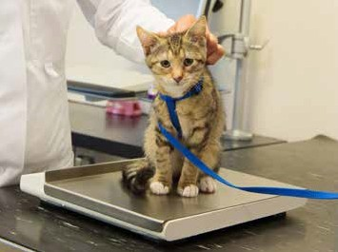

A responsible pet owner is someone who:
- considers the needs of all users of public space
- prevents their animal from causing harm or intimidation to others
- sees to the welfare and social needs of their animal, including vaccination
- abides by the dog control orders in public places
- minimises nuisance to others and the environment
- has an animal that is desexed, microchipped and registered

WHAT WE CURRENTLY DO | COMMUNITY VIEWS | NEW ACTIONS FOR 2022–25
Regulate animal ownership through the issuing of multi- animal permits.  Provide advice, links and resources on responsible pet ownership on our website.  Distribute brochures, fact sheets and other material developed by the Department of Jobs Precincts and Regions. | Most people understand the need to vaccinate their pets.  Our community could improve compliance with dog control orders, such as keeping dogs on-leash.  There is confusion about the  meaning of ‘effective control’.  Some people do not pick up after their pet.  More people should comply with the cat curfew | - Increase community understanding of effective control and responsible pet ownership through an education and awareness campaign.  - Support specialist training of animal management  officers in animal behaviour.  - Increase proactive patrols to enforce all aspects of responsible pet ownership with residents and visitors.  - Attend markets and other community events to promote responsible pet ownership.  - Build relationships with community groups in the municipality that promote responsible pet ownership.  - Link residents to dog training providers and resources.

16

ISSUE 10:
ANIMAL IDENTIFICATION AND LOST ANIMALS

Dogs and cats are legally required to be registered annually.
They also must be microchipped and wear a registration tag when they’re not at home.
Up-to-date registration and microchipping help us identify
pets and return them to their owners as soon as possible.
The cost of registration is set by the Victorian Government, increasing annually in line with inflation. The money is used to help fund responsible pet ownership initiatives.
We’re anecdotally aware that pet ownership has increased across our municipality as people spend more time at home, but this increase is not reflected in animal registration data. The number of unpaid registrations also doubled between 2019 and 2020. This suggests there are many domestic

animals living in Greater Geelong that are not currently registered.
When it comes to caring for and returning lost animals, we work with several important stakeholders to do this work. In particular, Geelong Animal Welfare Society (GAWS) in Moolap are contracted to deliver our pound services and play a key role in the management of domestic dogs and cats in our region.
We also work to help the community prepare for, and manage, situations that might lead to them losing their pet. As well as providing advice to prepare owners for emergencies, we also support local agencies to help pet owners who find themselves in crisis situations.

WHAT WE CURRENTLY DO | COMMUNITY VIEWS | NEW ACTIONS FOR 2022–25
Manage dog and cat registrations and renewals and reconcile data with the Central Animal Records Registry. | Most of our community is aware of the requirement to have dogs and cats microchipped and registered with the City.  Free registrations for the first year would be embraced by the community.  We need to educate the community to ensure all pet owners are aware they need to keep their details up to date with the City and Central Animal Records. | - Explore the feasibility of reduced or free pet registration for the first year.  - Develop an education program showing simple actions owners can take to make sure their pet will be safely returned  to them if lost, such as updating their details with Central Animal Records.  - Invest in upgrades to our pound facility.
Supply a registration tag to each registered animal.
Routinely conduct dog and cat registration and microchipping checks.
Carry out targeted property checks in areas of low registration.
Follow up on the sale of animals from Domestic Animal Businesses.
Check all dog and cat sale advertisements to check for microchip details.
Return lost or wandering dogs and cats to registered owners.
Maintain temporary holding kennels at the pound, as a short-term
alternative to impoundment.
Run free microchip detail checks.
Coordinate with local vets to return lost animals.
Work with domestic animal businesses to make sure they have emergency plans in place.
Educate residents to help them plan for their pets in emergencies.
Work with local agencies to support families in need of emergency care for their pets due to family violence and other crisis situations.

17

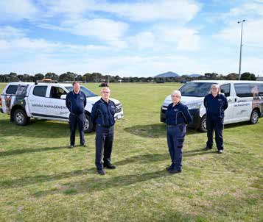
ISSUE 11:
OUR ANIMAL MANAGEMENT TEAM

A qualified, competent, visible and responsive team is required to deliver high standards of service to the community.
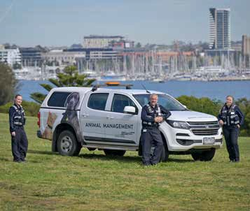
The size of the municipality makes it difficult to maintain a visible community presence. Additionally, while we maintain an on-call service, we currently do not conduct proactive patrols on weekends. This lack of visibility impacts public confidence in our service and encourages some pet owners to disregard local laws and dog control orders.
We currently employ 7 people to handle our animal management area, supported by a team lead, technical officer, a project and engagement officer, three administration officers and a prosecutor.
Our animal management officers are required to have either a Certificate IV Animal Control and Compliance, a Certificate IV in Government (Statutory Compliance), or higher-level qualifications.
We maintain a training register, detailing all the qualifications and training courses completed by each animal management officer. Each officer completes training in animal handling and prosecutions, including the collection of evidence for court proceedings. We also promote further training opportunities as part of annual performance reviews.

WHAT WE CURRENTLY DO | COMMUNITY VIEWS | NEW ACTIONS FOR 2022–25
Handle over 6000 animal-management-related requests for  service per annum. | More animal management officers are required. | - Develop a business case that supports additional resourcing for animal management services.  - Review our internal process to ensure it meets best-practice standards.  - Explore the financial viability  of conducting proactive patrols on weekends, in addition to our existing on-call service.  - Increase professional development opportunities for all animal management  officers, such as livestock and investigation training and animal behaviour training.
Collect evidence and prosecute people that have broken the law.  Maintain partnerships with internal and external stakeholders to make sure we can work at capacity. | Animal management officers and their vehicles should be more visible in the community.
Schedule regular training sessions for team members.
Carry out proactive patrols in areas of low compliance.  Inform those involved in animal management investigations about outcomes. | Some areas of our service need to improve.
Attend pet-friendly community events and share pet
ownership information.
Undertake community consultations on pet-related issues.

18

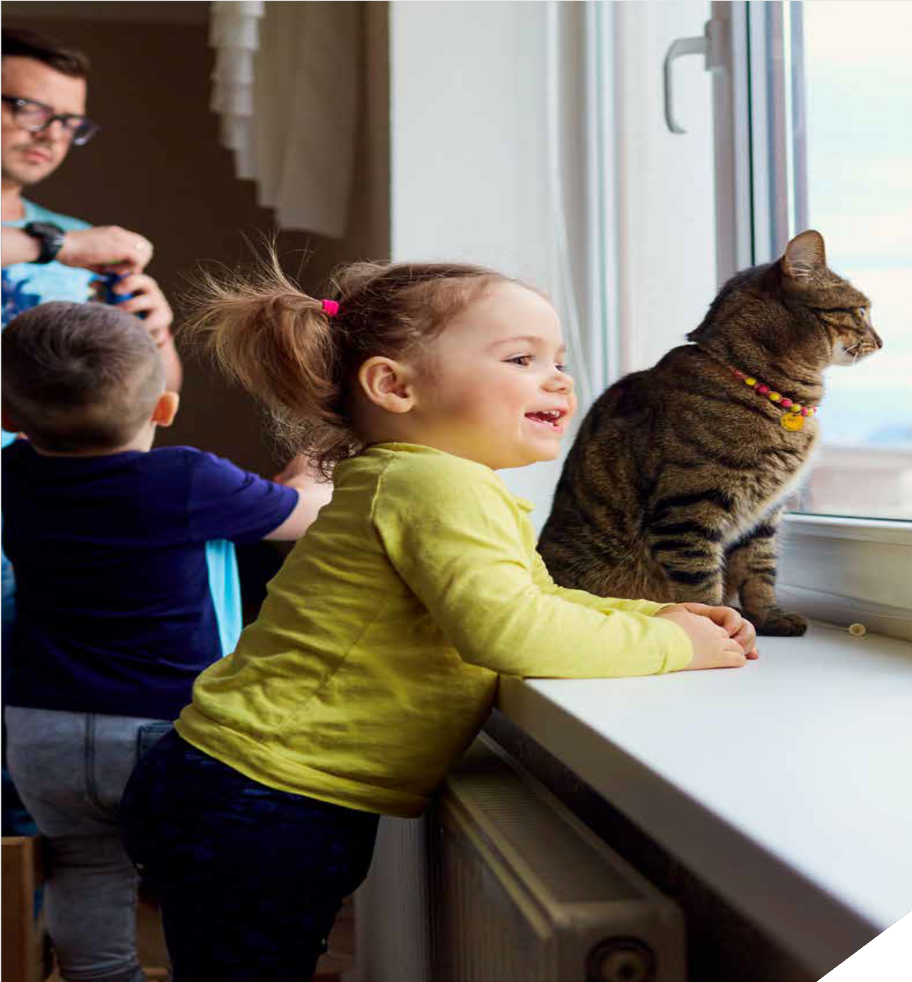

WADAWURRUNG COUNTRY
PO Box 104, Geelong VIC 3220
P: 5272 5272
E: contact@geelongcity.vic.gov.au
W: geelongaustralia.com.au

CUSTOMER SERVICE CENTRE
100 Brougham Street
Geelong VIC 3220 8.00am – 5.00pm

© City of Greater Geelong 2021

LATEST NEWS:

@CityofGreaterGeelong

@GreaterGeelong

@CityofGreaterGeelong

CityofGreaterGeelong

