draft Domestic Animal Management Plan 2022 - 25
community engagement summary report

Domestic Animal Management Plan
2022 – 25

community engagement summary
Introduction/Background
Every four years each Victorian local government prepares and implements a new Domestic Animal Management Plan. This plan guides how we manage dogs and cats within our municipal boundaries and is a requirement of The Domestic Animals Act 1994. The new four-year plan builds on the current 2018-21 plan, and provides a framework for the planning, development and evaluation of animal management services delivered by us.
The community helped to shape the draft 2022 – 25 Domestic Animal Management Plan’s objectives during an in-depth six-week feedback period in March and April this year where we heard from 717 people. For the second stage of engagement the City released the draft plan to the community for general feedback through the City’s Have Your Say page. Community engagement is a key part of developing this plan. It not only informs our priorities, but it keeps us on track throughout the process and ensures our plan reflects community sentiments. Feedback received from this engagement has been considered and used to finalise the plan. The final plan will now be presented to Council at its November 2021 meeting for endorsement before submitting to the Department of Economic Development, Jobs, Transport and Resources by 3 December 2021.
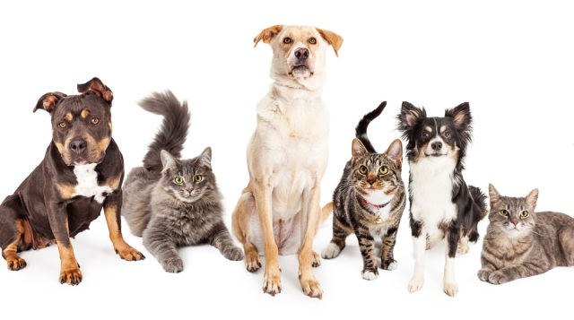 AGE

HOW WE ENGAGED
WHAT DID WE DO?
Over a 28-day period (30 August – 26 September 2021) we asked the community to have their say on the draft plan. An online community engagement approach was undertaken with a combination of the City’s Have Your Say page, email and telephone submissions. As a result of multiple COVID related lockdowns during the engagement period, face to face community consultation was not possible. To ensure our community had the opportunity to participate and provide equitable access for all to have their say, we offered the community the opportunity to give us a call, utilise the translating and interpreting services through Geelong Australia, mail a hardcopy form of our online tool, or forward their submission by email. This information was then transferred online to ensure there was a comprehensive collection of data.

2
Emails submissions received
Unique visitors to the Have Your Say page. Viewing the page 421 times.
282
Submissions in total from 31 people via online survey and email
35
38

28 DAYS
of engagement (Stage 2)
People now following the project (an additional 4 from this engagement)

DATA METHODOLODY
This engagement was accessible to all members of the community and everyone was encouraged to contribute. Followers of the project on the City’s Have Your Say page were sent a direct email when the engagement was launched.

ENGAGEMENT TOOL AND TECHINQUES
A project specific engagement page was developed to provide project information and methods of ways to engage with the City.
A range of engagement tools and techniques were used to provide different types of opportunities for stakeholders and the community to have their say. The main tools and techniques are explained in further detail below

HOW WE ENGAGED
Have Your Say Online Portal  Yoursay.geelongaustralia.com.au | An online Have Your Say project page was designed to share relevant information to encourage community feedback on the Domestic Animal Management Plan 2022 – 25 as of March 2021.
FEEDBACK (online and hardcopy) | Feedback was sought from the community through the online Have Your Say project page for the draft plan from 30 August to 26 September 2021.  The objective of this survey was to confirm that the community’s views from the original feedback period, March and April 2021, were captured in the plan’s objectives.
Written submissions | Open at any time during the public engagement period. Submissions could be provided by email or mail.
One on one interviews | The community were given the opportunity to provide feedback, or seek assistance completing the online survey, by telephone, as an alternative to face to face or one on one interviews due to the restrictions imposed during COVID and lockdown periods.

Communications
Media platforms were utilised to direct people to the Have Your Say page as well as promote the opportunity to read the draft plan.

Printed and online media including, the Geelong Advertiser newspaper, Geelong Australia website, Bay FM and K Rock radio stations, and the Mayor’s twitter feed, reported on and promoted the engagement opportunity

Who we engaged with

PARTICIPATION
During 30 August to 26 September 2021 more than 30 people engaged with the City. Of these 96.7% (30) engaged online through the Have Your Say page, 6.45% (2) engaged through direct email. 14.3% (5) community members submitted multiple (2) responses.
An additional 4 community members are now following the project, meaning they are engaged for the length of the project in addition to this engagement, and will receive future information including updates and outcomes.
Face to face engagement was not possible due to COVID restrictions across Victoria during this period.
The following is a snapshot of the interaction on the page.
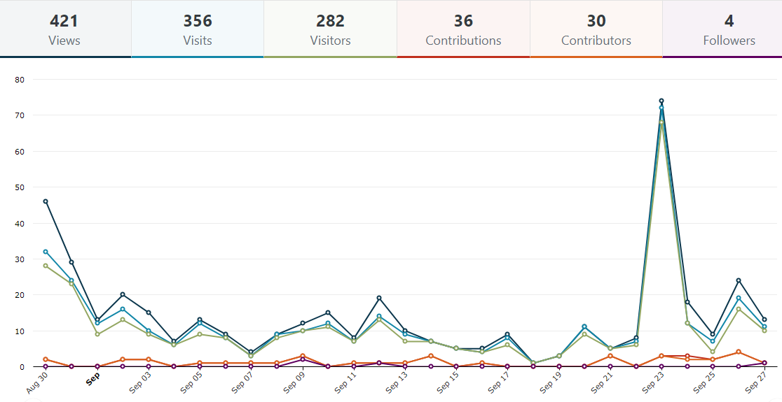
N.B. Graph line colours match categories above. The peaks align with media and online promotions of the engagement opportunity and timeframes.

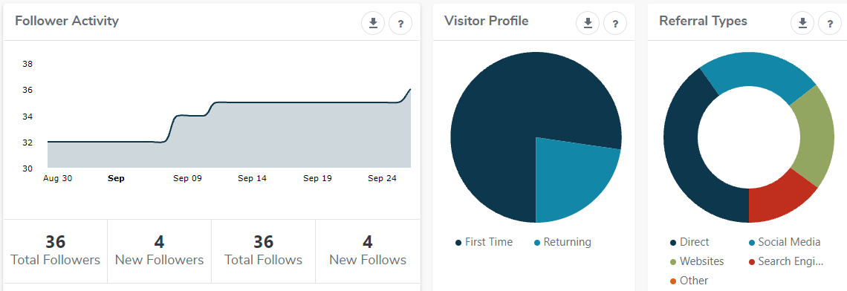
Direct = 40.2% (121)
Social Media = 24.25% (73)
Websites = 20.6% (62)
Search Engine = 14.95% (45)
Other = 0% (0)
First Time = 77.3% (218)
Returning = 22.7% (64)

An additional four community members followed the project, meaning they are engaged for the length of the project in addition to this engagement, and will receive all future information including updates and outcomes. There are now 36 followers in total for this project.

WHAT WE HEARD

THE FEEDBACK
Most submissions received supported the actions of the plan. Support is also evident through the high number of visitors to the page who did not make a submission. The assumption made is that these visitors were satisfied with the plan and did not feel a need to provide feedback or suggest changes.
A large portion of respondents thanked the City for the opportunity to contribute and have their feedback heard. The Animal Management Team was acknowledged for their work and the community expressed that they value the role and duties undertaken, seeing it as an important service for the City.
We have acknowledged resourcing needs to be maintained for high standards of service and have addressed in the plan. City Officers will be seeking funding support from Council to have a greater Officer presence in the community.
Below are verbatim comments from the Have Your Say submissions:
“issue 11, our animal management team. A qualified, competent, visible and responsive team is required to deliver high standards of service to the community. Feedback, to the front line team, Thank you.”
“For council to deliver the outcomes of the DAMP, it is imperative that the Animal Management team gain appropriate funding support to be able to do their job effectively. I look forward to seeing the final DAMP.”
“I made a complaint about a nuisance barking dog to the council. I would like to thank [the Officer] for [their] work to help resolve the situation. We have gone from rarely going out to our back garden and having to have windows and doors closed due to the endless yapping of this dog, to now where the dog is only out for short periods of same. We feel liberated now to enjoy our home once more. …Thanks for the opportunity to contribute.”

Many responses related to operational matters as opposed to strategic. This plan focuses on the strategic direction of animal management in our municipality, minimal changes were required to the draft plan. We reviewed each operational comment and confirmed we undertake these actions. Where action was required, we updated the plan. For example, emergency management and care of pets to support families in times of crises, including family violence, is an operational task currently undertaken by the animal management team in collaboration with local agencies. It was acknowledged that this is a significant issue and has been added to the plan to inform the community of what we do and what support is available for them.
OVERARCHING THEMES
The aim of this community consultation was to receive qualitative (open) answers to a review of the plan; specific questions or demographics were not requested. In total there were 38 contributions from 31 people or organisations. The contributions submitted generally related to more than one issue and as such were allocated to the relevant issue and reviewed accordingly.
The plan focuses on 11 issues; there were 12 issues in the 2018 - 21 plan. The plan details, ‘What we currently do’, ‘Community views’ and ‘New actions for 2022 – 25’ for each of the issues, as follows:
- Dogs in public places
- Open space needs
- Dog parks
- Dogs in coastal areas
- Nuisance cats and dogs
- Dog poo
- Cat desexing
- Dog attacks
- Responsible pet ownership
- Animal identification and lost animals
- Our animal management team

The following issues drew the largest responses:
Issue 5: Nuisance cats and dogs received the highest number of responses, with 74.19% (23) of the total contributions. Of the 23 responses, 86.96% (20) related to cats and 13% (3) dogs. The 20 respondents for cats focused on action 3, “Investigate the benefits of 24-hour cat confinement…”.
Of the 20 who gave feedback about the exploration of a 24-hour cat curfew, 85% (17) were against and 15% (3) supportive. It should be noted that at the time of this engagement activity beginning, the media (print and radio) chose to lead with a heavy focus on headlines such as, “City’s cat curfew crackdown…a ban on cats leaving the house…”. Information provided to media outlets included the draft plan. The plan includes an action “Investigate the benefits of a 24-hour cat confinement aligned with best practice in animal management and in consultation with cat owners.”. The City’s Customer Service Team also received several phone calls from community members in response to the radio news stories. In these instances, community members were provided with clarification surrounding this action and encouraged to review the Have Your Say page, read the plan and engage in the feedback activity.
The action to investigate a 24-hour cat curfew received vastly opposing views from the community across both engagement opportunities. Many respondents to the in-depth engagement earlier in the year stated they would like to see a 24-hour cat curfew introduced. These contrasting responses highlight the need to explore this option in greater depth. This action will remain in the plan as the intention is to explore the viability of 24-hour cat confinement as a tool to address nuisance cat issues. No curfews will be implemented without sufficient research with robust community and stakeholder engagement.
Below are verbatim comments from the Have Your Say submissions:
“As a responsible cat owner I am supportive of the current cat curfew and I ensure that my cat is locked indoors between the hours of 5 PM and 7 AM. However I am against any suggestion of cats being locked indoors 24 hours a day. I consider that restriction to be overly harsh and inhumane.”

The second highest responses were for Issue 1: Dogs in public places, and Issue 9: Responsible pet ownership, 43.48% (10) respectively.

Issue 1: Dogs in public places. The community raised several issues around dogs in public places, including fair and equal access to public open spaces and the appropriateness of existing dog controls. A major action for the plan is a review of the Dogs in Public Places Policy. This will involve consideration of dog controls in all areas across the municipality; community engagement will be a large and important component of this review. Development of and education about 10 commands of effective control is included as action 11.
Below are verbatim comments from the Have Your Say submissions:
“I strongly support the: The development of 10 commandments of effective control to clarify discrepancies and engage more dog owners to do the right thing.…”

“Within this management plan, please consider introducing a stricter policy for dog-off-lead parks and reserves, that better protect the safety of children…”

Issue 9: Responsible Pet Ownership. We heard that the community wanted us to work more closely with community groups in the municipality that promote responsible pet ownership and link residents to dog training providers and resources. We have added this action into the plan. A review of all animal related web content was also part of this issue’s feedback. We recognise our web content requires review and as such, this action was already included in the plan.

Below are verbatim comments from the Have Your Say submissions:
“it is not easy to locate specific information and some of the information is inconsistent…Review and update website content.”
“it is not easy to locate specific information and some of the information is inconsistent…Review and update website content.”

Issue 3: Dog parks. 34.78% (8) was the third most commented on issue. Dog parks received overwhelmingly positive feedback with support for additional parks and the exploration of exercise opportunities for Greyhounds.

Below are verbatim comments from the Have Your Say submissions:
My only comment at this late stage is that the Belmont (recently opened) fenced dog park, while great in conception, is simply about half the size it needs to be judged on current use. This will obviously increase with any further population/dog ownership. At the moment it is showing signs over over-use already with the degradation of grassed, and woodchippiped areas etc. There appears to be a large lot of land adjoining which could be added.”

Issue 11: Animal management team was the fourth most commented on issue with 22.58% (7). The team received positive feedback and a high level of support for further development and resourcing. This has been a pleasing result as feedback from the previous plan demonstrated that the community felt the team needed to be more visible in the community.
Below are verbatim comments from the Have Your Say submissions:
“Thank you for the opportunity to provide comment on the Domestic Animal Management Plan 2022-25. Firstly I would like to thank CoGG’s Animal Management Team for all the amazing and challenging work you all do. It is very much appreciated.”

NEXT STEPS

- The plan has now been successfully reviewed by the community in the development and finalising stage with two engagement activities undertaken. The plan has had a few minor changes based on the community’s feedback. Their views have been heard. The main issues and themes in this plan reflect best practice and community needs.
- The plan has now been finalised and will be presented at the November 2021 Council meeting for endorsement along with this engagement report. The endorsed plan will then be submitted to the Department of Jobs, Precincts and Regions by 3 December 2021.
Below are verbatim comments from the Have Your Say submissions:
“I fully support the guiding principles out lined in the Domestic Animal Management Plan (DAMP) and appreciate that it is very difficult to balance the needs of pet owners, non pet owners and local wildlife.”

