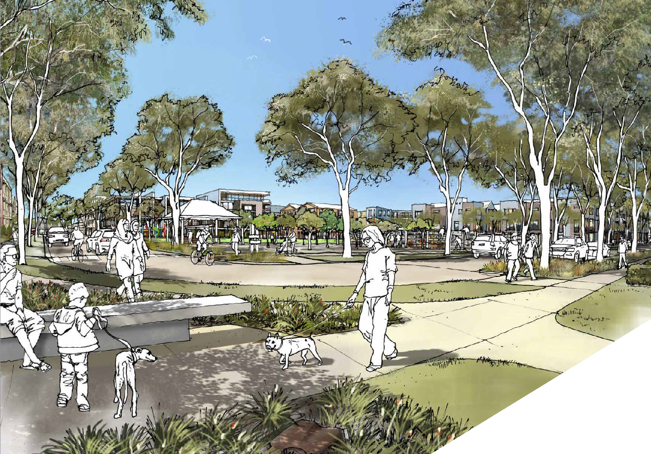

THE CITY OF
GREATER GEELONG
SALEYARDS
PRECINCT PLAN

FIRST DRAFT MAY 2020

- Purpose and Background 04
- Planning Policy Context 07
- Site Analysis 10
- Community Consultation 15
- Design Principles 18
- Framework Structure Plan 23
- Indicative Concept Plan 35
- Implementation Plan 39

BACKGROUND
The Precinct Plan study area consists of the Geelong Saleyards, Target Australia, Sphinx Hotel and associated landholdings and the industrial zone land to the north of these sites, but south of Victoria Street between Weddell and Thompson Road. The site is well located in relation to Central Geelong and the North Geelong Railway Station.

The closure of the Saleyards and the departure of Target retail business headquarters from Geelong presented an opportunity for the City to consider what the best use of this land should be.

In August 2017 Council resolved to close the Geelong Saleyards and, amongst other things, to:
- engage with the community to develop a strategy to recognise the history of the Geelong Saleyards;
- indentify Heritage elements to be retained at the Geelong Saleyards, and to make safe the site by demolishing unsafe infrastructure; (partial demolition of yards approved under planning permit PP742-2018)
- develop a Precinct Plan incorporating the provision of public open space.

In August 2018 a report to Council noted while the site is zoned for industrial use industrial development is not supported given the proximity of the site to the aged care facility and the residential development on the Geelong Golf Club site.

At this meeting Council supported:
- a mixed use development incorporating residential development in the Saleyards Precinct Plan
- consultation with the community and affected landowners to inform the directions of the Geelong Saleyards Precinct Plan

Large scale development of shops would be contrary to the City’s planning policies which seek to protect the existing shopping centres in Geelong and avoid the creation of new “out of centre” developments.
Similarly office development is not supported as the City’s efforts are focused on increasing the number of jobs in Central Geelong.

Therefore, a mixed development with a focus on housing is the preferred land use. This is consistent with the City’s housing policies that seek to support more infill housing development in established urban areas, particularly near train stations.

PURPOSE
The purpose of the Precinct Plan is:
- to develop a vision for the future use of the precinct;
- to prepare a concept layout plan that addresses land-use, built form, access and movement, drainage and preferred public open space network;
- to develop a suite of planning controls to implement the vision for the precinct.

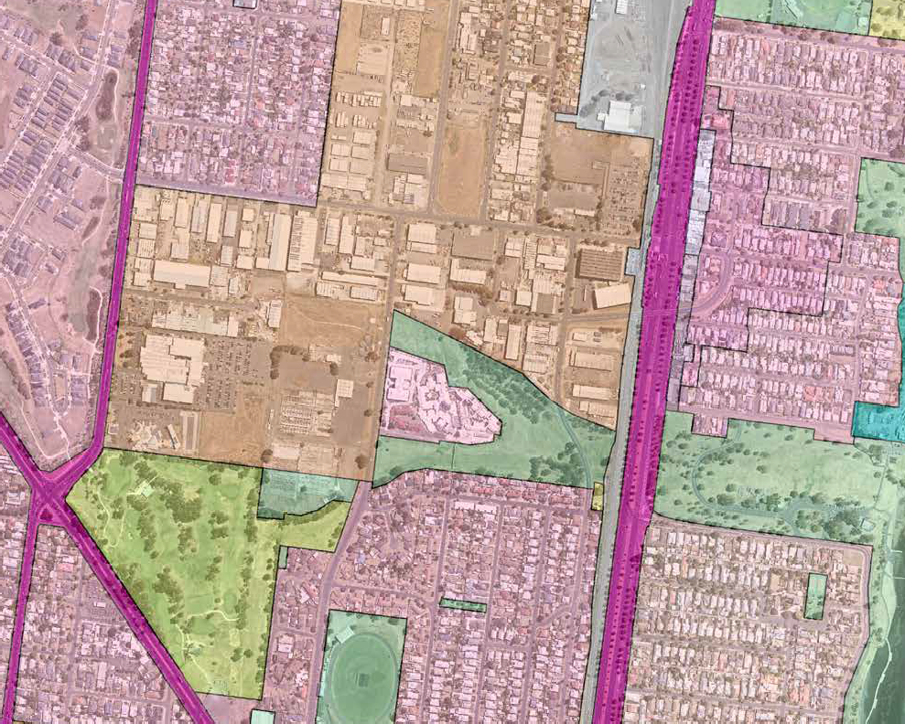
GRZ2
PUZ4
IN1Z
GRZ1
North Geelong
C1Z
RGZ2
C2Z
IN1Z
GRZ1
GRZ1
CD
PPRZ
RDZ1
PPRZ
PPRZ
RDZ1
GRZ1
SUZ3
GRZ2
NRZ2
PPRZ
Geelong Golf Course
Sphinx Entertainment
Aged Care Complex
Target Headquarters
Sale Yards

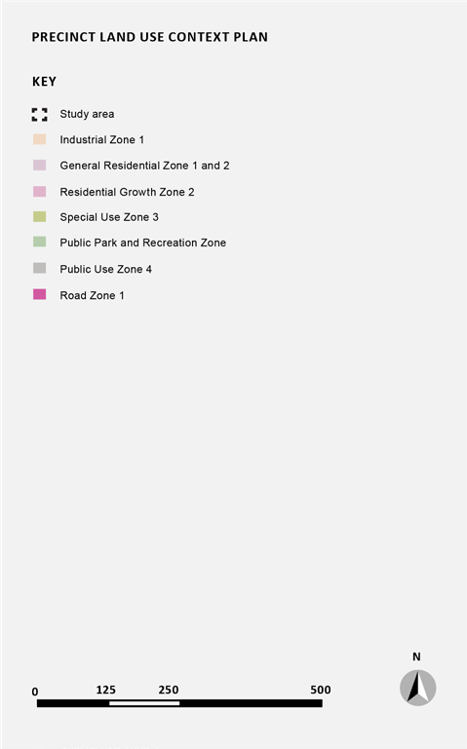

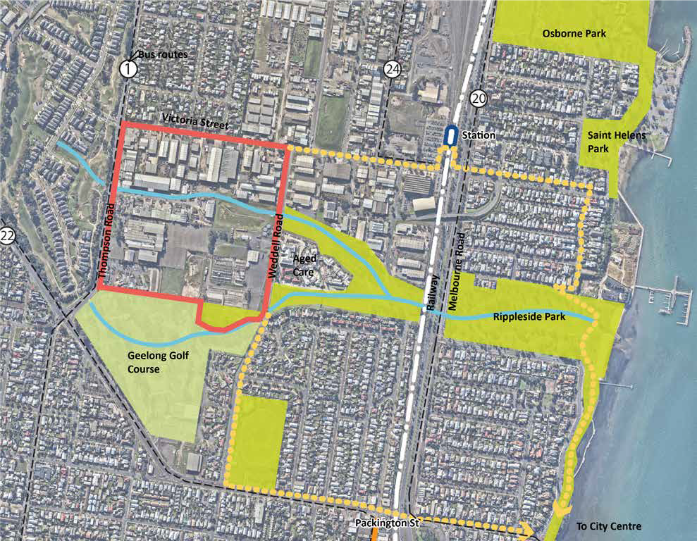
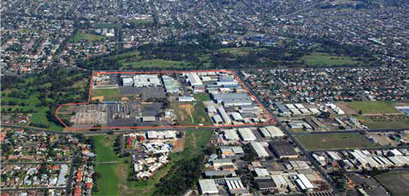
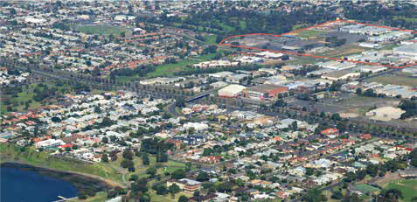
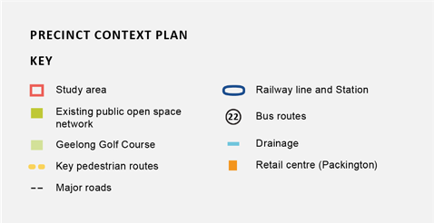

The following strategic work is relevant to the development of the Precinct Plan:

SETTLEMENT AND HOUSING

11.01-1S SETTLEMENT
  - Ensure regions and their settlements are planned in accordance with their relevant regional growth plan.
  - Limit urban sprawl and direct growth into existing settlements.
  - Promote and capitalise on opportunities for urban renewal and infill redevelopment.

16.01-3S HOUSING DIVERSITY
  - To provide for a range of housing types to meet diverse needs.
  - Ensure housing stock matches changing demand by widening housing choice.
  - Facilitate diverse housing that offers choice and meets changing household needs through: A mix of housing types.
  - Encourage the development of well-designed medium-density housing that respects the neighbourhood character, improves housing choice and makes better use of existing infrastructure.
  - Support opportunities for a range of income groups to choose housing in well-serviced locations.

21.06-3 URBAN CONSOLIDATION
  - To provide for the consolidation of existing urban areas in a managed way.
  - To encourage an appropriate range of development densities.

NEIGHBOURHOOD CHARACTER

15.01-5S NEIGHBOURHOOD CHARACTER
- To recognise, support and protect neighbourhood character, cultural identity, and sense of place.

21.06-4 NEIGHBOURHOOD CHARACTER
- To manage the impact of urban change on existing neighbourhoods.
- To ensure that new development responds to the existing neighbourhood character.
- To protect areas with a significant garden character.

HERITAGE

15.03-1S HERITAGE CONSERVATION
- To ensure the conservation of places of heritage significance.
- Encourage appropriate development that respects places with identified heritage values. Retain those elements that contribute to the importance of the heritage place.
- Encourage the conservation and restoration of contributory elements of a heritage place.
- Ensure an appropriate setting and context for heritage places is maintained or enhanced.
- Support adaptive reuse of heritage buildings where their use has become redundant.

CULTURAL HERITAGE
- To encourage the retention of culturally significant and contributory heritage places within Heritage Overlay areas.
- To encourage development to be undertaken in accordance with the accepted conservation standards of the ICOMOS Burra Charter.
- To conserve and enhance the natural or cultural features of an area or site and to ensure that any alterations or development complement their form and appearance.

INDUSTRY

17.03-1S INDUSTRIAL LAND SUPPLY
  - To ensure availability of land for industry.

13.04-1 CONTAMINATED AND POTENTIALLY CONTAMINATED LAND
  - To ensure that potentially contaminated land is suitable for its intended future use and development, and that contaminated land is used safely.

13.07-1S LAND USE COMPATIBILITY
  - To safeguard community amenity while facilitating appropriate commercial, industrial or other uses with potential off-site effects.

STRATEGIES

PLAN MELBOURNE 2017–2050
Plan Melbourne is a metropolitan planning strategy that defines the future shape of the city and state over the next 35 years. It seeks to integrate long-term land use, infrastructure and transport planning, and support jobs and growth, while building on Melbourne’s legacy of distinctiveness, liveability and sustainability.

G21 REGIONAL GROWTH PLAN
The G21 Regional Growth Plan is a plan to manage growth and land use pressures to 2050 in the G21 region. It sets a target of 40% of new dwellings provided through urban infill at average densities of 20 dwellings per hectare in urban Geelong.

GREATER GEELONG: CLEVER AND CREATIVE FUTURE
Greater Geelong: A Clever and Creative Future is a 30-year vision that guides all levels of government, community organisations, businesses and anyone wanting to make a genuine contribution to the Geelong city-region. In relation to development the following values are identified:
- sustainable development that responds to climate change
- design that makes best use of technology for better and more sustainable living
- development that enhances the identity of diverse neighbourhoods
- design excellence and innovation in new buildings and public spaces
- creating high amenity neighbourhoods that are well connected and sustainable
- easy access to open space and parkland near homes

HOUSING DIVERSITY STRATEGY
This strategy seeks to:
- provide for the development of a range of housing types and densities and encouraging urban consolidation within existing urban areas
- provide certainty to the existing and future community with regard to where different housing types would be supported or discouraged
- provide for a sustainable overall urban structure for the City

It does this by dividing the established urban area into three categories:
  - Key Development Areas – Higher density and mixed use housing
  - Increased Housing Diversity Areas – a mix of conventional housing with some medium density housing around activity centres and train stations.
  - Incremental Change Areas – primarily conventional residential housing The housing categories are described as:
Housing definition | Description | Density
Conventional housing | Single detached dwellings on lots generally ranging between 500 and 1,000 square metres (sqm). The development of an area for conventional housing | Generally results in a gross residential density 1 of 10 – 15 dwellings per hectare
Medium density housing | The provision of two or more detached or attached dwellings, townhouses  or apartments on a site below four stories. | The development of an area for medium density housing generally results in a gross residential density of 20 – 40 dwellings per hectare
Higher Density housing | Attached townhouses or apartments, usually more than 3 storeys in height | The development of an area for high density housing generally results in a gross residential density of more than 40 dwellings per hectare.

The Saleyards site will be defined as a ‘Key Development Area’ given it has the potential to accommodate high-density housing (including housing, as part of mixed-use developments) in excess of 40 dwelling per hectare (around 80 dwellings/ha based on the concept plan). It is within 800m from the North Geelong train station.

SOCIAL HOUSING PLAN 2018 – 2041 AFTER HOUSING DIVERSITY STRATEGY
This strategy seeks to:
  - Increase the supply of social housing across the City area to 13,500 by 2041.
  - Advocate for increased state and federal investment in new social housing.
  - Increase supply of social housing by contributing City-owned land to new developments.
● Amend the City’s Planning Scheme to require the inclusion of social and affordable housing in new developments, based on need.
● Continue to revitalise our neighbourhoods of high social housing to increase liveability and wellbeing.

It is council policy to seek an social and affordable housing assessment as part of the rezoning of major sites such as this one.

A social housing assessment is currently being undertaken and the outcome will form part of the site specific planning controls for this site.

SETTLEMENT STRATEGY
This strategy sets out how Greater Geelong will meet its housing need out to 2036.

Relevant strategies include:
● Direct the majority of future housing needs to urban Geelong
● Facilitate infill development to increase its housing supply contribution to 50 per cent, by 2047.
● Investigate a ‘rail corridor precinct’ approach to infill opportunities from North Geelong Station through to Breakwater
● Prepare design guidelines for areas of housing change to reduce uncertainty about the scale, form and design of neighbourhood developments.
● Investigate the infrastructure needs and funding mechanisms available to deliver upgrades as part of planning for increased housing densities.
● Ensure new major developments are designed and located to maximise public and active transport options.
● Advocate for improved public transport services in established areas to key destinations.
● Continue to invest in ‘place making’ activities – that is amenity and local facility improvements –
in urban renewal areas, key development and increased housing diversity areas and activity centres.
● Ensure housing diversity is achieved in existing communities.
● Increase the level of affordable and social housing
● Apply ‘One Planet Living’ principles to growth area planning and development.

A series of background studies were undertaken to inform the development of the Precinct Plan, including;
● Drainage (Rippleside Catchment Drainage and Flood Study underway)
● Environmental Site Assessment
● Movement and Access
● Heritage
● Existing trees
● Acoustic

The site analysis is summarised on the following pages.

NEIGHBOURHOOD CONTEXT
The site is surrounded by the suburbs of North Geelong and Geelong West.

The suburbs generally comprise small scale commercial and light industrial development as well as modest single storey residential development.

The surrounding open space is fairly rudimentary, developed around a pattern of drainage.

DRAINAGE
Flooding from storm events is identified as an issue in this area. We know that at times, Weddell Road experiences flooding as water flows from west to east towards Rippleside and Corio Bay. In recent years there has been some large developments occur in the wider catchment which has increased the amount of stormwater runoff, for example the residential development at the Geelong Golf Club.

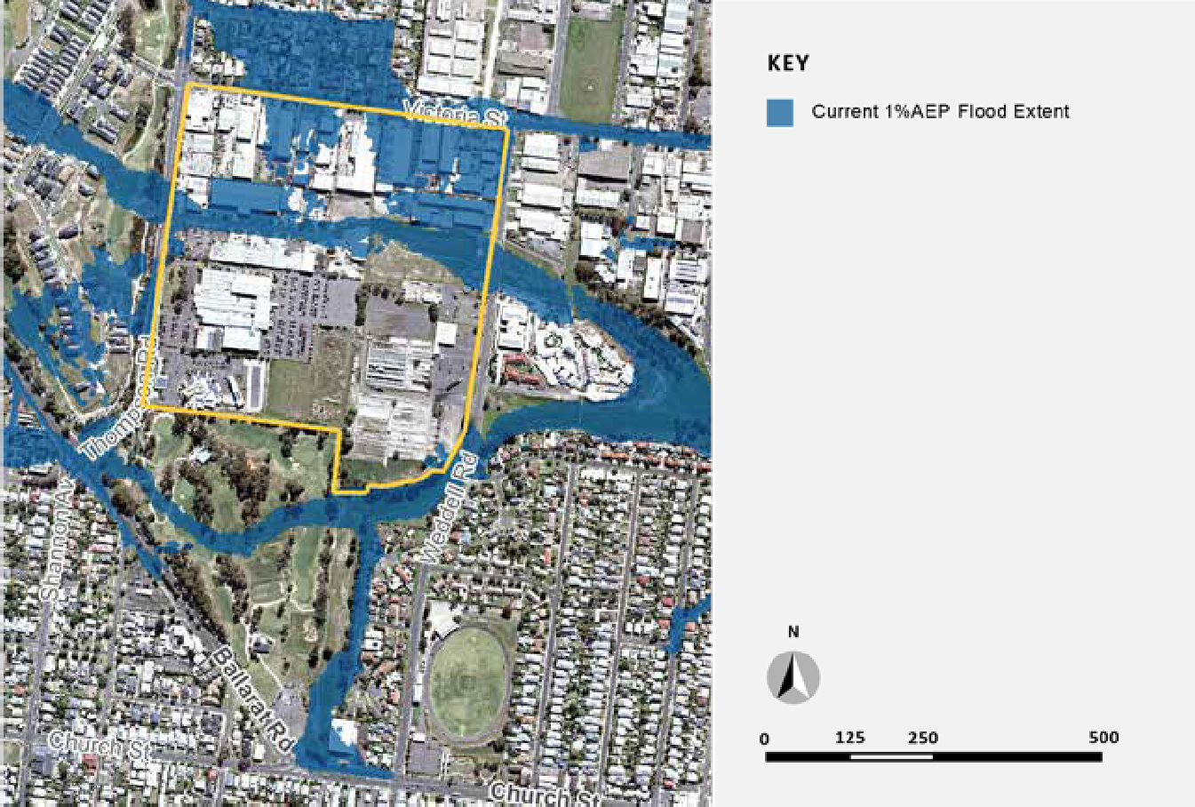
The City is preparing the Rippleside Catchment Drainage and Flood Study. The study will help The City and relevant authorities to better understand the flood risks and stormwater management opportunities in the 770Ha Rippleside catchment area. Flood studies such as these improve land use planning, emergency response, climate change adaptation and community flood preparedness.

ENVIRONMENTAL SITE ASSESSMENT
An environmental site assessment was commissioned to investigate the level of soil and ground water contamination on the Saleyards site. The report concluded that with appropriate works, the site can be remediated to accommodate residential or open space uses.

The contaminants were predominantly identified in shallow soil within the cattle yards and sheep yards and the western boundary of the site where the market office building was located. The former sheep dip location, just south of the truck wash included contamination at a greater depth. Site remediation will be required before any development occurs on site. The remediation response should be informed by a future development layout and could vary from complete removal of all contaminated material to leaving soils in situ and capping them. Further environmental assessments will be carried out on the former Target site and the vacant Sphinx land at a later date.

MOVEMENT AND ACCESS
A movement and access study was commissioned which suggested that vehicles access to the study area will be provided from both Thompson Road and Weddell Road. Thompson Road is a VicRoads arterial and any changes to this road will require VicRoads approval. The existing road network around the site is capable of accommodating the traffic generated from development in the precinct plan area. An east west connection through the area from Weddell Road to Thompson Road is required. It is recommended that the alignment be staggered to avoid it being used as though road.

The need for better pedestrian connections from the precinct to the broader transport network are also identified, including a pedestrian refuge on Thompson Road and the potential need to signalise the intersection of Victoria Street and Weddell Road as traffic volumes increase and pedestrians seek to access the train station from within the precinct.

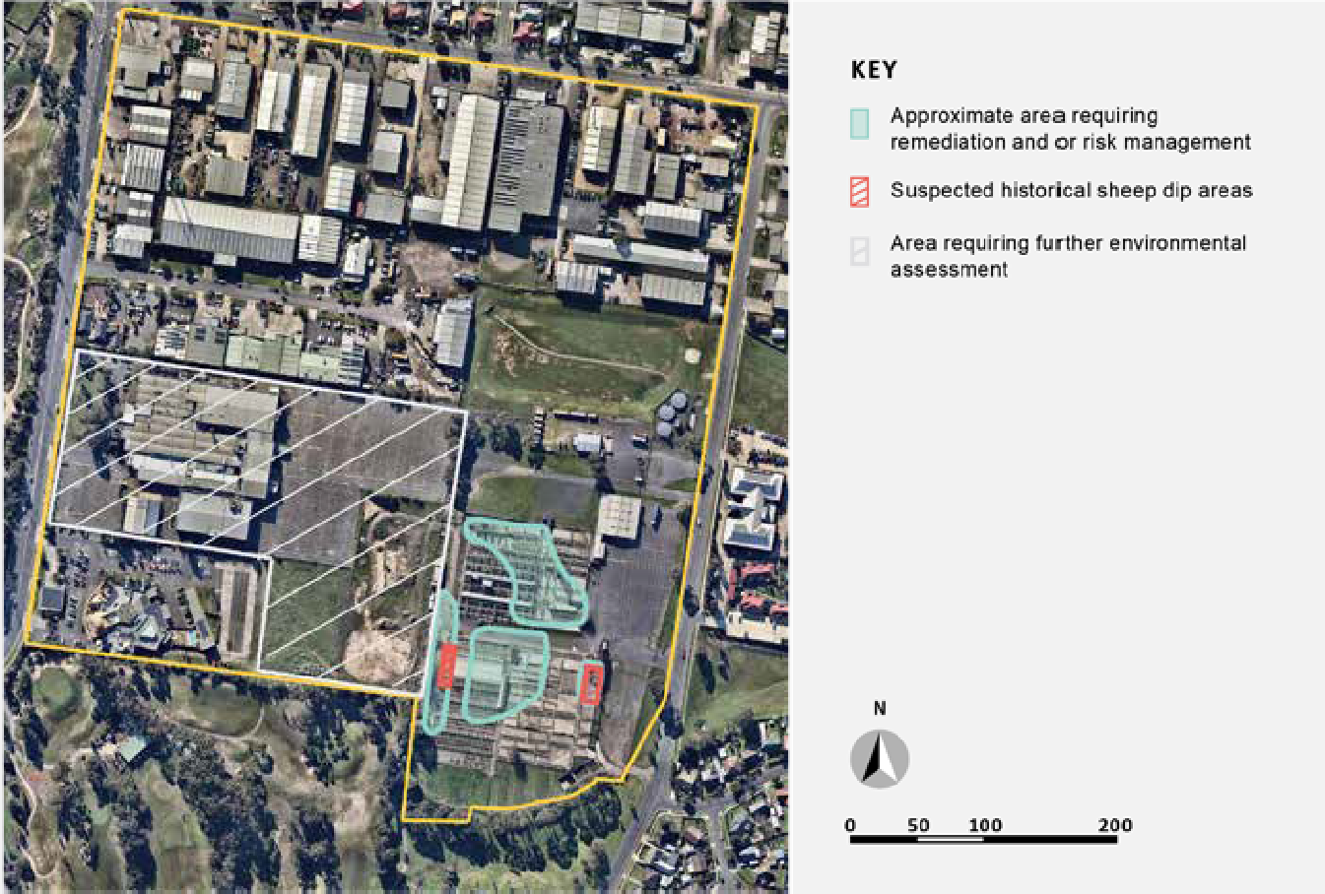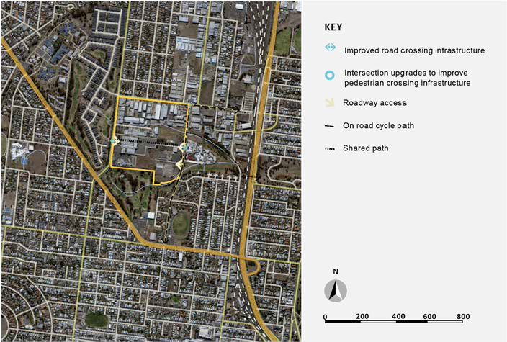

HERITAGE
To demonstrate the historical use and assist in interpreting the history of the site the following structures will be retained:
    - Two rows of cattle yards (immediately north of the central thoroughfare). Twenty pens in total. Exclusion: the elevated timber and steel walkways within this part of the cattle yards will be removed.
    - One timber cattle ramp.
    - The central thoroughfare, which does not have any historic fabric as such, but the east-west axis must be retained and incorporated into the Precinct Plan.
    - Bluestone paved drain in the sheep yards, south from the central thoroughfare, beneath the gabled open shed for a total distance of approximately 100 metres.
    - The Latrines Shed.

Incorporating the retained heritage fabric on the site is a key challenge for this project as much of the material is in a deteriorated state and there is no obvious new use that can be accommodate in the cattle pens. The ongoing maintenance and safety of these features and trying to find a balance between having the community access and appreciate these assets but ensuring the fabric is not further degraded by community use are key considerations.

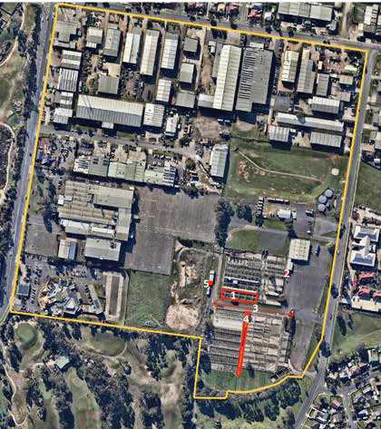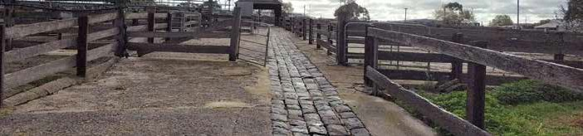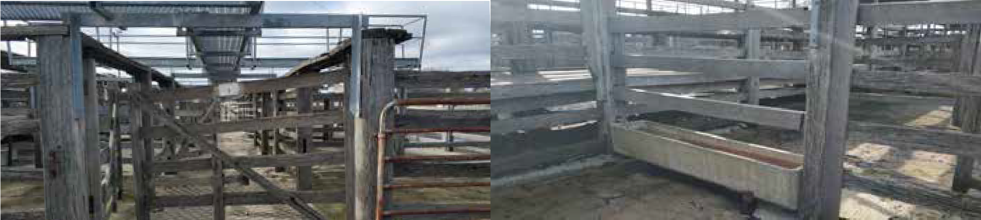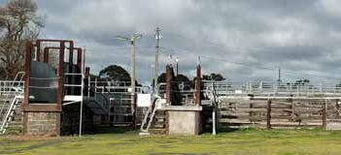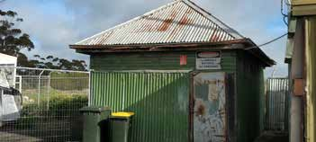
200
0 50 100
N
Heritage items to be retained as per planning permit

EXISTING TREES
An arborist assessment was prepared to look at all vegetation on the site and make assessment of its health, condition and useful life expectancy.

Target site: The trees in the large lawn area fronting the former Target head office are all Corymbia or Eucalyptus trees in good condition. The tress within the Target carpark are mostly Pyrus calleryana (Chanticleer and Capital), approximately 5 years old.

Saleyards site: The single planted specimen trees on the site were planted many years ago and have been managed for the purpose of giving shade to stock housed in pens. These trees have developed poor structures and offer limited use moving forward. Other trees have been planted as boundary plantations and have developed as plantation trees. Trees in boundary plantations offer amenity use,

however their structures have formed with a heavy reliance on other trees in their plantation.

Their tall often upright form means they have developed in a manner susceptible to storm cell impacts.

Therefore the focus will be on greening the site through appropriate new plantings combined with careful retention of a select few healthy trees.

Consideration will also be given to protection of trees on the neighbouring allotments and the municipal nature strip, so as not to impact them. This is achieved by using Tree Protection Zones.

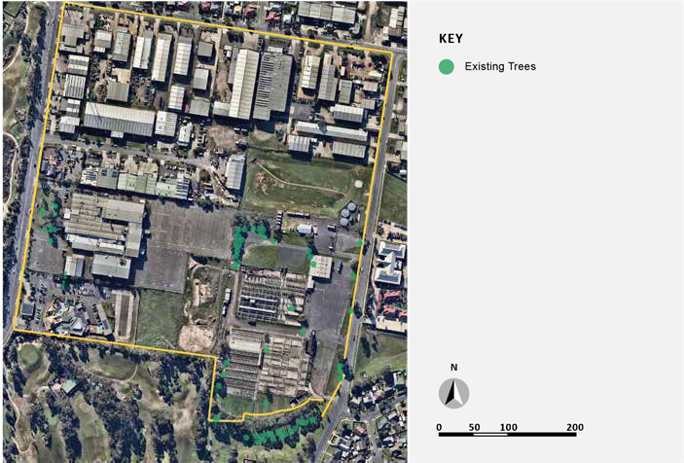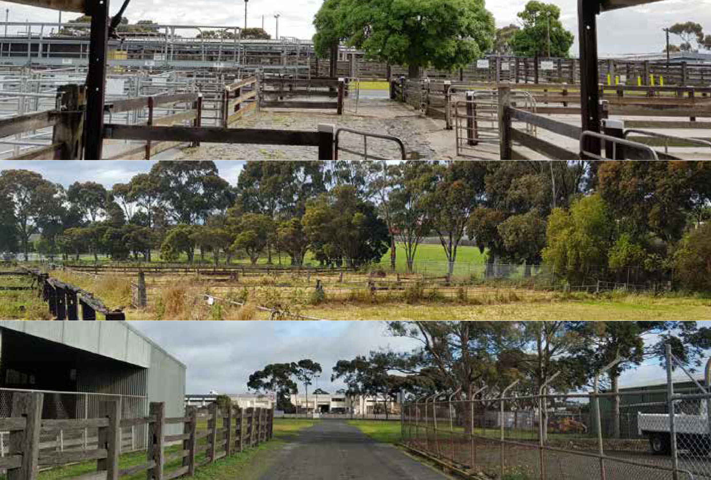

ACOUSTIC
An acoustic report was prepared to identify existing noise sources in the area and to identify how development should be designed to avoid noise impacts for future residents. Noise loggers were placed throughout the precinct and reported that the greatest noise sources were the industrial uses in the north, traffic noises from Thompson Road and music and car parking noise from the Sphinx entertainment complex. The report recommends acoustic fencing be included on site boundaries as shown on the map. It also recommends that new buildings located in some sections of study area be designed to reduce noise by using double glazing for example.

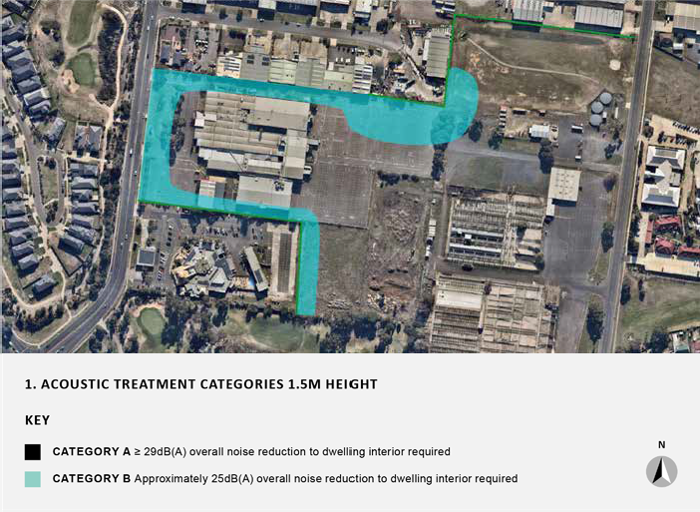
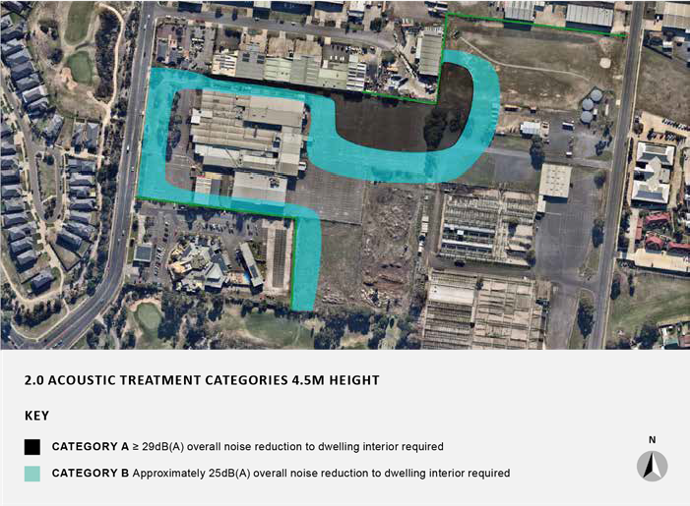

The City hosted a Precinct Planning workshop on the 3rd of September, 2019. The purpose of the workshop was to give landowners in the precinct, community members and key agencies an opportunity to inform the
precinct plan.
The topics of the consultation were;
● Preferred outcomes for the future site
● Future opportunities and challenges
● Three themes to guide the future planning
● Movement, access and connection to the site
● The look and feel of the place
● What people are doing

The outcomes of the consultation is summarised on the following pages.

PREFERRED OUTCOMES FOR THE FUTURE SITE

‘Flagship’ community of North Geelong
We will move beyond boundaries in re-imagining the potential of a large site close to the city centre and bay, creating a legacy for the city and future generations.

Where heritage and environment inspire
Our past is respected and part of community life; we live lightly, respecting the environment which nurtures us.

A welcoming, progressive, attractive place
All people are welcome here to create their home or visit. As in the past, common spaces and places facilitate and encourage community socialisation, healthy and active living. Our roads and pathways connect us to each other and beyond. We are safe.

Clever and creative ecological neighbourhood, continually evolving for generations now and into the future
Our apartment and township living and interactions with the world around us are ecological exemplars; sustainable living for today and tomorrow.

THE FUTURE OPPORTUNITIES AND CHALLENGES
When the community considered the future development of the Geelong Saleyards site the following opportunities and challenges influenced their thinking.
- The potential for a natural environment that provides ecological corridors for walking, trees for shade, natural vegetation that attracts bird life and a drainage reserve that forms a natural creek bed. An integrated ecosystem.
- The ability to be safely connected through walkways and cycle paths to the bay, station, city centre, shops, school and community spaces. Pedestrians and cyclists to be given priority over cars with improved wide footpaths and street lighting.
- A need for social infrastructure like public spaces and playgrounds where the community can come together
- The chance to design differently to create a place that connects to the past and provides a sense of community belonging and a destination. The opportunity to become a neighbourhood where all needs can be met by a 20-minute walk or drive.
- A clever and creative mix of housing that blends old and new, is affordable and caters for all life stages.

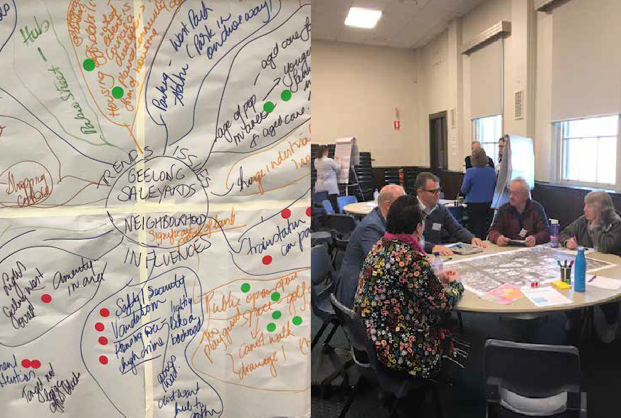THOUGHTS AND IDEAS AROUND THE THREE THEMES

MOVEMEN T, ACCESS AND CONNECTION

Shared pathways
  - Shared pathways for walking, cycling and mobility scooters
  - No footpath gaps on both sides of Weddell Road
  - Improved footpaths around the periphery
  - Footpaths connect to schools, aged care facilities, station and bay
  - Improved bicycle and walking access to Pakington Street
  - Facilities for bicycles, racks, bike hire
  - Consider a cycle lane along the north side of Victoria Street by possibly removing a parking lane Pathways through the site: vehicles to the periphery
  - Shared pathways through flood prone land
  - Walk and cycle to the places you use

Safety
  - Safe to move around with priority given to pedestrians not vehicles
  - Upgraded Victoria and Weddell Road intersections
  - Improved lighting on Weddell Road
  - Improved traffic light sequencing, Church Street and Weddell Road.
  - Close to Shannon Avenue which has a record of car accidents
  - Safety and speed issues resolved on Victoria Street and Weddell and Church Street intersections
  - Safe access on and off Thompsons Road
  - Kids can play on the streets

Public Transport
  - Improved bus routes and stops
  - Public transport utilises technology
  - Maybe not through the site core
  - Pathways connect to the railway station
  - Bus routes connect to railway station

Transport facilities
  - Electric vehicle charge points
  - Car sharing

LOOK AND FEEL

Green, natural and environmentally friendly
  - Trees provide shade to footpaths
  - Green and spacious, leafy tree-lined streets
  - Use of recycled materials
  - Green buildings
  - Plantings that encourage bird life
  - Reinstated creeks
  - Energy self sufficiency
  - Food production gardens
  - Retain and expand habitat
  - Drainage reserves are natural waterways

Creative design
  - Heritage is woven through
  - Integrated housing
  - Medium density housing allow space for amenity
  - Pedestrian friendly
  - Mixed housing, affordable
  - Town houses, apartments and family homes
  - Alternative parking, underground. Maybe not all houses have a garage

Full of life
  - Cafes, restaurants
  - Integrated public spaces
  - Café life integrated with public spaces
  - Small retail shops
  - A place for all age groups
  - Public spaces
  - Playgrounds for all ages

WHAT PEOPLE ARE DOING
  - Walking dogs
  - Walking for exercise
  - Walking and cycling rather than driving
  - Walking safely at night
  - Visiting and enjoying the destination
  - Using public transport
  - Walking to the station
  - Having family BBQ’s at the playground
  - Mothers are pushing prams
  - Raising families
  - Children playing
  - Getting together for coffee
  - Talking with neighbours
  - Shopping locally for bread and milk
  - Ageing in place
  - Attending community events
  - Learning about heritage
  - Living and working in the area
  - Growing vegetables
  - Going to the farmers market

The following design principles were formulated from the study analysis and consultation. These principles were used to inform the development of the Saleyards Precinct Plan.
- PROVIDE SPACIOUS PUBLIC OPEN SPACE AND IMPROVED HABITAT
Provide a multi-purpose open space that links to the surrounding open space network.
● Create a new central park which provides opportunities for cultural interpretation, play and recreation.
● Manage stormwater overland flows
● Create green links that provide habitat for local species.

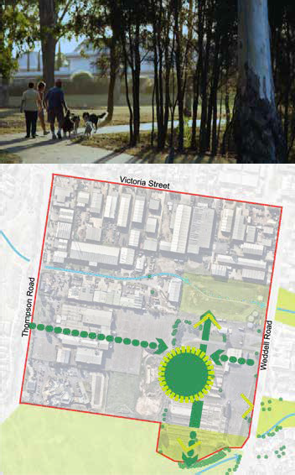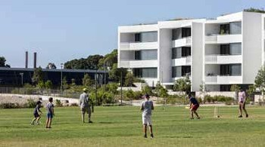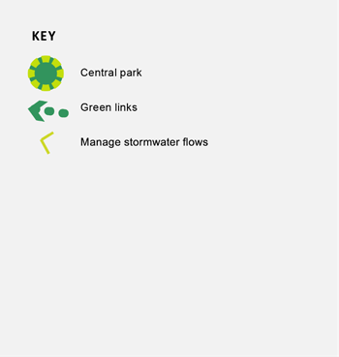
N

RESPECT THE HERITAGE OF THE SITE
Maintain and enhance the heritage values of the Saleyards in particular:
- Interpret the elements of significance, the cattle and sheep pens, ramp, bluestone drain and central thoroughfare in a central public open space.
- Interpret the historical function of the site as a livestock saleyard.

CONNECT TO SURROUNDING STREETS
Maximise site permeability and vehicular connections to the site
● Prioritise vehicular access from Weddell and Thompson Street as the main entry points to the site.
● Provide a secondary entry point to the site on Weddell Street which aligns with the historic thoroughfare.

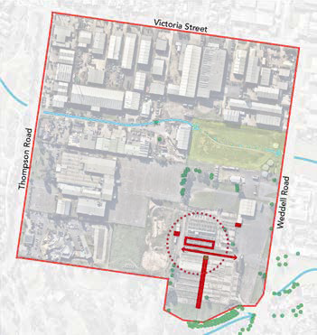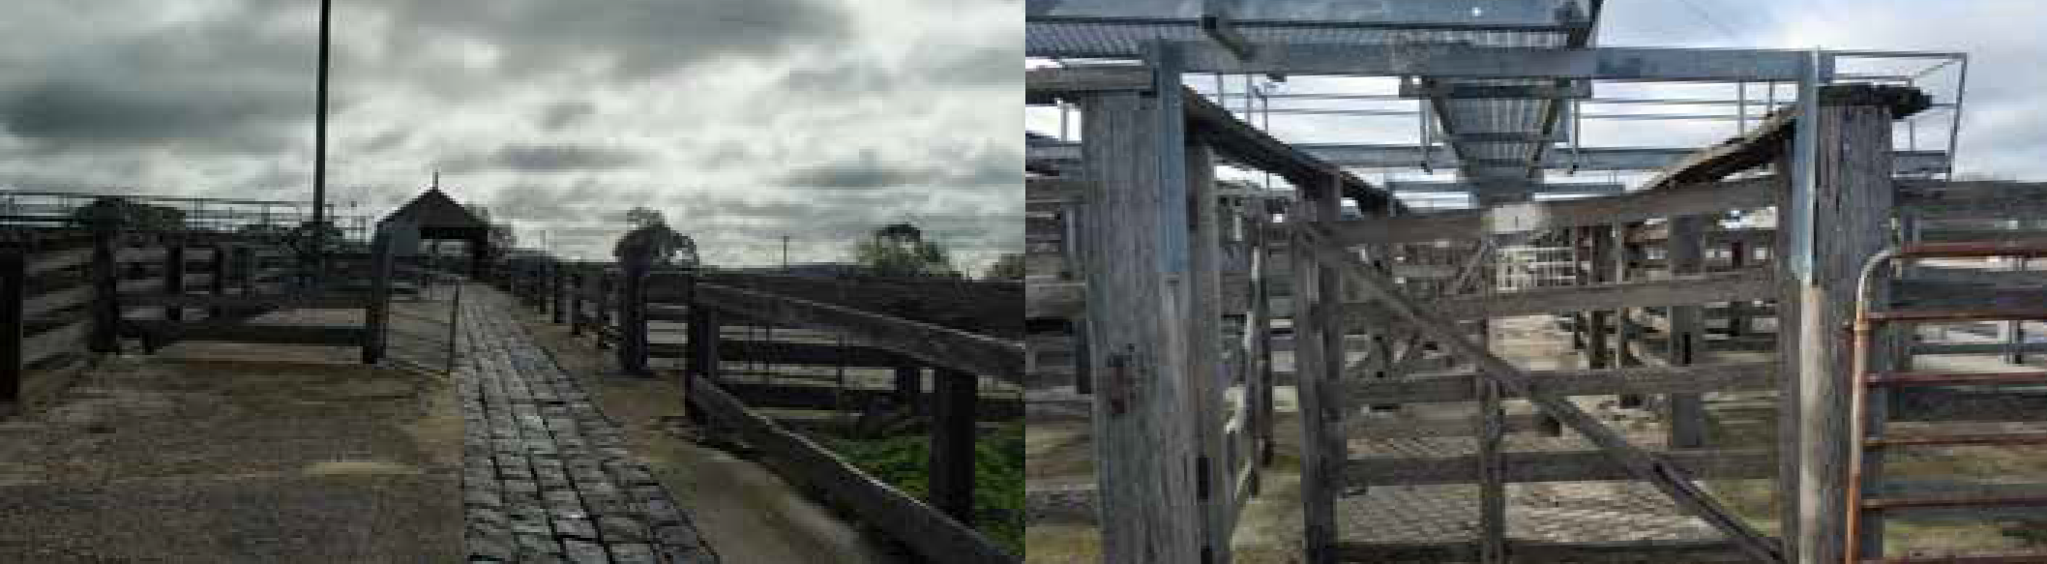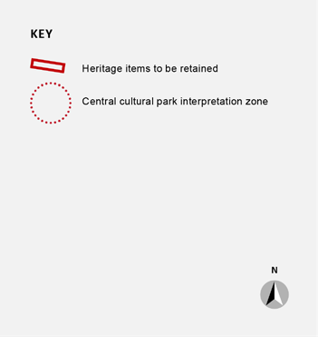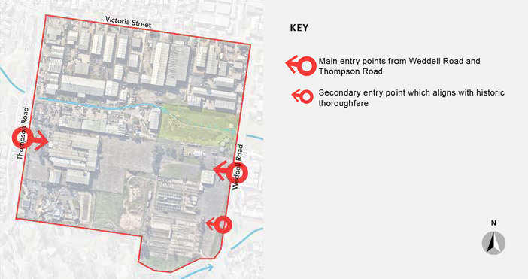

ENHANCE PEDESTRIAN AND BICYCLE NETWORKS THROUGH THE PRECINCT
Enhance pedestrian and bicycle networks through the precinct by:
- Prioritising a direct east west connection through the development
- Enhancing pedestrian and cycle connections to the train station
- Create a north/ south connection to connect to the reserves to north and south.

PROVIDE A COMMUNITY NODE
Create a community node off Weddell Street to support a range of uses for the new neighbourhood. The node may include services, small scale retail, gathering spaces.

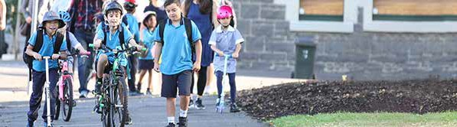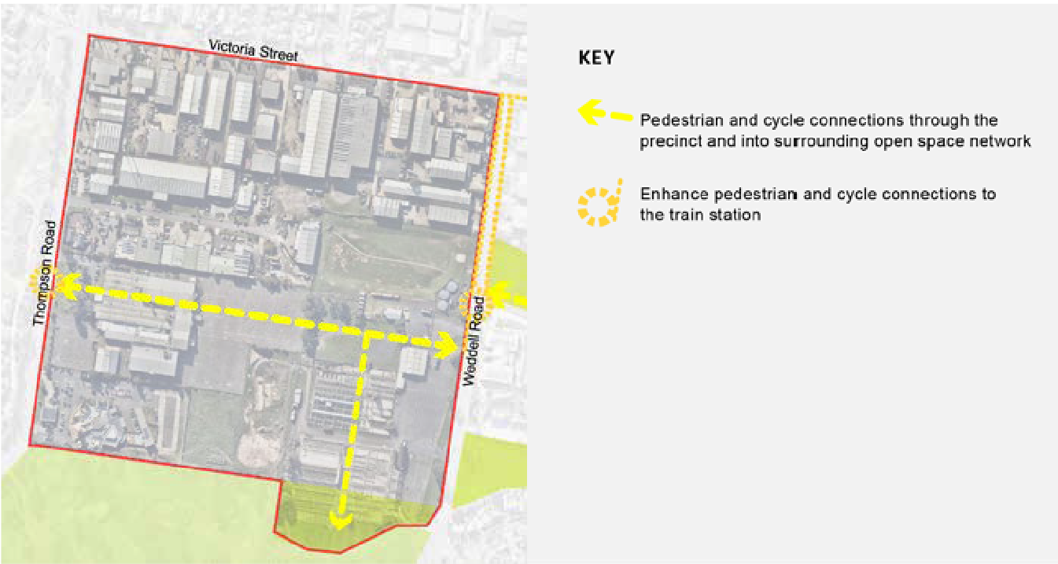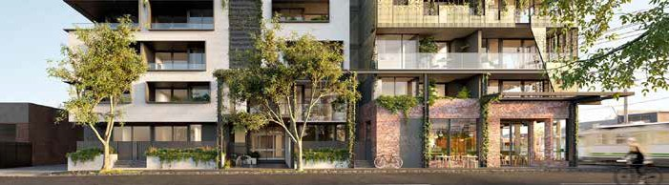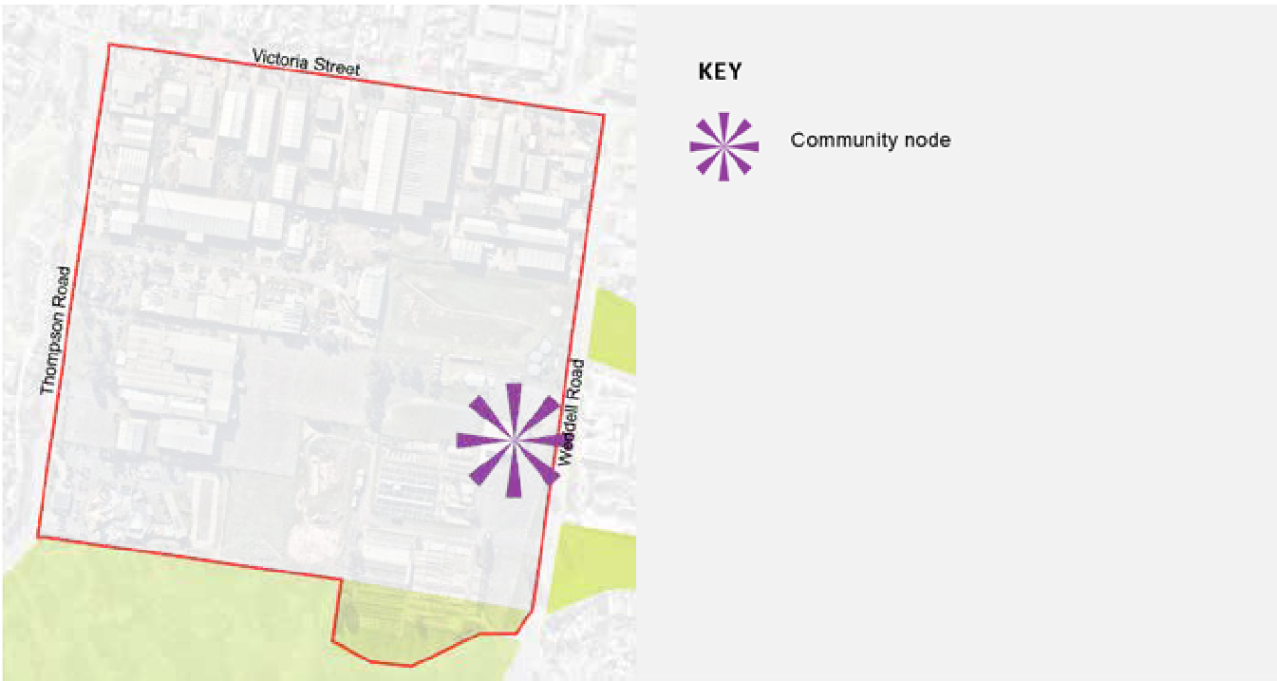

PROVIDE A CRITICAL MASS FOR HOUSING
Provide a critical mass of housing and other activities to support transport and services.

The residential precinct will provide a mixture of building types that are not provided by existing building stock in the surrounding neighbourhoods, including different typologies, tenures and adaptable and affordable housing. Buildings will demonstrate diversity in architectural expression with different architectural ‘hands’ within each street and development block.

6. CREATE A FRAMEWORK THAT SUPPORTS BEST
PRACTICE ENVIRONMENTALLY SENSITIVE DESIGN
Ensure that the future urban design framework supports:
- Generating minimal waste during construction and operation
- Minimise greenhouse gas generation through the development’s life cycle.
- Energy efficient building design
- Generating more energy than used
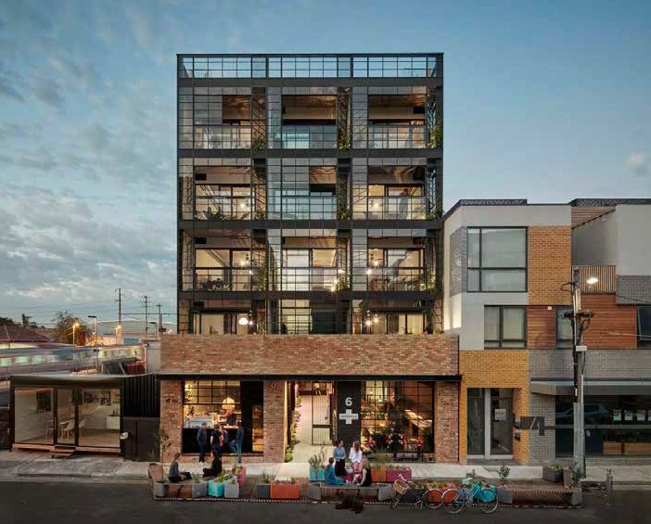
- Water sensitive urban design in streets and public parks.
- Minimise water use and maximise water reuse.
- Allowing for schemes such as car sharing.

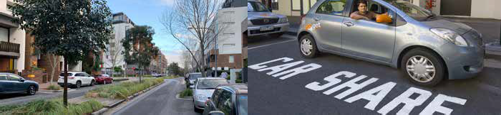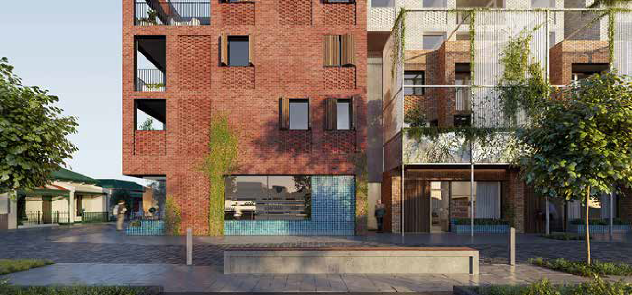

The following table is a comparison of the community/ stakeholder preferred outcomes for the precinct against the City’s design principles for development.

The principles directly respond to community/stakeholder aspirations.

 | PROVIDE SPACIOUS PUBLIC OPEN SPACE AND IMPROVED HABITAT | RESPECT THE HERITAGE OF THE SITE | CONNECT TO SURROUNDING STREETS | ENHANCE PEDESTRIAN AND BICYCLE NETWORKS THROUGH THE PRECINCT | PROVIDE A COMMUNITY NODE | PROVIDE A CRITICAL MASS FOR HOUSING | CREATE A FRAMEWORK THAT SUPPORTS BEST PRACTICE  ENVIRONMENTALLY SENSITIVE DESIGN
‘FLAGSHIP’ COMMUNITY OF NORTH GEELONG
WHERE HERITAGE AND ENVIRONMENT INSPIRE
A WELCOMING, PROGRESSIVE, ATTRACTIVE PLACE
CLEVER AND CREATIVE ECOLOGICAL NEIGHBOURHOOD, CONTINUALLY EVOLVING FOR GENERATIONS NOW AND INTO THE FUTURE

The Precinct will be a high quality and sustainable addition to the local urban fabric. When the precinct is fully complete it will provide more that 4ha hectares of publically accessible open space and will accommodate approximately 1300 residents.

A new high density residential precinct will provide diverse housing that will help meet existing and future local housing demand.

The site will provide a significant addition to the adjacent network of public open spaces providing places for relaxation and recreation.

The mixed use portion of the site will provide approximately 1800 m2 of retail on the ground floor. The heritage fabric will provide opportunities for interpretation and adaptive reuse of materials.
The interface with industrial land will be managed through noise attenuation fence design and requirements for specific building materials, such as double glazing.

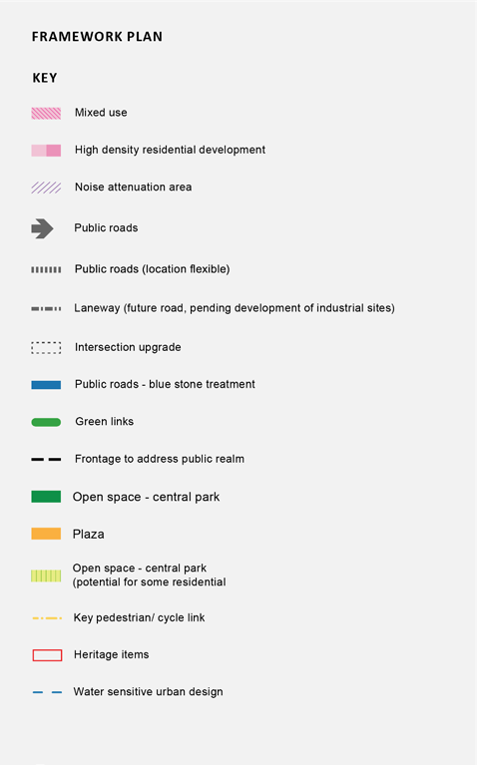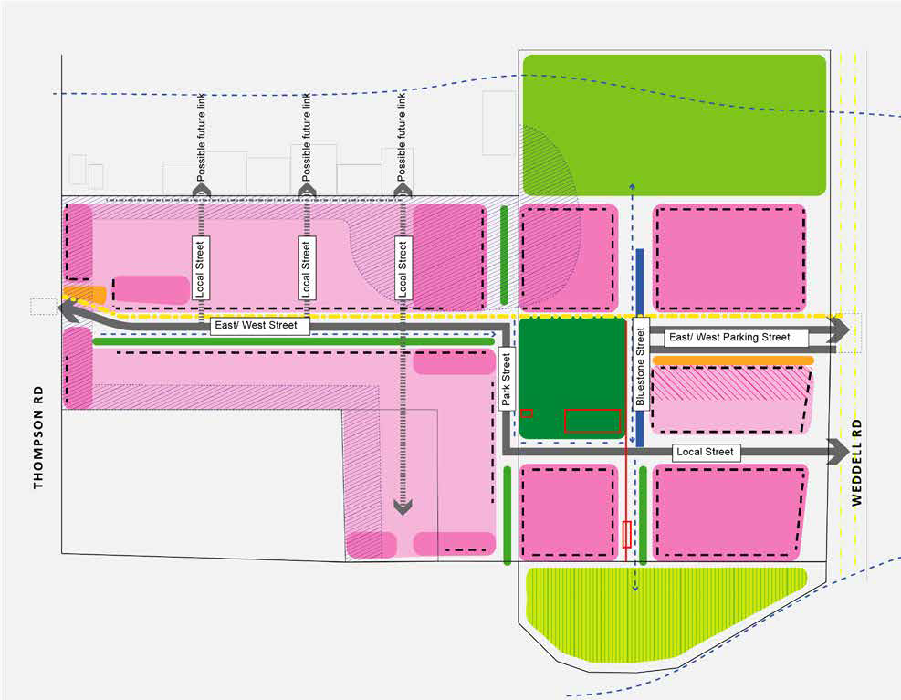

PUBLIC DOMAIN - OPEN SPACE
The plan will contribute approximately 4ha of public open space to the neighbourhood.

Open space has been developed as a co-ordinated group of spaces that deliver high accessibility and diversity of facilities, recreation opportunities and experience. The open spaces range from urban plazas, wetlands, to a planted central parkland.

The central parkland is a consolidated open space for both the Target and Saleyards sites which provides a number of benefits including:

  - Integrated interpretation of the historical uses of the site provided in the public domain, in particular the site’s association with Saleyards.
  - Providing active open space including a kick-about space, informal lawns, BBQ areas, a playground and community gardens.
  - Providing important pedestrian and cycle connections.
  - Provides high levels of amenity for the significant proportion of medium density housing proposed in the precinct.
  - Provide high quality habitat for indigenous species within the public open space.
  - The design of apartments should maximise the locational advantages of parkland settings with living areas and private open space overlooking and interacting with the public domain.

The urban plaza spaces will function as a meeting places, with mixed use development, hospitality based retail addressing the public domain. Elements for successful plaza design such as shade, shelter and greenery will be incorporated into its detailed design.

Smaller, linear parks are more relaxed and intimate spaces which link into the surrounding open space network and provide local outlook for development. There is opportunity to incorporate heritage elements and existing vegetation in some of these parks. It is anticipated that smaller linear parks will be provided under a body corporate arrangement.

The northern drainage basin will be reshaped with landscape enhancements to improve its appearance and water treatment outcomes. Possible wetland development with native planting and establishment of walking loops.

Most public open space is proposed on the former Saleyards site (with the exception of the green link), it is anticipated that development of the former Target site will contribute funds for the development of open space on the former Saleyards site.

BLOCK AND DEVELOPMENT PARCEL PLAN
The street layout and development parcels should be carefully devised and form the basis for the delivery of an integrated and high quality walkable urban neighbourhood.

The block and development parcel plan should allow for flexible medium density development of the precinct that meets the needs of a broad cross-section of the community and is able to respond well to future needs.

Opportunities for various building typologies include:
- a proportion of dwellings as 2 and 3 storey row housing and maisonettes.
- apartments, 4-6 storyes, with basement or semi-basement carparking.
- mixed use buildings with active frontages.

In general
- dwellings adjacent to public open space should have an ‘address’ to the parkland.
- dwellings adjacent to the primary East West Street must address the street.
- the use of private vehicles for transport will be minimised through parking provisions restraint.
- there should be no crossovers onto main roads Weddel and Thompson Street.
- reduce impacts of new vehicle access points on pedestrian, public transport and bicycle priority routes.

DENSITY
Residential development comprising of approximately 660 dwellings sited in a mix of apartment buildings, maisonettes, row housing and mixed use development.

This equates to appropriately 80 dwellings per hectare per net developable area for the precinct.

LINKAGES
Improvements are planned for both Weddell Road and Thompson Road. This includes pedestrian and cyclist safety improvements and a possibility of a turning lane or signalised intersection on Thompson Road.

An investigation is underway into the financial and engineering feasibility of connecting the site directly to Rippleside Park and the Waterfront.

BUILDING TYPOLOGIES AND ARCHITECTURE
The development of the Saleyards Precinct should result in a model example of ecologically sustainable urban renewal with a diverse and high quality residential precinct.

The development should create an appropriate mix of adaptable and affordable housing types to meet local housing demand. Dwellings will be suitable for one and two person households, with adaptable dwellings to support aging in place and compact garden units appropriate for moderate income families with children.

Architectural expression within each development block and on each street or public domain frontage of a development block should be varied and present as a group of buildings rather than one building designed by a single designer or company. At least two architectural firms should be used within each
street block, and buildings designed by the same architectural or design company should not be adjacent to, or opposite each other.

The style of the architecture on the site shall be visually recessive and of high quality construction. It is proposed that timber is the predominant construction material to reduce the carbon impact of the
development, set an example for sustainable contemporary architecture and provide a distinct character for the precinct.

The development will not create buildings that are visually prominent or act as local landmarks. A variety of building heights and forms should be achieved within a maximum height of 6 storeys. Buildings above 4 storeys in height should be designed to minimise the visual impact of the upper levels.

Apartment development will be perimeter block development surrounded by high quality landscaped gardens. The central open spaces within each block will provide a mixture of private gardens and green communal spaces for the enjoyment of all residents. Provision of green roofs will be encouraged to provide additional communal open space. Car parking will be provided in basement or semi basement configuration under buildings to provide opportunities for deep soil planting within central courtyard spaces.

Row house, mixed use and maisonette development shall ‘address’ the street and public realm frontage with garage access from a lane-way system at the rear.

BUILDING TYPOLOGIES
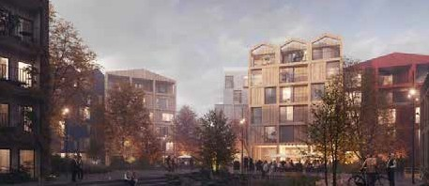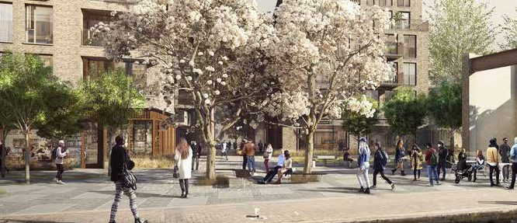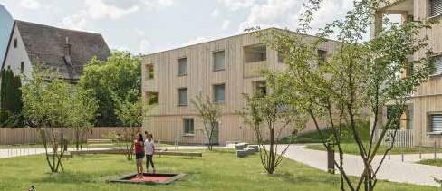
4-6 STOREY APARTMENT
3-4 STOREY MIXED USE
3 STOREY MAISONETTE

Perimeter block apartments are the highest density residential type proposed in the precinct. Developments will include central green communal open spaces. Provision of green roofs will be encouraged to provide additional communal space.

Maximum site coverage: 80%
Vehicular access/ parking: basement or semi basement

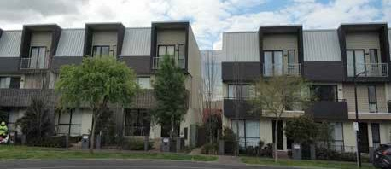
3 STOREY ROW HOUSE WITH NO REAR COURTYARD
The 3 storey rowhouse is own its own title, found within a larger comprehensive development focused around a shared central amenity area. It is defined by 100% site coverage within its own lot, deriving private amenity from decks and rooftop gardens.

Minimium lot size: 85m2
Maximun Site Coverage: 100%
Vehicular access/ parking: at grade garage access from rear lane
Mixed use units have no frontage setback, a higher ground floor ceiling height and a ground-floor at the same level as the street.

Minimium lot size: 85m2
Maximun Site Coverage: 100%
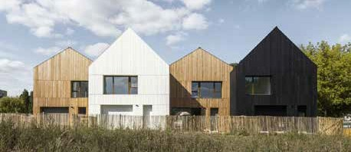Vehicular access/ parking: at grade garage access from rear lane
2-3 STOREY ROW HOUSES WITH REAR COURTYARD

The row house (terrace or attached unit) has one or two attached sides. This type of development includes duplexes at the end of the block.

Minimium lot size: 190m
Maximum site coverage: 70%
A Mainsonette is four or more separate apartments within a single 3 storey structure that share a common service core - effectively a small scale apartment building that reads like a single larger house on a large lot.
Minimum lot size: 600m2

Maximum Site Coverage: 70%
Vehicular access: at grade garage access from rear lane

ECOLOGICALLY SUSTAINABLE DEVELOPMENT
The development will focus on Urban Heat Island Effect mitigation (UHI) and emissions reduction as the key mechanisms to make better places.

EMISSIONS
To meet our zero emission strategic target, development proposals will require certified (Victorian or Australian) carbon offsets for all pre operation works, this will allow, at least from an accounting perspective a carbon neutral development prior to occupation.

ENERGY
A decentralised peer to peer energy generation (probably solar), storage (probably battery) and sharing scheme is proposed.
  - Achieve a 20 per cent improvement on current National Construction Code energy efficiency standards.
  - The orientation of buildings should consider natural light access, energy production, ventilation and wind breaks.
  - External shading (at minimum Northern and Western façade shading strategies) should be included as part of façade design.
  - Demonstrate how natural cross ventilation is incorporated into the design of buildings.
  - Residential developments should achieve an average 7 star NatHERS rating for each building.
  - Incorporate renewable energy generation, on-site energy storage, and opportunities to connect to a future precinct-wide or locally distributed low carbon energy supply.
  - Developments with 10 or more dwellings or 5000 square metres or more of floor space should submit evidence that the project has been registered to seek a minimum 5 Star Geen Star
Design (or equivalent) with the Green Building Council of Australia. Within 12 months of occupation of the building, certification must be submitted that demonstrates that the building has achieved
a minimum 5 Star Green Star Design (or equivalent).
  - Other buildings and alterations of more than 50 square metres should submit evidence that they have been registered to seek a minimum 4 Star Geen Star Design (or equivalent) with the Green Building Council of Australia. Within 12 months of occupation of the building, certification must be submitted that demonstrates that the building has achieved a minimum 4 Star Green Star Design (or equivalent).

URBAN HEAT ISLAND EFFECT MITIGATION (UHI)
Provide street tree, landscaped area plans indicating the approach to achieving at minimum 25% canopy coverage in streets and 40% in parking areas or demonstrate the maximum tree canopy coverage achievable as a % of canopy coverage. Include commentary on drought tolerant species selection.

At least 70 per cent of the total site area should comprise building or landscape elements that reduce the impact of the urban heat island effect.

TRANSPORT
Provide at least 5% of all parking spaces to be reserved for electric vehicle charging only and equipped with at least level 2 charging facilities and 5% of parking reserved for small vehicles. Every garage should be wired to allow for an EV charging point.

WASTE
- Reduce Portland cement content in all concrete used through replacement of a supplementary material by at minimum 30%.
- Increase recycled content in all roads
- All timber used in the building is responsibly sourced through a certified scheme or from a reused source.
- Where practicable, developments should create opportunities to optimise waste storage and efficient collection methods.

STREET NETWORK
Lot boundary
Lot boundary
The plan proposes new high quality public streets. The street network has been designed to maximise accessibility to both the residential precinct and the public parkland. Streets have been designed to provide views to the parkland within the site.

The street network will be designed to maximise priority for pedestrians and cyclists through the provision of continuous footpaths at accessible grades and shared pedestrian/cycle ways. Vehicular traffic speeds will be minimised through inclusion of narrow traffic lanes and large canopy tree planting.

All streets will be designed to maximise greening of the precinct by providing significant street tree planting.

Streets will provide a significant stormwater management role by inclusion of water sensitive urban design elements such as swales on the major east west street and adjacent to parkland.

All streets will be designed to comply with Crime Prevention Through Environmental Design principles and will be appropriately lit and passively surveyed from the adjacent residential dwellings.

The landscape design of the precinct will integrate the design of the front gardens with the design of the streets.

VEHICULAR ACCESS
Vehicular access to and from the site is distributed around the site’s perimeter, with one entry from Thompson Street and two entries from Weddell Street.

It is imperative that vehicle crossings to basement/semi basement carparking does not impact on the visual character of the precinct.

PEDESTRIAN AND BICYCLE ACCESS
A new east west pedestrian and cycle connection is proposed from Thompson Street to Weddell Street. The structure plan also shows a north south pedestrian connection to the southern drainage reserve.
Upgrades of footpaths are proposed at the site boundaries.

Upgrades of footpaths, and road crossings to the North Geelong Station are required.

MAIN EAST WEST STREET
The main East West street will be developed as a slow speed street which will provide a generous green link through the precinct.
The sunny southern side includes provision for a widened pedestrian path and swale for water treatment with large canopy trees.
The northern side inlcudes a shared path which connects through the precinct from Thompson Road and Weddell Road.
Parallel parking is provided on the southern side of the street.

Materials:
- Concrete footpath pavements.
- Trees within linear planting/ swale zone.
- Planted swale with ‘broken’ kerbs to southern road edge. Regular pedestrian crossings over swale.

Tree species:
- Angophora costata - evergreen tree in swale zone.
- Pyrus betulaefolia x Pyrus calleryana ‘Edgewood’ - decidious tree on road edges.
- Ulmus parvifolia ‘Todd’ - semi deciduous tree on road edges.
3.0
3.0
3.0
Building Shared
setback path
from
boundary
Nature strip/ Service zone
7.3
Carriageway and parking.
5.3
1.4 2.0
3.0
Swale with large evergreen trees. and regular bridge crossing points
*No electrical cabling etc in this zone.
Service zone
Path
Building setback from lot boundary
22m Road Reserve South side of the street

LOCAL STREETS
Local streets will be developed as slow speed streets.

Street trees and planting within nature strips will provide shade and greenery and visually narrow the carriageways.

Materials:
  - Concrete footpath pavements.
  - Trees and planting within nature strips. (Possible rain gardens or zone for public art etc.)

Tree species:
  - Corymbia citriodora ‘Scentuous’
  - Corymbia eximia ‘nana’

BLUE STONE STREET
The blue stone street will be a low speed street which is raised along the entire length.

Street trees will be planted within planted nature strips to provide shade for footpaths and visually narrow the carriageways.
The swale and tree planting will edge the park with bridge crossings at all intersection crossings for pedestrians.
The heritage blue stone drainage channel will be retained adjacent to the new swale system.

Materials:
- Raised blue stone (or similar) vehicular pavements.
- Concrete footpath pavements.
- Trees within planted nature strips.
- Retention of blue stone drain, reinstate where required. (5 blue stone pavers in width), adjacent to a new swale.
- Planted swale to park edges. Pedestrian bridge crossings at intersections.

Tree species:
- 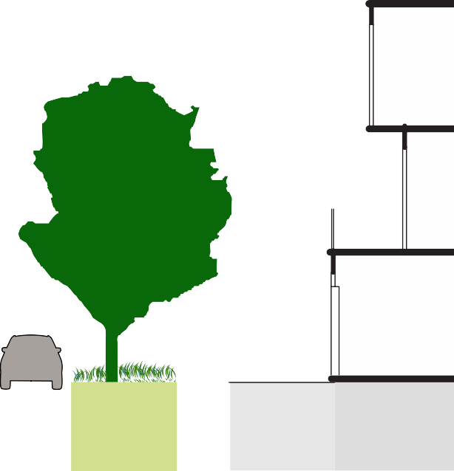Eucalyptus scoparia ‘Wallangarra White Gum’
3.0
1.5
3.0
3.0
1.5
3.0
Building Path
setback from
lot boundary
Planted naturestrip with tree planting Service zone
Carriageway and parking.
Planted naturestrip with tree planting. Service zone.
Path
Building setback from
lot boundary
16m Road Reserve

7.0
- Angophora costata (in swale)
1.0
3.0
6.0
3.0
1.5
Park Existing WSUD treatment Raised bluestone slow bluestone with pedestrian speed street. (Parking on
drain bridge crossings East side only)
Planted naturestrip with tree planting.
Service zone.
3.0
Path Building setback
from
lot boundary
14.5m Road Reserve

Lot boundary
Lot boundary
Park boundary
Lot boundary

PARK STREET
Park Street is a modification of the local street design.

It will be developed as slow speed street with street trees planted within planted nature strips to provide shade for footpaths and visually narrow the carriageways.

The swale and tree planting will edge the park with bridge crossings at all intersection crossings for pedestrians.

Materials:
  - Concrete footpath pavements.
  - Trees within planted nature strips.
  - Planted swale to park edges (east and west). Bridge crossing at intersections.

Tree species:
  - Eucalyptus scoparia ‘Wallangarra White Gum’
  - Corymbia citriodora ‘Scentuous’
  - Corymbia eximia ‘nana’
  - Angophora costata (in swale)
3.0
1.5
3.0
7.0
3.0
Building Path
setback from
lot boundary
Planted naturestrip with tree planting. Service zone.
Carriageway and parking.
WSUD treatment with pedestrian bridge crossings
Park
14.5m Road Reserve
Lot boundary
Lot boundary

LANEWAYS
Laneways will provide access to garages and service collection.

Materials:
- Ashpalt pavements.
- Concrete footpaths.
- Landscaping where possible.
Garage
Side fence
TYPE 1. With garaging on one side only
TYPE 2. With garaging on both sides
8.5m Road Reserve
Garage
1.5
5.5
1.5
Nature strip/ cross over/ utility services
Garage
7m Road Reserve
0.7
5.6
0.7
Lot boundary
Lot boundary

Lot boundary
Park boundary

THIS PAGE HAS BEEN INTENTIONALLY LEFT BLANK

EAST WEST PARKING STREET
The east section of the main East West Street will be developed as a slow speed entry to the precinct, providing both car parking to support adjacent mixed use and a green link into the precinct.

The sunny side includes provision for a public plaza for outdoor dining and the like.

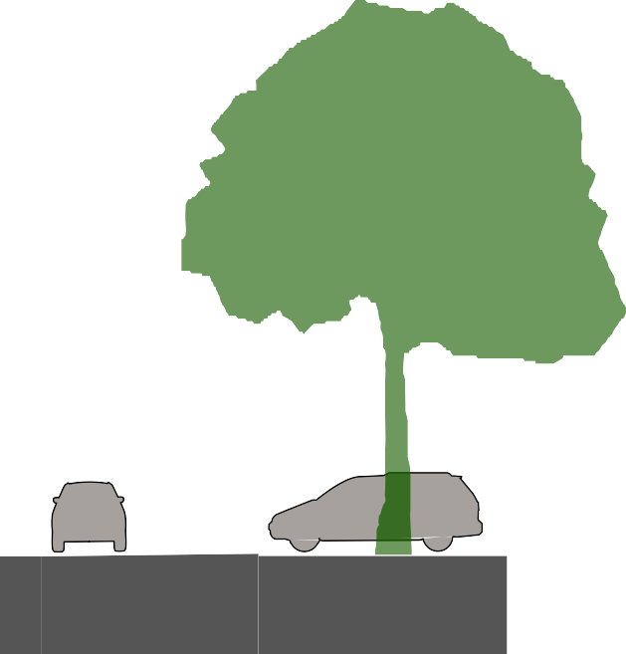Parallel parking is provided on both sides, with tree planting at intervals of 2 parking spaces.
90 degree parking is provided in the centre of the road with tree planting spaced between the road side planting.

Materials:
  - Concrete footpath pavements
  - Trees within parking bays established within wide trenches of structural soil.
  - Grassed nature strips.
Lot boundary
Lot boundary

Tree species:
  - Angophora costata - evergreen tree in garden bed (within central parking aisle)
  - Pyrus betulaefolia x Pyrus calleryana ‘Edgewood’ - deciduous tree on road edges.
  - Ulmus parvifolia ‘Todd’ - semi deciduous tree on road edges.
Buffer Carriageway Buffer Central 90 degree parking
Parking with dec. planting. Possible
structural soil
Shared Nature
path strip/ Service
zone

3.0
3.0

1.0
2.3 1.0
4.2
1.0
Building setback from boundary

5.4

Outdoor dining provided in building setback
rniture Path Public Plaza
/door (Limited outdoor
ening dining)
Buffer Carriageway Buffer Parking Fu
with dec. planting. op Possible structural
soil
2.3
4.0

1.5

.9

1.0
4.2

1.0

26.4m Road Reserve

Plaza on south side of the street

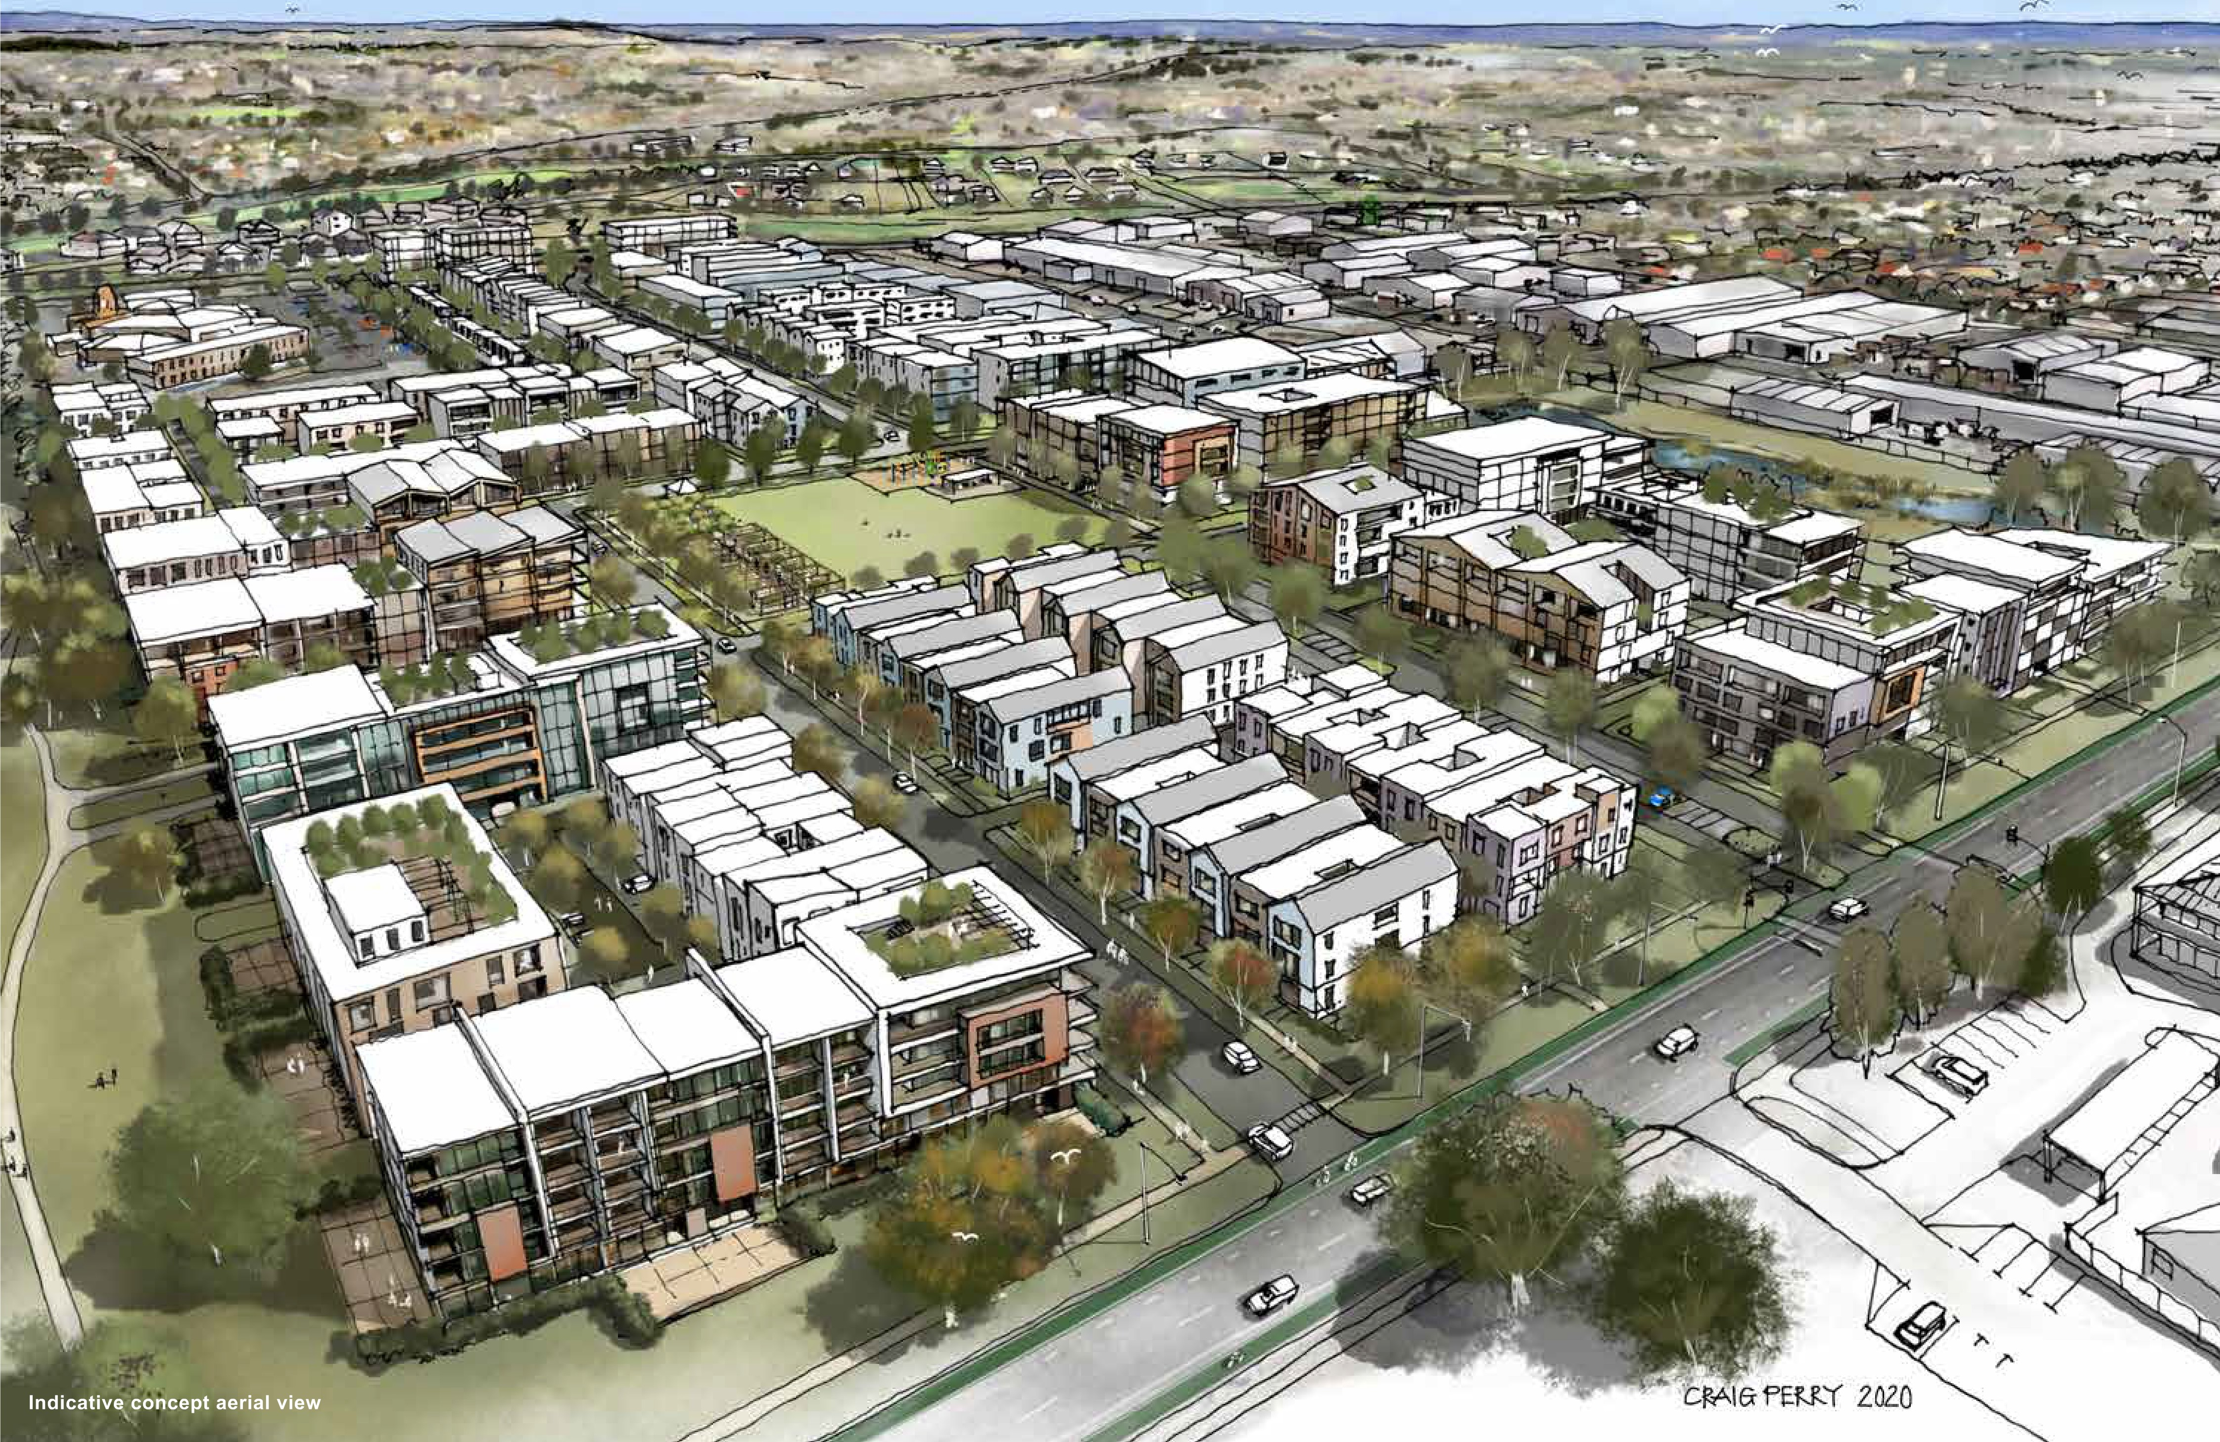
,.,... ..,,..

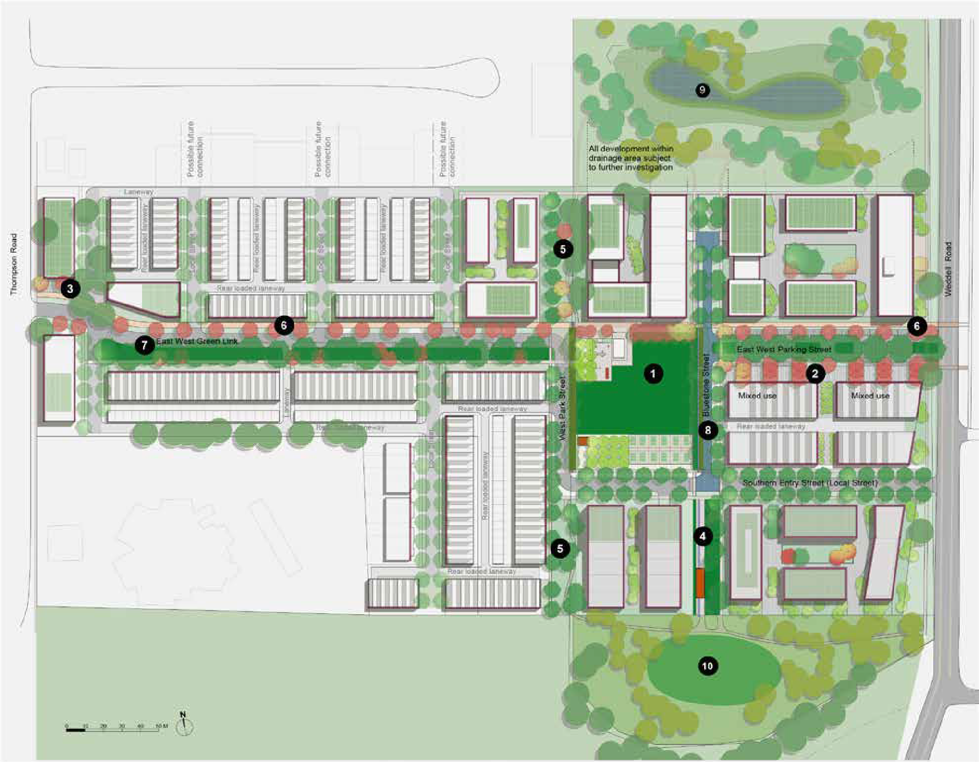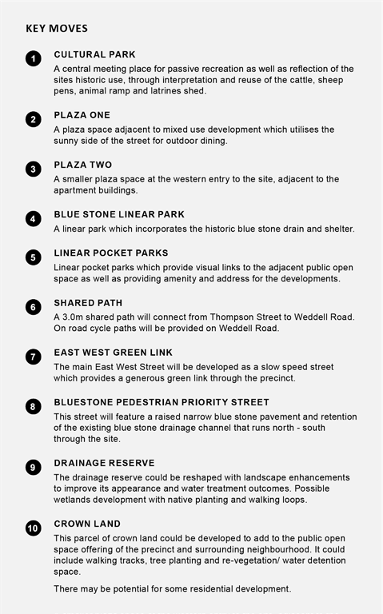

PPPPPPPPPPPPPPPPPPPPPPPPPPPPPPPPPLLLLLLLLLLLLLLLLLLLLLLLLLLLLLLLLL AAAAAAAAAAAAAAAAAAAAAAAAAAAAAAAAANNNNNNNNNNNNNNNNNNNNNNNNNNNNNNNNN 111111111111111111111111111111111
INDICATIVE CONCEPT PLAN
07

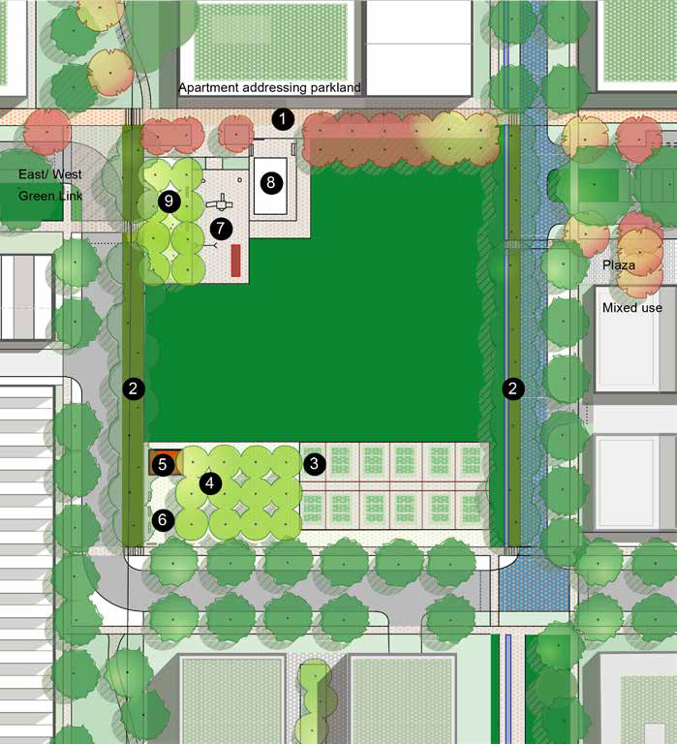
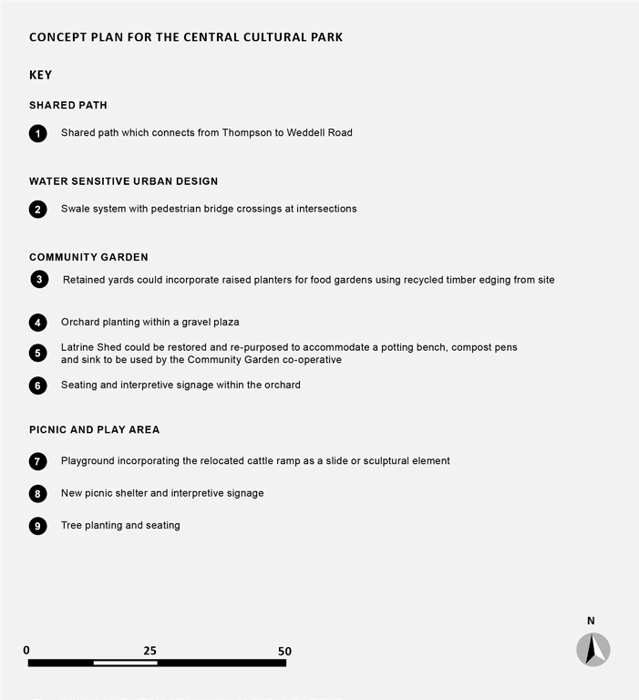

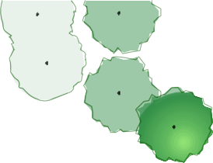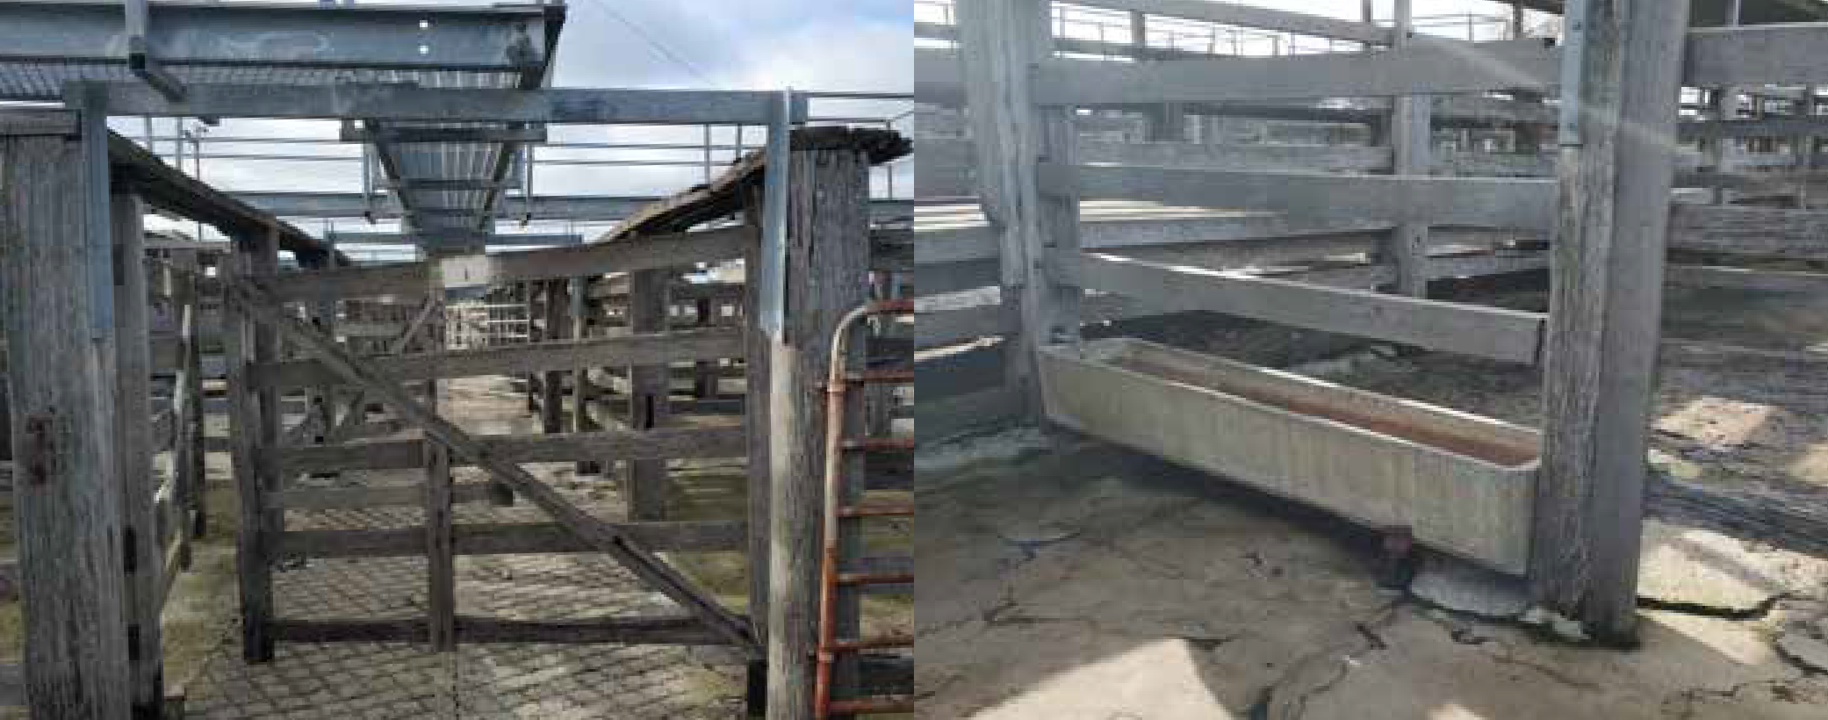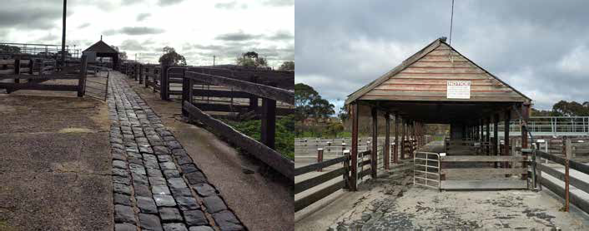
CONCEPT PLAN FOR THE BLUESTONE PARK

KEY
A
Retained bluestone drain with new pedestrian gravel path
B Retained and restored shelter with picnic facilities
N
0
25
50

Opportunity to reuse water troughs for planter boxes.

First rows for cattle yards to be retained as shown on the plan.

Structure to be retained and restored for use as a picnic shelter.

Bluestone channel to be retained and incorporated in park design.

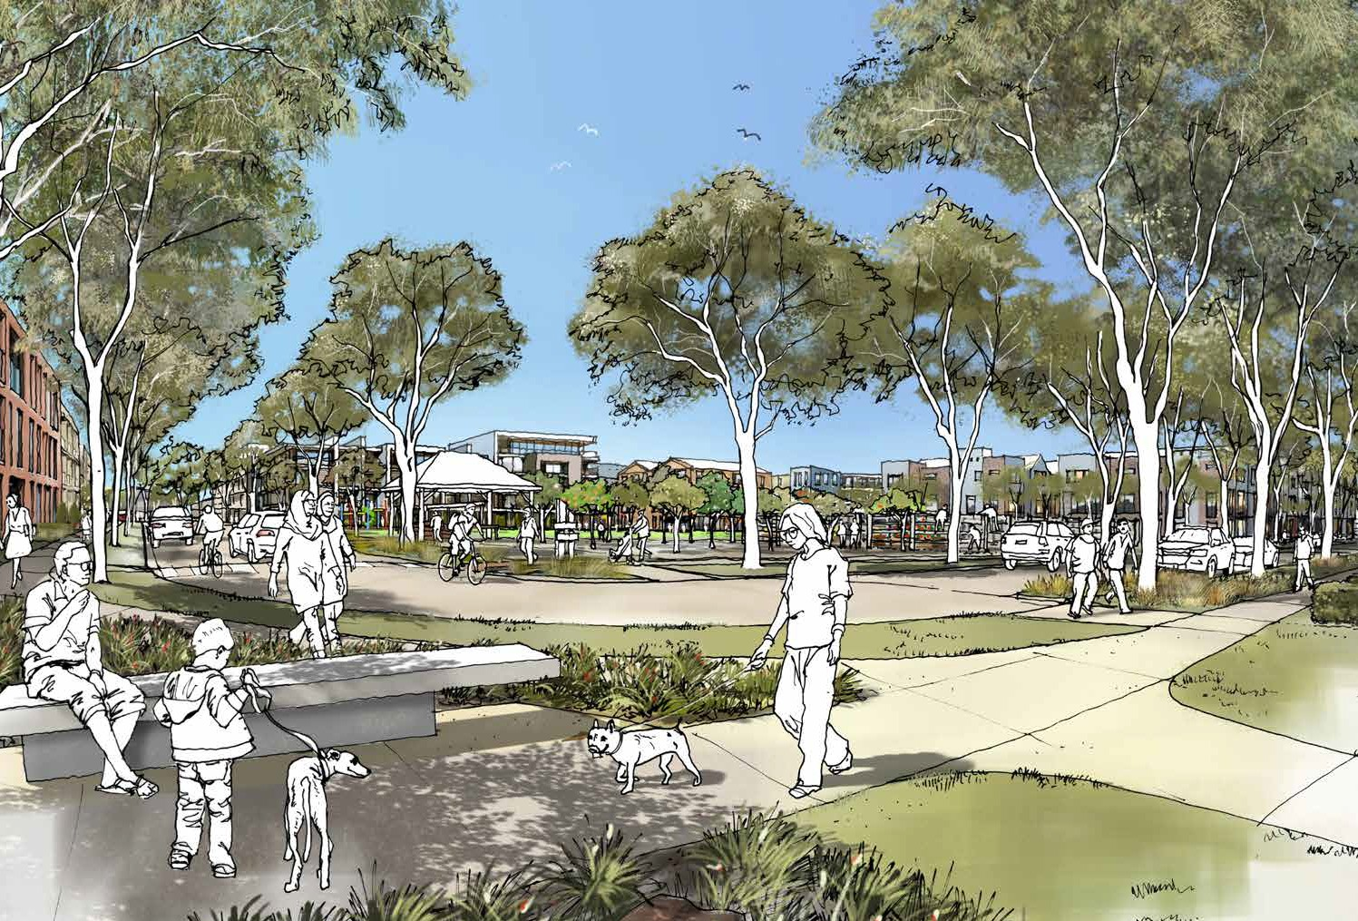

The Precinct Plan provides the basis for a number of implementation actions. They include the following:
  - Changes to the planning scheme have been considered that will assist in achieving the strategic direction and design outcomes sought for the Precinct. These include changes to the zone and overlays. Guidelines are also required.
  - A detailed land disposal strategy is required for the Saleyards site to best meet the objectives of the Precinct Plan.
  - A drainage study is happening concurrently, which may alter the requirements for the drainage basin on the north of the Saleyards site.
  - Preparation of a social housing and affordable housing assessment based on the principles set out in the City’s Social Housing Plan 2018 – 2041.

PLANNING SCHEME PROVISIONS
Following feedback on the draft Precinct Plan suitable planning tools will be identified to deliver the vision for the site.

Any future planning controls will need to:
  - Coordinate future use and development
  - Outline the design principles for the precinct including open space and movement networks
  - Provide direction on the form of development
  - Address environmental constraints
  - Provide certainty to landowners and third parties about the form of development and any permit exemptions

There are several zone options available including the use of the Mixed Use, Residential Growth, General Residential and/or Comprehensive Development zones. The final zone selection will need to balance an appropriate level of residential amenity while providing for a mix of complementary
uses that will help support a vibrant neighbourhood with employment, retail, leisure and entertainment opportunities.

To facilitate a coordinated approach to development across the precinct the use of a Development Plan or Incorporated Plan overlay would be appropriate. This will ensure an integrated and coordinated
approach to developing the site in accordance with the overall vision. A Design and Development Overlay would be appropriate to achieve specific built form outcomes.
The Environmental Audit Overlay could be applied to manage potentially contaminated land if these issues are not resolved prior to the land being developed.

The Special Building Overlay could be applied if the drainage study concludes the future development of the site will need to have regard to overland flows and these matters are not resolved prior to the land being developed.

Contributions can be sought via S173 agreements with the parties for infrastructure such as footpath and cycling upgrades, pedestrian safety upgrades, open space and community infrastructure.

Once a final suite of planning controls is developed a planning scheme amendment will be required to introduce them into the planning scheme. This will be carried out in accordance with the Planning
and Environment Act and includes a public notice period and another opportunity for interested parties to provide feedback and make submissions. Ultimately, the final Precinct Plan and associated planning controls will need to be adopted by Council and approved by the Minister for Planning.

COMMUNITY INVOLVEMENT
The Precinct Plan project generated community interest and involvement. Direct community participation in the implementation should be encouraged. Tasks for community groups could include:
- Refinement of the concept plan, particularly for the public open space and public realm works.
- Local initiatives for grant applications (i.e.. community gardens).
- In addition, a community group could actively share skills and information with other community based sustainable communities to develop more broadly based responses to sustainable living.

