Positive Ageing Strategy Conversation Toolkit

This toolkit helps you to have a conversation with a friend, sibling, parent, neighbour, or colleague who is aged 55 and over to discuss actions to make
our City of Greater Geelong community an age friendly place.

We invite you to host your conversation between Tuesday 15th February – Friday 11th March via an online or paper tool. All the information you need
is detailed below.

Please share this resource with others and encourage them
to host conversations.

Background Information

Following
on from the development
of the Positive Ageing Strategy 2021-2047,
the City of Greater Geelong is embarking on a co-design process to help build the three-year action plan and measurement framework that takes into account current work, highlights gaps, suggests new programs and identifies partners who can help bring the actions to life. The co-design process invites the community to be active participants in the design process to ensure the action plan is truly meaningful to the residents of Greater Geelong.
This Conversation Toolkit is an approach to encourage and support older people from different backgrounds, experiences, and perspectives to share their views and help shape Greater Geelong to be an age friendly place.
This toolkit helps everyone to move from participant to active partner
by having a conversation with
the people they are close to over
the age of 55. The views shared
will build on the Positive Ageing Strategy and inform actions
and work to meet local needs
and aspirations while building
on existing community assets.
These are conversations that we all need to be having because we want the places we live in to be age friendly communities where people as they age:
- are valued and thrive
- are respected, supported,
and participate in strong,
local communities
- have equitable access to social, economic, and civic activities; and
- are from all ages, backgrounds and abilities and are welcomed and enjoy interacting with
each other.

We are interested to know what actions we can take to make our community an age friendly place to live. You can take part by having this conversation with someone in your social circle or respond to the questions individually. The following pages provide you the information you need.
You can also scan this code to be taken to our online capture tool.

Discussion Topics
Please choose one or all of these topics to kick off your conversation with someone aged 55 and over:
- What makes you feel safe? Imagine a community where, as you age, you will feel completely safe and welcome. What types of things would you like to do? What actions need to take place for you to be able to experience this (either right now, or as you age)?
Examples might include activities, programs, use of facilities, improvements to infrastructure, signage, technology, etc.
- What actions would support and encourage you to participate more in your community through work, volunteering, leisure, socialising or study?
- What are the spaces, places, and services you love the most? What actions should be taken to ensure you can continue to access these as you age?
- What do you think will impact you as you age? What support do you think you may need as you age?

What do you need to get started?
Allow at least 20-30 minutes  for your conversation | Interview partner(s) | A space where  you both feel comfortable  to have the conversation.  It could be in a home, café, park, during a walk, over the fence,  in the yard, over the phone, or via Zoom. | Discussion Questions | A recording tool:  - Online link  - Video/voice recording  - Paper form (page 8)

Recording the conversation
Conversations which are documented will help inform the actions we need
to take to make our community an age friendly one. Here are some ways
you can record your conversation.
Online:
Visit https://yoursay.geelongaustralia.com.au/PAS or scan
the QR code shown on page 2, which prompts you to record
the interview directly into the online capture tool.
Video or voice recording:
Use your smart phone or the recording function on a Zoom conversation (don’t forget to ask for your interview partner’s permission). Please email randi_wagner@capire.com.au for information and instructions on where to upload your recording.

On paper
You can download and print a PDF version of this toolkit. Drop off completed PDF at one of the three customer service centres or you may scan or photograph hard copies and email them to Kylie Riley:
Kylie Riley | KRiley@geelongcity.vic.gov.au
Please contact Kylie for another collection option.

If you require further support, please contact us by emailing randi_wagner@capire.com.au

Tips for hosting a great conversation
Below are some tips and tricks you may want to use to ensure you have a rich and enjoyable conversation.
Set up the context | Invite someone for a conversation and let them know the conversation topics in advance, introduce yourself and your role as a conversation host and why you are doing it (we have included a script you can use on page 8), explain how you will be recording the conversation, and that it will be used to help inform actions for the City of Greater Geelong’s Positive Ageing Strategy.
Be curious and ask follow-up questions | For example, “can you tell me more about X”, “I am interested in something you said earlier about X”, “why?”, “how does that make you feel?”, “if you could imagine the perfect scenario what would that look like?”, “if you could remove (insert barrier) what would you do?”.
Encourage vivid details | For example, “What does it feel like when?”, “what would it look like if…?”, “what does that experience feel/sound/taste like?”.
Find the right space | Find a space where you both feel comfortable and won’t be interrupted.
Remember  to listen | Let them talk, don’t feel that you have to fill any silences  or finish their sentences, and record the conversation in their own words not yours.
Relax and be yourself | Enjoy the opportunity to learn more about the person  by just being yourself, staying curious and allowing  the conversation to flow at their pace.
Remember COVID safety | Ensure any in-person conversations take into account the appropriate safety measures. You can find these online here. You can also choose to host an online discussion  and record it via Zoom (with the permission of your interview partner).

Tip for hosting a group conversation
Do you want to host a group conversation with a social club, neighbourhood house, community group or some of your close friends? Here are some tips to help it run smoothly:
Find a facilitator | Assign someone to facilitate or host the conversation.  This will help to keep the conversation on track and allow everyone to participate.
Assign a scribe | You may ask someone to take notes and capture  the key points of the conversation into the online tool. Alternatively, you can print off paper copies of the toolkit and encourage members to summarise their own points after or during the conversation.
Give everyone a voice | Ensure everyone has a chance to speak, not just the loudest in the room. Share this intention at the start of  the conversation and remind those who may need it during the conversation. Sometimes this means respectfully asking for specific people to contribute to the conversation or reminding people to allow others to have their say.
Active listening | Essential to an enjoyable conversation is to actively listen. It’s important to really concentrate on what people are saying and how they are saying it. Reaffirm what you have heard by summarising or paraphrasing what you heard. This will help you record what was said.
Remember Covid safety | Ensure any in-person group takes into account the appropriate safety measures. You can find these online here. You can also choose to host an online discussion  and record it via Zoom (with the permission of the group).

Next Steps

The survey and conversations are part of our discovery phase which helps us uncover what people think about what is working, what isn’t, and what we can do about it.
After 11th March we’ll be summarising the results from these conversations into a findings report. This report
will be sent to all participants who provided us with their contact details and published online.
This information will also be used to help inform our design phase, which is scheduled to take place in March 2022. A 2.5-hour mini design forum will be held with experts, people
with lived experience and facilitators to explore potential solutions
to the identified needs and gaps.
We are encouraging any members of the community who are 55 years and older or who work with that group to express their interest in joining these sessions by emailing:
Kylie Riley
KRiley@geelongcity.vic.gov.au

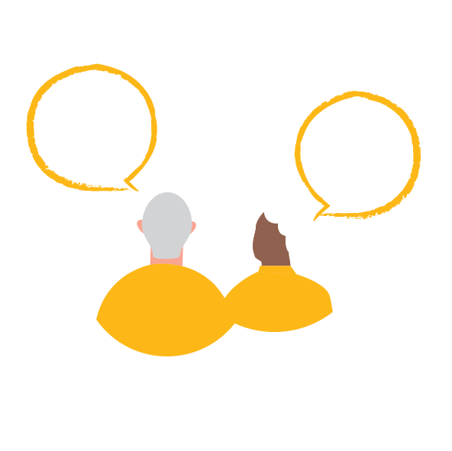

Conversation Toolkit
Written Capture Tool
You can capture your conversations by writing your answers below and then sending it to council via post or email.
Our online survey and capture tool can be found by scanning the QR code on page 2 or via the link here: https://yoursay.geelongaustralia.com.au/PAS

INTRODUCTION

“My name is ______________. I am supporting the engagement being undertaken to inform the preparation of the City of Greater Geelong’s Positive Ageing Strategy Action Plan.

For the next month, The City of Greater Geelong is encouraging people to have a conversation with a friend, sibling, parent, neighbour, colleague or groups of people who are aged 55 years and over to discuss actions that can help make our city community an age friendly place. The views you share with me will be used to help build on the Positive Ageing Strategy and inform actions and work to meet local needs and aspirations while building on existing community assets. If you are interested in learning more about the Positive Ageing Strategy you can download it online.

I feel that these are conversations that we all need to be having because we want the places we live in to be age friendly communities where people as they age:
- are valued and thrive
- are respected, supported, and participate in strong, local communities
- have equitable access to social, economic, and civic activities and
- are from all ages, backgrounds and abilities and are welcomed and enjoy interacting with each other.
Once we’ve had this conversation, I also encourage you to have the same conversation with a friend or relative who is also aged 55 and over. The more voices we can bring into this conversation the better our city will be.
We do not need to record any personal information or data; I can leave out any thing you do not wish me to record.”
Be sure to tell the person you are meeting with how you will be recording the conversations and seek their permission to do so. You can use the blank spaces below to record your discussions to the key discussion questions.
- What makes you feel safe? Imagine a community where, as you age,
you will feel completely safe and welcome.
What types of things would you like to do?
What actions need to take place for you to be able to experience this
(either right now, or as you age)?
Examples might include activities, programs, use of facilities, improvements to infrastructure, signage, technology, etc.
Write your answer here.

- What actions would support and encourage you to participate more in your community through work, volunteering, leisure, socialising or study?
Write your answer here.

- What are the spaces, places, and services you love the most?
What actions should be taken to ensure you can continue to access these as you age?
Write your answer here.

- What do you think will impact you as you age?
What support do you think you may need as you age?
Write your answer here.

Demographics of the group you are interviewing
Please collect this demographic information for the group you are interviewing here.
What type of group are you interviewing? (e.g. family, social, sporting, religious group) ______________________________________________
How many participants? ___________________________
What is the age range of the group?

  - Under 55 years of age
  - 55 to 59 years of age
  - 60 to 64 years of age
  - 65 to 69 years of age
  - 70 to 74 years of age
  - 75 to 79 years of age
  - 80 to 84 years of age
  - 85 to 89 years of age
  - 90 to 94 years of age
  - 95 years of age or older
  - Prefer not to say

Demographics of the person hosting the conversation
What is your relationship to the group you are interviewing?
- They are my client or patient
- They are my relative
- They are my friend
- They are my neighbour
- They are my colleague
- They are a part of a social/community group I attend/run

Please provide your contact details so that we can send you a copy of the conversations findings report, and in case we have any questions about the conversation(s) you have captured.
Please provide your email address ________________________________________
Drop off completed form at one of the three customer service centres or you may scan or photograph hard copies and email them to Kylie Riley:
Kylie Riley | KRiley@geelongcity.vic.gov.au
Please contact Kylie for another collection option

