Positive Ageing Strategy
Community Conversations:
15 February to 11 March 2022

Information for community members

Following on from the development of the Positive Ageing Strategy 2021-47, the City is embarking on a co-design process to help build the first three-year action plan and measurement framework.

The co-design process invites the community to be active participants to ensure the action plan is truly meaningful to the residents of Greater Geelong.

From Tuesday 15 February to Friday 11 March 2022, community members across Greater Geelong are invited to host conversations with people they know who are aged 55 or over – friends, family, colleagues or social groups. Capire Consulting has created a Conversation Toolkit to provide guidance, including key questions and conversation tips. The conversation is recorded via an online survey tool, video, or voice recording, or on paper and submitted.

If choosing to have face to face conversations, the community is reminded to be COVID safe and access information on our Coronavirus Support webpage.

The ideas collected will be taken into the next ‘design’ phase to create the action plan.

Older people from different backgrounds, experiences and perspectives are encouraged to share their views and help shape Greater Geelong to be a more age friendly place.

The information provided will be treated in accordance with the City’s privacy responsibilities.

Should you have any queries about this project, please contact Kylie Riley, Senior Health Planner at kriley@geelongcity.vic.gov.au or by phoning the City’s Customer Service team on 03 5272 5272.

Yours sincerely,
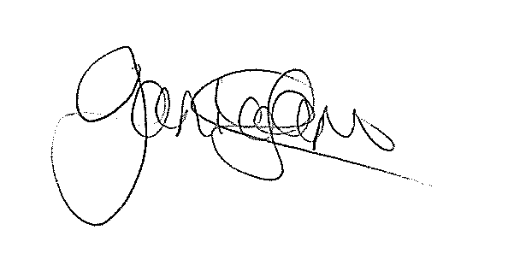

Janice Lane
Manager Healthy Communities
City of Greater Geelong

