Hamlyn Park Reserve
master plan

community engagement summary
The City of Greater Geelong recently invited the community and stakeholders to provide input to help set the direction of a new master plan for Hamlyn Park Reserve.
The current plan for the Reserve was developed in 2010 and changes in community recreation behaviours and expectations since then have highlighted a need for its review. The updated Master Plan will include recommendations that consider the cultural and environmental values of the Reserve, landscape and amenity, sporting infrastructure requirements, needs of tenant clubs and groups and connections with the surrounding schools and neighbourhood.
This first round of engagement with the community was undertaken to understand what they like, and what they would like to see improved, through the Master Plan. Engagement took place from 1 November to 3 December and involved online and face to face engagement opportunities.
A summary of the consultation process and feedback received is provided below.
Suggestions (comments) from the public left online via social map
45
138
Number of total people to leave feedback
32 DAYS
of engagement
NEWS

1
print adverts in local newspapers

134 contributions via online survey & drop in sessions

SOCIAL MEDIA
385
Reach/Impressions
30
Actions (Clicks, reactions,
shares, comments etc.)

Advertising pamphlets delivered
6321

KEY THEMES
The engagement feedback from all collection methods has been analysed to identify the key themes the community have identified.
Respondents wanted to see increased activation and improving facilities, whilst protecting and enhancing the landscape character of the reserve.
The infographic below shows the key themes raised during the community engagement process.
# 1 | # 2 | # 3 | # 4 | # 5
Protect mature trees and enhance natural areas | Renew and upgrade sports facilities | Provide places for children and young people to play | Provide Park amenity including pathways, trees, seating, bins, drinking stations | Deliver a safe place for people to recreate
“Retain the large, beautiful gum trees. The native birds nest in them”  “We love the trees and green space” | “Better sporting facilities to accommodate multiple teams & the increase in female participation”  “Female friendly change rooms”  “Modernise ballroom”  “Fix the BMX track and make into pump track” | “Replace the playground with a large contemporary play space and children’s education environment that celebrates the traditional owners of the area and encourages families and visitors to spend time enjoying all that the park has to offer.” | “Plant more native trees and upgrade the condition and safety of the walking tracks”  “Add picnic areas, such as rotunda, picnic benches, BBQ facilities” | “Reclaim areas of the existing parking to facilitate improved pedestrian movement and coherence between the existing elements of the park.”  “Lighting along walkways”  “Modernise, landscape, family friendly safe spaces.”

A detailed breakdown of the engagement responses is provided in the following pages.

SURVEY RESPONSE
The City of Greater Geelong received 123 online community surveys via Council’s Have Your Say engagement page.
Survey respondents were local residents (68%) and members of a community organisation or sporting club (25%). The data shows that those people that responded were involved in several groups along with being local residents.
Most survey respondents were female (67%) and between the ages of 25 and 49 years (63%). Over half (57%) of survey respondents have children across all children age cohorts (0 to 4 years – 39; 5 to 11 years – 40; 12 to 17 years – 26).
The graphics below provide a snapshot of the responses to the survey.
GENDER OF RESPONDENTS |  |  | VISIT
 | 33% MALE |  | 85% | of people surveyed visit the reserve at least once a week
 | 67% FEMALE |  | 81% | of people surveyed walk to the Reserve

ACTIVITIES
65% go walking at the reserve | 50% use the playground | 47% participate in informal sport/ activities | 40% go to socialise

PERFORMANCE
44%  Of survey respondents rated the overall facilities at the reserve as either good or very good | 34%  Of survey respondents rated the overall facilities at the reserve to be satisfactory | 20%  Of survey respondents rated the overall facilities at the reserve as poor | 2%  of respondents were very unsatisfied with the landscaping of the reserve

Usage
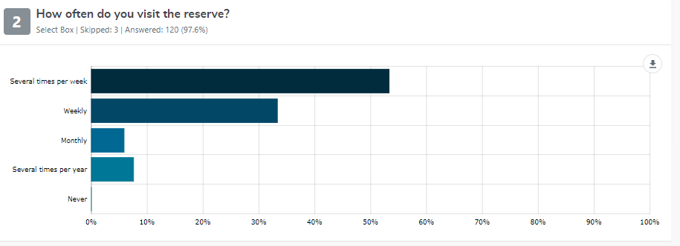
Over 85% of survey respondents visited the reserve weekly or several times per week.

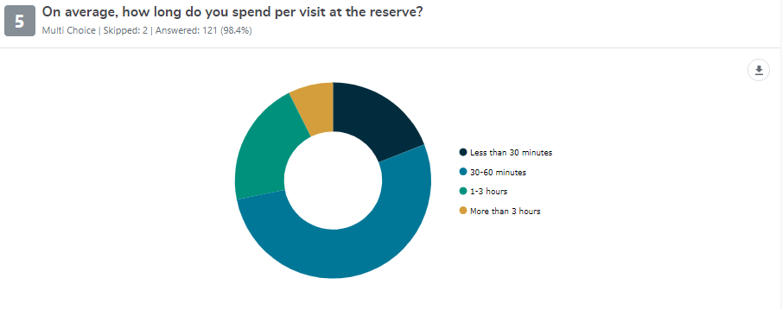
Most survey respondents spend 30 to 60 minutes (52%) at the reserve. The findings shows that importance of the reserve in supporting people’s health and meeting recommended physical activity guidelines.

The reserve is used for a wide range of activities. The most popular activities of survey respondents were walking (65%), using playground equipment (50%) and informal sport/activities (47%). This finding shows the important role the reserve plays for the community in providing a space for sport and for community for exercise, socialising and playing.

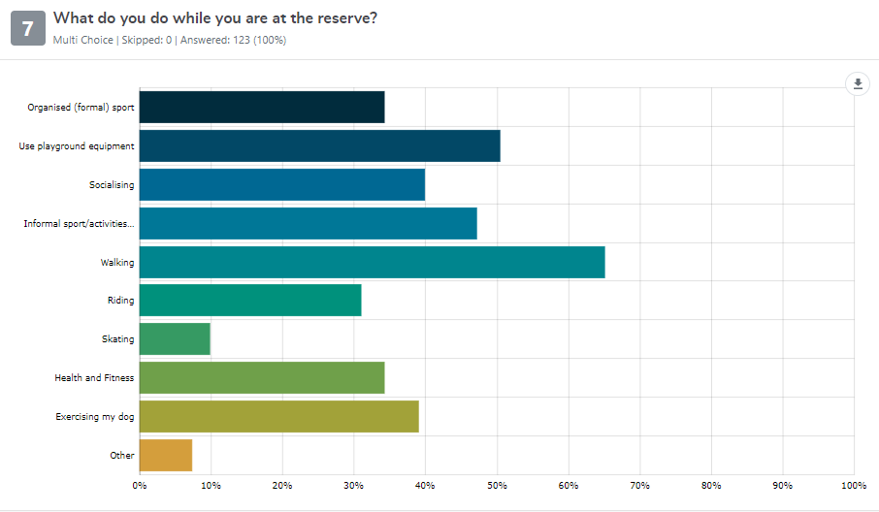

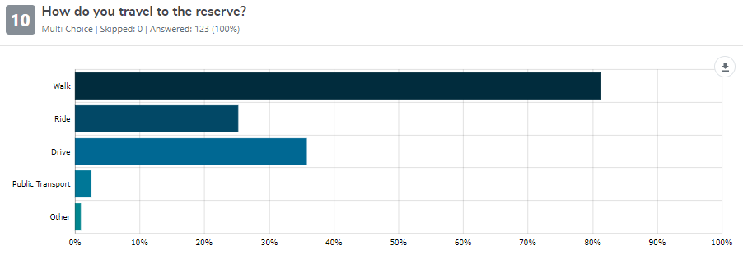
Most survey respondents walk (81%) to the reserve.

Facility Satisfaction
Survey respondents rated the overall facilities at the reserve as good (44%) or neutral (34%) whilst 22% commented that they were poor .
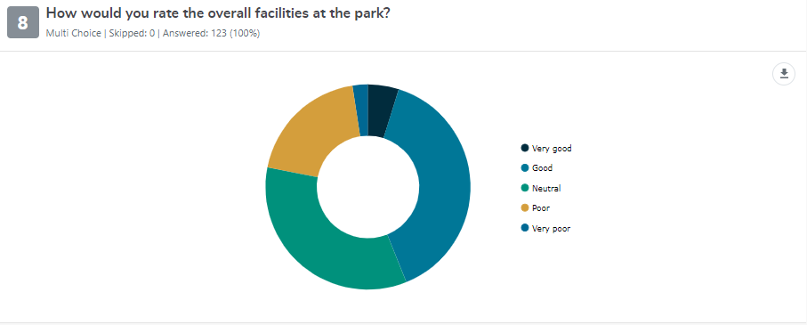

Survey respondents liked the following features of the reserve:
- Access to passive/ unstructured recreation options (playground, dog walking, BMX) (41%)
- Assess to a natural area with mature trees (29%)
- The existing sport facilities (25%)
- The location (20%).

Sample quotes:
“The beautiful trees, scale of open space and range of active areas.”
“Close proximity to home. Great community feels. Open and accessible”
“The ovals are well maintained. There are plenty of family-friendly sporting facilities. It's a big space with plenty of room for many to use at once.”
“The reserve is in a prime location where there are many young families that belong to the local schools.”
“The reserve needs updated facilities”
“It would be great to see improved playground and surrounding area, improved bike track, area around the playground better maintained, grass mowed regularly etc”

“I use it daily and value the green space most highly. More green space would be desirable”.

The following chart shows how survey respondents rate the facilities in terms of how well they meet current needs.

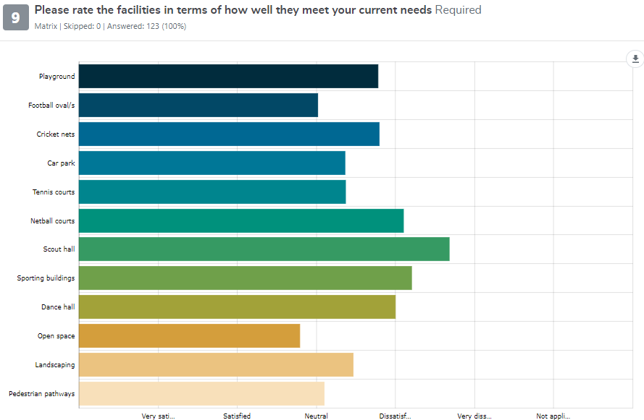

The following facilities were satisfactory (response rate of greater than one third)
- Football ovals (54%)
- Open space (48%)
- Tennis courts (48%)
- Car park (37%)
- Pedestrian pathways (36%)
- Cricket nets (33%).

The following facilities were unsatisfactory (response rate of greater than one third)
- Landscaping (54%)
- Pedestrian pathways (36%)
- Playground (35%)

Key Issues and Ideas
Survey respondents identified the following key issues facing the reserve and ideas for improving the reserve.
ISSUE |  | SATISFACTION RATING |  | IMPROVEMENT IDEA
Facilities are in poor condition |  | 54% of survey respondents were dissatisfied with the condition of the reserve. | Respondents would like to see a renewal of facilities, so they are modern, fit for purpose and encourage more people to use the reserve.  Improving the existing facilities within the reserve (25%) and improving the sporting facilities and club infrastructure (16%) were ideas raised by survey respondents.
The reserve is over capacity |  | 31% of survey respondents believed the reserve was over capacity or that the facilities were not keeping up with the current demand. | Respondents valued the established mature trees and access to natural areas.  Survey respondents suggest protecting the existing trees and enhancing the natural areas and landscape character of the reserve (19%)
Reserve is under-utilised |  | 29% of survey respondents believed the reserve was under-utilised. | Respondents wanted to see increased activation of the site.  Survey respondents identified developing a new playground (32%) and providing more activities, particularly a skate park (22%) as ideas for encouraging a wider range of ages and users at the reserve.
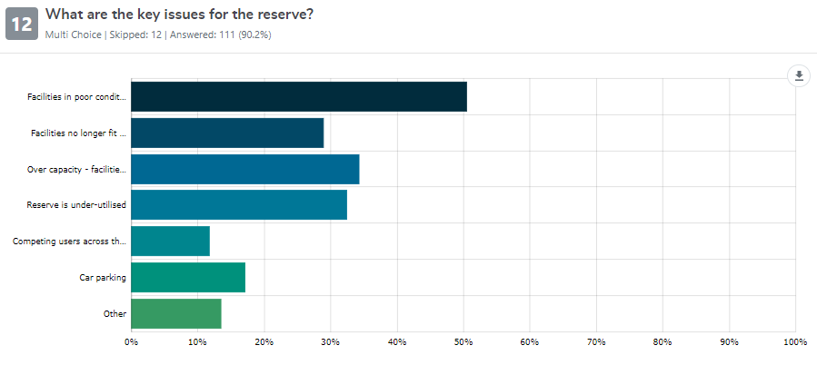

Map Your Ideas
The City of Greater Geelong hosted an on-line map your ideas forum. This forum encouraged respondents to identify items they were satisfied with or dissatisfied with and to submit their ideas. There were 45 contributions made to the map.
The map below summarises the key issues and ideas raised from the map your ideas forum:
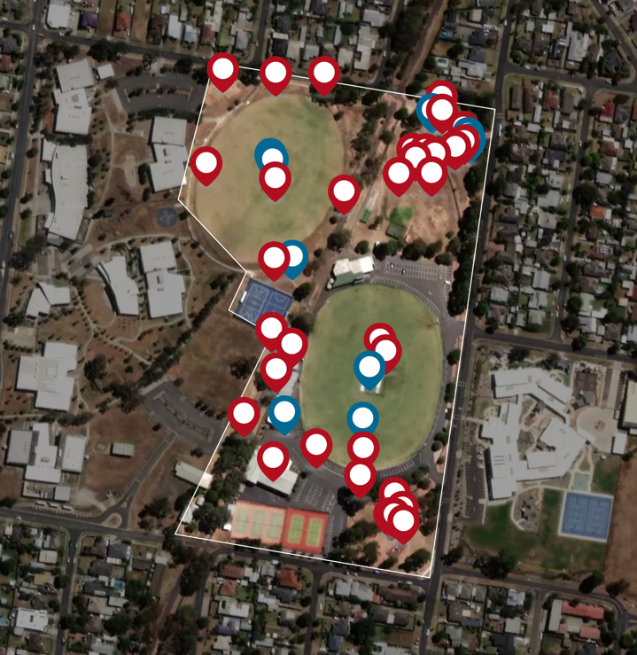
Issues:
Cars using walking / bike track and park north of reserve on sports days
Limited area for people to gather and enjoy outdoors
Park is dedicated mostly to sport
Bike jump track in need of maintenance. Good facility for local kids
Scouts hall and car park area is a wasted space
Ideas:
Extend fence north of reserve to encourage drivers to use road
Vacant area behind cricket nets could be used as meeting space for community, improved lawn with kick about space, BBQ, seating area, trees
Upgrade bike jumps and expand i.e. scooter loop track
Issues:
Too bare
Only playground in residential area
Seek a pleasant place to play and socialise
Like:
Beautiful established trees that attract wild birds
Ideas:
New and larger playground with monkey bars and equipment for up to 10 years
Covered BBQ
Improved grass area (irrigated)
Additional trees
Amenities
Seek perimeter footpath
Issues:
There is a lot of car parking. It is hot, unsafe and ugly
No safe spots to watch sport
Ideas:
Rationalise car parking
Remove some car park and repurpose as seating, benches or small grandstand
Upgrade asphalt car parking

Issues:
Walking / bike track is uneven and unsafe (at night)
Graffiti back of change rooms
Motorbikes using walking / bike track
Like:
Ballroom is fabulous and one of a kind in Geelong
Outdoor gym is well used
Ideas:
Allow public to book large scale events
Council management of ballroom
Upgrade walking / bike track surface and install lights
Security lighting
Issues:
There needs to be a balance between sport and community spaces
Ovals only support AFL and cricket
Rubbish problem
Wasted space at top end of school oval
Like:
Ovals are in great condition and serve local sport, school, exercise and dog walking
Ideas:
Pavilion to support netball courts and back oval with change rooms, toilets and shelter
Add soccer goals to optimise the use of the school oval
BBQ and picnic space at top end of school oval with avenue of trees

Next Steps
- The City of Greater Geelong has reviewed the engagement results. This input will be considered during the development of a draft master plan over the coming months.
- The draft master plan will be presented to Council for consideration to be released for further community engagement.

