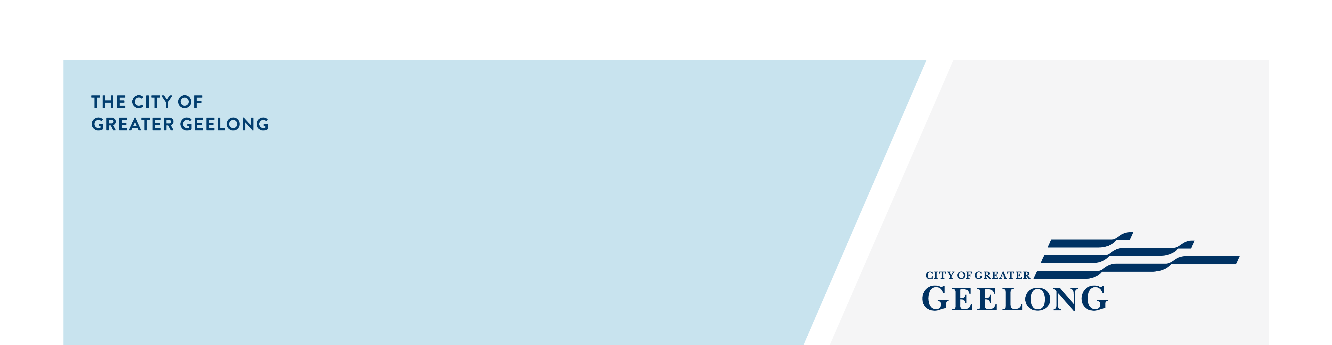 indented head woodland

nature reserve

|  |
| --- |
| community engagement summary |

Feedback on the Indented Head Woodland Nature Reserve Concept Plan has closed. The first stage of the community engagement was to seek feedback on the proposed Concept Plan. This was the first opportunity for public to comment on the key objectives and priority actions for the new reserve and identify if there are any other issues or opportunities that need to be considered in the development of the draft masterplan. The master plan process has enormous potential to generate significant environmental and social benefits.

**50 DAYS**   
of engagement (Stage 1)

NEWS

**4**

Media articles in local newspapers



**44**

Number of people to leave feedback

Visits to the Have Your Say web page.

**585**





People following the project

**35**

**3**

Residential letters delivered

**250**



Signs in the Reserve

|  |
| --- |
| what you tOLD US |

**“*to preserve one of the last remaining tenants of Plains Grassy Woodlands.”***

***“It is clear that the environmental values will be protected and enhanced, and I support that.”***

**“*As a resident who observed and photographed this reserve for nearly 20 years, I’m happy that a Master Plan and a very good Concept Plan is now seeking community consultation on the long term conservation and preservation of this Reserve.”***

***“Still frustrated at the council treatment of the Indented Head community and the way they gave developers everything they wanted.”***

|  |
| --- |
| Next Steps for this reserve |

The next stage of the Indented Head Woodland Nature Reserve project is to collate the feedback from the community consultation process and consider these in the development of the Draft Masterplan for the reserve.

Once the Draft Masterplan has been developed and approved by Council, we will be going back out for further community consultation in the event to develop the Indented Head Woodland Nature Reserve Masterplan.

This will guide the City on what the community would like to see on offer in this nature reserve for future generations.