round 2 community engagement summary report

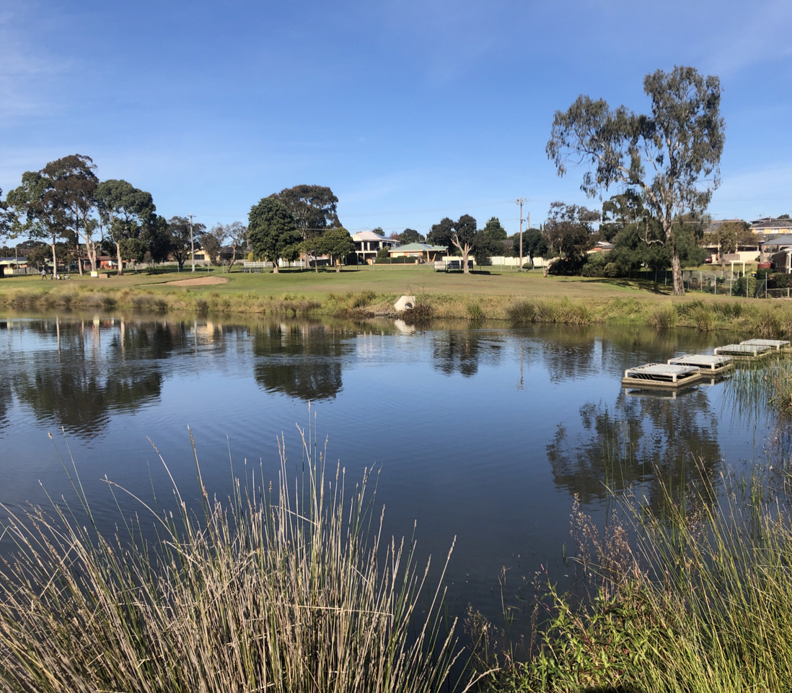
community engagement summary
Introduction
The City of Greater Geelong is currently undertaking stormwater studies across our region. These studies will help us to better understand flood risk and the opportunities for stormwater and integrated water management. Information on current and future stormwater studies can be found here https://yoursay.geelongaustralia.com.au/stormwater.
A key part of each of the stormwater studies is community engagement. In late 2021, we completed the second round of community feedback for the Clifton Springs and Drysdale Flood Study. The study area includes Clifton Springs, Drysdale, Curlewis and Bellarine.
During Stage 1 we asked the community to identify flood-prone areas to help confirm our flood modelling. Stage 2 engagement aimed to gain specific feedback on our goals and proposed options. The engagement also aimed to highlight the importance of catchment-wide mitigation prioritisation.
The feedback received during both stages of engagement provided valuable local insights for the study. The study will inform future stormwater management, including land use planning, community flood preparedness and emergency response.

HOW WE ENGAGED
The community engagement was promoted via local media, our Have Your Say page, social media and letters to property owners. During the 27 days of community engagement, we received:

70
Online forms submitted about the 1% AEP map
36
Phone calls, emails, and letters from the community
Comments on the interactive map outlining mitigation and Integrated Water Management options.
13
55
People following the project

More than 2,200 letters were mailed to selected properties, based on their proximity to flood prone areas from the draft study result.
Due to COVID-19 restrictions, in-person engagement was not possible, and we delivered the engagement online. We used a range of tools to allow the community to have their say. Residents could also request to provide feedback in writing or over the phone.
The main tools and techniques are explained below.

engagement tools and techniques
Have Your Say website | Designed to share information on the study and encourage community feedback.
rating tool | Community members were invited to rate the importance of the goals of the Stormwater Services Strategy 2020-30.
interactive 1% AEP Map & form | The 1% Annual Exceedance Probability (AEP) map highlights where water is likely to flow during a large storm event. The community were invited to locate their property or areas of interest, to see the potential impact. Property owners could also ask questions about the property and the map via a short form.
Interactive options Map | Residents, businesses, and property owners could locate their property or areas of interest and provide feedback on the proposed mitigation options, or identify any potential gaps.
Letter to property owners | Letters were sent to property owners that would likely be impacted in a 1% AEP event to inform them about the project and engagement period.
Written submissions | Submissions could be provided by email or mail and were open at any time during the public engagement period.
PHONE CALLS | Open at any time during the public engagement period.

WHAT WE HEARD

The following outlines the key issues and opportunities we heard during the engagement period.

OVERARCHING THEMES
Six overarching themes came through in the community responses, see figure X.

A high number of responses reported a drainage issue and requested stormwater upgrades and maintenance. Other responses related to the flood modelling results and flood modelling methodologies. This included queries regarding the 1% AEP flood extent and requests for removal of properties from flood overlays.
There were three responses relating to the proposed mitigation options. These included:
- The aesthetic value and pump noise related to the stormwater harvesting option at the Clifton Springs Golf Course
- The removal of an existing flood protection levee near the Clifton Springs Golf Course and suggestions for harvesting locations, with reference to the previously published plans on the Clifton Springs Golf Club website
- A request to consider recycled water for field watering

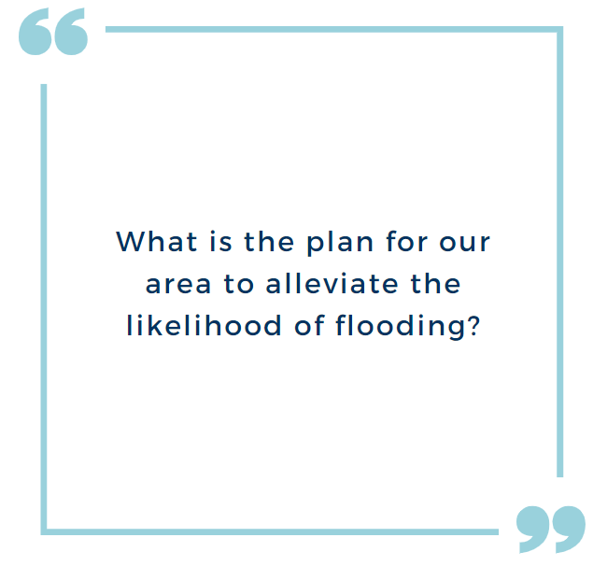
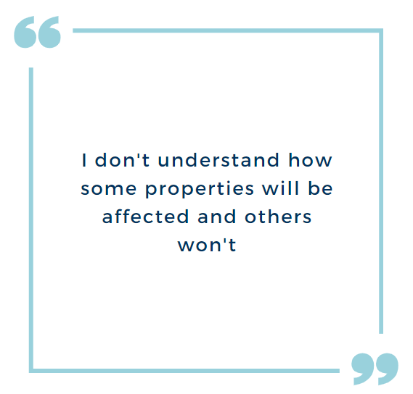

The Stormwater Services Strategy 2020-30 goals were ranked in the following order of importance by respondents:

This ranking demonstrates a preference for installation of stormwater systems that can adapt to needs and reduce the impacts of dangerous stormwater flooding, with slightly less regard for the financial sustainability and community partnerships required for successful implementation.

KEY FINDINGS
OVERALL KEY FINDINGS
The objective of this engagement was to gain feedback on our proposed goals and options, while promoting awareness of the importance of catchment-wide mitigation prioritisation. However, many of the responses related to specific individual properties.
Of the 101 theme-specific comments, only three responses provided an indication of the perceived opportunities and constraints relating to the Integrated Water Management (IWM) options. An additional two responses revealed a joint partnership mentality between the local community and the City that could be leveraged.
The key findings of the Stage 2 engagement included:
- Community confusion regarding “wet puddles” appearing separated from the main flow path in the filtered flood extent
- Strong community perception that local drainage capacity issues are the cause of a lot of the flooding issues
- Strong preference from the community for drainage upgrades to be part of the mix of flood mitigation options, despite limitation in mitigating major rainfall events
- Perception that land liable to flooding designation and flood overlays will result in reduced property value and increased insurance premiums
- Further education is required to alleviate concerns regarding the stormwater study.

NEXT STEPS
We will use the community feedback to validate the study analysis, investigate flood mitigation and identify IWM opportunities. We will also refine the flood overlays to minimise any unnecessary planning controls being applied to properties. The report will be finalised and is expected to be published online in August 2022.
We will continue to keep the community informed via the project website and contact residents directly regarding individual requests.

