community engagement summary report (STAGE 1)

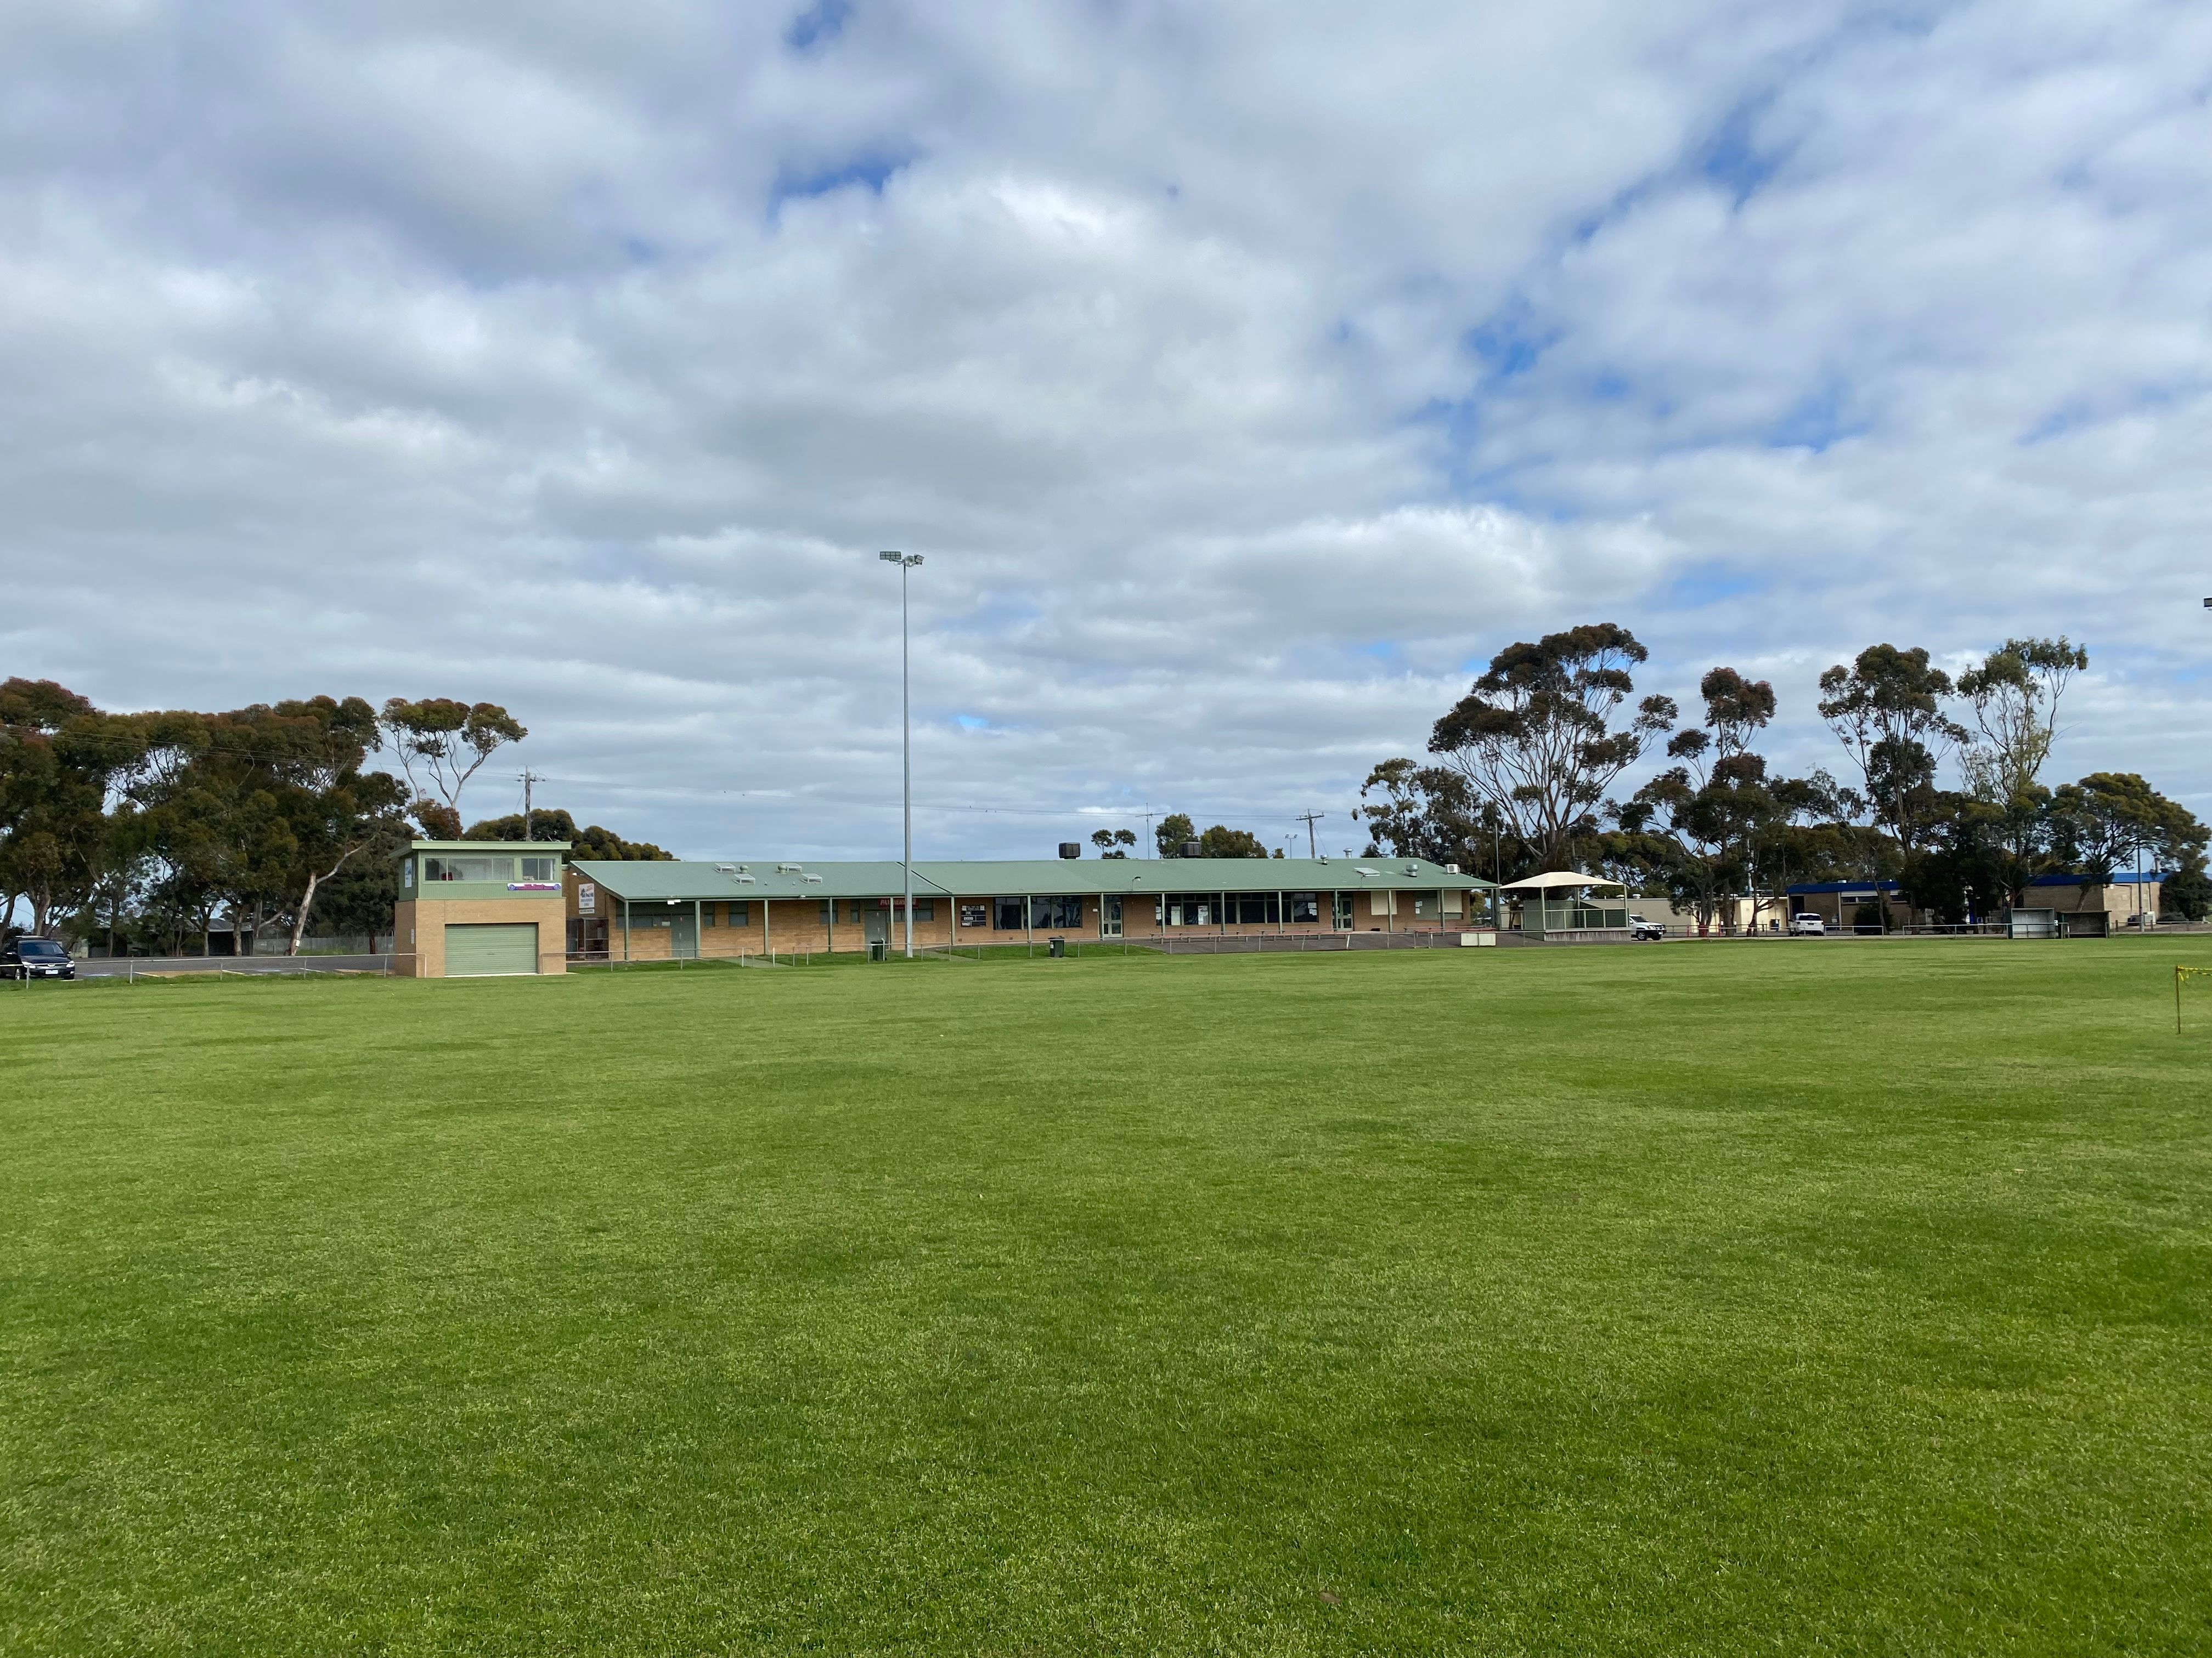
March 2022

Thank you for providing your feedback to help shape a new Master Plan for Myers Reserve.
Your feedback will help us make sure Myers Reserve remains a welcoming place that meets the needs of the local community.

Project background
The overall aim of this consultation was to engage with our community to help us ensure Myers Reserve remains a welcoming place that meets the needs of the local community. All feedback received will be considered in the developing the draft Master Plan
The City ran a four-week online engagement activity to find out more about why Myers Reserve is important to the community.
We had an amazing response and want to thank you all for your valuable insights. 594 visitors visited the Have Your say page with 106 community members providing feedback via an online survey or social interactive map.
From this feedback, we heard, our community:
- Values the open space at Myers Reserve.
- More female friendly and accessibility upgrades are required.
- Playgrounds need to be upgraded.
- More seating and shade shelters are required.
- Additional sportsgrounds are needed to cater for current and future demands.
The engagement summary below has been developed to report on the engagement process and findings.
HOW WE ENGAGED
The emphasis of the engagement with the community was to understand and acknowledge community concerns, aspirations, and views for Myers Reserve.

97
Surveys completed
106
Number of people to leave feedback
Posts & votes via the social map
75

19
28 DAYS
of engagement

People following the project

ENAGEMENT TOOLS & TECHNIQUES
Have Your Say (HYS) Online Portal  Yoursay.geelongaustralia.com.au | An online HYS project page was designed to share relevant information to encourage community feedback on an updated Master Plan for Myers Reserve.
Survey (online and hardcopy) | An online survey was developed, with the option for the community to request a hardcopy of this.
Online Interactive Map | The community was invited to interact with an online mapping tool by:  - Dropping a pin on the map to provide an idea or comment.  - Voting on an existing pin.
virtual drop-in session | One morning and an afternoon were set aside for the community to attend a virtual drop-in session with the Project Team.

communications
The community was informed about the engagement project in the following ways:
• The City’s Have Your Say page between 14 February and 13 March.
• Social Media - Facebook and Twitter.
• City News newspaper article.
• Direct emails to Myers Reserve sports clubs & HYS portal subscribers
• Signage on site
• Advertising pamphlets to households within a 400m radius of Myers Reserve.
All promotion articles directed people to the HYS project page.

SOCIAL MEDIA
11,453
Reach/Impressions
1,097
Direct e-mails sent

719
Actions (Clicks, reactions,
shares, comments etc.)
65 Likes
Actions

1,126
Have Your Say Page views
Advertising pamphlets delivered
301

Registered members of the HYS platform were sent an email, advising that a new project matching their interests was open for feedback. The email reached 1,097 community members with a 6%+ click through rate.

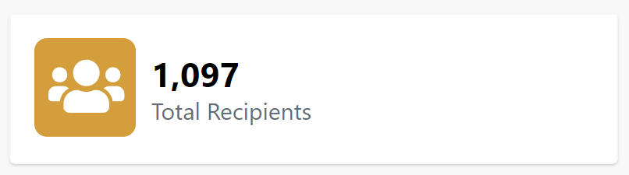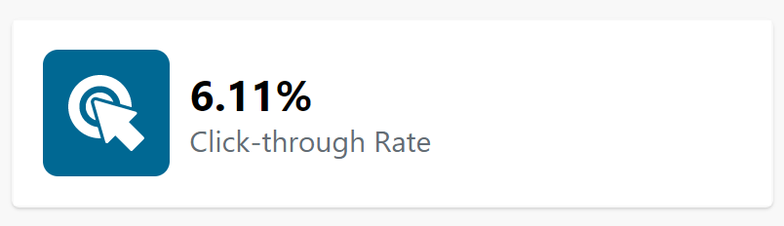
who we engaged with
Before consulting with the community, all sports clubs at Myers Reserve have been engaging with the Project Team discussing their ideas, concerns, and aspirations for the Reserve.
People were invited to share some demographic data with us, primarily through our online survey. The following is a snapshot of these people. The age groups were well distributed between 30-80, with the highest participant group aged between 40-44 & 65-69.
Most survey respondents (47%) were visited the park at least 2-3 times a week for various reasons.
23% Of the participants who provided suburb data were from Bell post Hill, 11% from Bell Park and others well dispersed.

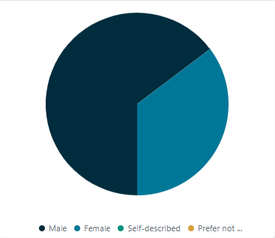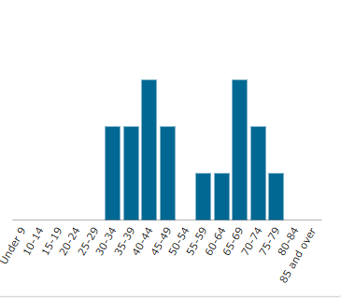
Participant gender Participant age
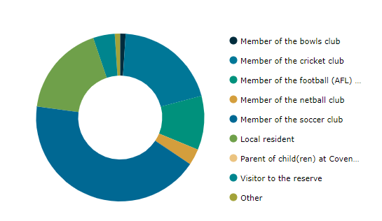
Participant connection to Myers Reserve

WHAT WE HEARD
The overall feedback on Myers Reserve was positive with several key themes and ideas coming through.
Top 3 reasons to visit Myers Reserve

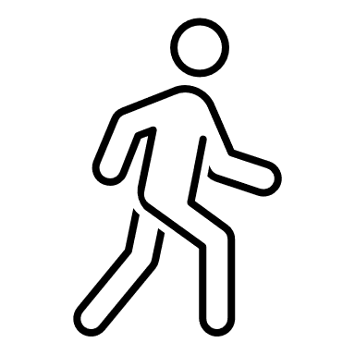
1.Play Sports 2.Socialising 3. (Dog) Walking
Most liked at Myers Reserve
- 50% of the respondents liked the Open Space at Myers Reserve the most.
- 15% of the respondents liked the variety of sports on offer the most.
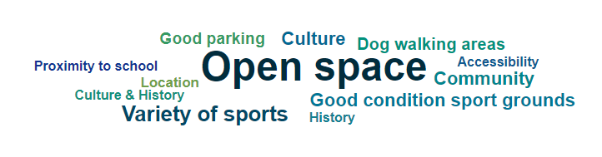
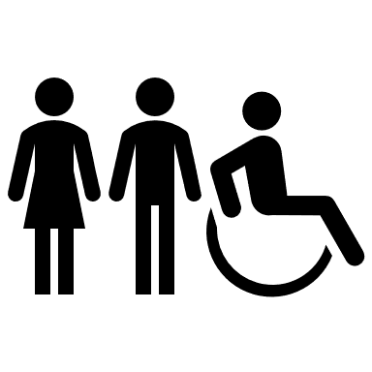
Top 5 ranked ideas to improve Myers Reserve
- Female Friendly & Accessibility Facilities upgrades
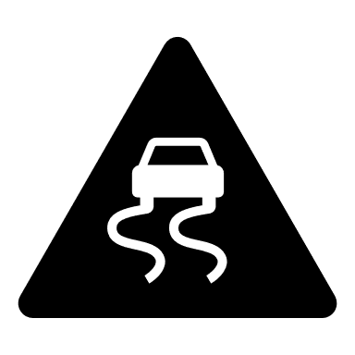
- Sealing the roads & car parks
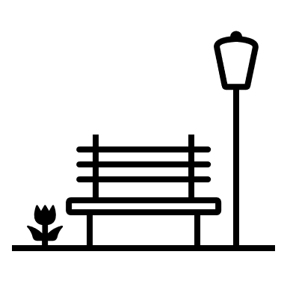
- More and improved spectator seating
- Additional sports grounds
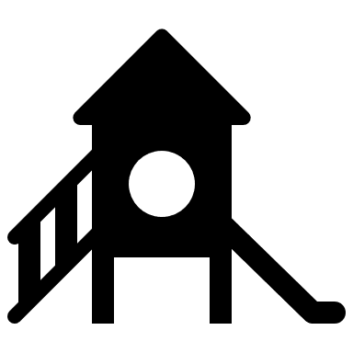
- Playground upgrade
Top 5 key issues at Myers Reserve
- Sports pavilions are ageing and no longer fit-for-purpose – 58%
- Change rooms are ageing and no longer fit-for-purpose – 50%
- Not enough rest areas/seating options – 30%
- Lack of gender-neutral toilets, change rooms or facilities – 22%
- Facilities are at over-capacity and not able to service current demand – 20%

What does the community NOT want to see at Myers Reserve?
We received a wide variety of responses with the main theme the community not wanting a shared pavilion between soccer and the other sports.
Overarching themes from feedback

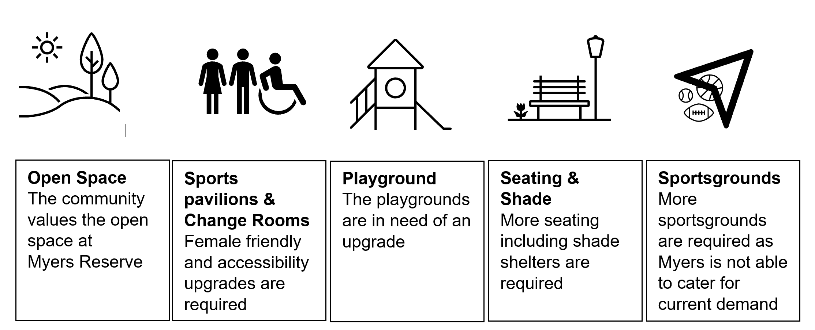
Further comments
Of the comments that were received, a few comments have been picked out below to provide some further insights into what the community told us. It is pleasing to see the number of positive comments received in relation to the future of Myers Reserve.
“Everything needs to be looked at for functionality. At the moment nothing is working when game day is on”
“The club rooms and change rooms facilities for both football and soccer side of Myers Reserve could do with some upgrades. Some female and disability facilities are much needed.
A fourth pitch in the vacant oval would be great for both clubs.”
“Bell Post Hill is growing and should have many sports included in this large sporting area and should be the best facilities around for everyone to use.”

NEXT STEPS
The City would again like to thank those who contributed to this project.
The City together with the external consultants are reviewing the engagement results and will prepare an Issues & Opportunities Report which will help inform the draft design work for Myers Reserve.
Further engagement with the Community will occur when the Draft Master Plan is approved for release later in the year.

