The City Of
Greater Geelong

Portarlington Recreation Reserve Master Plan

  - final Engagement report
  - december 2021

Contents
Introduction 3
Engagement Purpose 3
About this Report 3
How we engaged 4
Who we engaged 6
Survey respondent breakdown 6
What we heard 7
Breakdown of findings 7
Overall support of Master Plan 7
Visions and Goals 7
Recommendations 7
Key Themes 8
Key theme 1 – Upgrading existing facilities within recreation area 8
Sub-Theme – General Upgrade 8
Sub-Theme – Expanding active recreation area 8
Sub-Theme – Netball Courts 8
Key theme 2 – Environmental protection and cultural heritage 8
Sub-Theme – Protecting the passive recreation area 9
Sub-Theme – Native flora and fauna 9
Sub-Theme – Walking trails 9
Key theme 3 – Spaces for the community to gather 9
Sub-Theme – Community Garden 9
Key theme 4 – Safety 10
Sub-Theme – Oval buffer zone 10
Sub-Theme – Overall safety of active recreation area 10
Sub-Theme – Children’s play area 10
Key theme 5 – Flexibility in the use of different spaces 10
ACKNOWLEDGEMENT OF COUNTRY
The City of Greater Geelong acknowledges the Wadawurrung People as the Traditional Owners of this land.
It also acknowledges all other Aboriginal and Torres Strait Islander People who are part of the Greater Geelong community today.

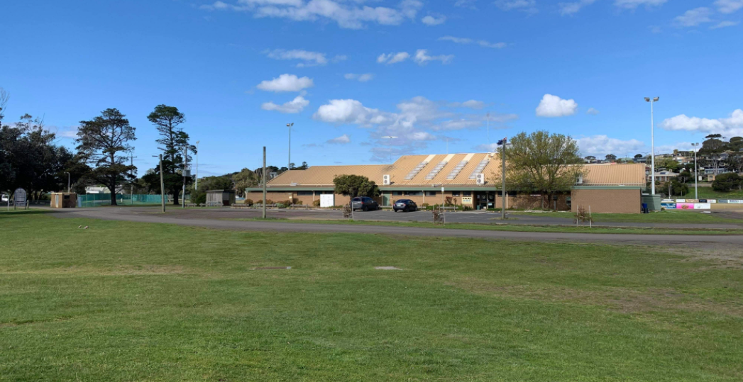 11
Sub-Theme – Multi-use spaces and pavilions 11
Other feedback 11
CFA Training Areas 11
Dog Walking 11
How we are responding 12
Key theme 1 – Upgrading exisiting facilities within recreation area 12
Key theme 2 – environmental protection and cultural heritage 12
Key theme 3 – Spaces for community to gather 12
Key theme 4 – Safety 12
Key theme 5 – Flexibility in the use of different spaces 12
Conclusion 13
Appendix A 14

Introduction
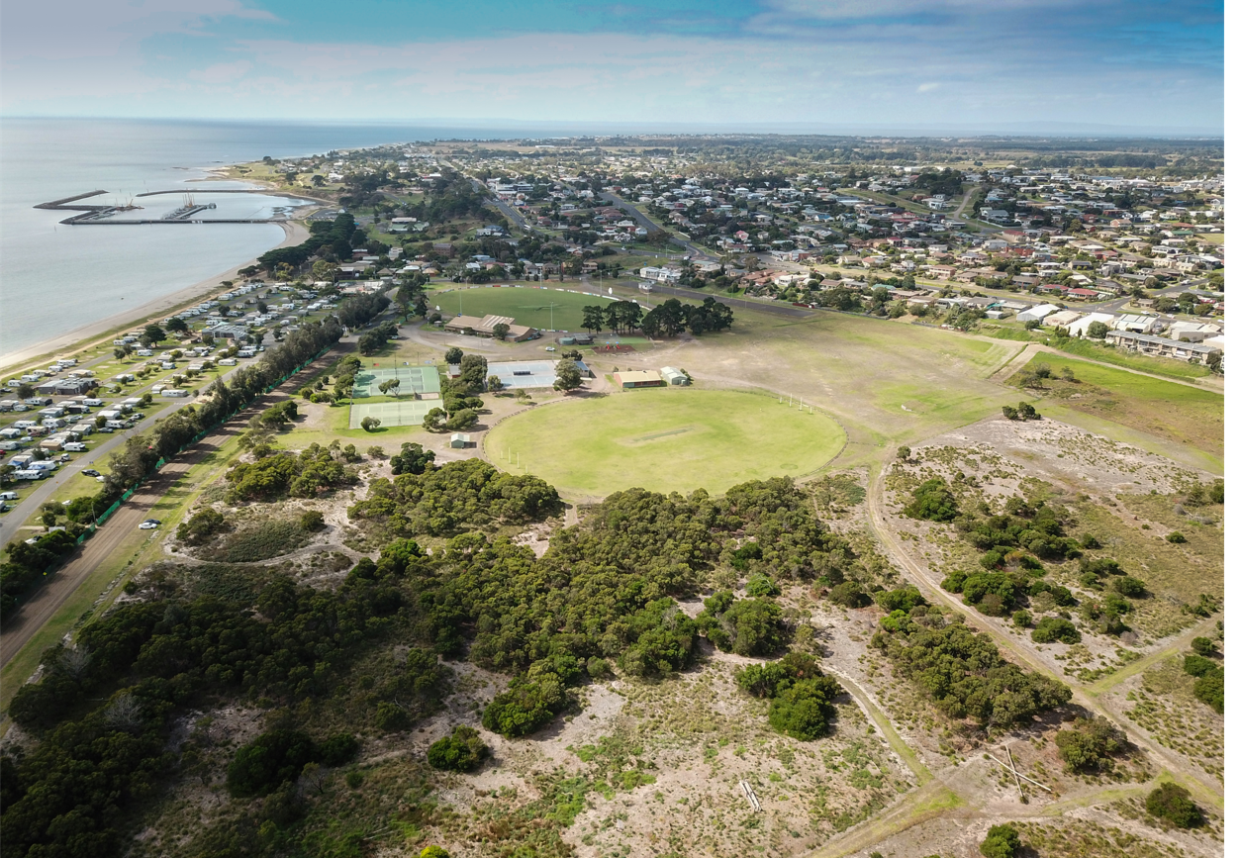
In late 2019, we started a project to refresh the Portarlington Recreation Reserve Master Plan and provide a consolidated new vision for the reserve over the next 10 years
The existing plan was outdated and no longer reflected the needs and uses of the park by the changing community of Portarlington. Ageing facilities, changes in sporting and building guidelines balanced with the need to protect the parks significant environmental, cultural values and open space all highlighted the need for a new plan.
The planned project would involve an assessment of current conditions, issues and opportunities, stakeholder input and broad community consultation to develop the new plan for the park.
To oversee the project development, we also invited the local clubs and groups who use the space to be part of a Project Reference Group

Engagement Purpose
The key aim of this engagement was to gain insight into community views about the draft plan, existing uses of the park and future needs. We also wanted to build community awareness of the project and strengthen relationships with, and between, all key stakeholder groups.

About this Report
This report summaries the community engagement process we used to seek feedback on the draft master plan and how that feedback has influenced the final plan.
This report consolidates the feedback received from the community through the engagement process, as well as feedback received from the Project Reference Group. The report also highlights how this feedback has been incorporated into the final plan.
The information contained in this report is intended to ‘close the loop’ with community members and stakeholders that contributed to the engagement process. It will also be used by councillors who will be endorsing the final master plan.
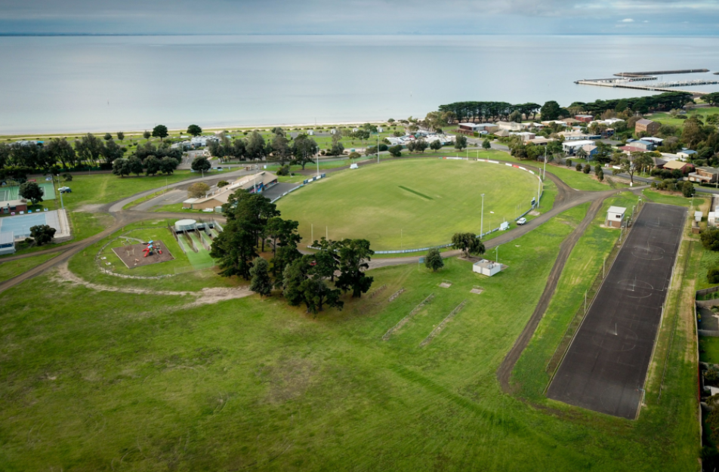
Image 1: Aerial views of Portarlington Recreation Reserve
Image 2: Aerial views of Portarlington Recreation Reserve
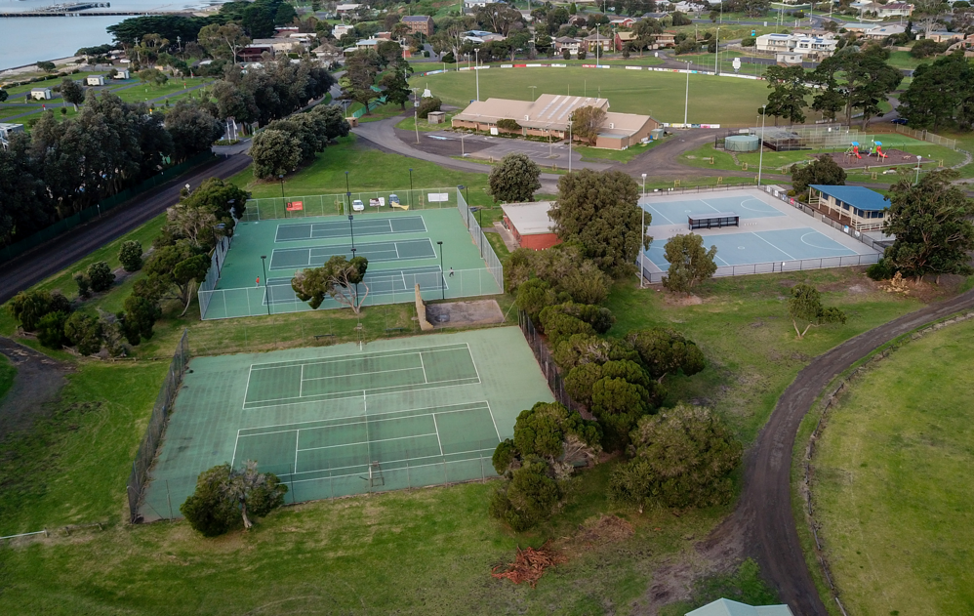
Image 3: Aerial views of Portarlington Recreation Reserve

How we engaged
The community engagement period was conducted over six weeks, from June to mid-September in 2021.
Our core engagement was conducted via the Have Your Say online platform, which was supplemented by a face-to-face drop-in session when COVID-related restrictions allowed.
The engagement was promoted via our many channels, including our direct mailout, posters in the park, a media release, and our Facebook page. A targeted post on Facebook created a reach of over 11,500 and 200 actions.
In total, there were over 3350 views of the Have Your Say project page, which converted to 289 contributions. To encourage contributions, the platform offered social maps, survey, and submission form. This was also supported by phone and email contacts and an onsite drop-in session.

515
Flyers delivered to residents
NEWS
3
Print adverts in local newspapers
211
Actions (Clicks, reactions,
shares, comments etc.)
11,533
Reach/
Impressions etc.
SOCIAL MEDIA
8
Posters installed across the park
111
Posts on the social maps.

50
Online written submissions
68
Surveys completed
3,358
Have Your Say website views
110
People following the project
289
Number of contributions

60
Contributions received
at drop-in session

Engagement details
Have Your Say online platform | An online ‘Have Your Say’ project page was designed to share relevant information to encourage community feedback. The initial release for information occurred in May 2020 and the core feedback period was opened on 30th June 2021 for 6 weeks closing on 10th September 2021.  Maps of the draft master plan were provided on the HYS page to allow respondents to post specific feedback on their areas of interest in addition to a survey and open submission option.
Survey (online and hardcopy) | The survey was available on online and/or in hard copies if required.  The online survey was the core feedback tool provided targeting people with 10-15 minutes of available time. 68 surveys were completed. The survey sought feedback on the vision and objectives, recommendations, and any issues that the community had with the future use and management of the park. The survey included some information and about peoples use and connection to the park.
Submission form | The submission form enabled people to provide more detailed open-ended feedback on any aspect of the draft master plan. This tool also enabled people to add attachments. 48 submissions were made with 14 attachments.
Email | A project specific email address was created enabling people to provide feedback through a fourth medium. 2 people provided email feedback about the plan.
Phone calls | The project manager’s phone number was provided on all posters and flyers that went out with the mailout. This enabled people who may not access to the internet to provide feedback. A call back option was also provided on the webpage for those wanting to speak to an officer at a suitable time. We did not receive any calls about the project.
Drop-in sessions | An onsite drop-in session was held on 10 November at the Reserve, following the easing of COVID 19 restrictions, to provide face-to-face engagement with our project team. Large format posters were displayed along with copies of the plan. Attendees were encouraged to discuss issues with our team and provide a sticky note comment on the maps about an area of interest. IPads were also provided for attended to submit their feedback to our online tools. In total 60 individual comments were recorded.
Draft landscape plan social map | The social map tool was designed as a quick means for respondents to post a note about their key areas of interest in the park. 111 responses were provided using this tool.

Who we engaged
The Portarlington Recreation Reserve is an important community asset that is accessed by a wide range of community users for many activities. Due to this we targeted local residents and groups, but also provided opportunities for the broader community to contribute their views.
In total, 289 people participated in the Portarlington Draft Master Plan engagement process. 72 per cent engaged online, and 28 per cent engaged in-person.
Additionally, the Project Reference Group represented all the stakeholder groups actively leasing or licensing space in the park, as well as community representatives.
As a whole the engagement reached a representative sample of the intended target audience and was a success in terms of its reach amongst the community.

Survey respondent breakdown
The online survey included a number of demographic questions. As Figure 1 shows, 44 per cent of respondents were general users of the park, 17 per cent were part of a sporting club, 6 per cent were part of a community organisation and 1 per cent were members of a service organisation.
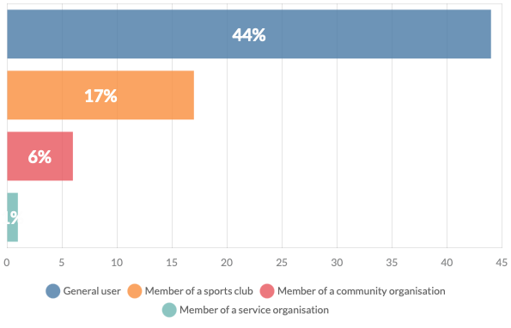
Figure 1: Survey respondents by type

When asked how often they use the park, 40 per cent of respondents indicated they use the park daily (see Figure 2). This shows how highly engaged the survey respondents are with the reserve.
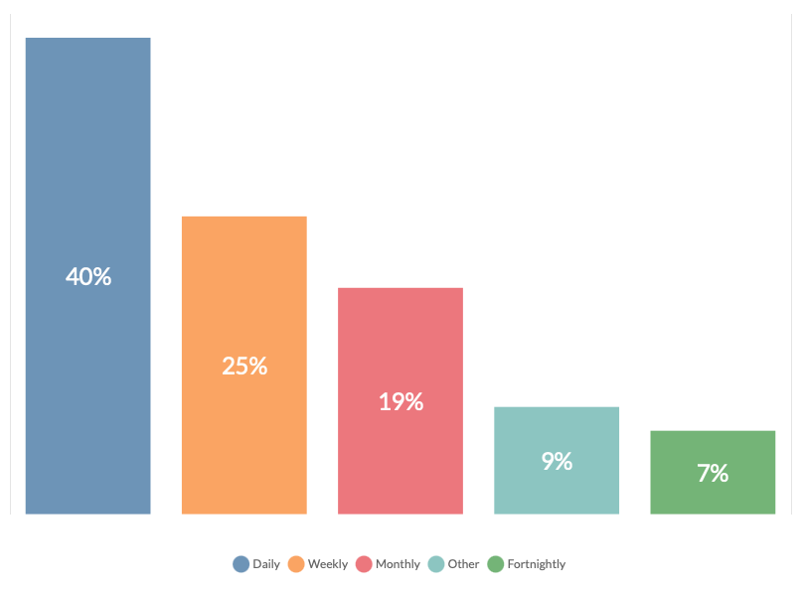
Figure 2: Survey respondent use of the park

Of the survey respondents the four top reasons for visiting the Portarlington Recreation Reserve were:
Nature Appreciation
25%
of people use the reserve to connect with nature
Play Organised Sport
21%
of respondents participate in sport
Walking / Dog Walking
15%
of people visit to take a walk or walk their dog

General Use / Passive Recreation
10%
of people use the park for general outdoor activity

Figure 3: Survey respondent reasons for visiting the park

What we heard
The level of engagement gives us a high degree of confidence that the feedback we received was representative of the community’s views and aspirations for the park and, importantly, their views on the draft plan.
All feedback was analysed to tease out key themes and specific issues that needed to be reflected on and, where appropriate, incorporated into the plan.
There has been a very spirited response to the draft Master Plan, with respondents from all the different feedback areas showing how passionately they care about their reserve. Even with some contention over specific zones in the reserve, there is significant support overall for upgrading and investing in this important community resource.
The first questions in the survey revealed feedback that was generally very positive with:
- over 85 per cent of survey respondents ‘very supportive’ or ‘supportive’ of the overall draft master plan.
- 90 per cent of survey respondents ’very supportive’ and ‘supportive’ of the vison and goals and
- 90 per cent of survey respondents ‘very supportive’ and ‘supportive’ of the recommendations proposed.
The feedback was grouped into five key themes, ranked in terms of the level of feedback:
- Upgrading existing facilities within recreation area
- Environmental protection and cultural heritage
- Spaces for the community to gather
- Safety
- Flexibility in the use of different spaces

Breakdown of findings

Overall support of Master Plan
As Figure 4 shows, more than 80 per cent of survey respondents supported the draft Master Plan overall. This was further validated through the open submissions and responses received through the social map.

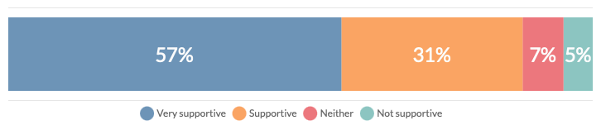
Figure 4: Survey respondent support of draft plan
Of the 5% of people who did not support the plan, the primary concern was the removal of CFA training areas, which will be discussed in more detail in the findings and key themes.

Visions and Goals
The draft master plan outlined the vision for Portarlington Recreation Reserve and detailed 6 key goals. 90 per cent of survey respondents were either very supportive or supportive of the visions and goals in the plan.

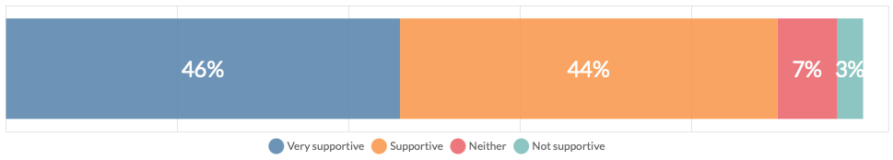
Figure 5: Survey respondent support for Vision and Goals

Recommendations
As Figure 6 shows, 90 per cent of survey respondents supported the 49 recommendations included in the draft plan, which covered all themes and uses of the park.
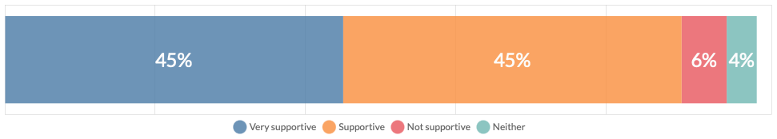
Figure 6: Survey respondent support for draft plan recommendations

Key Themes
Across all forms of feedback, there has been a lively response to the draft master plan, with many respondents having views on a variety of different aspects of the plan. Overall, however, each respondent had a clear area of focus in their feedback, and key themes have been determined based on the number of respondents who identified that theme as their prime concern.
Because there were so many comments in each key theme, sub-themes were created to capture the conversation across all feedback. The most common sub-themes are outlined in this report.

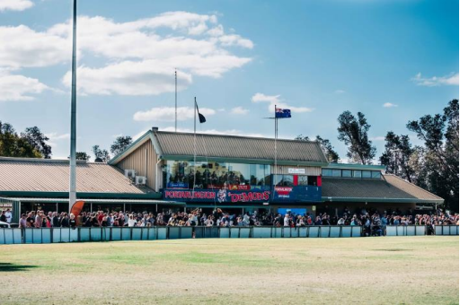
Key theme 1 – Upgrading existing facilities within recreation area
Image 4: Portarlington Recreation Reserve Pavilion

Ninety of the respondents were mostly interested in upgrading and investing in the active recreation area and sporting facilities, which represented 42% of all submissions. There were also 139 points of discussion in this theme across all feedback, making up 36% of discussion overall.
The areas of interest within this theme were broad, ranging from better car access and more defined pedestrian zones to more seating and better shading. There was unequivocal support for the upgrading of the area in general, and a real sense of enthusiasm around what the improved recreation area could bring to the Portarlington community.

Sub-Theme – General Upgrade
Of all the topics within ‘Key Theme 1’ the area that most people were concerned with was the general upgrading of the active recreation area and sporting facilities. There were 32 points of discussion on this sub-theme, making it the most discussed topic within ‘Key Theme 1’, and represented 8% of the discussion across all key themes. The feedback suggests that the community feel an overhaul of the area is needed, with particular interest in upgrading court surfaces, revamping change rooms (especially women’s change rooms) and creating facilities to be proud of.

Sub-Theme – Expanding active recreation area
With 22 points of discussion, the topic of expanding the active recreation area was the second most popular sub-theme within ‘Key Theme 1’. It represents 6% of discussion across all key themes.
Feedback around this sub-theme centred on having the option to use parts of the passive recreation area for sporting activities; arguing that as the Portarlington community grows, the need for increased recreation areas will become difficult to manage without having space to provide further facilities. However, the respondents who are in favour of protecting the passive recreation area outweigh those in favour of an increased recreation zone, which will be discussed in ‘Key Theme 2’.

Sub-Theme – Netball Courts
There were 16 points of discussion around the topic of the netball courts, making up 4% of the conversation overall. The feedback indicates that respondents more consideration given to improving the surface of the netball courts, as well as providing provision for more courts, and a better spectating area.
“Sports pavilions are aged and need to be updated and extended as a matter of priority”
“The whole reserve should remain a reserve for future growth for sports and activities in Portarlington and not be segregated”
“The aesthetics of the general area could be improved through strategic planting paths and seating”

Key theme 2 – Environmental protection and cultural heritage
Just as passionately as the community wish to upgrade the active recreation area, the feedback received also indicates that the community is very invested in the maintenance and protection of the environmental aspects of the reserve, in particular the passive recreation area.

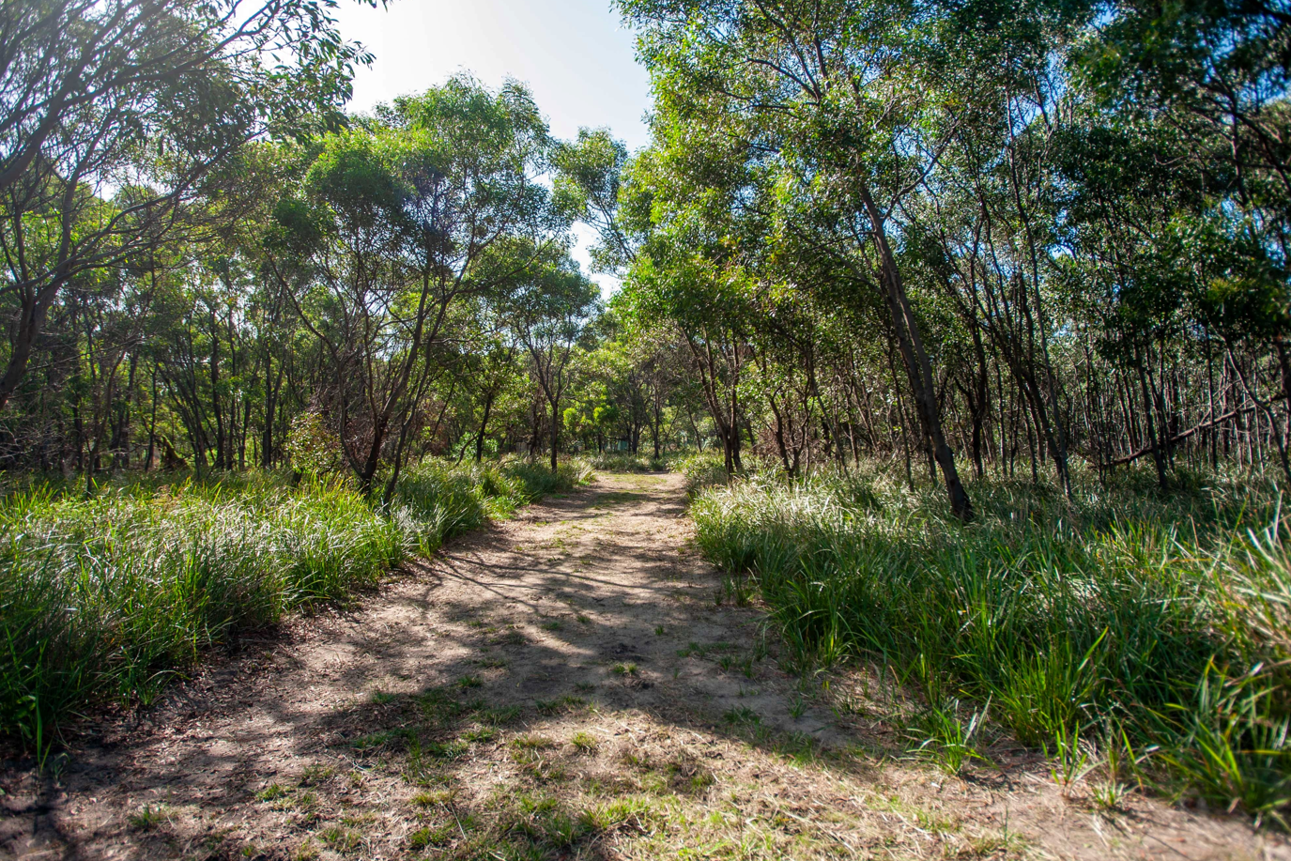
Image 5: Passive Recreation Area

Forty-nine respondents (23% of all respondents) were mostly concerned with environmental protection and cultural heritage in their responses. There were 109 points of discussion within this key theme, which represented 28% of discussion overall.

Sub-Theme – Protecting the passive recreation area
There were 37 points of discussion on the topic of protecting the passive recreation area, representing 10% of the discussion overall. This made it the sub-theme with the most interest overall.
It was extremely clear in the feedback that many respondents enjoy using the passive recreation area as a way of connecting with nature and are very keen to keep this part of the reserve protected from further development. This is also reflected in the survey (Q11) where the top reason for visiting reserve by respondents was ‘Nature Appreciation’.

Sub-Theme – Native flora and fauna
Very close behind the topic of protecting the passive recreation area was the sub-theme of native flora and fauna. There were 35 discussion points in this sub-theme, which represented 9% of all discussion.
In general respondents were in favour of protecting the native flora and fauna of the area, with resounding support to establish more plantings of flora endemic to the Portarlington region and develop strategies to keep weeds out. There was also particular concern around protecting native fauna such as the growling grass frog.

Sub-Theme – Walking trails
The third most discussed topic within ‘Key-Theme 2’ was the need to maintain and upgrade the walking trails throughout the passive recreation area. Not only to provide better access for the community, but also to make the area safer. While some respondents wanted to leave the walking trails as they are, most were in favour of improving the path network.
There were 16 points of discussion on this sub-theme, making up 4% of discussion across all key-themes.
“Improving this area through bush regeneration (e.g., weed removal), installation of dog litter bins and proper wetland management would help improve the biodiversity of the whole reserve”
“The environmental and cultural significance of the passive recreation area are really important to me and it’s good to see that reflected in the plan”
“Would love to see more walking trails with info along the way on history and fauna”

Key theme 3 – Spaces for the community to gather
Twenty-two respondents provided feedback that centred around community spaces, which represented 10% of all respondents. Overall, there were 57 points of discussion in this key-theme, making up 15% of the discussion across all feedback.
Even in responses that were more focussed on other key-themes, there was still huge support for fostering a sense of community through development of community focussed zones and initiatives.

Sub-Theme – Community Garden
The most discussed topic within ‘Key-Theme 3’ was the introduction in the draft master plan of a community garden. With 32 discussion points it was also joint third most discussed sub-theme across all feedback, representing 8% of the discussion overall.
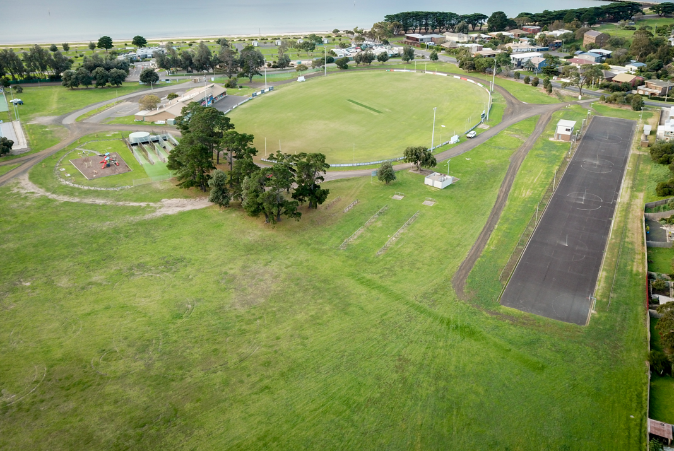
While there is some contention around where the community garden should go (detailed later in the report under ‘Other Feedback’), there is overwhelming support in the feedback to allocate space for this community resource.
Image 6: Active Recreation & Event Areas
“A community garden will enhance the Portarlington recreation reserve by bringing vibrancy and a sense of place”

Key theme 4 – Safety
Eighteen respondents made the theme of Safety central to their feedback, which represented 8% of respondents overall. There were 54 points of discussion under this key-theme, contributing to 14% of the discussion across all feedback received.
There was a definite emphasis on safety, even in submissions that were primarily focussed on other key themes. Areas of concern included carparking areas, accessibility, and the general condition of some of the facilities.
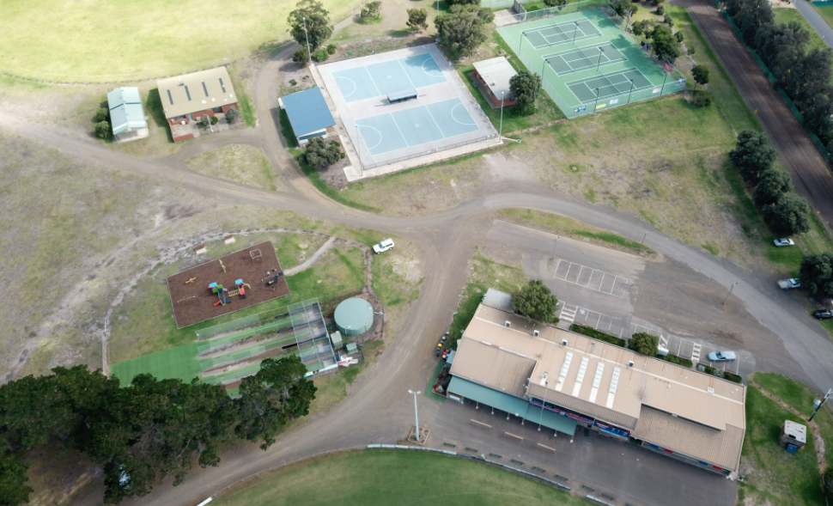
Image 7: Playground, cricket nets & Car parking Area

Sub-Theme – Oval buffer zone
Within ‘Key-Theme 4’ there were 17 discussion points around the topic of a buffer zone around the second oval, which represented 4% of discussion overall.
Feedback on this topic centred around the need for separation between the oval and the nearby vegetation to mitigate trip hazards and to prevent players encountering snakes when retrieving balls from the reserve.

Sub-Theme – Overall safety of active recreation area
There were 15 discussion points that focussed on the general need to upgrade safety across all facilities in the recreation area. This represented 4% of the discussion across all feedback.
In particular respondents felt that many of the sporting facilities such as netball courts and cricket nets needed to be addressed in terms of hazards.

Sub-Theme – Children’s play area
Eleven points of discussion within ‘Key-Theme 4’ listed the children’s play area as an area of concern in terms of safety. Overall, feedback suggested that the children’s play area should not be close to passing cars (including the carpark) and that sightlines should be considered so that parents can watch their children from other parts of the recreation reserve.
“I have witnessed cricket being played on this oval and the ball sometimes goes as far as the bush; the ball is very difficult to retrieve, and you may need to look at safety of retrieving balls”
“The netball area is very overgrown, and you always find things on the court that are a potential hazard”
“The current road is dangerous (between nets and clubrooms) and should be closed to allow children safe access to play areas.”

Key theme 5 – Flexibility in the use of different spaces
Focussing in on the active recreation area, thirteen respondents were mainly concerned with the flexibility of spaces and facilities. These respondents represent 6% of all people who provided feedback. There were also 26 points of discussion in this key-theme.
Overall, feedback suggests that respondents are interested in using the area in a more flexible way, to maximise the benefit to the community. This could be through opening up areas for special events or festivals, or by making courts multi-use.
Image 8: Portarlington Recreation Reserve Pavilion

Sub-Theme – Multi-use spaces and pavilions
There were 12 discussion points around multi-use spaces and pavilion within ‘Key-Theme 5’. This represented 3% of the discussion across all key-themes.
Feedback around this topic centred around being able to use the different spaces – outdoor and indoor – for a variety of different activities. This included the use of pavilions for activities other than sport.
“Development of facilities should be as multi-purpose as possible to allow for both sporting and cultural uses”

Other feedback

CFA Training Areas
The recommendation in the draft master plan, to replace the area that the CFA currently use for training with a community garden and BMX jump area has been met with some contention. While almost all respondents are supportive of introducing a community garden and BMX area, the feedback on where to put these community resources is divided. Some respondents are very supportive of the proposed location, while others feel the area should be reserved for the CFA and a new location should be found for the community spaces.
Overall, there were 23 discussion points on this topic, and 77% supported moving the proposed community garden and BMX jumps to a different area of the reserve and maintaining an area for CFA training.
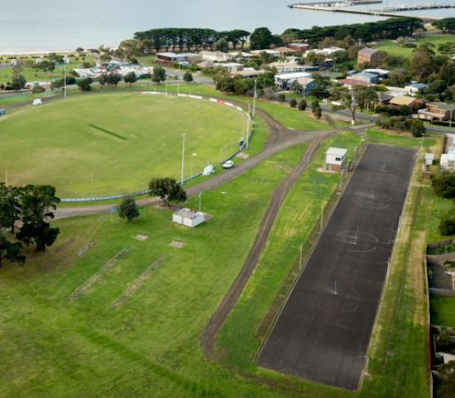
Image 9: Old Netball Courts
“I strongly support the provision of a space for a community garden, but the proposed area should be left for the dedicated use of the CFA, and another area allocated for the garden.”

Dog Walking
There were various comments made throughout the feedback about the provision of appropriate areas for dog walking. Some respondents felt there should be more consideration in the master plan for people who use the reserve to walk their dogs, while others highlighted the need for dog litter bins.

How we are responding
The key purpose of seeking community input is to ensure the master plan reflects the needs and aspirations of the community.
The project team reviewed and considered all feedback and key themes in preparation of the final plan, incorporating the following amendments.

Key theme 1 – Upgrading exisiting facilities within recreation area
Feedback provided was generally supportive of the proposed upgrades to facilities as shown in the master plan with some specific areas noted for further consideration. The following changes to the master plan were made:
- Warm up netball area next to netball courts and note surface improvements to netball & tennis courts on plan.
- Multipurpose line marking and goals on old netball courts.

Key theme 2 – environmental protection and cultural heritage
Based on the feedback provided in key theme two there have been no changes made to the master plan in relation to the passive recreation area. The master plan identifies:
- Protection of native flora and fauna.
- Improvement of walking trails.
- Improved access and safety in the passive recreation area.

Key theme 3 – Spaces for community to gather
Community feedback identified support for fostering a sense of community through development of community focussed zones and initiatives which is a key aim of the master plan. A space that was supported was the community garden, however, feedback suggested a review of location was needed.
- The community garden will be considered on the reserve following the investigation of a preferred location at an alternative reserve. Should the community garden be located at the recreation reserve it will be relocated off the old netball courts to the west.
- A shared trail has also been included around the reserve that will link to existing shared trails and provide a connection a walking and cycling connection into and around the reserve.

Key theme 4 – Safety
Feedback around this theme highlighted a desire from the community to further consider safety in a number of areas. Considering this the following changes have been made:
- Create an increased buffer zone between playground and car parking and highlight traffic calming measures in this area.
- Remove formal roadway south of playground and create informal managed access for events.
- Further highlight pedestrian crossings over vehicle access routes.
- Identify any informal vehicle access noted on the plan as managed access during events.

Key theme 5 – Flexibility in the use of different spaces
Feedback identified the need to make community spaces as flexible as possible which is a key goal of each of the master plan recommendations. Changes made to the plan to further enhance this aspect include:
- Multipurpose line marking and goals on old netball courts
- Relocate bike jump area to be incorporated into main playground area.
other feedback
Strong support was provided for the old netball courts to be made available to the CFA for training. The changes noted above to the old netball courts will allow this to occur. The City will continue to work with the CFA regarding access to the site.

Conclusion
All feedback and proposed responses have been discussed with individual stakeholder groups and the Project Reference Group and incorporated into the final master plan.
Both the updated plan and this report will be tabled for discussion and endorsement at the 26 April 2022 Council meeting.

Appendix A
The key objective of the survey was to gauge community support for the plan, as well as ascertain if there were any other opportunities or issues not identified.
A combination of quantitative and qualitative questions was included, as followed:
- How supportive are you of the overall draft master plan?
- How supportive are you of the Vision and Goals?
- How supportive are you of the recommendations overall?
- Please choose the recommendation that has the potential to deliver the greatest benefit to the community.
- Please choose the recommendation that you support and is the most important to you?
- How satisfied are you with the recommendations for the following areas?
- Please choose the area/feature that you feel could be improved the most?
- Please describe how they could be improved?
- Please provide any other feedback you feel is important about the plan.
- What are the most important features of the reserve to you?
- What is the main reason you visit the reserve?
- How often do you use the reserve?
- What is your involvement or connection to the reserve?
- Do you belong to a local group or organisation?
- How did you find out about the community engagement for the draft master plan?

