celebrting christmas in

geelong 2021

|  |
| --- |
| community engagement summary |

From 18 November 2021 to 14 January 2022, the community were invited to have their say about the Greater Geelong Christmas Program via an online survey.

The feedback from the survey will help the City evaluate the value and impact of the Christmas program to our local community and guide us in building on the program for 2022 and beyond.

The survey asked the community to tell us what they thought of key elements within the City’s Christmas Program, about their experiences and expectations at each of the activities.

We also asked children to participate by telling us which of the City's Christmas activity was their favourite, and why. Their feedback was captured using a Visioner online tool, this gave us an opportunity to better understand children’s views and suggestions through their lens.



**435**

Number of people visiting the page

**57 DAYS**   
of engagement

NEWS

**8**

print adverts in local newspapers



**181**

Surveys completed online



Comments from children on what was their favourite Christmas activity and why.

**21**



**40**

signs across the regions promoting the survey.



People following the project

**8**

|  |
| --- |
| what we heard – |

#### When asked how important the Christmas in Geelong program is for the region, more than 90 percent of respondents said “very important” or “important”.

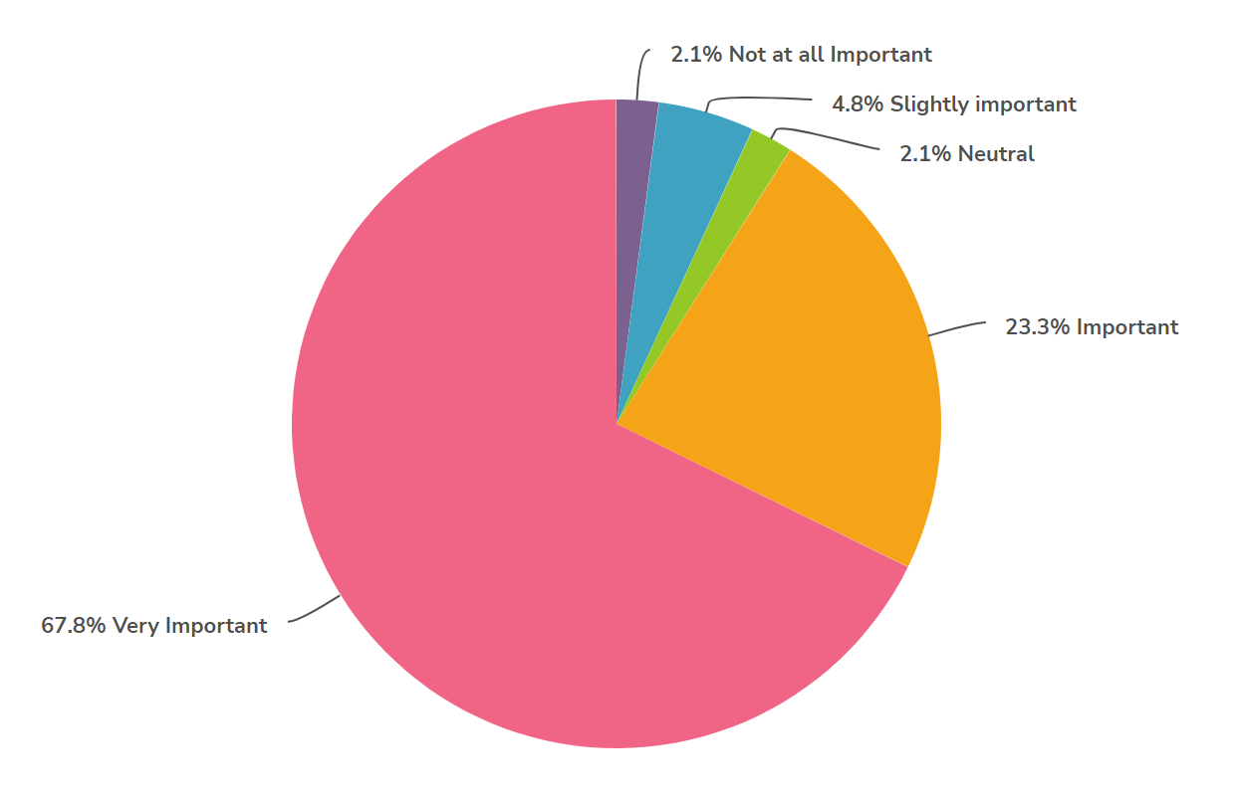

We asked the community how they felt when participating in the program:

* Over 88 per cent agreed or strongly agreed, that participating in the Christmas in Geelong program activities made them feel proud.
* Over 83 per cent agreed or strongly agreed that they felt welcome and safe when participating in the Christmas in Geelong program activities
* 78 per cent agreed or strongly agreed that the Christmas in Geelong program was accessible and inclusive and helped them feel connected to the people in the community.
* The Christmas in Geelong activities felt accessible and inclusive of a diversity of cultures, backgrounds, and abilities.
* When asked if they enjoyed the vibrancy and atmosphere during the Christmas in Geelong program, 83 per cent agreed or strongly agreed.

When also asked if Covid impacted on their visitation to the Christmas activities with 58 per cent of respondents answering no, whilst 42 per cent said yes.

General comments we heard from community members about the program

**“**“***I thought the selfie trail was a fun activity.”***

**“*I love the Christmas tree! It brings such joy and happiness to so many people and attracts visitors from all over Victoria”***

**“*I loved the community inclusivity and how lots of different schools got to help make an amazing art display.”***

**“*The sound on the 'sound and light' show was really poor. Needs to have multiple speakers and be louder.”***

|  |
| --- |
| Next Steps |

* We will be reviewing and analysing the results to help with planning the 2022 Christmas program.
* Results will be provided to Council for their information.