|  |
| --- |
| The City Of  Greater Geelong |
| **Social Equity Framework**  **2022-25** |
| Approval date:  **APPROVED BY:** |

Contents

[MESSAGE FROM THE MAYOR 3](#_Toc84822919)

[OUR VISION FOR EQUITY ACROSS THE CITY 4](#_Toc84822920)

[UNDERSTANDING SOCIAL EQUITY - DEFINITIONS 6](#_Toc84822924)

DEVELOPING [OUR SOCIAL EQUITY FRAMEWORK 7](#_Toc84822931)

[OUR SIX SOCIAL EQUITY ENABLERS 8](#_Toc84822933)

[OUR COMMITMENT TO PRIORITY GROUPS 9](#_Toc84822933)

[OUR SOCIAL EQUITY FRAMEWORK 12](#_Toc84822933)

[OUR BROADER SUSTAINABILITY PRIORITIES 13](#_Toc84822933)

[NEXT STEPS 15](#_Toc84822944)

[REFERENCES 16](#_Toc84822945)

[Appendix 1: Priority Actions 17](#_Toc84822946)

[Appendix 2: Legislative Context 18](#_Toc84822947)

[Appendix 3: Community Data 19](#_Toc84822947)

[Appendix 4: Glossary 2](#_Toc84822947)8

[Appendix 5: Case Studies 30](#_Toc84822947)

List of figures

[Figure 1 | Visual representation of Equality, Equity, Justice 4](#_Toc84825524)

Figure 2 | Statistics about our community…………………5

[Figure 3 | Our city’s enablers will assist us in pursuing a more Social Equitable community 8](#_Toc84825525)

[Figure 4 | Intersectionality and priority groups 9](#_Toc84825526)

[Figure 5 | Three pillars for a sustainable City 13](#_Toc84825527)

[Figure 6 | Sustainability delivered through our City’s strategic priorities 13](#_Toc84825528)

We acknowledge the Wadawurrung People as the Traditional Owners of the Land, Waterways and Skies. We pay our respects to their Elders, past and present. We acknowledge all Aboriginal and Torres Strait Islander people who are a part of our Greater Geelong community today.

Acknowledgement of Country in Wadawurrung language:

*We acknowledge the Wadawurrung People as the Traditional Owners of the land, water, and sky. We pay our respects to their Elders of the Past, Present, and those Emerging.  
  
Wadawurrung Dja muyni Djilang wurdi-karrong. Nganyaki-i-beek wurdi Wadawurrung gerrupa-tjarra-dja  
Wadawurrung kinkinbil beek wurdi getjawil detetj-gupma-bul mooroop-a.  
  
The City of Geelong is part of Wadawurrung Country. A small part of land that’s connected to the larger Country of Wadawurrung*

*We acknowledge the Wadawurrung People and the spiritual connection they share with the lands*

## 

## GEELONG PLEDGED SUPPORT TO THE ULURU STATEMENT FROM THE HEART

The City of Greater Geelong has proudly pledged their support for the Uluru Statement from the Heart which outlines the reforms – Voice, Treaty, Truth. The Statement calls to enshrine a First Nations voice in the Australian constitution and to establish a Makarrata Commission to supervise a process for both agreement making between governments and First Nations People, and historical truth-telling. This provides a path forward as identified by Aboriginal and Torres Strait Islander People for their own self-determination, and true reconciliation in accordance with the United Nations Declaration on the Rights of Indigenous Peoples.

# MESSAGE FROM THE MAYOR

**Our aim of a creative, thriving and socially sustainable Greater Geelong relies on equity for all members of our community. To achieve this, we will need to overcome existing barriers facing our underrepresented and most vulnerable groups.**

Our Social Equity Framework gives us a common set

of principles so that every member of our community

can be supported to participate fully, be included and

have the opportunity to live a healthy and fulfilling life.

We know that our population is growing rapidly and,

as we continue to welcome more people into our

community, we become stronger and more diverse.

To make sure we remain socially sustainable, we need

to focus on how we can support and celebrate the

unique experiences, skills, and stories each person

and group brings.

We recognise that right now, certain groups may

experience disadvantage, or their voices may not be

fully heard. This is something we want to change. This

framework outlines our approach to achieving greater

representation of every member of our community,

giving us a common understanding of how we think

about social equity. We have also identified groups

who need extra support, and we’ve developed a range

of action plans and strategies to help these important

members of our community access the resources

they need.

Everyone in Greater Geelong brings unique value, and

no group or identity exists in isolation from another.

Welcoming and hearing the voices of all individuals will

help us to create our diverse and inclusive, clever and

creative community.



**Cr Trent Sullivan**

Deputy Mayor,

City of Greater Geelong

# OUR VISION FOR EQUITY ACROSS THE CITY

## 

## VISION

Our community-led 30-year vision for a clever and creative future is underpinned by how we support every member of our community. Our vision is community-led and collaborative in how we address our challenges, create opportunities and embrace new ways of doing things.

Sustainability is a key challenge to achieving a thriving region over the next 30 years. Sustainability for Greater Geelong means focusing on creating the best outcomes for people, the environment, and the economy, both now and in the future. Social sustainability is about expanding opportunities to create a more inclusive community, empowering community members and fostering a more resilient and prosperous society.

We recognise that some social groups may experience barriers to representation and their voices may not be heard. This reinforces the importance of equity, access and inclusion in the way we deliver services and programs, and partner with community when achieving our community-led vision.

## purpose

The Social Equity Framework provides a common set of principles so that every member of our community can be supported to participate fully, be included, and can live a healthy and fulfilling life. The framework informs how we will work with the community to become a thriving region, with equitable access to council services and facilities, partnerships that achieve better health outcomes, and an approach that harnesses community knowledge to drive sustainable change.

This framework also considers the concepts of social justice, equity, diversity, inclusion, and human rights in every service and program we deliver, and every space and place we manage. By adopting an equity approach, we will move closer to realising social justice in our community.

Aligning to the community’s 30-year Clever and Creative Vision and Our Community Plan 2021–25, the framework

will help us strive for a fairer society by reducing barriers and sharing resources fairly.

By putting equity at the centre of everything we do, we will build a healthy, thriving community where everyone is welcomed and valued.

Figure | Visual representation of Equality, Equity, Justice

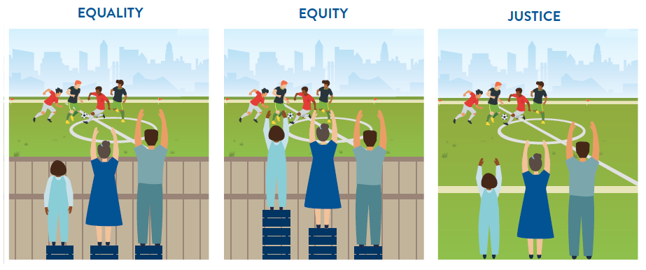

Figure 2 | Statistics about our community

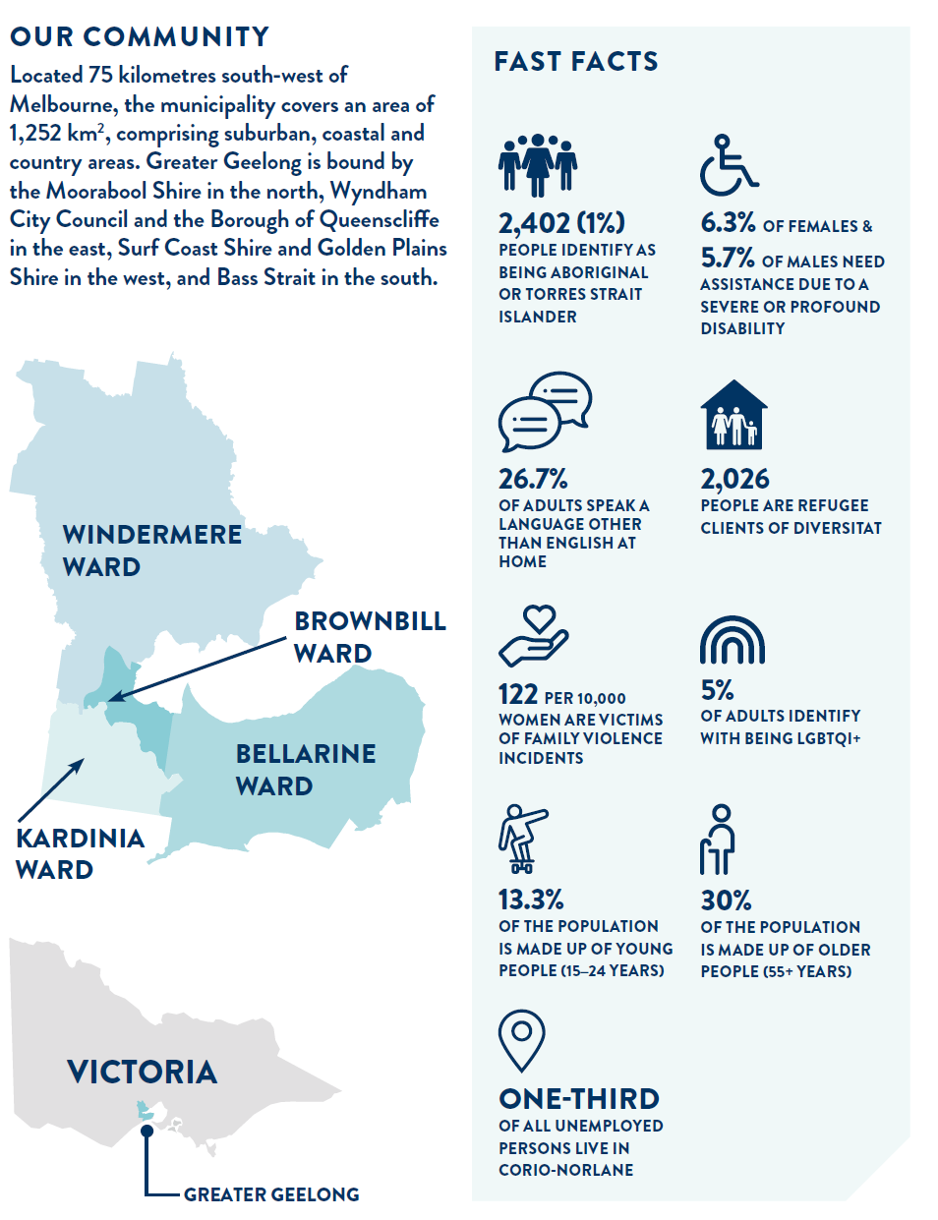

# UNDERSTANDING SOCIAL EQUITY – DEFINITIONS

## 

## EQUITY

Equity is a concept based on the principle of human rights and fairness in the distribution of services, resources, benefits and responsibilities, on the basis of people’s current opportunities and barriers. It recognises that people have different needs, life experiences, levels of influence and access to decision making and that these differences should be identified and addressed in a manner that rectifies imbalances, to provide equitable outcomes for all.

## HUMAN RIGHTS

Human rights recognise the inherent value of each person, regardless of background, where we live, what we look like, what we think or what we believe. They are based on principles of dignity, equality, and mutual respect, which are shared across cultures, religions and philosophies. They are about being treated fairly, treating others fairly and having the ability to make genuine choices in our daily lives. The Universal Declaration of Human Rights is a milestone document which outlines the common standard of treatment for all peoples and all nations. Respect for human rights is the cornerstone of strong communities in which everyone can contribute and feel included.

## Equality

Equality affirms that all human beings are born free and equal, having the same rights and are entitled to the same level of respect, treatment or prosperity regardless of gender, race, religion, ethnicity, sexuality, age, ability or religion.

## SOCIAL JUSTICE

Social justice is based on principles of human-rights and fairness. It recognises the systemic causes of disadvantage. It seeks to remove barriers to enable every individual to participate fully and equally in society, regardless of gender, age, race, ethnicity, religion, culture or ability.

## DISADVANTAGE

Disadvantage is linked closely to living standards and quality of life. Disadvantage is a complex interplay between the characteristics of residents in a community, and the effects of the social, economic and environmental context in which they live. We can think about disadvantage as components of deprivation, capability and social exclusion.

* Deprivation: What people miss out on because of where they live or what they can afford
* Capability: What people are effectively able to do and aspire to be
* Social exclusion: When people are unable to participate adequately in economic, social and cultural life.

## SOCIAL INCLUSION

Social inclusion is a process of improving the way individuals and groups can freely contribute to and benefit from the social, economic, political, and cultural spheres of community life. Like equity, it aspires to create equal opportunity, reduce disadvantage, and increase participation, by removing barriers for certain population groups. Social inclusion promotes active engagement, participation, and voice for all community members, especially those experiencing disadvantage based on their identity, and allows community members to shape their futures and influence decisions which affect them.

## DISADVANTAGE WITHIN OUR COMMUNITY

We have identified a number of priority groups that experience greater disadvantage in the Greater Geelong community. By placing an emphasis on equity, justice and inclusion, we can address the challenges and barriers these groups face.

# DEVELOPING OUR SOCIAL EQUITY FRAMEWORK

**We are committed to empowering and supporting all people in our diverse community. The *Social Equity Framework 2022-25* will guide the way we engage with the communities of Greater Geelong to hear their voices. It recognises that we need to create opportunities for participation, support community members to have a say in decisions that affect them, and listen to community needs, to progress social equity.**

With the City’s role in service provision, community infrastructure, enforcing state and local laws, planning for future communities and growth of the city, and supporting the health and wellbeing of all our community members, we can play a positive role in influencing equity in our community.

In 2017, we developed the following three fundamental Social Equity Principles to help ensure that fair and equitable access to all of our services and facilities regardless of gender, age, background, and ability, was a key focus of our work. The Principles are:

1. **Decision making informed by social equity data**

All activities of the City will be informed by demographic and geographic information on social equity in the region which is up-to-date and identifies priority areas and groups for attention.

1. **Effective and focused partnerships**

Planning of all activities will be informed by effective, focused partnerships and engagement with priority groups and areas, aimed at fully understanding the needs and obstacles they experience in accessing services and facilities.

1. **Designing for community need and equity**

Service and infrastructure design, location, communication and support arrangements will address the needs and obstacles faced by priority areas and groups.

The Social Equity Framework incorporates these principles and further identifies the:

* supporting Social Equity Enablers which we need to adhere to
* the need to promote the Social Equity Framework to our partners and stakeholders
* community outcomes that this Framework aims to achieve
* means to track our performance on an ongoing basis
* opportunities for our partners and agencies to better understand our community profile, apply these principles, in their own work and assist the broader commitment of Equity for All
* priority actions to take as next steps.

# OUR SIX SOCIAL EQUITY ENABLERS

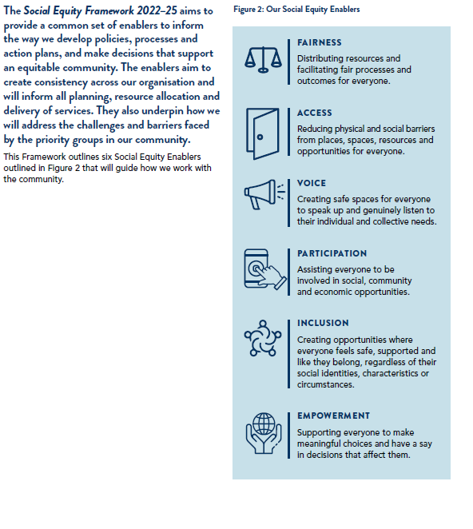

Figure 3: Our City’s enablers will assist us in pursuing a more Social Equitable community

# OUR COMMITMENT TO PRIORITY GROUPS

**Every member of our community belongs to multiple groups with intersecting identities, meaning they have unique experiences and face unique challenges within the community.**

According to our research and data, we know that identified priority groups experience increased disadvantage such as: accessing services, structural inequalities, linguistic and cultural barriers, discrimination and stigma, and geographical distance and isolation. We recognise and commit to addressing barriers experienced by these groups, as well as acknowledging that, within these groups, community members with extraordinary skills, knowledge and leadership exist. Economic and social disadvantage does not preclude resilience, neighbourliness, family unity, development or belonging.

Figure 4 | Intersectionality and priority groups

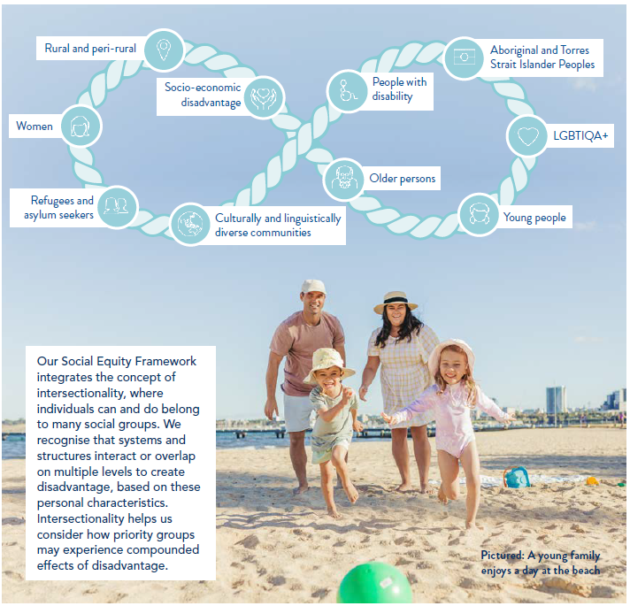

## 

## Aboriginal and Torres Strait Islander peoples

We support the right of Aboriginal and Torres Strait Islander Peoples to experience the full range of choice, opportunity and influence in their lives. We acknowledge that historically, government legislation and practices enforced on Aboriginal and Torres Strait Islander peoples have contributed to many being unable to realise their full potential. These policies have left lasting inter-generational impacts. Various pieces of government legislation and policies have contributed to dispossession of land, racism, social and emotional wellbeing issues, culture loss, family fragmentation, unemployment, poor housing, low literacy and numeracy rates, alcohol and substance misuse and poverty.

We have developed the Reflect Reconciliation Action Plan around four key deliverable themes including Relationships, Respect, Opportunities and Governance. It is based on priorities and aspirations identified through consultation with Traditional Owners and members of the local Aboriginal and Torres Strait Islander community. It builds on advancing a positive relationship, demonstrating respect and self-determination for local Aboriginal and Torres Strait Islander Peoples, and ensuring equality of opportunity and access in all dealings with the community.

## Culturally and Linguistically Diverse communities

Our City is strongly committed to respecting and celebrating the cultural, linguistic and religious diversity in our community. It recognises that our multicultural communities face unique barriers to participation, including lack of accessible information, cultural differences, racism and exclusion. We strive to create inclusive services, places and programs that respond to the needs of all our communities. Greater Geelong values the richness that multicultural communities bring to the social and economic fabric of the community.

## Refugee and Asylum Seeker communities

We acknowledge that our refugee and asylum seeker communities face unique and complex challenges, these include possible experiences of persecution, violence, conflict, detention, distance and lack of communication with families, visa insecurity, trauma, genuine fear and ongoing mental health issues, financial difficulties and lack of work opportunities. These challenges are in addition to linguistic and cultural barriers. We are committed to working with partner agencies to support our refugee and asylum seeker communities and ensure they are included, welcomed and valued in the Greater Geelong community.

## People with Disability

We recognise the need to reduce barriers created by structures, attitudes, and practices that limit opportunities for all community members to realise their right to fully participate and achieve their aspirations. For people experiencing disability, including physical, developmental, behavioural or emotional, and sensory conditions,we are committed to supporting and improving access and choice. We value including an individual’s unique experience and understanding of their disability to create opportunities for access and equal participation.

## Women

We recognise the power imbalances that exist for different genders, and the impact that this inequity can have on the safety, health and wellbeing, and economic life of women and gender diverse people. We understand that gender equality is crucial to ending violence against women and children. To achieve authentic gender equity and address gendered forms of disadvantage, we are committed to addressing barriers, acknowledging and celebrating the crucial role of women and girls in our community and economy, and recognising the importance of working together to create an equitable future for all.

## LGBTIQA+ communities

We work to ensure that the strength and diversity of lesbian, gay, bisexual, transgender and gender diverse, intersex and asexual people (LGBTIQA+) is valued, celebrated and affirmed. We recognise that the LGBTIQA+ community face barriers to participation including, vilification, exclusion, lack of safety, poor mental health and health and wellbeing outcomes. We are committed to working with the LGBTIQA+ community to build a safer and more inclusive community.

## 

## Young People

We recognise that young people make up a significant percentage of Greater Geelong’s community and are affected by decisions made on their behalf. We recognise that young people face many challenges relating to health and wellbeing, inclusion, access, voice and safety. We are committed to learning from and working with young people to understand their aspirations and needs, and to shape a sustainable and prosperous future for them.

## People as they age

We understand that everyone experiences ageing differently depending on biological, environmental, geographic, cultural and health factors; access to resources and support; and the inclusiveness of local environments. We address age specific barriers to ensure safe and equitable access to services, infrastructure and community amenities. These experiences can also be shaped by economic and social drivers such as where you live, employment background and housing stability. People as they age are at higher risk of facing poverty, isolation and exclusion. We are committed to fostering an age-friendly environment where people feel welcome, respected and connected to other people in their community, including through intergenerational connections, neighbours and social groups.

## SOCIO-ECONOMIC DISADVANTAGE

We recognise that some residents face multi-faceted inequalities due to poverty and low income which, are influenced by structural inequalities and have a community-level impact. The Socio-Economic Indexes for Areas (SEIFA) shows the suburbs of Norlane, Corio and Whittington experience higher levels of socio-economic disadvantage compared to Greater Geelong as a whole. While our municipality has experienced significant growth and change, this opportunity has not been evenly spread and there is a need to address low levels of employment, education, housing and health and wellbeing. We are committed to addressing these inequalities through various initiatives, including those related to environmental issues, liveability, mobility and transport, neighbourhood activity centres, open space and social infrastructure, as well as crime and safety.

## RURAL & PERI-urban COMMUNITIES

Peri-urban communities exist at the boundaries of urban development and rural environments and include those areas making a transition away from rural land use. Rural communities include those in farming areas and those with low population densities, at a distance from regional or urban centres. These communities face additional challenges with access to facilities, services and places, and exposure to weather, including extreme weather events. We are committed to addressing the barriers faced by these communities and ensuring there are opportunities for access, inclusion and participation in the social and economic activity of our region.

# OUR SOCIAL EQUITY FRAMEWORK

## 

## Leadership, commitment and governance

Our councillors and senior leaders will be responsible for demonstrating leadership and commitment to applying these Social Equity Principles across all decisions relating to council services, facilities, budgets, and planning approvals.

The responsibility to apply and uphold the Social Equity Framework lies with all directorates. In the initial phases of rolling-out and implementing the Social Equity Framework, the Community Life directorate will take stewardship of the Social Equity Principles, enablers, and future action plans, continuing to drive our organisation towards achieving strong community social equity outcomes. Furthermore, our Strategy, People and Performance directorate will work to ensure that the Social Equity Principles and enablers are ingrained in the DNA of the organisation by incorporating them into business plans to ensure that they are accurately tracked and measured internally, and that their importance and impact is shared more broadly with our community.

## Our partnership approach to social equity

Guided by our Social Equity Principles and driven by community need, we will work with existing advisory committees, priority groups and partners, as well as exploring new partnerships to achieve our desired community objectives.

We will undertake early engagement with community, priority groups and partners to ensure deliberative and meaningful engagement when considering services and facilities for those with the greatest need, and those most affected by our decisions.

## social equity outcomes for the GEELONG community

Successful implementation of the framework and guiding principles will be evidenced by the delivery of a range of outcomes over time for our community, including:

1. Positive shifts in the indices of disadvantage (e.g. Socio-Economic Indexes for Areas (SEIFA)) that reflect more equitable resource allocation and economic changes.
2. Positive shifts in community health and wellbeing indexes and data.
3. Increased number of community-based partnerships which focus on progressing social equity across our municipality.
4. Increased involvement and engagement from priority groups on community issues that affect them.
5. Increase, among priority groups, in awareness, attendance, and use of services, programs and events across our city.
6. Reduced incidence, prevalence and impacts of justice related matters and community safety issues, such as family violence.

## Measurement program

Our City will track these outcomes and monitor our social equity performance through our existing *Our Community Plan 2021-25* and sustainability reporting.

***Our Community Plan 2021-25* Reporting**

The annual report will provide an end-of-year overview of our performance, including how we are tracking against social equity aligned actions and indicators.

**Sustainability Performance**

We will report our sustainability performance annually against the Global Reporting Initiative Standards and align our activities with the United Nations Sustainable Development Goals.

# OUR BROADER SUSTAINABILITY PRIORITIES

**Sustainability is an integral part of our business strategy over the next 4 years.**

The three pillars of sustainability – environmental, social and economic - intersect and have direct impacts on each other. Therefore, although policies or frameworks may align more strongly to one of these pillars, it is important to consider how the pillars interact and influence each other.

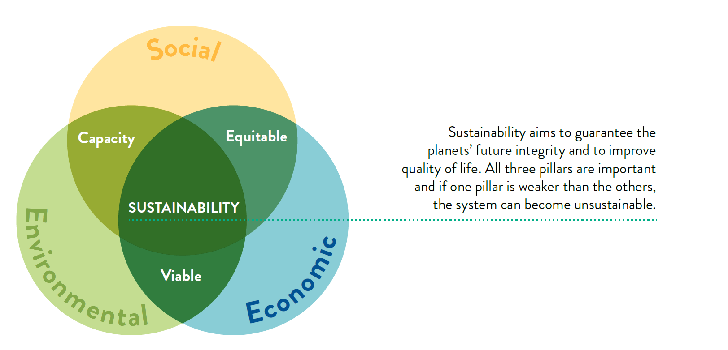Figure 5 | Three pillars for a sustainable City

*Our Community Plan 2021-25* outlines four strategic directions that align directly to the three spheres of sustainability, as illustrated below:

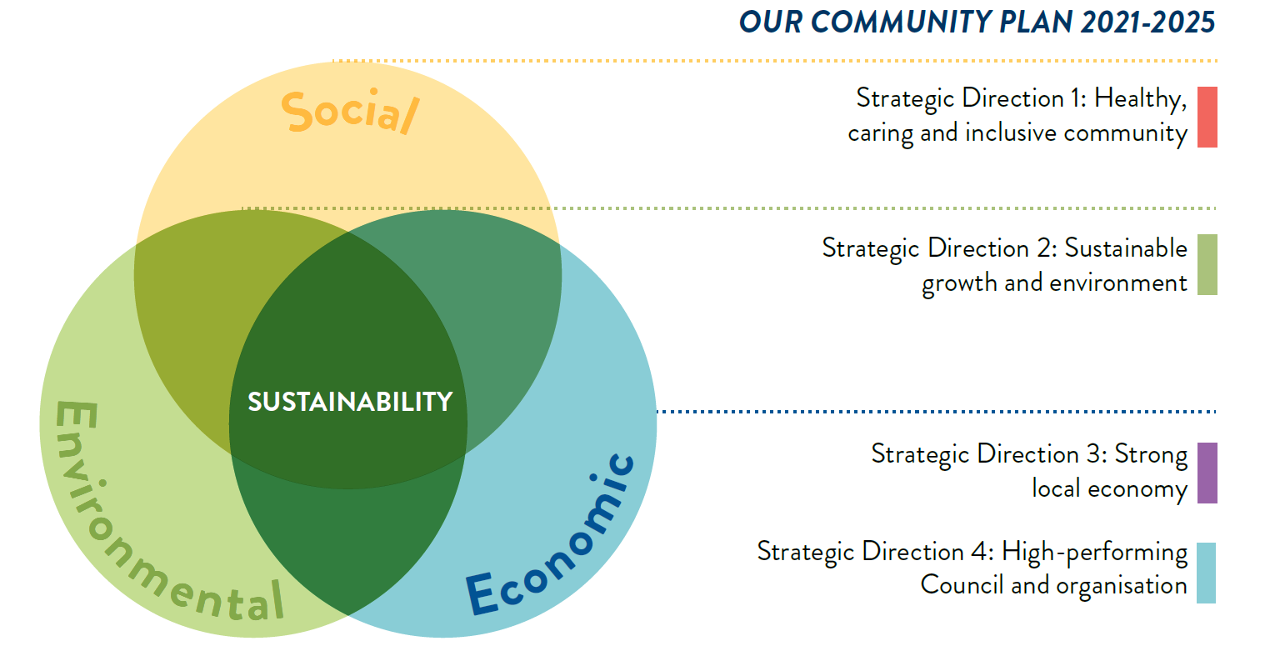Figure 6 | Sustainability delivered through our City’s strategic priorities

The Social Equity Framework aligns primarily to the ‘*social’* pillar of sustainability, providing targeted support to key priority groups to address issues of social equity. The Social Equity Framework outlines our approach to considering, consulting and designing equitable programs, services, spaces and places, across all strategic directions, and informs how specific action plans are developed and delivered.

Furthermore, it is important to also consider the influence of the ‘environment’ and ‘economic’ pillars on the priority groups identified through the Social Equity Framework. Socio-economic factors can also affect our community’s vulnerability and exposure to environmental risks - with socially disadvantaged groups being identified as more likely to suffer from the negative impacts of pollution, climate change and natural hazards. As we work to address the environmental and economic challenges of our time, in an effort to create a more sustainable future for generations to come, the Social Equity Framework will be critical to ensuring that priority groups are given adequate attention and support when planning to mitigate these risks.

Disadvantage and inequity are complex social issues that are challenging and may never be completely resolved. However, our actions as a community will make progress toward realising our shared vision. How we work with the community will be guided by the Social Equity Framework and will ensure we consider social equity in all that we do. This means ongoing consideration of ways to make our community fair for all, by providing resources and supporting priority groups in ways that are designed for them.

# NEXT STEPS

**To successfully implement this Social Equity Framework, we will take the following next steps:**

* socialising and embedding the framework into our practices (including through priority actions outlined in Appendix 1).
* continuing to develop action plans that address inequality for key groups and create opportunities for all, regardless of background
* designing engagements, services, programs, places and spaces to meet the needs of the community
* evaluating the impact of our social equity initiatives and continuing to refine these to meet changing community needs.

Social equity is key to achieving a thriving Greater Geelong that creates the best outcomes for all community members. We have worked in partnership with our community and have defined a pathway to guide us toward social equity. Our approach is collaborative and focuses on how we address our challenges together. We will work together to realise the vision of a socially sustainable Greater Geelong region that improves quality of life, creates opportunities, and removes barriers for all.

# REFERENCES

**City of Greater Geelong.** Access and Inclusion Action Plan 2018-2022

<https://www.geelongaustralia.com.au/accessibility/article/item/8d64bab74674f4c.aspx>

**City of Greater Geelong.** Ba-gurrk: A Gender Equity Framework.

<https://www.geelongaustralia.com.au/bagurrk/documents/item/8d6ab9a70541377.aspx>

**City of Greater Geelong.** Commission of Inquiry into the Greater Geelong City Council.

<https://www.parliament.vic.gov.au/file_uploads/Geelong_City_Council_Report_Combined_vn4s3j5T.pdf>

**City of Greater Geelong.** Community Engagement Policy

<https://www.geelongaustralia.com.au/governance/documents/item/654812cd.aspx>

**City of Greater Geelong.** Fair Play Strategy 2017

<https://www.geelongaustralia.com.au/common/Public/Documents/8d6539cef8d1f68-fairplaystrategy-finalreport18.09.17.pdf>

**City of Greater Geelong.** Health Equity and Planning Decision Making Tool 2021

Note: not currently available

**City of Greater Geelong.** Karreenga Aboriginal Action Plan 2014 – 2019

Note: no longer available, superseded

**City of Greater Geelong**. Managing Diversity Policy (1999)

Note: no longer available

**City of Greater Geelong.** Multicultural Action Plan 2018 - 2022

<https://www.geelongaustralia.com.au/multicultural/article/item/8cde43b4abe8ed6.aspx>

**City of Greater Geelong.** Municipal Emergency Plan 2017 – 2019

<https://www.geelongaustralia.com.au/em/management/documents/item/8cb3337e450a096.aspx>

**City of Greater Geelong.** Our Community Plan 2021- 2025

<https://geelongaustralia.com.au/ourcommunityplan/default.aspx>

**City of Greater Geelong.** Reflect Reconciliation Action Plan <https://www.geelongaustralia.com.au/rap/documents/item/8d85bb62ac4b736.aspx>

**City of Greater Geelong.** Social Infrastructure Plan – Generation One: 2020-2023

<https://www.geelongaustralia.com.au/sip/documents/item/8d8353a5236fb5e.aspx>

**City of Greater Geelong.** Sustainability Framework 2020 and Action Plan

<https://www.geelongaustralia.com.au/sustainability/documents/item/8d7bc2a4bd8bbf5.aspx>

# Appendix 1: Priority Actions

## In pursuit of social equity

Social Equity will be addressed in collaboration with our staff, stakeholders, partners and communities through the *Social Equity Action Plan 2022-2024*, as part of the Social Equity Framework.

This action plan outlines priority actions to be taken and draws on existing programs, plans and strategies, including, but not limited to:

* *Our Community Plan 2021-25*
* *Ba-gurrk: A Gender Equity Framework for the Greater Geelong region*
* *REFLECT Reconciliation Action Plan*
* *Respected, Connected and Thriving: Positive Ageing Strategy 2021-47*
* *Multicultural Action Plan 2018-2022*
* *Mental Health Action Plan*
* *Climate Change Response Plan 2021-30*
* *Social Infrastructure Plan – Generation One: 2020-23*
* *Access and Inclusion Action Plan 2018 - 22*
* *Municipal Early Years Plan 2018-22*
* *Gender+ Equality Action Plan 2022-25*
* *Diversity and Inclusion Road Map.*

|  |
| --- |
| Priority Actions |
| 1. **Incorporate Council’s Diversity and Inclusion Roadmap into relevant staff’s induction and training programs** |
| 1. **Gender Plus Impact Assessments to be incorporated into key business and community planning processes** |
| 1. **Gender Plus Impact Assessments to be conducted for programs, policy and services that have direct and significant impact on the public** |
| 1. **Determine the relevance and future use of social equity measures already in place** |
| 1. **Ensure that the summary advice on social equity implications in reports to Council are reflective of the principles and material outlined in the Social Equity Framework** |
| 1. **Define processes that link social inclusion and social equity gains, from externally funded programs, to the 30-year community-led vision *Greater Geelong: A Clever and Creative Future* measures of success** |
| 1. **Incorporate the Social Equity Principles and enablers within existing and new business and action plans** |
| 1. **Conduct regular reviews of Council services and facilities, to ensure fair and equitable access, noting the priority population groups as outlined in this framework** |
| 1. **Publish documents providing advice on matters relating to social equity** |
| 1. **Align the measurement and reporting of our social equity performance to the existing measures outlined in *Our Community Plan 2021-25* and s*ustainability reporting*** |

# Appendix 2: Legislative Context

**International context**

[International Covenant on Civil and Political Rights](http://www.ohchr.org/EN/ProfessionalInterest/Pages/CCPR.aspx" \t "_blank)

[International Covenant on Economic, Social and Cultural Rights](http://www.ohchr.org/EN/ProfessionalInterest/Pages/CESCR.aspx)

[Convention on the Elimination of All Forms of Racial Discrimination](http://www.ohchr.org/EN/ProfessionalInterest/Pages/CERD.aspx)

[Convention on the Elimination of All Forms of Discrimination against Women](https://www.ohchr.org/EN/ProfessionalInterest/Pages/CEDAW.aspx)

[Convention Against Torture and Other Cruel, Inhuman or Degrading Treatment or Punishment](http://www.ohchr.org/EN/ProfessionalInterest/Pages/CAT.aspx)

[Convention on the Rights of the Child](http://www.ohchr.org/EN/ProfessionalInterest/Pages/CRC.aspx)

[Convention on the Rights of Persons with Disabilities](https://www.ohchr.org/EN/HRBodies/CRPD/Pages/ConventionRightsPersonsWithDisabilities.aspx)

Universal Declaration on Cultural Diversity 2005

**FEDERAL LEGISLATION**

*Disability Discrimination Act 1992*

*Sex Discrimination Act 1984*

*Racial Discrimination Act 1975*

*Age Discrimination Act 2004*

*Australian Human Rights Commission Act 1986*

**STATE LEGISLATION & Policy CONTEXT**

*Racial and Religious Intolerance Act 2001*

*Multicultural Victoria Act 2004*

*Multicultural Victorian Amendment Act 2008*

The Victorian Charter of Human Rights and Responsibilities 2006

Women’s Charter <https://www.vlga.org.au/sites/default/files/190809%20Womens%20Charter.pdf>

*Gender Equality Act 2020*

Inclusive Practice Guide: <https://www.vic.gov.au/inclusive-language-guide>

Victorian Equal Opportunity and Human Rights Commission:

* <https://www.humanrightscommission.vic.gov.au/discrimination/discrimination/types-of-discrimination/gender-identity-lawful-sexual-activity-sexual-orientation>
* <https://www.humanrightscommission.vic.gov.au/human-rights/lgbti-rights>

# Appendix 3: Community Data

**Unless otherwise stated, data contained in this section was extracted from 2016 ABS Census data.**

|  |  |  |
| --- | --- | --- |
| Key Population group | First Nations peoples | |
| Facts and Stats –  Geelong population | 2402 people (1%) in Greater Geelong identify as being Aboriginal or Torres Strait Islander (2016 ABS Census). |
| Why a focus on First  Nations peoples? | We support the right of Aboriginal and Torres Strait Islander Peoples to experience the full range of choice, opportunity and influence in their lives. We acknowledge that historically, government legislation and practices enforced on Aboriginal and Torres Strait Islander Peoples have contributed to many being unable to realise their full potential. These policies have left lasting inter-generational impacts. Various pieces of government legislation and policies have contributed to dispossession of land, racism, social and emotional wellbeing issues, culture loss, family fragmentation, unemployment, poor housing, low literacy and numeracy rates, alcohol and substance misuse and poverty.  *City of Greater Geelong Reflect Reconciliation Action Plan* has been developed around four key deliverable themes including Relationships, Respect, Opportunities and Governance. It is based on priorities and aspirations identified through consultation with Traditional Owners, the local Aboriginal and Torres Strait Islander Community and input from the Working Group members.  Our Reflect Reconciliation Action Plan builds on advancing a positive relationship between Aboriginal and Torres Strait Islander Peoples and non-Indigenous people, demonstrating respect and self-determination for local Aboriginal and Torres Strait Islander Peoples ensuring equality of opportunity and access in all dealings with the community.  We aim to celebrate and promote Greater Geelong’s Aboriginal heritage, culture and achievements through funded events, our dedicated First Nations Heritage Grants program, and other targeted initiatives. | |
| Want to know more? | List/Link to City of Greater Geelong resources and policies that support this objective:   * [Reflect Reconciliation Action Plan](https://geelongaustralia.com.au/rap/documents/item/8d85bb62ac4b736.aspx) * [Kilangitj Aboriginal Advisory Committee](https://www.geelongaustralia.com.au/ct/documents/item/8d32805e697bc16.aspx) * [Aboriginal sites and venues, NAIDOC week](https://www.geelongaustralia.com.au/naidocweek/default.aspx) * [First Nations Cultural Heritage Grant Program](https://geelongaustralia.com.au/grants/article/item/8d927a95b044929.aspx) * [First Nations Woman In Community Life Award](https://www.geelongaustralia.com.au/wiclawards/article/item/8d8da696f7c0d92.aspx)   Contact: Aboriginal and Torres Strait Islander Senior Policy Officer, Healthy Communities PH: 03 5272 4480 | |

|  |  |
| --- | --- |
| Key Population group | Multicultural (Culturally and Linguistically Diverse) communities |
| Facts and Stats –  Geelong population | Countries with the highest number of people arriving to Geelong between 2011 and 2016:   * India (+1244) * China (+650) * Afghanistan (+432)   26.7% of Greater Geelong adults speak a language other than English at home. Top 3 languages:  1. Italian  2. Croatian  3. Mandarin  City of Greater Geelong has the highest percentage of people born in predominantly non-English speaking countries in the G21 region (11%).  English proficiency is an issue for 1.7% of residents (3896 people). |
| Why a focus on Multicultural? | We are committed to respecting and celebrating the cultural, linguistic and religious diversity in our community. We recognise that our multicultural communities face unique barriers to participation, including lack of accessible information, cultural differences, racism and exclusion. The City strives to create inclusive services, places and programs that responds to the community’s needs. We value richness that multicultural communities bring to the social and economic fabric of our region. |
| Want to know more? | List of City of Greater Geelong resources and policies that support this objective:  [*Our Community Plan 2021- 2025*](https://geelongaustralia.com.au/ourcommunityplan/default.aspx)  [*Multicultural Action Plan 2018 - 2022*](https://www.geelongaustralia.com.au/multicultural/article/item/8cde43b4abe8ed6.aspx)  [Reducing Racism – Community Reporting Tool](https://geelongaustralia.com.au/multicultural/article/item/8d752e1423ebb9d.aspx)  [Multicultural resources](https://www.geelongaustralia.com.au/multicultural/default.aspx)  Contact:  Multicultural Community Development Officer, Healthy Communities  PH: 03 5272 4480 |

|  |  |
| --- | --- |
| Key Population group | Refugee and Asylum Seeker communities |
| Key Population group | Refugee and Asylum Seeker communities |
| Facts and Stats –  Geelong population | Diversitat has 2026 refugee Greater Geelong clients (Humanitarian entrants who have arrived in Australia within the last 5 years). The top three ethnicities are Hazara (578 refugees), Karen (360 refugees) and Iraqi (184 refugees) (Diversitat 2020).  As of March 2021, 2.2% of asylum seekers who had arrived in Australia by boat, and settled in Victoria, were living in Greater Geelong (Department of Home Affairs 2021). |
| Why a focus on  Refugees and Asylum  Seekers? | We acknowledge that our refugee and asylum seeker communities face unique and complex challenges. These include possible experiences of persecution, violence, conflict, detainment, distance and lack of communication with families, visa insecurities, trauma and ongoing mental health issues, financial difficulties and lack of work opportunities. These challenges are in addition to linguistic and cultural barriers. We are committed to working with partner agencies to support our refugee and asylum seeker communities and ensure they are included, welcomed and valued in the Greater Geelong community. |
| Want to know more? | List of City of Greater Geelong resources and policies that support this objective:  [*Our Community Plan 2021- 2025*](https://geelongaustralia.com.au/ourcommunityplan/default.aspx)  [*Multicultural Action Plan 2018 - 2022*](https://www.geelongaustralia.com.au/multicultural/article/item/8cde43b4abe8ed6.aspx)  [Reducing Racism – Community Reporting Tool](https://geelongaustralia.com.au/multicultural/article/item/8d752e1423ebb9d.aspx)  [Multicultural resources](https://www.geelongaustralia.com.au/multicultural/default.aspx)  Contact:  Multicultural Community Development Officer, Healthy Communities  PH: 03 5272 4480 |

|  |  |
| --- | --- |
| Key Population group | People with disability |
| Facts and Stats – Geelong population | The reported need for assistance due to a severe or profound disability is higher for Greater Geelong females (6.3%) than males (5.7%). The need for assistance increases with increasing age. |
| Why a focus on people with a disability? | We value including an individual’s unique experience and understanding of their disability to create opportunities for access and equal participation. We recognise the need to reduce barriers for people with disability. These maybe created by structures, attitudes, and practices and limit opportunities for community members to fully participate. In addition, we recognise that built, social and policy environments can inhibit full participation. We are committed to supporting and improving access and choice for people with a disability. |
| Want to know more? | List of City of Greater Geelong resources and policies that support this objective: [*Our Community Plan 2021- 2025*](https://geelongaustralia.com.au/ourcommunityplan/default.aspx)[*Access and Inclusion Plan 2018-2022*](https://geelongaustralia.com.au/accessibility/article/item/8d64bab74674f4c.aspx)  [Wheelchair Accessible Taxis](https://geelongaustralia.com.au/accessibility/article/item/8ce2b032d21b09c.aspx)  [Geelong Awards for People with a Disability](https://www.geelongaustralia.com.au/disabilityawards/default.aspx)  [Disabled Parking Permits](https://geelongaustralia.com.au/parking/permit/article/item/8d90ae95ece4ea6.aspx)  Contact: Community Development Project Officer, Connected Communities Email: [SMuratti@geelongcity.vic.gov.au](mailto:SMuratti@geelongcity.vic.gov.au) |

|  |  |
| --- | --- |
| Key Population group | Women |
| Facts and Stats – Geelong population | In 2019, the victim reports of family violence incidents are higher for women than men in Greater Geelong (121.58 and 38.73 per 10,000 people, respectively) and Victoria (115.6 and 38.1 per 10,000 people, respectively) (Victorian Women’s Health Atlas 2019). |
| Why a focus on women? | We recognise the power imbalances that exist for different genders, and the impact that this inequity can have on the safety, health and wellbeing, and economic life of women and gender diverse people. It is evident that gender equality is crucial to ending violence against women and children.  We have collected qualitative data that illustrates the wide and complex range of impacts on women and gender diverse people caused by the COVID-19 pandemic, including how gender stereotypes and gendered roles were exacerbated. Negative experiences were heightened when there was more than one pre-existing challenge, such as lack of affordable housing, family violence, mental illness, disability, limited English language or limited mobility.  Gender equity is a governance, community and organisational issue. To achieve authentic gender equity, we must eliminate barriers and acknowledge and celebrate the crucial role that women and girls play in our economy and our community, and the importance of working together to create an equitable future for all.  As of 31 March 2021, we are obligated under the state government [Gender Equality Act](https://www.vic.gov.au/gender-equality-bill) 2020 to ensure that gender equity is embedded in all policies, processes and services, enabling an intersectional approach to the way the organisation does business. |
| Want to know more? | [*Ba-gurrk: A Gender Equity Framework for the City of Greater Geelong*](https://www.geelongaustralia.com.au/bagurrk/documents/item/8d6ab9a70541377.aspx)  [Women in Community Life Advisory Committee](https://www.geelongaustralia.com.au/womenincommunitylife/article/item/8d17ab36ff927e7.aspx)  [*Gender COVID-19 Impact Analysis Report and action plan*](https://cityweb.geelongcity.vic.gov.au/news/item/8d9528fd5219aff.aspx)  [Geelong Australia Family Violence, Gender and Culturally diverse support services. Gender information and resources](https://www.geelongaustralia.com.au/fv/default.aspx)  [Women’s Health & Wellbeing Barwon South West](http://www.womenshealthbsw.org.au/)  [Sexual Assault Family Violence Centre](https://www.safvcentre.org.au/)  [InTouch Multicultural Family Violence Service](https://intouch.org.au/)  [Women with Disabilities – our Place](http://wwda.org.au/)  Contact: Social Equity Policy Officer, Healthy Communities Gender Equity Officer, Healthy Communities  PH: 03 5272 4480 |

|  |  |
| --- | --- |
| Key Population group | LGBTIQA+ communities |
| Facts and Stats – Geelong population | 5% of Greater Geelong adults identify as being lesbian, gay, bisexual, transgender, intersex, queer (LGBTQ+)\* compared to 5.7% for Victoria (VAHI 2020).  \*VAHI 2020 refers to LGBTQ+ rather than LGBTIQA+ as used by the City. LGBTIQA+ includes lesbian, gay, bisexual, transgender and gender diverse, asexual, and intersex people. |
| Why a focus on LGBTIQ+? | The City works to ensure that the strength and diversity of lesbian, gay, bisexual, transgender and gender diverse, asexual, and intersex people (LGBTIQA+) are valued, celebrated and affirmed. It recognises that the LGBTIQA+ community face barriers to participation including, vilification, exclusion, lack of safety, poor mental health and health and wellbeing outcomes. The City is committed to working with the LGBTIQA+ community to build a safer and more inclusive community, which benefits from the contributions of all community members. |
| Want to know more? | List of City of Greater Geelong resources and policies that support this objective:  [‘Ba-gurrk: A Gender Equity Framework for the City of Greater Geelong'](https://www.geelongaustralia.com.au/bagurrk/documents/item/8d6ab9a70541377.aspx)  [The GASP Project](https://geelongaustralia.com.au/youth/article/item/8cbea2d51912362.aspx)  [Gender COVID-19 Impact Analysis Report and action plan](https://cityweb.geelongcity.vic.gov.au/news/item/8d9528fd5219aff.aspx)  [Geelong Australia Family Violence, Gender and Culturally diverse support services. Gender information and resources](https://www.geelongaustralia.com.au/fv/default.aspx)  Contacts: Community Inclusion, Connected Communities Youth Development Unit, Connected Communities [Email: gasp@geelongcity.vic.gov.au](mailto:Email:%20gasp@geelongcity.vic.gov.au) |

|  |  |
| --- | --- |
| Key Population group | Young People |
| Facts and Stats – Geelong population | Young people (15-24 years) make up 13.3% of the total population of the City of Greater Geelong (31,746) (2016)  The number of young people is expected to increase by 56.6% between 2016 and 2041 (from approximately 32,000 to 50,000).  In 2016, the local areas with the greatest proportion of young people were Waurn Ponds (29.3%); Lovely Banks - Batesford – Moorabool (17.6%); Corio (17.2%) and Norlane – North Shore (14.9%).  Areas projected to have a significant growth in the number of young people between 2016 and 2041 include Armstrong Creek (+3,043); Marshall - Charlemont (+2,090), Mount Duneed (+1,852) and Lovely Banks - Batesford – Moorabool (+1,780). |
| Why a focus on Young People? | The City recognises that young people make up a significant percentage of Geelong’s society and are impacted by decisions made on their behalf. The City recognises that young people face many challenges in regards to health and wellbeing, inclusion, access, voice and safety.  It works with young people to understand their aspirations and needs and to shape a future and livelihood that considers them and is sustainable and prosperous for them. |
| Want to know more? | [City of Greater Geelong- Young People](https://www.geelongaustralia.com.au/youth/default.aspx)  [Youth Council](https://www.geelongaustralia.com.au/youthcouncil/article/item/8d62f6743648767.aspx)  Youth Strategy  [Youth Spaces](https://www.geelongaustralia.com.au/common/Public/Documents/8d8353a5236fb5e-youthspacesnetworkreport-sipgenone2020-2023final.PDF)  [The fOrT](https://www.geelongaustralia.com.au/thefort/article/item/8cfccf90fc0dea2.aspx)  Contact: Youth Development Unit, Connected Communities  PH: 03 5272 5272 |

|  |  |
| --- | --- |
| Key Population group | People 55 and over |
| Facts and Stats – Geelong population | People 55 and over comprise a significant proportion of the total population of the City of Greater Geelong (CoGG). In 2016, people aged 55 years and over comprised approximately 30 per cent of the population of the City of Greater Geelong. The number of people aged 55 and over is expected to increase by 68% between 2016 and 2041 (from approximately 72,000 to 120,000).  In 2016, the local areas with the greatest proportion of residents aged 55+ years were Portarlington (54.3%); St Leonards - Indented Head (51.6%); Rural Bellarine Peninsula (42.3%) and Drysdale - Bellarine (39.5%).  Areas projected to have a significant growth in the number of residents aged 55+ years between 2016 and 2041 include Armstrong Creek (+5,417); Ocean Grove (+3,179); Mount Duneed (+2,972) and Marshall - Charlemont (+2,902). |
| Why a focus on people 55 and over | Everyone experiences ageing differently depending on biological, environmental, geographic, cultural and health factors; access to resources and support; and the inclusiveness of local environments. Targeted interventions are often required to address age specific barriers to ensure safe and equitable access to services, infrastructure and community amenity. These experiences can also be shaped by economic and social drivers such as where you live, employment background and housing stability.  Poverty is a real risk for people over 55 who are displaced from the workforce. Ageism often means they find it difficult to return to the workforce, relying on job seeker payments until they are eligible for the age pension at 67 years. This can lead to long-term experiences of poverty. Women are particularly at risk. They are often employed in a casualised workforce with low job security and little to no superannuation. Women 55 and over are the fastest growing cohort of people experiencing homelessness.  People as they age want to feel welcomed, respected and connected to other people in their community, including through intergenerational connections, neighbours and social groups. However, for some the experience of isolation has resulted in feelings of loneliness and segregation. Those from culturally and linguistically diverse populations are particularly at risk. The health impacts of this include increased risk of physical and mental health conditions such as heart disease, depression and cognitive decline. |
| Want to know more? | List of City of Greater Geelong resources and policies that support this objective  *Respected, connected and thriving - Positive Ageing Strategy 2021-47*  Access and Inclusion Action Plan 2018-2022  Social Infrastructure Plan 2020-2023  Social Housing Plan 2020-2041  Sustainability Framework  Social Equity Principles  Reflect Reconciliation Action Plan  Multicultural Action Plan 2018-22  Community Engagement Policy  Ba-gurrk Gender Equity Framework |
| More again | (external to City of Greater Geelong)  What’s Age got to do with it.  <https://humanrights.gov.au/our-work/age-discrimination/publications/whats-age-got-do-it-2021>  <https://www.theage.com.au/national/victoria/squalor-and-neglect-time-to-regulate-victoria-s-hidden-shame-20210927-p58v18.html>  Contact: Healthy Ageing Officer, Healthy Communities PH: 5272 4480 |

|  |  |
| --- | --- |
| Key Population group | Socio- economic disadvantage |
| Facts and Stats – Geelong population | **Norlane, Whittington and Corio**   * Areas with highest disadvantage (IRSD 2016 index: Corio 832; Whittington 821; Norlane-North Shore 731) * Unemployed people in Corio-Norlane represent almost **one-third** of all unemployed persons across Greater Geelong. * Over the last 10 years the unemployment rate of Corio-Norlane has been on average, **12 percentage points** higher than for Greater Geelong, with a gradually widening difference (at **14.8 percentage points** in the last 12 months). * **24% (**Norlane), **20%** (Whittington), **16**% (Corio) of young people (15-24 years) are disengaged (not employed or in education) (Greater Geelong: 9%).   Socio-economic disadvantage is not confined to certain suburbs and there are others across Greater Geelong affected, for example:   * 10.8% of households are experiencing housing stress, and 33% of rental households are in rental stress. * 9,654 people receive JobSeeker or Youth Allowance (Department of Social Services, February 2022). |
| Why a focus on Socio- economic disadvantage - Vital Communities in the 3 suburbs (Norlane, Corio, Whittington)? | The suburbs of Norlane, Corio and Whittington experience higher levels of socio-economic disadvantage compared to Greater Geelong as a whole.  Of note:   * All three suburbs are ranked in the 1st percentile for relative disadvantage (SEIFA) making them among the most disadvantaged areas in Victoria. * The *Dropping off the Edge Report (2015)* suggests that Corio and Norlane are two of the most disadvantaged areas in Australia. * In most key indicators (employment, education, housing and health and wellbeing) these suburbs rank poorly. There are also environmental issues with liveability including mobility and transport, neighbourhood activity centres, open space and social infrastructure, as well as crime and safety.   The challenges residents face are multi-faceted and influenced by structural inequalities that have a community-level impact. They are also mirrored in other areas of Australia, where outer-urban localities reliant on the manufacturing industry have become increasingly vulnerable as manufacturing has declined. Whilst Greater Geelong as a municipality has experienced significant change and challenges, the negative impacts have been unevenly felt in Norlane, Corio and Whittington. Because the outcomes of residents in those localities are so dependent on environmental and structural factors, additional effort and place-based strategies are required to support those communities to reach their potential. |
| Want to know more? | List of City of Greater Geelong resources and policies that support this objective:   * Vital Communities Project - Strategies for Alleviating Locational Disadvantage in Geelong (2021) * Social Housing Plan 2020-2041 * Corio-Norlane Structure Plan (2012)   Contact: Social and Affordable Housing Policy Officer, Healthy Communities Social Equity Policy Officer, Healthy Communities PH: 5272 4480 |

# Appendix 4: Glossary

**ACCESSIBILITY**

Accessibility refers to services, programs, facilities and places should be made available and easy to reach for all people in the community.

**ACCESS AND INCLUSION**

Access can be defined as the availability of physical features in the built environment that reduce barriers for people to participate in their community. Inclusion can be defined as fostering a culture that is open minded, unbiased and welcoming; a culture where everyone feels valued and part of the greater whole.

**CITY**

The City of Greater Geelong organisation, led by the CEO.

**COUNCIL**

The City of Greater Geelong Council comprised of elected councillors and led by the Mayor.

## DIVERSITY

Diversity refers to the visible and invisible differences that exist between people including (but not limited to) disability, sex, sexual orientation, gender identity and intersex status, age, race, ethnicity, religion, culture, physical impairment and relationship and parental status. Diversity also encompasses the ways people differ in terms of their educational background, life and working experiences, carer responsibilities, socio-economic background and geographical location[[1]](#footnote-2).

## ENGAGEMENT

A process for improved decision-making that invites the feedback from, and incorporates the insights, wisdom and concerns of, affected stakeholders and also meets the needs of the decision-making body.

## EQUALITY

Equality affirms that all human beings are born free and equal, having the same rights and are entitled to the same level of respect, treatment or prosperity regardless of gender, race, religion, ethnicity, sexuality, age, ability or religion.

## EQUITY

Equity is a concept based on the human-rights principles of justice and fairness in the distribution of services, resources, benefits and responsibilities on the basis of people’s current opportunities and barriers. It recognises that people have different needs, life experiences, levels of power and access to decision-making and that these differences should be identified and addressed in a manner that rectifies imbalances, in order to provide equitable outcomes for all.

## gENDER EQUALITY

Gender equality is the equal rights, responsibilities and opportunities of women, men and trans and gender diverse people. Equality does not mean that women, men and trans and gender diverse people will become the same, rather their rights, responsibilities and opportunities will not depend on their gender.

## HUMAN RIGHTS

Human rights are often defined in different ways, these include:

* The recognition and respect of peoples’ dignity;
* A set of moral and legal guidelines that promote and protect a recognition of our values, our identity and ability to ensure an adequate standard of living;
* The basic standards by which we can identify and measure inequality and fairness;
* Those rights associated with the United Nations Universal Declaration of Human Rights[[2]](#footnote-3).

## Social INCLUSION

Social inclusion acknowledges that every person has strengths, resources and skills and when these are contributed to a community, they add value, enhance resilience, contribute to solutions and exponentially benefit everyone. It presupposes that a society is less than it could be when parts of the community are excluded[[3]](#footnote-4).

It is a philosophy, that creates products, services, places, environments and experiences that are usable for everyone, and accessible to as many people as possible, regardless of a person’s age, level of ability, cultural background, or any other factors that contribute to the diversity of our communities.

## Social JUSTICE

Social Justice is based on principles of human-rights and fairness. It recognises the systemic causes of disadvantage. It seeks to remove barriers to enable every individual to fully and equally participate in society, regardless of gender, age, race, ethnicity, religion, culture or disability.

## Participation

Community participation is an active process whereby beneficiaries influence the direction and implementation of initiatives that affect their lives. This is done through meaningful engagement, consultation and having the community involved in decision making to enable people from all backgrounds and experiences to genuinely be a part of shaping their own community, environment and future.

Participatory Engagement

Participatory engagement involves one-way information exchange either from Council to community or community to Council. Participatory engagement typically occurs when feedback is invited on service satisfaction, ideas, alternatives or draft documents.

# Appendix 5: Case Studies

CASE STUDY 1:

MY STORY PROJECT

The MY STORY Project is one of the key events in our annual celebration of International Day of People with Disability and Inclusion Week. It is an opportunity for people with lived experience of disability and mental health challenges to find their individual voice and ‘tell their own story in their own way’.

To be as inclusive as possible, stories are told through a variety of mediums – words, paintings, digital imagery, photography, sound, music, performance and film.

The program runs over 12 weeks – from early June through to late September – with facilitators from a broad range of

professional creative disciplines volunteering to mentor the participants. Mentors work with small groups of participants each week to build their skills, confidence and capacity, and encourage them to recognise themselves as community leaders.

Facilitators and participants also come together fortnightly online to share their ideas, connect, engage and provide constructive feedback.

EMBEDDING SOCIAL EQUITY

As it is designed explicitly for people with lived experience of disability and mental health challenges, one of our identified priority groups, the MY STORY Project directly supports access, inclusion and equal participation. It also works to identify and reduce barriers experienced by some community members, while valuing their unique experiences and understanding of disability and mental health.

The MY STORY Project aligns strongly with the following Social Equity Enablers:

* Fairness: ensuring that the processes designed for the program are tailored to meet the needs of people with lived

experience of disability and mental health challenges.

* Access: reducing the barriers that could limit the opportunities of people with disability and mental health challenges to participate.
* Voice: providing a platform for people with disability and mental health challenges to communicate with the community through creativity.
* Participation: providing an experience for people with disability and mental health challenges that builds capacity

and self-efficacy, and can encourage and support greater participation in community life.

* Inclusion: providing an experience for people with disability and mental health challenges where they can feel safe,

supported and have a sense of belonging.

* Empowerment: providing an experience where participants have a strong sense of empowerment, can experience an

increase in confidence and have a sense of validation.

OUTCOMES AND IMPACT

The reach of the MY STORY Project extends well beyond the participants themselves, as both facilitators and community members engaged with the program and creative works can attest. Data from the 2020 shows the program reached:

* 119 participants
* 7 facilitators
* 6 stakeholders
* 33,627 via social media, with engagement of 1,039.

However, the impact of the program is best described by the participants themselves:

“I have gained a lot of wisdom out of the process. Sharing my story through song has been an awesome experience and I think this is just the start. I am going to keep writing songs about my life, my experiences and what matters to me.”

“It has been a privilege to be part of the MY STORY Project. To be part of something where for so long, I felt nothing. You have lifted me up with compliments and grace. I am so pleased to be alive and part of the human race.”

“It has been so special to be part of the MY STORY Project community. This was a big step to give myself permission to open up. I learnt that creativity can be expressed through so many mediums and, with this supportive community, I felt less afraid to share.”

“Every person has an incredible story worth sharing and it has been fascinating to see people express themselves in different ways and share vulnerability together. I was drawn to this project because it scared me to show vulnerability and I thought I was not creative. I have learnt so much from all the incredible people involved and I will cherish this experience forever.”

“The MY STORY project was an opportunity to share my story, decrease stigma of mental health and inspire others. But it ended up being so much more. This project helped me to heal and come to a deeper level of love and acceptance of myself. I learned to trust myself, my journey and my friends.”

LINKS TO OUR COMMUNITY PLAN

Strategic direction: Health, caring and inclusive community Desired outcome: Our community has equitable access to health and social services, information and infrastructure.



Shaylee Hester, The Dissociation Story. Photo: Andrew Mackinnon

Program link: https://www.geelongaustralia.com.au/

mystoryproject/default.aspx

CASE STUDY 2:

THE ABORIGINAL OUTREACH SUPPORT PROJECT

The Aboriginal Outreach Support Project in Whittington has been established to support local families and early years services in response to the disrupted learning experienced during the COVID-19 pandemic. As part of the project, an outreach worker supports Aboriginal children and their families to:

* maximise attendance at kindergarten for the remainder of 2021
* successfully transition to school in 2021
* increase enrolments for both 3-year-old and 4-year-old kindergarten and
* increase engagement in early learning supports, such as community playgroups.

EMBEDDING SOCIAL EQUITY

The Aboriginal Outreach Support Project supports social equity as it has been specifically designed to support not only Aboriginal families, but in particular those living in Whittington.

The Aboriginal Outreach Support Project aligns strongly with the following Social Equity Enablers:

* Fairness: allocating resources to develop bespoke, place-based processes for engagement with, and support for, local families.
* Access: working with local early years services to reduce barriers for Aboriginal families.
* Voice: providing an avenue for local Aboriginal people and Aboriginal organisations to impart their knowledge to the

local school and kindergarten, creating opportunities for increased dialogue and connection.

* Participation: creating opportunities for local families to connect and participate in community events and connect

with local organisations and services.

* Inclusion: supporting the local early years sector to provide an inviting and safe environment for local Aboriginal families, which includes a focus on cultural safety.
* Empowerment: establishing processes that support local Aboriginal families and people to provide input and influence

local services, while helping to build families’ confidence to connect with their local community.

OUTCOMES AND IMPACT

The Aboriginal Outreach Support Project has delivered a number of key actions so far, aimed at supporting stronger connections between Aboriginal families and the local early years sector.

These include:

* Whittington Early Years Open Day: a collaboration and coming together of local families and community organisations, Wathaurong Aboriginal Co-Operative, the local school and kindergarten and the local community centre.
* Early Years Open Session: engaging families with children aged between 2 and 3.5 years with supports to help them connect with Maternal Child Health, the local kindergarten and childcare, supported playgroup and the local school.
* Engagement with Local Aboriginal Elder: connecting with the local kindergarten and school to provide invaluable

knowledge and yarning.

* Children’s Week event: Encompass Enterprises, by utilising a Children’s Week Grant, completed a ‘makeover’ of the local kindergarten front garden to make the space more welcoming for local families.
* Professional Networking: connecting key organisations that support families in the local Whittington community.
* Early Years resources: focused on informing local families about local early years and school transitions, as well as
* resources aimed at early years professionals to support their work with local families. The impact of the program on the early years sector is well described by a testimonial from Angela Baum, an Early Childhood Development Officer and Best Start Facilitator Family Services:

“Working in collaboration with the Aboriginal Outreach support group has provided the opportunity to gain further knowledge on working in a culturally inclusive manner with Aboriginal and Torres Strait Islander communities and extended family networks. It has also emphasised the key issues facing First Nations families and the supports required for children and families to access, engage and participate in early childhood education and Maternal Child Health services.

Removing the barriers for families to participate in services has been a priority of the group and it has been vital to always be prepared to fit in with the community, work with key contacts, be visible, go to them, meet at times that suit them, always follow up and keep informed, involve them as part of planning.”

LINKS TO OUR COMMUNITY PLAN

Strategic direction: Health, caring and inclusive community Desired outcomes: Our community has equitable access to health and social services, information and infrastructure Four-year priorities: Strengthen relationships and partnerships with the Aboriginal and Torres Strait Islander communities in Greater Geelong

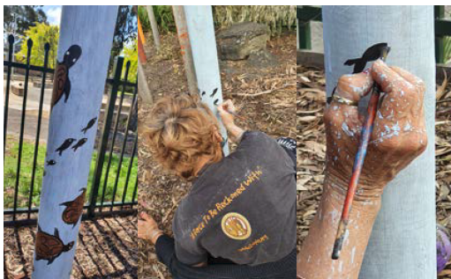

Aboriginal Art at Whittington Child and Family Centre. Photo:

City of Greater Geelong

CASE STUDY 3:

CULTURALLY AND LINGUISTICALLY DIVERSE SWIMMING PROGRAM

In 2019, we piloted a swimming program aimed at culturally and linguistically diverse (CALD) communities that was delivered to men and women separately. The program was supported by the Multicultural Action Plan Committee to help deliver on the ‘Increase social and health equity’ priority identified in our Multicultural Action Plan 2018–2022.

EMBEDDING SOCIAL EQUITY

The program is designed to meet the needs of diverse communities by tailoring the program approach to the targeted community by understanding the gendered aspects of culture. As an example, the program responded to feedback from women and young girls that they were not accessing sporting and recreational activities due to reasons including body image issues, cultural barriers and discomfort in mixed pools.

The swimming program aligns our proposed Social Equity Enablers in the following ways:

* Fairness: allocating resources to develop and maintain a program specifically designed for CALD communities.
* Access: reducing the barriers that have often limited the opportunities of CALD communities to participate in

swimming and other structured physical activities.

* Participation: providing an experience for people that builds capacity and self-efficacy and can encourage and support

greater participation in community life.

* Inclusion: providing an experience for people where they can feel safe and where they can engage in physical activity in a supported environment.
* Empowerment: providing an experience where participants can experience an increase in confidence and a sense of

control over their body.

OUTCOMES AND IMPACT

The 2019 pilot programs had significant reach over a 3-month period with participants from Karen, Karenni, Iranian, Liberian and Syriac communities. In total, the program attracted:

* 160 male participants
* 226 female participants.

The impact of the programs were described by the participants, who identified:

* how much they enjoyed meeting other people their improved connection with the community and what is available
* their increased confidence in getting out and about, as well learning water safety and swimming.

LINKS TO OUR COMMUNITY PLAN

Strategic direction: Health, caring and inclusive community

Desired outcomes: Healthy behaviours and environments are promoted, supported and accessible

Four-year priorities: Deliver health and community initiatives that are culturally sensitive and accessible across all life stages.



Splashdown Leisure Centre. Photo: City of Greater Geelong

Program link: https://www.geelongaustralia.com.

au/common/Public/Documents/8d90e4905c78437-

allwomensswimmingprogramv3.pdf

1. [https://www.lawcouncil.asn.au/docs/551ecf84-62b0-e611-80d2- 005056be66b1/Law\_Council\_Diversity\_Policy.pdf](https://www.lawcouncil.asn.au/docs/551ecf84-62b0-e611-80d2-%20005056be66b1/Law_Council_Diversity_Policy.pdf) [↑](#footnote-ref-2)
2. <https://www.humanrights.gov.au/our-work/education/human-rights-explained-fact-sheet-1-defining-human-rights> [↑](#footnote-ref-3)
3. City of Hobart, 2014: <https://www.hobartcity.com.au/files/assets/public/strategies-and-plans/city-of-hobart-social-inclusion-strategy-2014-2019.pdf> [↑](#footnote-ref-4)