St Helens Reserve Upgrade

June 2022

community engagement summary
As part of the City’s 2020/2021 budget, funding was allocated for the upgrading of the St Helen Reserve, Rippleside.
The project scope sought to improve the use of the identified space by proposing the construction of a new platform/shelter over an existing concrete slab. The upgrade will improve the use of the space and complement the park.

We worked closely with surrounding residents and asked the community for their feedback on the preferred design to ensure we meet the needs of the local community.

The four week period for feedback has closed, we had an amazing response and want to thank everyone for their valuable insights. A summary of the data and feedback is summarised below.
Visits to the Have Your Say web page.
413
NEWS

1
local newspaper article
21 DAYS
of engagement
(3 -24 May, 2022
138
Contributions received – 96 surveys and 42 Quick Poll responses

Advertising pamphlets sent
5341
People following the project
24

what you thought

86% of participants support the proposed concept.
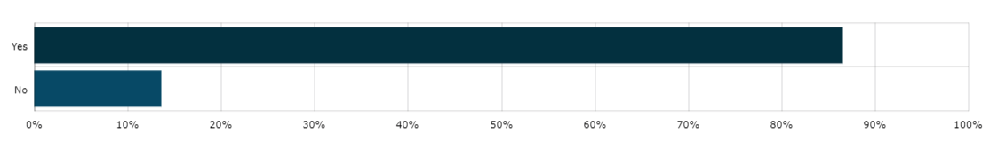
72% say they are more likely to stay longer or use the area more regularly because of the proposed concept.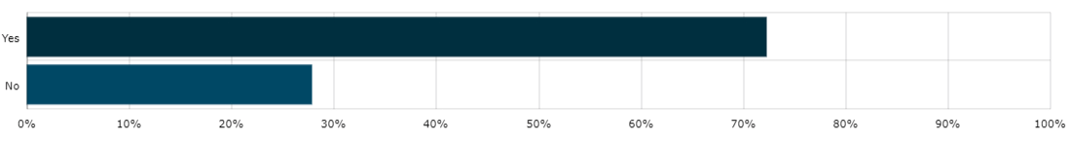

Partcipants are most likley to use the space for passive activites such as picnics, gathering and/or views/relaxation.
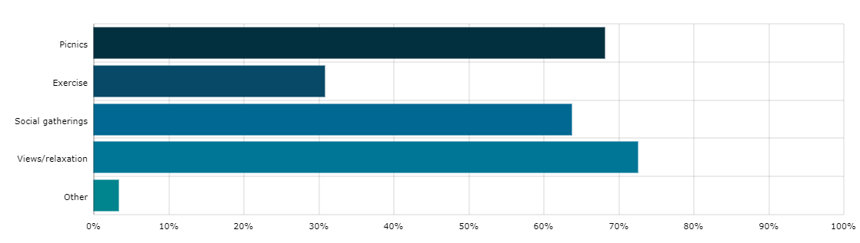
“Already have a BBQ facility 100 metres or less from this. Should just have table plus seats...no cover needed. Prefer money be used to clean up St Helens beach storm drain foreshore.”
“I use the existing site for personal training. It is well used in its current state. The existing trees on the site are well established and home to parrot wildlife during summer. It would be sad to see these trees go.”

“At present the site is used only by fitness groups. It is a wasted space that could be better utilised as a picnic/viewing space.”
“Great to see this space being upgraded, as it's a bit of an eyesore and underutilised.”

“The beautiful tree on the existing site is home to masses of parrots at the beginning of summer when the tree flowers. The tree is admired/adored by locals. There are various spaces for leisure within the park that are not used”.
“It provides a facelift, shade/shelter and seating and is inviting for residents.”
“Underwhelming facilities upgrade”.
OUtcome & Next Steps
- Taking into consideration all of the feedback and strong support for the concept, the City will proceed with the project as per the proposed design.
- Responding to some of the comments, as part of detailed design, the City will seek to have both of the existing trees retained.
- Detailed design and construction should commence late in 2022.

