The City Of
Greater Geelong

Insert project name

Engagement report

  - Insert Date

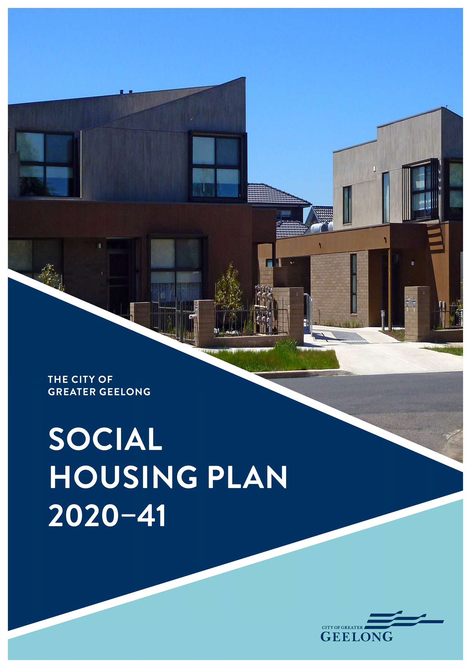
The City Of
Greater Geelong

Insert project name

Engagement report

  - Insert Date

The City Of
GREATER GEELONG
social housing on council-owned land

Engagement report

JULY 2022
CONTENTS

EXECUTIVE SUMMARY 3
THE PURPOSE OF THE ENGAGEMENT 6
Why action is required by the City for Social Housing 6
Why we engaged 6
THE ENGAGEMENT PROCESS 7
Who we engaged 7
How we engaged 7
What we asked 7
Who engaged with the City 7
SURVEY DATA AND FINDINGS 8
Overview of findings 8
116-120 Purnell Road, Corio 8
5a Dean Street, Belmont 9
2-14 Rollins Road, Bell Post Hill 10
The next steps 10
APPENDIX A: SURVEY QUESTIONS 11
APPENDIX B: DEMOGRAPHICS OF SUBMISSIONS AND ANALYSIS 14

EXECUTIVE SUMMARY

summary of WHY WE ENGAGED
Greater Geelong has a significant shortage of social housing with an estimated current shortfall of around 7,000 dwellings. It is also projected that by 2041 around 13,400 new social housing dwellings will be required to meet the community’s need. The City’s Social Housing Plan 2020-2041, adopted by Council in 2020, commits the City of Greater Geelong to supporting the growth of social housing through a range of actions including for the City to consider its own land for social housing development and make such land available to the community housing sector via a newly established Geelong Affordable Housing Trust.
The City identified three initial parcels of land to be considered for transfer to the Geelong Affordable Housing Trust for the purposes of social housing development. These sites are:
- 116-120 Purnell Road, Corio
- 5A Dean Street, Belmont
- 2-14 Rollins Road, Bell Post Hill (excluding no 8)
In February 2022, Council endorsed a 6-week community engagement in regard to the proposal to transfer these three parcels of Council-owned land. The engagement sought to understand the community’s views on the proposed transfer in order to inform Council’s decision on the matter.

summary of the engagement process
Feedback on this proposal was primarily obtained via a survey on the City’s Have Your Say online platform in addition to community members providing their views direct to council officers. The engagement and associated information sessions were promoted through a mailout to residents within a 200-metre radius of each site, onsite signage, social and print media, City News adverts and targeted emails to stakeholders as well as the City’s advisory committees and groups.
Engagement overview
People following the project
120
42 DAYS
of engagement
11
Information and feedback sessions held including:
- 8 online
- 3 onsite

736
Submissions received and over 50 emails and phone calls with council staff

Submission from City Advisory Committee members
11

Summary of findings
There were 736 survey submissions received with most submissions made by community members that had a connection to one of the proposed sites, predominantly those who live near or own a property near one of the sites. Of the 736 submissions close to 70% oppose the proposal to transfer the identified parcels of land for the purposes of social housing, however, the findings are more accurately understood when viewed as site-specific.

LEVEL OF SUPPORT - OVERALL
Level of support – overall data |  | Categories
strongly oppose | 62% | 69% oppose
oppose | 7%
neutral | 2% | 2% neutral
support | 5% | 29% support
strongly support | 24%

Site specific level of support : 116-120 Purnell Road, Corio
Level of support |  | Categories
strongly oppose | 14% | 20% oppose
Oppose | 6%
Neutral | 2% | 2% neutral
Support | 11% | 78% support
strongly support | 67%

Key themes - 116-120 Purnell Road, Corio
- Supportive of the proposal and the policy
- Good location for social housing
- Concern for potential tenants and anti-social behaviour
- Concern that Corio already has a high proportion of social housing compared to the municipality
- Preference for low density and targeted towards older people or people living with a disability.

Site specific: 5A Dean Street, Belmont
Level of support |  | Categories
strongly oppose | 53% | 61% oppose
oppose | 8%
neutral | 2% | 2% neutral
support | 6% | 37% support
strongly support | 31%

Key themes - 5A Dean Street, Belmont
- Opposed to the proposal.
- Preference to use the site as open space and for community use.
- Concern there will be a medium or high-density development and its impact on the neighbourhood.
- Concern for potential tenants and possible anti-social behaviour.
- Concern for a negative impact on property values in the vicinity.

Site specific: 2-14 Rollins Road, Bell Post Hill (excluding 8 Rollins Road)
Level of support |  | Categories
strongly oppose | 61% | 68% oppose
oppose | 7%
neutral | 0% | 0% neutral
support | 4% | 32% support
strongly support | 28%

Key themes - 2-14 Rollins Road, Bell Post Hill
- Opposed to the proposal.
- Preference to use the site as open space and retention of established trees.
- Concern for the impact on local traffic and parking.
- Concern for potential tenants and anti-social behaviour.
- Concern for a negative impact of property values in the vicinity.
The next steps
These findings will help inform the City and the Council in making decisions around the potential transfer of the identified parcels of land.

THE PURPOSE OF THE ENGAGEMENT

why action is required by the city for social housing
As identified in the City’s Social Housing Plan 2020-2041, Greater Geelong has a significant shortage of social housing with an estimated current shortfall of around 7,000 dwellings. It is also projected that by 2041, with population increases in our region, around 13,400 new social housing dwellings will be required to meet the community’s need.
Social housing is either State Government owned and managed, referred to as public housing, or owned and managed by the community housing sector by organisations called Registered Housing Associations. These organisations can develop new social housing by sourcing State Government funding and private finance, however, suitable land that is ideal for social housing is expensive and the associated costs can mean that a new social housing development is not viable. Using City-owned land, which is provided to the community housing sector at no or little cost, can reduce the costs of development significantly and mean that new housing is viable.
As a Local Government the City has a responsibility to strengthen the health and wellbeing of its community. It is well known that secure housing is critical to the health and wellbeing of everyone and that social housing is a key type of housing that provides secure homes for people and families with low incomes. Local Government also has the legislative authority to make decisions around land use and under section 14(1) of the Local Government Act 2020 (Vic) Local Government can “acquire, hold, deal with or dispose of property to perform its functions and exercising its powers”.

why we engaged
The City’s Social Housing Plan 2020-20411 commits the City to supporting the growth of social housing as a priority through a range of actions. Included within these actions is for the City to consider its own land for social housing development by making such land available to the community housing sector via a newly established Geelong Affordable Housing Trust.
Prior to transferring any land to the Geelong Affordable Housing Trust, the City decided to engage with the community in order to understand the community’s views on the transfer and to inform Council’s decision on the matter. In February 2022, Council endorsed a 6-week engagement in regard to the proposal to transfer three parcels of Council-owned land:
- 116-120 Purnell Road, Corio
- 5A Dean Street, Belmont
- 2-14 Rollins Road, Bell Post Hill (excluding no 8)

THE ENGAGEMENT PROCESS

who we engaged
The community engagement for this proposal was targeted both at residents local to the parcels of land being considered as well as the broader community.

how we engaged
Feedback on the proposal was primarily obtained via a survey on the City’s Have Your Say online platform, however, community members were also able to provide their views direct to council officers through letters, emails, phone calls and at numerous information sessions. The information sessions included three onsite, face-to-face sessions as well as eight online sessions.
These methods of engagement were promoted through a mailout to residents within a 200-metre radius of each site, onsite signage, social media, print media, City News adverts and targeted emails to stakeholders including the community services sector, the homelessness and community housing sector as well as the City’s advisory committees and groups.

what we ASKED
Community members were asked two key questions in the survey:
- To what extent do you support the Council’s intentions to transfer these three parcels of land to use for social housing? Community members were asked to rank their support: strongly oppose, oppose, neutral, support and strongly support.
- What is the reason for your response?
Additional questions were asked in order for the City to understand who was responding. This included:
- Whether respondents had a connection to one of the sites, for example if they lived nearby, owned a property nearby, operated a business nearby or worked nearby, or used to live nearby.
- Demographic questions in order for the City to monitor and ensure that the Greater Geelong community was being represented in terms of its diversity.
For the full survey, refer to Appendix A on page 11.

Who engaged with the city
The City received 736 survey submissions. Most survey submissions are from community members with a connection to one of the sites, predominantly from community members who live near and/or own a house near one of the sites. The majority of submissions received relate to 5A Dean Street and 2-14 Rollins Road with around a quarter of submissions relating to 116-120 Purnell Road, Corio.
Overall, the submissions are mostly representative of the Greater Geelong community in terms of diversity. However, this is not the case for submissions from community members identifying as “male” or from community members under the age of 18.
For the full analysis of the data relating to who responded in the community engagement, refer to Appendix B on page 14.

SURVEY DATA AND FINDINGS

overview OF FINDINGS
Level of support |  | Categories
strongly oppose | 62% | 69% oppose
oppose | 7%
neutral | 2% | 2% neutral
support | 5% | 29% support
strongly support | 24%

While overall close to 70% of submissions oppose the proposal, the findings are more accurately understood when viewed as site-specific. The following data relates to each site individually.

116-120 Purnell Road, Corio
Level of support |  | Categories
strongly oppose | 14% | 20% oppose
oppose | 6%
neutral | 2% | 2% neutral
support | 11% | 78% support
strongly support | 67%

The most common comments from community members relate to the urgent need for social housing and that the use of council-owned land for social housing is a good policy for the City of Greater Geelong.
In support of the proposal there are additional comments suggesting that 116-120 Purnell Road is a good location for social housing.
The emerging concerns for those opposed to the proposal relate to the following comments:
- potential tenants of the site with concerns that there could be anti-social behaviour.
- Corio and northern Geelong already have a high proportion of social housing and that such developments should be spread across the city.
- the use of council-land for social housing is not an appropriate use of the land.
- property values in the vicinity will be negatively affected.
There are also views on what should be considered in a future social housing development. This includes that it should be low density and cater for older people or people living with a disability.

Key themes from the community for 116-120 Purnell Road, Corio
- Supportive of the proposal and the policy
- Good location for social housing
- Concern for potential tenants and anti-social behaviour
- Concern that Corio already has a high proportion of social housing compared to the municipality
- Preference for low density and targeted towards older people or people living with a disability.

5a Dean Street, Belmont
Level of support |  | Categories
strongly oppose | 53% | 61% oppose
oppose | 8%
neutral | 2% | 2% neutral
support | 6% | 37% support
strongly support | 31%

Note: Around 80% of respondents who have a connection to this site, for example they live near or own a property near the site, are opposed to the proposal.
The most common comments from the community feedback relate to:
- a preference for 5A Dean Street to be used for open space and for community use rather than social housing.
- be maintained as green space and providing facilities for community use such as a playground, community gardens and a community building.
- a concern about any medium or high-density development on the site including issues around traffic, parking and overcrowding.
Regarding the other feedback where respondents are opposed to social housing on the site, there are concerns from local residents around potential tenants with reference to an increase in crime and anti-social behaviour. There are also concerns there may be a negative impact on property prices in the vicinity.
Where there is support for the proposal, the most common comments relate to the urgent need for social housing in the community and that the site is a good location for a social housing development.
There are some general comments stating the community has not been provided with enough detail on the potential development including the lack of a site design, the lack of impact assessments (traffic, sewage etc), and a lack of information about potential density and height.

Key themes from the community for 5A Dean Street, Belmont
- Opposed to the proposal.
- Preference to use the site as open space and for community use.
- Concern there will be a medium or high-density development and its impact on the neighbourhood.
- Concern for potential tenants and possible anti-social behaviour.
- Concern for a negative impact on property values in the vicinity.

2-14 Rollins Road, Bell Post Hill (excluding 8 Rollins Road)
Level of support |  | Categories
strongly oppose | 61% | 68% oppose
oppose | 7%
neutral | 0% | 0% neutral
support | 4% | 32% support
strongly support | 28%

Note: Around 90% of respondents who have a connection to this site, for example they live near or own a property near the site, are opposed to the proposal.
The most common comments in the feedback from the community relate to:
- the site being better used as an open space.
- concern for the possible impact on traffic and parking, which many residents see as an existing issue in the area.
- in relation to open space, there is a preference to use the site as parkland for community use.
- concerns from local residents about the loss of trees and the impact on wildlife.
Where there is opposition to the proposal there are additional concerns regarding potential tenants of the site with local residents concerned about a potential increase in crime and anti-social behaviour. Local residents are also concerned about a possible decrease in property values in the vicinity.
Where there is support for the proposal, most comments relate to the urgent need for social housing in the community and that it is a good policy for council to consider its own land for social housing development.

Key themes from the community for 2-14 Rollins Road, Bell Post Hill
- Opposed to the proposal.
- Preference to use the site as open space and retention of established trees.
- Concern for the impact on local traffic and parking.
- Concern for potential tenants and anti-social behaviour.
- Concern for a negative impact of property values in the vicinity.

The next steps
These findings will help inform the City and the Council in making decisions around the potential transfer of the identified parcels of land.

RELEVANT DOCUMENTS and links
Social Housing Plan 2020-2041
Social Housing webpage

APPENDIX A: SURVEY QUESTIONS

Please find below the questions that were asked during the community consultation period between 23 March 2022 and 6 April 2022.
To what extent do you support the Council’s intention to transfer these three parcels of land to use for social housing?
strongly oppose
oppose
neutral
support
strongly support

What is the reason for your response?

Does your response relate to:
116-120 Purnell Road, Corio
5A Dean Street, Belmont
2-14 Rollins Road, Bell Post Hill (excluding no. 8)
The use of City-owned land for the purposes of social housing
Other (please specify)

Do you have a connection to one of these sites? The types of connections are listed below in the next question.
Yes
No

If yes, what is your connection? Please select all that apply.
I own and live in a home near one of these sites
I rent a home near one of these sites
I am a landlord of a home near one these sites
I work near one of these sites
I own a business near one of these sites
I used to live near one of these sites
Other (please specify)

As this project progresses we will continue to keep you informed. How would you like us to do this? Please select all that apply.
Updates on this Have Your Say page (please ‘follow’ the page to receive updates)
Online or in-person meetings or workshops (subject to availability and COVID restrictions)
Via email (please provide email below)
Letter in post (please provide address below)
Other (please specify)

Please provide us with some information about you. This information helps us understand who is giving us feedback.

Town or suburb

What is your gender?
Male
Female
Adult or child who identifies as non-binary, gender diverse, or with descriptors other than man/boy or woman/girl
I’d prefer not to say
Other

Age group
0-18
18-24
25-34
35-49
50-59
60-69
70-84
85+

Do you speak a language other than English at home?
If yes, please specify.

Are you a member of a City of Greater Geelong Advisory Committee or Council?
If yes, please specify.

APPENDIX B: DEMOGRAPHICS OF SUBMISSIONS AND ANALYSIS

Summary of analysis
- Most submissions are from community members with a connection to one of the sites, predominantly from community members who live near and/or own a house near one of the sites.
- The submissions are mostly representative of the Greater Geelong community. However, this is not the case for submissions from community members identifying as “male” or from community members under the age of 18.

Demographic data
Do responders have a connection to the sites?
Yes | 72.58%
No | 27.42%

This connection includes: | Percentage of submissions
I own and live in a home near one of these sites | 71.84%
I rent a home near one of these sites | 10.47%
I am a landlord of a home near one these sites | 7.58%
I work near one of these sites | 5.23%
I own a business near one of these sites | 1.44%
I used to live near one of these sites | 6.68%
Other | 8.48%

Survey demographics: gender identification | Comparison to 2016 Census
Male: 35% | Male: 48.5%
Female: 61% | Female: 51.5%
Other: 6%

Age groups | Survey demographics | Comparison to 2016 Census
Under 18 | 0.5% | 21.7%
18-24 | 2.5% | 9.2%
25-34 | 24% | 12.7%
35-49 | 30% | 19.0%
50-59 | 18% | 12.8%
60-69 | 14.5% | 11.8%
70-84 | 10% | 10.1%
85 | 0.5% | 2.8%

Language other than English spoken at home | Survey demographics | Comparison to 2016 Census
Mandarin | 1% | 0.8%
Arabic | 0.5% | 0.3%
Cantonese | 0.5% | 0.2%
Vietnamese | 0% | 0.3%
Italian | 2% | 1.0%
Greek | 1% | 0.4%
Croatian | 2% | 0.9%
Persian/Dari/Hazaraghi | 0% | 0.4%
Macedonian | 2% | 0.8%
Filipino/Tagalog | 0.5% | 0.4%
German | 0.5% | 0.4%
Serbian | 0.5% | 0.3%
Punjabi | 0% | 0.3%

Survey submissions from members of the City’s committees
Access and Inclusion Advisory Committee - 2
Affordable Social Housing Advisory Committee - 2
Ageing Well Advisory Committee - 2
Multicultural Action Plan Advisory Committee - 1
Sustainability Advisory Committee - 1
Women in Community Life Advisory Committee - 2
Youth Council - 3

Survey submissions from stakeholder organisations
2 submissions are representing stakeholder organisations and these organisations also have representation on the Affordable Social Housing Advisory Committee:
  - Give Where You Live Geelong
  - Haven, Home, Safe
Note: these organisations have provided their consent to be named as a part of their submission.

© City of Greater Geelong 2022
CITY OF GREATER GEELONG
PO Box 104
Geelong VIC 3220
P: 03 5272 5272
E: contactus@geelongcity.vic.gov.au
www.geelongaustralia.com.au
CUSTOMER SERVICE CENTRE
Geelong
100 Brougham Street
Geelong VIC 3220
8:00am – 5:00pm
LATEST NEWS:
CityofGreaterGeelong
@GreaterGeelong
@CityofGreaterGeelong
@CityofGreaterGeelong

https://www.geelongaustralia.com.au/common/Public/Documents/8d7b9e5836a6cf2-socialhousingplan2020-2041.PDF
https://www.localgovernment.vic.gov.au/council-governance/local-government-act-2020
https://www.geelongaustralia.com.au/common/Public/Documents/8d9fba73410e5df-councilmeetingminutes-22february2022.pdf
https://yoursay.geelongaustralia.com.au/socialhousing

