The City Of
Greater Geelong

draft ocean grove sporting infrastructure plan (Ogsip)

interim Engagement report

  - July 2022

Contents
Executive Summary: 3
Introduction 5
Project Background 5
Engagement Purpose 5
About this Report 5
How we engaged 6
At a glance 6
communication snapshot 7
Who we engaged 8
Who we planned to engage 8
Demographics 8
What we asked 10
What we asked 10
What we heard 11
Key Findings overview 11
Breakdown of findings 11
Next steps 14
Next Steps 14

Executive Summary:
Project overview
This Draft Ocean Grove Sporting Infrastructure Plan (OGSIP) was approved at the May Council meeting for a six-week community consultation period between 30 May and 10 July 2022.
The key recommendations of the draft plan include:
- Develop soccer pitches and a new pavilion at Devlins Road Reserve, then relocate the Surfside Waves Soccer Club to the reserve.
- Convert soccer pitches at Shell Road Reserve to a second oval for football and cricket.
- Upgrade the Memorial Reserve hall and enhance the Reserve as a more informal open space whilst still hosting junior football and cricket games.
Engagement overview
The objective of the consultation was to hear from the community about the three key strategic recommendations as well as on the specific recommendations for each of the following six (6) reserves and the sporting and recreation activities conducted at them:
- Arthur Powell Reserve
- Collendina Reserve
- Devlins Road Reserve (Oakdene/Kingston)
- Memorial Reserve
- Shell Road Reserve
- Wallington Reserve
The engagement process included the following communication methods:
- Press release and placements
- Have Your Say (HYS) Project Page including online surveys
- Hardcopy flyers
- Posters
- Face-to-face consultation sessions
- Social media
- Direct e-mail campaign

Who we engaged

During the six-week consultation period, more than 350 people engaged with the City about the Draft OGSIP.
More than 20 people attended the face-to-face consultation sessions and the HYS page attracted:
- 6,902 views
- 372 contributions
- 1,670 downloads of draft plans
- 88 page followers.

What we heard

- 90 per cent of respondents supported the key strategic directions of the draft plan.
- Memorial and Wallington Reserves received 100 per cent support with respondents strongly supporting, supporting, or feeling the recommendations are ‘almost there’ for these reserves.
- Collendina Reserve also received a very strong positive response with 90 per cent of respondents feeling the same as above about Collendina.
- Responses across Arthur Powell, Devlins Rd and Shell Rd Reserves received mixed support with strong responses in favour and against the recommendations.

Next steps

- Further discussions will be scheduled with the key stakeholders of the reserves.
- We will further analyse and work through the common themes for each reserve and develop a final engagement report.
- Recommendations for change will be included in the final plan and presented to Council for endorsement.
- If endorsed, the final plan and final engagement report will be published online.

Introduction

Project Background
The draft OGSIP was approved at the May Council meeting for a six-week community consultation period between 30 May and 10 July 2022.
The primary scope and key considerations of the draft OGSIP are the following six (6) reserves and the sporting and recreation activities conducted at them:
- Arthur Powell Reserve
- Collendina Reserve
- Devlins Road Reserve (Oakdene/Kingston)
- Memorial Reserve
- Shell Road Reserve
- Wallington Reserve
Within the draft plan, the following three key strategic directions have been identified along with specific recommendations for each reserve:
- Develop soccer pitches and a new pavilion at Devlins Road Reserve, then relocate the Surfside Waves Soccer Club to the reserve.
- Convert soccer pitches at Shell Road Reserve to a second oval for football and cricket.
- Upgrade the Memorial Reserve hall and enhance the Reserve as a more informal open space whilst still hosting junior football and cricket games.

Engagement Purpose
The City invited the community to provide feedback on the Draft OGSIP.
The draft plan was developed with the input of key stakeholders and 20 user groups, including sporting clubs, community organisations and primary schools. It responds to the exponential increase in female sports participation and population growth, new design trends (female friendly, universal and environmentally sustainable design) and development of new facility standards, strategies, and policies.
The purpose of the engagement was to test the recommendations with the community and determine their level of support for the strategic and site-specific recommendations, in order to finalise the OGSIP and seek Council endorsement.

About this Report
This interim engagement report provides an initial high-level summary of the feedback received and will be used:
- To report back to the community on initial engagement findings.
- To inform stakeholders about the engagement process – planning, delivery, findings, and outcomes.
- To help develop the final plan.

A final engagement report will be included in the final plan.

How we engaged

At a glance

HOW WE COMMUNICATED
Have Your Say (HYS) Online Portal  yoursay.geelongaustralia.com.au | An online project page was designed to share information to encourage community feedback on the draft plan during the engagement period. The project page was open for feedback between 30 May and 10 July 2022.
Online surveys | The community was invited to interact by:  - Voting in a quick poll on the key recommendations in the draft plan.  - Provide feedback on each of the six reserves.  - Sharing feedback and level of support for the recommendations for each of the six reserves.  - Provide feedback on the overall draft plan.
Face-to-face community consultation sessions | Three two-hour face-to-face community consultation sessions at the following dates and locations:  - Saturday 18 June, 10.00am - 12noon, Wallington Reserve Pavilion  - Monday 20 June, 4.30pm - 6.30pm, Shell Road Reserve Pavilion  - Tuesday 21 June, 4.30pm - 6.30pm, Arthur Powell Reserve Pavilion
Posters, Postcards & Letterbox drop | 723 Flyers were delivered to residents neighbouring the reserves included in the draft plan. Posters were also placed at those reserves.
Written submissions | Written submissions were open at any time during the engagement period.
direct e-mail campaign | An e-mail to 1,732 Geelong Australia HYS followers was sent.
social media campaign | Social media posts promoting the consultation sessions were published.
Media release & press placements | A media release launched the engagement and was followed with press placements in City News publications across three different weeks.

communication snapshot

Who we engaged

Who we planned to engage
The main emphasis of the engagement was to give the community in Ocean Grove, Wallington and surrounds a chance to review and provide feedback on the identified recommendations for the reserves listed in the draft plan.
The six-week consultation period in combination with the variety of engagement tools used to engage, allowed time to reach stakeholders across the community, local residents, users, and visitors of the reserves. It also gave our local sports clubs, community groups and their members a chance to provide further feedback.
During the six-week consultation period, more than 350 people engaged with the City about the Draft Ocean Grove Sporting Infrastructure Plan. Of these, 84 per cent engaged online with 16 per cent engaging through written submissions, letters of support, and at our face-to-face consultation sessions.
Top Visited Pages on the HYS page
Page Name Visitation Visits Visitors
Ocean Grove Sporting Infrastructure Plan 91.76% 2,629 2,110
Devlins Road Reserve 16.96% 486 452
Collendina Reserve 16.09% 461 431
Wallington Reserve 14.21% 407 368
Shell Road Reserve 11.45% 328 307
Memorial Reserve 11.24% 322 302
Arthur Powell Reserve 8.34% 239 232

Demographics
The community were invited to share some demographic data with us, primarily through our HYS page.
From this data we can see that over 70 per cent of the responses came from members of local sports clubs and community groups.
Whilst the majority of the respondents live in Ocean Grove and Wallington (62 per cent combined), the draft plan also got a good broader response with 85 per cent of the respondents nominating a town or suburb within the Bellarine Peninsula as their home.

Other participation data included:
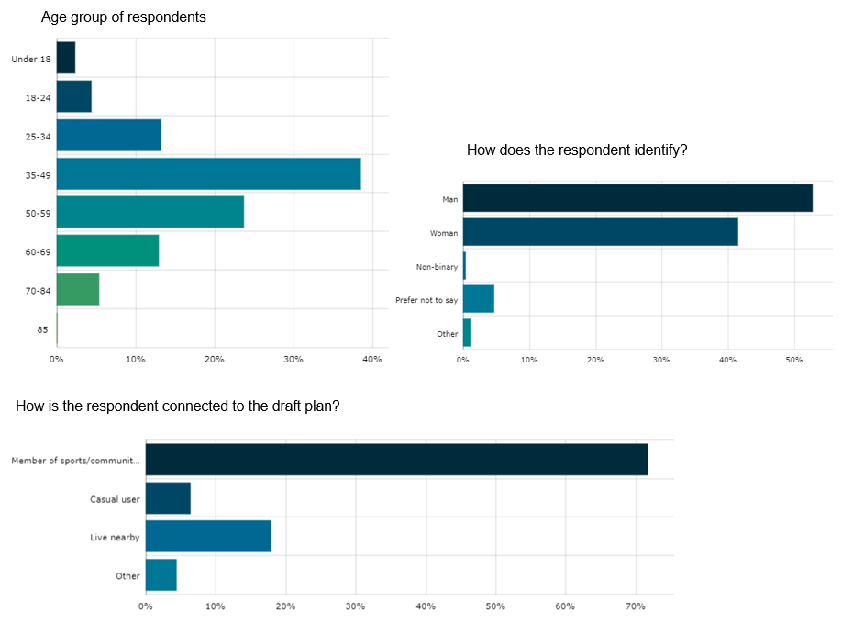

What we asked

What we asked

We asked the community to reflect on the identified key strategic directions of the OGSIP.
Respondents could select all reserves they wished to provide feedback on and were asked the following question for each reserve:
- Are you supportive of the recommendations for X reserve? (multiple choice: strongly support through to not supportive)
- Please tell us the reason for your response. (open text response)
- Is there anything else you think needs to be addresses at the reserve? (open text response)

A final question seeking general feedback on the draft plan was included at the end of each survey:
- Is there anything else you would like to share with us about the Draft Ocean Grove Sporting Infrastructure Plan? (open text response)

In addition to the survey, a ‘quick poll’ on the home page of the HYS page asked:
- Do you support the key strategic directions of the OGSIP? (yes/no answer)

What we heard

Key Findings overview
The objective of the consultation was to hear from the community about their feedback – and level of support – on the main three recommendations of the plan as well as on the specific recommendations for each of the six reserves.
This interim engagement report focuses only on the number of responses received and the level of support received for the OGSIP overall as well as the recommendations for each of the individual reserves.
All open text responses received 544 responses relating to individual reserves and 119 relating to the OGSIP overall.
The responses will continue to be reviewed with key themes identified and discussed with key stakeholders.
A final engagement report will be prepared and published on the HYS platform upon completion.
Support for key strategic directions
32 people responded to the quick poll asking the community if they supported the key strategic directions of the draft plan and 90 per cent (29) responded ‘yes’.
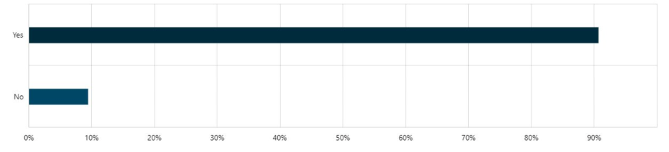

Breakdown of findings
Number of responses per reserve
The number of responses and level of support varied greatly between the reserves.
Arthur Powell only received 16 responses whilst 171 people provided feedback on the recommendations for Wallington Reserve. This equates to more than 55 per cent of all responses as per graph below.
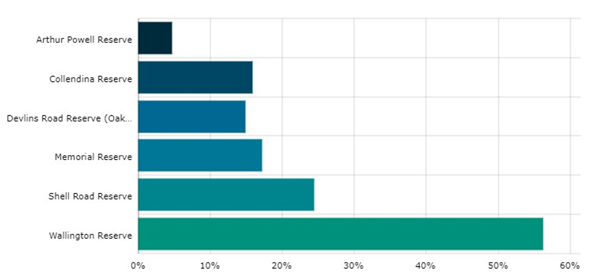
Level of support per reserve
As for level of support, 100 per cent of respondents provided either strong support, support or let us know we were almost there with the recommendations for both Memorial and Wallington Reserves.
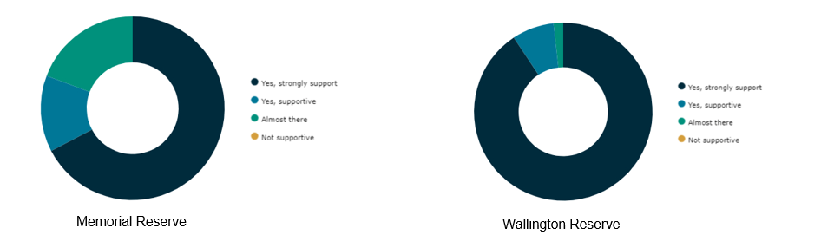
Collendina Reserve also had a mostly positive response with almost 90 per cent of respondents supportive or expressing we were almost there with the recommendations.
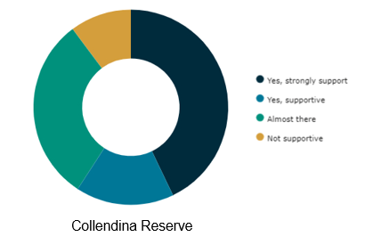
Arthur Powell, Devlins Rd and Shell Rd Reserves received mixed responses with both a strong base supporting and not supporting the recommendations.
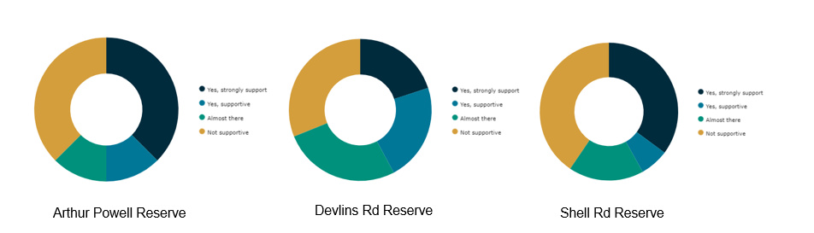

OVERARCHING THEMES

The following overarching themes came through in workshops and survey responses:
Reserve | overarching theme
Arthur powell reserve | Split support for recommendations centred around availability of the two public courts for the community.
collendina reserve | Strong support for recommendations.  Allocate an overflow ground to Collendina Cricket Club.  Address traffic and pedestrian safety at reserve.
devlins rd reserve | Need for Devlins Rd Master Plan to give soccer club the security they need to support the proposed move.
memorial reserve | Very strong support for recommendations.  Hall not compliant for pickleball which needs an outdoor home to cater for exponential growth.  Oval needs training lights and fencing.
shell rd reserve | Strong support for football, netball, and cricket upgrades.  Concerns from soccer community regarding proposed move to Devlins Rd and need for more clarity and security.
wallington reserve | Very strong support for upgrades.  Pavilion in desperate need of female friendly upgrades.  Outdoor public tennis courts could be re-surfaced and line-marked to make Wallington the home for outdoor pickleball.

Next steps

Next Steps

- This interim engagement report will be posted on the HYS project page and shared directly with all followers of the page.
- An e-mail with the interim results will be sent to the key stakeholders.
- All feedback received will continue to be reviewed with key themes addressed and used to finalise the Ocean Grove Sporting Infrastructure Plan.
- Further discussions will be held with key stakeholders on the key themes and recommendations coming out of the community engagement.
- The final OGSIP, along with the final engagement report, will then be presented to Council for adoption.
- If endorsed, the final Ocean Grove Sporting Infrastructure Plan, including final engagement report, will be published on the Have Your Say project page and Geelong Australia website.

