CITY OF GREATER GEELONG

URBAN FOREST STRATEGY

2015 – 2025

CITY OF GREATER GEELONG URBAN FOREST STRATEGY **1**

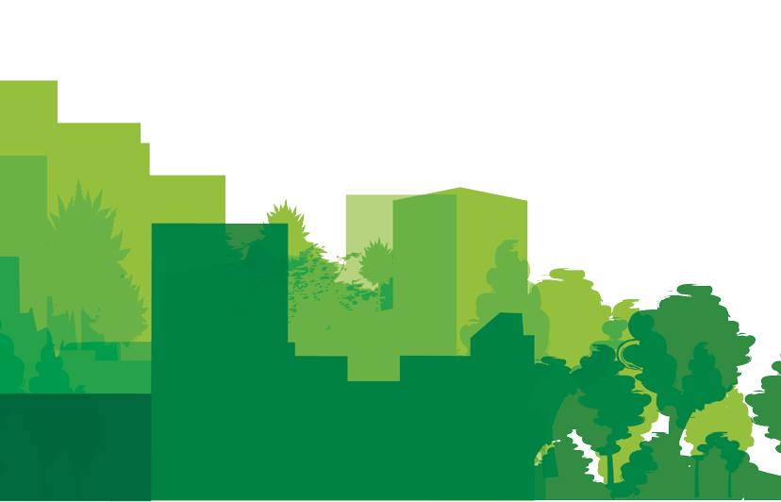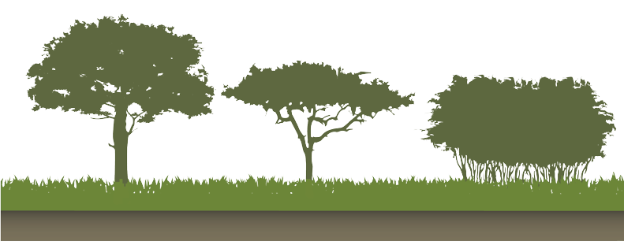

[**WWW.GEELONGAUSTRALIA.COM.AU**](http://WWW.GEELONGAUSTRALIA.COM.AU/)

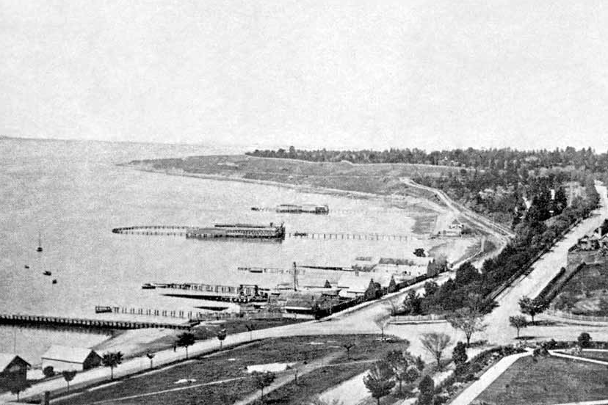

*“Geelong’s trees have played a key role in the*

*identity and character of the City since 1851”*

**2**

CITY OF GREATER GEELONG URBAN FOREST STRATEGY

CITY OF GREATER GEELONG

URBAN FOREST STRATEGY

REFERENCES

GLOSSARY

ACTION PLAN

GEELONG’S URBAN FOREST OF THE FUTURE

VISION, OBJECTIVES AND PERFORMANCE MEASURES

OPPORTUNITIES FOR GEELONG’S URBAN FOREST

ISSUES SURROUNDING GEELONG’S URBAN FOREST

GEELONG’S URBAN FOREST

TREE SPECIES DIVERSITY

STREET TREE HEALTH, STRUCTURE AND AGE USEFUL LIFE EXPECTANCY

TREE HEIGHT CANOPY COVER

THE ECONOMIC VALUE OF GEELONG'S URBAN FOREST

WHY AN URBAN FOREST STRATEGY FOR GEELONG?

WHY IS GEELONG’S URBAN FOREST IMPORTANT?

INTRODUCTION

CONTENTS

EXECUTIVE SUMMARY

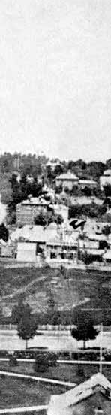

5

7

9

15

19

20

21

22

23

24

26

29

31

39

41

48

50

**3**

CITY OF GREATER GEELONG URBAN FOREST STRATEGY

**1**

EXECUTIVE SUMMARY

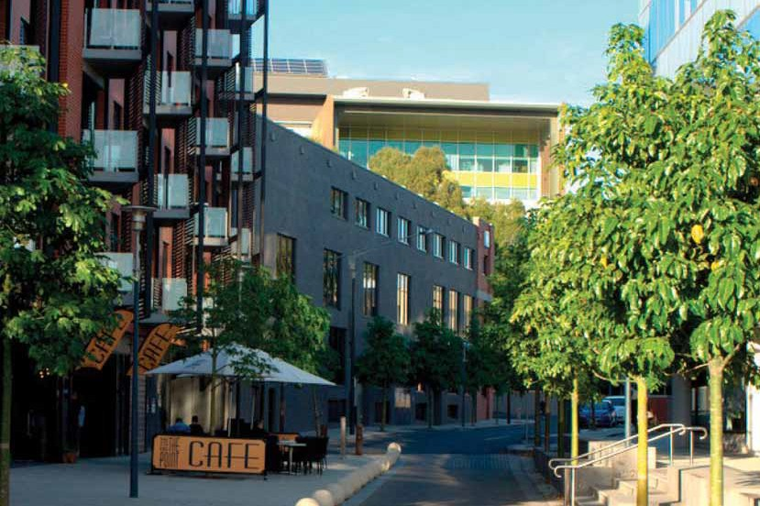

*“Geelong will be a cool green city for the future”*

**4**

CITY OF GREATER GEELONG URBAN FOREST STRATEGY

**5**

CITY OF GREATER GEELONG URBAN FOREST STRATEGY

By incorporating these opportunities into Council's planning framework, engaging our community to fully appreciate the City's trees and by continuing to utilise best practice urban tree management techniques we will ensure that Geelong will be a cool green city for the future.

Rejuvenating and renewing avenues and boulevards in heritage landscapes

Planting more indigenous trees in wetland reserves and conservation areas

Thousands of tree planting locations across Geelong's open space network

Revegetation of the Greenway, the Ted Wilson Bike Trail alongside the Geelong Ring Road

Developing tree lined entrances to our city

45,000 existing vacant nature strips in our streets

•

•

Improving the quality of streetscapes and open space in urban growth areas

•

•

•

•

•

**3**

The City has enormous potential to develop a healthier and more dynamic urban forest and improve canopy cover in our streetscapes, urban growth areas, open spaces and reserves. The prime opportunities are:

The City will utilise smarter and targeted planning, innovative and integrated tree planting solutions and develop partnerships internally and externally to reach an ambitious target of improving Geelong's tree canopy cover from 14% to 25% over a thirty year period.

**4 TO DEMONSTRATE BEST PRACTICE URBAN TREE MANAGEMENT**

Develop a complete set of technical guidelines for urban tree management and offer training and upskilling where needed

**TO ENGAGE THE CITY'S COMMUNITY AND BUILD REGIONAL PARTNERSHIPS**

More community activities: tree planting, arts and culture activities, use of social media, working with partners to improve and enhance tree planting projects

**1 TO GREEN THE CITY**

Increase tree planting and associated vegetation in appropriate and prioritised locations

**2 TO COOL THE CITY**

Increase canopy cover, increase use of smart water sensitive urban design and an increase in landscape permeability



This strategy will achieve it's vision by adopting four simple objectives into the City's day to day operations:

The Urban Forest Strategy expands on the concept of City in a Park, which is focused on Geelong's CBD, to enhance the public and private tree population in all of the suburbs and townships across Greater Geelong. The sum of all these trees and associated vegetation is called the urban forest.

VISION:

Geelong will be a cool green city for the future

*The City of Greater Geelong values the immense benefits of the City's urban tree population. Our trees provide shade and cool the city. They improve the look, feel and liveability of Geelong. They also have a strong positive influence on the health of our community. Geelong's trees are extraordinarily valuable assets that are worth investing in for the future.*

*to Geelong’s liveability”*

**2**

INTRODUCTION

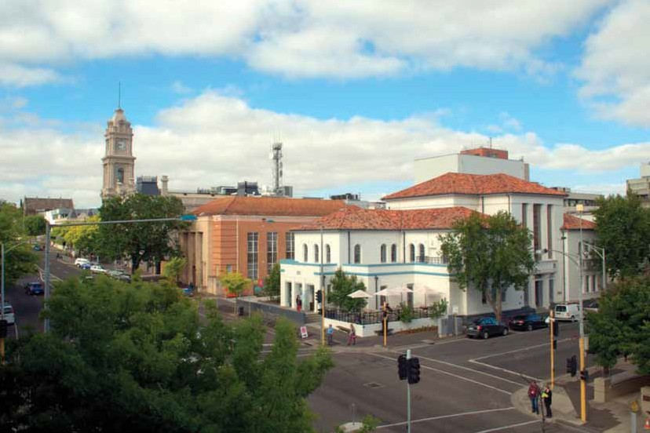

*“Trees make an important contribution*

**6**

CITY OF GREATER GEELONG URBAN FOREST STRATEGY

**Provide the framework for building future**

**relationships with private landholders to**

**encourage growth of the private realm**

**urban forest.**

**100%**

**75%**

**50%**

**20%**

**5%**

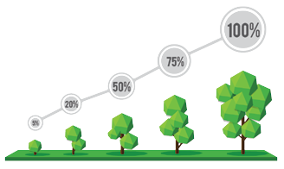

**Set key targets for the performance of the public**

**urban forest.**

**1**

The Strategy will specifically bridge the gap between the existing Council policy framework and the day to day work of the Tree Management Team. It will ensure that some of the goals set in City Plan, the Environment Management Strategy and the Health and Wellbeing Plan link into clear operational objectives to enhance urban greening.

The Urban Forest Strategy will primarily set guidelines for the management of the City's urban tree network which includes all satellite townships within the Municipality such as Lara, Ocean Grove and Barwon Heads. It excludes all rural roadways and rural land. The Strategy will also recognise the importance of the private realm and of all open space in Geelong in contributing to the urban forest.

The City’s public trees are an important component of Geelong’s urban forest. The urban forest is the sum of all vegetation across the City of Greater Geelong, excluding rural land. It contributes an extraordinary array of social, economic and environmental benefits to Geelong. Public trees, private gardens, remnant vegetation, waterway plants, green roofs and walls are all a part of Geelong’s urban forest.

**Geelong’s Urban Forest Strategy will:**



*Geelong’s trees have played a key role in the identity and character of the City since 1851*

*when the then Government set aside 200 acres of bay frontage for the development of the Geelong Botanic Gardens. Since then, Geelong’s trees have continued to quietly play an integral part in Geelong’s liveability, the health and wellbeing of Geelong’s community, its local ecosystems and biodiversity and the character of Geelong’s neighbourhoods and precincts.*

**2**

**7**

CITY OF GREATER GEELONG URBAN FOREST STRATEGY

**3**

RATIONALE

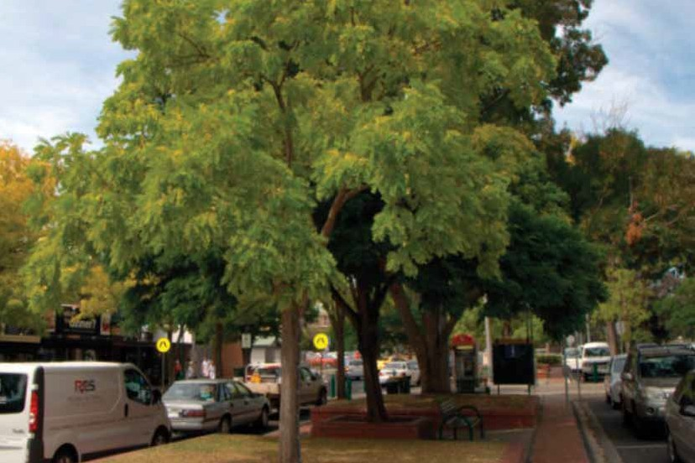

*“A healthy urban forest is critical for any city that*

*prioritises its environmental and social outcomes”*

**8**

CITY OF GREATER GEELONG URBAN FOREST STRATEGY

A connection to nature, especially for children

A unique City brand - attractive, well maintained green spaces reflect proactive and innovative Council management

A food source

Carbon storage and sequestration

Wind abatement

Air pollution amelioration

Energy savings in buildings through shading of walls and roofs

Amenity and landscape aesthetics

A sense of place

WHY IS GEELONG’S URBAN

FOREST IMPORTANT?

A healthy urban forest is critical for any city that prioritises its environmental and social outcomes. Geelong’s urban forest is a valuable community asset that crosses public and private boundaries, enhancing the local environment and providing a green network of spaces for the community to utilise. Geelong’s urban forest is important as it provides the following benefits:



Shade from tree canopies and reduction in sun exposure

Reduction of heat exposure during heatwaves

Improved property values along tree-lined streets

More attractive commercial and retail centres

Rainfall and stormwater interception, resulting in reduced stormwater flows into the bay and rivers

Microclimatic moderation for human thermal comfort

**9**

CITY OF GREATER GEELONG URBAN FOREST STRATEGY

Habitat for wildlife, particularly birds

Stormwater run-off is 62% higher from asphalt than from turf or tree pits.

Geelong’s street trees store 19,000 tonnes of carbon and sequester over 1,300 tonnes per year.

Geelong has 75,268 street trees and over 45,000 urban park trees.

Geelong’s public urban trees are worth over $370m.

DID YOU KNOW?



*“Geelong has 75,268 street trees and over*

*45,000 urban park trees”*

**10**

CITY OF GREATER GEELONG URBAN FOREST STRATEGY

Up to 80% of the cooling effect of trees is directly from shading.

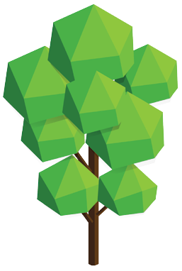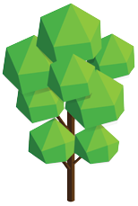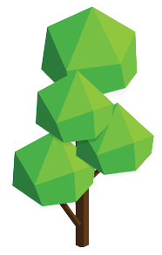

The public urban forest alone absorbs around four Olympic sized swimming pools of stormwater each year, preventing run-off into the bay.

The presence of street trees can improve residential property values by up to 30%.

**11**

CITY OF GREATER GEELONG URBAN FOREST STRATEGY

Large healthy trees can remove between 60 and 70 times more air pollution than smaller trees.

Temperatures can be between 5o Celsius and 20o Celsius cooler underneath tree canopies.

**20.0°C**

**20.0**

**25.0**

**30.0**

**35.0**

**40.0**

**45.0**

**50.0**

**50.0°C**

*Unshaded roadway is 15 degrees Celsius hotter than asphalt shaded by a tree.*

AMBIENT TEMPERATURE:

**33 DEGREES CELSIUS**

DATE:

**24 FEBRUARY 2015**

TIME:

**4.20PM**

SURFACE TEMPERATURE

REDUCTION EXAMPLES

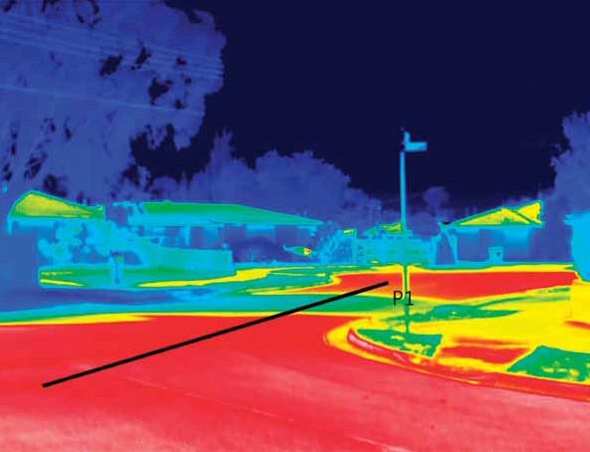

**12**

CITY OF GREATER GEELONG URBAN FOREST STRATEGY

**MEASUREMENT OBJECT**

**MAX TEMP (°C)**

**MIN TEMP (°C)**

**EMISS.**

**REFLECTED TEMP (°C)**

**AVERAGE TEMP (°C)**

Profile line (P1)

45.1

30.5

1.0

20.0

41.4

**EXAMPLE 1: ORBIT DRIVE WHITTINGTON**

**20.0**

**25.0**

**30.0**

**35.0**

**40.0**

**45.0**

**50.0**

**50.0°C**

*Asphalt shaded by trees is 19 degrees Celsius cooler than unshaded asphalt.*

AMBIENT TEMPERATURE:

**31 DEGREES CELSIUS**

DATE:

**24 FEBRUARY 2015**

TIME:

**5.00PM**

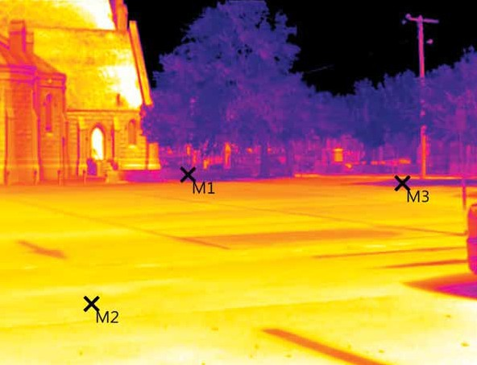

**20.0°C**

**13**

CITY OF GREATER GEELONG URBAN FOREST STRATEGY

**MEASUREMENT OBJECTS**

**TEMP (°C)**

**EMISS.**

**REFLECTED TEMP (°C)**

**REMARKS**

Measure point 1

28.2

1.00

20.0

Shaded

Measure point 2

46.8

1.00

20.0

Unshaded

Measure point 3

27.8

1.00

20.0

Shaded

**EXAMPLE 2: MYERS STREET HAYMARKET CARPARK**

DIAGRAM: A word cloud of issues important to the Geelong community captured in Vision 2.

**renew**

*attract*

unique

city

*improving*

water**climate**

*ecological* **neighbourhood**

place

**Geelong**

Healthy people **retailstrips**

**Urban** *change*

vibrant

**environment**

**character** communities

**performance**

**4**

GEELONG’S STRATEGY

**streetscapes**

*“Another pull quote from supplied section*

*nserted here”*

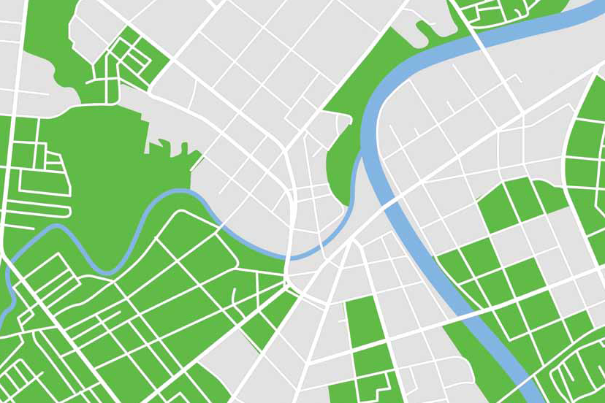

green

heritage

greening

*beautiful*

**sense**

*spine worldclass*

**stormwater**

*prosperous*

**enhance**

life

*spaces* river

**14**

CITY OF GREATER GEELONG URBAN FOREST STRATEGY

**Economy** - Economic transition and urban renewal are a key part of Geelong’s future. These processes require Geelong to enhance its unique character and its city brand, enticing investment and consumer spending. Public amenity is crucial to city branding, and the urban forest, through parks and gardens, tree lined streets, boulevards and city entry points contributes significantly. Places such as Brougham Street, Eastern Park and the foreshore currently demonstrate this renewal and unique character and should be replicated across the City.

WHY AN URBAN FOREST

STRATEGY FOR GEELONG?

Geelong has the capacity to establish itself among the world’s most innovative and liveable cities by recognising the role its urban forest plays in its future. There are three main drivers that support the development of an Urban Forest Strategy for Geelong: community demand, consideration of Geelong’s future and Council’s policy context.

A series of community consultation programs have been held in recent years to inform some of Council’s most important documents such as City Plan, the Environment Management Strategy and the Central Geelong Action Plan. In each of these consultations, the Geelong community demanded more urban greening.

**Climate Change** - Geelong faces a series of challenges as outlined in the City's Climate Change Adaptation Strategy: extreme weather events such as storms, heatwaves, flooding, sea-level rise and community and infrastructure vulnerability. The urban forest helps build ecological resilience towards these challenges through carbon storage and sequestration, stormwater interception, shade and cooling and wind abatement.

**Community Health and Wellbeing** - The future health of Geelong’s community is underpinned by multiple factors, not least the availability of quality open space, the Community’s engagement with nature within the City and behaviours towards physical activity. The urban forest offers a vast array of critical benefits to the people of Geelong and its management needs to incorporate factors such as social equity and encouragement of physical activity.

**15**

CITY OF GREATER GEELONG URBAN FOREST STRATEGY

**2. GEELONG’S FUTURE**

**1. COMMUNITY DEMAND**

**OPEN SPACE**

**STRATEGY**

**STRATEGY**

**BIODIVERSITY**

**CLIMATE**

**CHANGE**

**ADAPTION**

**STRATEGY**

**URBAN**

**FOREST**

**STRATEGY**

**PLAY**

**STRATEGY**

**ENVIRONMENT**

**MANAGEMENT**

**STRATEGY**

**CITY PLAN**

**2013-2017**

**PUBLIC**

**HEALTH AND**

**WELLBEING**

**PLAN**

**CENTRAL**

**GEELONG**

**ACTION PLAN**

Sets a mission to address biodiversity proactively and effectively through participation and partnerships

Promotes active lifestyles: the provision of healthy green open space is paramount for encouraging people outdoors

Commits to incorporate the natural environment, including trees to provide natural shade, within play spaces

Seeks to quantify the benefits of urban trees and encourage their strategic placement through the Urban

Forest Strategy

**5**

**6  
  
7**

**The Open Space Strategy (DRAFT)**

* Sets the platform for improvement in the quality of open space through the provision of natural shade by trees

**1**

**2**

**3**

**4**

**City Plan 2013-2017**

* Commits to an increase of 400 advanced street trees per year

**The Environment Management Strategy**

**2013-2017**

* Mandates the development of an Urban Forest Strategy
* Sets out the delivery of the One Planet principles, particularly Land Use and Wildlife

**8**

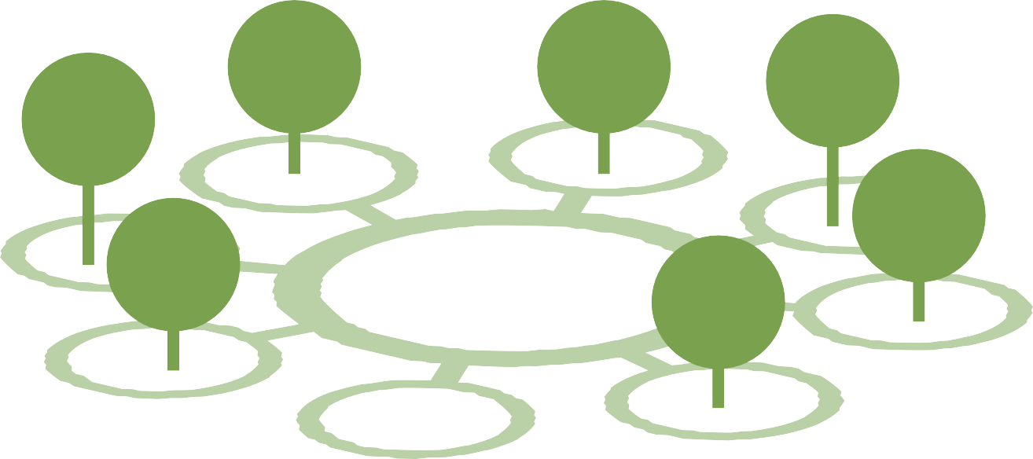

There are eight key Council documents that provide the framework for developing an Urban Forest Strategy for Geelong:

**The Climate Change Adaptation Strategy**

**2011**

•

**Geelong Play Strategy 2012-2021**

•

**Geelong’s Health and Wellbeing Plan**

**2013-2017**

**The Central Geelong Action Plan 2013**

•

•

Commits to growing a “City in a Park”

**The Biodiversity Strategy 2013**

•

**16**

CITY OF GREATER GEELONG URBAN FOREST STRATEGY

**1. POLICY CONTEXT**

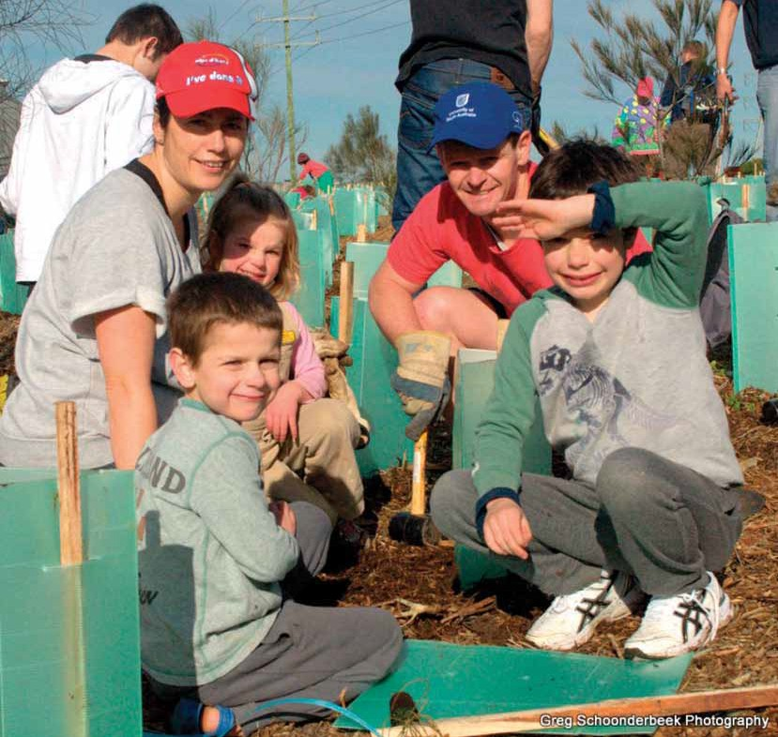

*“Geelong has the capacity to establish itself among the*

*world’s most innovative and liveable cities by recognising the role its urban forest plays in its future”*

**17**

CITY OF GREATER GEELONG URBAN FOREST STRATEGY

**5**

GEELONG’S URBAN FOREST

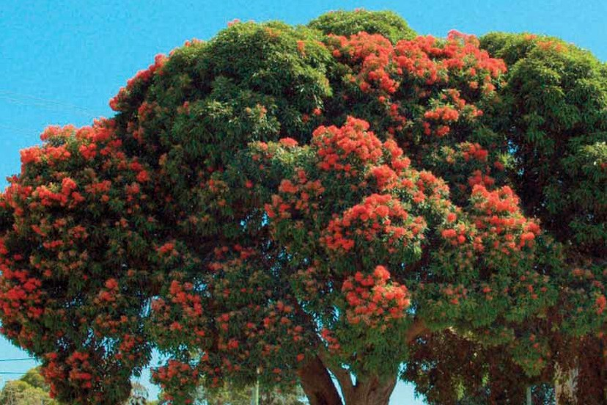

*“The urban forest promotes Geelong’s liveability*

*and influences neighbourhood characters”*

**18**

CITY OF GREATER GEELONG URBAN FOREST STRATEGY

**45,000**

**PARK TREES**

**75,268 +**

**STREET TREES**

**120,268 =**

**URBAN TREES**

Certain tree attributes were collected as part of the audit to model the dollar value of the environmental benefits that Geelong’s urban forest provides. Vacant tree sites were also measured to provide an indication of the opportunity available for increasing the tree resource.

To obtain an overall understanding of this status certain qualitative and quantitative criteria are analysed: species diversity, tree health and structure, useful life expectancy, tree age and canopy cover.

An audit of the City's existing street tree population was completed in 2014 providing information on their current status. This data only pertains to street trees and does not include park or conservation reserve trees. Whilst open space is an important provider of tree coverage, street trees provide greater design and maintenance challenges and are also more valuable for providing streetscape liveability.

This Strategy will provide a framework in which to actively manage the urban tree population including urban streets, urban parkland and urban conservation reserves for improved environmental, social and economic outcomes for Geelong.

Geelong’s urban forest is the sum of all vegetation across the City of Greater Geelong, excluding rural land. Council itself is responsible for managing around 120,000 urban trees: 75,268 trees in streets and around 45,000 trees in parks. Council also manages trees in conservation reserves and those along rural roadways, waterways and bike trails. Conservation areas in particular are addressed in Council’s Biodiversity Strategy. Whilst rural parkland trees and rural conservation areas are an important component of Geelong’s natural landscapes, urban trees have greater monetary values and more direct and positive health impacts in areas of greater human density and are therefore worth strategically managing and investing in. Council will continue to encourage private landholders to revegetate rural landholdings and Council will manage rural conservation reserves to complement the Urban Forest Strategy.

More than this, Geelong’s trees help characterise the City into what it is today: from the heritage values of the majestic Elm trees to the beauty of the lemon scented gums planted along Brougham Street, the Palms along Moorabool Street and the Norfolk Island Pines lining Geelong’s waterfront. Without our trees, Geelong would be a very different place.

*Geelong’s trees are a valuable, vibrant part of the city providing a vast array of environmental,*

*social and economic benefits to the local community. The urban forest promotes Geelong’s liveability and influences neighbourhood characters. It sequesters and stores carbon, enhances our local biodiversity, reduces stormwater run-off into rivers and the bay, absorbs air pollution and shades the city and its hard surfaces during hot summers.*

**The City of Greater Geelong is responsible for managing the following;**

**19**

CITY OF GREATER GEELONG URBAN FOREST STRATEGY

**1**

**2**

**3**

**4**

**5**

**6**

**7**

**8**

**9**

**10**

**% OF POPULATION**

**COMMON NAME**

**SPECIES**

TREE SPECIES DIVERSITY

Geelong’s streets house around 230 different tree species with the most common being Callistemon. The top 10 most common species are:

All top ten species are Australian natives, demonstrating a past trend and preference for planting native trees from the 1960’s to the 1980’s such as Callistemons, Melaleucas and Lophostemons.

**20**

CITY OF GREATER GEELONG URBAN FOREST STRATEGY

**2.1%**

Willow Myrtle

*Agonis flexuosa*

**2.3%**

Snow In Summer

*Melaleuca linariifolia*

**2.7%**

Weeping Bottlebrush

*Callistemon viminallis*

**2.7%**

Pincushion Hakea

*Hakea laurina*

**2.8%**

Prickly Leaved Paperbark

*Melaleuca styphelioides*

**4.1%**

Yellow Gum

*Eucalyptus leucoxylon*

**5.3%**

Red Flowering Gum

*Corymbia ficifolia*

**5.6%**

Kings Park Special

*Callistemon Kings Park Special*

**6.8%**

Queensland Brush Box

*Lophostemon confertus*

**8.4%**

Red Bottlebrush

*Callistemon citrinus*

Mature trees will need active monitoring and management for their eventual decline until their time of removal.

Ideally, within an urban forest there is a good mix of age ranges to ensure a dynamic population. 70% of Geelong’s street trees are still in their growing phase and 30% are at mature stage which represents a sound diversity of ages.

98.7% of Geelong’s public urban trees are healthy or are in fair condition and 97% are structurally sound. Best practice suggests that 90% of urban trees should be healthy so these figures demonstrate an active and effective maintenance program. The poorly performing trees are actively being managed as part of the City's tree maintenance program.

*FIGURE 2: Tree Structure across Geelong’s street tree population.*

**STREET TREE STRUCTURE**

**50**

**45**

**40**

**35**

**30**

**25**

**20**

**15**

**10**

**5**

**0**

*FIGURE 3: Tree Age across Geelong's street tree population.*

*FIGURE 1: Tree Health across Geelong’s street tree population.*

**TREE AGE**

**STREET TREE HEALTH**

MATURE

SEMI MATURE

YOUNG

STREET TREE HEALTH

STRUCTURE AND AGE

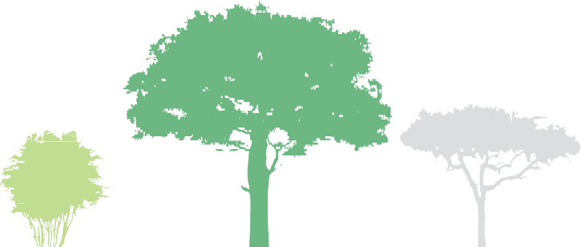

**GOOD**  **FAIR POOR**

**YOUNG**  **SEMI MATURE**  **MATURE**

**92%**

**6%**

**2%**

**22%**

**47%**

**31%**

**70**

**60**

**50**

**40**

**30**

**20**

**10**

**0**

**GOOD**  **FAIR POOR**

**59%**

**38%**

**3%**

**21**

CITY OF GREATER GEELONG URBAN FOREST STRATEGY

**10 YEARS**

**AROUND 14% OF THE CITY'S STREET TREES**

**WILL REACH THE END OF THEIR USEFUL**

**LIVES WITHIN A TEN YEAR PERIOD**

Whilst the current population is healthy and diverse, around 14% of Council’s street trees will reach the end of their useful lives within a ten year period, meaning they will require active maintenance and eventual removal. This figure is above normal, which is anecdotally a 10% loss each decade, and is primarily due to the prevalence of Callistemons, Melaleucas and Eucalypts. Callistemons are a relatively short lived tree species and having been planted en mass in the 1980’s, they are now reaching the natural end of their useful lives and will need removing in a relatively short period of time. Melaleucas and Eucalypts have vigorous root systems and many are outgrowing their locations.

**< 5 YEARS 5-10 YEARS10-20 YEARS 20+ YEARS**

**60**

**50**

**40**

**30**

**20**

**10**

**0**

Useful Life Expectancy (ULE) is an important indicator of urban trees as it provides an opportunity for the City to manage tree loss with a succession plan. ULE is a measure of how long a specific tree will remain functional in the landscape before it will need to be actively managed with a view to being removed. Many factors influence ULE such as tree age, tree health, structure and surrounding conflicts with infrastructure and ideally there is a spread of ULE’s across the population minimising the risk of mass tree removal in any given period.

USEFUL LIFE EXPECTANCY

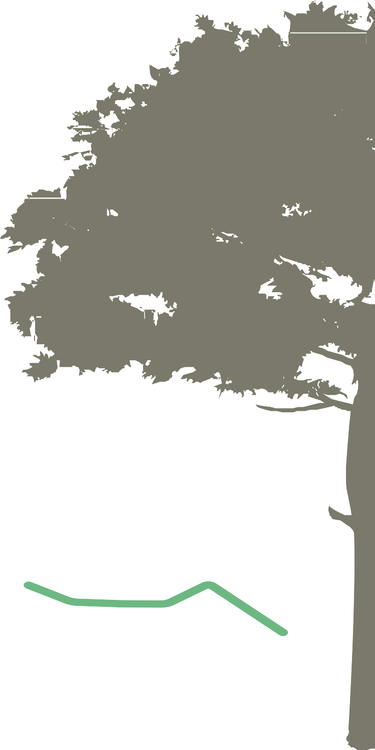

**70**

*FIGURE 4: Useful Life Expectancy for Geelong’s street tree population.*

**2%**

**12%**

**20%**

**66%**

**22**

CITY OF GREATER GEELONG URBAN FOREST STRATEGY

**> 20**

**METRES**

**5-10**

**METRES**

**10-15**

**METRES**

**15-20**

**METRES**

**< 5**

**METRES**

Whilst tree height is not a key criteria in measuring urban forest performance, it is of great interest to note that Geelong’s tree sizes are generally quite small. 93% of the population are only up to 10m in height and over half of the trees are only 5m in height. Given that only 22% of the street tree population are young, this suggests that the public urban forest consists of a very high percentage of small statured trees and is potentially not functioning at its most efficient capacity. This means that there is a large opportunity cost of missing environmental and economic values

such as shading, air pollution and carbon sequestering and stormwater interception. Large canopied trees are favoured for maximising these benefits and the results clearly show that Geelong has a small percentage of large trees.

TREE HEIGHT

**60**

**50**

**40**

**30**

**20**

**10**

**0**

*FIGURE 5: Distribution of tree heights amongst Geelong’s street tree population.*

**52.4%**

**40.3%**

**6.1%**

**1.2%**

**0.1%**

**23**

CITY OF GREATER GEELONG URBAN FOREST STRATEGY

**GREATER**

**Nillumbik**

**Maroondah**

**Banyule**

**Stonnington**

**Whitehorse**

**Bayside**

**Monash**

**Yarra**

**Ballarat**

**Kingston**

**Melbourne**

**Melton**

**Wyndham**

**Mornington Peninsula**

**Moonee Valley**

**Hobsons Bay**

**Greater Dandenong**

*FIGURE 6: Canopy cover measures for municipalities across Victoria (Jacobs et al, 2012).*

**Semi mature and juvenile plantings in residential**

**streets will contribute to future canopy cover.**

**GEELONG**

**10.9%**

**CANOPY COVER**

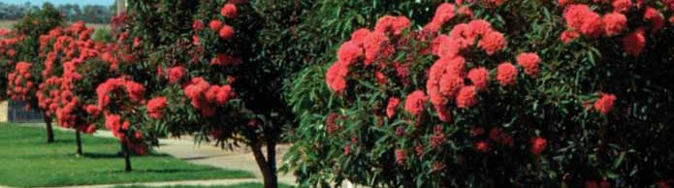

CANOPY COVER

Arguably, of most concern regarding Geelong’s urban forest is the lower than average tree canopy cover. Tree canopy cover measures the amount of tree canopy that spreads over the urban environ, particularly over hard impervious surfaces. The greater the canopy cover, the greater the benefits derived from the urban forest.

A simplified canopy cover analysis conducted by the Institute of Sustainable Futures across Australia found that Geelong had a municipal wide canopy cover of 10.9%, compared to other Victorian municipalities as detailed in Figure 6 below.

**80**

**70**

**60**

**50**

**40**

**30**

**20**

**10**

**0**

**24**

CITY OF GREATER GEELONG URBAN FOREST STRATEGY

**GEELONG**

**Wandana Heights**

**North Shore Industrial areas Indented Heads Lovely Banks Geelong North**

**Moolap Geelong South Waurn Ponds Breakwater**

**Rippleside/Drumcondra**

**Geelong Marshall**

**Corio Highton Bell Park**

**St Albans Park Bell Post Hill Point Lonsdale Whittington Portarlington**

**Norlane Geelong West St Leonards East Geelong**

**Leopold Drysdale/Clifton Springs**

**Lara Hamlyn Heights**

**Belmont Herne Hill Breamlea Manifold Heights Ocean Grove Newtown Newcomb Barwon Heads**

*FIGURE 7: Canopy cover measures for the city of Greater Geelong.*

**CITY OWNED**

**LAND**

**7%**

**CANOPY COVER**

**PRIVATE**

**LAND**

**7%**

**CANOPY COVER**

**URBAN**

**GEELONG**

**14%**

**CANOPY COVER**

**Wandana Heights, whilst displaying the lowest canopy cover has been the recipient of a targeted tree planting program so has a large number of small juvenile trees.**

Urban density is likely to affect the percentage of canopy cover on private land in future developments as the average house blocks are smaller and dwelling footprints are larger leaving less room for vegetation. This places greater emphasis and responsibility on Council to establish and maintain canopy cover on public land as well as investigating the possibility of mandating minimum lot sizes to accommodate one canopy tree per allotment and encouraging sufficient space for trees in new developments.

Using the same methodology, canopy cover was calculated for urban Geelong which excluded all rural land, giving more relevance to the figure for use in an urban forest analysis. Urban Geelong has a tree canopy cover of 14%, with approximately 7% on private land and 7% on Council land. Peer reviewed literature recommends an optimum urban land use canopy cover of 40% because it delivers the maximum benefits to an urban environment. Geelong’s urban canopy cover is well below this figure and is exacerbated by two factors: extensive industrial areas across the city with very few trees and a legacy of small statured, small canopied trees across residential areas. Canopy cover over specific suburbs is provided in Figure 7 below.



**25**

**20**

**15**

**10**

**5**

**0**

**25**

CITY OF GREATER GEELONG URBAN FOREST STRATEGY

**AMOUNT OF AIR**

**POLLUTION REMOVED**

**73**

**TONNES PER ANNUM**

*PICTURED RIGHT: Lophostemon confertus lining a Geelong residential streetscape.*

**STRUCTURAL VALUE $230,421,313**

**AVOIDED STORMWATER**

**RUN-OFF**

**8,455.74m3**

**PER ANNUM**

The results are as follows:

The model also produces a structural value for the urban forest, namely how much it would cost to replace all of the trees to their original size.

A value is placed on the capacity of the urban forest as a whole to ameliorate air pollution, reduce stormwater flows and save energy use in buildings by shading north and western walls.

Specific data was collected in order to model the dollar value of the urban forests environmental benefits. A United States Forestry Service model called i-Tree Eco was used to formulate an economic value of Geelong’s street trees.

THE ECONOMIC VALUE OF

GEELONG’S STREET TREES



**26**

CITY OF GREATER GEELONG URBAN FOREST STRATEGY

**NUMBER OF**

**TREES ANALYSED**

**75,268**

**CANOPY COVER**

**1,112,375**

**SQUARE METRES**

**LEAF AREA**

**5,010,413**

**SQUARE METRES**

**LEAF BIOMASS**

**451,817**

**KILOGRAMS**

**STORMWATER**

**RUN-OFF VALUE**

**$19,210.43**

**PER ANNUM**

**CARBON STORAGE**

**19,000**

**TONNES**

**CARBON**

**SEQUESTRATION**

**1,387**

**TONNES PER ANNUM**

**AIR POLLUTION**

**REMOVED**

**$3,311**

**PER ANNUM**

**Due to their size, stature and populations,** **the most valuable species in Geelong are the Lophostemon confertus (Queensland brushbox), Melaleuca and Yellow gums.**

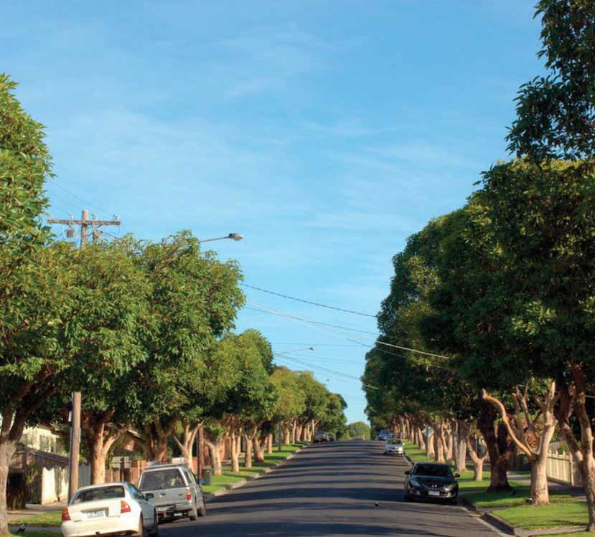

**Geelong’s street trees absorb 73**

**tonnes of air pollution each year and stem stormwater flows equivalent to the size of four Olympic swimming pools annually.**

**Geelong’s street trees alone** **store 19,000 tonnes and sequester 1,300 tonnes of carbon per year.**

*“It is estimated that Geelong's street and park trees*

*are worth over $370 million in structural asset value”*

**27**

CITY OF GREATER GEELONG URBAN FOREST STRATEGY

**6**

ISSUES SURROUNDING GEELONG’S URBAN FOREST

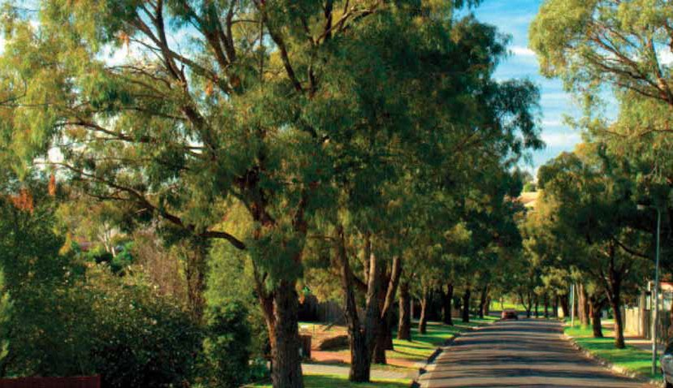

*“Planting trees now will enhance Geelong's*

*liveability for future generations”*

**28**

CITY OF GREATER GEELONG URBAN FOREST STRATEGY

Whilst urban vegetation plays a key role in building ecological resilience towards changing climates, the extremes in weather can also play havoc to the health and structure of an urban forest. Extreme heat, wind and rainfall have the capacity to damage the urban forest and even incremental changes in weather can change pest and disease patterns, leading to outbreaks which may lead to mass tree death. A healthy, diverse and structurally sound urban forest is far more likely to adapt to these changes, placing importance on sound planning and maintenance into the future.

**SCHOOLS**

**LOCAL**

**BUSINESS**

**GOVERNMENT**

**THE**

**COMMUNITY**

While trees are sometimes viewed as liabilities to be managed, there has been an increase in support for more urban greening in Geelong. Feedback from streetscape plantings, lower mortality rates from vandalism and increased requests for street trees demonstrate greater support for Geelong’s tree planting program. These supporters from the community, local businesses, schools, universities and within the various levels of government understand that Geelong’s trees are key community assets that provide a myriad of benefits to current and future residents. The Geelong community is becoming more involved and engaged in localised tree planting activities, yet the City recognises that there is still work to be done in fostering community support and encouraging additional trees in our urban landscape.

Storm damage

Pest and disease attacks

Requests from developers to make way for developments   
Trees failing or reaching the end of their useful lives

Inappropriate plantings such as those that have outgrown a site

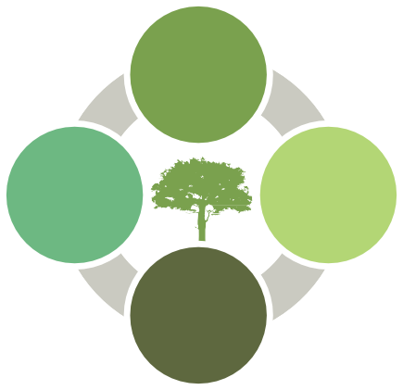

Each year the City removes around 1,000 public street trees in response to a range of factors:

•

•

•

•

•

The City’s budgets currently cover the planting of 1,050 advanced street trees per year so there is only a net gain, year on year of 50 trees. City Plan stipulates a net increase per year of 400 street trees. This mandate is not being met and at this stage has no capacity to be met.

**29**

CITY OF GREATER GEELONG URBAN FOREST STRATEGY

**3. CLIMATE CHANGE**

**2. SUPPORT FOR GREENING THROUGH TREE PLANTING**

**1. NO NET GAIN OF TREES**

**7**

OPPORTUNITIES FOR GEELONG’S URBAN FOREST

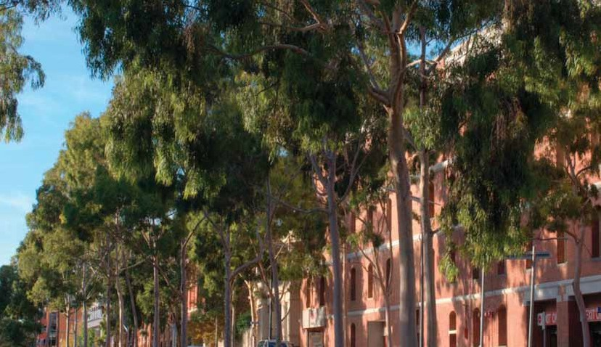

*“Geelong’s trees are a valuable community asset,*

*transcending the boundaries of land ownership to*

*provide benefits for all”*

**30**

CITY OF GREATER GEELONG URBAN FOREST STRATEGY

**AN OPPORTUNITY**

**EXISTS TO UTILISE**

**45,000**

**VACANT TREE**

**PLANTING SITES**

There are an estimated 45,000 vacant tree planting sites within streets across Geelong i.e. sites that have the potential to house a street tree yet currently don’t. This represents a tremendous opportunity to achieve our vision of a cool, green city simply by investing in an infill program over the next decade. Even an additional 500 advanced street trees planted per year using appropriate species that provide the maximum canopy cover suitable for each site can improve Geelong’s canopy cover significantly. Added to this are the potential for increased tree planting in existing open space and conservation reserves.

*IMAGES: 1. A streetscape in Whittington as it currently looks. 2. The same streetscape with its vacant sites planted out.*

ADDING VALUE TO OUR CITY

Geelong’s trees are a valuable community asset, transcending the boundaries of land ownership to provide benefits for all. They have the capacity to redefine Geelong’s identity into a green, liveable, attractive and innovative city. They also build the ecological platform of resilience, adaptation and mitigation against urban heat island effects and climate change. With this in mind, Geelong’s trees are for the future and accordingly must be planned for now. An enormous opportunity now exists for Geelong to plan for its future through the delivery of a robust, dynamic, climate suited and strategically planted urban forest.

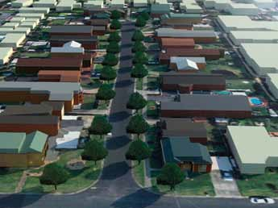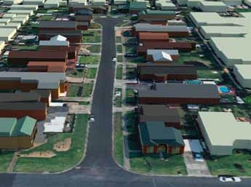

**1**

**2**

**31**

CITY OF GREATER GEELONG URBAN FOREST STRATEGY

**1. VACANT PLANTING SITES**

GEELONG HOTSPOTS

LOW: **15°C**

HIGH: **30°C**

**THERMAL IMAGE VALUE**

Heat mapping of the municipality using Satellite thermal imagery reveals certain areas of Geelong that heat up more quickly during periods of hot weather which are then likely to retain that heat well into the night. Surface types, topography, proximity to the bay and urban density are some of the contributing factors to the retention of surface heat as is low levels of tree canopy cover and open green space. The image was captured at 10:30am on a 36 degree day. The CBD has not yet had a chance to warm up and the surrounding suburbs remain warmer, probably due to a lack of sea breeze. Hotspot areas of Geelong include the northern industrial zone, Norlane and Corio, Whittington and Bell Park. Whilst a more detailed land surface analysis is needed to determine the exact causes of the heat retention and the limitations of the satellite thermal image, the City can prioritise these warmer areas for increased canopy cover.

**GEELONG HOTSPOTS**

*FIGURE 8: Satellite thermal imagery of Geelong and associated hotspots.*

PRIORITY TREE

PLANTING AREAS

The City has an extensive understanding of the existing landscape for trees. By overlaying information sets on certain parameters, priority areas have been identified for investment in street tree planting which will make a significant impact to environmental, social and economic outcomes.

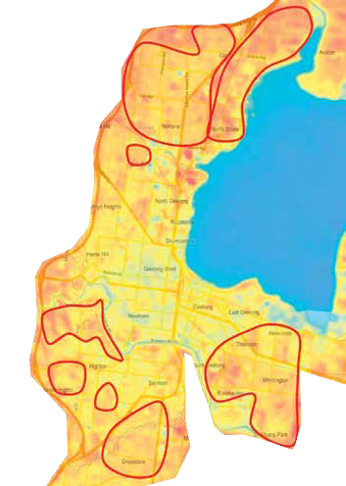

*SHOWN IN FIGURE 9*

**32**

CITY OF GREATER GEELONG URBAN FOREST STRATEGY

**1. HOTSPOT MAPPING**

LOW: **15°C**



HIGH: **30°C**

**THERMAL IMAGE VALUE**

Lone older persons

SEIFA disadvantage Non English speaking Aged accommodation

Playgrounds

Education Low income  
0-4 year olds

Kindergartens

Certain demographics within Geelong’s community are more vulnerable to this heat retention than others, particularly during heatwaves. The more vulnerable community members are young children, older lone households, low socio-economic households (measured by SEIFA index) and those with English not spoken at home. When mapped alongside the thermal hotspots in Geelong, priority areas in Corio, Norlane and Whittington are revealed. These three suburbs have in total around 7,500 vacant tree planting sites in nature strips. Streets and parks surrounding schools, playgrounds, hospitals and aged care facilities are also areas where tree planting will be prioritised.

**SOCIAL VULNERABILITY ACROSS GEELONG**

*FIGURE 9: Areas of social vulnerability across the north of urban Geelong.*

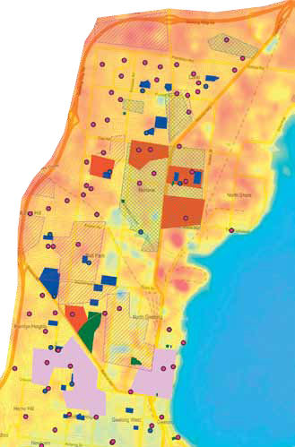

**33**

CITY OF GREATER GEELONG URBAN FOREST STRATEGY

**2A. SOCIAL VULNERABILITY**

Aged accommodation

Non English speaking

SEIFA disadvantage

Lone older persons

0-4 year olds

Low income

Education

Playgrounds

Kindergartens

LOW: **15°C**

HIGH: **30°C**

**THERMAL IMAGE**

**VALUE**

**SOCIAL VULNERABILITY WHITTINGTON**

PRIORITY TREE

PLANTING AREAS

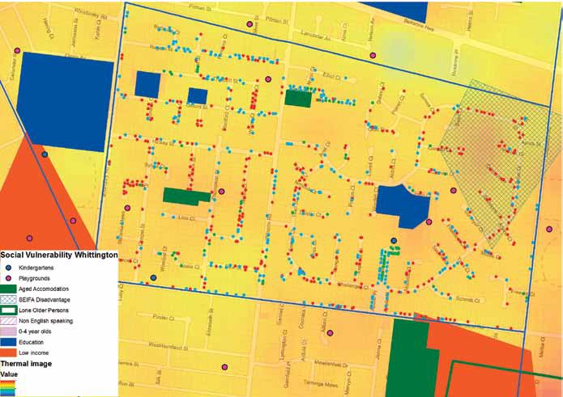

*FIGURE 10: Location of schools and aged care mapped against the heat map and street tree distribution in Whittington, one of Geelong’s hotspots.*

**34**

CITY OF GREATER GEELONG URBAN FOREST STRATEGY

**2B. SOCIAL VULNERABILITY**

**“Areas that display low levels of canopy** **cover or a higher percentage of trees with a low useful life expectancy will be targeted for a renewal program”**

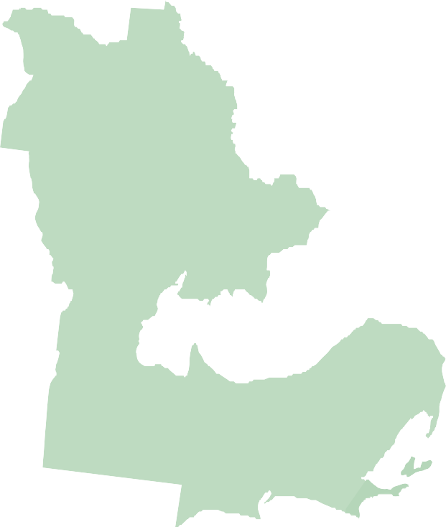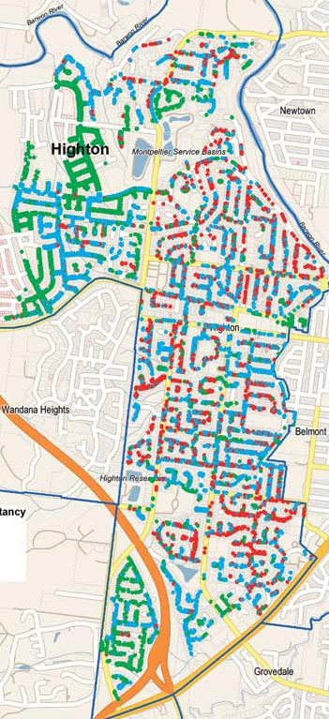

Areas that display low levels of canopy cover or a higher percentage of trees with a low useful life expectancy will be targeted for a renewal program, replacing unsuitable species with those that are best suited to each site to minimise conflicts with infrastructure, provide multiple benefits and appropriate canopy cover into the future.

**< 5 YEARS**

**20+ YEARS**

**5-10 YEARS**

**10-20 YEARS**

*FIGURE 11: Tree distribution across Highton where there is a higher concentration of trees that will need to be removed within a 10 year period (red dots). Highton will be targeted for a tree renewal program.*

**HIGHTON TREE USEFUL LIFE EXPECTANCY**

**35**

CITY OF GREATER GEELONG URBAN FOREST STRATEGY

**3A. LOW CANOPY COVER AND LOW USEFUL LIFE EXPECTANCY (HIGHTON)**

**< 5 YEARS**

**5-10 YEARS**

**20+ YEARS**

**10-20 YEARS**

**WHITTINGTON TREE USEFUL LIFE EXPECTANCY**

*FIGURE 11: Tree distribution across Whittington where there is a higher concentration of trees that will need to be removed within a 10 year period (red dots). Whittington will be targeted for a tree renewal program.*

PRIORITY TREE

PLANTING AREAS

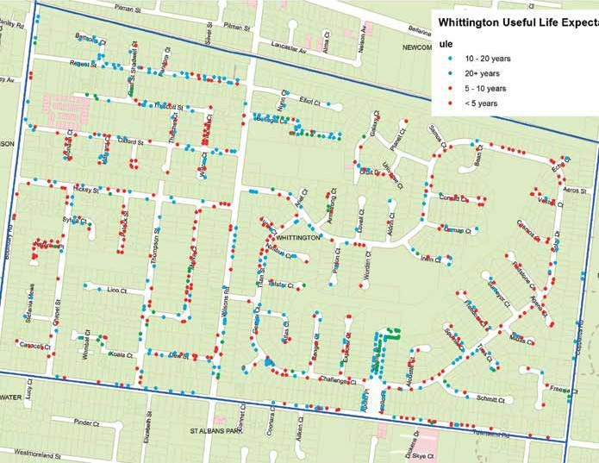

**36**

CITY OF GREATER GEELONG URBAN FOREST STRATEGY

**3B. LOW CANOPY COVER AND LOW USEFUL LIFE EXPECTANCY (WHITTINGTON)**

*PICTURED ABOVE RIGHT: A. An artist’s impression of the Greenway. B. Current state of the Greenway.*

Creation of boulevards Industrial areas

Bike paths

Gateways to Geelong   
Linear open space corridors Waterways

Commercial and Retail Zones Central Geelong

The Greenway: Ted Wilson bike trail Urban orchards

Open space and conservation reserves

All new capital works projects in existing open space

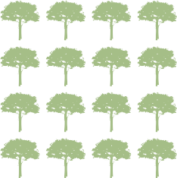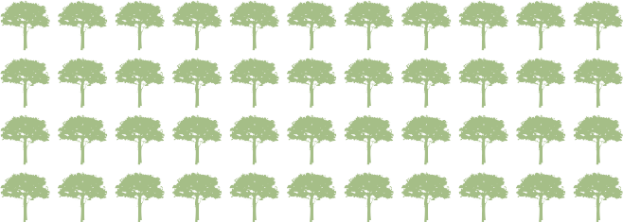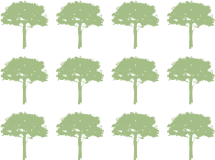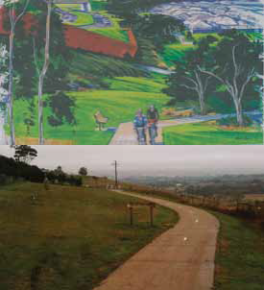

**5**

**2**

**3**

**1**

**4**

**8**

**10**

**12**

**9**

**6**

**7**

**11**

**Other areas to be prioritised for tree planting opportunities are:**

**1.**

**2.**

**3.**

**4**.

**5.**

**6.**

**7.**

**8.**

**9.**

**10**.

**11.**

**12.**

**A**

**B**

**37**

CITY OF GREATER GEELONG URBAN FOREST STRATEGY

**4. PRIORITISED TREE PLANTING OPPORTUNITIES**

**8**

GEELONG’S URBAN FOREST OF THE FUTURE

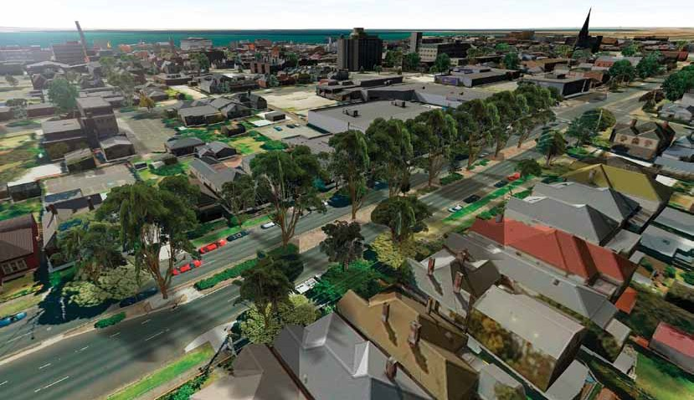

*“Council will aim for 25% canopy cover for*

*urban Geelong within 30 years”*

**38**

CITY OF GREATER GEELONG URBAN FOREST STRATEGY

VISION FOR GEELONG

This Strategy will help us shape the future landscape character of Geelong, focusing primarily on the soft green landscapes and their contribution to Geelong’s identity. The future landscape should be uniquely Geelong and add to the existing character of a City with a rich heritage, a diverse community and an abundance of natural beauty. Geelong’s urban forest should also provide green spaces for people to rest, work and play in and encourage a sense of place, a place that people like to spend time in. Further to this, our urban forest should be quietly working to adapt our City to changing climates, providing much needed shade, interception of rainfall, opportunities for stormwater to soak back into the ground, habitat and food to encourage biodiversity and greater biomass for storing and sequestering carbon and other greenhouse gases. **To achieve this we will aim for 25% canopy cover for urban Geelong within 30 years.**



Four key objectives will guide our daily decision making processes and provide the framework for an action plan to make sure we will reach our target and realise our vision.

**TO GREEN THE CITY**

Increase tree planting and associated vegetation in appropriate and prioritised locations

**1**

**TO COOL THE CITY**

Increase canopy cover, increase use of smart water sensitive urban design and an increase in landscape permeability

**2**

**TO ENGAGE THE CITY'S COMMUNITY AND BUILD**

**REGIONAL PARTNERSHIPS**

More community activities: tree planting, arts and culture activities, use of social media, working with partners to improve and enhance tree planting projects

**3**

**TO DEMONSTRATE BEST PRACTICE URBAN**

**TREE MANAGEMENT**

Develop a complete set of technical guidelines for urban tree management and offer training and upskilling where needed

**4**

**39**

CITY OF GREATER GEELONG URBAN FOREST STRATEGY

BEST PRACTICE URBAN

TREE MANAGEMENT

ENGAGE THE COMMUNITY AND

BUILD REGIONAL PARTNERSHIPS

COOL THE CITY

GREEN THE CITY

CITY OF GREATER GEELONG URBAN FOREST STRATEGY

ACTION PLAN

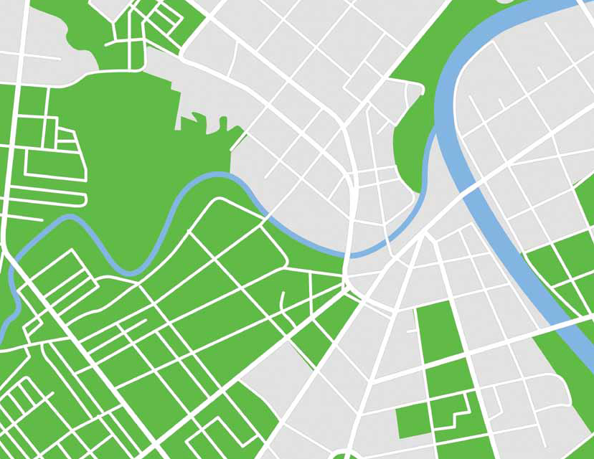

**1**

**2**

**3**

**4**

**40**

CITY OF GREATER GEELONG URBAN FOREST STRATEGY

Technical processes such as tree planning, planting, maintenance, removals and revegetation works can be more holistically managed to meet our objectives.

WHAT DOES THE CITY

OF GREATER GEELONG PLAN TO DO?

The Action Plan will pave the way for Council to deliver its strategic urban forest approach through its day to day operations.

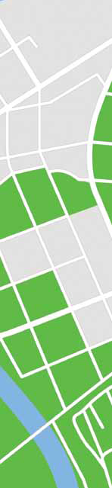

It will be delivered by the City's Parks and Gardens Department, through the Tree Management Team. There are however certain aspects that will rely on other Council departments to take an urban forest approach in their work and consider how their day to day operations can positively influence the City’s urban forest.

KEY PERFORMANCE INDICATORS

By setting Key Performance Indicators we can ensure our operational framework is working to achieve its vision.

Key Performance Indicators allow us to track our progress and refine processes where needed.

**41**

CITY OF GREATER GEELONG URBAN FOREST STRATEGY

Building on internal relationships to enhance urban greening through delivery of: The Open Space Strategy, Environment Management Strategy, Land use plans and Precinct Structure Plans, Network Operating Plans (Transport Strategy), Physical Activity Strategy, Reserve Master Plans, Community Development programs, Urban Design guidelines and existing asset management operations such as traffic management and engineering works

Integrate Open Space Planning with urban forest planning to meet multiple outcomes, including the development of corridors and connections

Conduct an in-fill planting program

**1**

**2**

**3**

**4**

**Create tree lined**

**entrances to Geelong**

**Completion of Geelong's**

**Greenway Project**

**Annual net gain of 500**

**street trees per year**

OBJECTIVE

1. GREEN THE CITY

*Actions*:

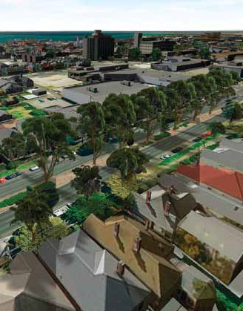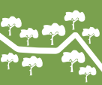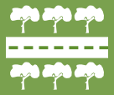

*Key Performance Indicators:*

Plant an additional 500 advanced street trees per year

Continue work along the Greenway: meet target of 80,000 trees by 2018

Incorporate other forms of vegetation where possible: green roofs, green walls, amenity plantings, garden beds

**5**

**6**

**42**

CITY OF GREATER GEELONG URBAN FOREST STRATEGY

**Improve water permeability**

**around street trees**

**Increase passive WSUD**

**treatments in the**

**public realm**

**Increase measurable**

**canopy cover to achieve**

**our target of 25%**

*Key Performance Indicators:*

**4**

**5**

**6**

**1**

**2**

**3**

OBJECTIVE

2. COOL THE CITY

*Actions*:

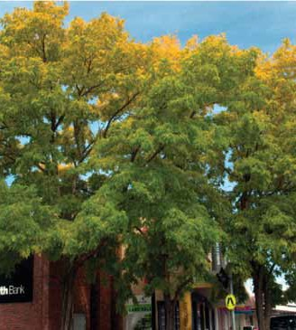

Develop Tree Species selection criteria

Set priority planting locations particularly for large canopied trees

Contribute towards the Playground Strategy, Transport Strategy, Tourism and Community Health to improve natural shade in the city

Include urban forest planning into Integrated Water Cycle Management

Incorporate street tree planting with water sensitive urban design where possible

Filtrate stormwater back into nature strips to provide irrigation for trees where possible

**43**

CITY OF GREATER GEELONG URBAN FOREST STRATEGY

Strengthen partnerships with other greening agencies such as Landcare, Greening Australia, 202020 Vision, Greening the West and local greening community groups

Develop key regional partnerships with developers, G21, Future Proofing Geelong, Greening the West, Barwon Water, Corangamite Catchment Management Authority, suppliers to deliver urban forest projects

Develop a model to create more community orchards in partnership with community groups

Build on existing arts and culture activities to include narratives and artworks around trees

Develop community and/or friends of groups to engage in community planting and greening activities in areas prioritised for tree planting

Conduct Community planting days

**Development of multiple**

**partner urban forest**

**projects delivering**

**community benefits**

**Increase the demand**

**from residents for a**

**street tree outside**

**their house**

**Increase number of**

**community members**

**involved in tree**

**planting days**

*Key Performance Indicators:*

**7**

**8**

**4**

**5**

**6**

**1**

**2**

**3**

OBJECTIVE

3. ENGAGE THE COMMUNITY AND BUILD REGIONAL PARTNERSHIPS

*Actions*:

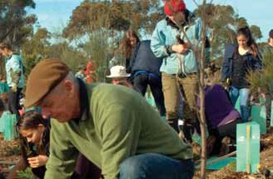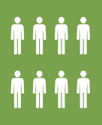

Increase the use of social media: advocacy, competitions, photo displays

Strengthen partnerships with service and utility providers: VicRoads, Powercor

**44**

CITY OF GREATER GEELONG URBAN FOREST STRATEGY

**1**

**2**

**3**

**4**

**5**

**6**

**7**

OBJECTIVE

4. BEST PRACTICE URBAN TREE MANAGEMENT



*Actions*:

Develop a complete Urban Tree Management Technical Manual

Develop an annual Tree Planting plan based on priority areas

Develop tree planting design guidelines

Develop and maintain a significant tree register

Measure all Key Performance Indicators in 2020 and report progress

Ensure the urban forest objectives are integrated into all key City documents where possible

Seek external funding where possible to boost the tree planting program

**45**

CITY OF GREATER GEELONG URBAN FOREST STRATEGY

*Key Performance Indicators:*

**Technical manual**

**completed and**

**disseminated to**

**relevant stakeholders**

**90% of the urban tree**

**population is healthy**

**Appropriate diversity of**

**tree age, species and**

**Useful Life Expectancies**

**All trees removed have**

**been replaced**

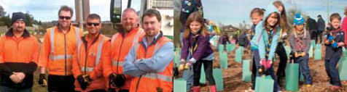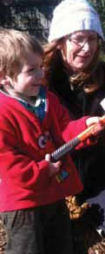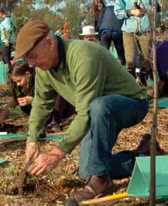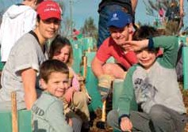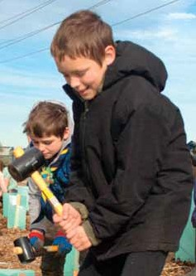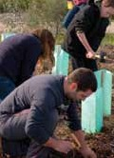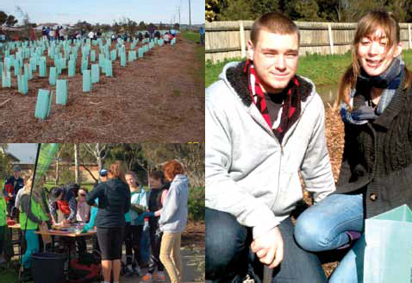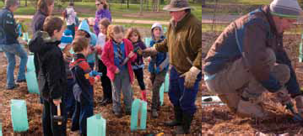

*“Geelong's community will be actively engaged*

*in building Geelong's urban forest”*

**46**

CITY OF GREATER GEELONG URBAN FOREST STRATEGY

GLOSSARY AND REFERENCES

CITY OF GREATER GEELONG URBAN FOREST STRATEGY

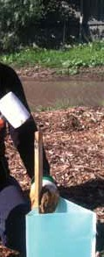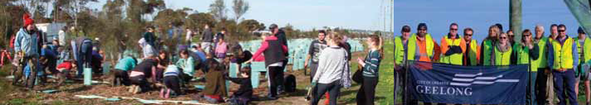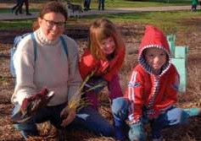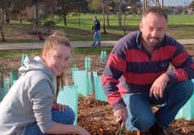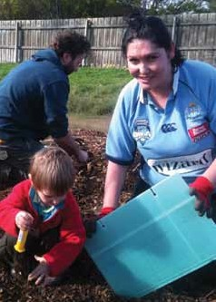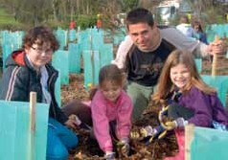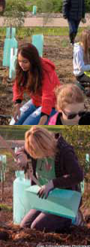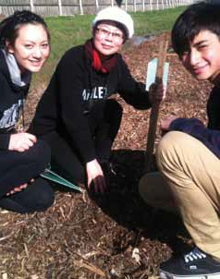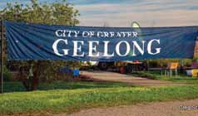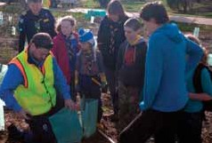

**47**

CITY OF GREATER GEELONG URBAN FOREST STRATEGY

**One Planet Principles:** A set of ten principles adopted by Council within the Environment Management Strategy 2013-2017 that help the community progress towards living and working sustainably.

**Microclimatic moderation:** The ability of trees to cool the ambient temperature through shading and evapotranspiration for the benefit of pedestrians.

**Integrated water cycle management:** A holistic approach to water that promotes the sustainable use of all available water resources in ways that best deliver multiple community objectives.

**I-Tree Eco:** A model built by the United States Forestry Service that analyses certain tree parameters in conjunction with air quality measures to determine an environmental value of a tree. The value includes air pollution, carbon sequestration and storage, energy saving benefits, stormwater flow reductions and a structural value, allocating an overall figure of worth on a population of urban trees.

**Greenway:** A project run by Council to revegetate the Ted Wilson bike trail that runs the length of the Geelong Ring Road. Supported by Barwon Water, The Federal Government’s Department of Environment, the People and Parks Foundation and the Lions Club. Council is committed to planting over 80,000 trees along the Greenway by 2018.

**G21:** Geelong Regional Alliance of government, business and community organisations working together to improve the lives of people across five municipalities: Surf Coast, Colac Otway, Golden Plains, Greater Geelong and Queenscliff.

**Ecosystem:** A community of organisms interacting with each other in their environment.

**CBD:** Central Business District.

**Biomass:** The biological material of a living plant.

**Biodiversity:** The variety of all life forms on earth: the different plants, animals and micro-organisms and the ecosystems in which they are a part.

GLOSSARY

**202020Vision:** A national campaign across Australia to increase urban green space by 20% by the year 2020.

**Greening the West:** An initiative that takes a regional approach to urban greening in order to enhance liveability for communities in the western suburbs of Melbourne.

**Capital Works Program:** A program of works conducted by Council which renews, upgrades or creates new infrastructure to support the delivery of services to the Geelong community.

**Carbon sequestration:** The ability of trees to absorb carbon dioxide from the atmosphere through their leaves.

**Ecological resilience:** The amount of disturbance an ecosystem could withstand without permanently changing or damaging it.

**Liveability:** An assessment of what a place is like to live in, taking into account environmental quality, crime and safety, education and health provision, access to shops and services, recreational facilities and cultural activities.

**Evapotranspiration:** The movement of water from the landscape to the atmosphere through vegetative matter by the process of evaporation and transpiration.

**Future Proofing Geelong:** A partnership of organisations that supports the Geelong region towards a low carbon future.

**48**

CITY OF GREATER GEELONG URBAN FOREST STRATEGY

**Water sensitive urban design:** The integration of the water cycle into urban planning and design by recognising all water streams in the urban environment as a potential resource e.g. rainwater, stormwater, grey water and blackwater. WSUD is often used to describe the infrastructure built to capture and reuse stormwater.

**Urban Heat Island Effect:** When urban areas are warmer than surrounding rural areas due to heat retention in hard surfaces. This build-up of heat is re-radiated at night time, increasing air temperatures which can have serious human health consequences particularly during heatwaves. The UHI effect can be mitigated by a range of factors. The most cost effective and efficient mitigation tool is an increase in tree canopy cover.

**Remnant Vegetation:** The patches of native trees, shrubs and grasses that remain in the landscape.



**SEIFA:** Socio-Economic Index for Areas which categorises census parcels based on socio-economic advantage or disadvantage.

**Stormwater interception:** The halt or reduced flows of stormwater into the drainage system for re-use.

**Urban density:** The number of people inhabiting a given urbanised area.

**49**

CITY OF GREATER GEELONG URBAN FOREST STRATEGY

City of Vancouver, 2014. Urban Forest Strategy. Vancouver, CANADA: 59pp.

Clark J.R., N.P. Matheny, G. Cross and V. Wake, 1997. A model of urban forest sustainability. Journal of Arboriculture. 23(1):17-30.

Coutts, A. M., & Harris, R. (2013). A multi-scale assessment of urban heating in Melbourne during an extreme heat event and policy approaches for adaptation (Technical Report, pp. 64). Melbourne: Victorian Centre for Climate Change and Adaptation Research.

<http://www.vcccar.org.au/sites/default/files/>publications/Multiscale%20assessment%20urban%20heating%20Technical% 20Report.pdf

Greening The West, 2014. Urban Greening for a healthier west, 12pp.

Greening the West, 2014. Greening The West – A regional approach, Strategic Plan, 40pp.

Jacobs, B., Mikhailovich, N., and Moy, C. (2014) Benchmarking Australia’s Urban Tree Canopy: An i-Tree Assessment, prepared for Horticulture Australia Limited by the Institute for Sustainable Futures, University of Technology Sydney.

McPherson E G, Simpson J R, Peper P J, Maco S E & Xiao Q, 2005. Municipal Forest Benefits and Costs in Five US cities, Journal of Forestry, December.

Norton B, Coutts A, Livesley S, Williams N, (2013). Decision Principles for the selection and placement of green infrastructure to mitigate urban hotspots and heatwaves, Victorian Centre for Climate Change Adaptation Research.

Norton, B., Bosomworth K, Coutts A, Williams N, Livesley S, Trundle A, Harris R, McEvoy D (2013). Planning for a Cooler Future: Green Infrastructure to Reduce Urban Heat, Victorian Centre for Climate Change Adaptation Research.

Nowak, D.J., P.J. McHale, M. Ibarra, D. Crane, J. Stevens, and C. Luley. 1998. Modelling the effects of urban vegetation on air pollution, pp. 399–407. In: Gryning, S.E., and N. Chaumerliac (Eds.). Air Pollution Modelling and Its Application XII. Plenum Press, New York, NY.

Nowak, D.J., and D.E. Crane. 2000. The urban forest effects (UFORE) model: Quantifying urban forest structure and functions, pp. 714–720. In: Hansen M., and T. Burk (Eds.). In: Proceedings Integrated Tools for Natural Resources Inventories in the 21st Century. IUFRO Conference, 16–20 August 1998, Boise, ID. General Technical Report NC-212, U.S. Department of Agriculture, Forest Service, North Central Research Station, St. Paul, MN.

Nowak, D.J., and D.E. Crane, Stevens, J.C., Hoehn, R.E., Walton, J.T., and Bond, J., 2008. A Ground-Based Method of Assessing Urban Forest Structure and Ecosystem Services. Arboriculture & Urban Forestry 34(6): November 2008. International Society of Arboriculture.

Pitman, S, 2014. Green Infrastructure: Life Support for human habitats. The compelling evidence for incorporating nature into urban environments.

Richards, N.A., (1983). Diversity and stability in a street tree population. Urban Ecology, 7: 159. 171.   
Spencer, R., Hawker, J., & Lumley, P., (1991) Elms in Australia. Royal Botanic Gardens, Melbourne.

van Wassenaer, P. J. E., Satel, A. L., Kenney, W. A., & Ursic, M. (2011). A framework for strategic urban forest management planning and monitoring. Trees, people and the built environment, Proceedings of the Urban Trees Research Conference 13–14 April 2011.

REFERENCES

**50**

CITY OF GREATER GEELONG URBAN FOREST STRATEGY

**CITY OF GREATER GEELONG**

PO BOX 104

GEELONG 3220 AUSTRALIA **GENERAL ENQUIRIES:** TELEPHONE: 03 5272 5272

[contactus@geelongcity.vic.gov.au](mailto:contactus@geelongcity.vic.gov.au)

**52** CITY OF GREATER GEELONG URBAN FOREST STRATEGY

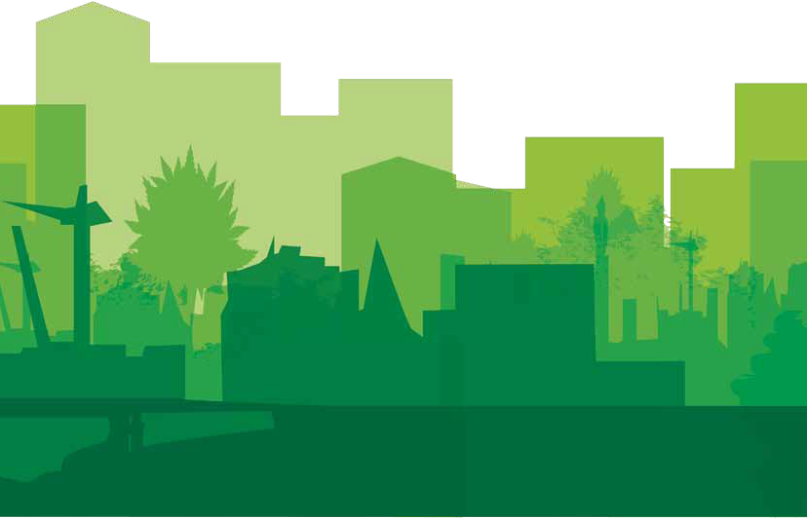

[**WWW.GEELONGAUSTRALIA.COM.AU**](http://WWW.GEELONGAUSTRALIA.COM.AU/)