**community engagement summary report**

**August 2022**

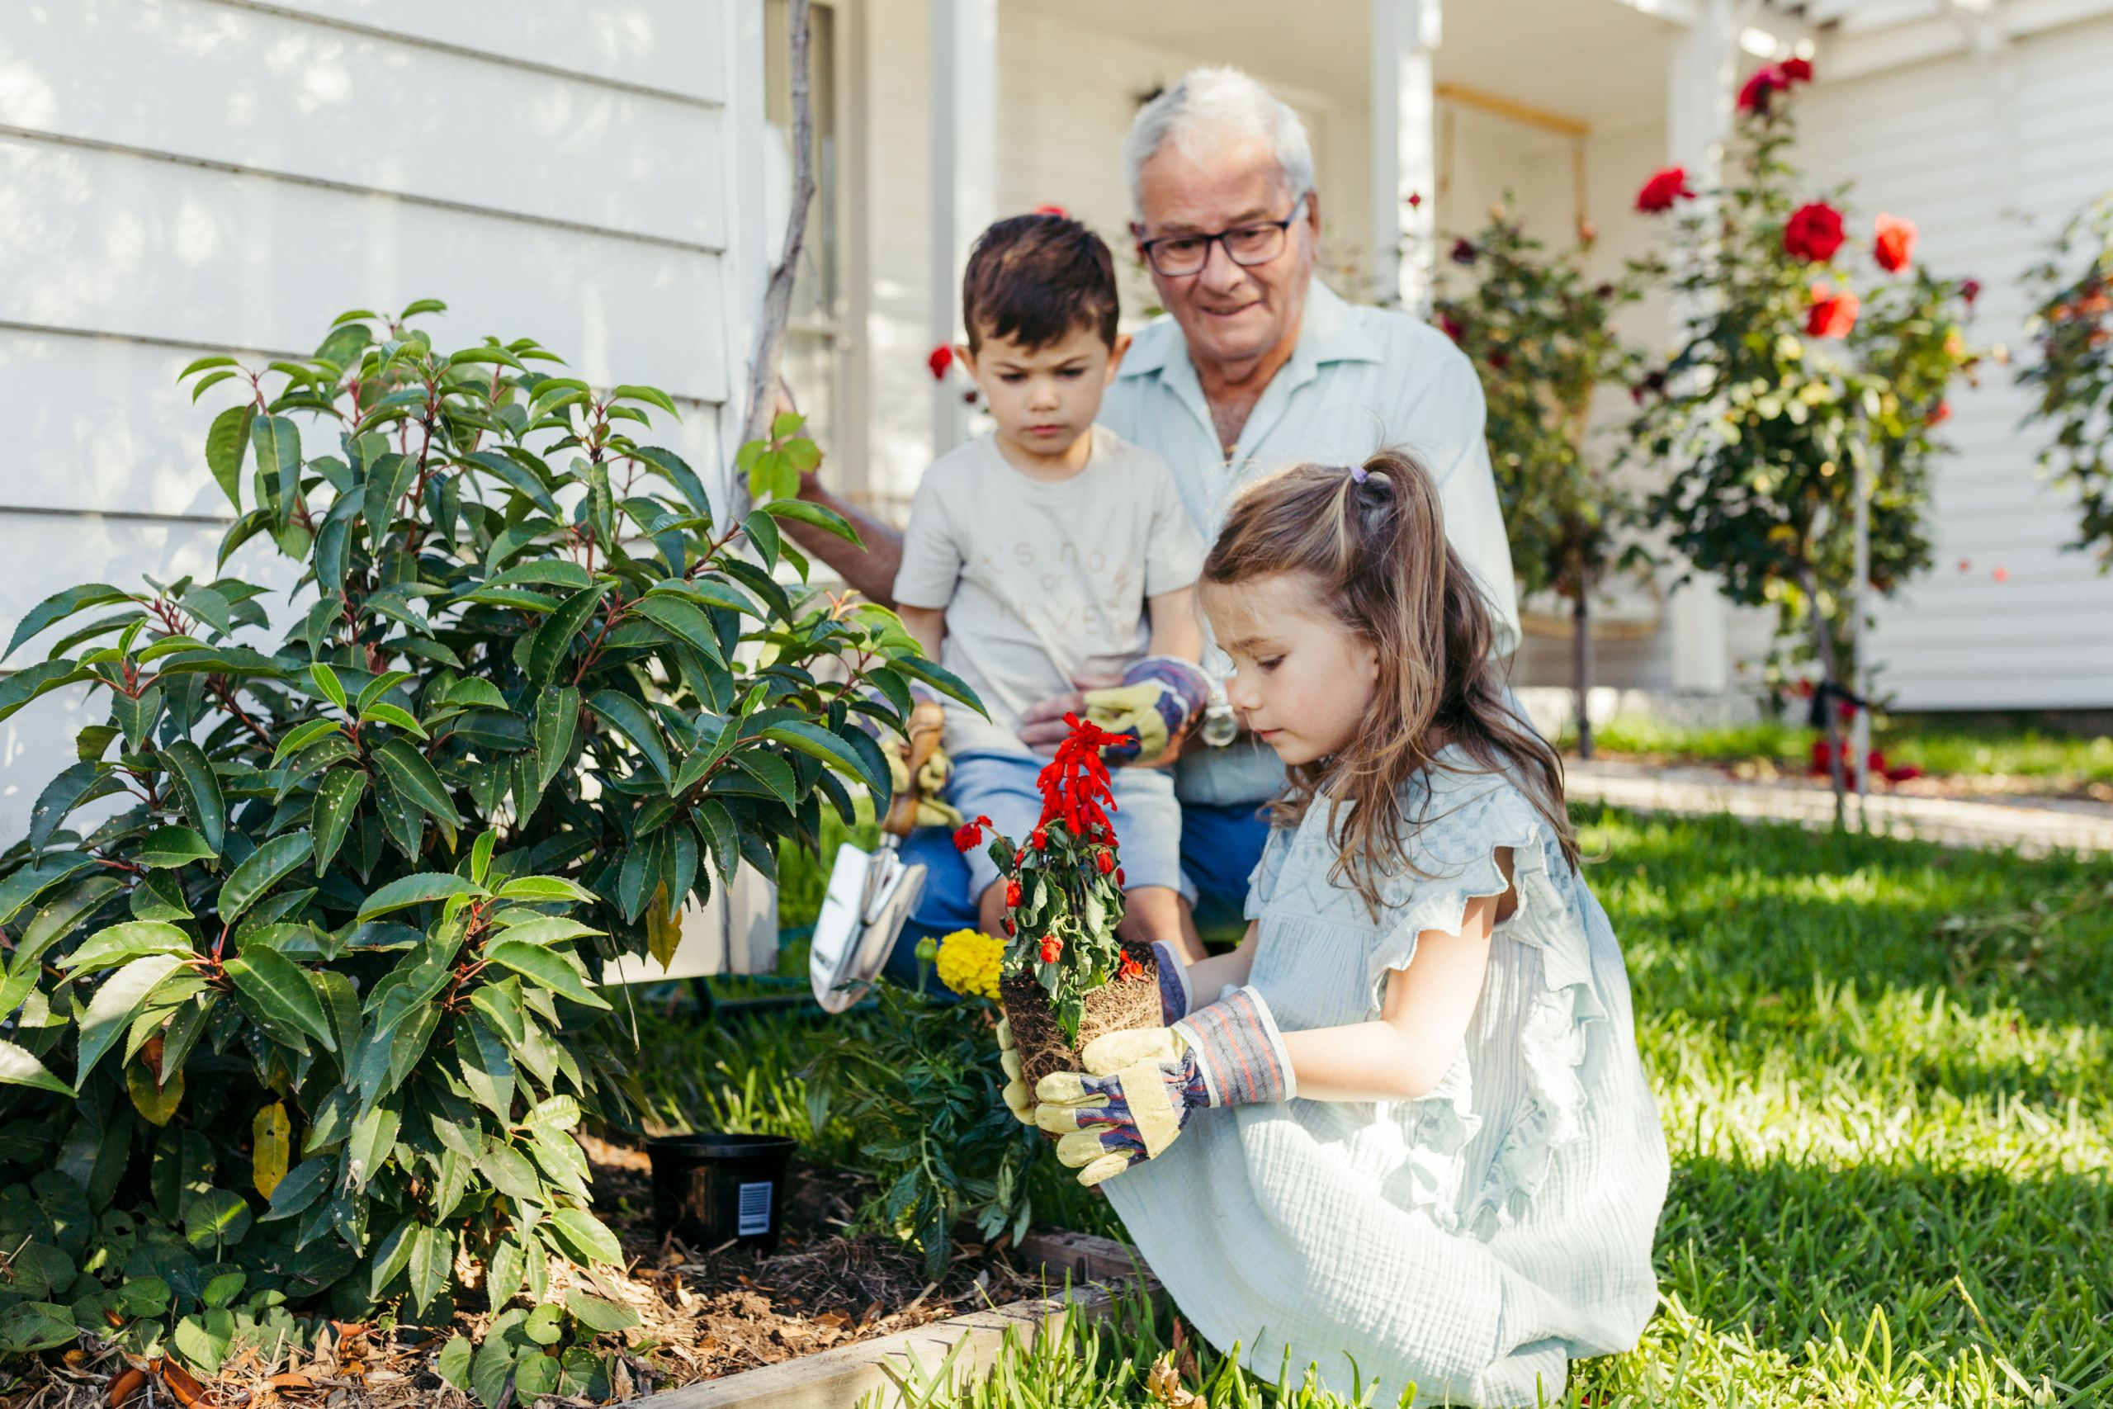

|  |
| --- |
| community engagement summary |

The City of Greater Geelong asked the community to share their views on a proposal from Warralily Community Garden 3217 Inc to establish a new community garden at 46-70 Central Boulevard Armstrong Creek.

|  |
| --- |
| HOW WE ENGAGED |

**THE ENGAGEMENT**



**53**

Number of people to leave feedback

**14**



**21 DAYS**   
of engagement

People following the project

**DATA METHODOLODY**

The engagement participants were self-selected, anyone who wished to was able to respond to the survey. The majority of responses were from people living in the local area, however, there were also some from the broader community.

**ENGAGEMENT TOOL AND TECHINQUES**

A project specific engagement page was developed to provide project information and methods of ways to engage with the City.

A range of engagement tools and techniques were used to provide different types of opportunities for stakeholders and community to have their say. The main tools and techniques are explained in further detail below

|  |  |
| --- | --- |
| HOW WE ENGAGED | |
| Have Your Say Online Portal  Yoursay.geelongaustralia.com.au | An online HYS project page was designed to share relevant information to encourage community feedback on 20 July 2022 |
| Survey (online and hardcopy) | Survey was available as part of the HYS project.  Objective of survey was to seek feedback and support from the community. |
| noticeboard onsite | Two noticeboards advising of the project were located on the proposed site:   * They gave basic information about the proposals, and * Provided a QR code linking to the HYS project page |
| Written submissions | Open at any time during the public engagement period. Submissions could be provided by email or mail. |

Communications

A targeted social media post on 6 August was used to advised people living in the Armstrong Creek area of the project and to direct them to the Have Your Say page for further information and to provide feedback.

Signage was installed on the site advising of the proposal and providing a QR code linking to the Have Your Say page.



**SOCIAL MEDIA**

**805**

Views

**47**

Actions (Clicks, reactions,  
shares, comments etc.)



Signage was installed on site

|  |
| --- |
| Who we engaged with |

**PARTICIPATION**

During the period 20 July to 10 August more than 6,888 people engaged with the City about the Warralily Community Garden 3217 Inc proposal. Of these 100% engaged online.

The community were invited to share some demographic data with us, through our HYS page or survey? The following is a snapshot of these people.

|  |
| --- |
| WHAT WE HEARD |

**THE FEEDBACK**

The community is overwhelmingly in support of the Warralily Community Garden 3271 Inc proposal to establish a garden at 46-70 Central Boulevard, Armstrong Creek.

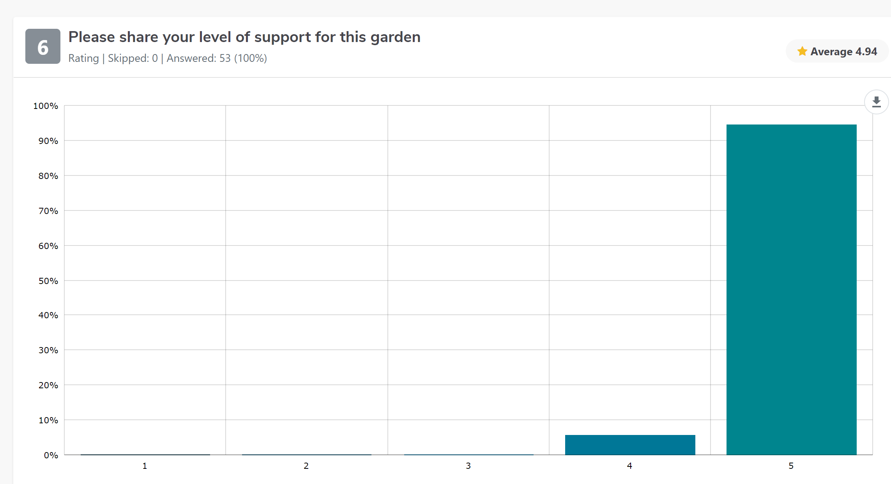

**OVERALL KEY FINDINGS**

The purpose of the survey was to gauge community support for the proposal and to provide the community with the opportunity to share their feedback.

**OVERARCHING THEMES**

Several overarching themes came through in survey responses:

* Community connection – bringing people together to garden and share knowledge as well as building friendships and a sense of local community.
* Positive health benefits both physical and mental.
* Providing residents with smaller blocks the opportunity to grow fresh produce.
* Promoting environmentally sustainable practices and helping to address food insecurity issues.

“100% support community gardens - creates more green space, fosters community evolvement and engagement, lowers crime in vicinity. Allows for residents of new estates and their smaller block sizes the opportunity to grow fresh produce.”

*Male respondent*

“I think it's an excellent initiative. Should be more community gardens. Great place to come together.”

*Female respondent*

|  |
| --- |
| what happens next? |

**NEXT STEPS**

* A final review of the proposal will now be completed, and a decision made on whether the Warralily Community Garden project will be approved.
* Thank you to everyone for their interest in this project and to those who responded to the survey and provided their valuable feedback.