A CONVERSATION ABOUT

JANUARY 26

ENGAGEMENT FINDINGS REPORT
7 October 2022
Image credit: Dr Jenny Murray-Jones
INTRODUCTION

Commencing in May 2022, the City of Greater Geelong started a conversation with and listening to local community about 26th of January - the day known as Australia Day.

The key purpose of this conversation is to understand, respect and acknowledge the experiences and goals of First Nations Peoples while ensuring the wider community’s voice is also heard on this matter.

The reality is that while the 26th of January is a day of celebration for some in our community, for many First Nations People it is a day of mourning, sorrow and survival; and this must not be ignored.

The decision to commence the consultation resulted from a request from the Kilangitj Aboriginal Advisory Committee, which advises Council on First Nations matters. That request was to consider engaging with First Nations People and the broader community about Council’s approach to the 26th of January.

The Australian Government has gazetted 26 January as a national holiday since 1994, and the community engagement by the City of Greater Geelong Council does not propose to change the date.

The engagement is occurring in two phases:

- Stage 1: Engagement with First Nations Peoples
- Stage 2: Engagement with the broader community

This is an interim report on what we have heard so far, the engagement will now be broadened to include all members of the wider community so that everyone can have their say about 26 January.

NEWS

4
print adverts in e-newsletters & City News

May to October
engagement (Stage One)
2
First Nations Forums held

Surveys completed by First Nations people
(hard copy and online)
1731
In-person
Engagement at Wathaurong NAIDOC week event and presentations to a range of First Nations groups

10
First Nations people participated in Forum discussions

During the first stage of engagement two First Nation forums were held in Corio and Central Geelong. A significant amount of surveys were completed through face-to-face discussions with community members and the HYS web page ( with a strong preference for face-to-face consultation).

INTERIM community engagement summary – WHAT WE’VE HEARD SO FAR
FIRST NATIONS PEOPLES - SURVEY RESULTS
Question 1: How do you feel about the 26 January?
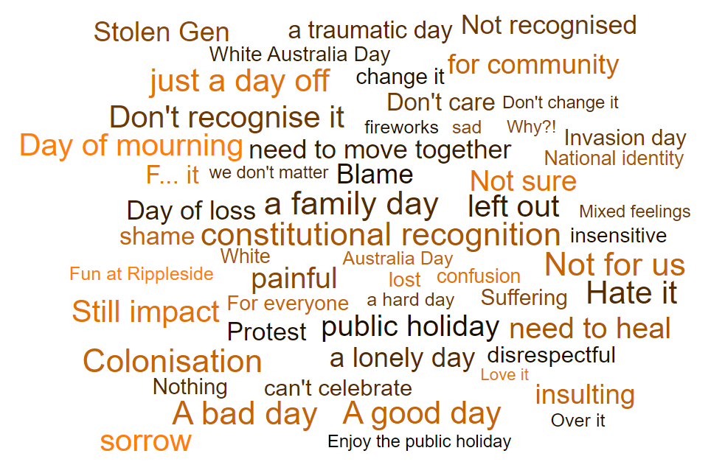
We received very strong feedback on this first stage of engagement - the largest we have ever experienced from the First Nations community on any issue.

Almost half (45 per cent) of First Nations Peoples responding to the survey made it clear that the 26th of January was far from being a day of celebration and that change was needed.

Whilst just over half of the First Nation respondents stated clearly that this day should be formally acknowledged and recognised through ceremony and Cultural events and activities to share the diverse heritage of the First Nation Arts and Culture in greater Geelong.

Themes that emerged include:

A bad day: The majority of responses expressed the 26th of January as “a bad day”. This encompassed key sentiments such as “a hard day” and “a lonely day”. Adding to this were key words such as “suffering”, “sorrow”, “painful” and “traumatic”. Many responses emphasised the clear feeling of division resulting from the 26th of January celebrations with results that include “a White Day”, “not for us”, “can’t celebrate” and “Colonisation”.

Just a day off: There were many comments that indicate neutral feelings and even ambivalence, such as “feel nothing”, “don’t care” or “just a public holiday”.

A good day: A smaller number of responses reflected positive attitudes, with statements such as “love it”, “enjoy the holiday” and “fun at Rippleside”.

Question 2: How can we be more inclusive of First Nation heritage and other communities in Greater Geelong?
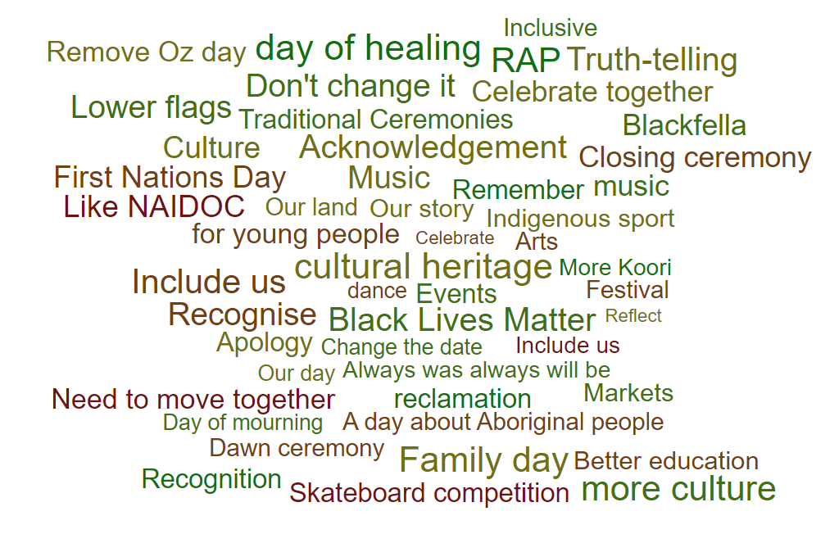
It is important to note that survey responses had a strong emphasis on the need for culture, with key themes of “recognition”, “traditional ceremonies” and “cultural heritage”.

Recognition: Recognition was a strong theme, underpinned by comments such as “better education”, “Black Lives Matter” and “Truth-telling”.

Events: There were many suggestions for Council to support First Nations events that embrace music, markets, dance, arts and indigenous sport.

Change the date: Even with this question there were clear calls for “change the date”, “day of mourning” and “apology”.

Youth and family: This was a strong sentiment, supported by comments such as “family day”, and even “skateboard competition”.
Question 3: Following this 6-month community conversation engagement, what would you hope council could deliver or put in place?
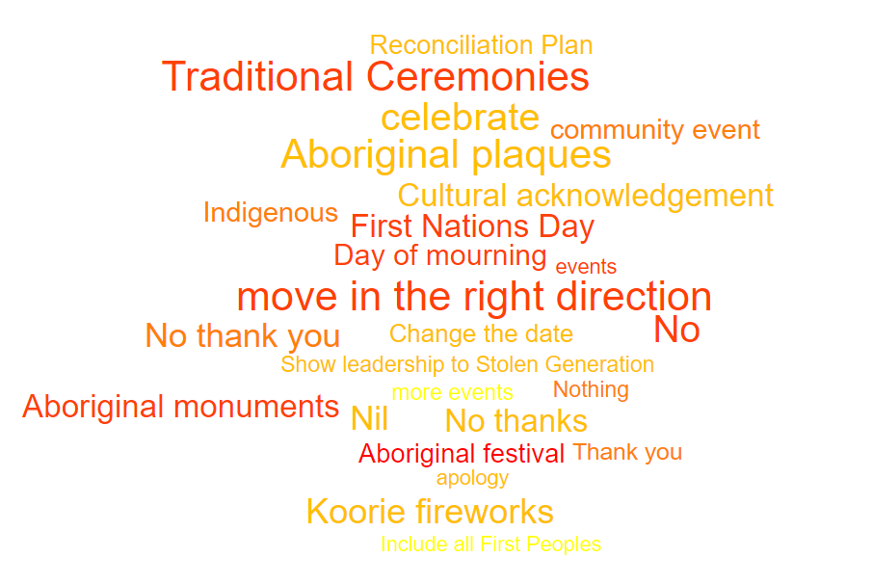
Only 55% of respondents answered this question. Of those that did, about half indicated nothing/nil/no, and about half called for cultural acknowledgement.

FORUM DISCUSSIONS
Two small forums with First Nations people allowed for discussion of the survey results and key questions. The themes that emerged are summarised below.
History: “We can’t celebrate the successes without first understanding the despair”
There are many painful stories of the history of Geelong, from colonisation and the Frontier Wars, to the Stolen Generations. There are also many positive stories to be shared. Truth telling and education is important to healing and to be able to move forward together as the whole community of Geelong.
Reclamation: “If we can’t change the date – let’s change the focus”
Recognise it as the day of colonisation and put First Nations voices and stories first. First Nations people want to reclaim their story and share their history.
Wider Change: “There is a groundswell of change”
There is a wider shift in focus for January 26 already occurring and it is time for Geelong to change too. There is momentum at the state and federal level for greater recognition of Aboriginal and Torres Strait Islander people, including the commitment to the Uluru Statement from the Heart. Other councils are changing, and other big organisations in Geelong are changing too.
Showing respect on 26 January: First Nations acknowledgement and stories
Start with a Dawn Ceremony at the Waterfront with a Cleansing of Country and a minute’s silence. It could be followed by Dance and/or a march. Share history and stories. It would be an inclusive gathering of all First Nations communities and non-Indigenous allies and family. Invite schools, invite other agencies. Invite new citizens and welcome them to the land. The afternoon could move to a celebration of cultural diversity.
The second forum also called for a statement of commitment from Council to the First Nations communities and Traditional Owners (broader than January 26).

NEXT STEPS
Community engagement will continue until the end of the year.
The next phase of the engagement will focus on the broader community. This will include an online survey, a public forum, engagement opportunities at the Geelong Show and presentations to key groups.
Further updates will be provided when more results have been received, with a final engagement report for community at the end of the year.
The Kilangitj Aboriginal Advisory Committee, which advises Council on First Nations matters, will be provided the community feedback and final engagement report for review and an opportunity to provide recommendations to Council for consideration.

