The City Of
Greater Geelong

Hamlyn Park recreation reserve Master Plan

  - DRAFT Report

Contents
Acknowledgements 4
Introduction 5
Project Overview 5
Methodology 5
Strategic Review 6
City of Greater Geelong Strategies 6
City of Greater Geelong Council Plan 2018-2022 6
Geelong Public Health and Wellbeing Plan 2018-2021 6
City of Greater Geelong Social Infrastructure Plan 2020 6
Geelong Indoor Recreation Facilities Strategy Review 2022 7
City of Greater Geelong Environment Strategy 2020-2030 7
City of Greater Geelong Urban Forest Strategy 2015-2025 8
Hamlyn Park Master Plan 2010 8
Western Heights College Master Plan 8
State Government Strategies 9
Victorian Government – Active Victoria 9
Strategic Review Key Findings 9
Demand Assessment 10
Demographic Review 10
Population 10
Diversity 10
Disadvantage and Social Capital 10
Future Population 10
Hamlyn Park Demographic Characteristics 10
Statewide Participation Trends 11
General Participation Trends 11
Sport Specific Trends 12
Gender Differences in Sports Participation in Victoria 12
AusPlay Physical Activities Data (Children 0-14 years) in Victoria 12
Local Participation and Use 13
Bell Park Sport and Recreation Club 13
Bell Park Junior Football Club 14
Bell Park Senior Football Club 15
Geelong Dragons – Bell Park All Abilities Football Program 16
Bell Park Cricket Club 17
Bell Park Netball Club 18
Geelong Ballroom Dance Club 19
Hamlyn Park Tennis Club 20
Western Heights College 20
Demand Assessment Key Findings 21
Sport and Recreation Value 22
Value of our parks and sport and recreation facilities 22
Changes in How we Value Parks, Sport and Recreation Facilities and Trails 23
Sport and Recreation Value Key Findings 25
Site Review 27
Site Overview 27
Occupancy Agreements 27
Site Observations 27
Asset Condition 28
Sports Oval and Lighting 28
Sports Courts and Cricket Nets 28
Buildings 28
Other 29
Site Review Key Findings 29
Stakeholder Engagement 36
Engagement Method and Reach 36
Community Survey 37
Usage 37
Facility Satisfaction 38
Key Issues and Ideas 39
Drop-In Sessions 40
Map Your Ideas Forum 41
Key Stakeholder Interviews 42
Bell Park Sports and Recreation Club 42
Bell Park Tennis Club Interview 42
Geelong Ballroom Club Interview 42
Scout Club Interview 43
Western Heights College Interview 43
Stakeholder Engagement Key Findings 44
Strategic Directions 45
Key Issues and opportunities 45
Strategic Support and Partnerships 45
Sport and Recreation Participation Growth 45
Asset Renewal and Upgrade 45
Protecting Natural Features and Improving Landscaping 46
Community Spaces for Social Family Recreation and Play 46
Traffic Management 46
Vision 46
Key Directions 46
Sport and Community Facility Improvements 46
Western Heights College Improvements 47
Open Space and Landscape Improvements 47
Traffic Management Improvements 47
Master Plan 49
Warranties and Disclaimers 50
Otium Planning Group 50
Warranties and Disclaimers 50

List of figures
Figure 1: Planning Process 5
Figure 2: Adult participation at least once per year 11
Figure 3: Adult participation at least once per week 11
Figure 4: Summary of the Sport Australia report into the value of community sport infrastructure 23
Figure 5: Site Plan 27
Figure 6: Have Your Say Page Visits 36
Figure 7: Frequency of Visits 37
Figure 8: Length of Visits 37
Figure 9: Activity Type 38
Figure 10: Mode of Travel to Reserve 38
Figure 11: Overall Satisfaction 38
Figure 12: Facility Type Rating 39
Figure 13: Key Issues 39

List of tables
Table 1: Planning and investment policy objectives 7
Table 2: Victorian Adult Sport Specific Participation Rates 2019 to 2021 12
Table 3: Victorian Children Sport Specific Participation for 2019 to 2021 13

Acknowledgements

We Acknowledge the Wadawurrung People as the Traditional Owners of the Land, Waterways and Skies. We pay our respects to their Elders, past and present. We Acknowledge all Aboriginal and Torres Strait Islander people who are part of our Greater Geelong community today.

We would also like to thank the many individuals and stakeholder groups who willingly shared their time, knowledge and experience to help us develop this plan for the benefit of the Greater Geelong community.

Introduction
The Hamlyn Park Master Plan will provide a vision and short, medium and long-term improvements to meet the future needs and aspirations of reserve user groups and local community.

Project Overview
Sport and recreation are important to the people of Greater Geelong, and Hamlyn Park is a key community asset in the municipality’s network of sport and recreation infrastructure, highly used by the community for sport, active recreation and play.
A Master Plan was prepared for the site in 2010. The outcomes of that previous plan have either been realised or superseded. The Master Plan now needs to consider contemporary sporting facility standards, changing participation patterns and the emerging constraints for facilities and at the site.
To ensure a co-ordinated approach to the future development of Hamlyn Park, the new Master Plan will align with community expectations and aspirations for use of the park, service the current and future sport and recreation participation and facility demands, optimise the use of activity areas and deliver long-term sustainability.

Methodology
To achieve these objectives, the planning process will include a site review, needs assessment and a comprehensive engagement process with key stakeholders and community.
The issues and options generated from these investigations has informed a vision and development ideas. These development ideas have been translated into a concept Master Plan.
This Draft Master Plan Report consolidates the key research findings, vision and strategic directions and concept Master Plan.
A Final Master Plan Report will be completed that includes an implementation plan and cost plan, following the public consultation process.
The project involves the following stages:

Figure 1: Planning Process

Strategic Review
This section reviews the strategic commitments and relationships to the Hamlyn Park Master Plan.

City of Greater Geelong Strategies
The City has made strategic commitments to providing social infrastructure and delivering major events as well as environmental sustainability. Key related City policies and strategies are outlined below.

City of Greater Geelong Council Plan 2018-2022
The City of Greater Geelong Council Plan 2018-2022 provides the overall strategic direction for Council over the coming years. The plan has a number of key themes and within these themes, actionable strategies to help achieve the goals set out in each of these key themes. The themes and strategies relevant to the project are as follows:
- Theme 1 – Improved Health and Safety of our Community
Promoting healthy eating and promoting active living.
- Theme 2 – Informed Social Infrastructure and Planning
Providing more quality spaces that support active lifestyles
Supporting the growth of localised and regional sporting facilities
Delivering accessible and attractive community infrastructure, based upon community need
Provide new sport and leisure facilities and upgrade existing ones.
- Theme 3 – A more Inclusive and Diverse Community
Improving access to facilities and programs for people of all abilities.
The two key objectives relevant to the Master Plan are:
- Supporting the growth of localised and regional sporting facilities.
- Provide new sport and leisure facilities and upgrade existing ones.

Geelong Public Health and Wellbeing Plan 2018-2021
The Geelong Public Health and Wellbeing Plan 2018-21 outlines the strategic directions for improving the public health and wellbeing in Greater Geelong.
The second goal of the plan is to ‘increase participation in physical activity’.
The Plan supports the following strategies relevant to the project:
- People-centred impacts: putting people, families and communities at the centre of our efforts.
- Place-based impacts: designing and delivering healthy places where people live, learn, work and play.
- Healthy and sustainable environments: reflecting the connection between health and liveable neighbourhoods.

City of Greater Geelong Social Infrastructure Plan 2020
The Social Infrastructure Plan 2020-2023 outlines the needs of the City of Greater Geelong community, investment priorities and the way forward to ensure that people know what is planned in the place that they live.
The Plan identifies social Infrastructure to be “places and spaces of a communal, human or social nature that is required, by the different areas of the community, and progressively as a community grows”. They provide places for community activity and offer a space to meet and connect. Social infrastructure also provides opportunities to grow the regional economy and are considered “key attractors for people to live, work, visit and play” in the City of Greater Geelong.
Leisure and sports facilities are considered social infrastructure. The Plan identifies the following challenges impacting the City’s ability to deliver and maintain social infrastructure:
- Significant population growth
- The state of our ageing assets (fit for purpose and asset condition)
- Gaps in provision and connections
- Emerging technologies
- Constrained funding opportunities
- Changing community expectations.
The Plan outlines how the City will respond to these challenges. Specifically, the Plan identifies the following key issues and recommendations for sport and recreation facilities:
- Many of Council’s community facilities and assets are ageing and will eventually need renewal and repair.
- As Greater Geelong’s community grows, so too does the pressure and demand for access to community facilities and spaces.
- The management, maintenance and increasing costs of providing community assets play a key part in Council’s capacity to meet community obligations now and into the future.
- There is a focus on maintaining and improving existing assets to maximise usage, maintain safety and meet contemporary user expectations.
- Council must adopt a strategic approach to managing sports facilities to ensure best value.
- Conduct a complete condition and fit for purpose audit of all outdoor and indoor sport and recreation assets. Develop an Asset Management Plan in line with asset condition.
The table below outlines the social infrastructure planning and investment policy objectives identified in the Plan. The strategic objectives provide a good reference point for decision making.
Table 1: Planning and investment policy objectives
Objectives | Description | Aims
Equitable | Fair access to facilities and services that are required across the municipality including healthy, safe and inclusive places, spaces and services. | Social equity, based on need, for all in the community.
Accessible | Accessible for all abilities, affordable and easy for people to get to. | Fair distribution, universally designed and affordable for all.
Adaptable | Flexible to meet the changing needs of the community and can be used for more than one purpose. | Responsive to changing needs and a range of uses.
Integrated | Integrated with other services where possible and a place for people to come together. | A seamless and positive experience of our services.
Sustainable | Environmentally, fiscally, socially and culturally responsible, well designed, effectively managed and usage is optimised, now and into the future. | Meet our Environmentally Sustainable Design (ESD) obligations, responsibilities under UNESCO Creative Cities Network, value managed places, spaces and services and ensure efficiency of operation.

Geelong Indoor Recreation Facilities Strategy Review 2021
The Geelong Indoor Recreation Facilities Strategy Review identifies a need for an additional 20 indoor sports courts by 2041.

The Stage 3 Master Plan at Western Heights College proposes a new stadium. The school is open to discussions with Council about providing courts for community use.

City of Greater Geelong Environment Strategy 2020-2030
This document outlines a roadmap to improving the region’s environment and reducing its environmental footprint. The Strategy outlines several planning and decision-making initiatives to improve the health of the local environment over the next 10 years.

The Strategy acknowledges that to respond to population growth estimates for the City, that it must lead, educate, advocate and support for the improvement, retention, development, and restoration of the natural environment.

Following extensive community consultation, five key goals were identified, including:
- Become a zero-emission, climate ready city and region
- Create greener community spaces;
- Contribute to a circular economy by reducing waste;
- Protect, enhance, and restore our region’s biodiversity; and
- Achieve better integrated water management through planning and design.
The Master Plan includes recommendations that align with improving the goals outlined within this Strategy. To ensure these objectives are met, the Master Plan has demonstrated commitment to contributing to a healthier natural environment for the present and future community.

City of Greater Geelong Urban Forest Strategy 2015-2025
This document outlines the key actions and tasks associated with increasing the urban tree population throughout the City to improve the City’s look, feel and liveability as well as the health of the community.

The City’s Urban Forest Strategy 2015-2025 has a vision for Geelong to be a ‘cool, green city for the future’. This vision aims to be achieved through the development of healthier and more dynamic urban forests and improved tree canopy in streetscapes, urban growth areas, open space areas and reserves.

The addition of tree planting, vegetation, and landscaping within the Master Plan recommendations will improve the Reserve’s environmental values and contribute to achieving this vision.

Hamlyn Park Master Plan 2010
The Master Plan was prepared in 2010. Key actions were:
- Develop netball change facilities – Not started
- Access improvements to the Ballroom – Not started
- Upgrade Alex Rizun Pavilion – Completed
- Gain permanent access across the railway line – Completed
- Ensure permanent access to the Tom McKean Trail – Completed
- Redevelop bus exchange – Completed
- Develop storage at Alex Rizun Pavilion – Not started
- Remove storage containers – Ongoing
- Upgrade the surface of the two lower tennis courts – Completed
- Drainage at tennis courts – Completed
- Improve the playground – Not started
- Open space area improvements – Not started
- Bike storage – Not started
- Capturing water for reuse – Not started
- Modernise the tennis club rooms – Not started
- Improve the current walking path surface – Not started
- Develop new pathway to the playground – Not started
- Improve Park furniture – Not started
- Landscape improvements – Not started
- Resurface Scout Hall car park – Not started
- Bell Park Sport and Recreation Club building improvements – Not started

Western Heights College Master Plan
Stage 1 and 2 of the Western Heights College Master Plan, which included the development of netball courts and sports oval, has been completed.
Stage 3 includes the development of a one court stadium. The school has now reached the student numbers to entitle them to one court.
The school has since developed a specialist sporting program and partnerships with Barwon Sports Academy, Geelong United Basketball Association, Geelong Netball Association and AFL Barwon.
The school would like to seek funding to complete Stage 3 of the Master Plan and is open to expanding the stadium into a multi-sport court facility.

State Government Strategies

Victorian Government – Active Victoria
Active Victoria is the Victorian Government’s strategic framework for sport and recreation in Victoria. The framework aims to reset the sector following the Covid 19 global pandemic, build on the existing foundations for the state to be recognised as the nation’s sporting capital and to deliver a more active Victorian population.

The vision of Active Victoria is to build a thriving, inclusive and connected sport and active recreation sector that benefits all Victorians.

The framework includes twelve key directions:
- Increase and promote opportunities so Victorians can participate in ways that suit them
- Target efforts towards individuals and communities who participate less
- Improve community sport and active recreation infrastructure coordination to better meet demand, with a focus on areas and populations who need it most
- Deliver inclusive, multi-use and sustainable community sport and active recreation infrastructure
- Attract and retain a skilled sport and active recreation workforce (paid and unpaid)
- Promote more financially sustainable organisations that reduce duplication and inefficiencies in service delivery
- Implement frameworks to create safe and inclusive sport and active recreation settings
- Build insights through better use of evidence and data
- Develop a world-leading suite of major stadium and state facilities
- Connected and co-ordinated pathways exist to pursue sport at the highest level
- Invest in state infrastructure that can host international and regional events and support event content that boosts the Victorian economy
- Partner to maximise leverage from investment in Victoria’s major events.
This study responds to the strategic directions outlined above, and directly aligns with the identified need to increase participation and deliver multi – use sustainable community sporting infrastructure.
Specifically, this project will be eligible for funding under the Local Sports Infrastructure Fund.

Strategic Review Key Findings
The Hamlyn Park Master Plan will need to support the City’s commitments to:
- Improve the health and safety of our community by promoting healthy eating and active living.
- Make informed social infrastructure and planning that provides more quality spaces that support active lifestyles, supporting the growth of localised and regional sporting facilities, delivers accessible and attractive community infrastructure, based upon community need, and provides new sport and leisure facilities, and upgrade existing ones.
- Create a more inclusive and diverse community by improving access to facilities and programs for people.
- Contribute to a healthier natural environment and sustainability.
There are actions that have not been delivered from the 2010 Master Plan. Some of these actions have development proposals from local user groups including a netball pavilion and improvements to the Ballroom. The currency of these actions will need to be considered as part of the new Master Plan.
The Stage 3 Master Plan of Western Heights College is an opportunity to further extend the successful relationship the City and user groups have with the school in providing a joint use benefit for the school and community sport and recreation. The school is open to investigating a multi-sport court stadium that would help address the current shortfall of 20 indoor sports courts across Greater Geelong.
A new stadium could also support other identified shortfalls or requirements of sports at Hamlyn Park.

Demand Assessment
This section reviews the demographic characteristics influencing participation demand, current participation and trends.

Demographic Review
The following section summarises the key population and demographic characteristics and trends likely to impact future sports and recreation participation in the City of Greater Geelong.
The resident profile is based wherever possible on the 2016 ABS Census data and has been sourced from .id, an online company that analyses ABS Census data.

Population
- The City of Greater Geelong has an estimated resident population of 252,217 for 2016. Between the 2011 and 2016 census the City’s population increased by 22,565 persons.
- There is a large proportion of the City’s population that fall into the 5-49 years old age bracket that are most likely to make regular use of outdoor sporting infrastructure. This accounts for 56.4% of the population.
- By 2041, there will be an additional 88,487 people living in the City who fall between the 5-49 years old age bracket.

Diversity
- As of the 2016 census, cultural diversity is lower within the City with 16.2% of residents being born overseas, compared to 33.8% in Greater Melbourne.
- However, cultural diversity is higher within the Northern Growth Corridor, with the percentage of residents being born overseas more closely mirroring the proportion of residents who were born overseas in Greater Melbourne.
- The proportion of residents who speak a language other than English at home within the City (10.6%) is lower than the proportion of residents who speak a language other than English at home in Greater Melbourne (32.3%).

Disadvantage and Social Capital
- The City ranks slightly below the Victorian average SEIFA index score (Social Economic Index For Areas, which represents the general level of socio-economic disadvantage of all the people in the area in which a person lives). The City scores 994.0 on the index, whilst Victoria scores 1010.0. In comparison, Greater Melbourne scores 1021.0.
- Analysis of the individual weekly income levels for the residents of the City shows that there is a lower proportion of residents earning a high income (over $1,750 per week), 8.6% compared to 11.9%, and a higher proportion of residents who earn a low income (under $500 per week), 39.7% compared to 37.8%.
- The findings above indicate a higher level of disadvantage across the City.

Future Population
- The population will grow from 258,834 (ERP 2019) to 393,216 by 2041, almost double the current population.
- The urban growth areas of Greater Geelong are forecast to grow the population of the City by 49.35% in the next 20 years, as follows:
  - The Armstrong Creek Growth Area will deliver 22,000 new lots and a future population of around 55,000-65,000 people.
  - The northern growth area is projected to provide 17,000 new dwelling lots and a population of around 40,000 - 50,000 people.
  - The western growth area is projected to provide 21,000 new dwelling lots and a population of around 55,000 – 65,000 people.
- The City is also experiencing growth in the established suburbs of Ocean Grove, Leopold, Curlewis, Highton and Marshall.

Hamlyn Park Demographic Characteristics
Hamlyn Heights population is projected to grow from 6,842 in 2021 to 8,456 in 2041.
Hamlyn Heights has a higher number of people aged between 20 to 34 years (21.5%), compared to the City average (19.4%). This age group are high users of sport facilities.
Other age group increasing are those 50 to 69 years of age. This age group are high users of recreation and cultural activities.

Statewide Participation Trends
This analysis of participation data trends for Victoria provides information to assist in determining the need for sport and recreation facilities and services.
Since 2001, data has been collected on participation in exercise, recreation and sport by adults aged 15 years and over. Consistent data was collected via the Exercise, Recreation and Sport Survey (ERASS) between 2001 and 2010. Similar data was collected by the ABS between 2011 and 2014. The AusPlay survey was introduced by the Australian Sports Commission in 2015 and collects sports participation data for children aged 0 to 14 and adults aged 15 and over. The latest data was released in April 2022 with results for calendar year 2021. The AusPlay survey results along with other sport and recreation participation research are summarised in this section.

General Participation Trends
Since 2017, on average 83% of the Victorian adult population participated at least once per week in some form of physical activity or sport for exercise or recreation.

Figure 2: Adult participation at least once per year
Approximately 83% of Victorian females participated at least once per week. This has declined by 2% since 2019.
Approximately 80% of Victorian male participated at least once per week. This has declined by 3% since 2019.
The results for participation by Victorians at least once per week by age groups is provided in the following chart.

Figure 3: Adult participation at least once per week
A review of the results for once-a-week participation rates indicates that:
- Participation in sport and recreation at least once per week has in past years been the 15 to 17 years age group, however in 2021 this has dropped to 76.5% from 89.3% in 2019
- There has been increases in 45 to 54 years and 55 to 64 years age groups participating at least once per week. The 45 to 54 years increased to 85% in 2021 from 82.7% in 2019 and 54 to 64 years increased to 83.5% from 81% in 2019
Other participation trend insights include:
- The average number of activities of adults participate in a greater mix of activities increasing from 2.01 in 2019 to 2.28 in 2020 and 2.40 in 2021.
- Physically distance or home-based activities are continuing to increase in popularity including walking (recreational), bushwalking, tennis, pilates, mountain biking and canoeing / kayaking.

- The social and mental health benefits of exercise continue to increase in importance for adults where 37% were motivated by the social benefits of participating (30% in 2019) and 30% were motivated by the mental health benefits they gained (21% in 2019). Physical health or fitness (83% in 2021) and fun / enjoyment (48% in 2021) remain the main motivators to participation.
- The use of open space for sport and physical activity in adults has increased from 6% in 2019 to 11% in 2021.
These influences show an increasing demand for a mix of sport and physical activities at our open spaces and a clear link to these places facilitating health and wellbeing benefits.

Sport Specific Trends
The top 15 activities participated in by Victorian adults in 2021 according to AusPlay data indicate that:
- The top five activities have remained stable for the past five years; these are walking (recreational), fitness/ gym, athletics/ track and field, swimming and cycling. Please note that athletics/ track and field includes social running and jogging i.e., Parkrun.
- Walking (recreational) continues to be the most popular activity (45%). This is consistent with previous trends.
The table below show the national participation rates of activities currently undertaken at Hamlyn Park.
- Most of these sports have remained stable or increased over the last five years, which indicates that it is likely the local penetration rate of these sports will remain stable and participation demand will increase in line with population growth.

Table 2: Victorian Adult Sport Specific Participation Rates 2019 to 2021
Sport | Participation Rate 2019 | Participation Rate 2020 | Participation Rate 2021
AFL | 2.7% | 2.7% | 4.7%
Cricket | 2.4% | 2.4% | 3.2%
Netball | 3.3% | 2.8% | 3%
Tennis | 4.2% | 5.0% | 4.6%

Gender Differences in Sports Participation in Victoria
For Victorian males and females in 2020, according the AusPlay data the gender differences in participation are:
- Females have a much higher participation rate than males in walking (recreational); 55.9% compared to 33.7%.
- Participation in Australian Rules football and cricket is much higher for males than females, where there is similar participation rates for tennis and much higher participation in netball by females than males.

AusPlay Physical Activities Data (Children 0-14 years) in Victoria
For Victorian children, the participation data shows that:
- Swimming (42%) is consistently the most popular activity for Victorian children
- Sports played at Hamlyn Park including Australian Rules football (16%), basketball (11.8%), dancing (11.3%), tennis (8.1%), cricket (6.5%) and netball (5.9%) all feature in the top 10 activities for Victorian Children.
The table on the next page details the top activities undertaken by children in Victoria.

Table 3: Victorian Children Sport Specific Participation for 2019 to 2021
Sport | Participation Rate 2019 | Participation Rate 2020 | Participation Rate 2021
Basketball | 13.7% | 12.4% | 11.8%
Australian Rules football | 16.8% | 11.5% | 16%
Dancing (Recreational) | 10.2% | 8.8% | 11.3%
Tennis | 6.4% | 8.2% | 8.1%
Netball | 5.8% | 6.4% | 5.9%
Cricket | 6.4% | 5.4% | 6.5%

Local Participation and Use

Bell Park Sport and Recreation Club
Sport or activity provided: Management of the Bell Park Sport and Recreation Club, including responsibility for the Social Club and support of the Cricket, Football, Junior Football, All Abilities Football and Netball sections.
Questions
Where possible, what are your membership numbers across the following Cohorts?  Please note - The numbers indicated represent player numbers. There is a social club membership component consisting of social club patrons, as well as family members of players and a strong supporter base.  65 paid up social club members (2021). | Cohort | 2017 |  | 2018 |  | 2019 |  |  | 2020 |  | 2021
 | 0-8 years Male (Sub Junior) | 54 |  | 68 |  | 50 |  |  | 25 |  | 71
 | 0-8 years Female (Sub Junior) | 117 |  | 23 |  | 52 |  |  | 36 |  | 45
 | Junior Male | 252 |  | 280 |  | 279 |  |  | 122 |  | 289
 | Junior Female |  |  | 74 |  | 75 |  |  | 93 |  | 108
 | Senior Male | 194 |  | 230 |  | 260 |  |  | 259 |  | 281
 | Senior Female | 65 |  | 66 |  | 68 |  |  | 68 |  | 66
 | Total | 582 |  | 741 |  | 784 |  |  | 603 |  | 860
Please list the programs you run (outside of competition and training) | The Bell Park Social Club. Whole Club reviews, Staff training, Compliance checks, Whole club policy development, Towards Zero initiatives, Bell Park Care- an active welfare /support group.
How many people attend these programs?
Please detail the days and times you train and compete. | Use Type | Mon | Tues |  | Wed |  | Thurs | Fri |  | Sat |  | Sun
 | Competition
 | Training
What events do you run during the year? | Fundraising events- auctions, social functions.
How many people attend these events? | Between 100- 250 people – more for special events e.g., Team of the Decade presentations.
A breakdown of Bell Park Sports Club for Junior Football, Senior Football, All Abilities Football, Cricket and Netball sections is provided below.

Bell Park Junior Football Club
Sport or activity provided: Auskick development program to Under 17 junior AFL football coordination. There are 2 x U9, 1 x U10, 1 x U11, 1 x U12 Girls, 2 x U13, 2 x U15 and 1 x U17 teams.
Questions
Where possible, what are your membership numbers across the following Cohorts?  Please note - The numbers indicated represent player numbers. There is a social club membership component consisting of social club patrons, as well as family members of players and a strong supporter base. | Cohort | 2017 |  | 2018 |  | 2019 |  |  | 2020 |  | 2021
 | 0-8 years Male (Sub Junior) | 54 |  | 68 |  | 50 |  |  | 25 |  | 71
 | 0-8 years Female (Sub Junior) | 14 |  | 8 |  | 22 |  |  | 6 |  | 10
 | Junior Male | 221 |  | 240 |  | 233 |  |  | 171 |  | 224
 | Junior Female |  |  | 4 |  | 5 |  |  | 23 |  | 28
 | Senior Male
 | Senior Female
 | Total | 289 |  | 320 |  | 310 |  |  | 225 |  | 333
Please list the programs you run (outside of competition and training) | NB AUSKICK numbers are included in the 0-8 figures above.  Specialist coaching  Kick to Advantage – all junior players every year  Player Coach – Brendan McCartney coaching our coaches. - 40 participants  Bell Park Academy – every second year, encourages and upskills young players with senior football potential – 20 participants.  Read the Play and other targeted programs in conjunction with AFL Barwon.
How many people attend these programs? | Kick to Advantage - 22
Please detail the days and times you train and compete. | Use Type | Mon | Tues |  | Wed |  | Thurs | Fri |  | Sat |  | Sun
 | Competition |  |  |  |  |  |  | x |  | x |  | x
 | Training |  | x |  | x |  | x |  |  |  |  | x
What events do you run during the year? | Fundraising events - auctions, senior /Junior player training/half time junior games, barbecues, season launches, presentations, Family social events, Parent social events,
How many people attend these events? | Up to 200 people at some events.

Bell Park Senior Football Club
Sport or activity provided: Senior football coordination of a senior Geelong Football League (GFL) team, a reserve team and U19 team.
Questions
Where possible, what are your membership numbers across the following Cohorts?  Please note - The numbers indicated represent player numbers. There is a social club membership component consisting of social club patrons, as well as family members of players and a strong supporter base. | Cohort | 2017 |  | 2018 |  | 2019 |  |  | 2020 |  | 2021
 | 0-8 years Male (Sub Junior)
 | 0-8 years Female (Sub Junior)
 | Junior Male
 | Junior Female
 | Senior Male | 95 |  | 98 |  | 102 |  |  | 91 |  | 105
 | Senior Female
 | Total | 95 |  | 98 |  | 102 |  |  | 91 |  | 105
Please list the programs you run (outside of competition and training) | Player Coach – Brendan McCartney coaching our coaches. - 40 participants  Bell Park Academy – every second year, encourages and upskills young players with senior football potential – 20 participants  Junior/senior players days  Volunteer training sessions – 20 participants  Towards Zero information sessions – 30 to 40 participants
How many people attend these programs? | See above
Please detail the days and times you train and compete. | Use Type | Mon | Tues |  | Wed |  | Thurs | Fri |  | Sat |  | Sun
 | Competition |  |  |  |  |  |  | x |  | x |  | x
 | Training | x | x |  |  |  | x | x
What events do you run during the year? | Fundraising events- auctions, social functions. Season launches, presentations,
How many people attend these events? | Between 100- 250 people

Geelong Dragons – Bell Park All Abilities Football Program
Sport or activity provided: Coordination of 2 to 3 mixed all abilities AFL football teams now participating in the Western Metropolitan Competition after initial involvement in the Western Country League. Bell Park hosts training and home match days and works with Leisure Networks and a parent management committee to facilitate the opportunity for all abilities players to participate in a purpose driven competition.
Questions
Where possible, what are your membership numbers across the following Cohorts?  Please note - The numbers indicated represent player numbers. There is a social club membership component consisting of social club patrons, as well as family members of players and a strong supporter base | Cohort | 2017 |  | 2018 |  | 2019 |  |  | 2020 |  | 2021
 | 0-8 years Male (Sub Junior)
 | 0-8 years Female (Sub Junior)
 | Junior Male
 | Junior Female
 | Senior Male | 23 |  | 47 |  | 67 |  |  | 67 |  | 61
 | Senior Female | 5 |  | 6 |  | 8 |  |  | 8 |  | 6
 | Total | 28 |  | 53 |  | 75 |  |  | 75 |  | 67
Please list the programs you run (outside of competition and training) | Social media awareness – 60  Social media interaction re training and connectivity.  Refresher re rules/ etc.- 60  Volunteer training - 10
How many people attend these programs?
Please detail the days and times you train and compete. | Use Type | Mon | Tues |  | Wed |  | Thurs | Fri |  | Sat |  | Sun
 | Competition |  |  |  |  |  |  | x |  |  |  | x
 | Training | x
What events do you run during the year? | Fundraising events, family barbecues, season launches, presentations, Zoom connection meetings
How many people attend these events? | 30-50 for team events  200 for a presentation

Bell Park Cricket Club
Sport or activity provided: Management of the Bell Park Cricket Club, including Woolworths Blasters program, junior and senior cricket teams and an all-abilities cricket team.
Questions
Where possible, what are your membership numbers across the following Cohorts?  Please note - The numbers indicated represent player numbers. There is a social club membership component consisting of social club patrons, as well as family members of players and a strong supporter base. | Cohort | 2017 |  | 2018 |  | 2019 |  |  | 2020 |  | 2021
 | 0-8 years Male (Sub Junior) |  |  |  |  |  |  |  |  |  | 30
 | 0-8 years Female (Sub Junior)
 | Junior Male | 31 |  | 40 |  | 46 |  |  | 51 |  | 65
 | Junior Female
 | Senior Male | 45 |  | 45 |  | 45 |  |  | 50 |  | 50
 | Senior Female
 | Total | 76 |  | 85 |  | 91 |  |  | 101 |  | 145
Please list the programs you run (outside of competition and training) | The Bell Park Social Club. Whole Club reviews, Staff training, Compliance checks, Whole club policy development, Towards Zero initiatives, Bell Park Care- an active welfare/support group.
How many people attend these programs?
Please detail the days and times you train and compete. | Use Type | Mon | Tues |  | Wed |  | Thurs | Fri |  | Sat |  | Sun
 | Competition
 | Training |  | x |  |  |  | x | x |  | x |  | x
What events do you run during the year? | Fundraising events- auctions, social functions.  Woolworths squad  All Abilities Cricket 2021 and 22
How many people attend these events? | Between 100- 250 people

Bell Park Netball Club
Sport or activity provided: Management of the Bell Park Netball Club, including Net-Set-Go development program, junior and senior netball teams.
Questions
Where possible, what are your membership numbers across the following Cohorts?  I have only been the President since 2018 so I do not have info relating to 2017. From memory it would be similar to 2018. | Cohort |  | 2017 |  | 2018 |  | 2019 |  | 2020 |  | 2021
0-8 years Male
(Sub Junior)
 | 0-8 years Female  (Sub Junior) |  |  |  |  |  | 15 x net-set-go participants |  | 30 x net-set-go participants |  | 35 x net-set-go participants
 | Junior Male
 | Junior Female |  |  |  | 70 |  | 70 |  | 70 |  | 80
 | Senior Male
 | Senior Female |  |  |  | 60 |  | 60 |  | 60 |  | 60
 | Total |  |  |  | 130 |  | 145 |  | 160 |  | 175
Please list the programs you run (outside of competition and training) | We run a net-set-go program for 10 x Sundays during the main winter season  Net-Set-Go focuses on girls and boys aged 6-8 years old.
How many people attend these programs? | 35 this year plus parents as the mature guardian (observers)
Please detail the days and times you train and compete. | Use Type | Mon | Tues | Wed |  | Thurs |  | Fri |  | Sat |  | Sun
 | Competition |  |  |  |  |  |  |  |  | 8am – 4pm
 | Training |  |  | Junior training  4pm – 7pm |  | Junior and Senior training  4pm – 8pm |  |  |  |  |  | Net- Set-Go – 9am – 10.30am
What events do you run during the year?  How many people attend these events? | Training for our junior and seniors each Wednesday and Thursday from March – September each year. Net-Set-Go – Sunday morning during winter.  The club hosts 9 games at home throughout the winter season and the football and netball would attract large numbers of players, supporters and their families on the day from our club and the club we are competing against.  We run a selection of social activities at the club throughout the season.

Geelong Ballroom Dance Club
Sport or activity provided: Management of The Ballroom. Activities include ballroom dancing, jazz and ballet. Other groups that are regular hirers of the venue are the fencing, badminton, gardening and Italian clubs.
Questions
Where possible, what are your membership numbers across the following Cohorts? | Cohort | 2017 |  | 2018 |  | 2019 |  |  | 2020 |  | 2021
0-8 years Male
(Sub Junior)
0-8 years Female
(Sub Junior)
 | Junior Male
 | Junior Female
 | Senior Male |  |  |  |  | 45 |  |  | 50 |  | 60
 | Senior Female |  |  |  |  | 45 |  |  | 50 |  | 60
 | Total |  |  |  |  | 90 |  |  | 100 |  | 120
Please list the programs you run (outside of competition and training) | Ballroom dancing: Saturday dance, private instructors, midweek lessons and dances.  Karen Feldman’s Dance Studio,  See attached Timetable
How many people attend these programs? | Over 700 each week.
Please detail the days and times you train and compete. | Use Type | Mon | Tues |  | Wed |  | Thurs | Fri |  | Sat |  | Sun
 | Competition
 | Training | yes | yes |  | yes |  | yes | yes |  | yes
What events do you run during the year? | Saturday dance every weekend. Between 30 to 80 people, 7.30 to 11.00pm  3-day Weekend of Dance each October – over 300 people over the weekend.  Fundraising / special events dances throughout the year. Approximately 80 to 100 people.  New Year’s Eve dance – approx. 120 people.  Christmas dances. 50 to 80 people  Permanent dance and instruction held every Monday and Wednesday – 7.30 to 9.30pm.
How many people attend these events? | See data above

Hamlyn Park Tennis Club
Sport or activity provided: Management of the Hamlyn Park Tennis Club, including Hot Shots development program, coaching, junior and senior tennis teams.
Questions
Where possible, what are your membership numbers across the following Cohorts? | Cohort |  |  | 2017 |  | 2018 |  | 2019 |  | 2020 |  | 2021
0-8 years Male
(Sub Junior)
0-8 years Female
(Sub Junior)
 | Junior Male
 | Junior Female
 | Senior Male
 | Senior Female
 | Total |  |  | 160 |  | 133 |  | 120 |  | 112 |  | 145
Please list the programs you run (outside of competition and training) | Cardio Tennis, Hot Shots, Coaching
How many people attend these programs? | 20 – 25 for Hotshots and Coaching (noting that we recently appointed a new resident coach in 2021 January
Please detail the days and times you train and compete. | Use Type | Mon | Tues |  | Wed |  | Thurs |  | Fri |  | Sat |  | Sun
 | Competition |  |  |  | 10:00am-1:00pm |  |  |  |  |  | 8:00am-4:00pm
 | Training |  | 4:00pm-7:30pm |  | About to commence more coaching / cardio tennis |  | 6:00pm-9:00pm
What events do you run during the year? | Christmas Break Up, Club championships, Open day, School Programs (Western Heights), Hire of Clubrooms.
How many people attend these events? | In order of listing above - 20 to 50, 20, 30, 30

Western Heights College
The Western Heights College includes specialist sporting programs for basketball, netball and AFL football. Soccer will be introduced in the next two years.

The school has 650 students (grown from 300 students in last five years) and has an aspiration of growing to 800 students in the next three years. The school has a capacity limit of 1,200 students.

The school utilise the school sports field, netball courts and strength and conditioning gym together with sports facilities off campus. Continued access to these facilities is required in the future. In addition, the school is investigating the future development of a new indoor sports stadium and synthetic soccer pitch.

Demand Assessment Key Findings
In total, Hamlyn Park provides for seven (7) sport and recreation clubs with a total of 1,125 participants. All sport and recreation groups have maintained or increased membership.
The social rooms and ballroom are hired out for community and private groups functions on a weekly basis.
The Western Heights College also use the football oval and netball courts on the school land. The school student population has increased to over 600 students and provides for a specialist sporting program.
The following demographic characteristics will fuel demand for sport and recreation activities in Hamlyn Heights:
- Growing population from 6,842 in 2021 to 8,456 in 2041.
- High proportion of young adults (between 20 and 29 years) that are high users of sports facilities and older workers/retirees (between 50 to 69 years) that are high users of recreation and cultural activities.
- Ageing community resulting in an increased need to provide accessible and social recreation and therapy-based activities.
- High levels of disadvantage means that sport and recreation participation opportunities will need to be provided in an affordable way. This will be coupled with the continued rise in non-traditional recreation activities.
State-wide participation trends shows that there will be a continued increase in the demand for informal, social and passive recreation opportunities, such as walking, cycling and gym/fitness.

These trends also show that the organised sport and recreation activities currently being undertaken at Hamlyn Park will remain stable in terms of participation rate and in line with population growth.

Sport and Recreation Value
This section identifies benefits of sport and recreation facilities and the participation trends that will influence the behaviour.

Value of our parks and sport and recreation facilities
Our parks, sport and recreation facilities are critical for community health and wellbeing, helping to benefit our community:
Physically and mentally by promoting physical activity and active lifestyles, reducing illness and disease, improving mental health and creating a sense of wellbeing.
Socially by generating stronger and more connected communities with improved social interaction and inclusion through provision of active and vibrant community hubs, access to facilities and resources, opportunities for volunteering and involvement.
Environmentally by developing well-planned and attractive settings encouraging active transport and use of public parks and leisure services. The provision of parks and green environments also include temperature reduction and mitigation of the urban heat island effect; air quality improvement; management of storm water reducing the incidence of flooding and water-borne disease; ecosystem support and biodiversity enhancement.
Economically by assisting to reduce health care cost through reduction in disease and illness associated with lack of physical activity and social interaction. A park and public space network can also provide local employment and investment opportunities and contribute to maintaining a healthy workforce.
Evidence from around the world for building cities and regional areas around public open space, active recreation areas, green streets and walking and cycling infrastructure, has repeatedly demonstrated this approach will deliver improved health, social cohesion, vibrant local economies, productivity, and environmental benefits.
Public open space, sport and recreation infrastructure could be defined as a critical investment in current and future populations. This “Urban Health Infrastructure” delivers multiple returns on investment.
The National Heart Foundation observes:
The health effects of physical activity are compelling. However, the potency of physical activity as a policy investment for Australia extends far beyond health. Active living plays a key role in broader economic and social goals for our nation:
- walking, cycling and public transport are affordable and sustainable solutions to traffic congestion
- these same behaviours contribute to cleaner air, reduced carbon emissions and sustainable environments
- active neighbourhoods and cities are more liveable, with higher levels of social capital and community cohesion and lower levels of crime
- in the context of an ageing community, physical activity enables older Australians to live more active lifestyles with reduced risk from disabling and costly chronic diseases
- fit and active workers are more productive, take fewer sick days and make a positive contribution to our economic wellbeing.
A Blueprint for an Active Australia, 2019
Sport Australia Report into the Value of Community Sport Infrastructure
In 2018, Sport Australia partnered with KPMG and La Trobe University to investigate the value of community sport infrastructure to Australia. The study quantified the value of community sport infrastructure across Australia to be at least $16.2b.

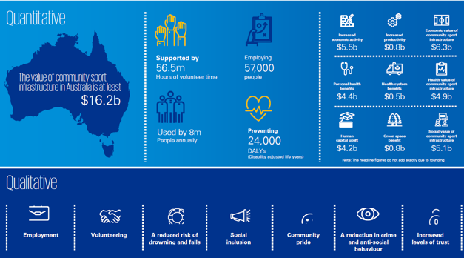
Figure 4: Summary of the Sport Australia report into the value of community sport infrastructure

Changes in How we Value Parks, Sport and Recreation Facilities and Trails
We value our parks, sport and recreation facilities and trails for they are important to our health and wellbeing and social connectedness with community.

Today we expect a diverse mix of participation opportunities that are accessible and affordable within parks and sport and recreation facilities that are of high quality and offer different experiences. We also expect to have bikeways and walking tracks available in our neighbourhoods that connect where we live to where we would like to go for commuting and recreation (exercise and activity).

The infographic on the next page summarises the key findings from Otium Planning Group research that show the changing attitudes and behaviour towards parks, sport and recreation facilities and trails that need to be considered in the development of the Master Plan.

Lessons from the Lockdown - Importance of Public Open Space
In addition to these influences, the recent impact of restrictions to reduce/eliminate the spread of the Covid-19 pandemic has highlighted just how important public spaces, parks, sport and recreation facilities and trails are to the community.

Anecdotal evidence from many towns and cities has highlighted the rapid increase in use of public spaces and how important the opportunity to get outdoors and be active has become to all. It is likely this rapid shift in behaviour will emphasise inequity in provision and may result in more permanent increases in outdoor activity and exercise.
“However, the sheer volume of people exercising in the open air has also exposed the limitations of historic design of some public spaces, with too many people crowded onto narrow walkways or poorly laid out parklands. That’s why our future precincts, parks and public spaces need to be designed to enable better social distancing, with wider footpaths, segregated cycleways and more linear parks, to meet the increased demand for these precious public spaces.”
Rob Stokes Minister for Planning 12/05/20 Guardian Australia
In October 2020, AusPlay released data on the early impact of Covid-19 on sport and physical activity participation by comparing data for the period of April to June 2020 with April to June 2019. Key findings include:
- The need for more frequent participation appears to have been prompted by Covid-19. 63% of females and 65% of males participated in physical activities 3+ times per week between April to June 2019. This increased to 66% and 70% respectively for April to June 2020.
- Recreational and fitness activities were most popular during April to June 2020. The top three activities for adults during this period were Walking (recreational) (86.3%); Exercise at home (81.6%) and Exercise biking (81.3%).
- Running (41.0%), Jogging (41.8%) and Yoga (38.6%) were the top three recreational and fitness activities adults participated in more in April to June 2020.
- Comparison of ABS emotional and wellbeing data shows an increase in emotions associated with anxiety and depression in April, before stabilising or reducing in June 2020.
- Data on motivation for participation showed physical and mental health and social reasons were more prevalent in April-June 2020 data.

Sport and Recreation Value Key Findings
Hamlyn Park provides several sport and recreation facilities and services that offer physical and mental health, social, environmental, and economic benefits to Geelong.
To continue to provide these benefits and optimise the use by community, Hamlyn Park will need to be designed in a way that can adapt to changing sport and recreation participation trends, leisure patterns and community expectations.
Key trends influencing the provision and design of sport and recreation facilities and services are:
- Participation in physical activity in Victoria has increased, however the majority of the growth has been in unstructured activities such as walking and cycling and gym/fitness.
- It will be critical that the development of or improvements to facilities and grounds are multi-use and are not putting unnecessary financial pressure on Council and do not duplicate facilities with available capacity.
- Insights from the Covid-19 pandemic highlighted the importance of local recreation facilities and the growing expectations from the community around the quality of their open spaces and sporting facilities.
- New facilities should be developed in a multi-use hub precinct to ensure the maximum value of investment is achieved, while also not duplicating facilities.
- Sports parks need to incorporate opportunities for co-location of sport with recreational offerings, including providing opportunities for walk/run paths and trails as this is the highest participation physical activity undertaken by the community.
- The large growth in female participation within traditionally male oriented sports is increasing pressures on playing facilities and increasing the need to diversify amenities to be universally accessible.
- Whilst nature and intensity of participation in sport may change over time in consideration of the type of sport, the need for suitable spaces to accommodate community demand will remain. Future facility provision and design needs to ensure spaces are adaptable to accommodate changing participation trends.
- The location of sport and recreation facilities need to be accessible to the majority of the community in order to encourage maximised use.
Councils are responding to these changing trends in several ways. These include:
- Master planning of sport and recreation places and spaces is becoming increasingly important to ensure well-planned, flexible, multi-use spaces that can adapt to community needs into the future.
- Contemporary planning seeks to create 'community hubs' for sport and recreation that can meet a broader range of needs and facilitate higher utilisation and viability.
- Awareness of the importance of ‘risk management’ and the need for a ‘whole-of-life’ approach to facility development and asset management.
- A network of facilities that provide a well-designed mix of community, commercial and service facilities for sport and recreation activities.
- Facility designs need to ensure specific needs of key users can be met, including universal design and female friendly principles.
- Creating environments that enable people to lead active and healthy lives, placing greater focus on integration with urban planning in public spaces, provision and/or connectivity of walking and cycling paths, provision of complementary and connected sport and recreation facilities and program, and the provision and access to parks, nature and open spaces.
- An increased emphasis on public parks, active transport and better access to formal and informal sport and active recreation in response to a global push for more active and healthy environments. For example, WHO (World Health Organisation) call to action for increasing green space is a direct outcome from extensive research into the benefits of green space to people and places.

Site Review
This section reviews the planning context, usage, occupancy and condition of Hamlyn Park.

Site Overview
Hamlyn Park Reserve is located at Calvert Street, Hamlyn Heights, and is nestled within a residential area as well as bordering two schools to the east and west.
The primary planning site (green) is owned by the City and has a total area of approximately 5.2 hectares. The reserve is zoned Public Parks and Recreation Zone (PPRZ). The primary function of the reserve is for active recreation.
To the west of the primary planning site is Western Heights College on Department of Education and Training (DET) land. This secondary planning area (blue) is also zoned PPRZ and currently provides facilities for use by sporting tenants of Hamlyn Park, including football, cricket and netball, under a joint use agreement.
The section of land between the City and DET is owned by VicTrack and is zone Public Use Zone. This is an interface area (green arrow) between the primary and secondary planning area and includes a shared use trail (Tom McKean Trail) and high-pressure gas line.
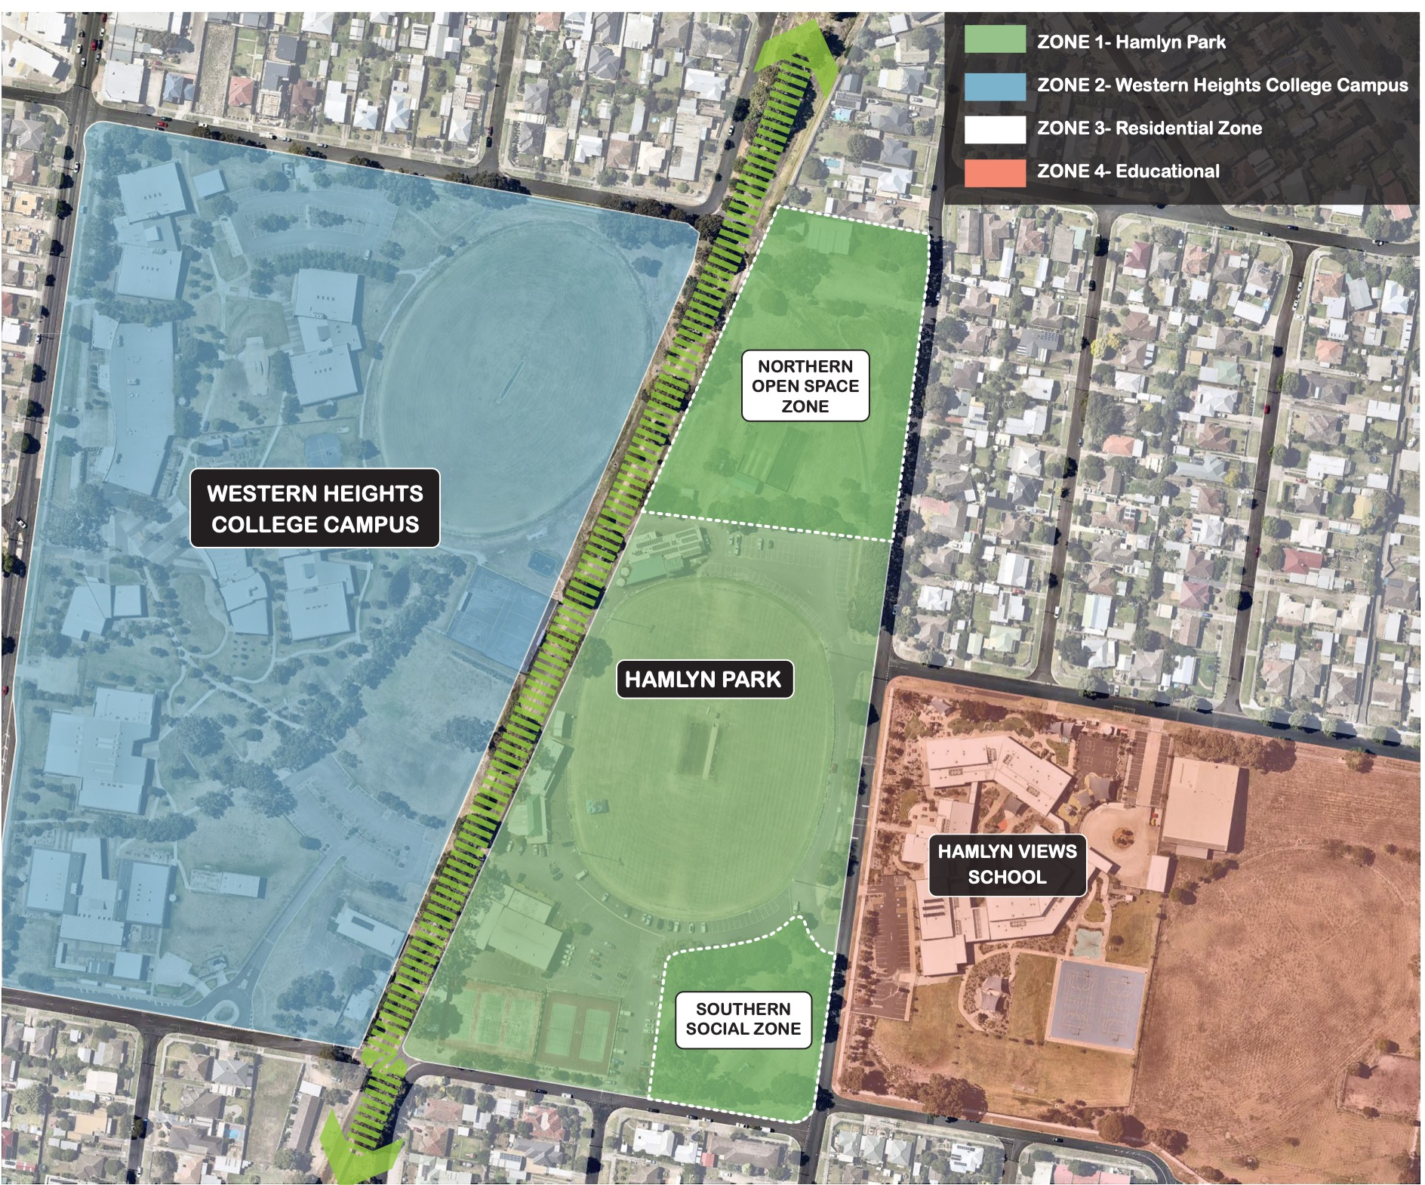
Figure 5: Site Plan

Occupancy Agreements
The reserve has a large range of user groups including football, netball, tennis, cricket, scouts and community groups such as ballroom dancing.
The current lease and license holders on the site include:
- Bell Park Sport and Recreation Club (Football, Cricket and Netball) – Sports oval and supporting pavilion and social rooms
- Hamlyn Park Tennis Club – Tennis facility including courts and small pavilion
- Geelong Ballroom Dance Club – The Ballroom
- Scouts Victoria – Scout Hall
- The City currently has a Joint Use Agreement with Western Heights College to allow community to access the sports oval and netball courts on school land.

Site Observations
OPG and City staff conducted a site inspection and observed usage of the reserve in November 2021. The following observations were identified:
- Sporting facilities at the reserve will need to be considered in the context of the reserve hierarchy in the local network.
- Facilities should complement other opportunities that exist or are planned across the catchment area to avoid an over/under-provision of facilities.
- The use of flexible and innovative solutions will be important for maximising multi-use and changing use as community demands vary over time.
- Existing public amenities and access pathways must be retained however, additional public facilities such as playgrounds, park infrastructure, pathways and amenities are required to cater for casual/informal reserve users.
- Social family recreation and play areas are needed in Hamlyn Park to meet the gaps in provision of these places.
- Pathways linking features within the site as well as to destinations outside of the reserve will be an important consideration of the Master Plan.
- There is formal and informal parking and access to the reserve. There are safety concerns from people driving on park areas and across the walking and bike trail. Additional traffic volumes into the site will require careful planning to provide safe entry, parking and exit points for vehicles, cyclists and pedestrians.
- The traffic management plan will also need to consider emergency vehicle access, peak car parking requirements, overflow parking options and general safety of all users. The needs of all adjacent properties must also be carefully addressed.
- There are multiple buildings onsite that support active recreation use that are no longer considered fit for purpose. Consideration of upgrades or consolidation of buildings will be important.
- Any new facilities or infrastructure will need to integrate and complement the existing infrastructure which have been outlined to be retained and align with relevant guidelines for sport.
- Pavilions will need to include opportunities for multi-use community spaces and consider the potential for consolidation or removal of the existing ageing infrastructure.
- All facilities will need to be developed using the Universal Design Principles, Crime Prevention through Environmental Design (CPTED) Principles and reference the Female Friendly Design Guidelines.
- There are opportunities to improve landscaping (seating, shade trees, drinking fountains, pathways, planted areas) of open space and community use areas to encourage social and family gathering, informal sport and recreation activities, community exercising and support spectator viewing.
- Pathway linkages and beautification between the sites will also be an important consideration of the Master Plan.
- Scouts Hall is old and now disused. Exploring alternative uses for the hall in partnership with Scouts Hall is an opportunity for the Master Plan.
- Western Heights College netball courts and sports oval are critical to support the growing participation of Bell Park Sporting Club groups (football, cricket and netball). The Master Plan will need to assess and confirm the opportunity for ongoing use with the school and determine what, if any, upgrades should be considered on DET land.

Asset Condition

Sports Oval and Lighting
- The main sports oval is in good condition and includes drainage, irrigation and new lighting to competition standards.
- The school oval is in good condition. There is no lighting on the school oval.

Sports Courts and Cricket Nets
- The acrylic netball courts are in good condition and include training lights.
- Three (3) of the synthetic tennis courts have recently been replaced and are in excellent condition. These courts have lighting for competition. The two public courts are serviceable but require renewal in the short to medium term. The public courts do not have lights.
- New cricket training pitches and nets with storage area has recently been installed and are in excellent condition.

Buildings
- The sports pavilion was refurbished in recent years after fire damage. The pavilion is required to support multiple sporting uses and facilities. It is well positioned on the wing of the sports oval and within proximity the netball courts and the Western Heights College oval. However, the pavilion has insufficient change rooms, and they are not designed as gender neutral.
- There are no adequate change facilities to support netball participation, Investigating the development options for improving the provision of gender-neutral change rooms is a priority.
- The Ballroom has an excellent standard dance hall and floor. However, the change rooms, toilets and kitchen are dated and access within the building is via stairs. Delivering universal design access and upgrading the change rooms, toilets and kitchen are priority improvements.
- The Ballroom also has “undamaged, sealed non friable asbestos” that requires a long-term management strategy and safe removal when refurbishing.
- The tennis pavilion is in serviceable condition but basic and falls short of contemporary universal design and female friendly design guideline facility requirements. Delivering universal design access and upgrading the change rooms, toilets and kitchen are priority improvements.
- The Bell Park Sporting Club Social Rooms support the social activities of the football, cricket and netball clubs. The facility is also a gaming venue. Refurbishment of the social facilities should be considered in the long term.

Other
- The playground is in poor condition and requires renewal in the short term.
- The footpath network is in average condition, disconnected and lacks connectivity between activity areas.
- The car park area near the social rooms is formalised and in good condition, however the entry, internal perimeter road (with bollard) and asphalt car parking area near pavilion, the Ballroom and tennis courts is extensive and informal.
- The BMX track layout is operational however in need of renewal.
- The exercise equipment is in good condition and appears well used by the community and linked with central shared use trail.
- The open space areas are undeveloped and require landscaping treatment to improve the aesthetic, shade and accessibility of the reserve.

Site Review Key Findings
Hamlyn Park offers a wide range of sport and recreation facilities that vary in condition with some requiring renewal.
Key site issues and improvements identified:
- The buildings (main sports pavilion, tennis pavilion and the Ballroom) are not designed to contemporary standards. Universal access (DDA) is an issue, the change rooms are dated, insufficient in number and are not gender neutral. There is limited access to appropriate change facilities for female participants, in particular a lack of netball facilities.
- The upgrade of change room facilities for netball, football and cricket, upgrade of the Ballroom and tennis pavilion, to provide accessible and female friendly facilities, and cater for the future participation growth and profile of users are priority improvements for the reserve. The Ballroom has asbestos that will need to be removed as part of any future redevelopment.
- The ovals are in good condition and the main oval offers competition standard lighting. Lighting the Western Heights College oval and investigating a synthetic surface would disperse training across two sports ovals and address the overuse of both ovals.
- The social family recreation and play areas within the community open space areas are lacking or in poor condition. These areas include the play space, bike track and pathways. A landscape improvement plan is needed that upgrades and extends the play space and bike track areas, activates public open space areas i.e., kick about space, dog park areas, social picnic areas. These areas should be supported by public seating, a connected and upgraded pathway network and shade tree planting.
- There is extensive informal asphalt car parking and some unauthorised access and egress from the park that is leading to unsafe conflict between cars and pedestrians, and inefficient traffic flow and car parking. A traffic management and car parking plan that integrates safe pedestrian flow and crossing between activity areas is recommended.

Photos of the site are shown on the following pages.

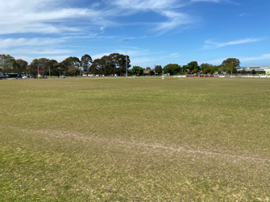

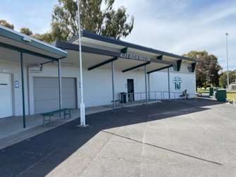

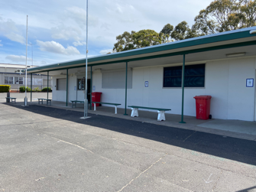

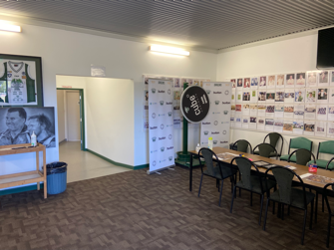

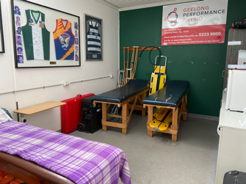

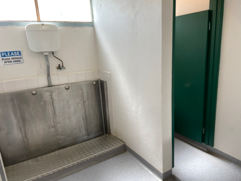
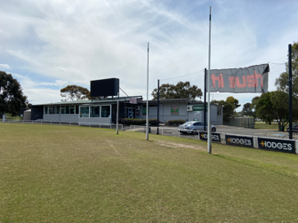

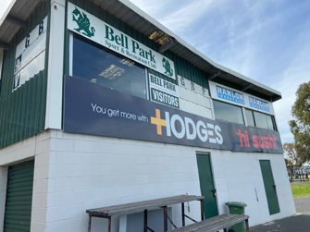

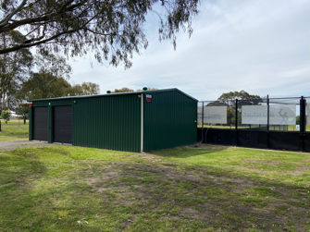

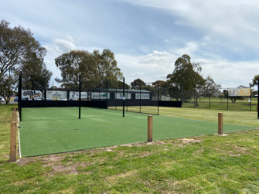

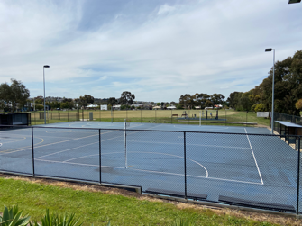

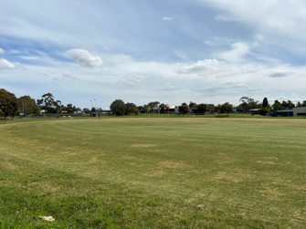
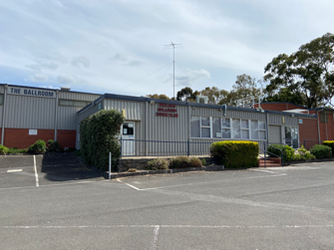

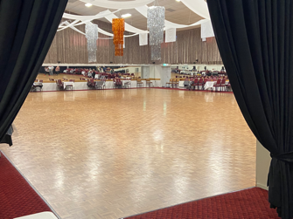

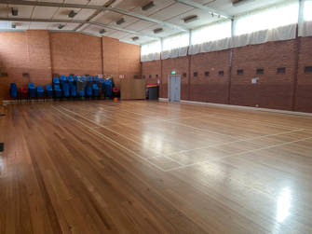

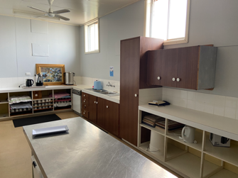

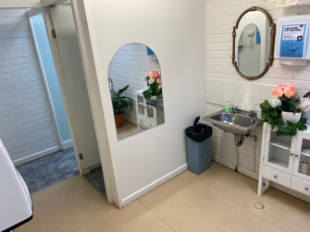

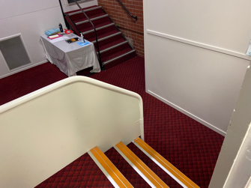

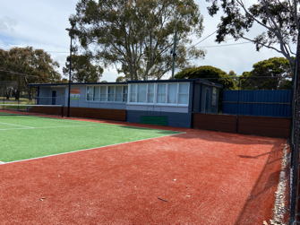

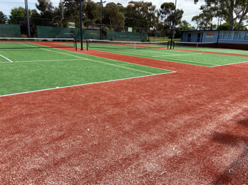

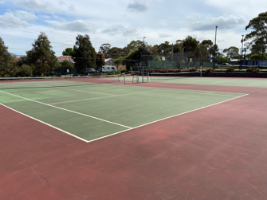

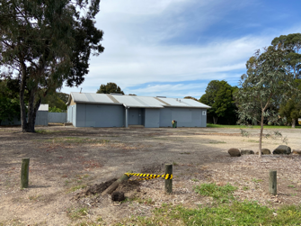

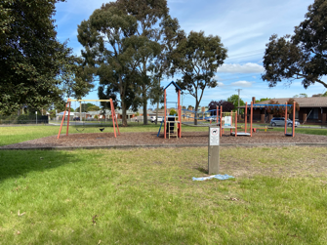

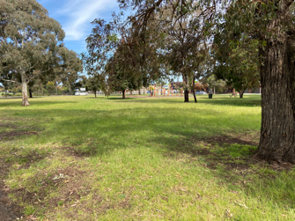

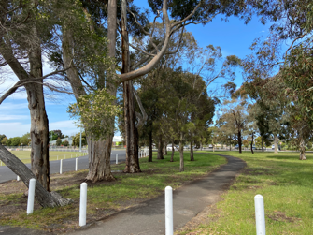

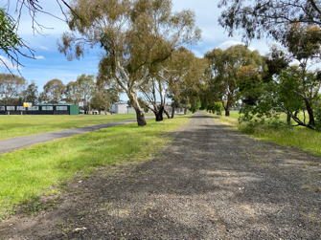

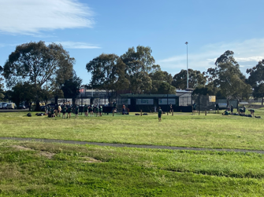

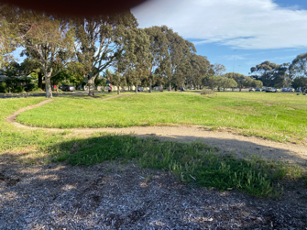

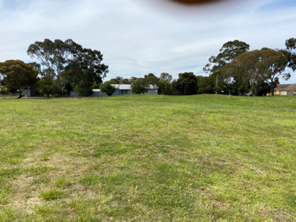

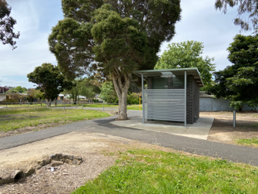

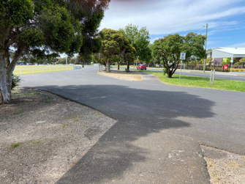

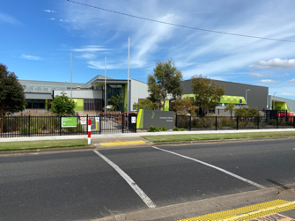
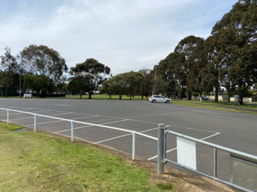

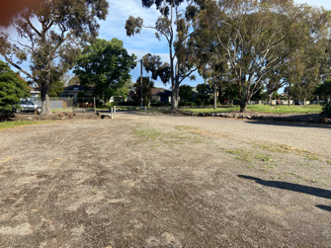

Stakeholder Engagement
This section summarises the community and stakeholder input into the Master Plan.

Engagement Method and Reach
This first round of engagement with the community was undertaken to understand what they like, and what they would like to see improved, through the Master Plan. Engagement took place from 1 November to 3 December 2021 and involved online and face to face engagement opportunities.
A summary of the consultation process and feedback received is provided below. A separate Engagement Findings Report has been prepared and is publicly available.

- 32 days of engagement
- 451 suggestions (comments) for the public left online via social map and via drop-in sessions
- 132 number of people to leave feedback
- 1 print adverts in local newspapers
- 385 social media reach / impressions
- 30 social media actions (clicks, reactions, shares, comments)
- 169 total contributions to the Have your Say page
- 42 people following the project
- 632 advertising pamphlets delivered.
The chart below shows the visitation peaks over the consultation period. There were 1,367 visits, 664 visitors and 132 contributors to the online engagement page.

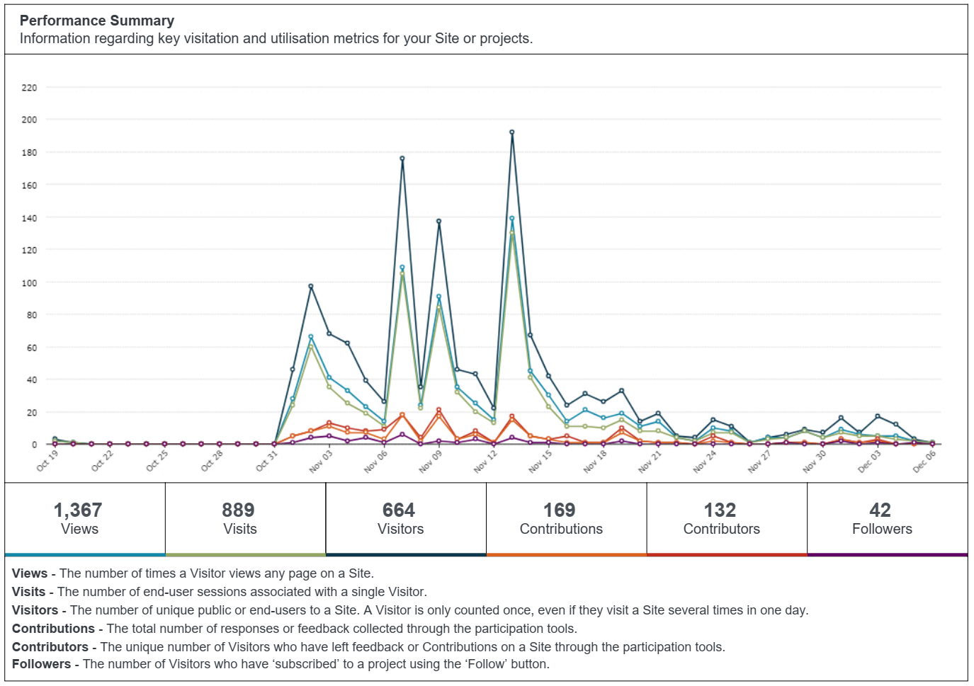
Figure 6: Have Your Say Page Visits

Community Survey
The City received 123 online community surveys via Council’s Have Your Say engagement page.
Approximately (68%) of survey respondents were local residents followed by members of a community organisation or sporting club (25%). The data shows that those people that responded were involved in several groups along with informal users and were local residents.
Most survey respondents were female (67%) between the ages of 25 and 49 years (63%). Over half (57%) of survey respondents have children across all children age cohorts (0 to 4 years – 39; 5 to 11 years – 40; 12 to 17 years – 26).
A snapshot of the responses to the survey is provided below:
- 33% Male and 67% Female respondents
- 85% of respondents visit the reserve at least weekly
- 81% of respondents walk to the reserve
- 65% of respondents go walking at the reserve; 50% use the playground; 47% participate in informal sport / activities; and 40% go to socialise
- 45% of respondents were satisfied with the reserve; whilst 22% were unsatisfied
- 54% of respondents found the ovals satisfactory; whilst 54% were unsatisfied with the landscaping of the reserve.

Usage
Over 85% of survey respondents visited the reserve weekly or several times per week.

Answer choices | Percent | Count
Several times per week | 53.33% | 64
Weekly | 33.33% | 40
Monthly | 5.83% | 7
Several times per year | 7.5% | 9
Never | 0% | 0
Total | 100% | 120
Figure 7: Frequency of Visits

Most survey respondents spend 30 to 60 minutes (52%) at the reserve. The findings shows that importance of the reserve in supporting people’s health and meeting recommended physical activity guidelines.

Answer choices | Percent | Count
Less than 30 minutes | 19.01% | 23
30-60 minutes | 52.89% | 64
1-3 hours | 20.66% | 25
More than 3 hours | 7.44% | 9
Total | 100% | 121
Figure 8: Length of Visits
The reserve is used for a wide range of activities. The most popular activities of survey respondents were walking (65%), using playground equipment (50%) and informal sport/activities (47%). This finding shows the important role the reserve plays for the community in providing a space for sport and for community for exercise, socialising and playing.

Figure 9: Activity Type

Most survey respondents walk (81%) to the reserve.

Answer choices | Percent | Count
Walk | 81.30% | 100
Ride | 25.20% | 31
Drive | 35.77% | 44
Public Transport | 2.44% | 3
Other | 0.81% | 1
Total | 100% | 123
Figure 10: Mode of Travel to Reserve

Facility Satisfaction
Survey respondents rated the overall facilities at the reserve as good (39%) or neutral (34%).

Answer choices | Percent | Count
Very good | 4.88% | 6
Good | 39.02% | 48
Neutral | 34.15% | 42
Poor | 19.51% | 24
Very poor | 2.44% | 3
Total | 100% | 123
Figure 11: Overall Satisfaction

Survey respondents liked the following features of the reserve:
- Access to passive/ unstructured recreation options (playground, dog walking, BMX) (41%)
- Assess to a natural area with mature trees (29%)
- The existing sport facilities (25%)
- The location (20%).
Sample quotes:
- “The beautiful trees, scale of open space and range of active areas.”
- “Close proximity to home. Great community feels. Open and accessible.”
- “The ovals are well maintained. There are plenty of family-friendly sporting facilities. It's a big space with plenty of room for many to use at once.”
- “The reserve is in a prime location where there are many young families that belong to the local schools.”

The following chart shows how survey respondents rate the facilities in terms of how well they meet current needs.

Figure 12: Facility Type Rating

The following facilities were satisfactory (response rate of greater than one third)
- Football ovals (54%)
- Open space (48%)
- Tennis courts (48%)
- Car park (37%)
- Pedestrian pathways (36%)
- Cricket nets (33%).
The following facilities were unsatisfactory (response rate of greater than one third)
- Landscaping (54%)
- Pedestrian pathways (36%)
- Playground (35%).

Key Issues and Ideas
Survey respondents identified the following key issues facing the reserve:
- 54% of respondents were dissatisfied with the condition of the reserve
- 31% of respondents believed the reserve was over capacity or that the facilities were not keeping up with the current demand
- 29% of respondents believed the reserve was under-utilised.
Survey respondents identified the following key improvement ideas for the reserve:
- Respondents would like to see a renewal of facilities, so they are modern, fit for purpose and encourage more people to use the reserve. Improving the existing facilities within the reserve (25%) and improving the sporting facilities and club infrastructure (16%) were ideas raised by survey respondents.
- Respondents valued the established mature trees and access to natural areas. Survey respondents suggested protecting the existing trees and enhancing the natural areas and landscape character of the reserve (19%).
- Respondents wanted to see increased activation of the site. Survey respondents identified developing a new playground (32%) and providing more activities, particularly a skate park (22%) as ideas for encouraging a wider range of ages and users at the reserve.

Answer choices | Percent | Count
Facilities in poor condition | 50.45% | 56
Facilities no longer fit for purpose | 28.83% | 32
Over capacity – facilities not keeping up with current demand | 34.23% | 36
Reserve is under utilised | 32.43% | 36
Competing users across the reserve | 11.71% | 13
Car parking | 17.12% | 19
Other | 13.51% | 15
Total | 100% | 111
Figure 13: Key Issues

Drop-In Sessions
The City hosted four drop-in sessions (online and in person) in November 2021. The drop-in sessions were attended by about 20 people. Those attending the drop-in sessions were encouraged to submit feedback through the online community survey and Have Your Say page.
Key issues and ideas raised during conversations at the drop-in sessions were:
- Provide a new play space. The condition and function are average. Develop a play space for all ages with social facilities, including seating, shelter and bins. The current site is well used by a lot of families in the area that would benefit from improved spaces.
- Protect the mature trees and natural spaces around the reserve. Retain and expand trees. There are significant tree nest sites for black cockatoos in reserve.
- Activate reserve and beautify natural open space areas around the reserve.
- Provide a youth space for teenagers. The BMX bike track is well used and could be improved and enhanced with a skate park.
- There are rubbish and vandalism concerns.
- There is an opportunity to repurpose the disused Scout’s Hall.
- Consider resurfacing the scout’s hall car park area.
- The school Master Plan process promised community access to a large open space with wetlands. The school design supported the idea of a “school in a park.” These ideas have not been realised.
- The reserve becomes exclusive use when sport is on. Can there be areas that can be designed for community to use at these times.
- The reserve has been a critical public open space for the Hamlyn Heights community during the Covid-19 global pandemic.
- There is a conflict between the BMX bike track and cricket nets. Consider a barrier to restrict balls to the cricket net area.
- The walking track needs to be resurfaced. Consider lighting along the walking path for safety and greater use.
- Improve the traffic management around site. A particular issue is behind pavilion, and across railway line on match days. Consider removing the boom gate so you can drive around reserve (for ambulance service).
- Enhance landscaping including way finding signage, tree planting, pathways, seating.
- Herne Hill PS and other schools in the area could be interested in a tree planting/community garden area.
- Both football and cricket have a strong investment in juniors. This has resulted in junior participation growth and an increase in teams. Investment in sport facilities is needed to accommodate this growth and standard e.g., gender neutral change rooms and gym.
- The ground is of a good standard, but surface is hard. This requires remedial work.
- Consider a dog walking space and area.
- Improve the kitchen in the tennis pavilion. The tennis club has recently resurfaced three courts. The two public courts are well used by community.
- The update of the cricket nets has been a positive outcome and are well used.
- The netball courts need to be retained but require access to change rooms.
- Refurbishment of ballroom facilities. This includes upgrading the change rooms and toilets, improving DDA access and increasing storage. There have been architectural plans submitted for consideration by Council. The members of the ballroom club would like these supported
- Consider environmentally sensitive design features on facilities including solar panel and water tanks.

Map Your Ideas Forum
The City hosted an on-line map your ideas forum. This forum encouraged respondents to identify items they were satisfied with or dissatisfied with and to submit their ideas. There were 45 contributions made to the map.
The map below summarises the key issues and ideas raised from the map your ideas forum:
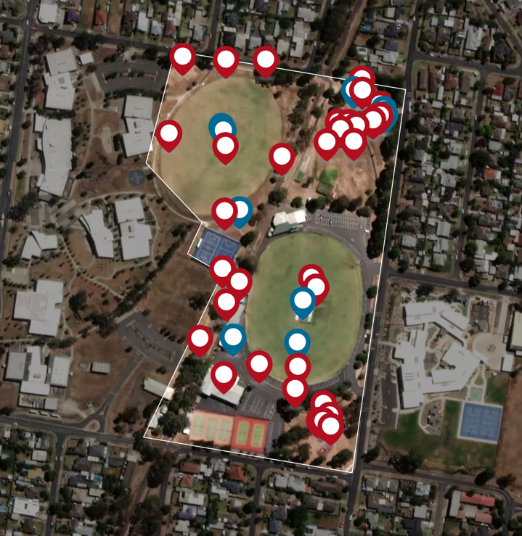
Issues:
There is a lot of car parking. It is hot, unsafe and ugly
No safe spots to watch sport
Ideas:
Rationalise car parking
Remove some car park and repurpose as seating, benches or small grandstand
Upgrade asphalt car parking

Issues:
Walking / bike track is uneven and unsafe (at night)
Graffiti back of change rooms
Motorbikes using walking / bike track
Like:
Ballroom is fabulous and one of a kind in Geelong
Outdoor gym is well used
Ideas:
Allow public to book large scale events
Council management of ballroom
Upgrade walking / bike track surface and install lights
Security lighting
Issues:
Too bare
Only playground in residential area
Seek a pleasant place to play and socialise
Like:
Beautiful established trees that attract wild birds
Ideas:
New and larger playground with monkey bars and equipment for up to 10 years
Covered BBQ
Improved grass area (irrigated)
Additional trees
Amenities
Seek perimeter footpath
Issues:
Cars using walking / bike track and park north of reserve on sports days
Limited area for people to gather and enjoy outdoors
Park is dedicated mostly to sport
Bike jump track in need of maintenance. Good facility for local kids
Scouts hall and car park area are a wasted space
Ideas:
Extend fence north of reserve to encourage drivers to use road
Vacant area behind cricket nets could be used as meeting space for community, improved lawn with kick about space, BBQ, seating area, trees
Upgrade bike jumps and expand i.e., scooter loop track
Issues:
There needs to be a balance between sport and community spaces
Ovals only support AFL and cricket
Rubbish problem
Wasted space at top end of school oval
Like:
Ovals are in great condition and serve local sport, school, exercise and dog walking
Ideas:
Pavilion to support netball courts and back oval with change rooms, toilets and shelter
Add soccer goals to optimise the use of the school oval
BBQ and picnic space at top end of school oval with avenue of trees

Key Stakeholder Interviews
Key stakeholder groups including the sporting and recreation groups and Western Heights College identified the need to improve facilities, so they were able to meet the growing demands of participants and students.

Bell Park Sports and Recreation Club
Overview
The Bell Park Sports and Recreation Club is a board of management (BELREC) made up of sporting groups including Bell Park Junior Football Club, Bell Park Senior Football Club, Geelong Dragons All Abilities Football, Bell Park Cricket Club and Bell Park Netball Club. BELREC is responsible for the Social Club and the sport clubs each look after their own respective sports. The sports clubs have a total of over 800 members.
Issues
- Lack of female friendly facilities
- Lack of storage
- Lack of meeting spaces
- Lack of shelter for visiting teams on both ovals
- Lack of shelter for netball
- The oval suffers from excessive use
- The facility is ageing
- There is no netball pavilion with change facilities
- The storge rooms are doubling as gym spaces
- The canteen is limited due to the size and age of facilities.
Opportunities
- Upgrade to the play space
- Upgrade to sports field lighting
- Linkages between schools and sports clubs
- Upgrade to facilities so they are fit for purpose and meet current (and future) standards
- Female friendly facilities.

Bell Park Tennis Club Interview
Overview
Hamlyn Park Tennis Club Inc. was established in 1967 and has a membership base of over 100, ranging in age from five to 90 years. The club offers members and public access to three (3) synthetic grass courts, two (2) plexipave courts and a clubroom.
Issues
- Lack of tracking court usage
- Membership numbers are static
- Lack of security
- Facilities have access issues and are not female friendly.
Opportunities
- More storage spaces
- Heating and cooling for the clubrooms
- New kitchen and appliances
- Upgrade facility so they are accessible and female friendly
- Upgrade to lighting
- Consider an additional two courts to support the reserve and surrounding schools.

Geelong Ballroom Club Interview
Overview
Geelong Ballroom Dance Club Inc. was established in 1984. They lease the ballroom which includes a large fit for purpose dance floor (two dance floors) that is recognised as one of the best floors in Victoria and has hosted State and National events; and multi-purpose rooms.
The club hosts weekly dances for around 120 ballroom dancers. The club manages the facility for dance classes, practice and members of the wider community who rent rooms for a range of group activities and social events. These include private dance groups, a community dance group for children and young people, fencing groups, an Italian group and gardening group. There are about 700 people that pass through the facility each week. A number of dance teachers have relocated to the facility, demonstrating the regional significance of the ballroom.
Issues
- Toilets and change facilities are dated and need to be upgraded
- The facility does not meet DDA standards. Ramps for DDA compliance
- Lighting for safety around the facility.
Opportunities
- Need for energy efficiency. Consider solar panels, heat pumps and rainwater tanks
- Outdoor seating and benches
- Landscaping.

Scout Club Interview
Scouts Victoria is not currently using the Scout Hall and is unlikely to seek a new lease if an alternative property is available in a nearby location. It will take Scouts six (6) months to know whether their plan in the alternate property is successful. If unsuccessful, Scouts Victoria has a paddling team and Geelong Showtime performing arts team that may be users of the Hamlyn Park Reserve Scout Hall.

Western Heights College Interview
Overview
Western Heights College was formed as a merger of three existing secondary schools - Bell Park High School, Geelong West Technical School and Bell Park Secondary College. The school began its vision four years ago to become a sports school, including a specialist sporting program rolled out in 2020 and a new strength and conditioning gym which will need to be relocated to the new stadium once built.
The school currently has 650 students (grown from 300 students in last five years) and has an aspiration of growing to 800 students in the next three years. The school has a capacity limit of 1,200 students. The school has specialist sporting program for basketball and AFL football. Both programs have 200 students in programs. The school is attracting students locally and from across country Victoria.
Stage 1 and 2 buildings are now complete. The school is advocating for Stage 3 to be realised. Stage 3 includes a single court (multi-use) stadium. However, the school has space for a four-court stadium.
Programming
- The school supports specialist sporting programs (basketball, AFL, netball, future – soccer)
- Current sport partnerships – Barwon Sports Academy (netball program), Geelong United Basketball, Geelong Falcons (AFL program), Geelong Netball. The school is actively pursuing more partnerships as their sports programs grow
- Local club partnerships – Bell Park Sports Clubs through a joint use agreement; and other groups through hire arrangements
- Other school facility hirers - dance and karate group.
Issues
- Currently expensive to hire courts and bus students (three times a year).
Opportunities
“We want to open the doors up to the community. We have great spaces for the community to use” – Principal

Western Heights College Stadium proposal:
- The school is entitled to one court with student numbers
- Prefer to have two courts to support school sport program
- Capacity for four courts on site
- Strength and conditioning space
- Meeting/learning spaces
- Change rooms
- First aid room and foyer.
A shared use model is proposed where community can use the stadium before and after school use. This is a possible Joint Use Agreement development proposal for the City to consider.

Stakeholder Engagement Key Findings
Respondents wanted to see increased activation and improved facilities, whilst protecting and enhancing the landscape character of the reserve. These are consistent with the issues.
The infographic below shows the key themes raised during the community engagement process.

# 1 | # 2 | # 3 | # 4 | # 5
Protect mature trees and enhance natural areas | Renew and upgrade sports facilities | Provide places for children and young people to play | Provide Park amenity including pathways, trees, seating, bins, drinking stations | Deliver a safe place for people to recreate
“Retain the large, beautiful gum trees. The native birds nest in them”  “We love the trees and green space” | “Better sporting facilities to accommodate multiple teams & the increase in female participation”  “Female friendly change rooms”  “Modernise ballroom”  “Fix the BMX track and make into pump track” | “Replace the playground with a large contemporary play space and children’s education environment that celebrates the traditional owners of the area and encourages families and visitors to spend time enjoying all that the park has to offer.” | “Plant more native trees and upgrade the condition and safety of the walking tracks”  “Add picnic areas, such as rotunda, picnic benches, BBQ facilities” | “Reclaim areas of the existing parking to facilitate improved pedestrian movement and coherence between the existing elements of the park.”  “Lighting along walkways”  “Modernise, landscape, family friendly safe spaces.”

Strategic Directions
The market research, site review and engagement findings have identified key issues and development options for Hamlyn Park Master Plan.

Key Issues and opportunities

Strategic Support and Partnerships
The key strategic objectives of the Hamlyn Park Master Plan are to:
- Improve the health, wellbeing and safety of the community.
- Provide quality and inclusive spaces that support active lifestyles for a diverse community and are accessible, attractive and based upon community need.
- Support the growth of localised and regional sporting facilities by providing new sport and leisure facilities and upgrading existing ones
- Contribute to a healthier natural environment and support environmental sustainability.
The market research and engagement process has identified actions in the previous 2010 Master Plan that were not delivered and are still current today.
Western Heights College is a critical partner to the success of sport and recreation at Hamlyn Park. Stage 3 of the Western Heights College Master Plan is an opportunity to further extend this successful relationship by investigating a multi-sport court stadium that would contribute to addressing the shortfall of 20 indoor sports courts in the next 20 years.

Sport and Recreation Participation Growth
Hamlyn Park provides for seven (7) sport and recreation clubs with a total of 1,125 participants. All sport and recreation groups have maintained or increased membership.
Further, the social rooms and Ballroom are hired out for other community and private groups weekly.
The Western Heights College has 650 students that use the football oval and netball courts on the school land. The school now runs a specialist sporting program.
Organised sport and recreation activities at Hamlyn Park are projected to increase in line with the current participation rate and population growth.
Hamlyn Heights will grow from 6,842 in 2021 to 8,456 in 2041 and maintain a higher proportion of young adults that are high users of sports facilities and workers/ retirees that are high users of recreation and cultural activities.
Other demographic and leisure trends impacting the future use of the reserve are:
- An ageing community that will require access to accessible, social recreation and therapy-based activities.
- Increasing demand in informal, social recreation activities like walking, cycling, fitness and play.
- The location around the park supports early learning, primary and secondary schools which means Hamlyn Park is a central destination for children and young people.
Hamlyn Park is very well used with 85% of respondents visiting the reserve at least weekly for organised and informal sport, walking, play and socialising.

Asset Renewal and Upgrade
Hamlyn Park facilities vary in condition with some requiring renewal.
The engagement findings found that 45% of respondents were satisfied with the reserve, whilst 22% were unsatisfied.
The buildings including main sports pavilion, tennis pavilion and the Ballroom are not designed to contemporary standards for universal access and female friendly design; and are insufficient in size and function. There are no change room facilities to support netball participation.
Further, the Ballroom and tennis facility are both of an age and condition that require renewal. The Ballroom has asbestos that will need to be removed as part of any future redevelopment.
A plan for the redevelopment and upgrade of these facilities is needed, including the provision for female change rooms for netball, AFL football and cricket.
All new or upgraded facilities should consider environmentally sensitive design features including solar panels, heat pumps and water tanks.
The playing fields, cricket nets, netball and tennis courts are in good condition. 54% of respondents found the sports oval and courts to be of satisfactory condition. Key renewal and improvement projects include renewal of public tennis courts and installation of lighting on courts and Western Heights College sports oval. This will allow for training to be dispersed across sports fields.
The engagement findings identified priority developments for the reserve were the upgrade of the play space, bike track and footpath network.

Protecting Natural Features and Improving Landscaping
Protecting the mature trees and natural areas and providing park amenity were key themes raised by the community.
A landscape improvement plan that extends the natural open space and treed areas in public open space areas within the reserve and supports ongoing environmental sustainability is recommended.

Community Spaces for Social Family Recreation and Play
The social family recreation and play areas within the community open space areas are lacking or in poor condition. These areas include the play space, bike track and pathways. 54% of respondents were not satisfied with the landscaping of the reserve.
An improvement plan that features upgrades to the play space and bike track areas and activates public open space areas i.e., kick about space, dog park areas, social picnic areas is recommended.
These areas should be supported by public seating, a connected and upgraded pathway network and shade tree planting.

Traffic Management
There is extensive informal asphalt car parking and some unauthorised access and egress from the park that is leading to unsafe conflict between cars and pedestrians, and inefficient traffic flow and car parking. A traffic management and car parking plan that integrates safe pedestrian flow and crossing between activity areas is recommended. Car park and traffic improvements and measures to address unauthorised access and pedestrian safety has been included in the landscape master plan.

Vision
Hamlyn Park is a shared community and school parkland for sport, recreation, socialising and learning. An open space to escape to that encourages active living.

Key Directions

Sport and Community Facility Improvements
- Pavilion Improvements
a) Stage 1 works include development of a change room facility supporting netball courts and WHC oval. Priority improvements include providing unisex change rooms for netball, AFL, cricket and referees.
The fitness station will need to be relocated north of the new change room facility.
b) Stage 2 works include refurbishing the Alex Rizun pavilion to meet contemporary sporting standards.
The design of the sports facilities should be fit for purpose and accommodates football, cricket and netball facility requirements and in line with AFL Preferred Facility Guidelines, Netball Victoria Facilities Manual and Cricket Victoria’s Community Cricket Facility Guidelines.
Retain scorers’ box and consider future refurbishment to improve access and amenity.
c) Stage 3 works include future refurbishment of social facilities.
- Upgrade Geelong Ballroom with improved access, refurbished change rooms / toilets and kitchen.
Deliver upgrades to the Geelong Ballroom to provide much needed improvements to access, toilets, change rooms and kitchen. This will require safe removal of asbestos, as per the asbestos report.
- Upgrade Hamlyn Heights Tennis Club facility.
Stage 1 works includes renewal of public courts and install lighting.
Stage 2 works includes refurbishment of tennis facility change rooms / toilets, kitchen and storage.
The improvement is to be redeveloped in line with Tennis Australia’s Infrastructure Planning Resource.

- Main sports field improvements.
Install ball protection fence at the southern end of the main sports fields.
Install new boundary fence and upgrade sports field at time of renewal.
Replace coaches boxes.

Western Heights College Improvements
- Support improvements to Western Heights College sports field including training standard lighting, boundary fence and ball protection fence at northern end. Support investigation of feasibility into a synthetic surface for the WHC sports field.
Installing sports field lighting to training standards will help disperse training activities across two fields and to reduce the use of the main oval during winter season.
Installing a 1.2m high boundary fence around the sports field will limit vehicle access and defines school boundary to students.
Support school’s investigation into a synthetic field to increase field capacity and use.
- Support Western Heights College proposal for feasibility and joint use (school and community) of a new multisport court stadium as part of the Stage 3 Master Plan for Western Heights College.
The multi-sport stadium has the potential to support the school’s specialist sporting program and community indoor sport use.

Open Space and Landscape Improvements
- Improved pathway / landscaping to create better connection between active zones. Pathways to consider access and inclusion design features.
- Create a new social family recreation area in northern open space zone.
Create a social and family recreation zone with new play space and bike pump track in the north open space area of the reserve.
This will involve extending the open space area to replace the Scouts Hall and gravel car park. This area will be supported by an improved grassed area for kick about space and dog exercise area, planting and social seating.
A ball protection fence will be installed at the cricket nets to improve safety to the kick about space that can also be used for fielding training.
Provide a small car park area off Calvert Street including disabled car park spaces.
- Landscape improvements to southern open space zone.
Improvements include extending planting, providing social seating and shelters and renewing the playground in accordance with the City’s playground replacement program.
The improvements will create a place where people can connect with nature amongst the mature gum trees and gather to socialise and a play zone in the southern open space area of the reserve.
- Create an outdoor forecourt (pedestrian zone) between sports pavilion and Geelong Ballroom.
Providing an outdoor, landscaped, pedestrianised and social seating area between the Geelong Ballroom and sports pavilion will improve safety between pedestrians and car movements at entry points.
- Upgrade and extend pedestrian pathway network to connect all activity areas with safe crossing areas and with the shared use track (Tom McKean Trail).
Extending the footpath network will provide a fitness circuit and provide safe pedestrian movements between activity areas of the reserve.
This footpath network will connect with the City wide trail network through the shared used trail (Tom McKean Trail) dissecting the reserve.
- Develop a landscape improvement plan for site.
Develop a landscape improvement plan that protects the mature trees onsite and extends shade tree planting in open space areas and along footpath/trail network.
Protection and enhancement of green spaces and tree canopy will support environmental sustainability in line with the City’s strategic objectives.

Traffic Management Improvements
- Bollard treatment around car park area to separate cars from open space area and shared use trail.
Installing bollards around car park area will address unauthorised access into the open space areas of the reserve.
- Remove boom gate and formalise car parking.
Removing the boom gate that is no longer required for school bus drop off and pick up will improve traffic flow around the site.
- Prepare a traffic management plan for site.
The traffic management and car parking plan should:
- Create an efficient traffic flow and car parking area in southern asphalt area and internal access road along eastern boundary.
- Address unauthorised access and egress from the park that is leading to unsafe conflict between cars and pedestrians.
- Integrates safe pedestrian flow and crossing between activity areas is recommended.
- Provides accessible car parking at active zones.
- Review function and safety of entry points.

Master Plan
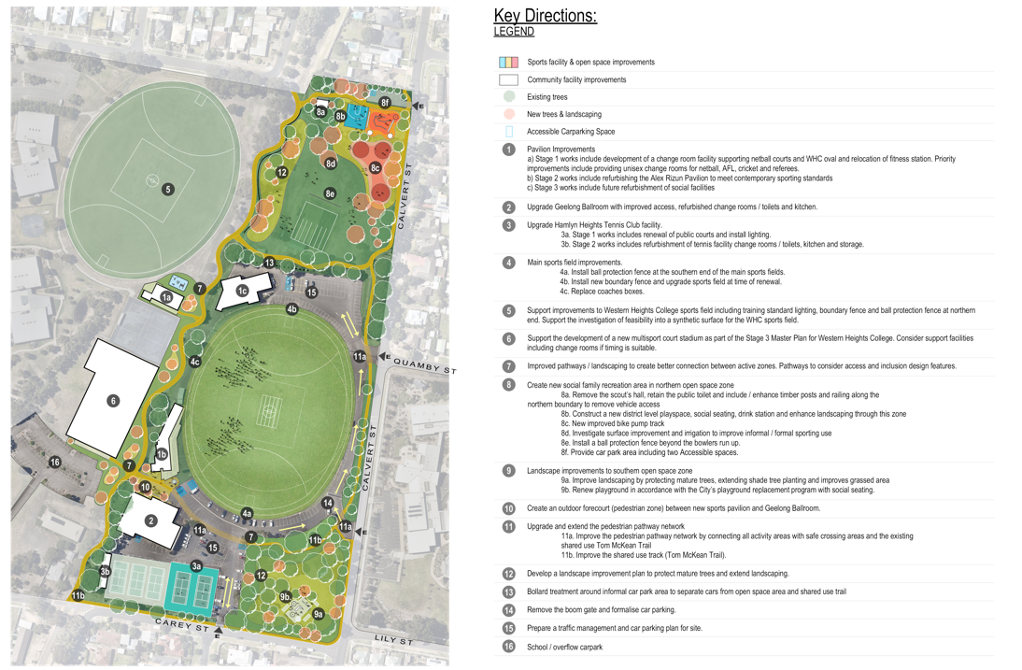

Warranties and Disclaimers

Otium Planning Group
Head Office:
304/91 Murphy Street
Richmond VIC 3121
ABN: 30 605 962 169
Phone: (03) 9698 7300
Email: info@otiumplanning.com.au
Web: www.otiumplanning.com.au

Otium Planning Group has offices in Auckland, Brisbane, Cairns, Christchurch, Melbourne, Perth and Sydney.
Otium Planning Group acknowledges the Australian Aboriginal, Torres Strait and South Sea Islander peoples of this nation. We acknowledge the traditional custodians of the lands on which our company is located and where we conduct our business. We pay our respects to ancestors and to Elders, past, present and emerging. Otium is committed to national reconciliation and respect for indigenous peoples’ unique cultural and spiritual relationships to the land, waters and seas, and their rich contribution to society.

Warranties and Disclaimers
The information contained in this report is provided in good faith. While Otium Planning Group has applied their own experience to the task, they have relied upon information supplied to them by other persons and organisations.
We have not conducted an audit of the information provided by others but have accepted it in good faith. Some of the information may have been provided ‘commercial in confidence’ and as such these venues or sources of information are not specifically identified. Readers should be aware that the preparation of this report may have necessitated projections of the future that are inherently uncertain and that our opinion is based on the underlying representations, assumptions and projections detailed in this report.
There will be differences between projected and actual results because events and circumstances frequently do not occur as expected and those differences may be material. We do not express an opinion as to whether actual results will approximate projected results, nor can we confirm, underwrite or guarantee the achievability of the projections as it is not possible to substantiate assumptions which are based on future events.
Accordingly, neither Otium Planning Group, nor any member or employee of Otium Planning Group, undertakes responsibility arising in any way whatsoever to any persons other than client in respect of this report, for any errors or omissions herein, arising through negligence or otherwise however caused.

State of New South Wales (Department of Planning, Industry and Environment) 2020 Draft Greener Spaces Design Guide

