The City Of
Greater Geelong

Rippleside inclusive playspace

Engagement report

  - July 2022

introduction

Rippleside Inclusive Playspace will be a unique place to play where people of all abilities will be able to play alongside each other in an engaging and beautiful setting.
At the Council meeting on 27 April 2021, Council resolved to endorse the proposed final concept plans for the new play space. The concept plans were then progressed to the detailed design phase.
The purpose of this engagement was to present the community with the detailed concept plans and to raise awareness of the project. We wanted to know what the community thought of the plans and ask for feedback. Do the plans capture design ideas we heard in the previous community engagements? What do you like about the plans or is there anything we missed?
This engagement was the third and final round of community engagement before the playspace is to be constructed. It was open between 20 June to 17 July 2022.
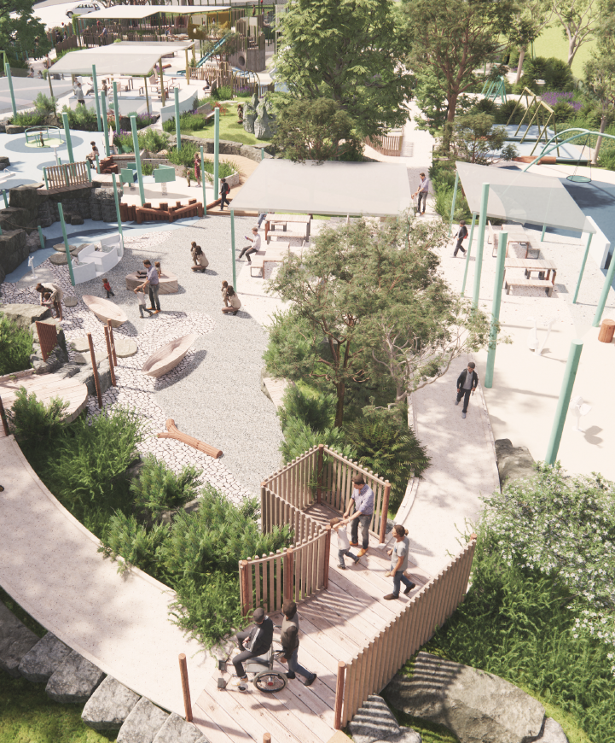
Scope of engagement
At this stage of the design process many elements of the project have already been endorsed through the concept development phase and Council Meeting Resolution including:
- Its location within the municipality at Rippleside Park
- Its location within the park
- Its size and footprint
- That the new playspace will replace the existing playground.
- That it will be fenced
- The inclusion of a feature play structure
- The inclusion of shelters and picnic facilities within the space
- Upgraded toilet block including a Changing Places facility
- The provision of park furniture outside of the playspace fence line
- Increase to the number of accessible car spaces within the existing hard surfaces
- The commitment not to expand asphalted car parking into the parkland.

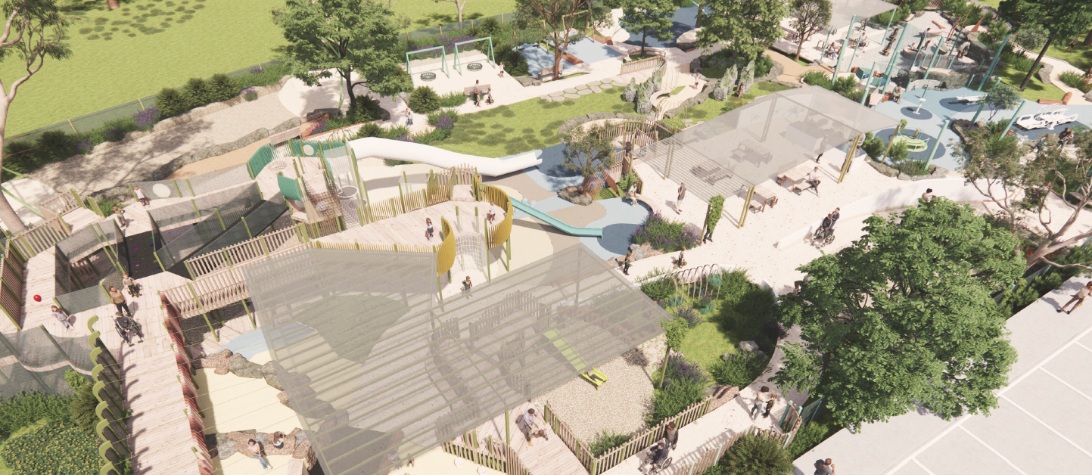

HOW WE ENGAGED
WHAT DID WE DO?
We presented the detailed concept plans and 3D renders to the community for their feedback. Plans for both the playspace and the toilet facility upgrade were presented on The City’s Have Your Say (HYS) webpage.

339
Number of people to leave feedback

96
People provided written submissions
Views of the Have Your Say webpage
2,768

28 DAYS
of engagement (Stage 3)
20th June – 17th July
58
People following the project

DATA METHODOLODY
The engagement was both self-selected and targeted. Anyone was able to respond to the survey provided on the Have Your Say (HYS) webpage but select stakeholders who were already engaged were notified and invited to submit a response.
ENGAGEMENT TOOL AND TECHINQUES
A project specific HYS page was developed to provide project information and an opportunity to feedback to the City.
A range of engagement tools and techniques were used to provide different types of opportunities for stakeholders and community to have their say. The main tools and techniques are explained in further detail below

HOW WE ENGAGED
Have Your Say Online Portal  Yoursay.geelongaustralia.com.au | An online HYS page was designed to share relevant information to encourage community feedback on the playspace plans. It was open for 4 weeks between 20th June – 17th July 2022.  Plans for both the playspace and the toilet facilities were presented along with 3D renders.  Other information provided on the HYS webpage included  -details of past engagements,  -a history of the existing playspace,  -an opportunity to register your contact details if you would like to keep your fence picket from existing playground.  -an opportunity to post any memories/photos from the existing playground  -FAQ’s  The HYS platform was chosen as we wanted to engage with a broad range of stakeholders across the municipality
Survey (HYS online) | Two Survey methods were available. A ‘quick poll’ and an open-ended survey were offered on the HYS page. Participants could respond to either or both surveys. As this was the third round of engagement a ‘quick poll’ was offered. We were aware that many responders had already provided feedback twice previously and did not have further comments. The quick poll was an opportunity to show level of support very briefly without having to also provide written comments.
Meeting | A presentation to the Access and Inclusion Advisory Committee (AIAC) was given on 20 June 2022. The plans were presented to the committee followed by discussion and questions. The meeting took place on-line as part of the AIAC regular meeting.  The AIAC were specifically targeted as they play a key role in providing advice on universal access and inclusion for all. They represent the interests of all people in the municipality who have lived experience of disability. They have been involved throughout the duration of the project. The workshop allowed participants to provide their feedback and apply their expertise.
Written submissions | Written submissions were able to be submitted via the HYS page through the open-ended survey or the opportunity to attach documents/letters to the submission. This option was open at any time during the public engagement period. Submissions could be provided by email or mail.

Communications
The engagement was promoted via press releases, social media and signage on-site. Stakeholders were contacted direct via email or telephone call.
Articles appeared in the major local media platforms including The Geelong Advertiser, Geelong Independent, Geelong Times, BayFM and K-Rock
A sign was installed at Rippleside Park at the current playground (the location for the new playspace). The sign showed images of the proposed plans and invited the community to look at the detailed plans and provide feedback via the HYS page. A QR code was provided for direct access to the HYS page.
The Social Media platforms used were Facebook, Instagram, twitter. These posts were used to direct people to the Have Your Say page.
46.3% (503) of visitors to the HYS page were made through social media.

SOCIAL MEDIA
25,708
Reach/Impressions
647
Actions (Clicks, reactions,
shares, comments etc.)

Who we engaged with

PARTICIPATION
During the 28 days the engagement was open more than 339 people engaged with the City about the Rippleside Inclusive Playspace.
These engagements were through the online HYS page.
The people who responded to the survey were invited to share some demographic data with us 1) where they live, 2) how old they are and 3) are they or a family member living with a disability.
The following is a snapshot of the responders.

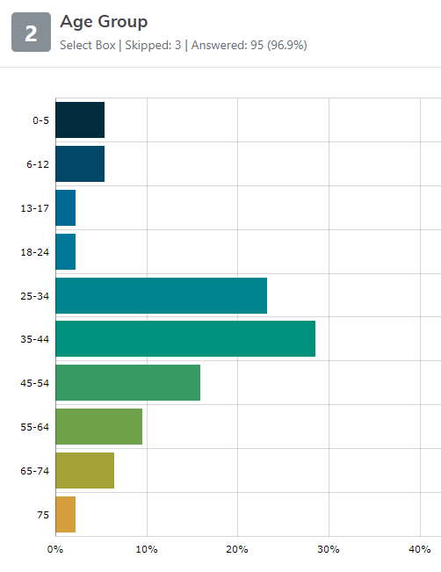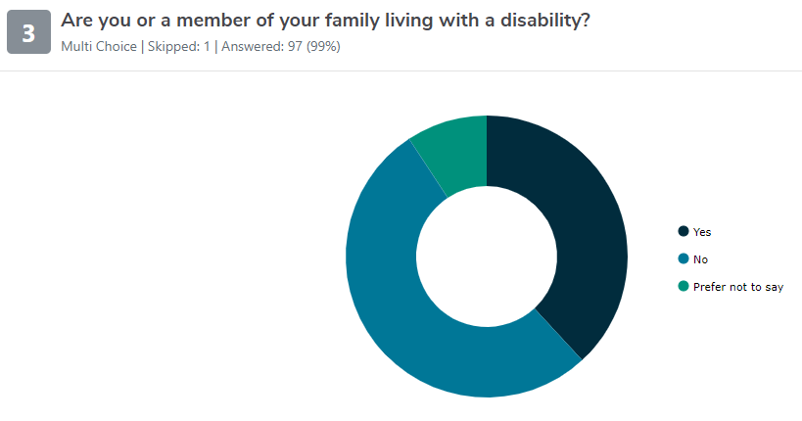

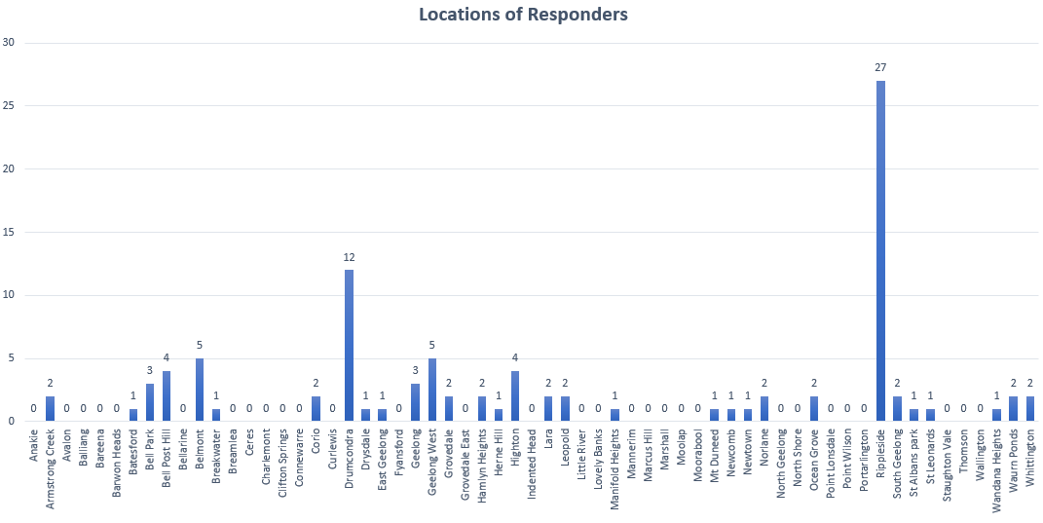

WHAT WE HEARD

THE FEEDBACK
The community feedback was in the majority supportive of the design plans.
The following outlines some of the key issues and opportunities we heard from the engagement activities.

OVERALL KEY FINDINGS
Responses were received in two formats. The Quick Poll and the written responses.
75% of responders to the Quick Poll thought the plans looked good.

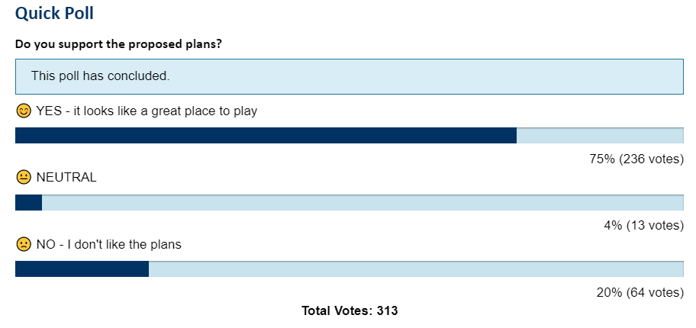

The written response survey collected qualitative data (eg. free text responses) and the responses were categorised based on ‘themes’
The data told us:
- That the playspace is being well supported and it will be very well utilised when constructed.
- The responders valued the existing adventure playground and will be saddened to see it replaced.

OVERARCHING THEMES
Several overarching themes came through in the survey responses:

theme | description | Comment
Car parking and traffic | Car parking and traffic was the issue that concerned most responders. There were 17 mentions about current and future provision of car parking and increased traffic. Many stated that the car parking within the park was already at capacity. Several responders did not want to see additional car parking within the park | There will be no loss of green space to accommodate additional car parking. The capacity to include more carparks within the asphalt surface will be investigated.
trees, green spaces | The responders valued trees, green spaces and natural elements. There were requests for the provision of trees outside of the playspace. Several responders thought the proposed playspace would encroach too far into the grassed open space area of the park. | Feedback to be provided to the landscape architect. Landscaping and tree planting is included as part of the plans. Tree planting will also occur outside the fenced playspace in the broader park. The proposed playspace footprint will occupy a total of 5% of the park.
play elements | The provision of play elements that kids could climb, hide in and explore was the most common playspace design feature mentioned (13). Many responders stated that what they liked most about the existing playground is the maze-like structure, small hidey-holes and climbing elements. | Feedback to be provided to the landscape architect.
traditional play equipment | The provision of traditional play equipment such as swings and slides were stated as important with 10 mentions. It was clear that the provision in the new development should equal or exceed the current provision. | Feedback to be provided to the landscape architect.
natural elements | The use of nature for play and the provision of natural elements such as the use of timber, natural surfaces, more greenery, plants and integration with nature was highly desired by responders with 12 mentions. | Feedback to be provided to the landscape architect. Nature play was a key component of the design brief.
secure fencing | The provision of secure fencing was a design feature that was valued with 8 responders mentioning it was important | Already included in the draft plans presented and an element of the project already endorsed through the concept development phase and Council Meeting Resolution
Uniqueness | Many responders stated that it was important to make the space different from other playgrounds and to ensure that it was truly unique and specialised to Geelong. | Feedback to be provided to the landscape architect
Don't expand current size | 9 responders said they did not want to see the current playspace size expanded | This is an element of the project already endorsed through the concept development phase and Council Meeting Resolution The new footprint has not been enlarged since the original concept plans. The enlarged playspace footprint is 5% of the total parkland in Rippleside Park.
Keep exisiting playground equipment | 6 responders wanted to see the existing playground retained. | This is an element of the project already endorsed through the concept development phase and Council Meeting Resolution. The existing timber playground is over 20 years old and due for replacement.
Keep exisitng and expand to accommodate new | 15 responders wanted to see the existing playspace retained and the site expanded to accommodate the new playspace | This is an element of the project already endorsed through the concept development phase and Council Meeting Resolution The existing timber playground is over 20 years old and due for replacement.

I would also like to see more trees planted

I am all for an inclusive and accessible playground being built, but why must it come at the expense of the existing playground?

I am very pleased to hear there will be additional paths developed connecting the playground with the bay trail

maintain some picnic tables in a shaded area outside the play space

It is absolutely imperative that the playground has a secure fence

Having this park is very exciting given it is so inclusive
our key concern is parking

I would highly recommend that these plans are discussed with a disability trained occupational therapist, physiotherapist and speech pathologist

NEXT STEPS

The feedback provided has now been considered by the Project Working Group (PWG) and the Project Control Group (PCG).
The specific design recommendations, as detailed in the table above, will be given to the Landscape Architects for their consideration and inclusion in the final design documents.
Both the PWG and PCG have endorsed the plans, with considerations, to proceed to design documentation.
It is expected that construction will commence late 2023.
This engagement report will be shared with the community via the HYS page.

