The City Of
Greater Geelong

Blue waters lake Reserve Master Plan

  - final Engagement report
  - august 2022

Contents
Introduction 3
Engagement purpose 3
About this Report 3
Engagement 4
How we engaged 4
Who we engaged 5
What we heard 5
Breakdown of findings 7
Key messages from feedback 8
How we are responding 9
Key message 1 - Environment and Biodiversity 9
Key message 2 - Water qualtiy and Drainage 9
Key message 3 - Community access 9
Conclusion 10

ACKNOWLEDGEMENT OF COUNTRY
The City of Greater Geelong acknowledges the Wadawurrung People as the Traditional Owners of this land.
It also acknowledges all other Aboriginal and Torres Strait Islander People who are part of the Greater Geelong community today.

Introduction
The Blue Waters Lake Ocean Grove Master Plan 2022 seeks to protect ecological and cultural heritage values while improving water quality, landscape amenity and community access.
Blue Waters Lake Reserve in Ocean Grove features a natural shallow lake that is approximately 7.4 hectares in size (see Figure 1). The lake provides habitat for a range of rare and threatened waterbirds.
The public land around most of the lake is only 5 to10 metres wide and is overlooked by the adjoining private properties, which enclose the reserve on all sides.
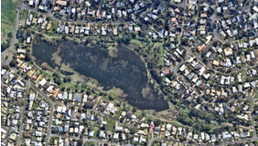
Figure 1. Blue Waters Lake Reserve
There is public access from Blue Waters Drive and Cuthbertson Drive, and the 1.6 km unsealed circuit walking path that circumnavigates the lake is popular for daily exercise, family walks and bird watching. Areas of mown grass on the southern bank provide space for informal picnics and a number of seats are located around the reserve. The steep north-eastern escarpment, which is largely inaccessible, is characterised by significant indigenous Grassy Woodland vegetation, including a stand of rare Bellarine Yellow Gums.
The reserve plays an important role in the Ocean Grove drainage network, filtering pollutants and nutrients from stormwater before it makes its way into the Barwon River.
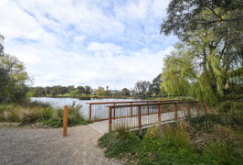
Figure 2. Blue Waters Lake bridge

Engagement purpose
The key aim of this engagement was to gain insight into community views about the draft plan, and the future needs of the park. We also wanted to build community awareness of the project and strengthen relationships with, and between, all key stakeholder groups.
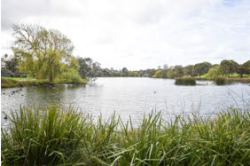
Figure 3. Blue Waters Lake

About this Report
This report summaries the community engagement process we used to seek feedback on the draft plan and how that feedback has influenced the final plan.
This report consolidates the feedback received from the community through the engagement process. The report also highlights how this feedback has been incorporated into the final plan.
The information contained in this report is intended to continue the community engagement process and keep the community informed.

Engagement

How we engaged
The community engagement period was conducted over two separate stages totalling 80 days.
Phase one of community engagement ran from 1 September 2020 to 20 September 2020 and asked a series of questions to gain insight into the community’s likes, dislikes, and aspirations for the reserve. Feedback from the first round was compiled and used to inform the development of the draft plan.
178
Surveys completed
Phase two of engagement sought feedback on the draft plan and ran from 30 May 2022 to 29 July 2022. We asked whether we had accurately captured everyone’s thoughts or whether we had missed anything from the first round of engagement. We avoided face-to-face engagement during both rounds of consultation to minimise the risk of spreading COVID-19.
2
Signs installed
Our primary method of engagement was our ‘Have Your Say’ (HYS) online platform. This online survey was targeted toward users of the reserve.
NEWS
2
Media Releases
In total, there were 2,055 visits and 1,680 visitors to the HYS project page over the two engagement periods, which converted to 200 contributions. To encourage contributions, the platform offered an online survey (hard copies were also made available upon request) and vision board in Stage 1. Both engagement periods had a strong local participation rate.
People registered for email updates
67
1
The engagement was promoted via our many channels, including signs in the reserve, a media release, and our Facebook page. A targeted post on Facebook created a reach of over 16,033 Instagram 1,933 and Twitter 378 views.
34
Vision Board contributions

Over the course of both consultation periods the City achieved the following:

16,033 Facebook Views

1,933 Instagram Views

378 Twitter Views

80 DAYS
Total engagement

Engagement details
Have Your Say online platform | An online HYS project page was designed to share relevant information to encourage community feedback. The initial HYS occurred in September 2020 and the survey period was open for 4 weeks. After feedback was collated, the draft plan was released for community feedback on the 1st of June 2022 for 6 weeks and closed on the 30th of July 2022.
Survey (online and hardcopy) | The survey was available on online or in hard copy on request.  The online survey was the primary feedback tool and took about 10-15 minutes to complete. 178 surveys were completed in total. The survey sought feedback on “what is important to you when you visit the reserve”, “What excites you about the plan” “Do you have any concerns about the plan”, “To what extent does the plan reflect the future aspiration of the local area” and “Do you have any other specific feedback about the plan ?”
Visioner Tool online | The Visioner Tool was intended to give community members a quick means to post a not about their vision and objectives for the park, but we also use to provide feedback about all elements of the plan. Thirty-four individual responses were provided using this tool and 112 likes/dislikes were posted (total of 162 contributions).
Email | Sixty-seven people registered for email updates regarding the Masterplan development. Four email updates were provided. Two people provided feedback via email.
Phone calls | The Project Officer’s name and phone numbers were provided as a call back option for those wanting to speak to an officer at a suitable time. Six calls were received about the project.
Onsite discussions  Web site | The Project Officer had one request for an onsite meeting to discuss online feedback.  The draft plan was downloaded 591 times.

Who we engaged

Survey respondent breakdown
People were invited to share some demographic data with us, primarily through our online survey.
All participants were ages between 25 and 85 years, with the highest percentage participant group (40 percent) being those aged 60 - 69 years.
Over 85 percent of the participants who provided suburb data were from the local area of Ocean Grove.

What we heard
The feedback we received was representative of the community’s views and aspirations for the reserve and, importantly, their views on the draft plan.
All feedback was collated and combined into themes, which then contributed to the final plan.
There is an overwhelming amount of support for the City to maintain and preserve the natural values of the reserve, address water quality issues and upgrade the surrounding path to permit all season access.

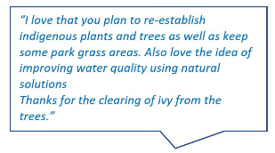

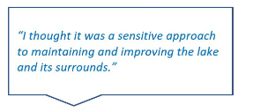

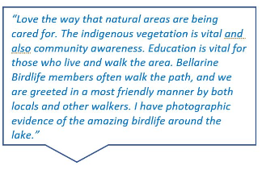
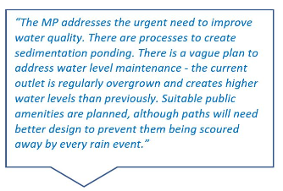

Breakdown of findings

Support for the Master Plan
Overall, the feedback from the two engagement periods suggest the community highly value Blue Waters Lake Reserve and are supportive of the plan with over 90 percent of respondents affirming they were ‘very satisfied’ or ‘somewhat satisfied’ with the plan.
The plan also aligns with the commuity’s future aspirations for the reserve with 92 percent indicating the vision for the reserve ‘strongly represents’ or ‘somewhat represents’ their aspirations.
We responded to feedback from Phase 2 of the community engagement by making minor changes to some actions in the plan where it was possible to accommodate requests. There were no significant changes made to the plan as the draft was well received by the community.

Key messages from feedback

Key message 1 –
Environment and biodiversity
Overwhelmingly most of the feedback on the plan was focused on the environment and biodiversity, particularly relating to protecting and improving habitat for birds.
Comments included:
- Continue planting native and bird attracting plants, but do not remove existing trees, including the willows, as the birds use them for habitat.
- Leave tree branches/logs that fall into the lake, so that birds can use them for nesting purposes.
- Consider including more bird nesting and bird habitat areas within the reserve.
- One willow tree in particular. It is in the area marked area 6. Hidden amongst the willow fronds often hide Nankeen Night Herons.
- Do not remove the Typha – it’s a good area for various crakes and rails.
- Love the way that natural areas are being cared for. The indigenous vegetation is vital and community awareness.
- Bellarine Birdlife members often walk the path, and we are greeted in a most friendly manner by both locals and other walkers.
- Several native birds (nankeen night herons and tawny frogmouths) live for extended periods in some of the willows.
- Retention of existing ecological values, and planned embellishment of these values.
- Plant more native trees around the lake edges. Protect the native wildlife.
- How do the Council plan to ensure that dogs are on leads as signs do not mean that there is compliance? many people feed bread to ducks at BWL- can it be publicized that this is not an appropriate diet for the birds and does effect water quality. This needs community education and monitoring of the practice.

Key message 2 –
Water quality and drainage
Water quality and drainage featured highly in the feedback. Most of which related to improving water quality and fixing flooding issues associated with inundation of the path.
Comments included:
- Water quality is poor following rain events – consider a retarding basin to remove some nutrients.
- New drains are delivering more water during heavy rain events – consider litter traps.
- Drainage points need cleaning up to reduce silt build-up and this is meant to occur every three years.
- “That the water flow is not controlled so the lake is held at a good level but does not hinder run off rates to stop flooding. The water barrier under the walk bridge needs to be higher but wider to allow a higher level to be kept to help reduce evaporation over summer period. All the drains that lead into the lake need to be cleaned and outfalls filtered for rubbish and contamination.”
- Investigate where nutrient load is originating and stop it to prevent algal growth when the water is warmer.
- Weedy growth is choking the outlet channel, affecting the water flow and creating minor flooding.

Key message 3 –
Community access
Community access is also a high priority for the community including improving the path through the reserve and providing more seating around the lake.
Comments included:
- Upgrade path to allow for all year access.
- “Would have loved a plan for raising the path so that we can continue to walk all the way around even after heavy rain.”
- Update picnic facilities and add more seating around the lake.
- I am not happy about tables/seating being installed, as this is an invitation for rubbish to be left around the area, prolonged noise in that area, and indeed vandalism will follow day AND night, if this is provided! The area remains unique in that it is a short term through way, which provides the peace and ambience of the area. I can’t imagine any resident or visitor wanting this peace to be threatened by ANY table installation!!
- Investigate parking options for Blue Waters Drive.

How we are responding
The key purpose of seeking community input is to ensure the plan reflects the needs and aspirations of the community.
The project team reviewed and considered all feedback in preparation of the final plan, incorporating the following overall statements.

Key message 1 -
Environment and Biodiversity

Based on the feedback provided around this theme, there have been no changes made to the plan in relation to the protection of the biodiversity of the reserve. The plan identifies:
- Protection of native flora and fauna.
- Our Nature Reserves Team will actively manage the Grassy Woodland with ongoing weed control, monitoring of significant indigenous vegetation, and maintaining of fire breaks.
- Ongoing weed management across the rest of the reserve to continue improving natural values.
- Re-establishment of indigenous vegetation along the edge of the lake and inlet zone.
- Selective removal of Willows over a period of years while new indigenous plantings establish.
- New interpretive signage about the flora and fauna that inhabit the reserve.

Key message 2 -
Water qualtiy and Drainage

Based on the feedback provided around this theme there has been no changes made to the plan in relation to water quality and drainage. The plan identifies:
- Monitor water quality, water levels and health of aquatic vegetation in the lake. Review sediment accumulation at the eastern end of the lake and adjust water levels using the weir plate under the footbridge as needed to optimise water quality and bird habitat values.
- Investigate establishment of a sediment pond and ephemeral wetland downstream of the existing concrete inlet structure.
- A densely planted shallow ephemeral wetland will remove nutrients and other pollutants before water enters the lake.
- Investigate establishing dense vegetation on submerged earthen embankments constructed to trap sediments and pollutants from local drainage catchments.
Investigate whether potential upgrades to the outfall channel could be made to better manage water levels during and following rain events.

Key message 3 -
Community access

Based on the feedback provided around this theme there have been no changes made to the plan in relation to the passive recreation area. The plan identifies:
- Retain maintenance access along the existing lake circuit path to Barwon Water Sewer Mains.
- Retain mown grass along the south bank and establish a small local timber picnic table near the existing timber platform.
- Establish bench seat and interpretive signage at various locations around the reserve.
- Investigate options to improve pedestrian link and safety at Blue Waters Drive crossing to across Lake Reserve.
- Investigate options to improve on street parking at the Bluewater Drive entry.
- Monitor existing timber infrastructure and replace as require.

Conclusion
All feedback and proposed responses have been discussed with individual stakeholder groups and incorporated into the final master plan.
Both the updated plan and a summary of this report will be tabled for discussion and endorsement at the November 2022 Council meeting.
Actions described in the plan will then be prioritised and implemented over the next 5 to 10 years.

