OCEAN GROVE MAIN BEACH

DOG TRIALS

ENGAGEMENT SNAPSHOT
COMMUNITY ENGAGEMENT SUMMARY
Summary
Barwon Coast and the City of Greater Geelong consulted on dog controls across the region in 2019-2020 when more than 1700 community members provided feedback. Responses highlighted the preference for an area of beach to be set aside as dog-free all year round.
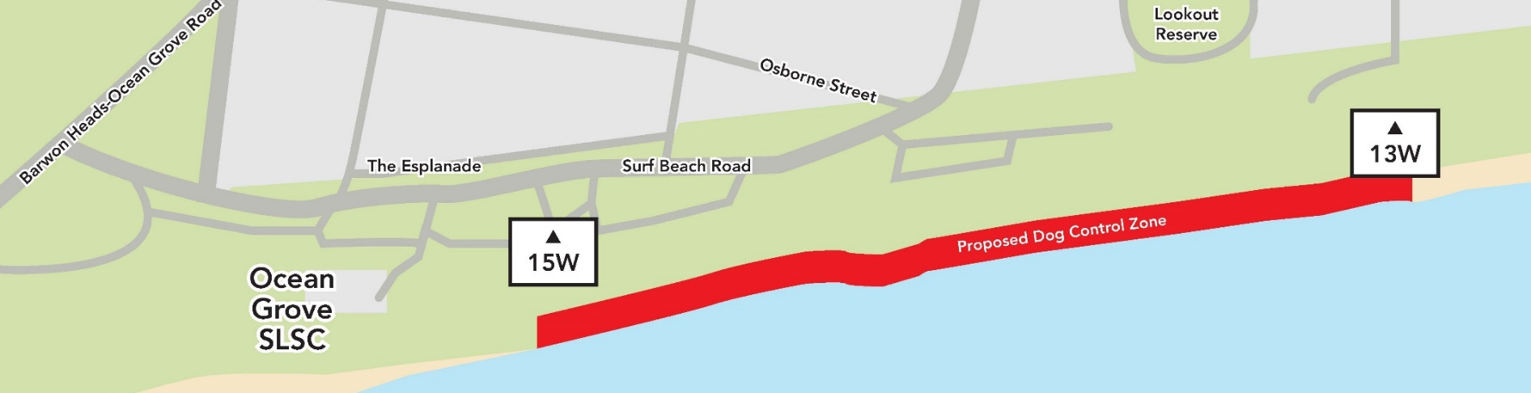
Barwon Coast determined that Ocean Grove Main Beach (‘Main Beach’), a high-use activity node, was the most suitable location. This area comprises 5% of Barwon Coast’s management area and is approximately 805 metres long.
To understand what dog control arrangements would best suit community members, a two-year trial was conducted at Ocean Grove Main Beach:
- Year One (2021) - dog walking was allowed on a leash from 1 May to 30 November and prohibited for the remainder of the year.
- Year Two (2022) - dog walking is prohibited for the entire year.
Surveys were conducted asking the community for their feedback on these two options. The first regarding the on-leash access was surveyed during August/September 2021 and the second regarding the dogs prohibited option was surveyed in August/September 2022.
1,139 responses and one mailed submission were received in Year 1 and 837 responses were received in response to the Year 2 survey, along with seven emailed submissions.

YEAR ONE - SNAPSHOT
40 DAYS
of engagement (Year 1)
1,139
Number of people to leave feedback
NEWS

11
Placements in local newspapers
6 SIGNS
Posted around Main Beach

SOCIAL MEDIA
15,865
Reach/Impressions
428
Actions (Clicks, reactions,
shares, comments etc.)
Media releases
3
People who visited the HYS page

2579
4
Media articles

YEAR TWO - SNAPSHOT
SOCIAL MEDIA
5,866
Reach/Impressions
38
Actions (Clicks, reactions,
shares, comments etc.)
837
Number of people to leave feedback
NEWS

6
Placements in local newspapers
Media releases
1
Media articles
5
5 SIGNS
Posted around Main Beach
47 DAYS
of engagement (Year 1)

People who visited the HYS page

2055

WHAT WE HEARD
Reasons for visiting Main Beach
The reasons for visiting the beach cited in the two surveys were very similar; most people visit the beach to exercise (>90%), spend time with family and friends (>61%) or recreate (>57%).
Reasons for not visiting Main Beach
In Year 1, the main reasons cited for not visiting Main Beach were fairly evenly split between animal-related (47%) and it is not their closest or preferred beach (41%)
In Year 2, 56% of respondents who didn’t visit the beach said they went to other beach areas where they could walk their dogs. The proportion of people who didn’t visit because of animals on the beach reduced in Year 2 to 10%.
The dog controls trial - Awareness
Respondents were invited to provide feedback on the dog controls trial for Main Beach. Of these, 79% (Y1) and 90% (Y2) indicated that they knew the trial was taking place.
Comments in support of no dogs | comments in support of dogs on-lead
- Dog owners don't always comply with on-leash restrictions/dogs are often not under effective control/leave dog poo (157 Y1, 162 Y2)  - People have a right to enjoy dog-free beaches/not everyone likes dogs/dogs can be scary. Children especially need to be safe. (111 Y2 and the basis of five submissions)  - Dogs should not be allowed at all (comments made often as a result of negative dog experiences)/the Year 1 trial was not limiting enough (104 Y1)  - Importance of protecting wildlife, especially during the breeding season/there should be designated 'dog free' zones for children and wildlife (15 Y1, 20 Y2 and a key component of one submission)  - This beach is too crowded (2 Y1) | - Dogs should be allowed on-lead (at all times or no season indicated) (268 Y1, 105 Y2)  - The trial is too limiting (190 Y1, 146 Y2)  - The beach is empty/quieter in off season/mainly residents on the beach (155 Y2)  - Social connection (with other people and their dogs) is very important/there are mental health benefits/this is family time/the dog is part of the family/I feel safer when walking with my dog (101 Y1, 117 Y2)  - The trial is biased against responsible dog owners/the majority do the right thing (80 Y2)  - More ranger presence/enforcement/fines would help (35 Y1, 64 Y2)  - Don't agree with the dog ban in 2022 (61 Y1, 146 Y2)  - Can't see what the problem is/there's enough space for everyone/my dog is well-behaved/I’ve never had an issue (18 Y1, 33 Y2)  - There are not enough places where dogs are allowed/other areas will become too crowded (16 Y1)

Impact of the trial (Year 1 and 2 feedback combined)
- 144 respondents said they have visited (or will visit) Main Beach less because of the restrictions preventing them from taking their dogs.
- 143 respondents were unhappy that the trial had limited or changed how they use the beach.
- 95 respondents said they felt safer with a dog-free section.
- 80 respondents reported that they still see dogs on or off-leash in the restricted area.
- 79 respondents said they were still visiting as normal or the controls had not impacted them.
If dogs return to Main Beach
All Year 2 survey respondents were asked whether they had concerns about dogs returning to Main Beach. 61% of respondents identified at least one concern.
- Owners do not take responsibility for their dogs' actions on/off leash (including lack of effective control) (34).
- Dogs off-lead rush up to the respondent or others, especially children and the elderly (18).
- Owners do not pick up their dog’s waste (18).
- No dogs/some people prefer a dog-free space (18).
- No enforcement/rangers/fines (17)
- Dog owners are not following signage rules and restrictions in place (15)
Signs, promotion and enforcement
671 (Y1) and 769 (Y2) suggestions were received for improving signs about the dog controls. They included the following; numbers in brackets refer to the number of times a suggestion was made in each survey.
Sign content and size
- Bigger/more obvious signs (116 Y1, 111 Y2)
- Make them less wordy/consistent/present the content simply and clearly/use maps/ensure they are not confusing or contradictory (139 Y1, 147 Y2)
- Explain why the controls are in place, provide links to surveys, include penalties, use humour, QR codes to provide more information, explain ‘effective control’, positive messaging and language, multi-lingual, and give a number to call or report concerns (11 Y1, 21 Y2)
- Change signs seasonally as restrictions change (8 Y1)
Number and location of signs
- Need more signs to cover all access/exit points/zones/carparks/ other prominent places (158 Y1, 142 Y2)
- Place signs at beach entrances and alongside dog poo dispensers (30 Y1, 31 Y2)
- Put signs on the beach if restrictions change as you walk along (32 Y2)
- Remove signs/there are too many restrictions/they ruin the look of the area/can be hazardous/keep them away from swimmers in high tides/replace signs with brochures and maps (25 Y1, 32 Y2)
- There are too many signs (16 Y1, 17 Y2)
Please note all data included in this snapshot has been sourced from the Year One and Year Two engagement summary reports available on the City’s Have Your Say website.
Next Steps

The two year trial has now ended and community engagement is closed. A process of evaluation and review is now underway.
The results of the analysis of community feedback will be prepared in a community engagement report along with a report for Council’s December 2022 meeting.

