The City Of
Greater Geelong

DOGS IN PUBLIC PLACES POLICY REVIEW

Engagement report

  - JULY - AUGUST 2022

Contents
Executive Summary 3
Introduction 4
Engagement Purpose 4
About this Report 4
How we engaged 5
At a glance 5
A little bit more 5
Who we engaged 6
Who we planned to engage 6
Participation 6
Demographics 6
Suburb 7
Age 7
Gender 7
Dog ownership 8
Who actively engaged 8
What we asked and heard 9
Locations of Interest 9
Feedback topics 9
Compliance 10
Enforcement 10
Promotion and education 11
Environment and wildlife protection 12
Safe shared spaces 12
Signage 13
Equestrian Centres 13
Seasonal access 14
Dog parks 14
Current Orders 15
Bin Availability 16
Why we asked all these questions 16
Key Findings 18
Survey Overview 18
Respondents 18
Hot topics 18
Face to Face consultation OVERVIEW 19
Drop-In sessions 19
Pop- Up Consultations 20
Internal stakeholder discussions 20
Discussion 20
Advertising 20
Key themes 21
Community engagement successes 21
Community engagement areas for improvement 21
What we have done and next steps 23
What we have done 23
Next Steps 23
Appendix A – Advertising materials 24
Appendix B – Survey hardcopy 25
Appendix C - Survey questions with logic 26
Appendix D – Written submissions (2) 27

Executive Summary

The Dogs in Public Places policy review and it’s ensuing community consultation were undertaken to ensure that the dog control orders in place, are appropriate to how our community use open spaces.
By involving the community in this review, as well as gaining feedback from key stakeholders within the City, we were able to hear what is working well and what needs improvement, from a range of people who use, develop, and maintain our reserves and trails, as well as enforce the dog orders that are in place across them.
From this feedback, Council can analyse the current orders and proposed changes to these orders across the City and make decisions that ensure balance is achieved between dog-friendly and dog-restricted areas.
The community consultation took place over a 6-week period and involved an online survey, advertised drop-in sessions and random pop-up consultations across the City’s reserves and trails, to maximise the community’s opportunity to leave feedback and discuss issues in further depth if they so wished.
We received 691 survey responses containing 1701 open comments on various dog control and ownership topics; seven drop-in session attendees across three designated sites; two written submissions, and three internal stakeholder meetings with City staff from Environment, Community and Recreation, and Waste departments.
Overall, strong themes emerged regarding:
- A lack of “dog owner compliance” with dog on-lead orders, and additionally, lack of effective control of dogs who are in off-lead areas.
- More enforcement needed by the City’s Animal Management Officers, as many respondents felt that dog owners “think they won’t get caught” doing the wrong thing.
- The want and need for more designated Dog Parks
- Increased access to off-leash areas for dogs across the City, and particularly in new, and often compact estates.
- The need for increased education of dog control orders across the City, Doggy etiquette in public places and at

dog parks, and improved promotion of “what is effective control”.
- Improved clarity and distribution of dog signage throughout the City.
- More bins needed across the City’s reserves and on trails. More than half of respondents reported there weren’t enough bins at the public spaces they frequent, and that it is very unpleasant carrying bagged dog poo for hundreds of meters and sometimes kilometers without access to a bin.

Going forward, the information collated in this report will be available to the community, as well as presented to City Managers with a vested interest in the use and maintenance of reserves and trails, and to Council for consideration when reviewing the Dogs in Public Places policy for 2022.

Introduction

The Dogs in Public Places policy undergoes review every four-years and is an integral document to the Health and Local Laws department, as it stipulates what dog orders are in place across all reserves, parks and trails in the Greater Geelong region.
It is important that the dog orders across the City’s public spaces reflect the needs of our diverse community groups, as well as protect environmentally sensitive areas and endangered wildlife.
To strike this balance, the City wanted to hear from both internal and external stakeholders to better understand the strengths and weaknesses of the current orders across the City.

Engagement Purpose
The City ran a community consultation to understand what is currently working well, and what needs improvement regarding dog control orders in public spaces.
The feedback collected would help inform whether any changes needed to be made to existing orders and the locations of said changes.

About this Report
This report collates and themes all feedback received through community consultation on the Dogs in Public Places (DiPP) review, including survey findings, informal pop-up consultations and drop-in sessions. This report will be circulated to all internal stakeholders and interested community members.
It will additionally be presented to Council to assist in decision-making regarding dog orders across the City.

How we engaged

At a glance
The community consultation ran for a 6-week period from July 4 to August 14, and from this, all data has been compiled, themed and will be considered to inform decisions regarding changes to specific dog orders and/or the locations in which orders are present.
The City engaged with the community through several avenues:
- An online survey (hardcopy in Appendix B)
- Pop-up consultations with trail and reserve users
- Drop-in community sessions at advertised locations across the municipality
The City also sought feedback from various internal stakeholder groups who are impacted by dog control orders, including Environment, Community and Recreation, and Waste.
The review of Dogs in Public Places responds to the “Healthy, caring and inclusive community” pillar in our Community Plan, by supporting active living and healthy lifestyles, improving mental wellbeing of our residents, and ensuring our community feels welcome, safe, and connected.
All engagement activities were promoted through the City’s Have Your Say page, as well as through boosted social media posts, radio ads on K-Rock and Bay FM, and printed ads in three local newspapers.

A little bit more
The anchor of this community engagement was a survey available through the City’s “Have Your Say” (HYS) page for the 6-week engagement, and this was the main medium in which community members were encouraged to leave their feedback. Being online, and consistently available meant some accessibility barriers could be overcome such as time of day, day of week, conflicting work schedules and parenting commitments, and all-ability access.
Surveys are also a helpful tool as all responses are recorded verbatim and can be easily reviewed and collated to understand themes in feedback.
Along with the survey, various face-to-face consultations were held by the City, and staffed by team members from the Health and Local Laws department. These included 15 pop-up consultations across the City’s

most used reserves and trails, 3 drop in consultations which ran for 2-3 hours, at community halls in Portarlington, Geelong West, and Grovedale.
At all the face-to-face sessions, community members had the opportunity to leave feedback with staff or complete the survey on a City-provided device, as well as ask questions and discuss issues in greater depth.
The City felt it was essential to provide the community with face-to-face opportunities, should they wish to discuss matters further with City staff, and to have these in both scheduled, advertised locations, and additionally in impromptu settings capturing the thoughts of reserve users whilst they were using the space, without a strong agenda.
The advertised drop-in sessions ran on:
- Saturday 16 July, 10am – 12pm
- Saturday 30 July, 2pm – 5pm
- Tuesday 9 August, 4:30pm – 6:30pm

The pop-up consultations occurred at the following reserves and trails:
- Barwon River Trail
- Bay trail
- Bellarine Rail Trail
- Central Boulevard Reserve
- Drysdale Recreation Reserve
- Eastern Beach
- Eastern Gardens
- Gateway Sanctuary
- Kardinia Park
- Kingston Park
- McDonald reserve
- Richmond Oval
- Rippleside Park
- Ted Wilson Trail
- Waurn Ponds Trail

Who we engaged

Who we planned to engage
The City was committed to hearing from all interested members of the Greater Geelong community regarding their experiences, suggestions, and preferences in relation to dogs in public spaces. When consulting on dogs’ accessibility, historically, dog owners are the most vocal, however we advertised this review to encourage feedback from non-dog owners too, as we wanted an accurate representation of both dog owners and non-dog owners within our community.
By hearing from a mixed representation of the community, including groups with differing interests, it helped the City see what orders were or were not working for various groups, and how we may be able to achieve a better compromise on certain issues.
The City also engaged with internal stakeholders within the City, including staff from Environment, Community and Recreation and Waste, to ensure that these departments had their concerns and preferences voiced and documented as part of the consultation process.
These departments all deal with dog-related issues, whether it be protecting endangered species of flora and fauna from dogs, complaints or complications regarding dog waste, and the shared use of public reserves including timed access at sporting facilities.
This consultation announced on its landing page that the review was only considering dog orders on City-managed land, meaning that Land Management Authority areas such as the coastline of Connewarre, Barwon Heads, Ocean Grove, Collendina, St Leonards, Indented Head and Portarlington, which are managed by Barwon Coast Committee of Management Inc, and Bellarine Bayside Foreshore Committee of Management, were not part of the consultation.

Participation
Over the 6-week consultation period, the City had 691 people complete the online survey, 7 people attended our advertised drop-in consultation sessions, and 250 flyers were handed out to the public through our “pop up” consultations.
An additional two people wrote to the City to voice their opinions and suggestions in lieu of the structured engagement activities above (Appendix D).

Demographics
Demographic information was primarily captured for survey participants, as there were several preliminary questions to help us filter data.

Suburb

The suburbs with the highest response rates were:
- Ocean Grove (63)
- Highton (48)
- Belmont (47)
- Leopold (44)
- Grovedale & Geelong West (34)
We did not hear from any residents in the following Greater Geelong suburbs: Avalon, Batesford, Ceres, Drumcondra, Little River, Mannerim, Marcus Hill, Moolap, Moorabool, Point Wilson and Staughton Vale.

Age

The age group with greatest representation was 35 – 49-year old’s (192). There was a fairly even representation of age groups all the way from 25- to 69-year-olds.
Three respondents elected to skip this question.

Gender

A gender identification question was included in this survey to understand if there were any links between gender and feelings of safety in the feedback received. It also helps us identify in future who to direct educational materials to, and where there may be less engagement around pet ownership.
Those identifying as women had the highest response rate, at 467 (68%) of respondents.
Three respondents elected to skip this question.

Dog ownership

Seventy-eight percent (78%) of survey respondents were dog owners.

Who actively engaged
Historically, when the City consults on dog control orders, most respondents are dog owners, and this consultation proved to be no exception, with 78% of survey participants being dog owners.
Whilst it makes sense that dog owners feel more invested in dog control orders that directly affect them and their four-legged friends, people without pets are also affected by the presence or absence of dogs in public places, and therefore the City promoted the consultation to all public space users in the Greater Geelong region.

What we asked and heard

Locations of Interest
Survey participants were encouraged to select all map areas that they wanted to leave feedback on and could elect to further refine this if there was a certain location of importance.

Barwon River trail (363), Geelong Waterfront (274), Shared sporting reserves (239), Western Beach/Rippleside/St Helens (202) and Bellarine Rail trail (195) were the 5 areas of greatest interest to the respondents when it came to leaving feedback.

Of the 691 survey respondents, 37.8% left feedback on specific locations within the areas listed above, including …

Feedback topics
Respondents were encouraged to select all topics that they wanted to leave feedback on. The top three were:
- Safe shared spaces for all (484)
- Dog owner compliance (436)
- Enforcement (271)

If respondents chose to leave feedback on any of the various topics throughout the survey, a mandatory question would generate asking them to rate the City’s efforts on said topic, and if they gave a rating of 7 or less, further questions would populate asking how the City could improve.

Compliance
Respondents were asked to rate the level of compliance they see by dog owners, out of a maximum score of 10.

The most common answers were 1/10 and 3/10 (67 responses each).
The average weighted score was 4.26
Answers of 8 or higher were deemed positive and required no further investigation. If respondents rated compliance at a score of 7/10 or less, it triggered an additional question, asking why they perceived there is a lack of compliance with dog orders.

The two reasons most stated as to why compliance is low were:
- Owners don’t care about the dog control laws
- Owners don’t think they’ll get caught breaking the dog control laws

Enforcement
Respondents were asked to rate the City’s enforcement efforts, out of a maximum score of 10.

The most common score was 1/10, and the average score was 2.72.

The overwhelming trend in enforcement feedback was that there is simply not enough of it (226). 5, 8 and 9 respondents reported too much enforcement, unpleasant interactions with rangers and too harsh infringements, respectively.
Other comments included:
- I have never seen a ranger
- Rangers need to issue more fines to change people’s behaviour, because they think they won’t get caught, or get let off with a warning if they do.
- Unclear how to report/follow up in an incident
- Infringements should be higher
- Create a community reporting system

Promotion and education
Respondents were asked to rate the City’s promotion and education efforts regarding dog control orders, out of a maximum score of 10.

The most common rating was 1/10 and the average score was 3.87.

When queried about their current knowledge of various dog control orders, 20 – 50% of respondents did not know various dog orders when asked.

Environment and wildlife protection
Respondents were asked to rate the City’s environment and wildlife protection efforts regarding dogs, out of a maximum score of 10.

The most common rating was 1/10, with an average score of 4.32.

Almost 81% of respondents claimed, “too many dog owners disobey on-leash laws in protected areas”, and 62% feared dog poo was contaminating waterways.
An additional 11 respondents also reported witnessing dogs killing wildlife.
Other comments included, “Orders are fair” (2) and public spaces are “over-regulated” (2)

Safe shared spaces
Respondents were asked to rate the City’s ability to balance the needs of the community and create safe, shared spaces for all to enjoy, out of a maximum score of 10.

The most common answer was 5, and the average score was 4.24.

Respondents were encouraged to provide further information on how they suggest the City can improve community access to safe, shared spaces, using an unrestricted text box where their comments would be tagged and themed during the data analysis process.
Top themed responses were as follows:
- More enforcement needed (78)
- Increase off-leash access (53)
- Add more dog parks (47)
- Increase community education (37)
- More signs needed (34)
- Employ more rangers (26)
- Complete fencing required on dog friendly areas (24)
- Lead non-compliance (24)
- Council supply doggy poo bags (17)
- Dogs on leash at all times (17)

Signage
Respondents were asked to rate the City’s dog control signage, out of a maximum score of 10.

The most common rating was 1/10, and the average rating was 3.69.

Whilst 10 people reported there is too much signage, 144 (76.6%) stated there isn’t enough. 16% reported signage is damaged, and those who elected “other” typically stated signage needed to be clearer and more positive.

Equestrian Centres
Only three respondents completed the equestrian component of the survey, and when asked which of the following venues do you use, all of them utilise Elcho Park, two use Portarlington Pony Club and Lake Lorne. Mt Duneed and Barwon Heads Village Park were used by one respondent each.

Grinter Reserve was not used by any respondents for equestrian activities.

Regarding dog access to equestrian areas, the answers were evenly split with one vote each going to, “No” [dogs in equestrian areas ever], “Yes, at all times” and “Yes, but only when horses are not present”.

Seasonal access
Respondents were asked if they were aware of the reasoning behind seasonal orders across the City.

A two-thirds majority (66.2%) of respondents understood why seasonal orders exist and what some of the reasoning behind them may be. 11.5% said they did not, and an additional 21.3% stated they “somewhat” understood. This highlights the need for the City to increase education around reasons why these orders exist.

When asked how they would like this and other information communicated, respondents requested more advertising (82) in the form of social media, adding information to rates notices and radio ads, more signs (48) and increased community education campaigns (13).

Dog parks
Dog parks are a facility managed by the City’s Open Space Planning team, and it has been frequently reported that they play an important role in connecting the dog-ownership community.
When asked to rate the benefit of dog parks to the community, respondents provided a score out of a maximum 10 points.
Over 44% of respondents strongly agreed (10/10) that dog parks are beneficial to the community, with an average score of 7.9.

11% of respondents provided a score of 4 or less out of 10, showing disagreement or strong disagreement to the benefits provided.
An additional 10% gave a rating of 5 or neutral.

There was a large level of support for more dog parks to be created across the City, with 67.9% voting they would like more. Nominated preferred locations (in order of response frequency) for additional dog parks included:
- Bellarine Peninsula
- Armstrong Creek/Mt Duneed
- Leopold
- Every suburb
- Highton/Waurn Ponds
- In upcoming housing estates
- Geelong West/Manifold Heights
- Waterfront/central Geelong
- Bell Post Hill/Bell Park
- Newcomb
- East Geelong

Whilst 17.5% of respondents were “unsure” if they wanted more dog parks across the City, almost 15% of reported not wanting more dog parks and key reasons for this included:
- Dog park incidences (41)
- Enough dog park access already (37)
- Lack of effective control (26)
- Unsafe dogs (25)
- Disease spreading (25)
- Irresponsible owners (22)

Suggestions were also made as to whether dog parks could have timed access or capped numbers to reduce over-crowding, or alternatively, be much larger in size than the area they are currently allocated.

Current Orders
The orders currently in operation were finalised as part of the Dogs in Public Places policy in 2018.
That review saw the introduction of some new orders and places dogs could and could not frequent, both on and off lead.
Survey respondents were asked to share their observations of how well they think the current orders are abided to.

Regarding observed behaviour and compliance around current dog control orders, the most witnessed activity was dogs using sporting reserves when no organised sports are taking place (33.4% always, 41.1% often).
The highest level of observed non-compliance witnessed was regarding “dogs prohibited within 10 meters of playgrounds” with 8.3% and 35.9% stating they never witness or rarely witness compliance with this order, respectively.
60.3% of respondents confirmed that they “don’t know” compliance rates at “facilities of regional importance” in which dogs are prohibited.

Bin Availability
The final question of the survey was regarding bin availability and whether it’s at a satisfactory level.

360 (52.4%) of the 687 respondents reported they were unhappy with the number of bins available at the reserves and trails they frequent.

When asked where they would like to see more, many individual locations were listed, however the following locations were most frequently mentioned:
- Barwon River trail
- Ocean Grove beach
- Bellarine rail trail
- Eastern Beach/Eastern Gardens
- Residential streets
- Mirambeena Park/Armstrong Creek walking tracks
- Ted Wilson trail
- Waurn Ponds trail

Additionally, several comments were made regarding using 4WD or a Kaboda to collect bins in truck inaccessible areas, as there were complaints of having to walk hundreds of meters, if not kilometres, with bagged dog poo in hand and nowhere to dispose of it.

Why we asked all these questions
Demographic information was collected to help us see who the most engaged groups of the community were, according to age, gender, location, and dog-ownership status.
Having this information also allows us to filter responses according to those categories, so we could find trends within user groups.

The initial question we asked regarding “which areas would you like to leave feedback on”, was regenerated from a list of options from the 2018 review of the dogs in public places policy, to try and achieve consistency and the ability to compare data.

All further questions on the various elements and areas of dog control, including signs, enforcement, compliance levels etc, were asked to be rated by respondents, so that there was no positive or negative tone to any opening questions. From here, if scores out of 10 were less than 7, respondents were prompted to state what they believe was not working well.
All these questions were multiple choice, with set answers for the respondents to choose from, as well as an “other” option, where they could write out a response that was specific to their experience.
There were additional qualitative open answer sections for respondents to write in, and the mix of this with the quantitative multiple-choice questions, meant there was a good balance struck between being able to analyse data efficiently, whilst also letting respondents speak freely in their submissions.

An infographic of the survey questions logic can be found in Appendix C.

Key Findings

Survey Overview

Respondents
691 responses were received through the online survey.
Most respondents were directed to the HYS page and its affiliated survey via social media (56.8%). 31% of respondents directly entered the web address. We can assume they’ve seen this on printed material, whether that be a flyer or newspaper advert.
Demographically, the most common survey respondents were women, aged 35 – 49, who own dogs and reside in Ocean Grove, Highton, or Belmont.
From the 691 respondents, 1701 comments were left regarding what is working well, what needs improvement and any other dog control related feedback.

Hot topics
The topics which received the most feedback were:
- Safe Shared Spaces (484)
- Lack of compliance (436)
- Enforcement (271)
The topic with least interest from the public was Equestrian area use (3).

“Enforcement”, “Signage” and “Promotion and Education” scored the lowest ratings of all consulted categories, and achieved below-average weighted scores of 2.72, 3.69 and 3.87, indicating the City is not meeting community expectation in all these areas.

Safe Shared Spaces
Community suggestions on how to better achieve safe, shared spaces for all to enjoy included: more enforcement, increase off-leash accessible areas, add more dog parks, increase community education on dog control orders, etiquette and ownership tips and training, more signage needed and employ more rangers.

Enforcement
93.8% of respondents believe there is not enough enforcement of dog control orders.
Additionally, there were many comments regarding infringements not being given out enough (too many warnings) and that the penalty needs to be higher to curb poor compliance.

Signage
76.6% of respondents believe there is not enough signage.
The City’s current position is that Greater Geelong is an on-leash municipality unless otherwise signed, and therefore only exceptions to this rule, being dogs prohibited and dogs off-leash will be signed going forward. It is anticipated during 2023, that the City will run an educational blitz on this on-leash message as well as on effective control.

Promotion and Education
49.1% of respondents stated they did not know what dog orders are in which public spaces, whilst a further 29.3% do not know dogs are to be on lead unless otherwise signed.
If this is representative of the wider community, a large portion of our residents do not know basic dog control orders, and education around this needs to be focussed on in 2023, along with the other educational messages mentioned above.

Dog Parks
Dog parks, whilst disliked or questioned by some, proved to be viewed positively regarding their community impact by most respondents, with a weighted score of 7.8/10.
The top 5 locations where residents want to see more dog parks were:
- Bellarine Peninsula (44)
- Mt Duneed/Armstrong Creek (22)
- Geelong West (20)
- Waurn Ponds (17)
- Highton (13)
An additional 30 respondents stated they wanted dog parks in all suburbs ideally.
A copy of this report, including the feedback captured regarding dog parks, will be passed on to the Open Space Planning unit to inform further dog park discussions.

Bins
When asked if respondents were satisfied with the availability of bins at reserves they frequent, 52.4% of 687 respondents replied they were not.
According to respondents, key locations needing more bins included:
- The City’s trail network (including Barwon River trail, Ted Wilson trail, Bellarine rail trail, Waurn Ponds trail)
- Ocean Grove beach (BCCM)
- Eastern Beach/Eastern Gardens
- Mirambeena Park/Armstrong Creek walking tracks
- Residential streets

Respondents also regularly commented that more baggies are needed at all reserves, whilst several others stated that a more environmentally friendly option to bags and bins needs to be investigated, like composting, septic systems etc.

Compliance
The level of compliance witnessed by the community regarding the current dog control orders was varied.
The order with the perceived lowest level of compliance was the “dog prohibited within 10m of playgrounds” order, and the most adhered to order, according to the community, is that dogs are accessing sporting reserves off leash when no organised sport is taking place.
It is worth note however, that anecdotally in the open text comments, 27 different people all thought that dogs should be removed from sporting reserves. They’ve stated that this arrangement is rarely followed well, and they have witnessed incidences between children and dogs, uncollected dog litter, holes dug into playing surfaces, and a consensus that dogs needs are taking precedent over human needs.

Face to Face consultation OVERVIEW

Drop-In sessions
The Portarlington, Geelong West and Grovedale face-to-face advertised sessions had four, three and zero attendees respectively.
Those who attended presented information and queries related quite closely to the location in which the consultation was held.

Portarlington
Attendees at Portarlington came from Indented head, Portarlington, St Leonards, and Whittington.
They noted the following work well:
- “Good regulations”
- A-Frame use over the summer period to remind tourists of orders.
They suggested the following:
- Increased enforcement presence
- Online dog training course for residents
- Coach Rd reserve be made to a dog park
- Edwards Point (Parks Vic) has an incorrect sign installed

Geelong West
Geelong West attendees came from Newtown, Rippleside and Mount Duneed.
They noted the following currently work well:
- Dog park features are good
- Timed access at Rippleside Park is striking a good balance between dogs and the rest of the community.
They suggested the following:
- Increased Ranger presence needed
- Change the timed access at Rippleside Park to 4pm off leash in Winter, as 5pm is too dark.
- More community education regarding dog park etiquette and rules
- Seats within dog parks to cater for all ability owners
- Pet expo run by Council
- More signage at Rippleside Park clarifying orders
- Online table with all orders outlined, in addition to Google dog map
- Doggy shower facilities at dog friendly beaches
- Undercover shelter for dogs at parks to prevent breach of orders in bad weather (as dogs aren’t permitted with 10m of BBQ)
- Greyhounds have been seen using dog parks

Grovedale
No members of the public attended this session, and therefore, no data was collected.

Pop- Up Consultations
Approximately 150 postcards were handed out at our pop-up consultations across 15 different sites. And an additional 100 postcards were dropped in letter boxes in nearby neighbourhoods to where staff attended.
All interactions were friendly, but no one spoke much of their experiences with dogs in public places (other than commenting on uncollected dog poo) or elected to complete the survey in person with City staff.

Internal stakeholder discussions
Meetings were held with several units within the City of Greater Geelong who play a role in the management or maintenance of the City’s reserves and trails.

Environment
Staff from the Environment team noted some existing and emerging reserves which have environmental and cultural significance, and requested dogs be either prohibited from, or on-leash these within these spaces.

Waste
The team from Waste acknowledged that the main dog-centric issues they face are regarding the littering of dog poo, and collection of dog waste bins.
The Animal Management team and Waste went on to discuss the supply of baggies, using a Ute or Kaboda to collect bins in locations not accessible by a garbage truck, and to explore more environmentally friendly options of dog poo disposal.

Community & Recreation
Community and Recreation’s staff’s main points were regarding the dog orders at equestrian centres and the shared use of sporting reserves. They have been receiving some complaints from sporting club tenants about dogs damaging the sports ground surfaces and uncollected dog poo, as well as complaints from dog owners that equestrian based dog orders are too restrictive on dog access.

Discussion
By utilising three different forms of community engagement, including the online survey, face-to-face drop-in sessions, and pop-up reserve consultations, and then advertising our engagement via social media, print and radio ads, we received quality feedback from as many interested community members as possible.
The mix of engagement modalities allowed us to minimise barriers for participation and to be as inclusive as possible.

Advertising
The Dogs in Public Places policy community engagement was well advertised over the 6-week consultation, with 3 x print ads placed in the Geelong Independent, Ocean Grove Voice and the Bellarine Times, 3 x boosted social media posts on Facebook, and two weeks of daily radio advertising on Bay FM, a local radio station (Appendix A).
Social media proved to be the most effective at converting the audience into action, as 56.8% of all survey respondents came from this source.
The boosted posts additionally attracted a high level of interaction, with a reach of 32,290 accounts and 865 clicks.
With those who engaged directly to the webpage, it is impossible to know whether they were directed by radio, print media or flyers circulated through pop-up consultations and letter box drops, however the combined effort of these other ads resulted in over 800 people being directed to the HYS page, despite not all of them choosing to partake in the survey.

Advertising schedule and cost breakdown
City News
Spend: $1,140 ($380 per week x 3 weeks)
- Times 21/7, Indy 22/7, and Addy 23/7
- Times 28/7, Indy 29/7, and Addy 30/7
- Times 4/8, Indy 5/8, and Addy 6/8
City News E-Newsletter
No charge
- Friday – Indy 22/7
- Friday - Indy 29/7
- Friday - Indy 5/8

Bay FM
Budget: $2,500
- Start date: Monday 1/8; End date: Saturday 13/8
- 30 sec pre-recorded radio ad/Scheduling: Weekday
- Breakfast, Morning, Afternoon, Drive-home/Weekend – Run of Station
- Call to action: Do you have a dog? We want to hear from you! Have your say now!

The total spend for the above campaign: $3,640

Key themes
Through all forms of engagement, the key themes to emerge were that the community want more enforcement, more off-leash areas for dogs, more signage, more bins and poo bags, more community education, and more dog parks, including ones that would be suitable for greyhounds to use.
Additionally, there were noted themes of observed lack of compliance to orders by many dog owners due to a lack of care and a perception that they won’t get caught.
Many respondents, whether dog owners or not, complained of this lack of lead compliance, as dogs off leash in on-lead areas pose a threat to young, anxious, and/or previously traumatised on-lead dogs, as well as are burdensome on people undertaking their own recreational activities. Others claimed dogs can be perceived as threatening to young children and those who have a fear of dogs, as they do not want or expect to be approached by them, regardless of whether the owner states “they’re friendly”.

Community engagement successes

Social media reach
The social media reach, as previously mentioned was very strong as three boosted posts resulted in over 30000 accounts reached and drove over 50% of the HYS page traffic.

Survey response rate
Of those who went on to the Dogs in Public Places HYS page, 47% completed the survey, 75 people “followed” the project, which would provide them with alerts to updates on the page, and 96 people downloaded the attached 2018 Dogs in Public Places policy, to familiarise themselves with current orders, before leaving feedback.
Furthermore, 372 respondents elected to have a copy of the consultation findings emailed to them, indicating a considerable level interest in this topic and the outcomes of the policy review.

Pop-up consultations
Whilst we anticipated that we would gain good anecdotal commentary from pop-up consultations with the public, and that they would take the opportunity to use the City’s iPads to complete the survey in situ, no one did. Instead, they opted to take a postcard that contained all the HYS information as well as a QR code that would direct them to the survey in their own time.
The postcards proved a great tool to hand out, and considering we had 250 of them, and received 806 direct hits to the HYS page, it would seem these cards played a strong role in directing this online traffic.
Furthermore, the pop-up consultations were deliberately not advertised so that the more moderate voices of everyday reserve users would be heard, rather than typically hearing from the very pro-dog and anti-dog voices, thar often come through in these sorts of engagements.
Those who did speak with City officers and attend the face-to-face sessions stated they appreciated the chance to talk through issues and leave feedback.

Community engagement areas for improvement

Drop in session attendance
Whilst the engagement levels for the online survey were at an expected level, the City was surprised by the lack of turnout for our advertised community drop-in sessions.
Each site was chosen to facilitate access for those living on the Bellarine, and in the Greater Geelong region’s north and south. Moreover, the session times and days were also chosen to maximise the community’s opportunity to attend a session by selecting a mixture of weekends, mornings, afternoons, and after-hours weeknight sessions.
The first of which took place at Portarlington Parks Hall on Saturday, July 16th from 10am – 12pm, and had only four attendees.
The second session was at Geelong West Town Hall on Saturday, July 30th, and ran for 3 hours from 2pm – 5pm. we only had 3 attendees this day.
The last session was on Thursday, August 9th in Grovedale from 4:30pm – 6:30pm. It was hoped that this session would provide “after school” and “after work” face-to-face accessibility to community members who wanted to discuss dog orders with City staff. This session had no attendees.
The weather was miserable for the first and last session, and sunny for the second session, but when looking at the numbers, appears to have little effect on turnout.
Perhaps the low face-to-face attendance rates were due to a combination of people preferring to remain anonymous when leaving feedback, the ability to do so from the warmth and comfort of their own home rather than attending a public event, and the online accessibility to informative documents such as the Dogs in Public Places Policy, the City’s Dog Order Google Map and Domestic Animal Management Plan 2022 – 2025, that removed the need to meet with City staff and discuss any matters further.

Equestrian interest
Only three respondents out of the 691 who completed the survey, opted to leave feedback on dog orders in equestrian centres.
In the months prior to this engagement, many requests for service (RFS) and complaints have been sent through regarding the lack of use of these large outdoor areas, and that dogs should be permitted access to them, when horses are not present.
We expected to receive considerably more feedback from the community on this topic. And moreover, the feedback we received was evenly split across dogs being banned 24/7, allowed access when horses aren’t present and allowed access at all times.
For future engagements we will proactively target equestrian groups to ensure the needs of this public space user group are accurately reflected.

What we have done and next steps

What we have done
After collating all the data collected through the surveys and face-to-face consultations, a “Snapshot report” (Appendix C) was shared to the HYS page so that interested members of the public could access this preliminary update.

Next Steps
The engagement findings captured in this report will be presented to the community via the HYS page, as well as emailed to all persons who elected to provide their email address for additional updates.
This engagement report will also be presented to Managers in the various departments within the City who are affected by dog control orders. Additionally, this report will be presented to Council, along with suggested dog control order amendments in 2023.

Appendix A – Advertising materials

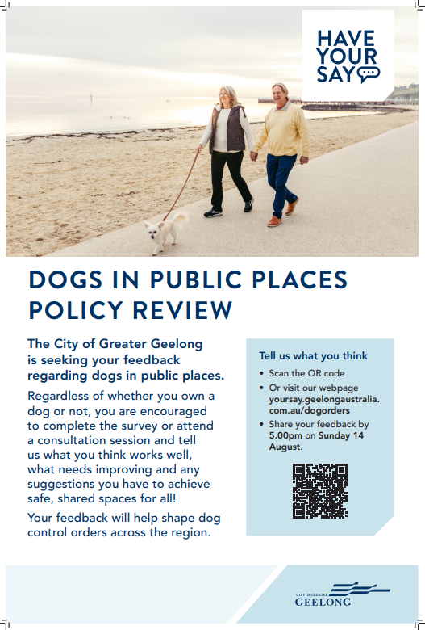
Appendix B - Hard Copy Survey
Appendix C - Qualitative responses collected
Appendix D - Letters received

Remember to adhere to Council’s privacy policy when reporting on any feedback received from your engagements and do not include any personal information.

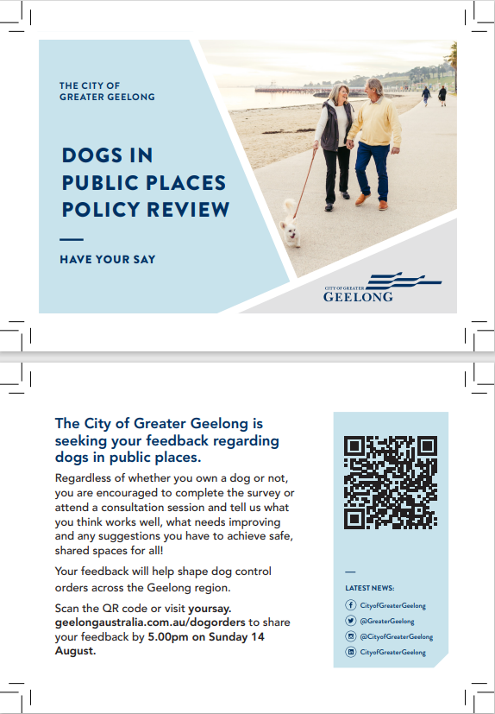

Appendix B – Survey hardcopy

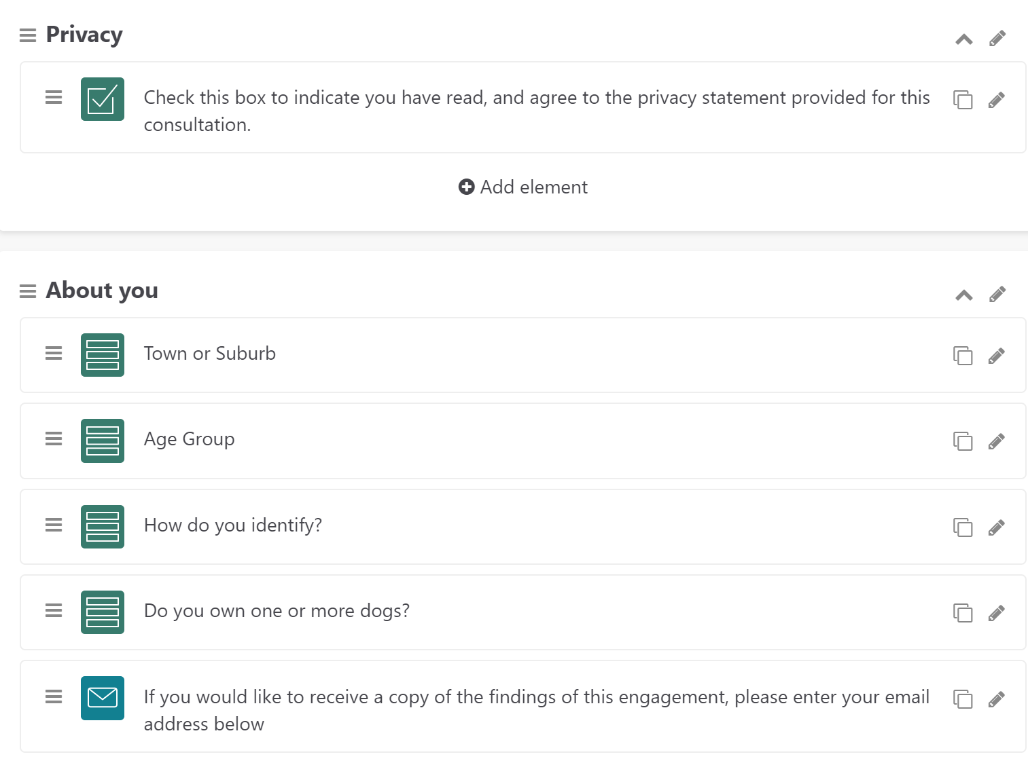
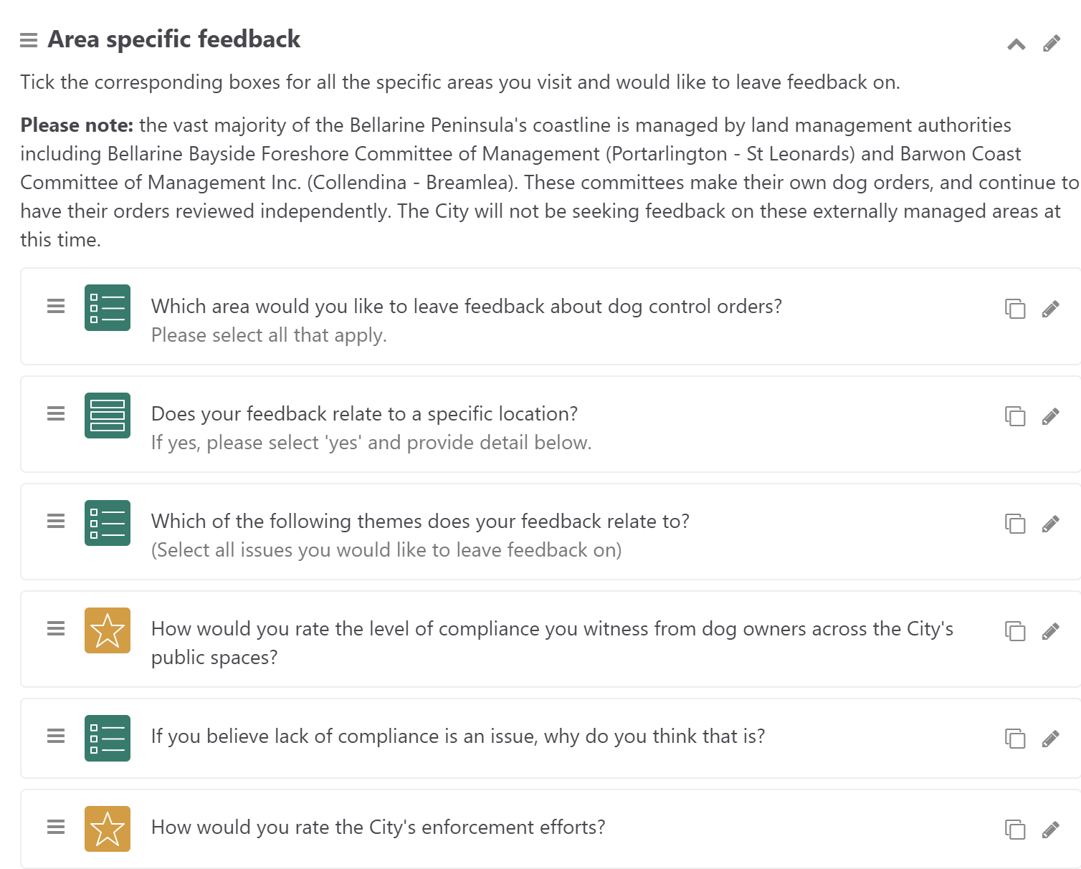
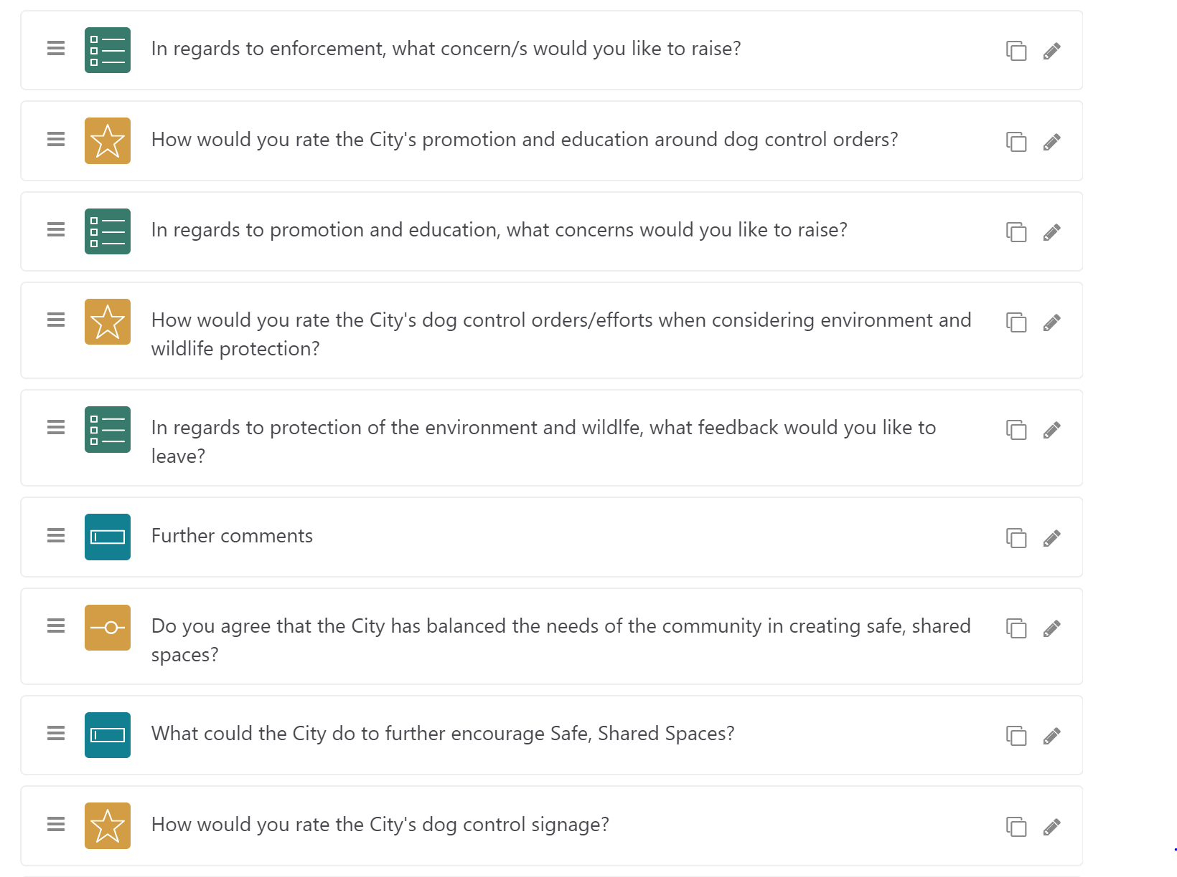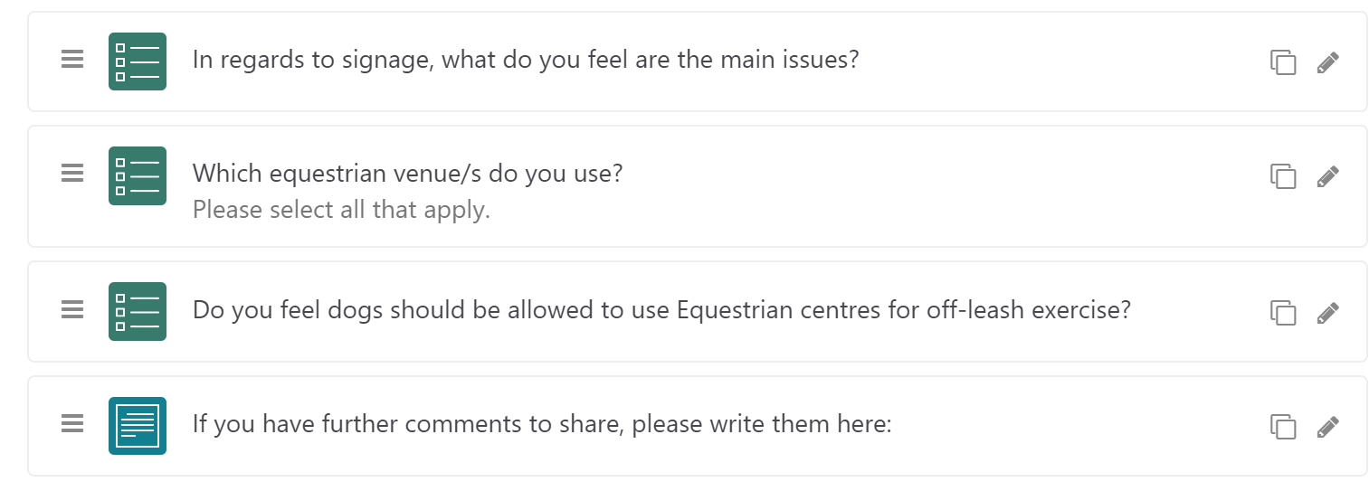

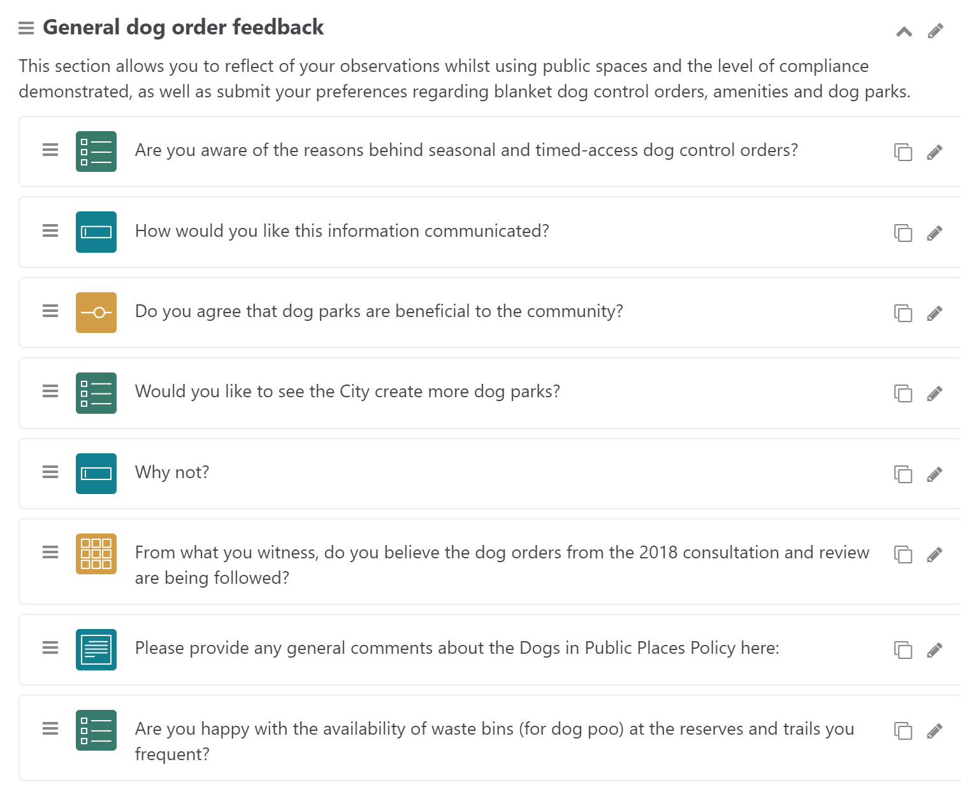

Appendix C - Survey questions with logic

Appendix D – Written submissions (2)

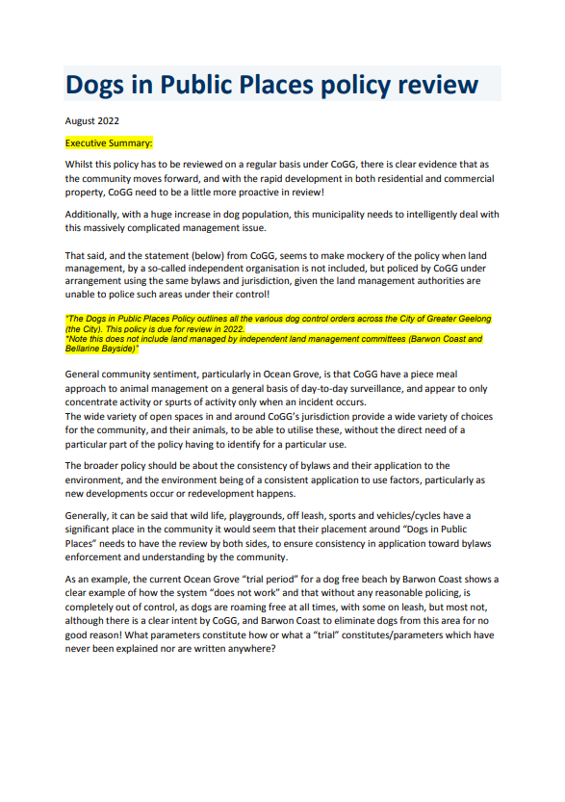

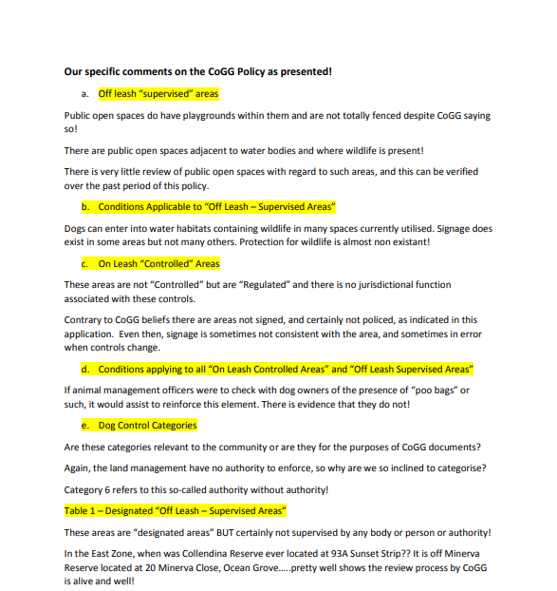

Hi ,

I missed the survey period, however I wish to provide this input.
Geelong badly needs more Dog Parks like the excellent Belmont Dog Park which I visit most days of the week every week.
We need more of these fenced parks in the Central Geelong area.
The Belmont dog park is being loved to death. Most users feel that we do not need the central strip within the park does not need to be a grassed area. Hence it doesn’t need to be fenced off in order to restore the grass. The same surface as in the boundary run/path areas is fine and drains well.
Many I meet there drive from Bannockburn, Herne Hill and surrounding townships as they love to let their dogs enjoy being able to run good long distances safely off lead and with other dogs.
I want to advocate for other public areas to be similarly fenced with the same area engaged / and with overhead (rain cover) like the bridge and tree at Belmont.

Lastly and of high significance and importance. This has become the ‘happy place’ for so many people who share chats with new people, also dog lovers, in an environment of casual, social leisure (away from usual daily pressures) and with time to ‘take time to talk’. For people living alone, people with a disability, young socially isolated people and families with children, it is a God-Send.

This is an important social role which may perhaps have be previously unrecognised in relation to these joyous places. We can relax because it is a fenced area where our dogs can move freely and socialise widely.
I think Geelong would be well served to have 3 or 4 of these in the city area. For example- Say, on the Fyansford Common, in the west, behind the Botanical Gardens (central), on the old Rail Track ( north Geelong ) etc.
thank you for the opportunity to contribute about this important matter for everyone.
My best

