Hamlyn park draft master plan

community engagement

interim report

community engagement summary
The City of Greater Geelong invited the community and stakeholders to provide feedback on the Draft Hamlyn Park Reserve Master Plan.
The draft master plan identifies several priorities including development of compliant, fit for purpose change rooms to support netball participation, and upgrade of other existing sporting facilities, including the Geelong Ballroom Dance Club building.

The draft master plan also aims to improve pedestrian safety, linkages throughout the reserve and open space to provide greater passive recreation opportunities within the Hamlyn Park Recreation Reserve precinct.
Several stages of the master planning process have been completed, including a site and needs analysis, issues and opportunities report, and initial community engagement, which have all contributed to the development of the draft plan.
This round of engagement with the community was undertaken to receive feedback on the draft Master Plan and understand if any changes were required to be made for the final plan. Community engagement took place from 28 October to 9 December, 2022 and involved online and face to face engagement opportunities.

A summary of the consultation process and feedback received is provided below.

Page Views on the HYS platform
1048
44 DAYS
of engagement (Stage 2)
95
Number of people that left feedback
NEWS

1
print adverts in local newspapers

SOCIAL MEDIA
6578
Reach/Impressions
50
Actions (Clicks, Reactions)

Advertising pamphlets delivered
632
People following the project
19

125
Total Contributions

SURVEY RESponse profile

Profile data was only collected through the online platform. During the community engagement period there were 83 survey contributions. Of the survey respondents 57% said they are a local resident, with 69% members belonging to a community organisation or sporting club and 53% regular users of the reserve. Remaining responses were occasional users of the reserve or other. This data provided some insights into the community and the fact that many people were involved in several groups along with being local residents.
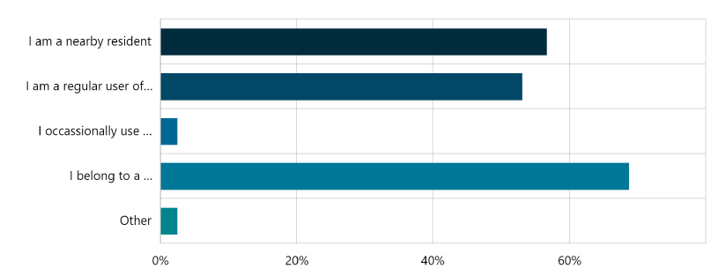

It also showed a spread of respondents from different age groups reflecting indicating the many uses the reserve offers.
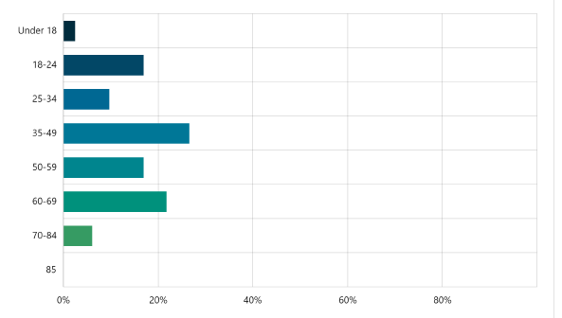

SNAPSHOT OF WHAT WE HEARD – survey results
The responses received highlighted that:
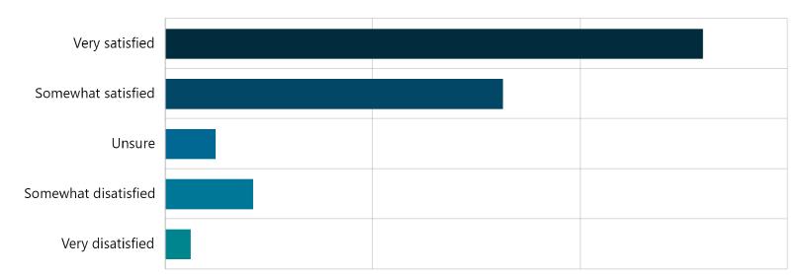
- The majority of respondents (84%) were satisfied with the master plan.

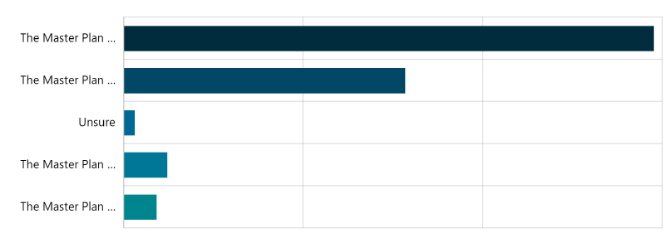
- The majority of respondents (90%) felt that the draft master plan reflects the future aspirations/needs of the local area.
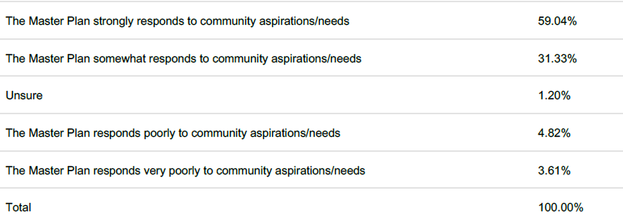

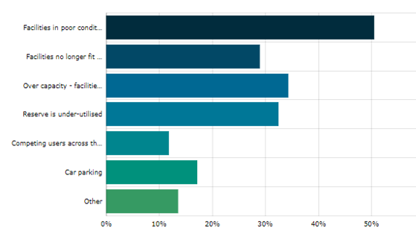
Next Steps

Community engagement is now closed for evaluation and analysis. Feedback from this engagement stage will be used to inform any changes that may be required to the draft master plan.
Following the review, we will provide a detailed key findings report that summarises the community engagement process we used to seek feedback on the draft master plan and how that feedback has influenced the final plan.
The master plan will be presented to Council for adoption in early 2023.

