Myers Reserve draft master plan

community engagement

interim report
community engagement summary
The City of Greater Geelong invited the community and stakeholders to provide feedback on the Draft Myers Reserve Master Plan.
The Myers Reserve Draft Master Plan provides an informed, consolidated, and long-term approach to future infrastructure development across the site. The need for the plan has arisen from stakeholders identifying specific constraints within the reserve and the inability to meet their current and future sporting and recreation needs. Changing population demands, ageing facilities and exponential growth in female sports participation have also highlighted the need to review the 2005 Master Plan which is now more than 15 years old.

The key macro trends impacting industry planning for organised sport reinforce the need for flexibility when planning for future community uses. The capacity of Myers Reserve to meet the requirements of the existing sporting user groups as well as the increased demand from the Creamery Road Precinct will become a challenge in the immediate future.

Several stages of the master planning process have been completed, including a site and needs analysis, issues and opportunities report, and initial community engagement, which have all contributed to the development of the draft plan.

This round of engagement with the community was undertaken to receive feedback on the draft Master Plan and understand if any changes were required to be made for the final plan. Community engagement took place from 28 October to 9 December 2022 and involved online and face to face engagement opportunities.

A summary of the consultation process and feedback received is provided below.

92
Number of people that left feedback
NEWS

1
print adverts in local newspapers
Page Views on the HYS platform
903
44 DAYS
of engagement (Stage 2)
People following the project
8

SOCIAL MEDIA
5187
Reach/Impressions
43
Actions
(Clicks, Reactions)

Advertising pamphlets delivered
303
126
Total Contributions

SURVEY RESponse profile

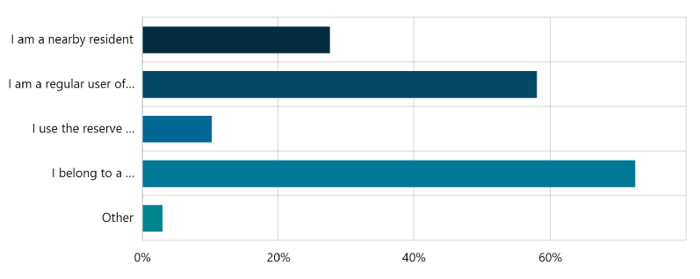
Profile data was only collected through the online platform. During the community engagement period there were 69 survey contributions. Of the survey respondents, 28% said they are a local resident, 72% belong to a sporting club and 58% are regular users of the reserve. Remaining responses were occasional users of the reserve or other. This data provided some insights into the community and the fact that many people were involved in several groups along with being local residents.

It also showed a spread of respondents from different age groups reflecting indicating the many uses the reserve offers.
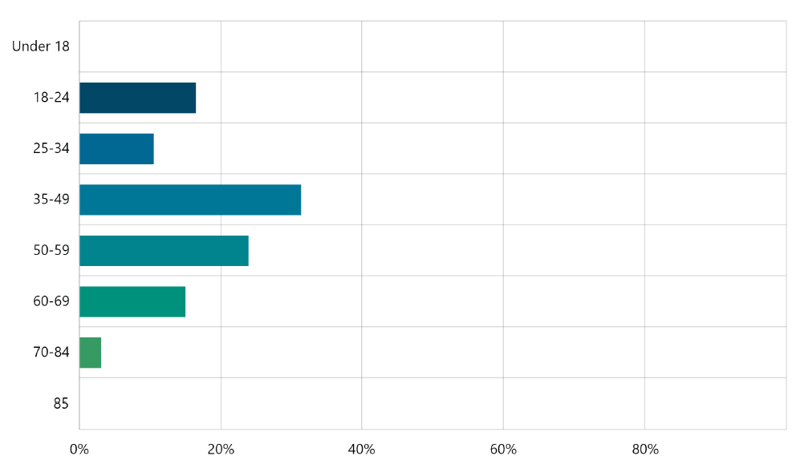

SNAPSHOT OF WHAT WE HEARD – survey results
The responses received highlighted that:
- The majority of respondents (62%) were satisfied with the master plan.
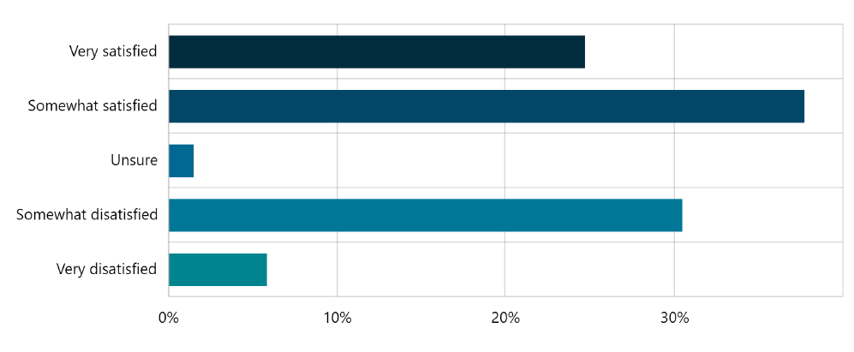
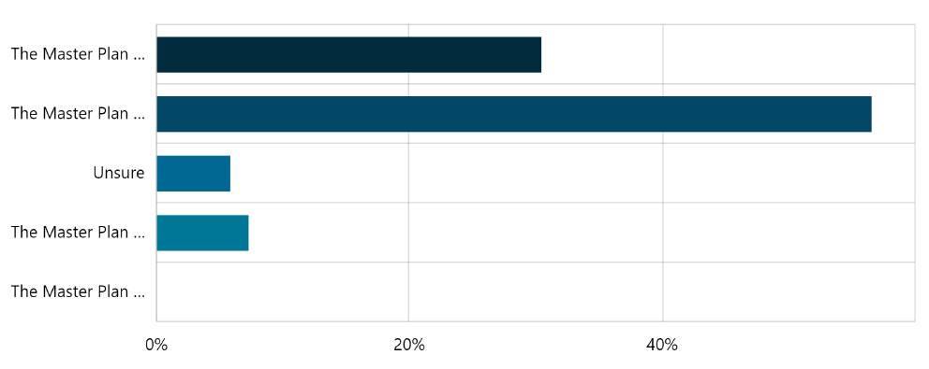
- The majority of respondents (87%) felt that the draft master plan reflects the future aspirations/needs of the local area.
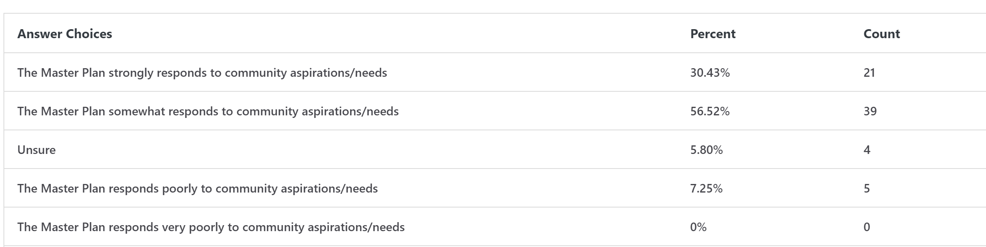

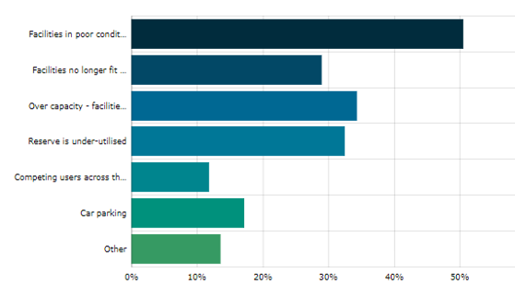
Next Steps

Community engagement is now closed for evaluation and analysis. Feedback from this engagement stage will be used to inform any changes that may be required to the draft master plan.
Following the review, we will provide a detailed report that summarises the community engagement process we used to seek feedback on the draft master plan and how that feedback has influenced the final plan.
The master plan will be presented to Council for adoption in early 2023.

