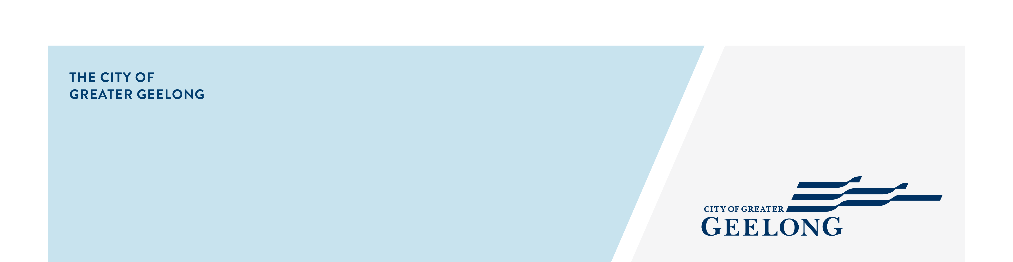whittington family & community hub

concept plan

engagement report 1

|  |
| --- |
| community engagement summary |

The City in partnership with key community stakeholders, is undertaking a project to shape the future of the Whittington Link community infrastructure.

Whittington Link is a significant public space for the residents of Whittington and is currently home to a range of community services operating from a variety of community facilities. These include:

* Bellarine Living and Learning Centre (Neighbourhood House)
* Apollo Place Preschool
* Whittington - City Leaning & Care

We know that these facilities are very much loved by the community, and as they are now functionally at the end of their life, we have an opportunity to work together to reimagine a facility for the Whittington community.

The City engaged with stakeholders and the local community to develop a concept design for an integrated community hub to accommodate:

* an early year's service space
* neighbourhood house programs
* youth programs
* community activities; and
* improved connection with the Whittington Primary School
* improved access and utilisation of the Whittington Link open space

Hearing the community and stakeholders' visions for a future community hub in the Whittington Link precinct helped the City to understand your specific needs for community infrastructure.

A community survey was the first stage to help us understand current visitation to Whittington Link, and your priorities and ideas for the area into the future. The survey was available from September 12th to October 16th, 2022 via yoursay.geelongaustralia.com.au/thelink

The stakeholder engagement and community survey have informed the development of preliminary plans currently under review by the City.

The following is a snapshot of survey results



**9**

Hard copies of surveys received

NEWS

**3**

print adverts in local newspapers



**64**

Number of people to leave feedback



Suggestions (comments) from the public left online via social map

**74**

**34 DAYS**   
of engagement (Stage 1)



**SOCIAL MEDIA**

**4,862 & 13,702**

Reach/Impressions

**1,764** Engagements

**272** Clicks

6 comment



Advertising pamphlets delivered

**6300**



People following the project

**19**

 **1**

Visioning Workshop

|  |
| --- |
| Next Steps |

Survey respondents were asked to close their eyes and describe their vision for Whittington Link…

“*Local organisations and services working together and complimenting one another. I would like to see people connecting outside in the Link and using the great space as well as inside. It would be great to see community events, Thai Chi and other exercise groups bracing the Whittington Link. I would like to see kids playing in the playground and families using the BBQ area to bring it to life.  
The future and community family hub needs to bright and welcoming attracting all life stages to access the facilities. It needs support culture and individual rights and ensure everyone feels safe and comfortable. The new hub needs to have a buzz about it where people want to come in and enjoy activities, learning opportunities and be able to access the services that they need.”*

When asked… “What do you love or value about Whittington Link?” the community responded with:

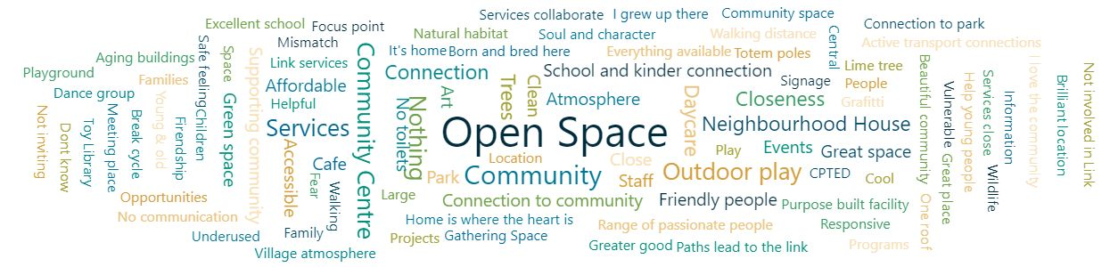

Next steps - Community engagement is now closed for evaluation and reviews. The City will be reviewing the survey results and incorporating your feedback into the development of preliminary concept design options.

Ongoing refinement of the design will be undertaken with the community stakeholders in coming months and the concept design options will be used to advocate for the development of community infrastructure for the Whittington community.