|  |
| --- |
| community engagement summary |

Feedback on the North Valley Road Greening consultation has closed. Thank you to everyone who provided feedback, your contribution is valued and appreciated.

The City invited the community and stakeholders to provide feedback on a greening project of the North Valley Shopping Centre. The key aim of the first phase of community engagement was to build awareness of the project and gain insights from the community. The underlying theme is to create a healthy environment and vital shopping centre.

From 25 January 2023 to 3 March 2023, the community were invited to share their ideas and issues on an online interactive social map. These ideas and issues will then form the basis of a concept design which will be available for comment at a later stage.

**Project Background**

Council has put forward a $50,000 budget this year to provide greening to the North Valley Shopping Centre. The engagement is to collect ideas and issues specific to the area to inform a design which can be built to the funding available.

|  |
| --- |
| HOW WE ENGAGED |

**WHAT DID WE DO?**

Below is a summary of the engagement:



**751** visitors to the Have Your Say (HYS) page



**35**

Number of people who left feedback



Suggestions (comments) from the public left online via the social map

**69**

**20**

**39 DAYS**   
of engagement (Stage 1)

People following the project

**ENGAGEMENT TOOL AND TECHINQUES**

A project specific engagement page was developed to provide project information and methods of ways to engage with the City.

A range of engagement tools and techniques were used to provide different types of opportunities for stakeholders and community to have their say. The main tools and techniques are explained in further detail below.

|  |  |
| --- | --- |
| HOW WE ENGAGED | |
| Have Your Say Online Portal  Yoursay.geelongaustralia.com.au | An online HYS project page was designed to share relevant information to encourage community feedback on [North Valley Road Greening project](https://yoursay.geelongaustralia.com.au/NVRG). |
| Online Interactive Map | The community was invited to interact with an online mapping tool by dropping a pin on the social map to provide an idea or issue. |
| Posters | Posters were placed at some trader premises situated in North Valley Road . |
| Trader Discussion | Visit to traders to provide information and get feedback . |
| Trader letters | Letters were sent to owners and occupiers of the area in the scope of the project. |

Social Map with 69 ideas and issues: -

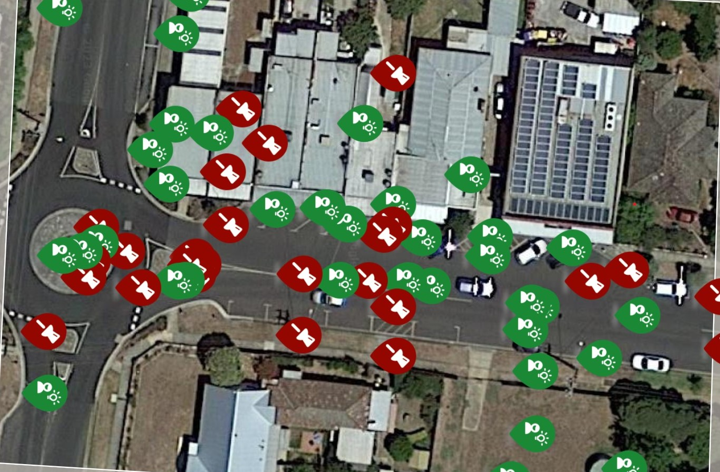

|  |
| --- |
| Who we engaged with |

**PARTICIPATION**

During the consultation period more than 750 people visited the North Valley Road Greening project Have Your Say page with 69 pieces of feedback provided.

|  |
| --- |
| WHAT WE HEARD |

There were a number of key themes that came out of the engagement. A summary of key themes and verbatim comments can be found below: -

|  |  |  |  |  |
| --- | --- | --- | --- | --- |
|  |  |  |  |  |
| Key themes |  |  |  |  |
| Tree planting | **Planting** | **Traffic calming and planting at centre of road** | **Pedestrian crossings and traffic calming** | **Traffic and car parking** |
| You told us: |  |  |  |  |
| Plant trees to provide shade and enhance the street with green. | More planting and renew old plantings. | Provide traffic calming and planting in the centre of the road. | Provide better pedestrian crossing points and connected footpaths. | Concerns were raised about various traffic and car parking issues. These are out of scope of this project but will be referred to our traffic unit for review. |
| *“Upgrade the streetscape opposite the centre. 1. Install a permeable footpath 2. Plant large canopy trees to shade the path all along the street, allowing sufficient clear space towards the corner to ensure drivers' clear vision when turning corners”* | *“Add some lovely trees and planter boxes along the path - would look really nice. (Maybe some colourful flowers)”* | ***“****Would love to see element of Porter Avenue here, also as a traffic calming measure. Do plant some public trees opposite too”* | *“A pedestrian crossing at a distance far enough from the roundabout to ensure pedestrian safety and better flow of traffic”* | *“Cars consistently move through this roundabout without slowing, looking etc. Very dangerous roundabout. Also needs better pedestrian management to safely cross road”* |
| *“Extend the project further down Mt Pleasant: Plant canopy trees on the nature strip to provide shade and greenery for footpath users and to cool the area around the bus stop”* | *“This is such a great opportunity to enhance biodiversity, increase shade and act on climate in our local area. Let’s prioritise locally native plants, especially those that are threatened, and increase permeable areas so rain can be absorbed rather than just creating runoff. Nest boxes in larger trees would be great too”* | *“A lot of people enter this shopping strip via the roundabout, find a carpark outside the shops, then, when leaving, they reverse from their parks and try to do a U-turn to take them back through the roundabout. It's dangerous for all and causes congestion for cars entering the roundabout and heading towards the shops.*  *I suggest that the road be widened (reducing the nature strips on the North* side of the road) to incorporate a green strip in the middle of the road, so that people can no longer U-turn outside the shops”*. (*East Side) | *“Seniors with walkers have to wheel themselves to the corner crossing to navigate the curb. Additional pedestrian crossovers needed. Dangerous to be on road as cars turn around corner”* |  |

|  |
| --- |
| NEXT STEPS |

This is the first stage of the engagement process. Comments provided will inform a concept design which will be then presented to the community for further comment on the City’s Have Your Say (HYS) website.

The concept design will endeavour to incorporate the comments into a cohesive greening project to the allocated budget.

Comments that are outside our scope of works will be referred to other City departments for comment. Where there is some information/response we will present it on the HYS page.