MULTICULTURAL ACTION

PLAN 2023-2024
community engagement summary – STAGE 1
Feedback on the Multicultural Action Plan consultation has closed. Thank you to everyone who provided feedback, your contribution is valued and appreciated.
Brief Summary – This report outlines feedback received during the first stage of engagement to inform the Multicultural Action Plan 2023-2024. The updated plan builds on the previous Multicultural Action Plan which was implemented between 2018 and 2022. The updated plan will continue to provide direction for the City to think, plan and deliver for the needs of our culturally and linguistically diverse population.
From 21 November 2022 to 20 January 2023, the community was invited to provide feedback to help us plan and deliver project, services and programs that meet and support the needs of our culturally diverse population.
An online survey on the City’s Have Your Say page was used to capture community feedback. Hard copies of surveys were also made available. In addition, two workshops were organised and community members were given the opportunity to provide direct feedback to officers in the Healthy Communities Department. The consultation was advertised on the City’s Have Your Say platform, social media, City News, direct email to key stakeholders, via Council Advisory Committees, and to internal staff by direct email and internal newsletters. Promotional materials in 10 languages other than English were also used to encourage feedback from community members.
During the consultation period, approximately 400 people visited the Multicultural Action Plan’s Have Your Say page. We received 54 online submissions from the Have Your Say platform. Additional contributions were received through the two workshops undertaken with the Multicultural Action Plan Advisory Committee and key service providers in the region.

54
Number of people who left online feedback
SOCIAL MEDIA
4,473
Reach/Impressions
16
Actions (Clicks, reactions, shares, comments etc.)

11
Hard copies of surveys received
15
Number of people who participated in workshops
60 DAYS
of engagement (Stage 1)

In terms of demographic characteristics of the Have Your Say respondents, almost 70% identified as permanent resident or Australian-citizen, 59% identified as overseas-born, 38% identified as speaking a language other than English, and 15% identified as from a refugee background.
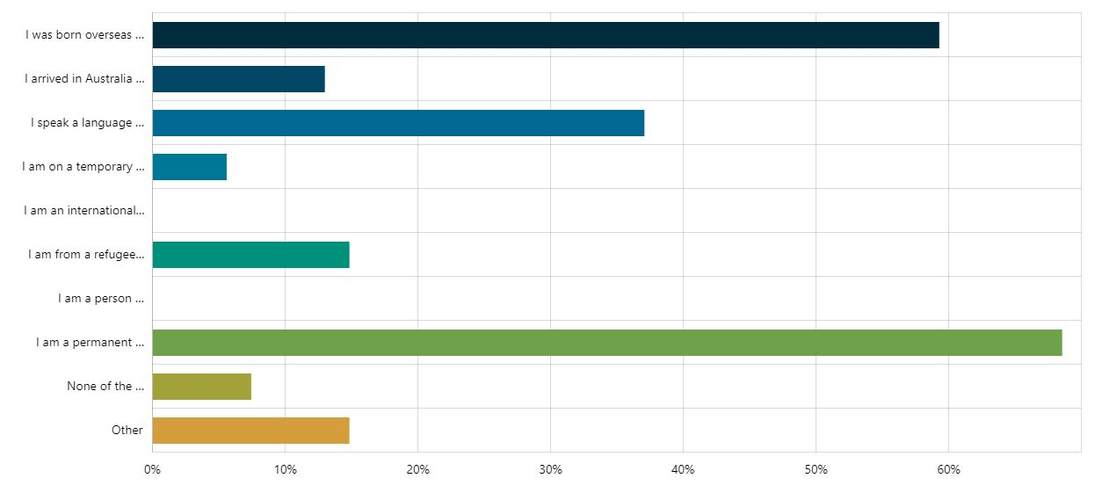

WHAT WE HEARD
Feedback from the community engagement will be used to inform the development of the Multicultural Action Plan 2023-2024. A summary of feedback and emergent key themes can be found below:
- When asked, “How well are we doing as a City in being welcoming and inclusive of people from all cultures and faiths?”, the respondents gave an average rating of 3.39 on a scale of 1 to 5 (with 1 being “very poorly” and 5 being “very well”).
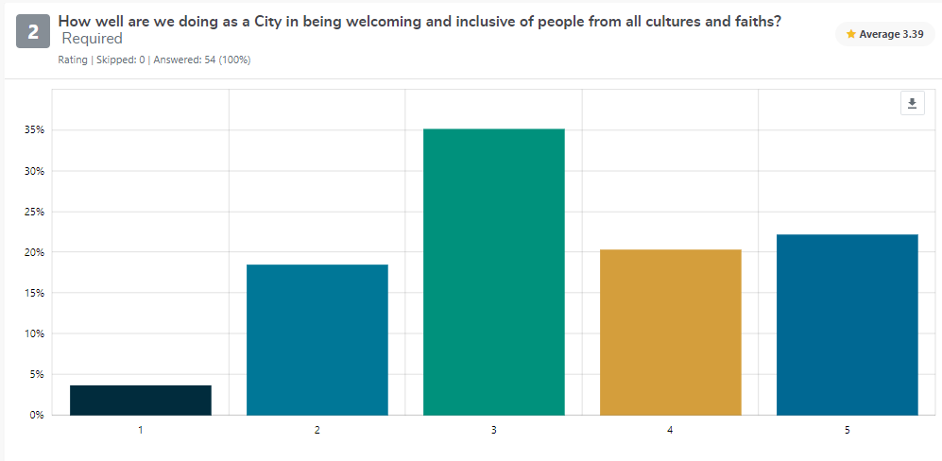

- When asked, “How does the City of Greater Geelong make you feel welcome and included in the community?” the key responses were:
- Inclusive and affordable community events and activities such as festivals, cultural events, and neighborhood gatherings that are open to everyone. These include Pako Festa, White Night, Bantu Fest, AfroBeats, activities organised by Cultura, the Fort, neighbourhood houses, libraries, and cultural and social clubs;
- Inclusive community spaces such as the Waterfront, the fOrT, Neighbourhood Houses, libraries, and social clubs as well as the reflection spaces in Wurriki Nyal;
- Having a friendly and welcoming community and neighbours;
- Diverse City of Greater Geelong staff; and
- Cultural representation and visibility in public spaces such that include public art (street art) and campaigns such as StreetFace and the projections highlighting different cultures during Harmony Week
- When asked, “How can we make the City of Greater Geelong more welcoming and inclusive of people from all cultures and faiths?” the key responses were:
- Events and activities that highlight different cultures and faiths and that encourage interaction between different community groups;
- Welcome activities and resources for newly arrived residents, particularly those from refugee and asylum-seeking backgrounds;
- Accessibility and language support including the use of translation in Council communication channels, resources developed in community languages, in-language information sessions, and having bicultural workers;
- Cultural representation such as signs in key community languages and to welcome people from refugee and asylum-seeking backgrounds (e.g. Refugee Welcome Zone signs);
- More visible representations of cultural diversity through signage, public art and campaigns;
- Cultural education and increased awareness of cultural diversity within diverse groups, including the First Nations community;
- Community engagement and connection including promotion of existing resources, access to Council services, and opportunities to provide feedback to Council;
- Capacity-building for City of Greater Geelong staff to increase and confidence;
- Advocacy and support across education, employment, housing, health, and transport;
- Community spaces that are affordable for community groups to hold events; and
- Support for different age groups (i.e. early years, youth, and seniors)

- When asked, “What do you think stops people from all cultures and faiths from participating in activities or programs in the City?”, the three main barriers identified were language barriers, lack of information, and costs.
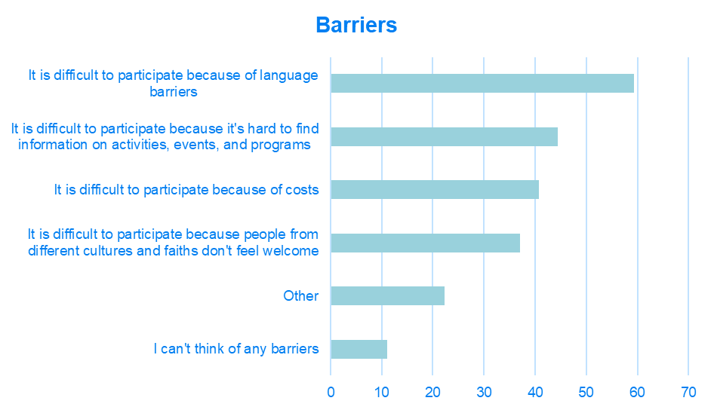
Next Steps
Community engagement is closed for evaluation and reviews. The community feedback gathered during this engagement is being used to inform the development the draft Multicultural Action Plan 2023-2024. This action plan will provide strategic direction and guidance to Council to think, plan and deliver inclusively in response to the diverse needs of our increasing culturally and linguistically diverse population.
The draft action plan is due to go before Council in June (TBC) to be endorsed for public comment.

