|  |
| --- |
| community engagement summary |

Feedback on the Highton Village Laneways Upgrade consultation has closed. Thank you to everyone who provided feedback, your contribution is valued and appreciated.

The City invited the community and stakeholders to provide feedback on a street upgrade to the laneways at Highton Shopping Centre. The key aim of the first phase of community engagement was to build awareness of the project and gain insights from the community.

From 9 February - 21 March 2023, the community – including Highton business owners and landlords - were invited to share their ideas and issues on an online interactive social map. There was also a map showing the high-level concept from the original Highton Urban Design Framework, (UDF) to comment on as well. These ideas and issues will now form the basis of a detailed concept design which will be available for comment at a later stage.

In addition to the online engagement, Highton Shopping Centre shops were visited by the Project Team in mid-March.

**Project Background**

Council is funding the design and construction of the Laneway redevelopment over the next few years. The aim of the engagement is to collect ideas and issues specific to the area to inform a design which can be built to the funding available.

|  |
| --- |
| HOW WE ENGAGED |

**WHAT DID WE DO?**

Below is a summary of the engagement:



Suggestions (comments) from the public left online via the social map

**197**

**SOCIAL MEDIA**



**1352** visitors to the Have Your Say (HYS) page



**63**

Number of people who left feedback

**7110**

**40 DAYS**   
of engagement (Stage 1)

Reach/Impressions

**330**

Actions, (Clicks, shares, comments etc.)

**ENGAGEMENT TOOL AND TECHINQUES**

A project specific engagement page was developed to provide project information and methods of ways to engage with the City.

A range of engagement tools and techniques were used to provide different types of opportunities for stakeholders and community members to have their say. The main tools and techniques are explained in further detail below.

|  |  |
| --- | --- |
| HOW WE ENGAGED | |
| Have Your Say Online Portal  Yoursay.geelongaustralia.com.au | An online HYS project page was designed to share relevant information to encourage community feedback on the Highton Laneways upgrade. |
| Online Interactive Map | The community was invited to interact with an online mapping tool by dropping a pin on the social map to provide an idea or issue. |
| Posters | Posters were placed at some trader premises situated in Belle Vue Arcade and Village Walk. |
| Trader Discussions | Visits to traders to provide information and get feedback. |
| Trader letters | Letters were sent to owners and occupiers of the area in the scope of the project. |
| social media | Paid Facebook campaign targeting Highton suburb |

Social Map with 197 ideas and issues:

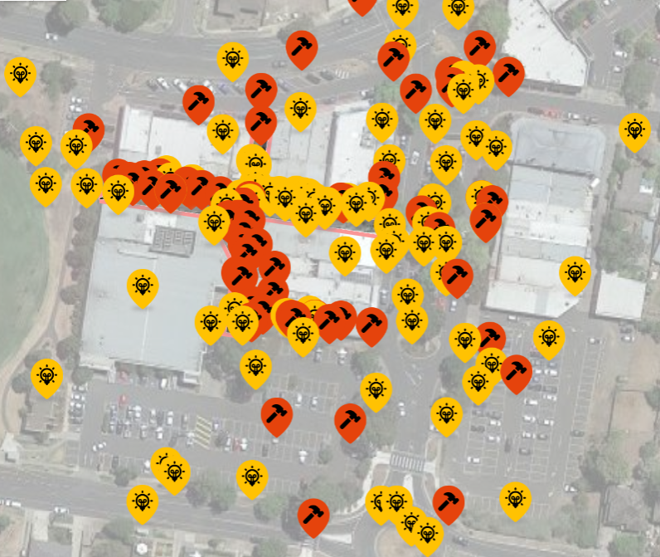

|  |
| --- |
| Who we engaged with |

**PARTICIPATION**

During the consultation period more than 1350 people visited the Highton Village Laneways Upgrade Have Your Say page with 197 contributions received.

|  |
| --- |
| WHAT WE HEARD |

There were several key themes that came out of the engagement. A summary of key themes and verbatim comments can be found below:

|  |  |  |  |  |
| --- | --- | --- | --- | --- |
|  |  |  |  |  |
| Key themes |  |  |  |  |
| Laneway comments | **Laneway**  **Planting** | **Service Road closure/ making the area more pedestrian friendly** | **Roof the lane** | **Laneway furniture** |
| You told us: |  |  |  |  |
| Dark, dingey, make non-smoking, play elements, consistent visual appeal. | More greenery, pergolas. | Close to vehicles or the service lane only accessible to pedestrians. | Weatherproof the laneways. | More seating, fountains (dog and human). |
| *“Dark dingey laneway”*  *“Make the whole zone non-smoking”*  *“Some kids equipment - music/ water feature. Something to bring the little kids (& their parents) through to enjoy and increase the pedestrian traffic”*  *“Remove brick structure and make clear pedestrian pathways”*  *“I love the idea of alfresco dining surrounded by greenery, especially if Little Malop is the vibe you're going for”* | *“Please green up the whole area, not just above as suggested. Large planters incorporating more seating would be wonderful.*  *“Greening the laneways, adding lighting and alfresco areas, and putting pedestrians first would be AMAZING”.*  *“Add shady trees or covers to block run and weather and perhaps create seating areas and planters or string lights criss-crossing down the path. This strip is very dated and bare but would have the opportunity to be a beautiful sit down oasis with some planning and effort. The facades of some of the shops doesn't leave much to be desired but don't expect council can do much about that”* | ***“****Cars always speed down this lane and don't even look! It's very dangerous for pedestrians and not sure why cars are allowed here at all to be honest. We should be blocking this lane to cars and adding greenery / murals on the walls. That would be a huge improvement!”*  *“Very narrow, car access and pedestrians can clash, need to restrict one or the other. Presently pretty ugly, needs rethink.*  *“Cars using this service lane is a big safety issue and risk. It should be for pedestrians only”.* | *“Is there a plan for rain cover for the arcades? Open pergolas are beautiful but if there is no rain cover people will not be able to have a coffee (assuming there are tables there for any coffee shops). Somehow, we need some covered areas WITHOUT IT BEING TOO DARK”*  *“Provide roof weather protection to the east-west and north-south sections. Gets very hot in summer at times and also would help in winter. Lots of older people and those with reduced mobility use this frequently.”* | *“Recognising the multigenerational neighbourhood too would be good to have some children’s play equipment or interactive street furniture to encourage families to use this space”.*  *“A lot of people walk their dogs around this area. It would be great if there could be a drinking fountain with dog-bowl facility”.*  *“Only providing public benches for seating can limit social interactions. There are lots of other options that promote different social interactions. Eg Movable furniture (but heavy!), or fixed table and chairs can provide a good overflow spaces for cafes, somewhere to sit and work in your laptop, Somewhere to sit with the kids and unpack a lunchbox, or somewhere to play a game of chess”.* |

|  |  |  |  |  |
| --- | --- | --- | --- | --- |
|  |  |  |  |  |
| Key themes |  |  |  |  |
| Laneway bins | **Laneway**  **Lighting** | **Large existing trees in car park, Service lane** | **Signage** | **Out of scope comments** |
| You told us: |  |  |  |  |
| Remove existing bin structure and line of bins. | Better lighting and interactive. | Remove trees or keep. | Notice board, shop and entrance signs. | Barrabool Road, Bellevue Ave, Roslyn Rd, etc. |
| *“As a long time business owner, we would like the commercial bins removed from our doorstep. More and more are appearing (10 industrial bins and 13 red bins. They are an eyesore in the lane way. Please find an alternative”*  *“Smelly bins so close to the lanes tend to put people off using this lane. Can a better location for rubbish bins be considered to open up this space and safer access?”* | *“Smart or interactive lighting in the area in collaboration with the City's Smart City team could provide entertainment for children. Dynamic lighting sequences could attract more people off Belle Vue Ave but would need to be balanced with providing a base level of ambient light for diners. “Please green up the whole area, not just above as suggested. Large planters incorporating more seating would be wonderful.”* | *“I was admiring the trees in this carpark the other day, thinking they must be quite old and how wonderful that they were kept. Please don't chop any down! The weed trees can go though :)”*  *“This unmaintained tree needs to be removed, the stench it secretes is disgusting, the droppings have damaged surrounding businesses and cars. The roots create an unsafe environment for pedestrians as the footpath is uneven”.* | *“A Community Noticeboard would be great to have in the Highton Village, for community events and information”.*  *“Include some historic or fun, trail style facts about Highton in the laneway paving. Also, some directional markers that complement the feel of the village- point out the river, sports oval, playground, library etc”.*  *“Could the redesign of tenancy boards be updated with a new design and more contemporary”* | *“Add a turn right arrow to assist traffic flow into the village and down Barrabool Rd”*  *“Unattractive frontage for the shopping centre. Planting and landscaping required”.*  *“This area is an eyesore. Who would want to visit if driving down Barabool Road?*  *Pity that it isn't the first priority”*  *“Include a sign on the two facing roundabouts”*  *"Welcome to Highton Village, you are on Wadawarrung Country"* |
| NEXT STEPS | | | | |

This is the first stage of the engagement process. Comments provided will inform a concept design which will then be presented to the community for further comment on the City’s Have Your Say (HYS) website.

The concept design will endeavour to incorporate the comments into a cohesive laneways upgrade project to fit the allocated budget.

Comments that are outside our scope of works will be referred to relevant City departments for comment. We will provide updates on the HYS page as the project progresses.