|  |
| --- |
| community engagement summary |

Feedback on the Drysdale Townsquare Upgrade consultation has closed. Thank you to everyone who provided feedback, your contribution is valued and appreciated.

The City invited the community and stakeholders to provide feedback on the proposed new town square and landscape.

From 24 March –16 April 2021, the community – including Drysdale business owners and landlords - were invited to share their comments online via a survey. These comments were then fed back into the detailed design.

**Project Background**

This engagement follows several other consultations including for the Urban Design Framework, Library and park and now more detailed town square and landscape. Council has funded the design and construction over the next few years to coincide with the new Library. The aim of the engagement is to refine the design before it goes to tender.

|  |
| --- |
| HOW WE ENGAGED |

**WHAT DID WE DO?**

Below is a summary of the engagement:



Suggestions (comments) from the public left online via the social map

**35**



**34**

Number of people who left feedback



**1571** visitors to the Have Your Say (HYS) page

**23 DAYS**   
of engagement

**ENGAGEMENT TOOL AND TECHINQUES**

A project specific engagement page was developed to provide project information and methods of ways to engage with the City.

A range of engagement tools and techniques were used to provide different types of opportunities for stakeholders and community members to have their say. The main tools and techniques are explained in further detail below.

|  |  |
| --- | --- |
| HOW WE ENGAGED | |
| Have Your Say Online Portal  Yoursay.geelongaustralia.com.au | An online HYS project page was designed to share relevant information to encourage community feedback on the Drysdale Town Square upgrade |
| online survey | The community was invited to answer questions in a survey about the proposal. |
| Posters | Posters were placed in the park inviting submissions. |
| Trader Discussions | Visits to traders to provide information and get feedback. |
| Trader letters | Letters were sent to owners and occupiers of the area in the scope of the project. |

Survey with 35 responses:

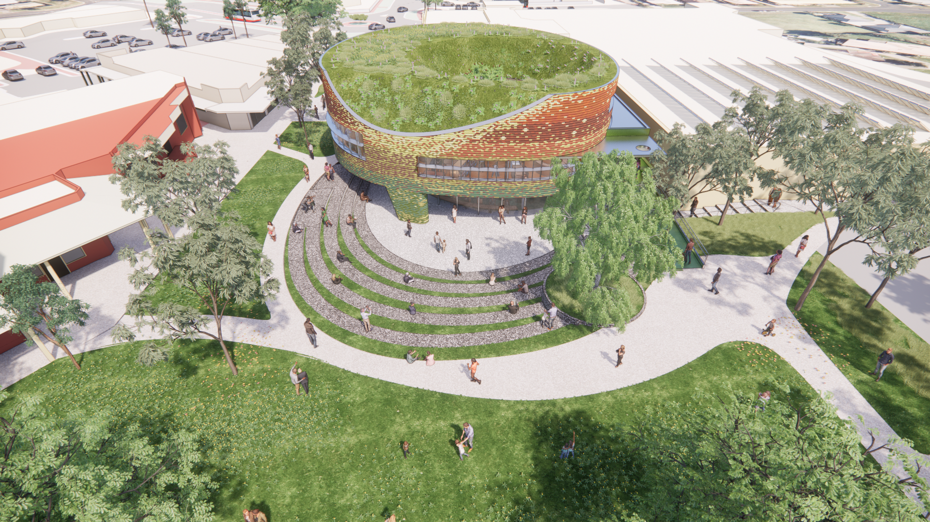

|  |
| --- |
| Who we engaged with |

**PARTICIPATION**

During the consultation period more than 1500 people visited the Drysdale Town Square Have Your Say page with 35 contributions received.

|  |
| --- |
| WHAT WE HEARD |

There were several key themes that came out of the engagement. A summary of key themes and verbatim comments can be found below:

|  |  |  |  |  |
| --- | --- | --- | --- | --- |
|  |  |  |  |  |
| Key themes |  |  |  |  |
| Trees and green space | **Play Area** | **Art** | **Bike infrastructure** | **Out of scope comments** |
| You told us: |  |  |  |  |
| Keep existing trees and green space, indigenous planting. | Needs a play area. | Artistic elements in the space. | Promote more bike use. | Library design |
| *“Modern, green, it would give a nice, much needed "freshen up" to the area!”*  *“I like that there will still be lots of green space and the natural look of the town square”.*  *“Consider planting of local indigenous plants (not just natives) rather than exotics. Much more beneficial “*  *“More trees,*  *Park benches or seating areas under the trees - elderly people often sit and take a break if walking to the supermarket complex, and when my children were small a trip to the library was an outing for us and we would often stop at the rotunda - the kids would run around and be silly on the grass ( have a break) then we would continue on our way doing our errands.*  *It is a lovely spot to sit - so a few seats near some shade would be great.* | *“It has no play area for kids. Promoting events and outdoor dining is great for families. Help them by providing a place to play safety. There is no safe space for kids in the main town area. It does not have to be traditional play equipment- just something to help keep active little ones busy.that”*  *“Can there be a nature playground of some description incorporated? Rocks and trees to climb please. Something for teens too maybe?”*  *“Nice and green plenty of play space for the kids”* | ***“****Perhaps some local art could be showcased? e.g Sculptures in the garden? Or, interactive outdoor spaces which are interesting to all age groups and visually appealing could be explored? Public art...you get my drift! Happy planning ?”* | *“more bike racks, if people ride to the library, and signal where bus stops are, so people can easily get to and from via public transport.”*  ***“****Please have somewhere to park a bicycle!”* | *“I dont like the round look as I dont think it fits with the HISTORIC town character of Drysdale. ( its not a new modern subdivision) As a third generation resident I feel it needs to better suit the nature of the town: from previous experience I also feel that this sort of design would also require additional funding, rather than if it was traditional and have square edges, the architects have not designed it with the township in mind or reflective of what we want our semi rural township to be retained as or part of the future of our town. What is the ongoing maintenance cost?*  *“Amphitheatre is nice and good idea, like library location”* |
| Design Response: |  |  |  |  |
| -Over 2000 indigenous plants to be planted  -Some deciduos trees used for providing shade in summer and sun in winter  -30 new trees | -There are grass mounds and open space to play in as well as a new sculpture which has a play element. | -A new sculpture is being commissioned to be placed on the lawn area.  -Events will be encouraged to use the amphiththeatre and grassy hill. | -Many new bike parking areas will be incorporated into the new mall and landscape. | -The Library consultation has closed and comments have been incorporated into the design wherever possible. |

|  |
| --- |
| NEXT STEPS |

Feedback will be incorporated into the detailed design wherever possible. You can see updated plans on the HYS page in the near future.

We will then be going out for tender and construction. The works will be timed to be built along side the new Library.