sparrow park playground

renewal

community engagement summary
Feedback on Sparrow Park Playground renewal consultation has closed. Thank you to everyone who provided feedback, your contribution is valued and appreciated.
The City invited the community to provide feedback on renewing Sparrow Park playground in Geelong West. The key aim of the community engagement was to build awareness of the project and gain insights from the community about how the 20+ year old playground could be renewed. The playground is currently classified as a district playground within the City’s “Play Strategy 2017-2021”.
What do we mean by playground renewal? It was proposed the current playground equipment be replaced with new equipment, a seat be installed, and trees planted for shade. The surface around the play equipment would remain as soft fall (playground safe tan bark), with the playground hierarchy to remain as “district”.

From 24 February - 27 March 2023, the community were invited to share their thoughts, ideas, and concerns via an online Have Your Say survey. The City also held two in-person engagement sessions to allow the community to further discuss the proposed design, discuss ideas and seek clarity from City officers.

Project Background
The existing Sparrow Park playground was installed in 2000. Playgrounds are independently safety audited on an annual basis. In 2022, Sparrow Park received an independent safety audit rating of 5 (1 being excellent and 10 being in poor condition). Independent audit information together with maintenance information, forms part of the playground renewal schedule that is reassessed annually. The general life cycle of a playground is 15 – 20 years with many site-specific variables that help to determine when the playground will be renewed.
Additional funding for opens space renewals provided a unique opportunity to provide needed renewal for Sparrow Park. The purpose of the engagement was to collect ideas and issues specific to the area to inform a design which could be built to the funding available.

how we engaged

WHAT DID WE DO?

Below is a summary of the engagement:
587
Number of people to
leave feedback

100
Number of people who attended in-person consultations
SOCIAL MEDIA
406
Actions (Clicks, reactions,
shares, comments etc.)
2,239
Visitors to the Have Your Say (HYS) page

Suggestions (comments) from the public left online
623
30 DAYS
of engagement

ENGAGEMENT TOOL AND TECHINQUES
A project specific ‘Have Your Say’ online engagement page was developed to provide project information and for community to engage with the City.
A range of engagement tools and techniques were used to provide different types of opportunities for stakeholders and community to have their say. The main tools and techniques are explained in further detail below.
how we engaged

Have Your Say Online Portal  Yoursay.geelongaustralia.com.au | An online HYS project page was designed to share relevant information, present the proposed design and encourage community feedback on Sparrow Park playground renewal
social media | Facebook campaign advising of the playground renewal
Face to face consultation | 2 on-site community consultations on Wednesday 22 March 2023 and Sunday 26 March 2023
onsite signage | A corflute sign was onsite promoting the engagement, directing people to the HYS page

who we engaged with
PARTICIPATION
During the consultation period more than 3,497 people visited the Sparrow Park Playground renewal Have Your Say page, with 623 contributions received.
- 34 per cent of respondents were Geelong West residents
- Almost half of respondents (49 per cent) said they travel more than 1km to access the playground (24 per cent travelled 500m-1km, 19 per cent travelled 100-500m and 7 per cent travelled less than 100m)
- The bulk of respondents (40 per cent) said they visited the playground weekly
- The vast majority of respondents said the people in their family using the playground were either 0-3 years old (62 per cent) or 4–7-year-old (62 per cent) (this totals more than 100 per cent as families could select multiple age brackets)

out of scope

This engagement was specifically designed to seek feedback on the fixed play equipment only. The following areas of the playground and surrounding park were not included and as such feedback received relating to these areas has not been considered in the following analysis but will be kept on file for future discussions.

This renewal does not include change to;
- the basketball court,
- BBQ shelters,
- existing shade structures,
- any additional fixed shade structures,
- water play,
- an increase in playground size or change of playground hierarchy (i.e., this playground will remain a District playground).

what we heard

The community told us they did not think the proposed design covered all the design elements expected of a Local/Neighbourhood playground with:
- 52 per cent saying no, it didn’t meet all the design elements,
- 35 per cent saying it was ‘almost there’, and
- 13 per cent saying it did meet the design elements

There were several key themes that came out of the engagement. A summary of key themes and verbatim comments can be found below:
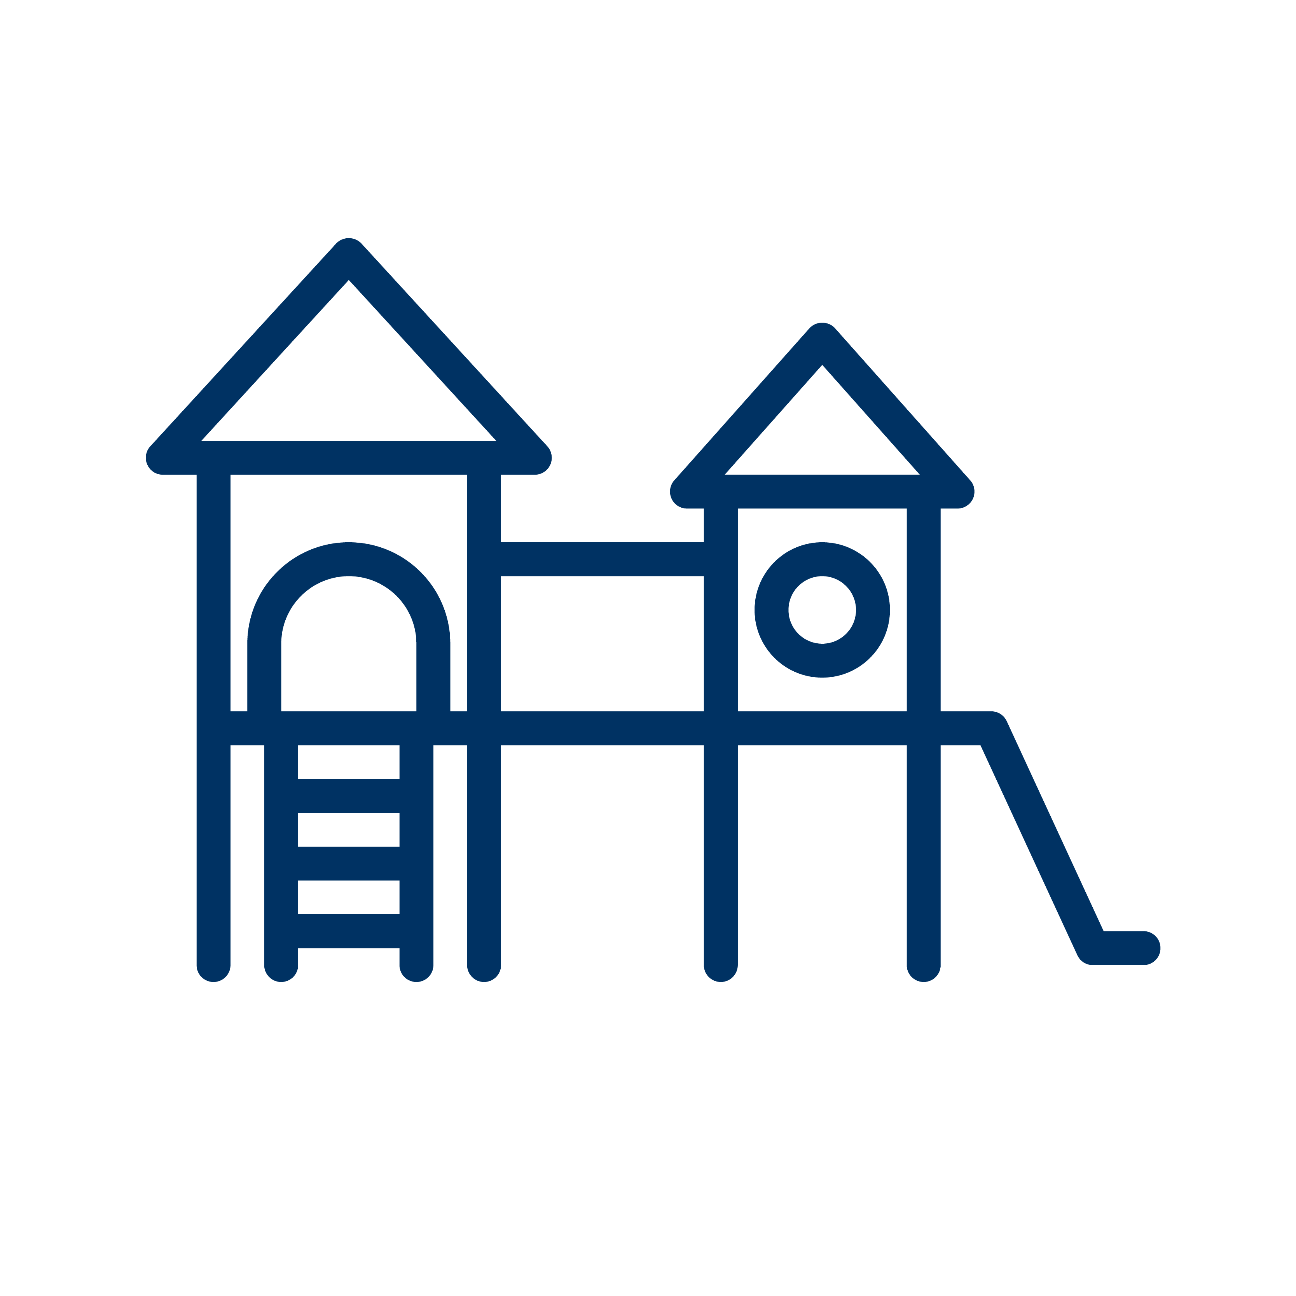
KEY THEMES
Retain The Maze | Nature Play and Plantings | Retain the Multiple Slides | More Swings | Unique Design
YOU TOLD US

We love the maze! | Include nature play elements | The three skill levels of slides cater for all ages | We need more swings | No cookie cutter designs
“The design is limited and unimaginative. It is replacing current play structures without improving on the space. The maze is amazing” | “Add shady trees or covers to block sun and weather”. | “The spiral slide is the most popular slide at the park, and this is not included in the new design”. | “The decrease in the number of swings is not good. There are so many babies in the neighbourhood. And young kids in general. I do like that the swings are together”. | “This plan is basic and short sighted. I would be more supportive of an improvement plan that makes the park an attraction, an asset for the neighbourhood”.
“We come here for the maze; we call this park the maze park!” | “Include logs, stick cubby structures” | “The 3 types of slides cater for all our children’s ages and skill levels". | “It's such a busy park, I am worried the decrease in equipment won’t be enough for everyone to enjoy!” | “The plastic structures instead of wood are unfortunate. Plastic is always ugly, and it is unfortunate that we are adding more plastic to the world”.
“The loss of the maze would be sad, it's always full of kids running” | “We don’t want to lose our timber playground!” | “One slide is a concern; we like the current different slide options” |  | “Please give us a beautiful modern playground and park the neighbourhood can be proud of”
“Why remove the maze?” | “Currently a large space to run around the equipment, it such a beautiful park!” | “One slide is not enough!” |  | “It looks very bland”

KEY THEMES
Retain The Skate Park | Variety for Multiple Ages | Accessible | Out of Scope Comments
YOU TOLD US

Junior skate area is great! | Cater for All Ages | Maintain the Ramps
“This skate park is the best for younger children learning to ride skateboards and scooters” | “Recognising the multigenerational neighbourhood too would be good to have some adult’s play equipment or interactive street furniture to encourage all families to use this space”. | “The wheelchair spinner is great!” | “When it rains it is a mud maze with large pools of water at each entrance. The sand pit is also a wet pool all winter "
“The mini skate park is great; kids use the rubber side for all different kinds of play and developmental activities” | “Currently, it is a wonderful space that provides activities for all ages and activity levels, babies, and toddlers in the sand pit to bigger kids on the skate park and basketball court. The maze is wonderful activity that many children enjoy” | “Please make sure the ramps stay” | These plans do not include any drainage work or improvements to the maze or sand pit which is a massive failing. The flooding areas may not have come under the upgrade needs based on the state and age of the equipment, but it is irresponsible to spend taxpayer in such a short-sighted way”.
 | “Many grandparents come here, please provide access to the playground for everyone” | “There seems to only be one accessible feature which seams a token tick box”. | “Move the toilets closer”

where to from here
The City will:
- further investigate the maze and other wooden components of the playground to establish if they are structurally sound and can be retained in their current form and condition.
- revisit the concept design and identify which elements can be incorporated from community feedback, emphasising key components of play that are highly valued.
- discuss the current drainage issues onsite with the City’s Parks Department.
- confirm project scope based on consideration of the above.
- develop a community response to be shared on the Have Your Say page and emailed to all page followers – detailing the outcome of the above steps and how the renewal project will progress.
A revised playground design based on considerations from the community will be delivered prior to June 30, 2024.

conclusion
Community strongly value Sparrow Park as a destination playground with a lot of people referring to the space as a community hub.
Whilst Sparrow Parks is identified as a district playground the community see it as much, much more.
We had an overwhelming response to retain the maze, provide additional swings (as identified in the draft plan), retain the multiple level slides, and incorporate timber products and natural play elements.
There were quite a few suggestions for new additions to the park, that are out of scope however, some suggestions will be investigated.
The key challenge will be to deliver a design within the current budget, which is largely supported by community. The renewal elements also need to align with the embellishments required to ensure the playground’s current hierarchy is maintained (District).
Comments provided will inform a revised playground equipment design. The design will endeavour to incorporate the comments into a renewed playground design to fit the allocated budget.
Comments that are outside our scope of works will and have been referred to relevant City departments for comment. We have already rectified some of the issues identified and will endeavour to achieve more as the works take place.
The City will continue to work with Rotary to identify any plastic and steel playground components that can be utilised as part of their playground harvest program. We will provide updates on the HYS page as the project progresses.

