Waurn Ponds Skatepark
community engagement summary report

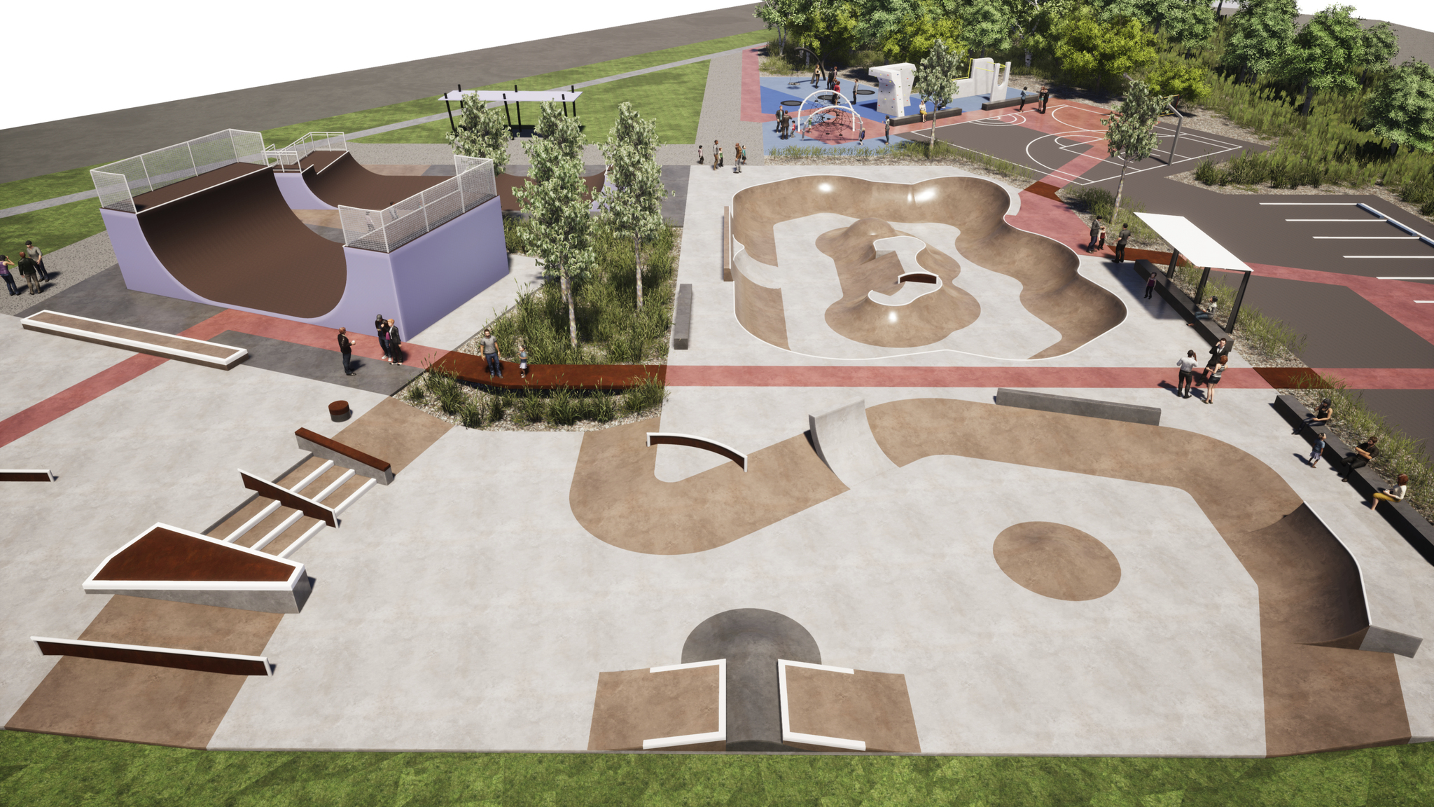
Figure 1 - Waurn Ponds Skatepark concept plan
Introduction/Background
The Waurn Ponds Skatepark is a regional level facility that caters to a range of skate styles. Facility assessments in recent years identified that the park was in poor condition and had several design issues. A staged upgrade has been taking place and the most recent community engagement in 2021 was focused on ensuring the renewal of the skate area would meet the needs of the community.
The engagement objectives were:
- An agreed concept design for the skatepark that is accepted by current and prospective skatepark users and other stakeholders;
- Provide an opportunity for local residents to be engaged in discussions on the design of the park upgrade;
- To deliver a genuine engagement that would guide the design of the facility.

HOW WE ENGAGED
WHAT DID WE DO?
The community engagement was conducted in 3 stages including pre-design input and two rounds of feedback on concept plans.

207
Quick Poll responses received
Number of people to provide feedback online via surveys and polls
3371
30
Pre-design workshop participants

83
3
Stages of engagement
People following the project

DATA METHODOLODY
Participation in the engagement was self-selected. Communications targeted user groups and residents although anyone interested in the project was able to respond.
ENGAGEMENT TOOL AND TECHINQUES
A project specific engagement page was developed to provide project information and methods of ways to engage with the City.
A range of engagement tools and techniques were used to provide different types of opportunities for stakeholders and community to have their say. The main tools and techniques are explained in further detail below. Covid-19 restrictions during the engagement period limited the number of in-person opportunities for engagement.

HOW WE ENGAGED
Have Your Say Online Portal  Yoursay.geelongaustralia.com.au | An online HYS project page was designed to share relevant information to encourage community feedback on the skatepark concept plans.
Survey (online) | June 2021: Concept Plan v1 Survey  August 2021: Concept v2 Plan Survey
Workshops x 2 | April 2021: Pre-design drop-in workshop onsite at the Waurn Ponds Skatepark to gather community ideas for the re-development.  June 2021: Concept plan feedback session held onsite at the Waurn Ponds Skatepark including the design team to directly hear feedback from the community.
Posters | To help inform facility users about the project, posters were displayed on site to promote feedback opportunities.
Communications
We used the City’s social media platforms including the Youth Development Unit’s YDU.Skate Instagram account and the City’s Facebook page to promote the consultations.
Onsite signage was also used to ensure facility users were aware of the project and opportunities to contribute.

Who we engaged with

PARTICIPATION
The City’s ‘Have Your Say’ web page for the Waurn Ponds Skatepark was visited by 4208 people during 2021 and 2022. There were 390 online contributions through the Have Your Say page during the community engagement activities in 2021.
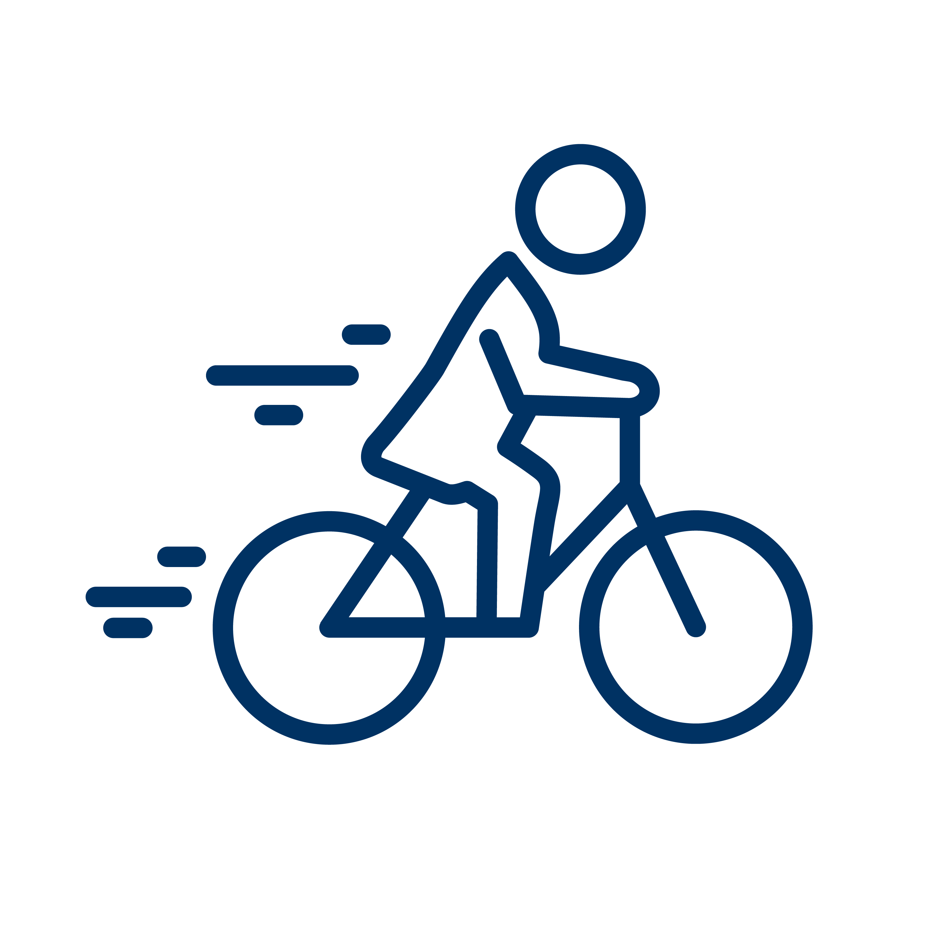
The community were invited to share some demographic data with us through our survey. The following is a snapshot of these people.
Respondents were primarily male across the different engagement opportunities (approximately 87%).
Multiple skate sports were represented including skate, scoot, bmx and rollerblading. Skateboarding was the most common response. Intermediate and advanced skaters were represented in greater numbers than beginners.
26 Greater Geelong suburbs were represented plus a small number of respondents from outside the municipality. This reflects the regional nature of the facility.
All age groups from under 9 to 65-69 were represented except the 60-64 age group.

WHAT WE HEARD

THE FEEDBACK
The community feedback on the first set of concept plans provided a range of comments that informed the revised concept plans. The revised concept plan received much more positive feedback.
Respondents had the option to complete a survey with a range of questions or a simple ‘quick poll’.

OVERALL KEY FINDINGS
- The quick poll results and survey responses for the revised concept plan showed a high level of support and was confirmed to meet the needs of the majority of users of the facility.
- 75% of respondents said that the revised concept ‘definitely’ or ‘mostly’ meets their needs, 17% said ‘somewhat’, while 8% said ‘only a little bit’ or ‘not at all’.
- The ‘Quick Poll’ results showed that 76.8% of respondents considered the revised concept plan to be ‘perfect’ or ‘great’, 14.5% said it was ‘okay’, while 8.6% said it was ‘not great’ or ‘terrible’.
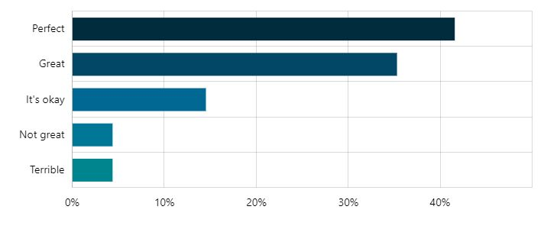
Figure 3 Responses to Quick Poll: ‘What do you think of the updated concept plan for Waurn Ponds Skate park?’
- The YDU.Skate Instagram post of the revised concept plan received 306 likes and 40 comments that generally noted the plan was an improvement on the first concept plan.
- Additional suggestions included: toilets, a pump track or other beginner-friendly elements, more shade and lighting. Improvements to cater to BMX riders were also suggested.
- The advanced bowl shown as part of the future works area received mixed comments with a small number of skatepark users identifying that an advanced bowl would be required to cater to their skill level and allow greater progression for others while others noted they understood there would be budget constraints and preferred the advanced bowl to be part of future works rather than compromising the overall design.

NEXT STEPS

The feedback provided throughout the community engagement enabled the revised concept plan to be supported .
- The City used the concept plan to progress the project to detailed design and engage a contractor to complete the works.
- Skatepark works are due to be completed in 2023.

