Feedback on the North Valley Road Greening concept plan has closed. Thank you to everyone who provided feedback, your contribution is valued and appreciated.

The City invited the community and stakeholders to provide feedback on the concept plan developed from the initial community engagement. The key aim of the second phase of community engagement was to target comments on the proposed concept plan. The underlying theme is to create a healthy environment and vital shopping centre.

From 25 January 2023 to 3 March 2023 (Stage 1), the community was invited to share their ideas and issues on an online interactive social map. These ideas and issues formed the basis of a concept design which was presented back to the community.

From 3 March 2023 to 5 May 2023 (Stage 2), the community was invited to provide feedback on the proposed concept design. The feedback was then used to finalise the design for construction.

**Project Background**

Council has put forward a $50,000 budget this year to provide greening to the North Valley Shopping Centre. The engagement collected ideas and issues to form a plan ahead of construction starting this year.

|  |
| --- |
| HOW WE ENGAGED |

**WHAT DID WE DO?**

Below is a summary of Stage 2 engagement:



**590** visitors to the Have Your Say (HYS) page



**48**

Number of people who left feedback



Suggestions (comments) from the public left online via the online form

**48**

**11**

**63 DAYS**   
of engagement

People following the project

**ENGAGEMENT TOOL AND TECHINQUES**

A project specific engagement page was developed to provide project information and methods of ways to engage with the City.

A range of engagement tools and techniques were used to provide different types of opportunities for stakeholders and community to have their say. The main tools and techniques are explained in further detail below.

|  |  |
| --- | --- |
| HOW WE ENGAGED | |
| Have Your Say Online Portal  Yoursay.geelongaustralia.com.au | An online form was designed to share relevant feedback to encourage community feedback on [North Valley Road Greening project](https://yoursay.geelongaustralia.com.au/NVRG). |
| Online form | The community was invited to interact with an online form by leaving comments on the concept. |
| Posters | Posters were placed at some trader premises situated in North Valley Road. |
| Trader Discussion | Visit to traders to provide information and get feedback . |
| Trader letters | Letters were sent to owners and occupiers of the area in the scope of the project. |

Concept plan: 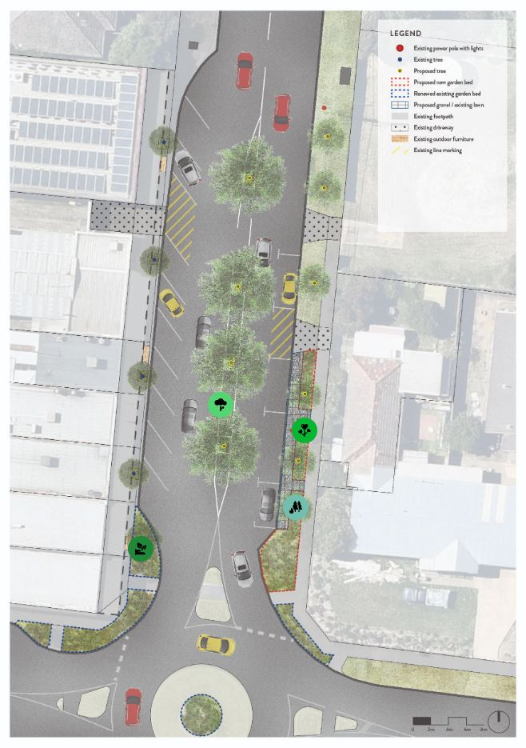

|  |
| --- |
| Who we engaged with |

**PARTICIPATION**

During the second consultation period 590 people visited the North Valley Road Greening project Have Your Say page with 48 pieces of feedback provided.

Over the two stages of consultation there were 1,384 visitors to the project and 117 contributions.

The community was invited to share some demographic data with us, primarily through our HYS page. Of these, 88.1 per cent were first time visitors.

|  |
| --- |
| WHAT WE HEARD |

There were several key themes that came out of the engagement. A summary of key themes and verbatim comments can be found below:

|  |  |
| --- | --- |
|  |  |
| Key themes |  |
| Centre road tree planting and traffic calming | **Garden Beds and greening** |
| You told us: |  |
| Concerns on the median trees | More planting and renew old plantings in the garden bed area. |
| *“Added greenery to the middle of the road. I think it will give the shopping strip a nicer feel, like Highton village”.*  *“It looks like 'boxes' are proposed for middle of road planting. How do large trees with canopy span as shown in drawing grow, safely and healthy? Trees need dripline size of their mature canopy size!*  *“The bitumen between trees in road is an invite for U-turn. Which will cause problems as most drivers cannot calculate turning circle of their car.”*  *“The area is already congested, often difficult to reverse due to hills and being close to the roundabout. Adding trees will make it more dangerous as vision will be impacted.”*  *“I'm happy with the traffic calming idea - people will have to slow down.”* | *“creating a garden bed on opposite side of road.”*  *“Center road plantings and additional garden beds will improve public realm”*  *“creating a garden bed on opposite side of road”*  *“A ‘greener’ upgrade is nice”.*  *“Garden beds planted with native shrubs and plants”*  *“The use of locally indigenous plants, increased canopy cover and greening”.* |
| Response: |  |
| Centre of the road trees. | More planting and renew old plantings in the garden bed area. |
| * Due to a large number of people against the centre of the road trees and cost escalation we have removed these trees and added more planting to the garden beds. See updated plan below. | * Indigenous plants have been chosen for new and old garden beds. |

|  |
| --- |
| WHAT WE HEARD |

**THE FEEDBACK**

While there were positives in trying to calm traffic and create better tree canopy cover, there were quite a few people worried about traffic and parking impacts.

Due to the communities concerns, we have removed the proposed centre of the road trees and increased planting in the existing and new garden beds. See updated plan below.

|  |
| --- |
| NEXT STEPS |

This is the final stage of the engagement process. Comments provided have been considered and captured in the final plans.

Comments that are outside our scope of works will be referred to other City departments for comment. Where there is some information/response we will present it on the HYS page.

The plan will now be sent for quotes and a contractor will be appointed to construct as soon as possible.

Thank you.

|  |
| --- |
| Final plan |

